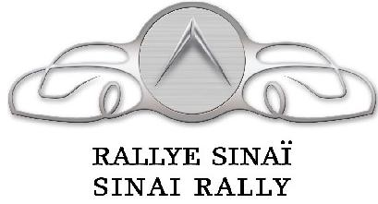
Mr. John Supporter
123 Any Street
Great City, QC X1X 1X1

Dear John,

I am thrilled to announce that I am driving in the 11th annual Mount Sinai Hospital Car Rally on Sunday, August 16th, 2015. The Sinai Rally is an exciting way to raise funds for a fantastic cause: an exceptional hospital.

All monies raised will be allocated to Respiratory Care. Mount Sinai offers one of the most thorough and advanced respiratory disease treatment centers in the province. Prevention, diagnosis, treatment and education are all combined to provide a unique, comprehensive and multi-faceted approach to patient care.

The Sinai Rally raises crucial funds for this unique hospital, and I would be grateful if you support me in achieving my goal of raising $2,500 or $1,000 by sponsoring my car.

Please join me at www.sinairally.org in order to make your donation or simply call the Foundation at 514-369-2222 ext. 1305.

I deeply appreciate and value any amount you donate. If you have any questions or comments, please do not hesitate to email me at xxxxx@yyyy.com or call me at xxx-xxx-xxxx.

Sincerely,

Your Name

