How to use bayMDS package

## Installation

### 1. Installing packages from CRAN using R command

install.packages("bayMDS",dependencies=TRUE)

### 2. Installing packages from CRAN using Rstudio GUI

In menu, select “Tools” -> “Install Packages..”

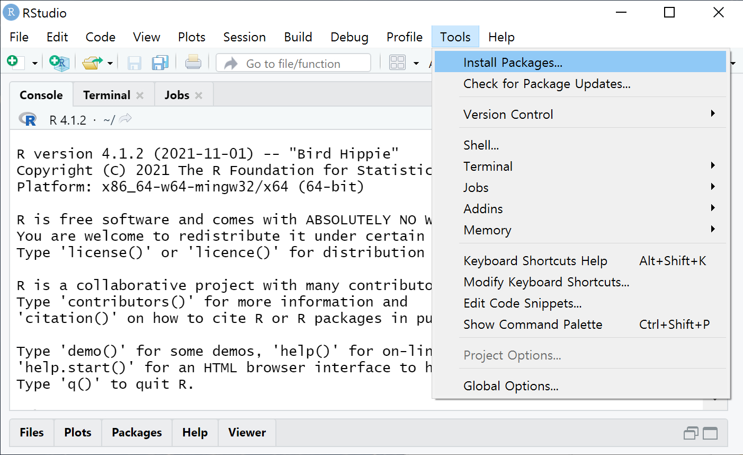

1. type **bayMDS** under **packages (separate multiple with space or comma)**
2. check **Install dependencies**
3. click **Install** button

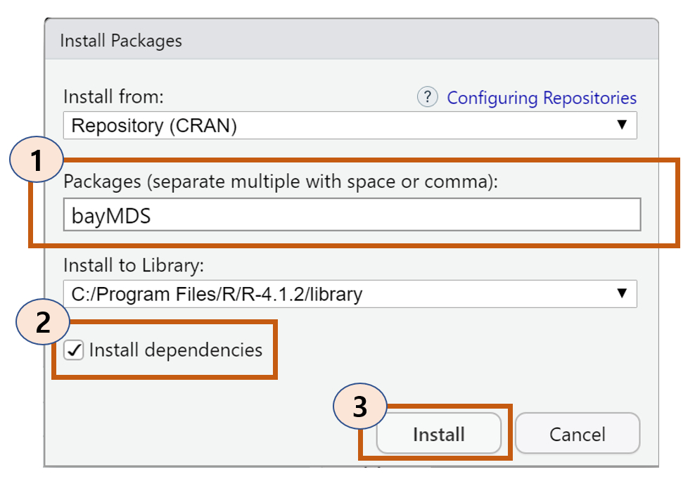

## checkDIST

library(bayMDS)  
x <- matrix(rnorm(100), nrow = 5)  
dist(x)

## 1 2 3 4  
## 2 5.927525   
## 3 4.928006 5.711210   
## 4 4.794217 6.246252 4.744029   
## 5 5.714881 6.486252 5.326936 5.607144

checkDIST(dist(x))

## 1 2 3 4 5  
## 1 0.000000 5.927525 4.928006 4.794217 5.714881  
## 2 5.927525 0.000000 5.711210 6.246252 6.486252  
## 3 4.928006 5.711210 0.000000 4.744029 5.326936  
## 4 4.794217 6.246252 4.744029 0.000000 5.607144  
## 5 5.714881 6.486252 5.326936 5.607144 0.000000

## bmdsMCMC

data(cityDIST)  
result<- bmdsMCMC(cityDIST,p=3)  
str(result)

## List of 12  
## $ DIST : num [1:30, 1:30] 0 39 22 59 54 33 57 32 89 73 ...  
## $ x_bmds : num [1:30, 1:3] -27.31 18.96 4.73 36.29 -38.25 ...  
## $ minSSR : num 31044  
## $ stress : num 0.0951  
## $ e_sigma : num 84.7  
## $ var_sigma: num 33.8  
## $ minSSR_id: int 4330  
## $ SSR.L : num [1:5000, 1] 45258 45264 44810 51288 44499 ...  
## $ lam.L : num [1:5000, 1:3] 0.001254 0.001044 0.000916 0.000753 0.001033 ...  
## $ sigma.L : num [1:5000, 1] 88.7 83.2 83.2 87.7 87.7 ...  
## $ del.L : num [1:5000, 1:435] 49.3 56 61.9 60.3 60.3 ...  
## $ cmds : num [1:30, 1:3] -31.9 15.2 -3.9 38.8 -44.9 ...  
## ..- attr(*, "dimnames")=List of 2  
## .. ..$ : NULL  
## .. ..$ : NULL

## plotDelDist

plotDelDist(result)

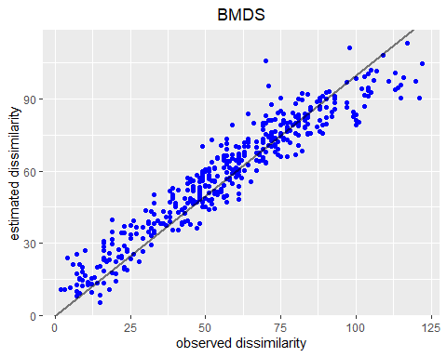

## plotObj

plotObj(result)

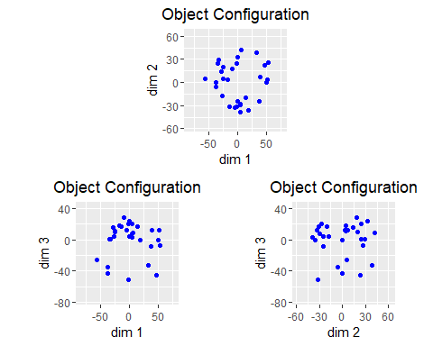

## plotTrace

plotTrace(result,para=c("del","sigma", "lambda"))

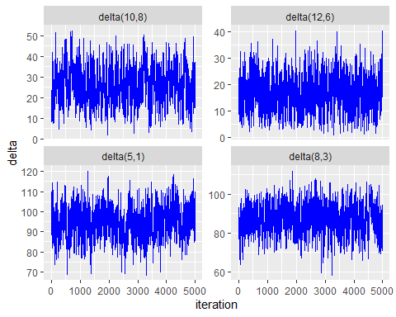

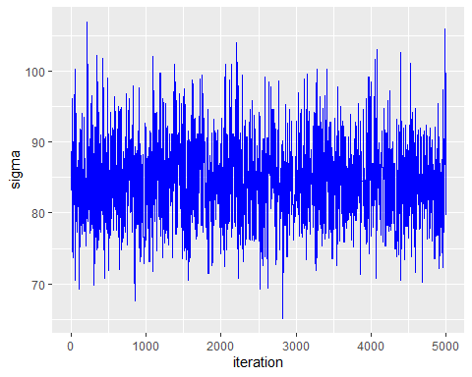

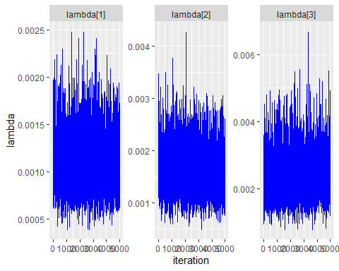

## bmds

out <- bmds(cityDIST, min_p=1, max_p=5 )  
summary(out)

## Length Class Mode   
## n 1 -none- numeric  
## min_p 1 -none- numeric  
## max_p 1 -none- numeric  
## niter 1 -none- numeric  
## nwarm 1 -none- numeric  
## DIST 900 -none- numeric  
## x_bmds 5 -none- list   
## minSSR.L 5 -none- list   
## stress.L 5 -none- list   
## e_sigma.L 5 -none- list   
## var_sigma.L 5 -none- list   
## minSSR_id.L 5 -none- list   
## SSR.L 5 -none- list   
## lam.L 5 -none- list   
## sigma.L 5 -none- list   
## del.L 5 -none- list   
## cmds.L 5 -none- list   
## BMDSp 5 -none- list

## MDSIC

MDSIC(out)

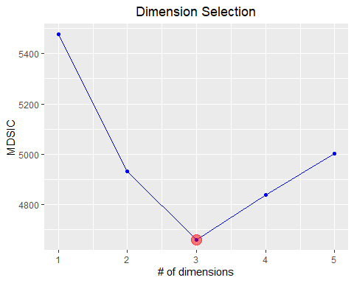

## $mdsic  
## [1] 5477.101 4930.651 4659.218 4839.483 5001.448  
##   
## $llike  
## [1] -642.62603 -361.58110 79.56272 41.04931 0.00000  
##   
## $penalty  
## [1] 96.17639 90.14776 100.70229 120.91596 0.00000

## bayMDSApp

bayMDSApp(out)

