Aquarium Fish Store
Finalized Product Catalog — 40 Ornamental Fish
Category | Fish Name | Scientific Name | Price (BDT) | Description | Product Photo
Goldfish | Common Goldfish | Carassius auratus | 80 | Classic hardy goldfish, great for beginners. Cold-water fish, needs a spacious tank. | 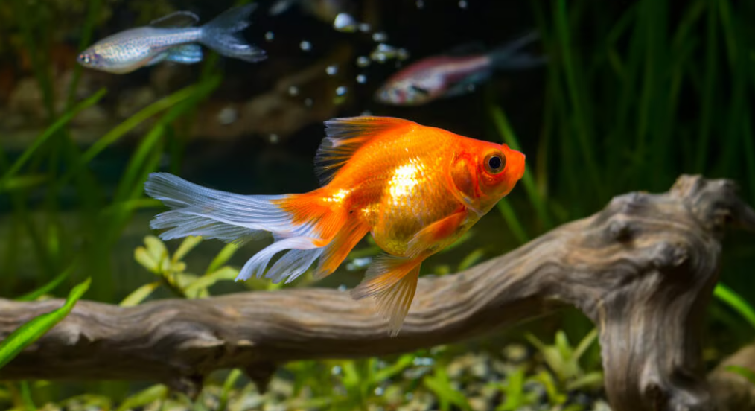
Goldfish | Fantail Goldfish | Carassius auratus | 150 | Round-bodied goldfish with a split tail fin. Peaceful and easy to care for. | 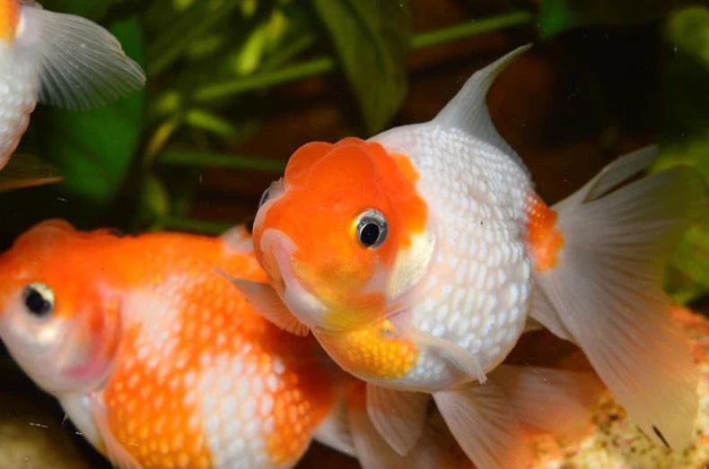
Goldfish | Oranda Goldfish | Carassius auratus | 450 | Goldfish with a distinctive raspberry-like head growth (wen). Slow swimmer, needs calm tankmates. | 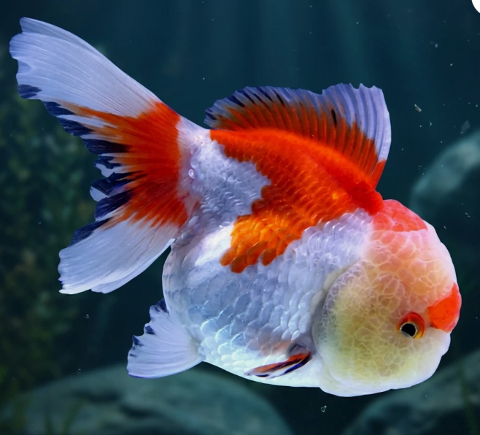
Goldfish | Black Moor Goldfish | Carassius auratus | 300 | Velvety black goldfish with telescope eyes. Needs smooth decor to protect its eyes. | 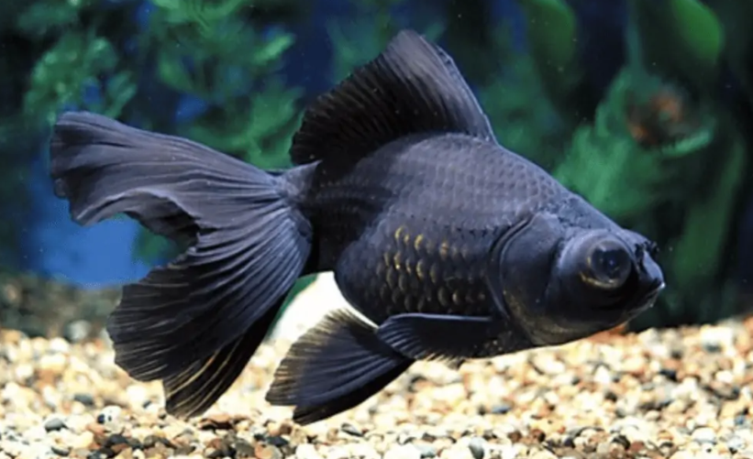
Goldfish | Ryukin Goldfish | Carassius auratus | 350 | High-backed fancy goldfish with flowing fins. Prefers cooler water and good filtration. | 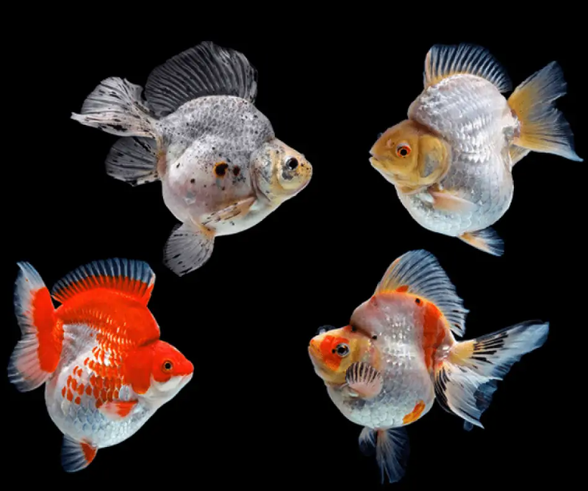
Betta | Veiltail Betta | Betta splendens | 120 | Classic long-flowing-finned betta. Best kept alone due to territorial nature. | 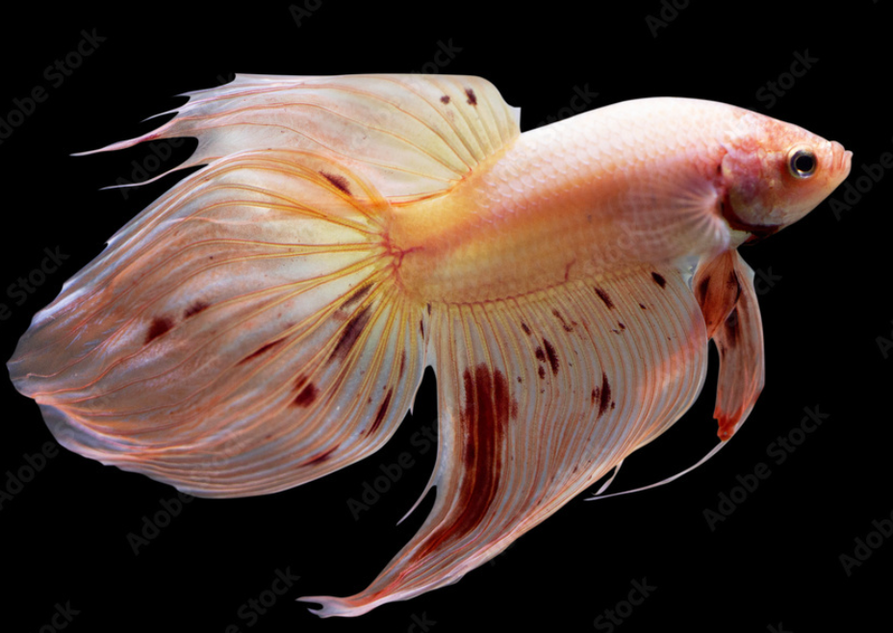
Betta | Halfmoon Betta | Betta splendens | 350 | Betta with a fin spread of 180 degrees when flared. A show-quality favorite. | 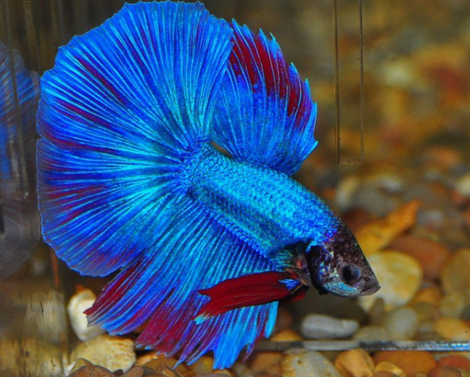
Betta | Crowntail Betta | Betta splendens | 280 | Betta with spiky, crown-like fin rays. Bold colors and striking appearance. | 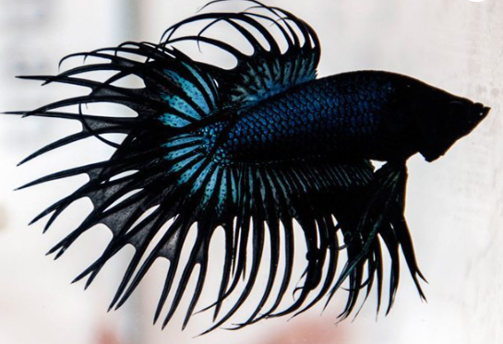
Betta | Plakat Betta | Betta splendens | 250 | Short-finned, athletic betta closer to the wild form. Active swimmer. | 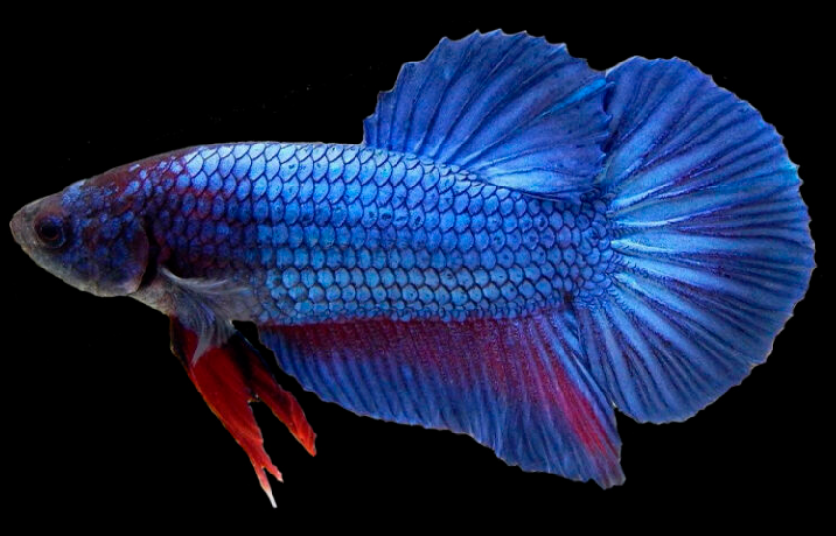
Livebearers | Guppy (Mixed Colors) | Poecilia reticulata | 40 | Small, colorful, and easy to breed. Perfect starter fish for community tanks. | 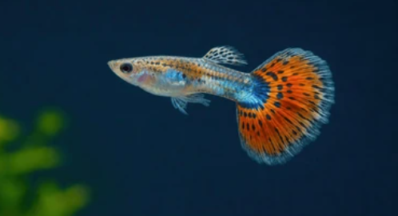
Livebearers | Balloon Molly | Poecilia sphenops | 60 | Round-bellied molly with a peaceful temperament. Does well in slightly salty water. | 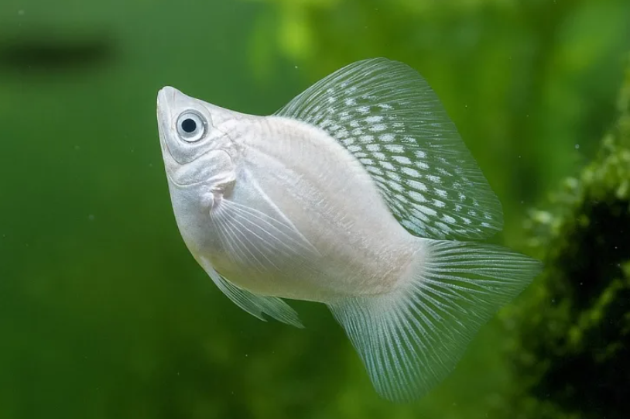
Livebearers | Platy | Xiphophorus maculatus | 45 | Hardy, colorful livebearer that breeds easily. Great for beginner community tanks. | 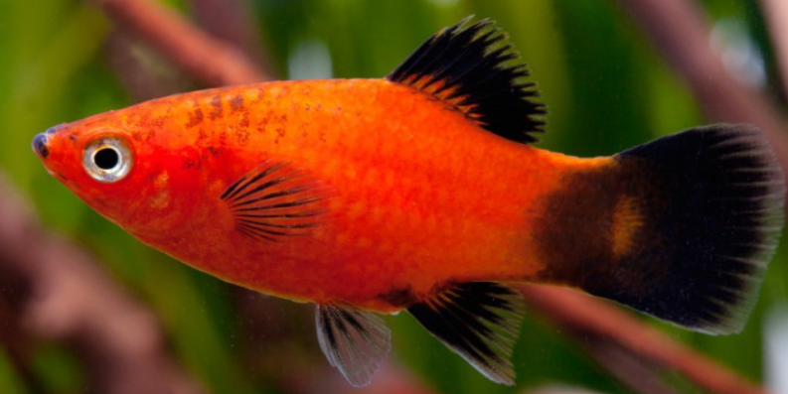
Livebearers | Swordtail | Xiphophorus hellerii | 55 | Active livebearer named for the sword-like extension on the male's tail fin. | 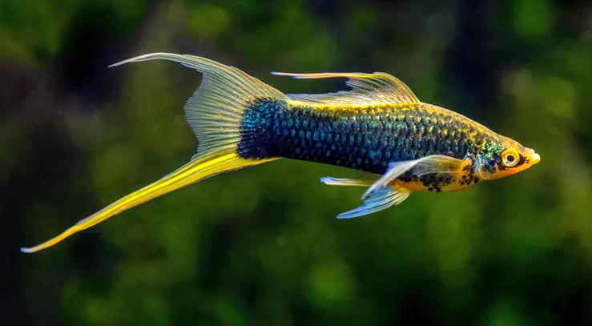
Livebearers | Endler's Guppy | Poecilia wingei | 70 | Smaller, more colorful cousin of the common guppy. Very active and hardy. | 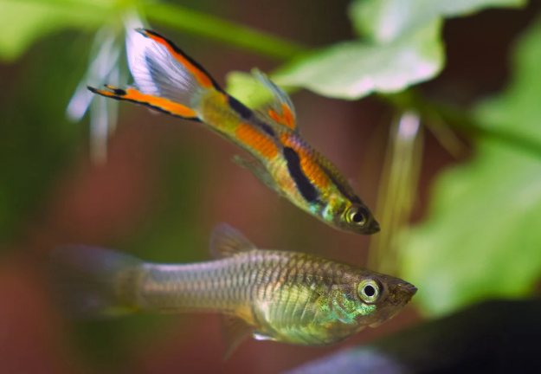
Tetra | Neon Tetra | Paracheirodon innesi | 35 | Small schooling fish with a bright blue-red stripe. Best kept in groups of 6+. | 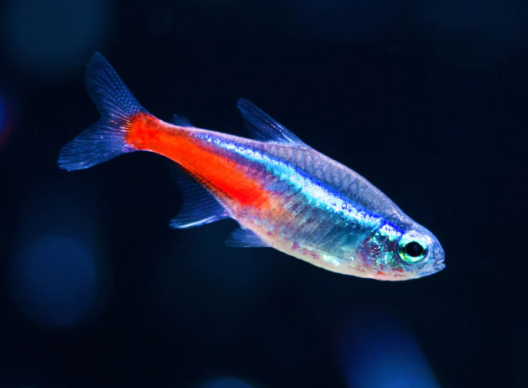
Tetra | Cardinal Tetra | Paracheirodon axelrodi | 60 | Similar to neon tetra but with a longer red stripe. Stunning in planted tanks. | 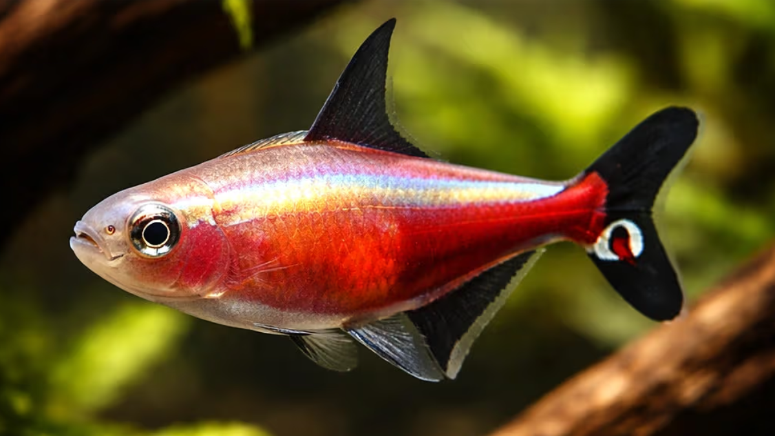
Tetra | Black Skirt Tetra | Gymnocorymbus ternetzi | 40 | Black, flowing-finned schooling fish. Hardy and adaptable to varied water conditions. | 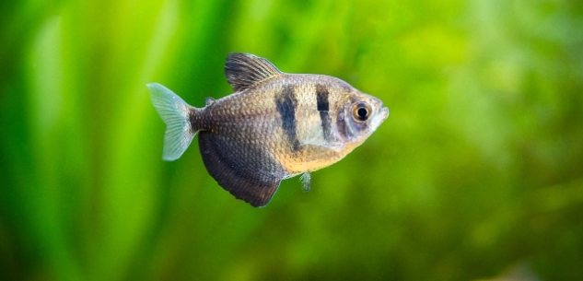
Tetra | Ember Tetra | Hyphessobrycon amandae | 45 | Tiny, glowing orange schooling fish. Ideal for small nano planted tanks. | 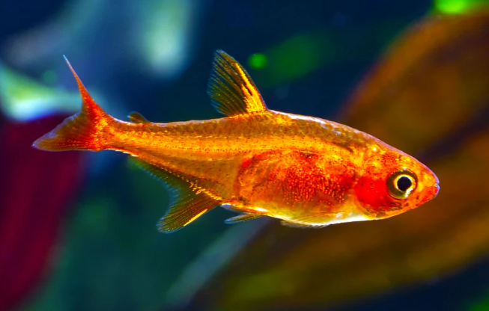
Tetra | Rummy Nose Tetra | Hemigrammus bleheri | 70 | Recognizable by its bright red nose and striped tail. Peaceful schooling fish. | 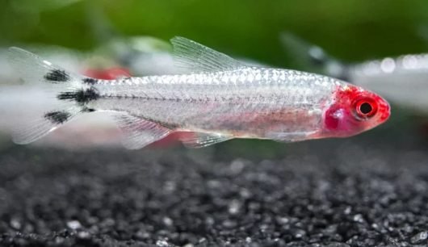
Barb | Cherry Barb | Puntius titteya | 40 | Small, cherry-red schooling barb. Peaceful and suitable for community tanks. | 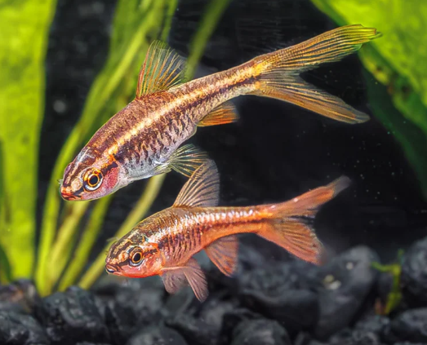
Barb | Tiger Barb | Puntius tetrazona | 45 | Striped, active barb best kept in larger groups to reduce fin-nipping. | 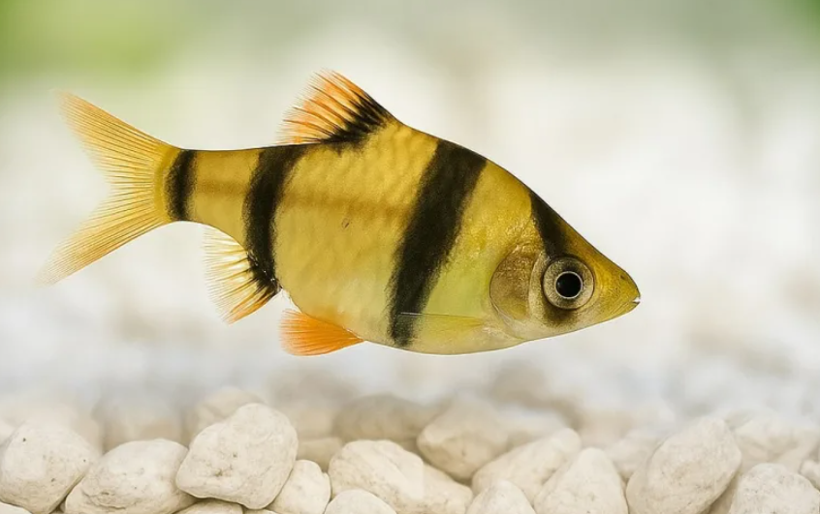
Barb | Rosy Barb | Pethia conchonius | 50 | Hardy pink-toned barb, good for slightly cooler community tanks. | 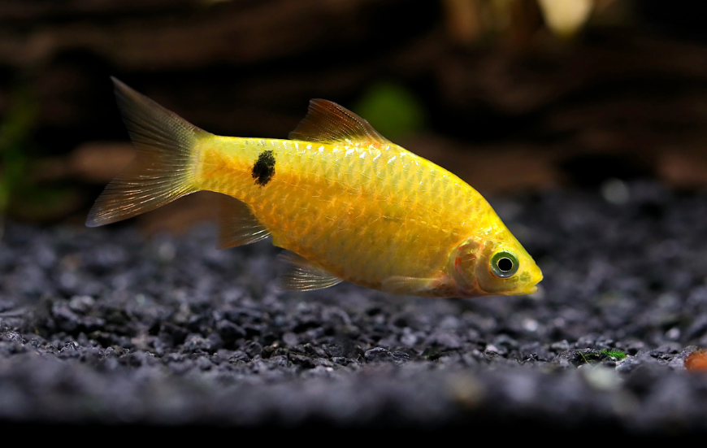
Gourami | Dwarf Gourami | Trichogaster lalius | 120 | Colorful, labyrinth-breathing fish that can gulp air at the surface. Peaceful. | 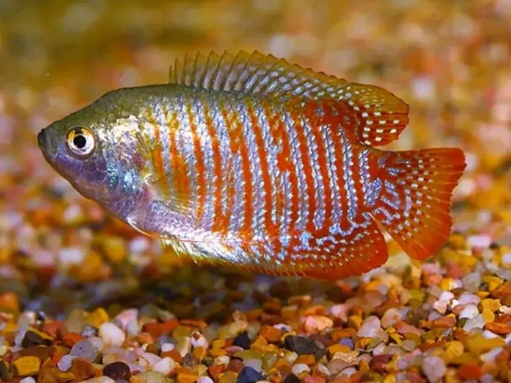
Gourami | Pearl Gourami | Trichopodus leerii | 180 | Elegant fish with a lace-like pearl pattern and a threadlike ventral fin. | 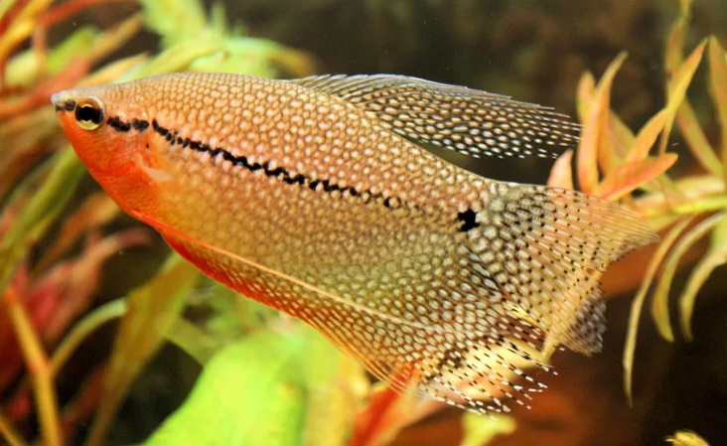
Gourami | Blue gourami | Trichopodus trichopterus | 150 | Larger, hardy gourami with a calm temperament, good for bigger community tanks. | 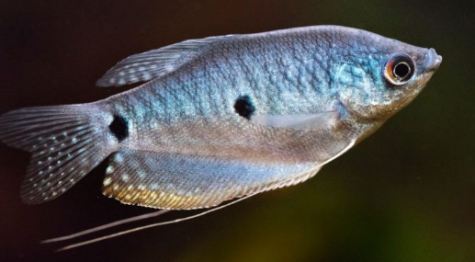
Cichlid | Angelfish | Pterophyllum scalare | 220 | Tall, graceful cichlid, an aquarium classic. Needs a tall tank to accommodate its fins. | 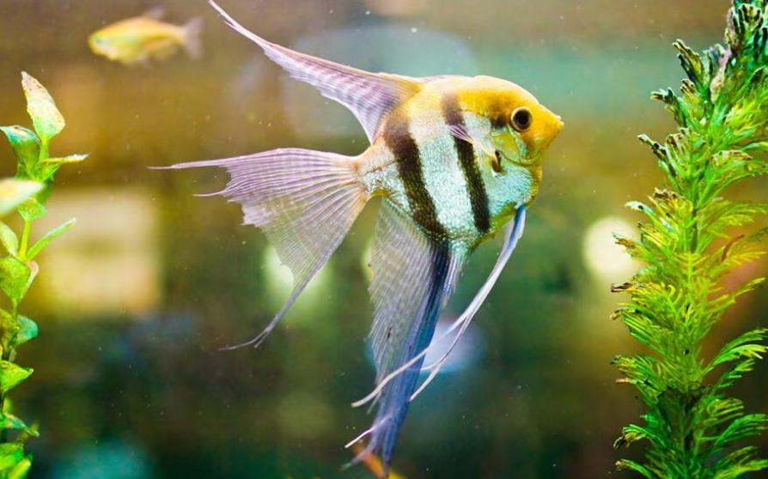
Cichlid | Discus | Symphysodon aequifasciatus | 1800 | Premium disc-shaped cichlid prized for its color and pattern. Needs stable, warm water. | 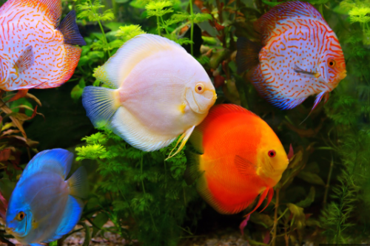
Cichlid | Oscar Fish | Astronotus ocellatus | 500 | Large, intelligent cichlid that recognizes its owner. Needs a big tank as it grows. | 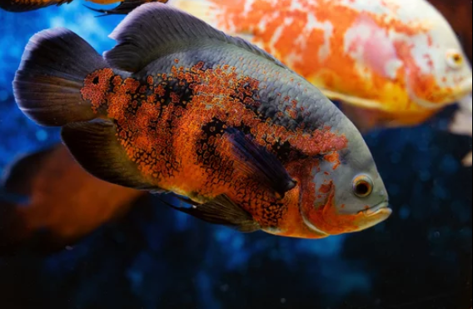
Cichlid | Flowerhorn | Hybrid cichlid | 1500 | Bold hybrid cichlid known for its head hump and vivid colors. Territorial, keep alone. | 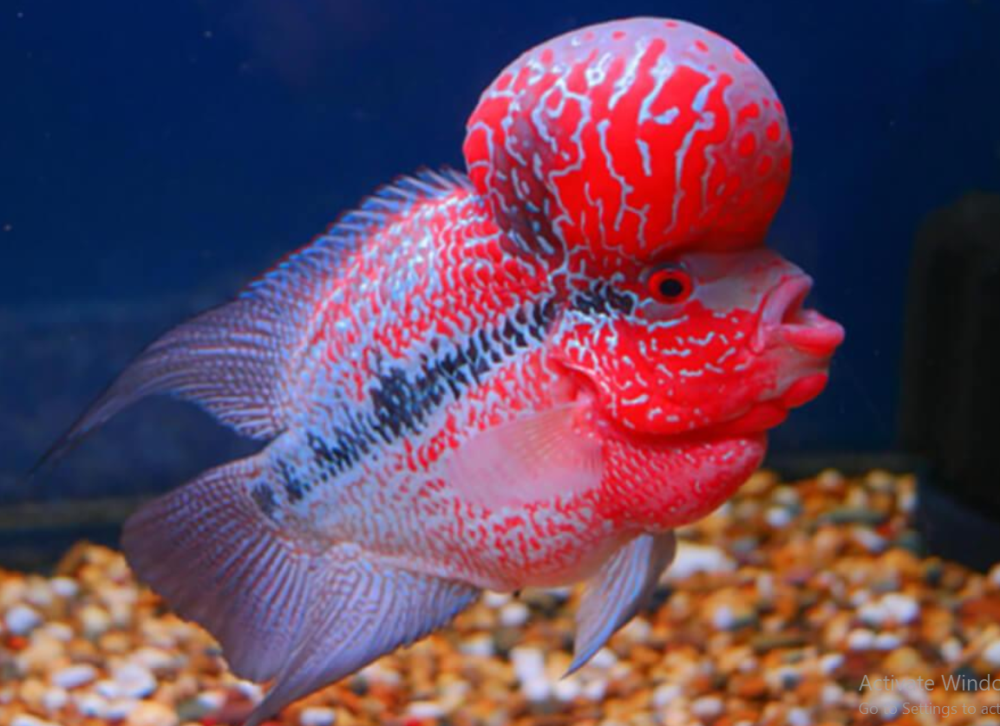
Cichlid | Convict Cichlid | Amatitlania nigrofasciata | 90 | Striped, hardy, and easy to breed cichlid. Can be territorial when spawning. | 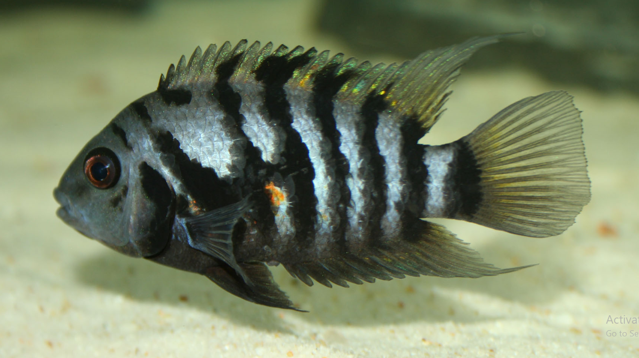
Cichlid | Electric Yellow Cichlid | Labidochromis caeruleus | 150 | Bright yellow African cichlid, popular for colorful cichlid community tanks. | 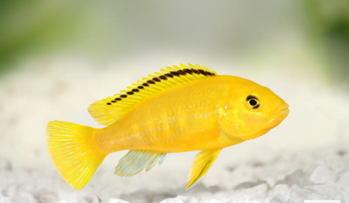
Catfish/Bottom Dweller | Bristlenose Pleco | Ancistrus cirrhosus | 180 | Algae-eating catfish, great tank cleaner. Peaceful and mostly nocturnal. | 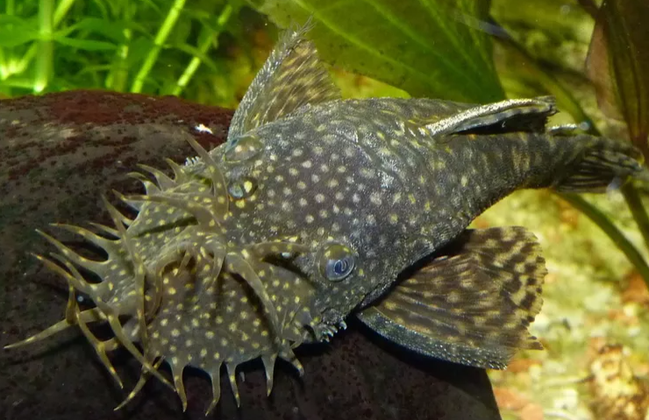
Catfish/Bottom Dweller | Corydoras Catfish | Corydoras spp. | 90 | Small, friendly bottom-dweller that helps keep the substrate clean. Best kept in groups. | 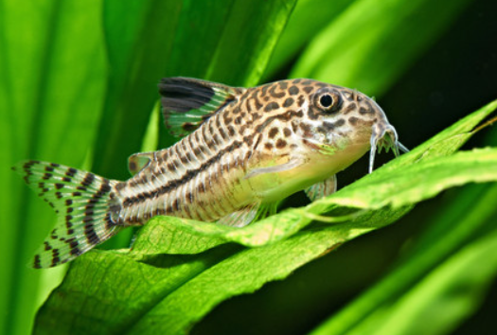
Shark Type | Red Tail Shark | Epalzeorhynchos bicolor | 130 | Black-bodied fish with a bright red tail, resembling a small shark. Can be territorial. | 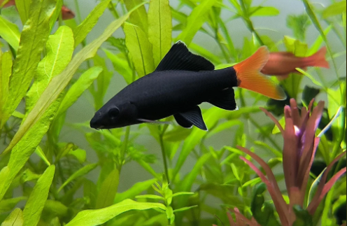
Shark Type | Bala Shark | Balantiocheilos melanopterus | 200 | Silver, torpedo-shaped, active schooling fish. Needs a large tank as it grows big. | 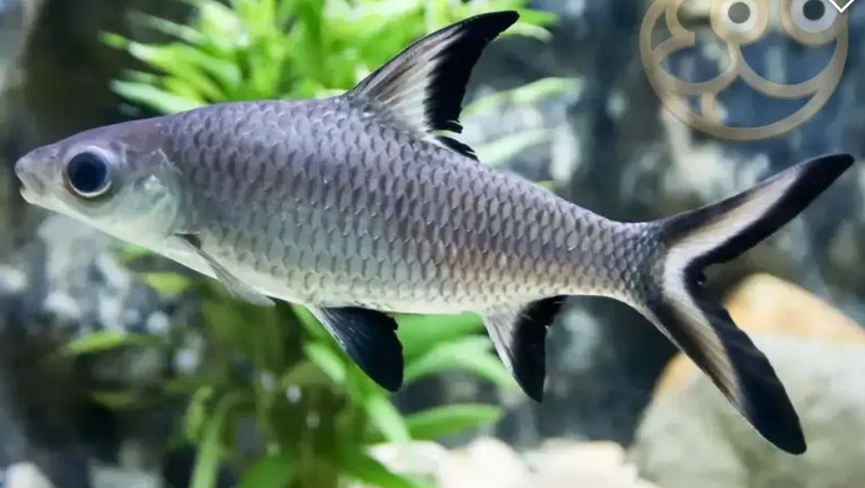
Nano Fish | White Cloud Mountain Minnow | Tanichthys albonubes | 40 | Cold-tolerant, hardy nano fish good for beginners and unheated tanks. | 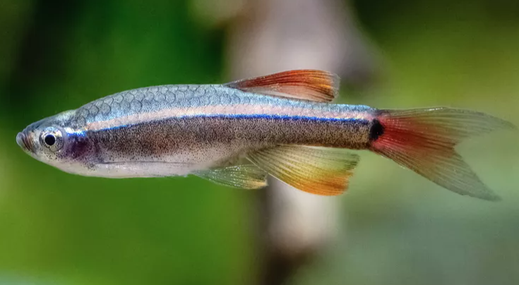
Nano Fish | Chili Rasbora | Boraras brigittae | 60 | Extremely small, vivid red nano fish, ideal for tiny planted tanks. | 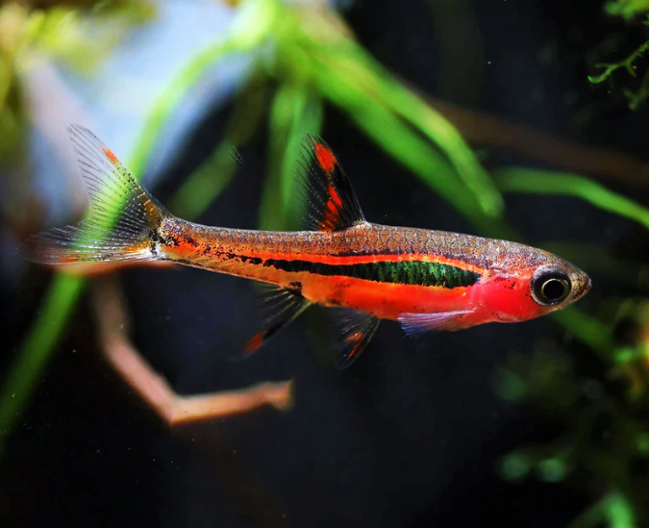
Premium/Rare | Silver Arowana | Osteoglossum bicirrhosum | 3500 | Large, prestigious predator fish known as the 'dragon fish'. Needs a very large tank. | 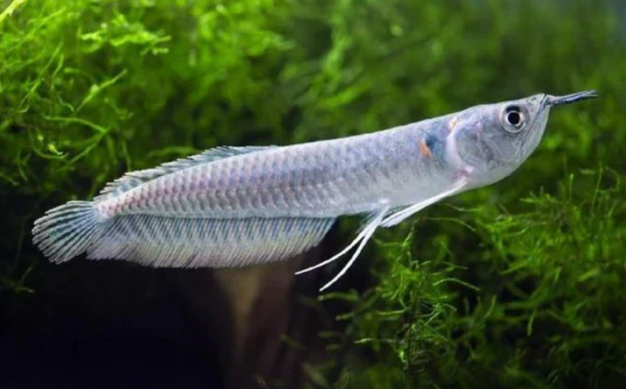
Premium/Rare | Freshwater Stingray | Potamotrygon spp. | 4500 | Rare, striking bottom-dwelling ray. For experienced keepers with large, soft-water tanks. | 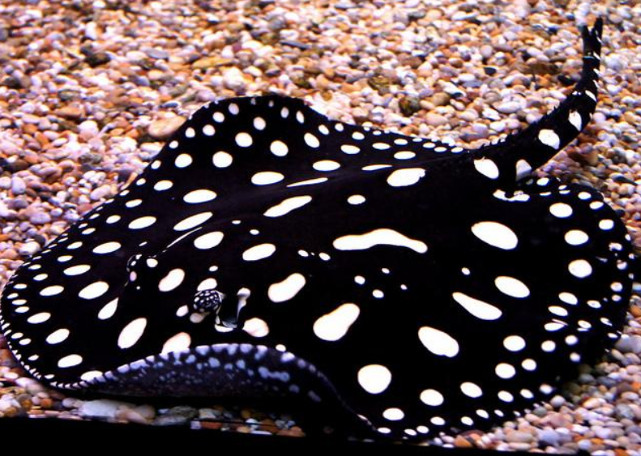
Invertebrate | Cherry Shrimp | Neocaridina davidi | 50 | Small, bright red algae-eating shrimp. Easy to keep and breeds readily in planted tanks. | 