**SOFTWARE TESTING ASSIGNMENT**

**MODULE 1 (FUNDAMENTAL)**

**Q1. What is SDLC?**

**Ans**. SDLC is a structure imposed on the development of a software product that defines the process for planning, implementation, testing, documentation, deployment and ongoing maintenance and support.

**Q2. What is software testing?**

**Ans.** Software testing is a process used to identify the correctness, completeness, and quality of developed computer software.

**Q3. What is agile methodology?**

**Ans.** The agile methodology is a project management approach that involves breaking the project into phases and emphasizes continuous collaboration and improvement.

It is an approach to software development that seeks the continuous delivery of working software created in rapid iterations.

**Q4. What is SRS?**

**Ans.** SRS stands for Software Requirement Specification**.** SRS is a detailed specification and description of software requirements that must be met for a software system to be successfully developed.

**Q5. What is OOPS?**

**Ans.** Object Oriented Programming System (OOPS) is basically a computer programming design methodology that organizes software design around data, or objects rather than function and logic.

**Q6. Write basic concepts of OOPS.**

**Ans.** Basic Concepts of OOPS are:

* Object
* Class
* Encapsulation
* Inheritance
* Polymorphism
* Abstraction

**Q7. What is Object?**

**Ans.** Object is instance of a class. Class is nothing without objects. It is used to create memory in a class and to access the whole properties of a class except private.

**Q8. What is class?**

**Ans.** Class is a collection of data member (variable) member function (process methods) with its behaviors.

**Q9. What is encapsulation?**

**Ans.** Encapsulation is the process of wrapping up of data (properties) and behavior (methods) of an object into a single unit. Encapsulation enables data hiding, hiding irrelevant information from the users of a class and exposing only the relevant details required by the user.

**Q10. What is inheritance?**

**Ans.** Inheritance means properties of parent class extends into child class. Its main purpose is reusability and extensibility. There are mainly 5 types:

1. Single
2. Multilevel
3. Hierarchical
4. Multiple: java does not support.
5. Hybrid: java does not support.

**Q11. What is polymorphism?**

**Ans.** Polymorphism means one name having many forms. It allows different objects to respond to the same message in different ways, the response specific to the type of the object.

There are mainly 2 types:

1. Compile time polymorphism(Overloading)
2. Runtime polymorphism(Overriding)

**Q12. Write SDLC phases with basic introduction.**

**Ans.** There are six phases in SDLC.

1. Requirements Collection/Gathering: Establish what customer Needs.
2. Analysis: Model and specify the requirements.
3. Design: Model and specify a Solution.
4. Implementation: Construct a solution in software.
5. Testing: Validate the solution against the requirements.
6. Maintenance: Repair defects and adapt the solution to the new requirements.

**Q13. Explain phases of the waterfall model.**

**Ans.** The waterfall model was the first model to be introduced. It is a linear, sequential approach to the SDLC that was popular in software development. In this model, the software development is done step by step like waterfall between various development phases.

Its phases are explained below:

1. Requirements: The aim of this phase is to understand the exact requirements of the customer and to document properly.
2. Design phase: This phase aims to transform the requirements gathered in the SRS in to a suitable form which permits further coding in a programming language.
3. Implementation: During this phase, design is implemented. If the SDD is complete, the implementation or coding phase is done smoothly, because all the information needed by software developers is contained in the SDD.
4. Testing: Unit testing determines the efficiency of individual modules. In this phase, the modules are tested for their interactions with each other and with the system.
5. Maintenance phase: Maintenance is the task performed by every user once the software has been delivered to the customer, installed, and operational.

**Q14.Write phases of spiral model.**

**Ans.** The spiral model has 4 phases:

1. Planning: Determination of objectives, alternatives and constraints.
2. Risk analysis: Analysis of alternatives and identification/resolution of risks.
3. Engineering: Development of the next level product.
4. Customer evaluation: Assessment of the results of engineering.

A software project repeatedly passes through these phases in iterations (called Spirals in this model).

**Q15. Write agile manifesto principles.**

**Ans.** The agile manifesto are written below:

* Individuals and interactions over processes and tools.
* Working software over comprehensive documentation.
* Customer collaboration over contract negotiation.
* Responding to change over following a project plan.

**Q16. Explain working methodology of agile model and also write pros and cons.**

**Ans.** Agile is a project management approach developed as a more flexible and efficient way to get products to market. The word ‘agile’ refers to the ability to move quickly and easily. Therefore, an Agile approach enables project teams to adapt faster and easier compared to other project methodologies.

Agile projects require an iterative approach, which supports incremental, frequent, and consistent delivery of workable products to your customer or client. This innovative approach ensures your project team can consistently deliver concrete products without being delayed by changes and evolving requirements.

Agile has a high level of customer involvement and includes frequent reviews of progress with both the project team and the customer.

**Pros:**

* Little or no planning required.
* Easy to manage.
* Gives flexibility to developers.
* Resource requirements are minimum.
* Promotes teamwork and cross training.

**Cons:**

Not suitable for handling complex dependencies.

More risk of sustainability, maintainability and extensibility.

Transfer of technology to new team members may be quite challenging due to lack of documentation.

**Q17. Draw usecase on online book shopping.**

**Ans.**

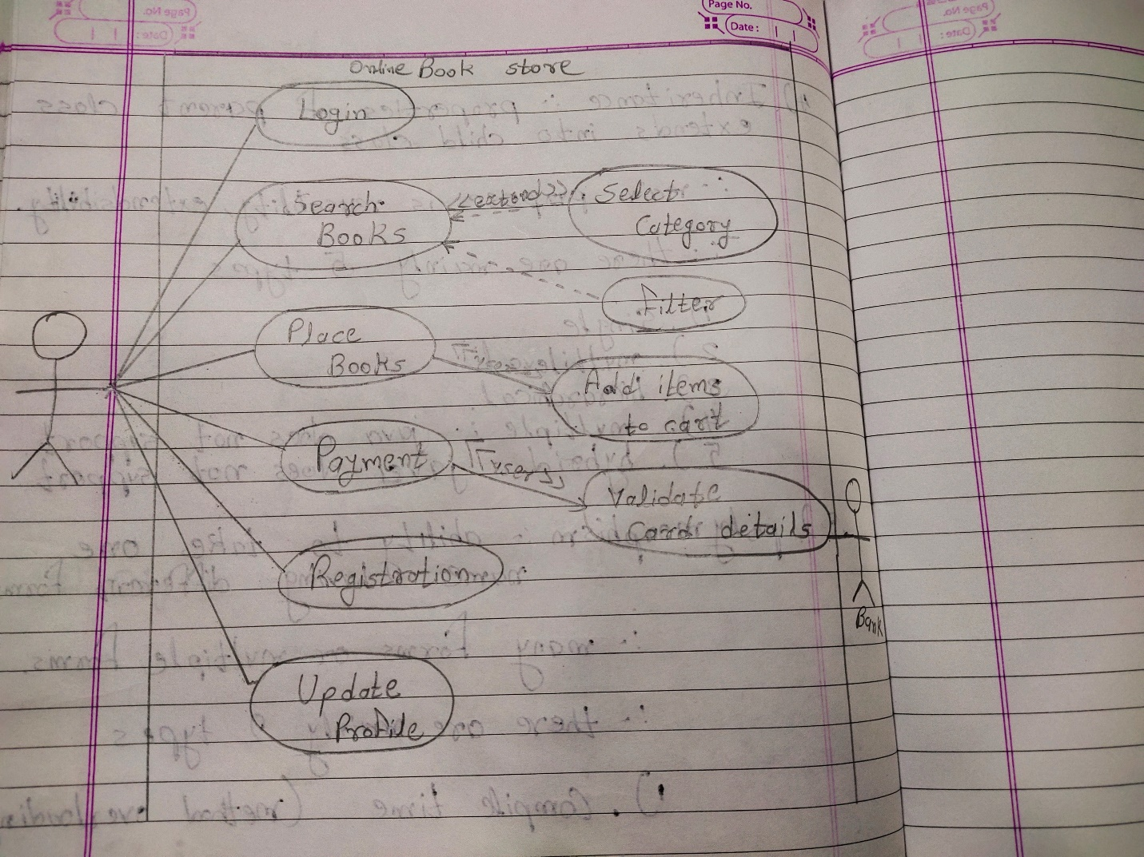

**Q18. Draw usecase on online bill payment system (paytm).**

**Ans.**

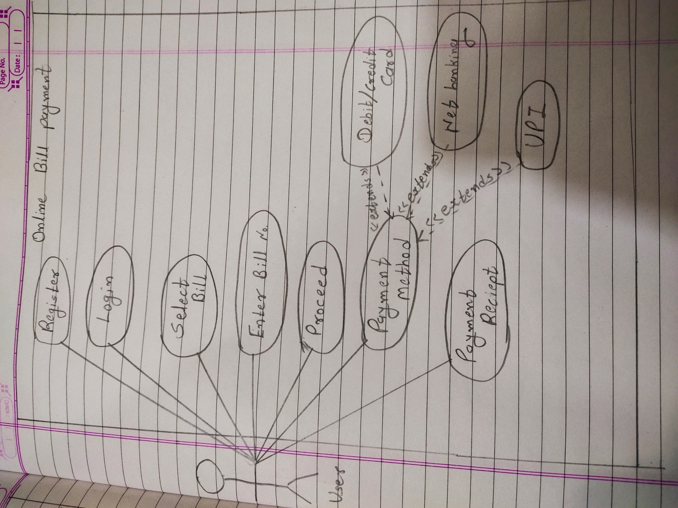

**Q19. Draw usecase on online shopping product using COD.**

**Ans.**

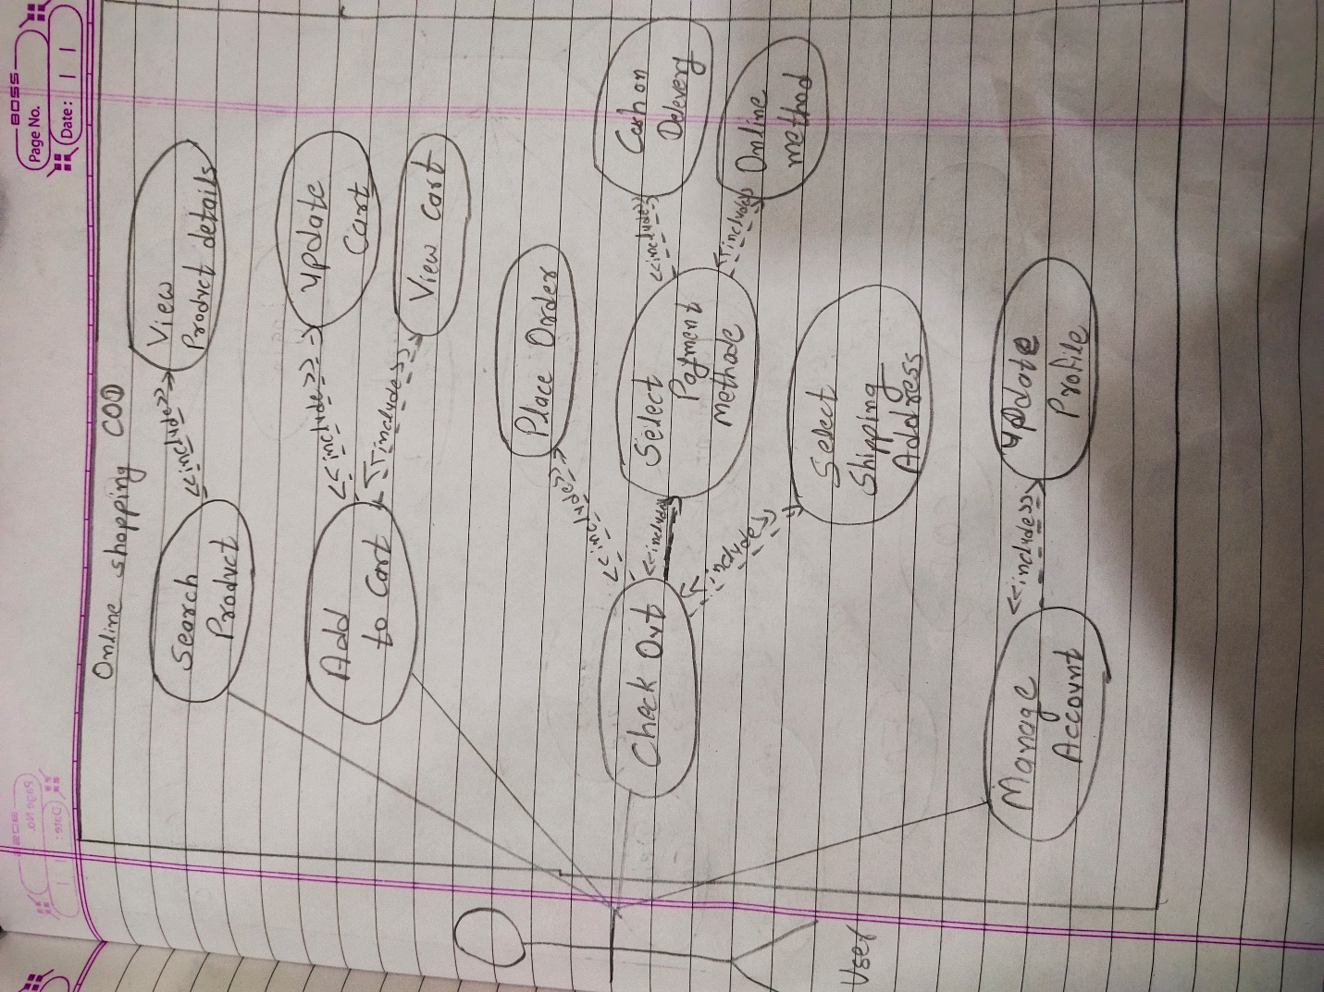

**Q20. Draw usecase on online shopping product using payment gateway.**

**Ans.**

