Hanwha Vision (IVTECH) Phase-2 Requirements

- Collect the data from camera if camera disconnected from application, during disconnection time data should fetch to the app. (Bala has to provide the CGI command and need to have a call with HQ development) -
=> Keep track of when the camera API did not respond and mark the camera as disconnected.
=> Save datetime when the camera is marked as disconnected.
=> In next cycle when API is responding, call the API by passing the start time as time when the camera got disconnected and end time as current time and fetch the data.
=> APIs are different for SUNAPI and WiseAI.
=> New Widget to be created for Connected/Disconnected Camera.
=> API / CGI commands will be shared by Ganesh.

- Database Limit setting - Retention period, archive option should available (we will have months or years to maintain the retention period) need to discuss in detail with DB team and our Technical Team
=> In General Configuration Settings, give option to select period, unto which the data needs to be retained.
=> Options will be in months.
=> User will enter number of months for which data needs to be retained.
Q => Data will be archived in existing database/new database
=> Data will be archived at the end of the month.
D => Cron job to be created to archive the data.
D => While displaying the historical data, if the selected filter is before the retention period, then data needs to be fetched from archive data and displayed.
Q => Suggest for separate reports for archived data. Either user can see archived data or current data in the report.

- Can be separate database in separate machine. (Need to do R&D on this and check how we can create a solution)
=> The option to define where the application database (MongoDB) will reside will be given in the application installation step.
=> While installing the application, user can select the drive in the same machine where database needs to be installed.
=> If user wants to have database on separate machine, it is required that Mongo DB is already installed in that machine and is accessible to the machine where Vision Insight application is installed.
D => Change to be done in App Settings file to set connection string of the DB on new server.

- Backup - Is database available in backup, if server crashed can database restore, DB export should available. If database crashed, can possible to recover. (We will keep only first 7 days backup and rest it will be overwritten First in First out base at any given point of time we will have 7 days backup)
=> In General Configuration Settings, give option to enter the path where the Database backup files will be created and stored daily.
D => Create a Cron job (Scheduler) to create a backup of database and store it in the specified path.
=> The database backup files that are more than 7 days old will be deleted.
=> In case of server or db crash, user will manually select the database backup file from the path and can restore the data.

- TAB to be add in SSM. Two-way (Need to integrate with SSM Dashboard and show in separate page for dashboard) API’s and integration will be discussed with HQ developers. Bala will arrange the call) Need to share how the architecture will work and what are API to be integrated.

=> Add and edit SSM site.
=> Display all the registered SSM site in new page with filter.
=> Changes in roles and permission to give permission to new page.
=> Create background job which will continuous keep storing historical data from the registered SSM servers.
=> Create new dashboard for display SSM. Is it license based?
=> Filters on dashboard 1. SSM Site selection, 2. Datetime selection
=> based on filter below data will display on the dashboard Need to identify APIs to get the data from the SSM servers, Ganesh will provide API details.
- Total camera count
- Total SSM Server count
- Failure camera count
- Failure SSM server
- Display server-based data. Image2
  - Server connection details
  - Server storage details per drive
  - Connected / Disconnected devices
  - Raid Disk What is this? Is it required or not?
  - CPU > system manager, media server
  - RAM > system manager, media server
Image1
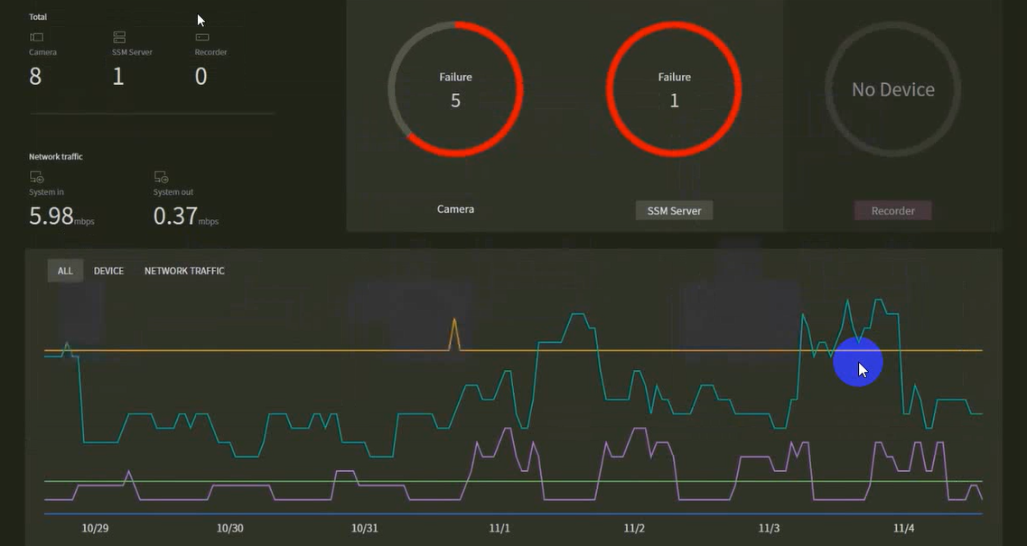
Image 2
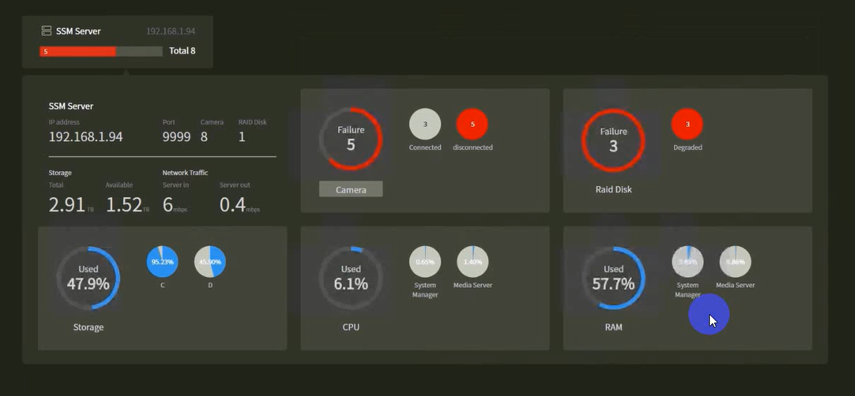
Image 3
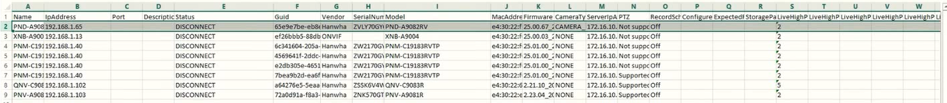
=> Note: network detail is not required
=> Health report
=> user can select sites and date range.
=> System will generate CSV report for the selected filter. Report will display each record when device is online/offline. If any device online/offline multiple time within specific period in this case display each record with specific datetime. Image 3 is their existing report.

- How to trouble shooting if any error, where to collect audit log.
=> Implementation of audit log for every transaction and error logs.
=> New screen to see audit logs
=> Separate screen to see error logs.
=> Option/Button to send the error log as email to developer.
=> Permission based screen. User should have rights to view audit log screen.

- API not responding - How to know. (Offline, Online and API not responding) need to have one widget
=> Camera is online, but if any API is not responding then mark that camera as API not responding.
=> New Widget to show number of cameras with API not responding.
=> Show which camera API is not working.
=> In pop-up show in tabular form which camera are not working.
D=> Check with Sandip for design of how to show the camera for API not responding.

- Need to check X Series Wisenet 9 API issues
=> Development is already done. Need to consider efforts in the estimation.

- Need to add Time Format 12 and 24, for reports and widgets full application
=> Implement 12/24 hour format in all screens, widgets, reports as selected in the configuration by the user.

- Need to test dual lens camera as well - PNM Series 2Ch, 3Ch, 4Ch, and 5Ch (Need to create Multi Channel and it should max 5Ch, based on camera API number channels should be enable) and the license should be deducted based on number channels)
=> In Manage Device screen, add new type of "Multichannel" camera.
=> Give textbox to enter the number of channels supported by the camera. Usually it will be between 2 to 5 channels.
=> Treat this camera implementation similar to AI Box.
=> Each channel will reduce 1 camera count from the License.

- iDRAC Integration
=> Separate menu for iDRAC which will have Configuration Settings and Dashboard
=> New screen to add Dell server with ip, UserName, Password, set alerts when CPU, Memory, Storage goes beyond set limit
=>

- ANPR Integration (Need to share API, need to have separate Dashboard widgets showing number of Vehicle in and out based on LPR,)(F105B196)
=> Separate license required to use ANPR feature. (F4B4)
=> Add ANPR option in manage device when add edit device. Here user will also define Entry / Exit setting for specific camera. (F8B8)
=> Application will accept ANPR event from the camera. (F0B16)
=> Validate the vehicle event data and open the gate barrier integration alarm by CGI command. Same process for exit vehicle. For exit gate barrier will not open if vehicle is not registered. Need to confirm (F0B16)
=> For restricted vehicle do not open gate and fire alarm. Need CGI command. (F0B4)
=> Keep store large image and cropped image of ANPR detection on configured location. (F0B4)
=> Data from the ANPR event. Datetime, Plate Image, Plate series, Vehicle number, Plate code, Region, Country, Plate Category, Plate length, Make, Model, Colour. (F0B0)
=> LPR search parameter (License plate recognition) (F16B16)
- Select the floor/zone/devices
- Datetime range
- License Plate:
  - Plate series
  - Vehicle number
  - Country
  - Region
  - Colour
  - Category
  - Length
- Vehicle:
  - Type
  - Colour
  - Manufacturer
  - Model
- Owner Information
  - Owner
  - Building
  - Unit
=> Display LPR search result in the grid with standard pagination and export to CSV option (F8B8)
=> Configuration
- Plate image storage location (F4B4)
  - Configure the path where all the plate images will be store.
- Data and image retention period
  - Configure in the month. After configured retention older image and data will be deleted from the system.
  - Create background job which will execute daily and delete old data as per retention configuration. (consider delete not archive) (F0B8)

==================================
=> LPR Monitoring
=> Vehicle Management. Register owners and their vehicles.
Register Owner (F8B8)
- Name
- Building
- Unit
- email
- Allowed vehicle (number of allowed vehicle in parking) (F0B2)
- Allowed from time (if it is configured owner cannot enter before this time) (F0B2)
- Allowed to time (if it is configured owner cannot enter after this time) (F0B2)
- Allowed gates (if it is configured owner can enter on selected gates only) (F4B6)
- Enable alarm for overstay (if vehicle is not exit before Allowed to time) (how alarm will trigger) (F0B0)
- Enable alarm for 24H stay (how alarm will trigger) (F0B0)
Register vehicle with below details (F8B8)
- Country
- Region
- Series
- Vehicle number
- Registration date
- Expired date
- Vehicle Owner
- RegistrationType[Registered, Visitor, Restricted]
- Vehicle Owner (select owner in case if Registered)
- Temporary owner name (for Temporary Visitor)
- email
- Temporary Allowed from time (for Temporary Visitor)
- Temporary Allowed to time (for Temporary Visitor)
- Temporary Allowed gates [] (for Temporary Visitor)
- Enable alarm for overstay (if vehicle is not exit before Temporary Allowed to time) (how alarm will trigger)
- Enable alarm for 24H stay (how alarm will trigger)
=> Create background job for overstay alarm. (F0B8)
=> Create background job for 24H stay alarm. (F0B8)
=> Management history for audit data. (F16B16)
All the details must be available like who register/update the vehicle/Owner data.
=> CSV upload features for register vehicle. Need predefine format(F1B8)
=> Allow manually open gate barrier from the camera grid. (F2B4)
=> Set device as maintenance mode ON/Off from the grid. Keep open the gate barrier in case of maintenance mode is on. (provide CGI command) (F2B4)
=> calculate utilization based on in and out vehicles. (where/how utilization will be display?) (F4B16)
=> map floor zone with ANPR camera. (F12B16)

- Heat maps plotting on floor plans or Maps
=>

- Basic Maintenance features need to be added. (Assets tag details, Warranty, Maintenance schedular, RMA, before and after) we will have call on this with Vijeesh and ganesh)
=> Separate license required to use Maintenance feature.
=> Maintenance plan
- Create/Update maintenance plan
  - Plan name
  - Duration
  - Start date
  - End date
  - Devices (multi select)
- View all the maintenance plan in grid
=> Maintenance schedule page
- Filter for search maintenance data, User can search by floor, zone, date and maintenance status. (floor and zone mapping will work as per existing implementation)
- Maintenance data
  - Display all the maintenance data in grid with standard pagination.
  - User can export data in CSV.
  - Background job will create new data for future maintenance up to 30 days.
  - User can capture live camera preview and update status to in maintenance progress.
  - User can compare before and after preview and update status to maintenance complete.
  - User can move status to maintenance rework if required.
  - Rework status history will display under maintenance complete popup.
- User can start maintenance of any device manually in case of any high priority maintenance need.
=> Maintenance Mode Widget from the Figma UI
- Maintenance Mode
- Camera Disconnection
- Cameras in Maintenance
- Camera Maintenance Status
=> In Manage Devices, add new fiels in Add/Edit Device - Assets Tag, Manufacturing Date, Utilization Setting (CPU Load, temperature, memory usage)
- Extra field will be added in all types of devices pls confirm
=> User will receive notification for due maintenance devices. Need to discuss notification criteria
=> RMA (Return Material Authorization)
- Create new RMA
- User can search RMS data by floor zone date and RMA status (In progress/Completed)
- Display RMA data in Grid with standard pagination
=========================
=> Screen for Maintenance Plan and which camera are in that maintenance plan. Fields will be Camera (multi select), Type (Quarterly, half-yearly, yearly), Start Date, End Date.
=> When Maintenance Plan is created, backend service has to be created that will create records in maintenance schedule table for all future maintenance that may be upcoming in next 30 days.
=> Status change when camera goes in maintenance, which will trigger before image capture. This image needs to be stored.
=> New screen Maintenance Schedule, where user will manually create schedule for camera maintenance. Fields will be Camera, StartDateTime, EndDateTime, Notes.
=> Notification required based on camera's maintenance plan. If quarterly plan is selected for camera and last maintenance was before 3 months then notification should come.
=> RMA (Return Material Authorization) is separate from scheduled camera maintenance.
=> Before and After image comparison will be for scheduled maintenance only, not for RMA.
=> User can re-schedule maintenance if image comparison is not satisfactory. In the comparison popup form, give grid of how many times the re-schedule happed for that specific camera for that schedule.

- Generative AI this is mandatory

=> GPU required for using Generative AI feature.
=> Model has to be downloaded locally and use it to make this feature work.
=> In response, on the screen, we have to show specific widget or report based on user’s search.
=>

- Voice enabled features to be enhanced to reports and other widgets (Need to create what type of widgets will work and create filter or comparison)
=> More voice commands to be implemented to open reports.

- Need to have import option to upload cameras in Device management. (Bulk upload for cameras) needs to have excel Template for this.
=> Give excel upload feature to import cameras in Device Management screen.
=> Once user uploads excel, we have to check duplicate camera, call API to verify camera connection.
=> In response we can give list of camera records from excel which are not inserted.

- Need to have export to CSV to see number of devices and list (Need to have export option on device manager based on filtration)
=> In Device Management Screen, give option to export to CSV all the added/filtered devices.

- Need to have calculator on the “export your report” to have manual percentage value to be defined. F34B64
=> In Export Report popup, give option to open the Advance Options.
=> In Advance Options, user can select the type of visitors (staff, security, exhibitors, repeated customers ), text box to enter the number, option to define whether the entered value is number/percentage and option to select add/subtract. F10B0
=> Based on the selection, the value in the report will be displayed. F0B40
=> This is required only in People/Gender/Vehicle/Vehicle Type/Forklift In/Out widgets.
=> In PDF, show the parameter options selected by user. F4B4
=> In PDF, At the bottom of the graph, show in tabular form In, Out and Total for each day. In last line also show Total In, Total Out and Total In-Out. F16B16
=> In PDF, at the bottom of table, write summary by finding the date on which the In-Out was more. F4B4
=> Summary will be available only for those widget for which calculator option is considered.

- Multiple themes – Give 8 more theme selection in Vision Insight BI Dashboard application.
=> In General Configuration Settings, give option to change theme of the application.
=> Give 8 more themes selection other than the current orange theme.

- Admin user creation which needs to be shared to customer
=> Currently 2 users are created by default. Superadmin and systemadmin user. Create a third default user named “viadmin”.
=> Only “viadmin” username and credentials will be shared by Hanwha team to their customers.
=> After installing the application, once the “viadmin” user does login, force the user to Reset Password.
=> “viadmin” user cannot be deleted from the application.
=> If password of “viadmin” user is forgotted, superadmin user can change the password (handled by Hanwha team).

- Old widget for People/Vehicle In/Out
=> Add old widget of People/Vehicle

- Multi-Language Support - Minimum we need 15 language including English
English
Arabic
Chinese
Czech
Danish
French
German
Italian
Korea
Spanish
Malay
Swedish
Polish
Portuguese
Norwegian/Hungarian
=>

