Software Project Interface Prototype

**Messenger**

**Client – Server Application**

**Simple Message Protocol (SMP)**

**Version 1**

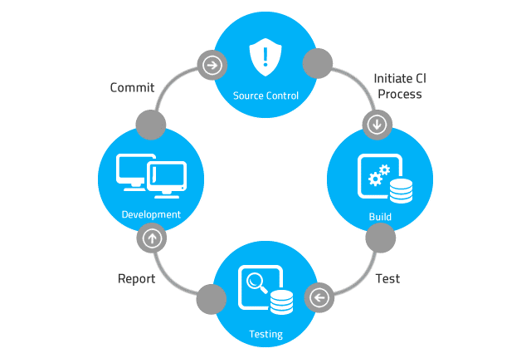

# Table of Contents

Table of Contents 3

1 Interfaces 4

1.1 Message Producer Client Interface 4

1.2 Message Queue Server Interface 4

1.3 Message Consumer Client Interface 5

# User Interfaces

**Software Application User Interface (UI)**

User Interface (UI) Design focuses on anticipating what users might need to do and ensuring that the interface has elements that are easy to access, understand, and use to facilitate those actions.

Based on the software requirements document, the team’s next task is to develop the software application’s user interface (UI). The UI can be console-based, implemented as a command-line user interface (CLUI), or graphical-based, implemented as a graphical user interface (GUI).

Your team’s project manager should be prepared to present and discuss the software applications UI.

**References**

<https://www.usability.gov/what-and-why/user-interface-design.html>

<https://en.wikipedia.org/wiki/Graphical_user_interface>

<https://www.w3computing.com/systemsanalysis/graphical-user-interface-gui-design/>

<https://www.interaction-design.org/literature/topics/ui-design>

## SMP Server Interface

## Start Server Button

The Start Server button starts the SMP Server. An SMP message consists of a priority level, the message content, and the current date and time. The server adds the message to a text file. There is one text file for each of the priority levels. The text files serve as queues. Which text file the server writes to depends on the priority selected.

## Show Messages Button

Depending on which option button is selected, the Show Messages button should read in records from the appropriate file and display the message date, message priority, and message content for each of the messages in the file and list the messages in the Messages window.

## Message Producer Client Interface

## Send Message Button

The SMP Message Producer client program is designed to send an SMP PUT request to the server.

When the Send Message button is clicked, an SMP message is sent to the server. The message sent to the server consists of a date and time stamp, the message priority, and the message content. The server adds the record to the file associated with the message priority.

## Message Consumer Client Interface

## Get Message Button

The SMP Message Consumer client program is designed to send an SMP GET request to the server.

When the Get Message button is clicked, an SMP GET request is sent to the server. The server responds with an SMP message. Which message is sent back from the server depends on the priority selected. The message sent back to the client consists of the message date and time stamp, message priority and message content. After the client acknowledges that it has received the message, the server deletes the record from the file.

