Software Project Information File

**Messenger**

**Client – Server Application**

**Simple Message Protocol (SMP)**

**Version 1**

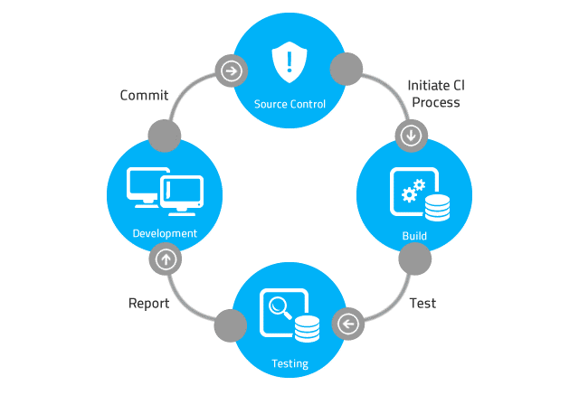

# CONTENTS

1. CONTENTS 2

2. REVISION HISTORY 3

3. PURPOSE 4

4. SCOPE 4

5. SOFTWARE PROJECT REPOSITORY LOCATION 4

6. Project Members 4

7. REFERENCES 4

8. DOCUMENTS and LOCATION 4

9. CODING STANDARD 5

10. SOFTWARE BUILD INSTRUCTIONS 5

# REVISION HISTORY

|  |  |  |  |
| --- | --- | --- | --- |
| ***Rev.*** | ***Date*** | ***Author*** | ***Comments*** |
| 1 | 5/1/2023 | Michael Koepp | Initial release. |
|  |  |  |  |
|  |  |  |  |
|  |  |  |  |
|  |  |  |  |
|  |  |  |  |
|  |  |  |  |
|  |  |  |  |
|  |  |  |  |
|  |  |  |  |
|  |  |  |  |
|  |  |  |  |
|  |  |  |  |
|  |  |  |  |
|  |  |  |  |
|  |  |  |  |
|  |  |  |  |
|  |  |  |  |
|  |  |  |  |
|  |  |  |  |
|  |  |  |  |
|  |  |  |  |
|  |  |  |  |
|  |  |  |  |
|  |  |  |  |

# PURPOSE

The Software Project Information File (SPIF) is used to determine the location of the Software Project Repository and other important artifacts.

Each software project must contain a Software Project Information File (SPIF). The SPIF must be located in the root directory of the Software Project Repository.

The contents of the SPIF should include:

* The location of the Software Project Repository.
* The name and location of the main software development documents.
* Instructions on how to build the software, and the names and locations of all tools needed to build the software, or the name of the file that has this information. If a reference to a file is made that has this information, then the Software Project Repository directory should contain this file.

# SCOPE

This document is to be referred to when creating or modifying software development projects.

# SOFTWARE PROJECT REPOSITORY LOCATION

**Description**: The repository is versioned controlled using the Git DVCS.

**Location**: GitHub: <https://github.com/NCSS/Messenger>

**Login:** See project manager or project technical lead

# Project Members

**Product Manager**: Winnie Pooh

**Project Manager**: Mickey Mouse

**Technical Lead**: Minnie Mouse

**Systems Test Lead:** Donald Duck

**Alternate Contact:** Daffy Duck

# REFERENCES

**File Name**: Software_Development_Process.doc

**File Location**: GitHub: [https://github.com/NCSS/Messenger/Docs/Refs](https://github.com/NCSS/Messenger/Docs/Refs/)

**File Name**: Software_Development_Process_Checklist.doc

**File Location**: GitHub: <https://github.com/NCSS/Messenger/Docs/Refs>

# DOCUMENTS and LOCATION

**Software Project Plan**

**File Name**: SMP_Software_Project_Plan.docx

**File Location**: GitHub: <https://github.com/NCSS/Messenger>/Docs

**Software Requirements Document**

**File Name**: SMP_Software_Requirements.docx

**File Location**: GitHub: <https://github.com/NCSS/Messenger>/Docs

**Software Design Specification**

**File Name**: SMP_Software_Design_Specification.docx

**File Location**: GitHub: <https://github.com/NCSS/Messenger>/Docs

**Software Technical Specification**

**File Name**: SMP_Software_Technical_Specification.docx

**File Location**: GitHub: <https://github.com/NCSS/Messenger>/Docs

**Software System Test Plan**

**File Name**: SMP_Software_System_Test_Plan.docx

**File Location**: GitHub: <https://github.com/NCSS/Messenger>/Docs

# CODING STANDARD

**File Name**: CSharp_Coding_Guidelines.pdf

**File Location**: GitHub: <https://github.com/NCSS/Messenger>/Docs/Standards

**File Name**: CppCodingStandards.pdf

**File Location**: GitHub: <https://github.com/NCSS/Messenger>/Docs/Standards

**File Name**: CCodingStandards.pdf

**File Location**: GitHub: <https://github.com/NCSS/Messenger>/Docs/Standards

# SOFTWARE BUILD INSTRUCTIONS

**Build Files:**

SMP_GUI.sln

**Required Build Tools**

Microsoft Visual Studio Community 2022 (64-bit) - Current

Version 17.3.5

Microsoft .NET Framework

Version 4.8.09032

**Build Instructions**

1. Start Visual Studio
2. Open SMP_GUI.sln
3. Choose Build->Rebuild Solution