Computer programming

Final Project

Report

I.E.S. San Vicente
San Vicente del Raspeig (Alicante)
2016/2017

Teachers:
José Ignacio Cabanes / Ignacio Iborra

Student:
Roberto Garcia Marcos

1. Introduction
Project name
Galaxy Shooter

Made by
Roberto Garcia Marcos

Short description of the project
Galaxy Shooter is a videogame based on some classicals games, for example “Space Impact” from Nokia. The idea is bring back that old game to the new generation of videogames and computers.
There will be 3 difficulty levels. Each increase in difficulty improve the health of enemies, the speed and your guns will be less effective.
The player have to kill enemy ships and final bosses. Uses SDL graphics and no copyright sounds and music. Sprites are made by Roberto Garcia Marcos.

2. Functionality of the project
After entering the program, a welcome screen will we displayed, where the user can choose between:

• Play the Game.
• Survival Mode.
• High Scores.
• Quit the game.

Play the Game option is like the Campaign mode. The player travell trough differents levels and each level is more complex and hardest. At the end of each level, the player must defeat a Boss. This Boss is more complex and has large health points. If the boss is defeated, a power-up is given to the player (random). If the player kill some enemies, they can drop a power up. The player must to catch it.
Survival Mode is an enemy wave that the player has to resist until dead. Randomly, the enemies can drop power-ups.
High Scores show the scores of all players. When the player finish the game (completing all levels or dying), he can enter his name and the score will save in the High Score table.

3. Screen prototype
The game screen will look like this:
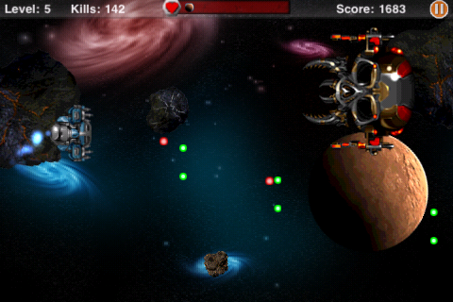

4.Analysis

4a. Requisites
Requisite | Date achieved
The program will allow a player to enter the main screen and select a gamemode or other options, like credits, high scores...
The program will allow a player to play campaign mode in a few levels.
The program will allow a player to play the survival mode.
The program will allow a player to play an entire campaign in differents dificulty levels.
The program will allow a player to show the high scores.
The intro screen will allow the user to enter a Credits screen, which will display data about the programmer.
The game can be paused pressing "P", and then returned by pressing any other key
The game will use SDL graphics library, and the images will be optimized so that the whole game fits in no more than 10 Mb.

4b. Basic pseudocode

Program body:
Display the main screen
Wait for user to select an option
If option = “Start Campaign” and Key = Enter, launch the campaign mode.
If option = “Survival” and Key = Enter, launch the survival mode.
If option = “High Score” and Key = Enter, go to high score screen.
If option = “Exit” and Key = Enter, show Credits screen and exit the game.
If key = Esc, exit from the game.

Campaign mode screen:
Display the first level.
The game starts.
If key = P, pause the game.
If key = Arrow_Up, the ship goes up.
If key = Arrow_Down, the ship goes down.
If key = Spacebar, the ship shoots.
The enemies go on.
If player survives to a determitate enemies, boss appears in the scene.
If player kills the boss, go to next level.

Survival mode screen:
Display the level.
The game starts and enemies go on.
If key = Arrow_Up, the ship goes up.
If key = Arrow_Down, the ship goes down.
If key = Spacebar, the ship shoots.
If the player losses all of his lives, game ends and show final score and save it in High Score.

High Score screen:
Show the screen with all the data.
If key = Esc, go back to the main menu.

4c. Classes diagram

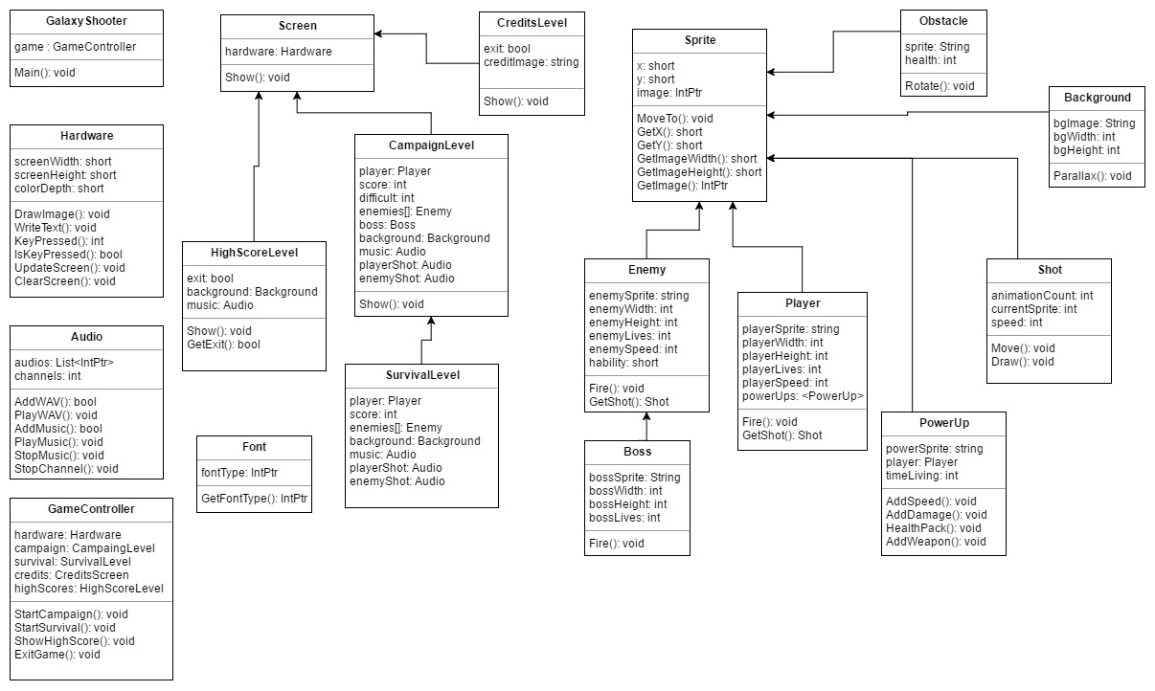

5. Initial planning and expected deliveries

5a. Expected deliveries
- Version 1: Load player sprite, main game loop and first level, with moving elements (asteroids, simple background...). Still not playable.
- Version 2: Player movement, limits with the map and shoots. Still not playable.
- Version 3: Main menu and posibility to select the options and change the screen. Still not playable
- Version 4: Movement and patterns of enemies and they can shoot. Playable but simple.
- Version 5: Create power-ups. The player can obtain from the enemies.
- Version 6: Movements of a determined boss and how are their attacks.
- Version 7: Adding sounds and music on main menu, and some levels. Add the player sounds when shoots or pick up a power up. Add sounds when enemy shoots. Different music when a boss is going on.
- Version 8: Create the first three levels. In each level there are a determined number of enemies and when the player survives all of them, the boss appears in the level.
- Version 9: Create the survival gamemode. Random enemy waves. There aren´t bosses in this gamemode.
- Version 10: High Score Screen that can be saved in a file.
- Version 11: Save player´s info and score to the High Score table.
- Version 12: Difficult system in campaign mode.
- Version 13: Advance Backgrounds and parallax effect with more moving elements.
- Version 14: Credit Screen and improves like program size, ‘fps’, etc...
- Version 15: Create cheats and development options.

5b. Real deliveries
- Version 1 (09 May): Main game loop created. Player sprite created and loaded and first level (simple background) with moving elements (asteroids).
- Version 2 (10 May): Player movement and map limits. Shots implemented but not correctly.
- Version 3:

6. File formats

6a. Plain files format

6b. Entity-Relationship Diagram (If needed)

7. Problems found and solutions

8. Improvements or restrictions to the starting design

9. Screenshots of the final project

10. Source code of the final project

