KAUNO TECHNOLOGIJOS UNIVERSITETAS

INFORMATIKOS KATEDRA

INFORMATIKOS FAKULTETAS

Duomenų struktūrų (P175B014)

Projektas

DynamicArray realizacija

KAUNAS

2016

DynamicArray duomenų struktūra – tai tarsi masyvas, kurio ribos prasiplečia arba susimažina priklausomai nuo į jį talpinamų reikšmių kiekio. Java kalboje šis funkcionalumas yra realizuotas ArrayList klasėje, todėl įgyvendindamas DynamicArray, realizavau visus ArrayList metodus. Sąsaja IDynamicArray atrodo taip:

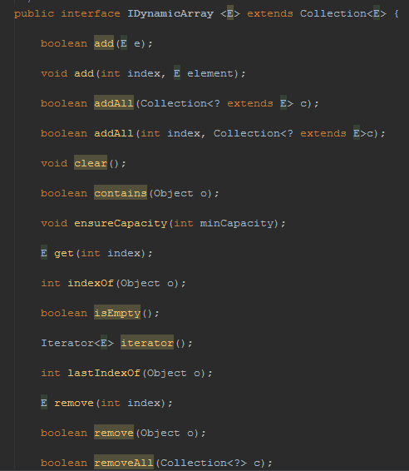

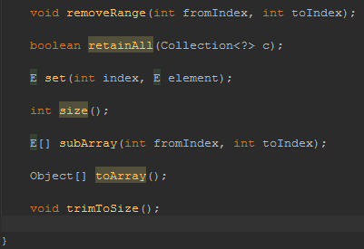.

Kadangi realizuojamų metodų yra tikrai nemažai, jų realizacija pridedama prisegtame ZIP failiuke. Įgyvendintus sąsajos metodus testavau naudodamas JUnit testavimo karkasą, rašydamas Integration testus. Tik pilnai ištestavęs metodų veikimą, pradėjau lyginti DynamicArray realizaciją su ArrayList greitaveikos atžvilgiu. Rezultatai tokie:

Add method. DynamicArray vs ArrayList

DynamicArray amount of time after 100 iterations is 53496.0

DynamicArray amount of time after 200 iterations is 76201.0

DynamicArray amount of time after 300 iterations is 117878.0

DynamicArray amount of time after 400 iterations is 163909.0

DynamicArray amount of time after 500 iterations is 198432.0

DynamicArray amount of time after 600 iterations is 261258.0

DynamicArray amount of time after 700 iterations is 295781.0

DynamicArray amount of time after 800 iterations is 345233.0

DynamicArray amount of time after 900 iterations is 384733.0

DynamicArray amount of time after 1000 iterations is 416457.0

ArrayList amount of time after 100 iterations is 36078.0

ArrayList amount of time after 200 iterations is 65936.0

ArrayList amount of time after 300 iterations is 80865.0

ArrayList amount of time after 400 iterations is 100770.0

ArrayList amount of time after 500 iterations is 125652.0

ArrayList amount of time after 600 iterations is 152400.0

ArrayList amount of time after 700 iterations is 164530.0

ArrayList amount of time after 800 iterations is 179770.0

ArrayList amount of time after 900 iterations is 205585.0

ArrayList amount of time after 1000 iterations is 210561.0

Array list is faster by: 205896.0 ns

Get method. DynamicArray vs ArrayList

DynamicArray amount of time after 100 iterations is 5909.0

DynamicArray amount of time after 200 iterations is 9642.0

DynamicArray amount of time after 300 iterations is 27682.0

DynamicArray amount of time after 400 iterations is 31104.0

DynamicArray amount of time after 500 iterations is 34214.0

DynamicArray amount of time after 600 iterations is 40745.0

DynamicArray amount of time after 700 iterations is 44478.0

DynamicArray amount of time after 800 iterations is 50077.0

DynamicArray amount of time after 900 iterations is 53498.0

DynamicArray amount of time after 1000 iterations is 56608.0

ArrayList amount of time after 100 iterations is 14929.0

ArrayList amount of time after 200 iterations is 21771.0

ArrayList amount of time after 300 iterations is 32657.0

ArrayList amount of time after 400 iterations is 43543.0

ArrayList amount of time after 500 iterations is 55984.0

ArrayList amount of time after 600 iterations is 64381.0

ArrayList amount of time after 700 iterations is 71223.0

ArrayList amount of time after 800 iterations is 78377.0

ArrayList amount of time after 900 iterations is 85842.0

ArrayList amount of time after 1000 iterations is 93307.0

Dynamic array is faster by: 36699.0 ns

Index of method. DynamicArray vs ArrayList

DynamicArray amount of time after 100 iterations is 419257.0

DynamicArray amount of time after 200 iterations is 724369.0

DynamicArray amount of time after 300 iterations is 929332.0

DynamicArray amount of time after 400 iterations is 1003977.0

DynamicArray amount of time after 500 iterations is 1064315.0

DynamicArray amount of time after 600 iterations is 1129007.0

DynamicArray amount of time after 700 iterations is 1210184.0

DynamicArray amount of time after 800 iterations is 1313754.0

DynamicArray amount of time after 900 iterations is 1401151.0

DynamicArray amount of time after 1000 iterations is 1539244.0

ArrayList amount of time after 100 iterations is 318486.0

ArrayList amount of time after 200 iterations is 640393.0

ArrayList amount of time after 300 iterations is 995579.0

ArrayList amount of time after 400 iterations is 1248750.0

ArrayList amount of time after 500 iterations is 1323707.0

ArrayList amount of time after 600 iterations is 1455891.0

ArrayList amount of time after 700 iterations is 1575012.0

ArrayList amount of time after 800 iterations is 1644680.0

ArrayList amount of time after 900 iterations is 1778730.0

ArrayList amount of time after 1000 iterations is 1875147.0

Dynamic array is faster by: 335903.0 ns

RemoveAt method. DynamicArray vs ArrayList

DynamicArray amount of time after 100 iterations is 6844027.0

DynamicArray amount of time after 200 iterations is 7538849.0

DynamicArray amount of time after 300 iterations is 8150940.0

DynamicArray amount of time after 400 iterations is 8719798.0

DynamicArray amount of time after 500 iterations is 9198771.0

DynamicArray amount of time after 600 iterations is 9581327.0

DynamicArray amount of time after 700 iterations is 9889860.0

DynamicArray amount of time after 800 iterations is 1.0124681E7

DynamicArray amount of time after 900 iterations is 1.0282991E7

DynamicArray amount of time after 1000 iterations is 1.0349861E7

ArrayList amount of time after 100 iterations is 74334.0

ArrayList amount of time after 200 iterations is 157688.0

ArrayList amount of time after 300 iterations is 248817.0

ArrayList amount of time after 400 iterations is 319107.0

ArrayList amount of time after 500 iterations is 401216.0

ArrayList amount of time after 600 iterations is 482081.0

ArrayList amount of time after 700 iterations is 512561.0

ArrayList amount of time after 800 iterations is 527179.0

ArrayList amount of time after 900 iterations is 546152.0

ArrayList amount of time after 1000 iterations is 554549.0

Array list is faster by: 9795312.0 ns

Contains method. DynamicArray vs ArrayList

DynamicArray amount of time after 100 iterations is 189412.0

DynamicArray amount of time after 200 iterations is 411793.0

DynamicArray amount of time after 300 iterations is 506033.0

DynamicArray amount of time after 400 iterations is 548332.0

DynamicArray amount of time after 500 iterations is 594674.0

DynamicArray amount of time after 600 iterations is 644127.0

DynamicArray amount of time after 700 iterations is 697622.0

DynamicArray amount of time after 800 iterations is 772890.0

DynamicArray amount of time after 900 iterations is 839448.0

DynamicArray amount of time after 1000 iterations is 912538.0

ArrayList amount of time after 100 iterations is 56294.0

ArrayList amount of time after 200 iterations is 148356.0

ArrayList amount of time after 300 iterations is 284583.0

ArrayList amount of time after 400 iterations is 335279.0

ArrayList amount of time after 500 iterations is 413968.0

ArrayList amount of time after 600 iterations is 489857.0

ArrayList amount of time after 700 iterations is 572900.0

ArrayList amount of time after 800 iterations is 661852.0

ArrayList amount of time after 900 iterations is 753603.0

ArrayList amount of time after 1000 iterations is 1461177.0

Dynamic array is faster by: 548639.0 ns

Add with index method. DynamicArray vs ArrayList

DynamicArray amount of time after 100 iterations is 1591808.0

DynamicArray amount of time after 200 iterations is 2134541.0

DynamicArray amount of time after 300 iterations is 2679762.0

DynamicArray amount of time after 400 iterations is 3266971.0

DynamicArray amount of time after 500 iterations is 3914829.0

DynamicArray amount of time after 600 iterations is 4584147.0

DynamicArray amount of time after 700 iterations is 5291410.0

DynamicArray amount of time after 800 iterations is 6057145.0

DynamicArray amount of time after 900 iterations is 7185531.0

DynamicArray amount of time after 1000 iterations is 8355905.0

ArrayList amount of time after 100 iterations is 78689.0

ArrayList amount of time after 200 iterations is 182259.0

ArrayList amount of time after 300 iterations is 279920.0

ArrayList amount of time after 400 iterations is 310711.0

ArrayList amount of time after 500 iterations is 362340.0

ArrayList amount of time after 600 iterations is 404017.0

ArrayList amount of time after 700 iterations is 464355.0

ArrayList amount of time after 800 iterations is 525315.0

ArrayList amount of time after 900 iterations is 597783.0

ArrayList amount of time after 1000 iterations is 661543.0

Array list is faster by: 7694362.0 ns

Kaip matome, mano kurtas DynamicArray yra greitesnis naudojant Get, Contains, bei IndexOf metodus.

IŠVADOS:

Darydamas šį projektą įgyjau JUnit testavimo žinių, supratau kaip realizuojama ArrayList(DynamicArray) klasė, sužinojau, kad tiesiogiai neįmanoma sukuri GenericArray.