EXECUTIVE SUMMARY
Care Transition Efficiency & Placement Outcome Analytics — HHS UAC Program
Data covers January 12, 2023 – December 21, 2025 (720 reporting days)

Why This Matters
The UAC Program moves children through four linked stages: apprehension into CBP custody, transfer to HHS care, sheltering and case management, and discharge to a vetted sponsor. Aggregate headcounts are tracked routinely, but how efficiently children move through this pipeline — and where delays build up — has not been. This analysis turns three years of daily reporting into five process-efficiency indicators so leadership can see bottlenecks before they become capacity crises.

Headline Findings
- System volume has fallen sharply. The HHS care census dropped about 78%, from a December 2023 peak near 11,069 children to 2,484 by December 2025.
- Efficiency did not improve as volume fell. The Transfer Efficiency Ratio (CBP-to-HHS movement relative to custody load) weakened every year — 0.83 (2023) → 0.78 (2024) → 0.46 (2025).
- Placements became less consistent. The Outcome Stability Score, which tracks how predictable daily discharge performance is, fell from about 0.78 in 2023–2024 to 0.55 in 2025.
- Backlogs build in bursts, not steadily. The longest sustained buildup ran 12 consecutive reporting days (Aug–Sep 2024); these buildups are typically cleared later by large discharge waves rather than continuous processing.
- Data gap: the published feed contains almost no Friday or Saturday records, so true weekday-vs-weekend comparisons are not currently possible.
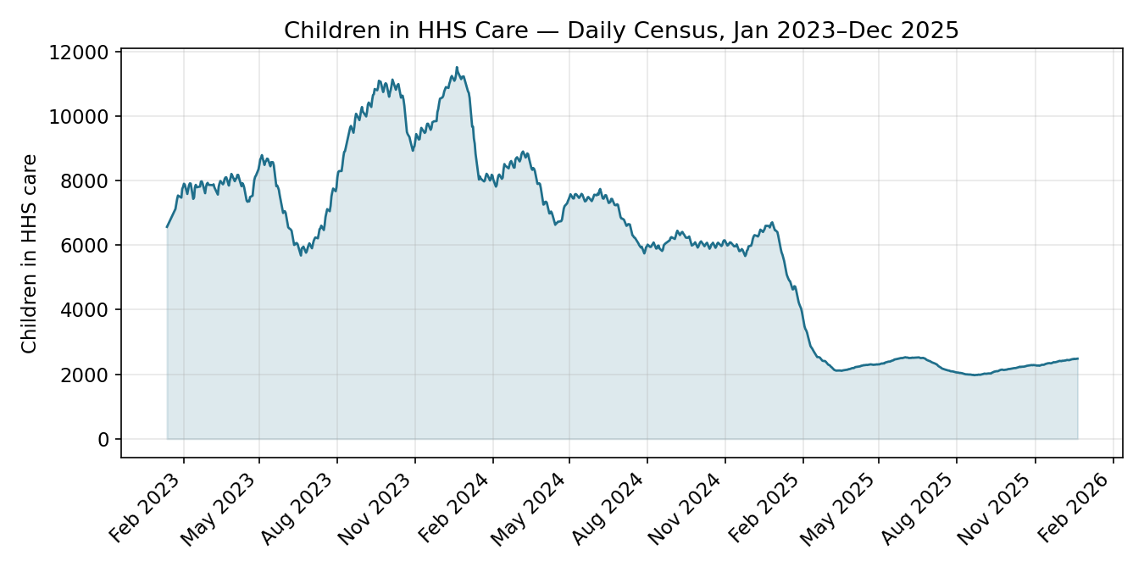
Children in HHS Care — daily census, 2023–2025.

KPI Scorecard by Year
Indicator | 2023 | 2024 | 2025
Transfer Efficiency Ratio | 0.83 | 0.78 | 0.46
Discharge Effectiveness | 3.3% | 2.9% | 0.9%
Pipeline Throughput (30-day) | 2.54 | 1.55 | 1.99
Outcome Stability Score | 0.78 | 0.77 | 0.55

What We Recommend
- Track cohort-level (entry-to-discharge) data so true wait times can be measured directly.
- Treat the Transfer Efficiency Ratio as a standing bottleneck indicator and review CBP-side transfer capacity.
- Investigate what drove the 2025 drop in placement consistency (staffing, sponsor vetting, or procedural changes).
- Build automated backlog alerts to flag buildup within days, not after the fact.
- Extend reporting to include Friday and Saturday for a complete weekly picture.

Supporting Materials
A full research paper (detailed methodology, chart-by-chart findings, and limitations) and an interactive Streamlit dashboard accompany this summary for teams that want to explore the underlying data directly.

