CARE TRANSITION EFFICIENCY &
PLACEMENT OUTCOME ANALYTICS
A Process-Efficiency Analysis of the HHS Unaccompanied Alien Children (UAC) Care Pipeline
Research Paper — Internship Project
Prepared under: Unified Mentor | Dataset: U.S. Department of Health and Human Services (HHS)
Analysis Period Covered by Data: January 12, 2023 – December 21, 2025
Prepared: July 2026

Contents
- 1. Background and Context
- 2. Problem Statement
- 3. Project Objectives
- 4. Data & Methodology
- 5. Exploratory Data Analysis
- 6. Transition Efficiency Metrics
- 7. Backlog & Delay Identification
- 8. Temporal & Pattern Analysis
- 9. Outcome Stability Analysis
- 10. Key Performance Indicator Summary
- 11. Key Insights
- 12. Recommendations
- 13. Limitations
- 14. Conclusion

Executive Summary
The Unaccompanied Alien Children (UAC) Program functions as a multi-stage pipeline — apprehension and CBP custody, transfer into HHS care, sheltering and case management, and discharge to a vetted sponsor. This analysis reframes the publicly reported daily census figures from a capacity-monitoring lens into a process-efficiency lens, applying five derived KPIs — Transfer Efficiency Ratio, Discharge Effectiveness Index, Pipeline Throughput Rate, Backlog Accumulation Rate, and Outcome Stability Score — to 720 daily reporting records spanning January 2023 through December 2025.
Three findings stand out. First, the HHS care census fell by roughly 78% from its December 2023 peak (a monthly average near 11,069 children) to its December 2025 level (2,484 children), reflecting a structural decline in system-wide volume rather than a temporary dip. Second, despite this smaller volume, the Transfer Efficiency Ratio — transfers out of CBP custody relative to the CBP custody load — actually weakened, falling from a 2023 average of 0.83 to 0.46 in 2025, indicating that CBP-to-HHS movement did not become proportionally faster as the system shrank. Third, the Outcome Stability Score, which measures consistency of discharge performance, dropped from roughly 0.78 in 2023–2024 to 0.55 in 2025, meaning placement outcomes became noticeably less predictable even as absolute case volume fell.
The report also identifies a data-availability finding worth flagging to stakeholders: the published dataset contains almost no Friday or Saturday entries (2 and 0, respectively, out of 720 records), so genuine weekday-versus-weekend transition-speed comparisons cannot be made from this data source alone.
Full methodology, chart-by-chart findings, a KPI summary table, and recommendations follow. A companion Streamlit dashboard operationalizes these metrics for interactive, date-range-filtered monitoring, and a separate executive summary distills the findings for non-technical stakeholders.

1. Background and Context
The UAC Program operates as a multi-stage care and reunification pipeline rather than a static healthcare system. The pipeline consists of four linked stages:
- Apprehension and placement in CBP custody
- Transfer from CBP to HHS care
- Medical screening, sheltering, and case management under HHS
- Discharge and reunification with a vetted sponsor
From a policy and humanitarian standpoint, the speed, continuity, and reliability of movement through this pipeline are as important as the raw capacity of any single stage. A child can be safely housed at every stage and still experience harm from unnecessary delay, inconsistency, or an unpredictable path to reunification. This project treats the publicly reported daily counts as a process to be measured, not only a population to be counted.

2. Problem Statement
Aggregate counts of children in custody are monitored routinely, but process-efficiency metrics — how quickly children move between stages, whether discharges keep pace with inflows, and where backlogs form — are largely absent from standard reporting. This leaves several operationally important questions unanswered:
- How efficiently are children transferred from CBP custody to HHS care?
- Are discharges keeping pace with inflows into HHS care?
- When and where do care backlogs accumulate?
- Are placement outcomes improving, deteriorating, or becoming less consistent over time?
Without structured transition analytics, bottlenecks in the pipeline remain invisible until they surface as capacity crises.

3. Project Objectives

Primary Objectives
- Measure the efficiency of CBP → HHS transitions
- Evaluate discharge and sponsor-placement outcomes
- Identify delays and process bottlenecks in the pipeline

Secondary Objectives
- Support faster reunification
- Improve case-management workflows
- Inform policy-level process reforms

4. Data & Methodology

4.1 Dataset Description
The source dataset is HHS's publicly reported daily UAC program file. After removing 450 fully blank trailing rows, 720 dated reporting records remain, spanning January 12, 2023 to December 21, 2025. Reporting is not strictly daily: only 720 of the 1,075 calendar days in that span have a record (see Section 5.1).
Column | Description
Date | Reporting date
Children apprehended and placed in CBP custody | Daily intake volume into CBP custody
Children in CBP custody | Active CBP custody load (snapshot)
Children transferred out of CBP custody | Daily flow of children moving from CBP into HHS care
Children in HHS Care | Active HHS care load (snapshot)
Children discharged from HHS Care | Daily successful sponsor placements

4.2 Data Cleaning
- Removed 450 fully blank rows appended after the last valid record.
- Parsed the Date field (e.g. "December 21, 2025") into a proper date type and sorted records chronologically.
- Stripped thousands-separator commas from the "Children in HHS Care" field and cast all volume columns to numeric type.
- Verified there were no missing values in any of the 720 remaining records for any column.

4.3 Care Pipeline Model
The system is modeled as a three-stage flow: CBP custody → HHS care → Sponsor placement. Daily movements between stages are tracked using the four flow columns (apprehended, transferred out, in HHS care, discharged), with the two "in custody / in care" columns treated as point-in-time stock levels (snapshots) rather than flows.

4.4 KPI Definitions
Three KPI formulas were specified directly in the project brief; two (Backlog Accumulation Rate and Outcome Stability Score) were left conceptual and were operationalized here as documented below, so the definitions can be reviewed and adjusted by stakeholders.
KPI | Formula used | Interpretation
Transfer Efficiency Ratio | Transferred out ÷ CBP custody (daily) | How much of the current CBP custody load is being moved to HHS per day; values near 1 indicate custody is being cleared as fast as it is held
Discharge Effectiveness Index | Discharged ÷ HHS care (daily) | Share of the current HHS census successfully discharged to sponsors per day
Pipeline Throughput Rate | 30-day rolling sum of discharges ÷ 30-day rolling sum of apprehensions | Whether exits are keeping pace with entries over a period long enough to absorb processing lag (see note below)
Backlog Accumulation Rate | (Transferred out − Discharged) ÷ HHS care (daily) | Net rate at which the HHS census is growing (positive) or shrinking (negative) relative to its own size
Outcome Stability Score | 1 − (30-day rolling std ÷ 30-day rolling mean) of Discharge Effectiveness | Consistency of discharge performance; higher = more predictable, lower = more erratic
Note on Pipeline Throughput: a same-day ratio of discharges to apprehensions is extremely volatile (0 to over 20 in this dataset) because discharges on a given day largely reflect children who entered the system weeks or months earlier, not same-day arrivals. A 30-day rolling-sum version is used throughout this report as the meaningful measure of throughput; the raw daily ratio is available in the companion dashboard as a supplementary view.

5. Exploratory Data Analysis

5.1 Reporting Cadence & Data Coverage
Before analyzing efficiency, it is important to characterize the data itself. Of the 720 dated records, the weekday distribution is: Tuesday (149), Thursday (147), Wednesday (147), Monday (145), Sunday (130), Friday (2), and Saturday (0). In other words, the published series is effectively a Sunday-through-Thursday feed; Friday and Saturday are almost entirely absent.
This is a data-availability finding rather than an operational one: it means the brief's planned "weekday vs. weekend transition speed" comparison cannot be meaningfully performed from this dataset, since there is virtually no weekend data to compare against. Section 8 reports what the weekday pattern looks like across the five well-populated days instead.

5.2 Custody & Care Census Trends
The HHS care census (the daily snapshot of children in HHS custody) rose through 2023, peaked at a monthly average of roughly 11,069 children in December 2023, and then declined steadily through 2024 to about 6,454 by the year's end. The decline accelerated sharply in 2025: the January 2025 monthly average of about 4,991 fell to roughly 2,782 by February and has since held in a narrow 2,000–2,500 band through December 2025 (2,484 at the final record).
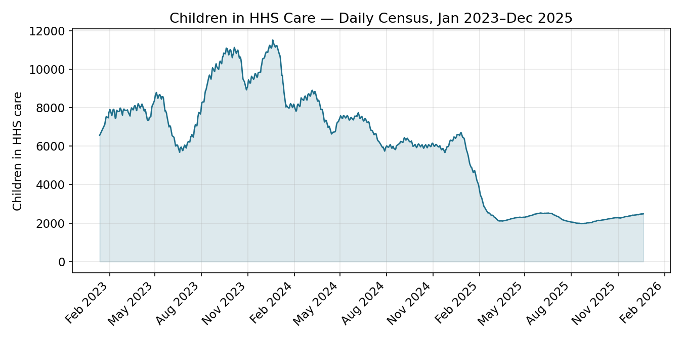
Figure 1. Children in HHS Care — daily census, Jan 2023–Dec 2025.
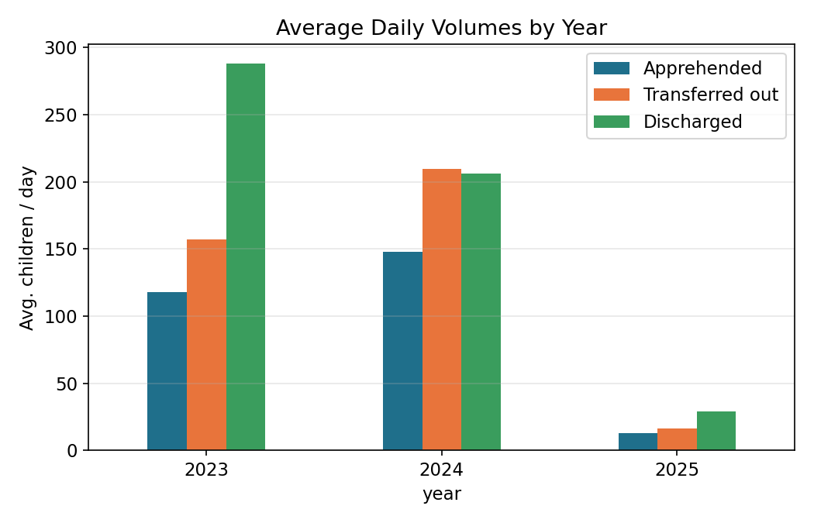
Figure 2. Average daily apprehensions, transfers, and discharges by year.
Average daily apprehensions fell from about 118/day in 2023 to 148/day in 2024 (a further build-up), then collapsed to about 13/day in 2025 — an 91% decline from the 2024 level. Average daily discharges followed a similar but less extreme arc: 288/day (2023), 206/day (2024), 29/day (2025).

5.3 Pipeline Flow Volumes
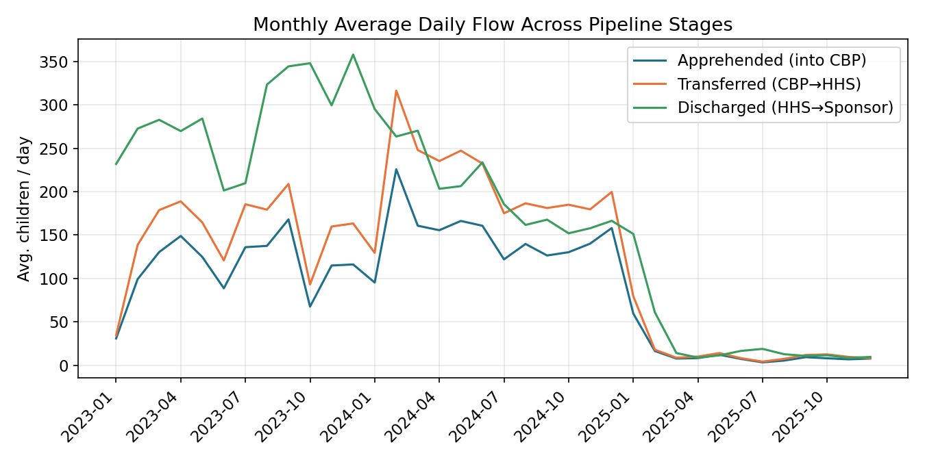
Figure 3. Monthly average daily flow across the three pipeline stages.
All three flow series (apprehended, transferred out, discharged) move together at a coarse level, confirming the pipeline behaves as a connected system rather than independent stages. The gap between the discharged line and the other two lines is largest in 2023, when the system was still working down a large existing census, and narrows sharply after the 2025 volume decline.

6. Transition Efficiency Metrics

6.1 Transfer Efficiency Ratio
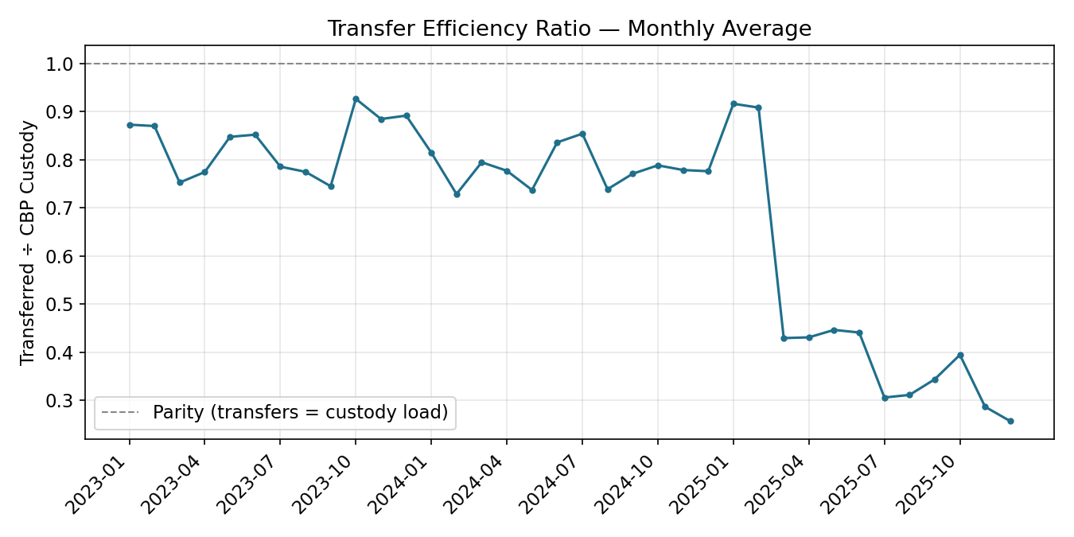
Figure 4. Transfer Efficiency Ratio — monthly average, with parity line at 1.0.
The Transfer Efficiency Ratio averaged 0.83 in 2023, 0.78 in 2024, and 0.46 in 2025 — a meaningful decline. Because this ratio compares same-day transfers to the current CBP custody snapshot, values below 1 are normal (custody is not fully cleared every day), but the direction of change matters: the ratio weakened even as absolute custody volumes fell by an order of magnitude between 2024 and 2025. This suggests the CBP-to-HHS transfer step did not scale down its relative speed in proportion to the smaller intake — a bottleneck signal that a pure volume-based view of the system would miss.

6.2 Discharge Effectiveness Index
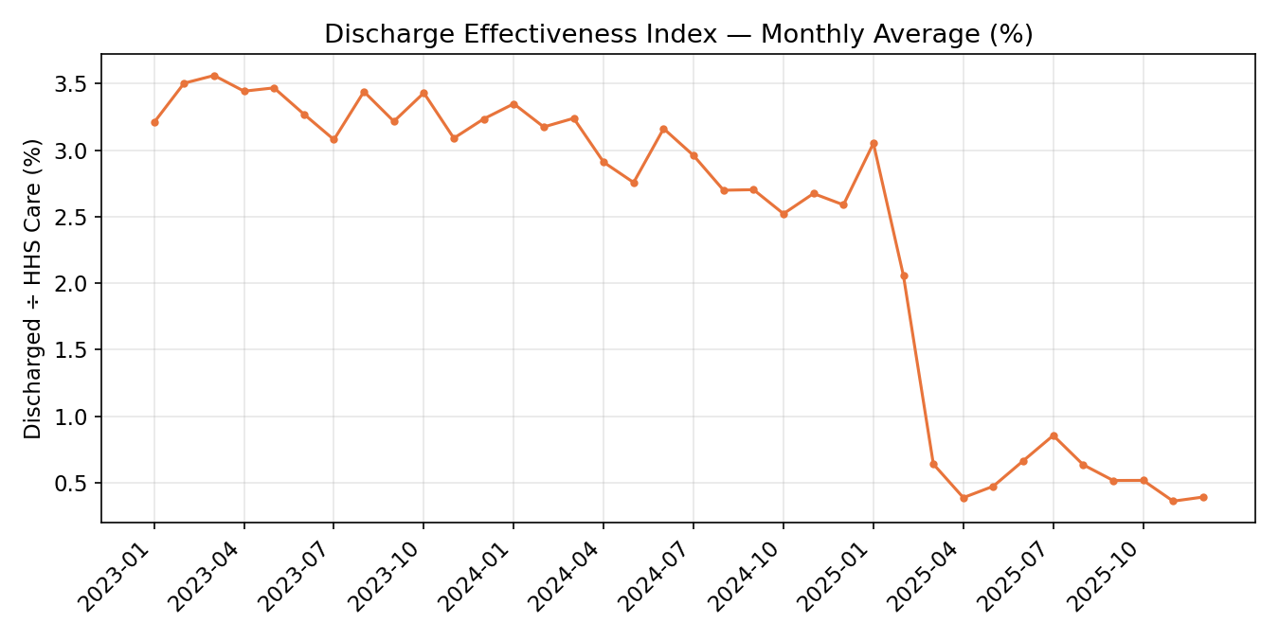
Figure 5. Discharge Effectiveness Index — monthly average, percent of HHS census discharged per day.
Discharge Effectiveness averaged 3.3% per day in 2023, 2.9% in 2024, and 0.9% in 2025. The 2025 figure is the lowest of the three years by a wide margin, indicating that a smaller share of the (much smaller) HHS census is being placed with sponsors on any given day compared with prior years.

6.3 Pipeline Throughput Rate
Using the 30-day rolling-sum version of throughput (discharges ÷ apprehensions over the trailing 30 reporting days), the yearly averages are 2.54 (2023), 1.55 (2024), and 1.99 (2025). A value above 1 means discharges are outpacing new apprehensions over that window — consistent with 2023 and 2025 being periods where the system was net-clearing its census, and 2024 being closer to balanced/slightly net-building given the census still grew for part of the year.

7. Backlog & Delay Identification
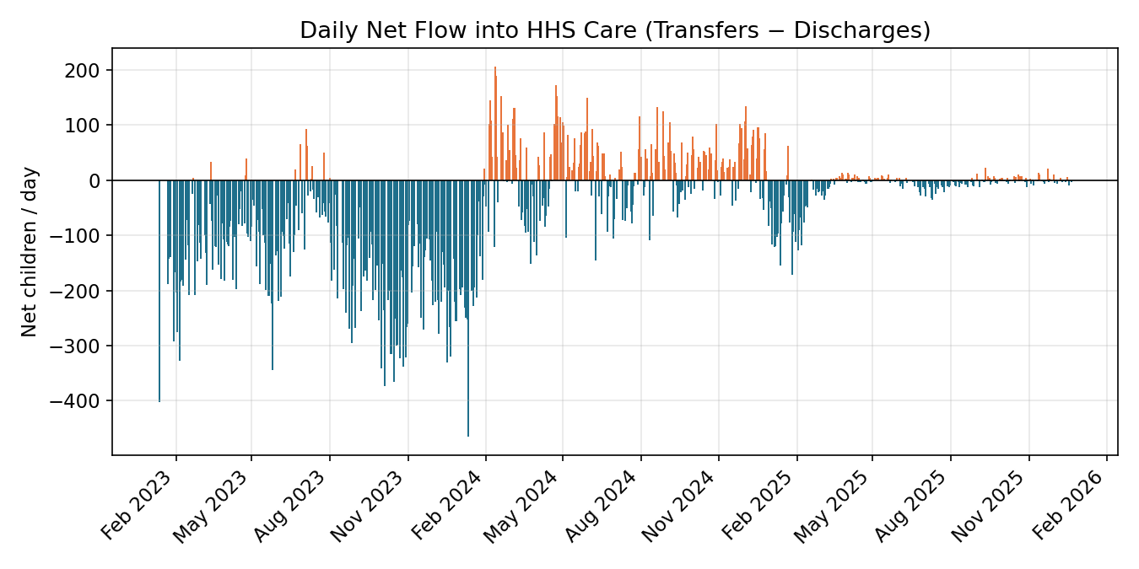
Figure 6. Daily net flow into HHS care (transfers in minus discharges out); positive bars indicate a same-day backlog contribution.
Rather than moving smoothly, net flow into HHS care shows a sawtooth pattern: sustained runs of days where transfers exceed discharges (building backlog), interspersed with sharp discharge waves that clear it. The five longest sustained backlog-building streaks identified in the data are:
Period | Length (reporting days)
Aug 18 – Sep 5, 2024 | 12
Nov 25 – Dec 8, 2024 | 10
May 20 – Jun 3, 2024 | 10
Apr 21 – May 2, 2024 | 10
Mar 19 – 31, 2025 | 9
Four of the five longest streaks fall in 2024, even though the year's overall census growth was modest compared with 2023's build-up — meaning 2024's apparent stability masked a more erratic underlying process, punctuated by large discharge batches rather than continuous throughput.

Backlog Accumulation Rate
Measured as net daily flow relative to the current census, the Backlog Accumulation Rate averaged −1.5% per day in 2023 (net drawdown), +0.1% per day in 2024 (roughly flat, slightly net-building), and −0.4% per day in 2025 (modest net drawdown). The near-zero 2024 average, combined with the streak analysis above, confirms that 2024's system-level stability was the product of offsetting build-up and clearing periods rather than a genuinely steady process.

8. Temporal & Pattern Analysis

Weekday Patterns
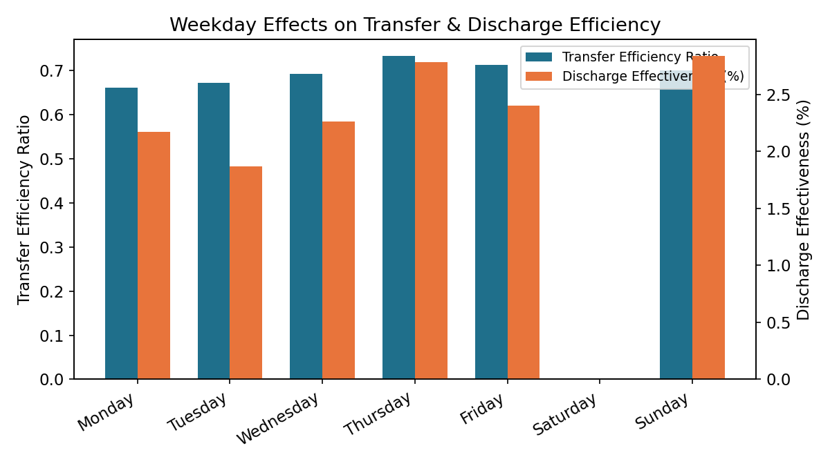
Figure 7. Transfer Efficiency Ratio and Discharge Effectiveness by weekday (Sunday–Thursday only; see Section 5.1).
Across the five well-populated reporting days, Thursday shows the strongest Transfer Efficiency Ratio and the highest average discharge count, while Tuesday and Monday are comparatively weaker on transfer efficiency. Sunday, despite being a weekend day, shows discharge volumes comparable to weekday levels — likely reflecting that HHS discharge processing does not fully pause on this dataset's reporting calendar. As noted in Section 5.1, Friday and Saturday cannot be reliably compared due to near-total absence of data.

Month-over-Month Placement Trends
Placement volume (discharges) peaked in absolute terms in 2023, declined through 2024, and fell to its lowest and most stable monthly levels in 2025 (roughly 8–19 discharges per day on average, month to month), after a sharp transitional drop in the first two months of 2025.

Prolonged Stagnation Periods
The clearest stagnation period is the census plateau from March through December 2025, where the HHS care load moved in a narrow 2,000–2,500 band for ten consecutive months after the steep January–February 2025 decline — a marked contrast to the more continuously trending behavior of 2023 and 2024.

9. Outcome Stability Analysis
The Outcome Stability Score (1 minus the 30-day rolling coefficient of variation of the Discharge Effectiveness Index) captures how consistent, rather than how large, daily placement performance is. Yearly averages are 0.78 (2023), 0.77 (2024), and 0.55 (2025).
2023 and 2024 show similar, comparatively high stability despite very different volume levels, suggesting the discharge process was operating in a consistent regime across those two years. The drop to 0.55 in 2025 indicates a materially less predictable discharge process during the low-volume period — day-to-day discharge effectiveness swings by a larger proportion of its own (much smaller) average than in prior years. This is consistent with the backlog analysis in Section 7, where even 2025 shows sustained build-up streaks (e.g., March 2025) despite an overall lower and calmer census trend.
- Sudden drops in reunification success are more frequent, in relative terms, during 2025 than in the two prior years.
- A lower Outcome Stability Score alongside a lower Discharge Effectiveness average implies both fewer and less consistent placements in the most recent year of data.

10. Key Performance Indicator Summary
KPI | 2023 | 2024 | 2025
Transfer Efficiency Ratio | 0.830 | 0.783 | 0.460
Discharge Effectiveness Index | 3.34% | 2.90% | 0.90%
Pipeline Throughput Rate (30-day) | 2.54 | 1.55 | 1.99
Backlog Accumulation Rate | −1.47%/day | +0.10%/day | −0.35%/day
Outcome Stability Score | 0.781 | 0.771 | 0.549
Read together, the table shows a system that shrank dramatically in volume between 2024 and 2025 while simultaneously becoming less efficient on a proportional basis (lower Transfer Efficiency Ratio and Discharge Effectiveness) and less predictable (lower Outcome Stability Score). Smaller does not mean smoother in this dataset.

11. Key Insights
- The HHS care census fell roughly 78% from its December 2023 peak (~11,069) to December 2025 (2,484), representing a structural regime change rather than a temporary dip.
- Transfer Efficiency Ratio declined each year (0.83 → 0.78 → 0.46), showing that CBP-to-HHS movement did not speed up proportionally as intake volume fell — a bottleneck signal that pure headcount monitoring would not surface.
- Discharge Effectiveness fell from 3.3% to 0.9% of census per day across the three years, its steepest one-year drop occurring in 2025.
- Backlog does not build up smoothly: sustained multi-day build-up streaks (up to 12 consecutive reporting days) are interspersed with large discharge waves, a pattern most pronounced in 2024.
- Outcome Stability dropped materially in 2025 (0.55 vs. ~0.78 in 2023–2024), indicating placement performance became less consistent even as volumes fell to their lowest levels in the dataset.
- The published dataset is effectively a Sunday–Thursday feed (2 Friday records, 0 Saturday records out of 720), which limits any genuine weekday-vs-weekend analysis and should be treated as a reporting-cadence finding for stakeholders.
- Single-day Pipeline Throughput ratios are highly volatile (0 to over 20) because discharges reflect children who often entered weeks or months earlier; rolling-window measures are necessary for a meaningful reading.

12. Recommendations
- Publish or make available cohort-linked data (entry date paired with discharge date for the same child) so true length-of-stay and dwell-time can be measured directly, rather than inferred from aggregate daily snapshots.
- Track the Transfer Efficiency Ratio as a standing bottleneck indicator — its multi-year decline, even as volumes fell, suggests it warrants direct operational review (e.g., CBP-side staffing or processing capacity) rather than being read as a side-effect of lower intake.
- Investigate the drivers of the 2025 drop in Outcome Stability Score (sponsor-vetting timelines, staffing changes, shelter capacity shifts, or reporting-practice changes), since consistency of placement affects child welfare outcomes independently of raw speed.
- Default the live dashboard to rolling 7-day and 30-day versions of every ratio KPI, keeping single-day ratios available only as a supplementary detail view, to avoid the volatility described in Section 6.3 misleading viewers.
- Extend reporting cadence to include Friday and Saturday, or explicitly document why those days are excluded, so future weekday/weekend analysis is possible.
- Implement automated backlog alerts — for example, flagging any period where the Backlog Accumulation Rate stays positive for more than 5–7 consecutive reporting days — to catch build-up earlier than the after-the-fact streak analysis in Section 7.

13. Limitations
- The data consists of aggregate daily snapshots and flow counts, not individual child-level records, so all KPIs are systemic proxies rather than exact dwell-time or success-rate measures for any given child.
- Reporting is not on a strict daily cadence and is heavily concentrated on Sunday through Thursday (see Section 5.1), which constrains temporal analysis, particularly any weekend comparison.
- The project brief specified formulas for three KPIs (Transfer Efficiency Ratio, Discharge Effectiveness, Pipeline Throughput) but left Backlog Accumulation Rate and Outcome Stability Score conceptual; this report operationalizes them as net-flow-to-census and one-minus-coefficient-of-variation respectively, and documents the choice transparently so stakeholders can adjust the definitions if a different formulation is preferred.
- The dataset contains no contextual variables (staffing levels, shelter capacity, policy or procedural changes, sponsor availability), so any explanation offered for a trend in this report is associative, not causal.

14. Conclusion
This analysis reframes the UAC dataset from a capacity-monitoring lens into a process-efficiency and outcome-evaluation lens. The headline finding is that the pipeline's dramatic reduction in volume between 2024 and 2025 was not accompanied by a proportional improvement in efficiency or consistency — if anything, the Transfer Efficiency Ratio, Discharge Effectiveness Index, and Outcome Stability Score all weakened in 2025 relative to the two prior years. Structured transition analytics of this kind make bottlenecks and inconsistency visible in a way that aggregate headcounts alone cannot, and provide a concrete, reproducible basis for targeting reunification-timeline improvements, case-management workflow changes, and policy-level process reforms.

