**Flight Instructor Refresher Course – Aeroplane**

**Course Number: FIRC 17-01**

**January 31, February 1, February 2**

**Kwantlen Polytechnic University**

**Langley, British Columbia**

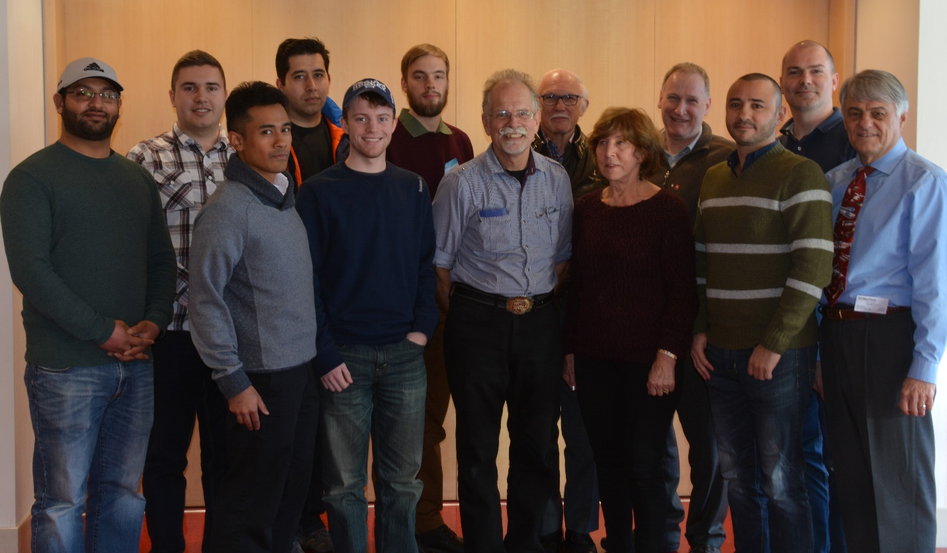

**Back row: Gordon Brett, Ali Khosrowtaj, Thomas de Waard, Alistair Beaton, Francis Ervin, Stephan Heinemann**

**Front row: Jojhar Singh Gill, Imran Ismail, Ryan Eberlin, Barry Stanley,  
Rita Methorst, Oussama Rifai, Bob Leroux (Course Manager)**