PROJECT REPORT
SEARCH ENGINE

By
MVN MURTHY
(110102 11CA48)



DEPARTMENT OF MATHEMATICAL AND COMPUTATIONAL SCIENCES

NATIONAL INSTITUTE OF TECHNOLOGY KARNATAKA SURARTHKAL, MANGALORE – 575025

CERTIFICATE

This is to certify that the P.G. Project Report entitled “SEARCH ENGINE” submitted by MVN MURTHY (Roll Number: 11CA48) as the record of the work carried out by them, is accepted as the P.G. Project Work Report submission in partial fulfillment of the requirements for the award of degree of Master of Computer Applications in the Department of Mathematical and Computational Sciences.

ACKNOWLEDGEMENT

First of all, we like to thank the Almighty for His blessing that helped us to achieve everything we had wished for till now.
This is and has been our feeling to express our deep gratitude to our lecturer and guide Mr. C. Nagaraju, under whose benevolent guidance and supervision the present study was undertaken and completed. Her continued encouragement and guidance at every stage facilitated this work and made it possible for us to complete it. Her ideas, stimulating comments, interpretations and suggestions increased our awareness and have considerably helped us for making a deeper analysis of the subject under study.
We are also indebted to Mr. Murulidhar N. N., HOD MACS Department, and other faculty members for their valuable guidance during the execution of this project work and who enlightened us with conceptual knowledge before undertaking this project.
Last but not least, we are thankful to our parents, and our friends for their constant support and blessing.

MVN MURTHY (11CA48)

DECLARATION

I hereby declare that the Project Report Work entitled “SEARCH ENGINE” which is being submitted to the National Institute of Technology Karnataka Surathkal, in partial fulfillment of the requirements for the award of the Degree of Master of Computer Applications in the department of Mathematical and Computational Sciences, is a bonafide report of the work prepared by us. This material is collected from various sources with utmost care and is based on facts and truth. The material contained in this Report has not been submitted to any University or Institution for the award of any degree. This project is prepared by us with our knowledge, experience and sheer advice from our teachers.

MVN MURTHY (11CA48)

ABSTRACT

SEARCH ENGINE is implemented in Django,Python, sqlite3 Databse. Main aim of this project is to develop a search engine which will search given query from html files and display results which are more useful for users. In present trend search engines are used by every for finding required information on the web. Google is one of the mostly used search engine followed by yahoo and bing. In this project we used Inverted Index, page ranking technique to search for a give query and ranking so that most similar documents can shown.

INDEX
Page No.

1 Introduction 8

2 System Requirement Specification 9
2.1 Project Overview 10
2.2 Purpose 10
2.3 Problem Definition 11
2.4 Project Description 11
2.5 Existing Features VS New Features 12
2.6 Software Perspective 13
2.7 User Characteristics 13
2.8 Specific Requirements 14
2.8.1 Functional Requirements 14
2.8.2 Non-Functional Requirements 15
2.9 SDLC Model 15
2.10 Security 16
2.11 Module Description 17
2.12 Design Constraints 18
2.12.1 Technology Used 18
2.12.2 System Requirement 18
2.12.2.1 Software Requirements 18
2.12.2.2 Hardware Requirements 18
3 System Design 19
3.1 Module Description 22
3.1.1 Platform 22
3.1.1.1 Java 22
3.1.2 Features 23
4 Source Code & Snapshots 24
4.1 Java Source Code 24
4.2 Interface Screenshots 40
5 Testing 45
6 Conclusion And Future Scope 47
7 Bibliography 48

1. INTRODUCTION

SEARCH ENGINE is implemented in Django,Python, sqlite3 Databse. Main aim of this project is to develop a search engine which will search given query from html files and display results which are more useful for users. In present trend search engines are used by every for finding required information on the web. Google is one of the mostly used search engine followed by yahoo and bing. In this project we used Inverted Index, page ranking technique to search for a give query and ranking so that most similar documents can shown.

2. SYSTEM REQUIREMENT SPECIFICATION

System Analysis refers to the process of examining a situation with the intent of improving it through better procedures and methods. System design is the process of planning a new system to either replace or complement an existing system. But before any planning is done, the old system must be thoroughly understood and the requirements determined. System Analysis is therefore, the process of gathering and interpreting facts, diagnosis problems and using the information to re-comment improvements in the system. Or in other words, System Analysis means a detailed explanation or description. Before computerizing a system under consideration, it has to be analyzed. We need to study how it functions currently, what are the problems, and what are the requirements that the proposed system should meet.
The main components of making software are:
- System and software requirements analysis
- Design and implementation of software
- Ensuring, verifying and maintaining software integrity

System analysis is an activity that encompasses most of the tasks that are collectively called Computer System Engineering. Confusion sometimes occurs because the term is often used in context that all dues it only to software requirement analysis activities, but system analysis focuses on all the system elements- not just software.

System analysis is conducted with the following objectives in mind:
- Identify the customer’s need
- Evaluate the system concept for feasibility
- Perform economic and technical analysis
- Allocate functions to hardware, software, people, database and other system elements
- Establish cost and schedule constraints
- Create a system definition that forms the foundation for all the subsequent engineering work.
System Analysis is consisting of two main works i.e. Identify the need and Preliminary Investigation.

2.1 PROJECT OVERVIEW

SEARCH ENGINE is a web application for the searching queries in websites. Even with the availability of advance hardware and software, this project is developed using the basic instruments of coding and development to produce a web application for even the simplest machine.

2.2 PURPOSE

Our mission is to offer cost-effective, superior quality and commercially viable services and solutions to our clients by evolving into a significant global IT-solution provider.
We shall adhere to strong internal value systems with integrity, fairness and the pursuit of excellence in all our activities. These principles will be visible in our interactions with our clients, partners, associates and employees.

2.3 PROBLEM DEFINITION

Search Engine application that is developed in Django,Python. Main aim of this project is to develop a search engine which will search given query from html files and display results which are more useful for users. This server should allow a client to connect.

2.4 PROJECT DESCRIPTION

SEARCH ENGINE is implemented in Django,Python, sqlite3 Databse. Main aim of this project is to develop a search engine which will search given query from html files and display results which are more useful for users. In present trend search engines are used by every for finding required information on the web. Google is one of the mostly used search engine followed by yahoo and bing. In this project we used Inverted Index, page ranking technique to search for a give query and ranking so that most similar documents can shown.

2.6 SOFTWARE PERSPECTIVE
SEARCH ENGINE is implemented in Django,Python, sqlite3 Databse. Main aim of this project is to develop a search engine which will search given query from html files and display results which are more useful for users. In present trend search engines are used by every for finding required information on the web. Google is one of the mostly used search engine followed by yahoo and bing. In this project we used Inverted Index, page ranking technique to search for a give query and ranking so that most similar documents can shown.

2.6 USER CHARACTERISTICS

The user should be familiar with the basic computer organization and design. The user should know the details of the control functions and operations for the basic computer.
A set of instructions is provided along with the product for first time users.
The application will require a 32-bit system, and also supports 64-bit system.
Reliable CPU is necessary.

2.7 SPECIFIC REQUIREMENTS
2.7.1 FUNCTIONAL REQUIREMENTS

Static Requirements are those that do not impose constraint on the execution characteristics of the system. These include requirements like the number of terminals to be supported, the number of simultaneous users to be supported, and the number of files that the system has to process and their sizes.
Dynamic Requirements are which specify constraints on the execution behavior of the system. These typically include response time and throughput constraints on the system. Response time is the expected time for the completion of an operation under specified circumstances. Throughput is the expected number of operations that can be performed at a time.

2.7.2 NON-FUNCTIONAL REQUIREMENTS

Security: The system that we developed is the secure One. That is the system cannot be used by a third party person who has not got registered to the system.
Reliability: The system that we developed is a reliable one. That is once the client submits the sales order within seconds he will get the sales invoice.
Scalability: The system that we developed can be extended in future. That is our system is scalable.
Accuracy of data: The system which we developed is of very accurate. Because the client will get the exact sales invoice regarding to the sales order which he submitted.
Safety: The system which we developed is of safe.
Privacy: The system is very much private because it is available to only those who has got registered to the system.
Portability: The system which we developed is of portable because once it is developed it can run on any platform.
Modifiability and Extensibility: The system which we developed can be modified and can be extended in future.

2.8 SOFTWARE DEVELOPMENT LIFE CYCLE MODEL

As this software is first of its kind, Prototype Model was adopted for its development.
Software prototyping, refers to the activity of creating prototypes of software applications, i.e., incomplete versions of the software program being developed. It is an activity that can occur in software development and is comparable to prototyping as known from other fields, such as mechanical engineering or manufacturing.
A prototype typically simulates only a few aspects of, and may be completely different from, the final product.
Prototyping has several benefits: The software designer and implementer can get valuable feedback from the users early in the project. The client and the contractor can compare if the software made matches the software specification, according to which the software program is built. It also allows the software engineer some insight into the accuracy of initial project estimates and whether the deadlines and milestones proposed can be successfully met.
The first prototype was built entirely on C++ with just the basic features and no interface. This very prototype was used to improve and produce a better version for the advanced hardware.

2.9 SECURITY

Security involves both policies and mechanism to protect data and ensure that it is not accessed, altered or deleted without proper authorization. Integrity implies that any properly authorized access, alteration or deletion of the data in the database does not change the validity of the data. Security and integrity though distinct, are related. Implementation of both security and integrity requires that certain controls in the form of constraints must be built in to the system. The DBA, in consultation with the security administration specify these controls. The system enforces the controls by monitoring the actions of the users and limiting their actions with in the constraints for them.
To prevent the dissemination of sensitive information from the data base to unauthorized users and thence to outside competitive or hostile agents, an organization must established effective security policies. Database security policies are guidelines for present and future designers regarding the maintenance of the data base security. Database security mechanisms are the function used to enforced database security policies. These functions could be implemented by a combination of one or more of the following: administrative control procedures, hardware functions, software function, firmware functions.
The administrative controls procedures are the implementations of security policies to provide protection, external to the database, operating systems, and computer hardware. An example of such type is that a password to provide for a program be a random string of alphanumeric characters, at least eight in length, and be changed regularly.
The operating system must ensure that files belonging to the database are not used directly without proper authorization.
This authorization can consist of the user providing the proper passwords for the file. The operating system must also ensure that illegal users using public communication facilities are not allowed access to the system. Users must be required to use adequate identification and passwords.
The authorization mechanism prepares the user profile for a user and indicates the portion of the database accessible to that user and the mode of access allowed. The enforcement the security policies in the database system require that the system knows the identity of the user making the requests. This in turn requires that before making any request, the user has to identify him / her to the system and authenticate the identification to confirm that the user is in fact the correct person. The simplest and most common authentication scheme used is a password to authenticate the user. The user enters the user name or number and then authenticate himself/herself by the password. Typically, these identification/authentication steps are used once for the initial sign-on to the system. However, for sensitive data, this step could be repeated for each operation.
As this is a desktop based application with no database, there are no textual user inputs required, this application does not require any security measures to be taken.

2.10 MODULE DESCRIPTION

The project has been divided into sub modules based on various grounds.

Based on platform used :
Python : The backbone of the project, that is the resources for the application has been developed using python,django . The application includes development of resources for developing in advanced systems using python,django.

2.12 DESIGN CONSTRAINTS

2.12.1 TECHNOLOGY USED
Python,Django .
2.12.2 SYSTEM REQUIREMENT:
2.12.2.1 SOFTWARE REQUIREMENTS:
Windows XP , Linuxor above.
Windows installer.
Browser : Any Web Browser
Languages : Not Required
Operating Systems : Windows 98,Linux .
Communication Protocols : TCP/IP
2.12.2.2 HARDWARE REQUIREMENTS (MINIMUM):

Hard Disk : 40M.B
Processor : Pentium P4 Onwards
RAM : 256MB (512 MB is Suggestible)

3. SYSTEM DESIGN

It describes desired features and operations in detail, including screen layouts, business rules, process diagrams, pseudo code and other documentation. The most creative and challenges phase of the software development life cycle is software design. The term design describes final software and the process by which it is developed. The purpose of the design phase is to plan a solution of the problem specified by the requirements document. It also includes the construction of programs and program testing. Design takes us toward how to satisfy the needs. The design of a system is perhaps the most critical factor affecting the quality of the software; it has a major impact on the later phase, particularly testing and maintenance. The output of this phase is the design document.
The first step is to determine how the output is to be produced and in what format. Samples of the output and input are to present Second, input data and master files (database) have to be designed to meet the requirement of the purposed output. The operational (processing) phases are handled through program construction and testing, including a list of the programs needed to meet the software objectives and complete documentation.
The design activity is often dived into two phases-system design and detailed design. System design, which is sometimes also called top-level design, all the major data structures, file formats, output formats, and the major modules in the system and their specification are decided.
During detailed design, the internal logic of each of the modules specified in system design is decided. During this phase further details of the data structure and algorithmic design of each of the modules is specified.
In system design focus is on identifying the modules, whereas during detailed design focus is on designing the logic for each of the modules. In other words, in system design the attention is on what components are needed, while in detailed design how the component can be implemented in software is the issue.
The design of an information system produces the details that state how a system will meet the requirements identified during systems analysis. Often systems specialists refer to this stage as logical design, in contrast to developing program software, which is referred to as physical design.
As soon as the user accepts the system proposal, work can start on preparing the system specification. This phase takes the requirements as agreed and the work, which has led up to producing the proposal and develops the system to the level of details necessary to prepare the way for programming. At this point the analysts is concerned with the detail of input and output, the processing required, and the way in which the system will operate on a day-to-day basis. Depending on the level of complexity of the system and the amount and quality of work done at the earlier stages, this phase can take many months of hard work. It is concerned with the computer-oriented design of the system--the detail of the input transactions, the details of the printed reports, screens and other outputs, the file or database structure, the contents of records, the processing required and the efficiency of the system from a computer processing point of view.
Systems analysts start by identifying reports and other outputs the system will produce. Then the specific data on each is pinpointed, including its exact location on the paper, display screen, or other medium. Usually designers sketch the form or display as they expect it to appear when the system is completed.
The system design also describes the data to be input, calculated or stored. Individual data items and calculation procedures are written in detail. Designers select file structures and storage devices, such as magnetic disk, magnetic tape, or even paper files. The procedures they write tell how to process the data and produce the output.
The documents containing the design specifications use different ways to portray the design-- charts, tables, and special symbols--some of which you may have used and others that may be totally new to you. The detailed design information is passed onto the programming staff so that software development can begin.
Designers are responsible for providing programmer with complete and clearly outlines specifications that state what the software should do. As programming starts, designers are available to answer questions, clarify fuzzy areas, and handle problems that can front the programmers when using the design specifications.
A typical system specification will contain :
1. An introduction converting the relevance of the document and how it has evolved from the previous phases.
2. A description of the system. This is usually an outline in a narrative from with accompanying flow charts, procedure charts, and data flow diagrams or data models.
3. Detailed description of inputs, outputs and files, for example document layouts (input), screen layouts, report layouts, file/record layouts, and database schemes.
4. A description of the control, which operate within the system. This includes control over input and processing, restriction on access (e.g., passwords and control over input and processing, restrictions on access (e.g., passwords and control on output (e.g. numbering of checks.)
5. Processing required. This may in fact be handled by specifying generally what watch program in the system is expected to do and by backing this up with individual program specifications issued separately. Arrangements for testing may also be described in this section.
6. Implementation consideration -- arrangements for converting existing files checking parallel runs, production of user procedures and production of computer -related procedures.
7. A detailed development and implementation time-table. This section should list all of the tasks to be done, including individual programs, showing the interrelationship between each task and the planned start and completion date for each task.
8. A back -up plan. This should describe be procedures to be developed for taking security dumps of files, for ensuring system resilience (e.g., duplexing) and for running the system at an alternative site in the event of the computer not being available.
It is at this stage that the first reliable estimate of the amount of computer programming effort required can be produced. Up to this point the estimates are to a large extent informed guesses and what comes out at the end of this exercise may be quite frightening compared with the previously available estimates. This is a valid reason for ensuring that senior management continues to have an approval role at the conclusion of this stage.

3.1 MODULE DESCRIPTION

3.1.1 PLATFORM
The project has been divided in to two modules based on the platform on which it has been developed.

3.1.1.1 Indexing

In this module the indexing of the web pages is done. That is, it indexs all web pages using inverted index this code is done in indexer app. of the project. This module includes development of the resource. In this case, development of the graphics header file that includes the graphic functions for 32 bit GUI based web browser. The main task in this module was to index the web pages

3.1.2 FEATURES

Application is Platform Independent. The project is developed in Java vision 1.4, and is platform independent.
Application Provide Searching : In this application, search his query and it display the results that are relevant to query.
4. Source Code
4.1 Source Code
from django.http import HttpResponse

from django import forms

from django.contrib.auth.forms import UserCreationForm

from django.template import RequestContext

from django.http import HttpResponseRedirect

from django.shortcuts import render_to_response

from django.contrib.auth.decorators import login_required

from django.contrib.auth.views import login, logout

from django.contrib.auth.models import User

from searchengine.indexer.models import *

from searchengine.search.models import *

import os,sys
, ntpath
, re
, glob
, pickle

from math import sqrt,log

from stemming.porter2 import stem

from bs4 import BeautifulSoup

from django.utils.encoding import smart_str

def Index(doc_name):

soup = BeautifulSoup(open(doc_name))

doc_text = smart_str(soup.body.text) # parse body only

doc_text = (doc_text + ' ' + smart_str(soup.title.text)).lower()

doc_text = re.sub(r'[^0-9a-z]',' ',doc_text)

doc_text = doc_text.split()

doc_name = ntpath.basename(doc_name)

#stemming words

doc_text = [stem(w) for w in doc_text]

#stop word removal

doc_text= [w for w in doc_text if w not in Stop_Word.objects.filter(word=w)]

#add words to database

for loc,word in enumerate(doc_text):

obj = Inv_Index()

obj.word = word

obj.doc_name = doc_name

obj.word_pos = loc

obj.save()

try:

obj1 = term_Frequency.objects.get(word=word,doc_name=doc_name)

obj1.word_freq +=1

obj1.save()

except:

obj1 = term_Frequency()

obj1.word = word

obj1.doc_name = doc_name

obj1.word_freq = 1

obj1.save()

#normalize term frequency

normalize = 0

for obj in term_Frequency.objects.filter(doc_name = doc_name):

normalize += (obj.word_freq**2)

normalize = sqrt(normalize)

#calculating term frequency

for obj in term_Frequency.objects.filter(doc_name = doc_name):

obj.term_freq = obj.word_freq/normalize

obj.save()

print "Done indexing: "+doc_name

@login_required

def index_all(request):

if request.method == "GET":

#site_root = os.path.dirname(os.path.realpath(__file__))

html_files = os.getcwd()+'/searchengine/static/html_files'

file_list = glob.glob( os.path.join(html_files, '*.html') )

N = len(file_list)+0.0

for file_iterator in file_list:

Index(file_iterator)

#calculating Inverted Document frequency

for obj in term_Frequency.objects.all():

try:

idf_obj = IDF.objects.get(word=obj.word)

except:

idf_obj = IDF()

idf_obj.word = obj.word

idf_obj.idf = N/len(term_Frequency.objects.filter(word = obj.word))

idf_obj.save()

obj.tf_idf = obj.term_freq * idf_obj.idf

obj.save()

#print l

return HttpResponse("Indexing Done!!!")

@login_required

def index(request):

if request.method == "POST":

return HttpResponse(request)

else:

return render_to_response("indexer.html", {

'user_logged':request.user.username

}, context_instance=RequestContext(request))

@login_required

def stop_word(requests):

stop_word_call()

return HttpResponse("Stop Words Updated")

#to load stop_words to database!!!!

def stop_word_call():

with open(os.getcwd()+'/searchengine/misc_files/stop_words.txt') as f:

for s in f.readlines():

try:

obj = Stop_Word.objects.get(word=s.strip())

except:

obj = Stop_Word(word = s.strip())

obj.save()

@login_required

def index_file(request, slug):

site_root=os.path.dirname(os.path.realpath(__file__))

html_files = os.path.join(site_root, '../static/html_files')

file_list = glob.glob( os.path.join(html_files, '*.html') )

slug_file = html_files+"\\"+slug

if slug_file in file_list:

with open(slug_file, 'rb') as f:

for line in f.readlines():

Index(line, slug_file.replace(html_files + "\\", ''))

return HttpResponse('indexed')

else:

return HttpResponse('not there')

Searching Module:
# Create your views here.

from django.http import HttpResponse

from django import forms

from django.contrib.auth.forms import UserCreationForm

from django.template import RequestContext

from django.http import HttpResponseRedirect

from django.shortcuts import render_to_response

from django.contrib.auth.decorators import login_required

from django.contrib.auth.views import login, logout

from django.contrib.auth.models import User

from collections import defaultdict

import os,sys

import re

import glob

import pickle

from stemming.porter2 import stem

from bs4 import BeautifulSoup

from django.utils.encoding import smart_str

from searchengine.indexer.models import *

from searchengine.search.models import *

def ranking(query,doc_list):

query.sort()

doc_vector = []

for doc in doc_list:

obj = term_Frequency.objects.filter(doc_name = doc).order_by('word')

doc_vector.append([(i.word,i.word_freq) for i in obj])

query_vector = defaultdict(int)

for i in query: query_vector[i]+=1

query_vector = [(i,query_vector[i]) for i in query_vector.keys()]

def process_results(results,q):

html_files = os.getcwd()+'/searchengine/static/html_files'

result_list = []

for i in results:

r = {}

r['link']= html_files+'/'+i

soup = BeautifulSoup(open(r['link']))

r['title'] = smart_str(soup.title.text)

content = smart_str(soup.body.text).split()

content = [stem(w) for w in content]

index = content.index(q[0])

start = index-10

end = index + 10

if start < 0 : start = 0

if end >= len(content): end = len(content)-1

r['content'] = ' '.join(content[start:end+1])

result_list.append(r)

return result_list

def home(request):

q_words=''

word = ''

if request.method == "POST":

def Process_Word(words):

words = words.lower()

words = re.sub(r'[^0-9a-z]',' ',words)

words = words.split()

#stemming words

words = [stem(w) for w in words]

#stop word removal

words = [w for w in words if w not in Stop_Word.objects.filter(word=w)]

return words

search_results = defaultdict(int)

query= []

word = request.POST['q']

q_words = word

m = re.search(r'"$',word)

if m is None:

case = 2

else:

case = 3

word = word.strip('"')

query = Process_Word(word)

if len(query)== 1: case =1

# for single word or multiple word

if case ==1 or case==2:

try:

for word in query:

for obj in Inv_Index.objects.filter(word=word):

search_results[obj.doc_name]=1

except:

search_result={}

results = list(search_results)

if case ==3:

doc_list=[]

for word in query:

w = Inv_Index.objects.filter(word=word).values_list('doc_name').distinct()

for i in w: search_results[i[0]]+=1

for i in search_results:

if search_results[i]==len(query):

doc_list.append(i)

results=[]

for doc in doc_list:

n=[]

in_order = set()

for word in query:

n.append([i.word_pos for i in Inv_Index.objects.filter(word=word,doc_name=doc)])

n = [[x-i for x in n[i] ]for i in range(len(n))]

in_order = set(n[0]).intersection(*n[1:])

if in_order:results.append(os.getcwd()+'/searchengine/static/html_files/' + doc)

if len(results)==0:

results = 'Not Found'

else:

results = process_results(results,query)

else:

results = None

return render_to_response("search.html", {'results': results,'query':q_words,'user_logged': request.user.username}, context_instance=RequestContext(request))

4.2 Interface Screenshots
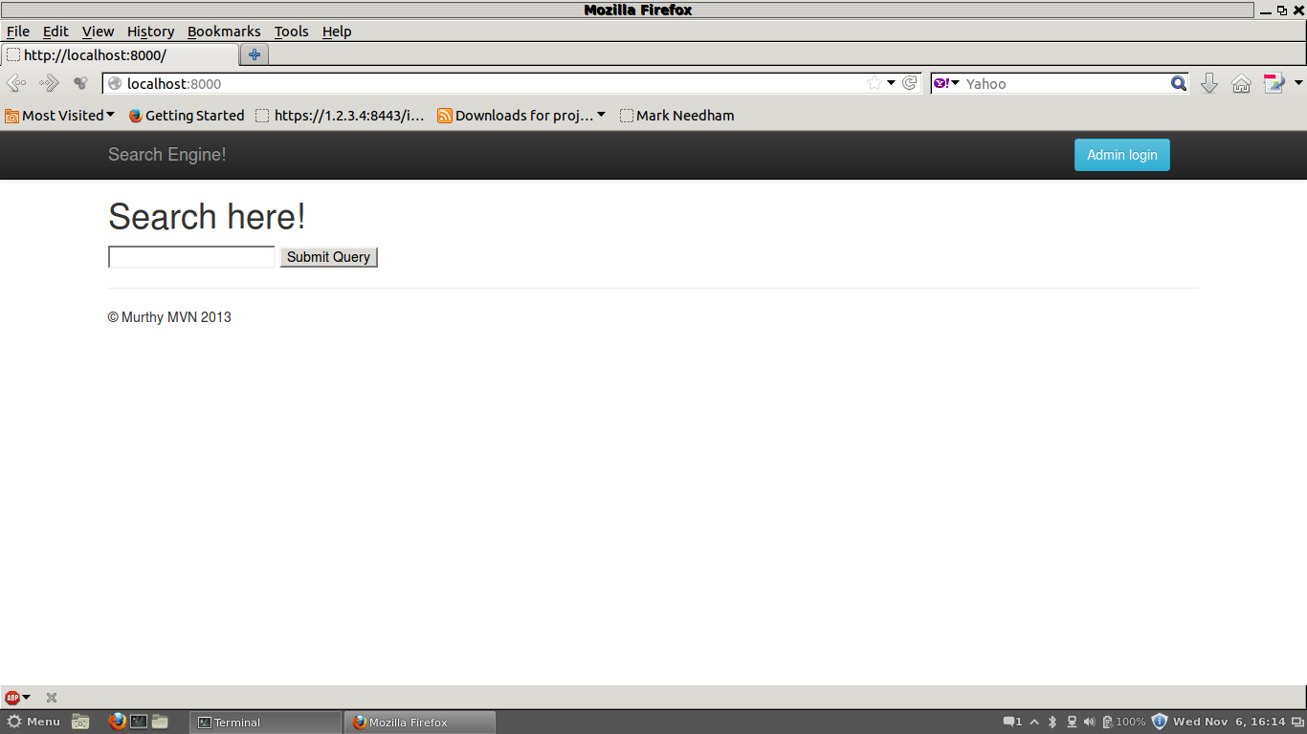
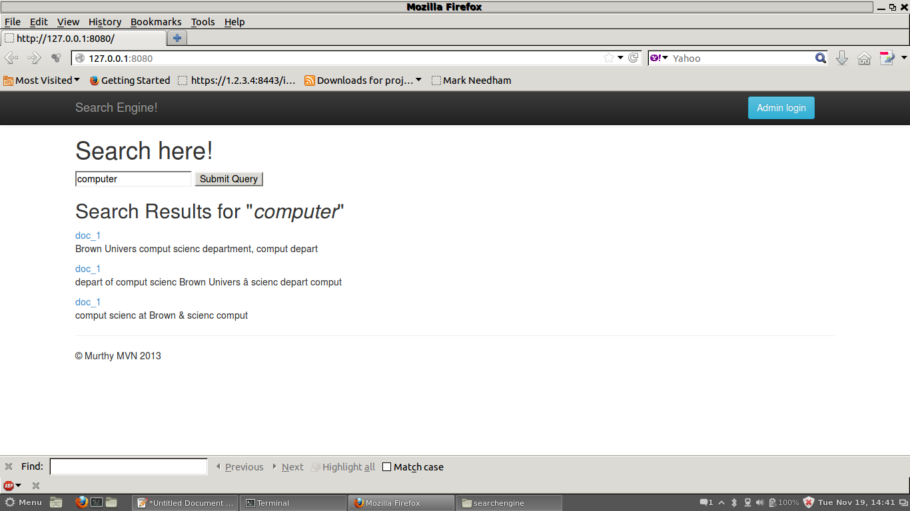

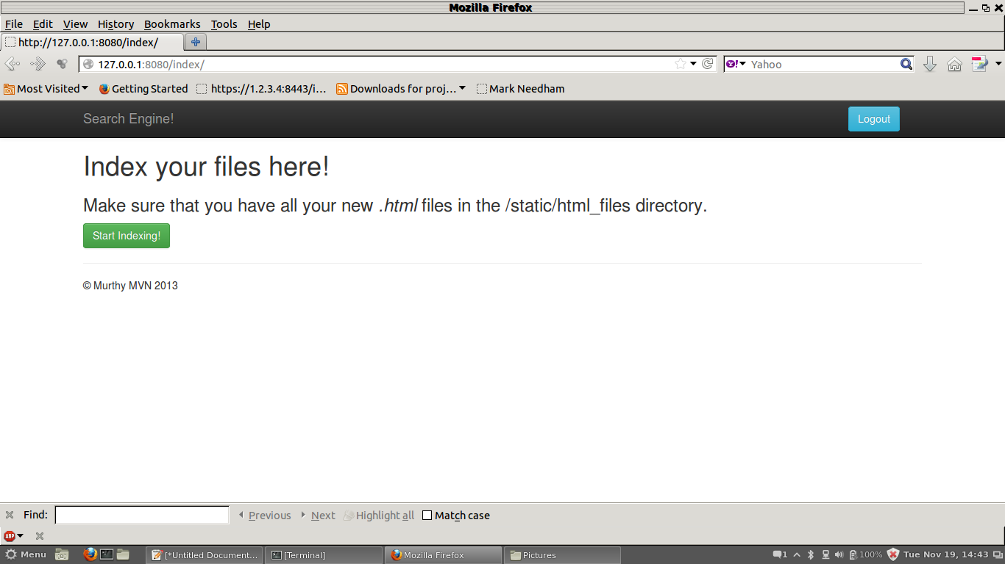
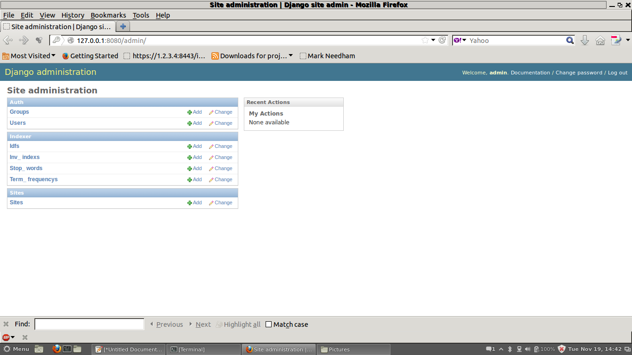

5. Testing

It brings all the pieces together into a special testing environment, then checks for errors, bugs and interoperability. Software testing is the process of testing the software product. Effective software testing will contribute to the delivery of higher quality software products, more satisfied users, lower maintenance costs, more accurate, and reliable results. However, ineffective testing will lead to the opposite results; low quality products, unhappy users, increased maintenance costs, unreliable and inaccurate results.
Testing is the major quality control measure used during software development. Its basic function is to detect errors in the software. It is a very expensive process and consumes one-third to one-half of the cost of a typical development project. It is the process of executing program (or a part of a program) with the intention of finding the errors, however, testing cannot show the absence of errors it can show that errors are present.
“Errors are present within the software under test”. This cannot be the aim of software designers they must have designed the software with the aim of producing it with zero errors. Software testing is becoming increasingly important in the earlier part of the software development life cycle, aiming to discover errors before they are deeply embedded within systems. In the software development life cycle the earlier the errors are discovered and removed, the lower is the cost of their removal. The most damaging errors are those, which are not discovered during the testing process and therefore remain when the system ‘goes live’.

Testing Procedure
Different type of checks like duplicate checks, completeness check, validity, checks etc. are incorporated in this system, as the data has to be entered in different forms.
The user is not familiar with new system the data entry screens are designed in such a way that they are
- Consistent
- Compatible
- Easy to use
- Had quick response
The following conventions are used while designing of the various screens to make the system user friendly
- All the items that are logically related are together.
- Error and validation messages are provided wherever required.
- System testing is against its initial objectives, it is done in a simulated environment.

Test Review

Test review is the process, which ensures that testing is carried out, as planned test review decides whether or not the program is ready to ship out for the implementation. For each data entry screen, we prepared test data with extreme values and under all relevant data- entry screen against real this process helped in rectifying the modules time.

6. CONCLUSION AND FUTURE SCOPE

The main aim of this project is to develop a search engine that searches for a given text and to develop the algorithms for the operations that are available. User can search queries in efficient way.
We shall adhere to strong internal value systems with integrity, fairness and the pursuit of excellence in all our activities. Further in future we can add clustering method to search in efficient manner.

7. Bibliography

7.1 Books & Magazines
A) Software Engineering by Roger S. Pressman, 5th Edition.
B) Thinking Like A Computer Scientist,Python
C) Software Engineering Principles by Rajib Mall, 3rd Edition.

7.3 Websites
A) www.google.com
B) www.djangoproject.com
C) www.stackoverflow.com

