DEPARTMENT OF INFORMATION TECHNOLOGY


VISHWAKARMA INSTITUTE OF INFORMATION
TECHNOLOGY, PUNE
A project report on
Pharmacy Management System
Submitted by:
NAME | GR. NO. | ROLL NO.
Mr. Meet Kakadiya | 17U122 | 331032
Mr.Pratik Jagtap | 17U645 | 331047
Mr.Nihar Manerikar | 17U661 | 331035
Mr.Manthan Agrawal | 17U209 | 331031

Guided By
-Mr. Dheeraj Rathode

Table of Contents
Table of Contents ii
Revision History iii
1. Introduction 1
1.1 Purpose 1
1.2 Document Conventions 1
1.3 Intended Audience and Reading Suggestions 1
1.4 Product Scope 1
2. Overall Description 2
2.1 Product Perspective 2
2.2 Product Functions 2
2.3 User Classes and Characteristics 2
2.4 Operating Environment 2
2.5 Design and Implementation Constraints 2
2.6Assumptions and Dependencies 3
3. External Interface Requirements 3
3.1 Hardware Interfaces 3
3.2 Software Interfaces 3
4. System Features 4
4.1 Feature 1: Login Authentication……………………………………………4
4.1.1 Description ……………………………………………………………4
4.1.2 Functional requirements ……………………………………………...4
4.2 Feature 2: User Creation …………………………………………………...4
4.2.1 Description 4
4.2.2 Functional requirements 4
4.3 Feature 3: Medicinal Database 4
4.3.1 Description 4
4.3.2 Functional requirements 4
4.4 Feature 4: Search Tool 4
4.4.1 Description 4
4.4.2 Functional requirements 4
4.5 Feature 5: Database Editing 4
4.5.1 Description 5
4.5.2 Functional requirements 5
4.6 Feature 6: Threshold Report 5
4.6.1 Description 5
4.6.2 Functional requirements 5
4.7 Feature 7: Billing 5
4.7.1 Description 5
4.7.2 Functional requirements 5
5. Other Nonfunctional Requirements 6
5.1 Performance Requirements 6
5.2 Safety Requirements 6
5.3 Security Requirements 6
5.4 Software Quality Attributes 6
6. Appendix 6
Appendix A: Glossary 6
Appendix B: Analysis Models: Database Schema Diagram 6
Appendix C: Use case diagram………………………………………..7
Appendix D: Activity diagram.................................................................8
Appendix E: Sequence Diagram...............................................................9
Appendix E: State Diagram....................................................................10
7.Implementation ……………………………………………………....11
7.1 Benefits……………………………………………………………………...11
7.2 Features……………………………………………………………………...11
7.3 Screenshots………………………………………………………………….12
8.References…………………………………………………...17

Introduction

Purpose
This document provides a complete description of the project, its functions and specifications. It will cover the purpose, scope of the project; explain features, interfaces and functions of the project. The expected audience of this document is our project guide and examiner, including members who will use this system. The purpose of this Software Requirements Specification is to serve as the repository for all of the requirements that the system shall or should possess. This specification is the primary document upon which all of the subsequent design, implementation, and test/validation plan will be based.

Document Conventions
Main topics of the document are bolded and represented by whole numbers.
Sub topics are bulleted beneath the main topic and represented as decimal version of whole numbers.
Font used is Arial.

Intended Audience and Reading Suggestions
This document is to be read by development team, project guide, examiners and documentation writers. The SRS has been organized approximately in order of increasing specificity. The developers need to become intimately familiar with the SRS.
This Software Requirements document is intended for:
- Developers who can review project’s capabilities. So that they can easily understand where their efforts should be focused to improve or add more features to it.
- Project testers so that they can use this document as a base for their testing strategy.
- End users of this product who wish to read about this project’s features and what it can do.

Product Scope
This is a python application that will support every aspect of the pharmaceutical shop owner. This includes shop owner registrations, admin and user login, medicines data, bill generation on purchase, medicine availability in the stock.

Overall Description

Product Perspective
This software is a pharmacy management system that manages all the features and task required by the pharmacy shop owner to run his business. The system is a python application that uses relational database management system as a data tier. Every user of this system will need a python application to use the system and connect to it. The system will be based on MySQL technologies which provide easy and rapid development. This product is developed in perspective of reducing human efforts.

Product Functions
- Login authentication.
- Registrations.
- Access to medicine details.
- Access to medicine stock details.
- Record of alternative to medicine if medicines are out of stock.
- Billing facility for the orders of the medicines.
- Access to customer data.
- Access to doctor data

User Classes and Characteristics
The main user for this software is pharmaceutical shop owner. Technical expertise is not required to use this software as it is providing a user friendly interface. Pharmaceutical knowledge however is required to use the software as the database used for this software deals with the various medicines prescribed for different diseases. User must understand how to navigate around interface and perform conceptual tasks such as logging into a secure account, uploading pictures, and inputting data into specified fields.

Operating Environment
The software will work on Linux based operating system.

Design and Implementation Constraints
This software requires database to be updated frequently as new medicines arrive in the shop. Small shop owners who want to use this software may experience some constraints if there are no computers for working of the software.

Assumptions and Dependencies
This software is developed with the assumption that the user already has the hardware required and the Ubuntu operating system installed on it. Any new entry arriving in the database should be given by user i.e. pharmacist should add the new entries in the database.

External Interface Requirements

Hardware Interfaces
- Processors: Intel Atom processor or Intel Core i3 processor or above
- Disk space: 1 GB
- Ram: 512 MB

Software Interfaces
- Operating systems: Ubuntu 14.04 and above.
- Java versions: 13.2
- MySQL version: 8.0.X and above.
- Compatible tools: NetBeans

System Features

This application provides various features. There exist common features for every user type. Some of the basic features of application provide and their functional requirements are described in this section. These features and functional requirements are described to assist the testers and developers that will provide future extensions. Features mentioned in this section will be implemented in the final product.

Login authentication:

Description:
This function specifies the signing-in process of the system user name and password will be required for login process.

Attributes are:
- “USERNAME”- field: Unique usernames will be allotted as per registration, in this box the users will enter their unique username.
- “PASSWORD”- Users will need to enter password

Functional Requirements:
REQ -01: verify the entered username and password are valid and check if they match or not.
REQ-02: if yes then user shall be allowed to enter and if no then re-enter.

User creation:

Description:
The Admin has special rights to create a user.
Creation of user:
1. Filling in the username, password and the user type.
2. Retyping the password to confirm.

Functional Requirements:
REQ-01: CONDITION: Application should not accept numerical and special characters in the username.
REQ-02: CONDITION: Application should accept at least one special character and one numeric character in the password.

Medicine database:

Description
This pharmacy management system stores the detailed information including name, price, company’s name, description of drugs used, cautions, how to use, etc.

Functional Requirements:
REQ-01: Application should contain the database of all the medicines available in the shop.
REQ-02: Application should have columns such as:
- Med ID
- Name
- Company
- Drug description
- Caution
- usage

Search tool:

Description:
One of the most important feature of the Pharmacy Management system is to search the medicine for user’s customers and show name, price, alternative medicines, check availability of the med.

Functional Requirements:
REQ-01: User need to enter a letter/word in search box to get the list of appropriate meds, the user is searching for.
REQ-02: Application should present all the relatable meds with the searched letter/word.

Database editing:

Description:
Editing of database includes adding new records, delete old ones, and editable if needed. These records are nothing but medicine records.

Functional Requirements:
REQ-01: User shall be allowed mad any changes in the database, as per user’s need.
REQ_02: After the changes are made, user will need to confirm making changes in the database.
REQ_03: All the changes should made permanent and should updated with server.

Threshold report:

Description:

The users must know which meds are most frequently being sold, and which are rarely being sold and which meds are about to get expired. This record will flag those meds whose stock or quantity is less than the set threshold.

Functional Requirements:
REQ-01: The database must keep count of quantity of medicines in the database.
REQ-02: The threshold report must show the current count of medicines as well as the number of times it was purchased
REQ-03: It should also suggest medicines which should be purchased from the wholesale market before the stock gets short on supply.
REQ-04: The application should mention the most selling and least selling medicines.

Billing:

Description:
For purchased meds by user’s customers need to be billed and this software provides a billing feature with GST and discount if any.

Functional Requirements:
REQ -01: GST number of the user should be mention on the bill
REQ-02: All the purchased items should be listed in the bill.
REQ-04: Application should count the total of the bill.
REQ-04: User should be given a confirmation message before printing the bill and sending it to the server.

Other Nonfunctional Requirements

Performance Requirements
This system must have less delay time while searching, while traversing between windows and should be interactive. All the searching, filtering, billing, editing must have less delay time, less than 2 seconds.

Safety Requirements
While billing process, the cart must contain exact quantity of medicine added to the cart. If any new entries of medicine are to be added to the dataset then the system should check if the entries are already available in the dataset and warn the user.

Security Requirements
Login section of this system must have proper mechanism to avoid any hacks. The billing system must have proper GST section to avoid any wrong doing of work.

Software Quality Attributes
- Usability:
The system will have a simple and user-friendly graphical interface. Users will be able to understand and use all the features easily. Any action will be performed with just a few clicks.
- Portability:
This software is small in space requirements and can be install easily and sent to other devices easily vie portable devices.

6. APPENDIX
6.1 Appendix A: Glossary

- SRS (Software Requirements Specification): is a complete description of the behavior of the system to be developed.
- DBMS (Database Management System): is a set of programs that enables you to store, modify, and extract information from a database, it also provides users with tools to add, delete, access, modify, and analyze data stored in one location.
- MySQL (My Structured Query Language) is the world's most used open source relational database management system (RDBMS) as of 2008 that run as a server providing multi-user access to a number of databases
6.2 Appendix B:
Analysis Models: Database Schema Diagram:
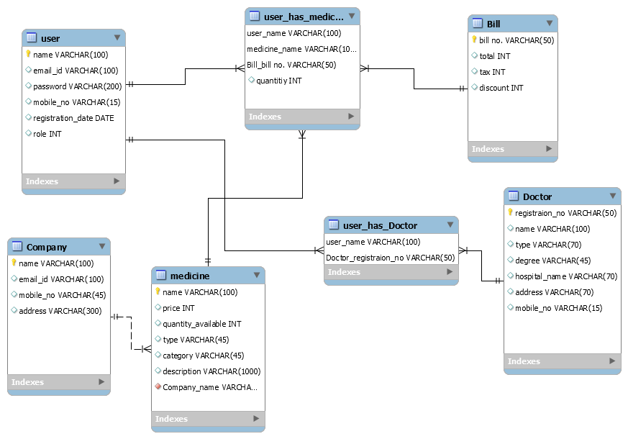

6.3 Appendix D: Use case diagram

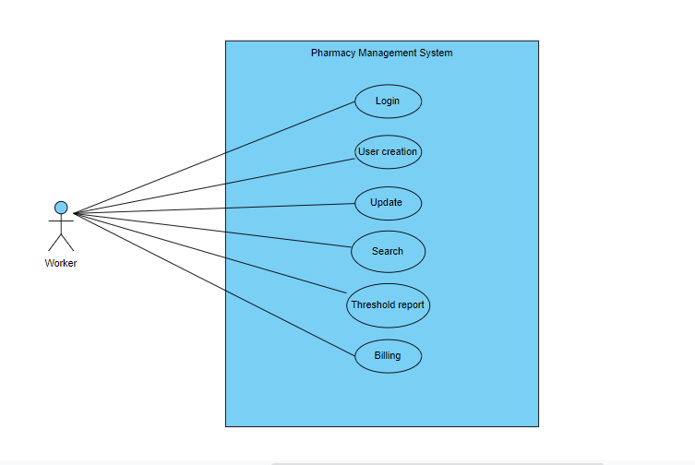
6.4 Appendix D: Activity Diagram

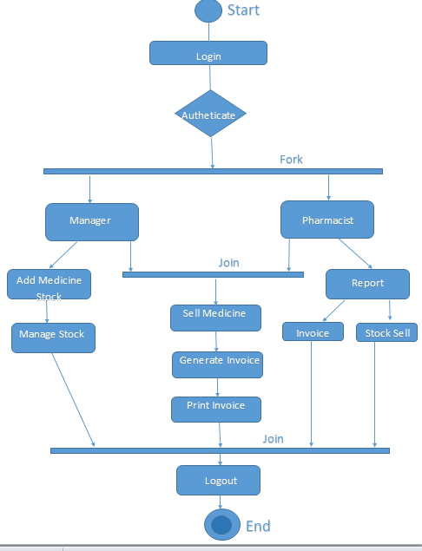

6.5 Appendix D: Sequence diagram
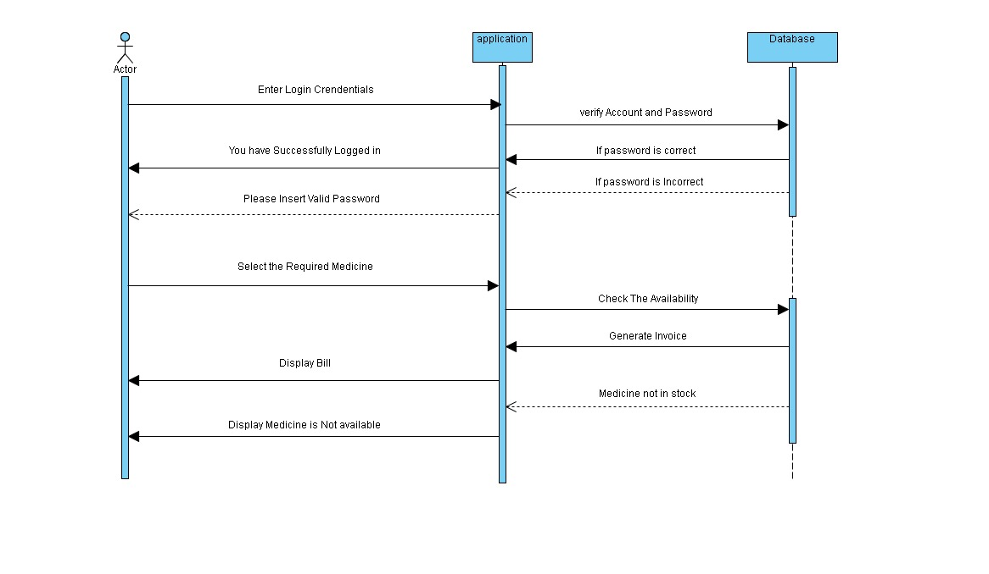
6.6 Appendix E: State Diagram
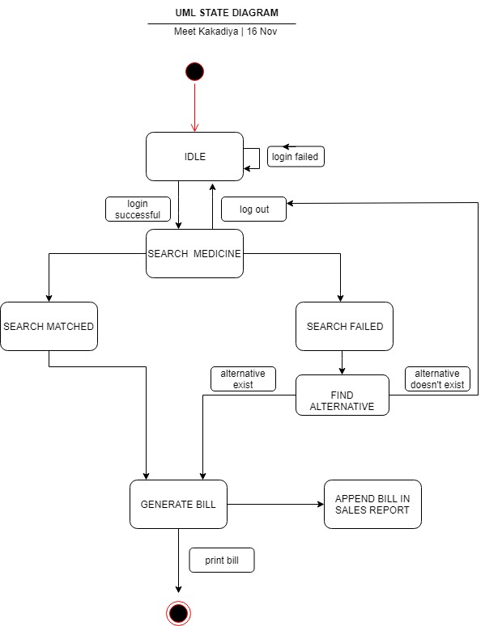

7.0 Implementation

7.1Benefits:
- Avoids typing task
- Faster documentation retrieval
- It is easy to manage, update and delete
- Bill generation is fast and accurate
- It provides ease of access to user

7.2Features:
- Login- separate admin and pharmacists and separate database entries
- Signup- instant database update when a new account is created
- Search bar- helps to find required medicine with ease
- Add to cart- to add required medicines with desired quantity
- Generate bill-to create final bill for the user
- Add doctor- a function to add doctor name and their hospitals in the database
- Add company-function to add new companies of medicines to the database
- Add medicine- function to add new medicines to the database
- Discount – to provide desired amount of discount
- Report- function used to display the entire medicinal log for desired time period

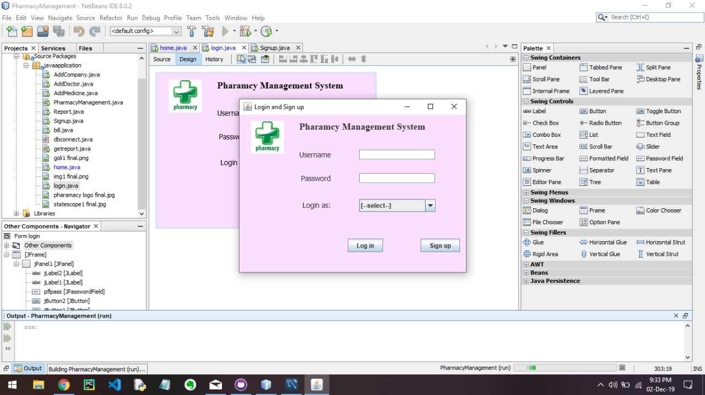
7.3SCREESHOTS

1.Login/signup page

2.Home
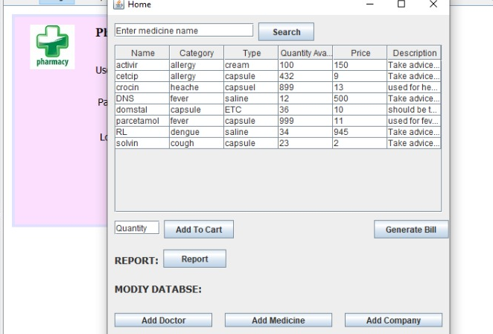

3.Add doctor

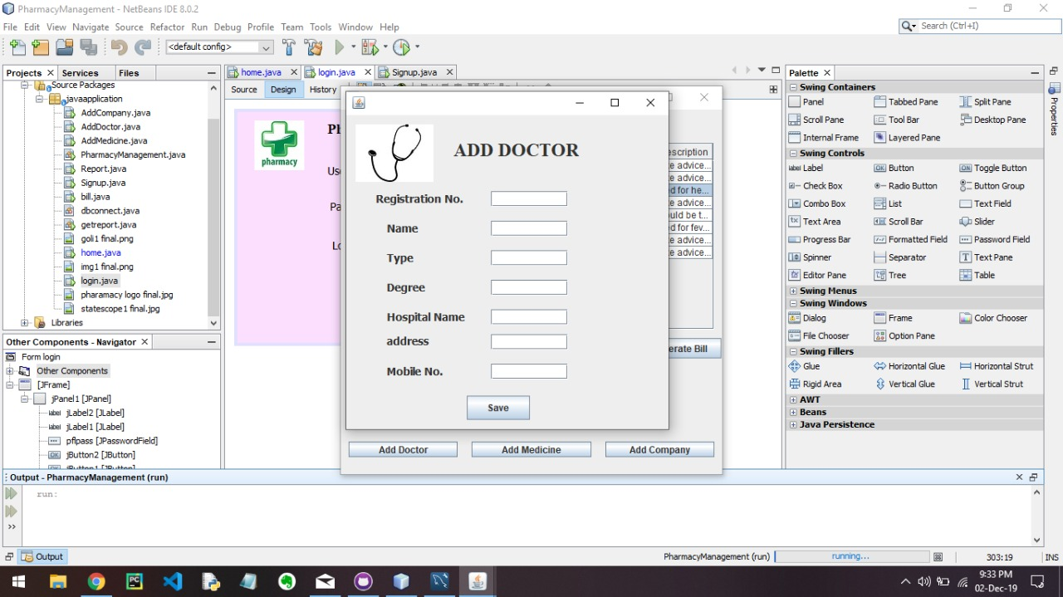

4.Add medicine

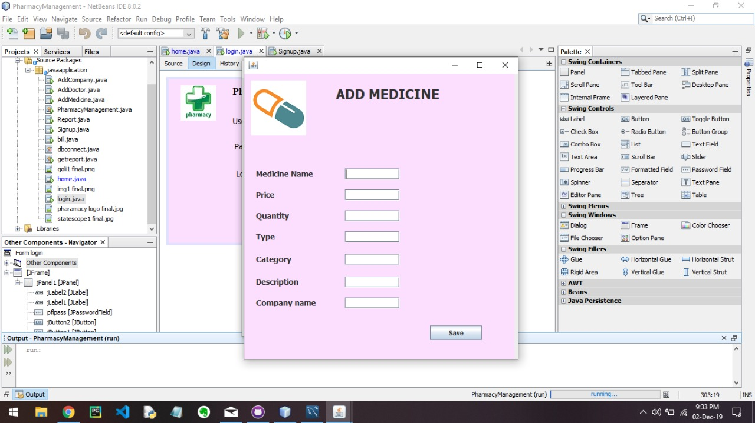

5.Add company
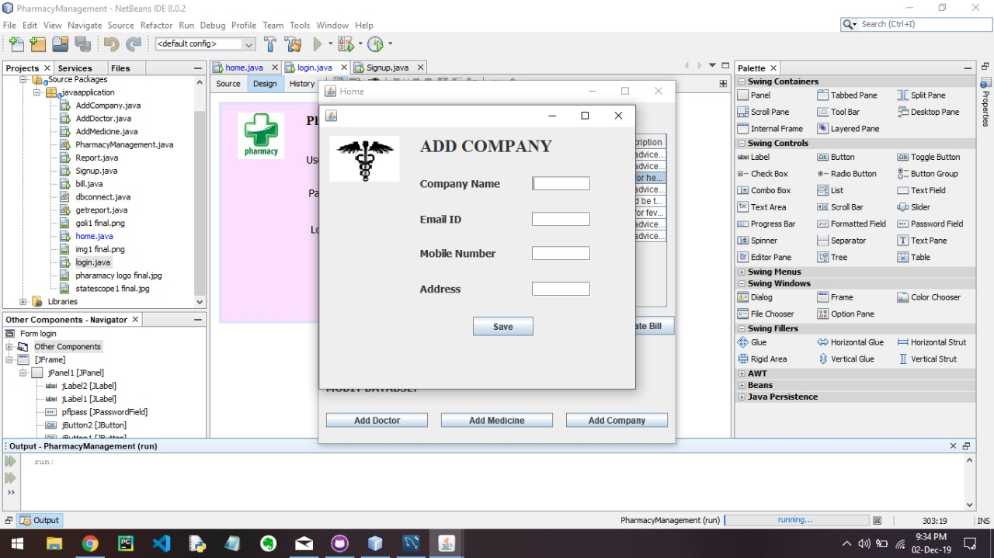

6.Bill

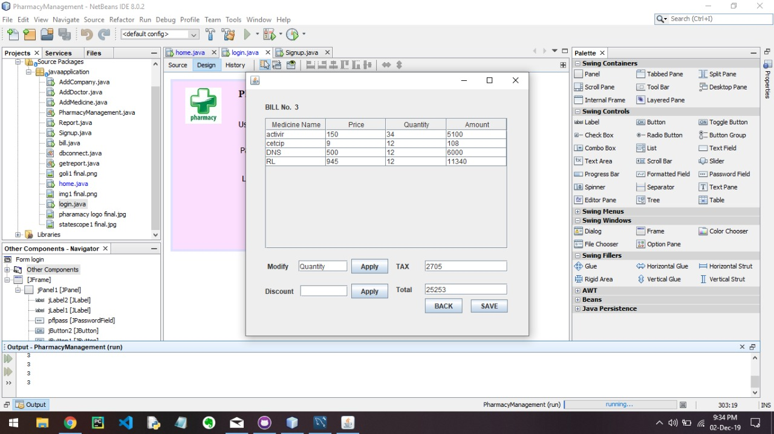

7.Report
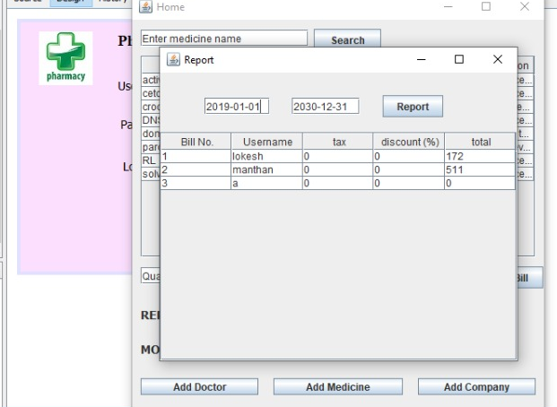

8.References

- Standard SRS template given by IEEE.
- SQL tutorial:-
https://www.w3schools.com/sql/default.asp
- Trigger and procedure:
https://youtu.be/EGzjNRfRt0U
- Java – net beans tutorials
https://www.youtube.com/watch?v=AGI0dGLdM7Q&list=PLNHw_0qv1zy-cVdEX6HqJX2a8ZLHbG3Ox
- https://www.youtube.com/watch?v=AGI0dGLdM7Q&list=PLNHw_0qv1zy-cVdEX6HqJX2a8ZLHbG3Ox
- https://www.w3schools.com/sql/
- https://repo1.maven.org/maven2/mysql/mysql-connector-java/5.1.23/

