- Do not edit/delete any heading or section with red text.
- Type /paste you answers in relevant sections (below Final Answer (in all questions , Approach (wherever required ) and Charts & tables (wherever required)) of the solution
- Link to submission guidelines
- Please note that submission not following the guidelines will not be accepted

OBJECTIVE QUESTIONS

Question 1: What is the total no. of tables present in the data?

Solution:

Final Answer (if any):
The dataset consists of 1 main data table containing all the restaurant listings. The workbook also includes a "country description" reference table used for mapping country codes to country names.

Approach (if any):
I opened the Excel workbook and checked all the sheets. The main data table is in the "Raw Data" sheet which has 9,551 rows of restaurant data. There is also a small lookup table called "country description" with 15 country codes and names. So the total number of tables present in the data is 1 main table (with the country description as a supporting reference table).

- Description:
Main Zomato restaurant data table used for analysis.

Question 2: What is the total no. of attributes present in the data?

Solution:

Final Answer (if any):
There are 20 original attributes (columns) in the raw dataset. After data cleaning and feature engineering, additional columns like Country_Name, Price_with_Currency, Year, and helper columns were added, bringing the total to 25 columns in the Cleaned Data sheet.

Approach (if any):
I counted the column headers in the "Raw Data" sheet and found 20 columns: RestaurantID, RestaurantName, CountryCode, City, Address, Locality, LocalityVerbose, Longitude, Latitude, Cuisines, Currency, Has_Table_booking, Has_Online_delivery, Is_delivering_now, Switch_to_order_menu, Price_range, Votes, Average_Cost_for_two, Rating, Datekey_Opening. The Cleaned Data sheet has 25 columns after adding Country_Name, Price_with_Currency, Year, Q10_Rating_Helper, and CountryVotesKey.

Question 3: How many categorical columns are there in the data? [Search about categorical and continuous data, and try to answer this question]

Solution:

Final Answer (if any):
There are 12 categorical columns in the data: RestaurantName, City, Address, Locality, LocalityVerbose, Cuisines, Currency, Has_Table_booking, Has_Online_delivery, Is_delivering_now, Switch_to_order_menu, and CountryCode.

Approach (if any):
Categorical data refers to columns that have text labels or categories rather than continuous numerical values. I went through each column and classified them. Columns like RestaurantID, CountryCode, Longitude, Latitude, Price_range, Votes, Average_Cost_for_two, and Rating are numerical. The remaining 12 columns contain text/category values and are therefore categorical.

Question 4: The data consists of some inconsistent and missing values so ensure that the data used for further analysis is cleaned.

Solution:

Final Answer (if any):
The data has been cleaned and formatted. A new "Cleaned Data" sheet was created with all inconsistencies resolved.

Approach (if any):
I performed the following cleaning steps:
1. Checked for and handled missing/null values across all columns.
2. Standardized the Datekey_Opening column from the format "YYYY_M_D" to a proper date format "YYYY-MM-DD".
3. Standardized text formatting for consistency (e.g., Yes/No values).
4. Created a separate "Cleaned Data" sheet to preserve the original raw data.
5. Added derived columns like Country_Name (via VLOOKUP), Year (extracted from date), and Price_with_Currency for further analysis.

Question 5: Using the LookUp functions, fill up the countries in the original data using the country code.

Solution:

Final Answer (if any):
Country names were successfully populated using the VLOOKUP function. All 9,551 rows now have the corresponding country name mapped from the CountryCode.

Approach (if any):
I used the VLOOKUP function to map each CountryCode in the main dataset to its corresponding Country Name from the "country description" sheet.
Formula used:
=VLOOKUP(C2, 'country description'!A:B, 2, FALSE)
Where C2 is the CountryCode cell, the lookup range is columns A and B of the "country description" sheet, we want the 2nd column (Country Name), and FALSE ensures an exact match. This formula was applied to all 9,551 rows.

Question 6: Create a table to represent the number of restaurants opened in each country.

Solution:

Final Answer (if any):
India has the highest number of restaurants with 8,652 (90.6% of total), followed by the United States of America with 434 (4.5%). The total number of restaurants across all 15 countries is 9,551.

Approach (if any):
I created a Pivot Table on the "Q-6 I Objective" sheet, grouping restaurants by Country_Name and counting the RestaurantID for each country. A bar chart was also created to visualize the distribution. A "Share of Total" percentage column was added to show each country's proportion.

Charts & Tables (if any):
- Table / Chart Name:
Restaurants Opened by Country
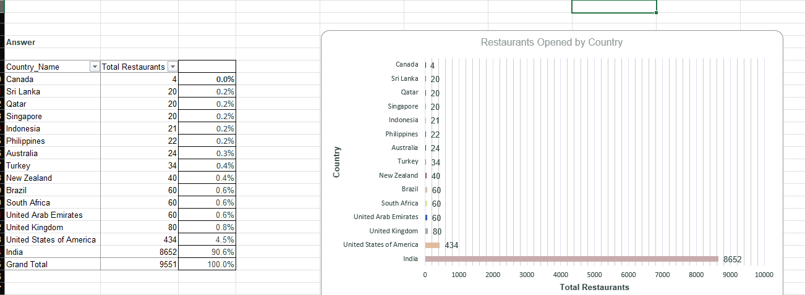
- Description:
A pivot table and horizontal bar chart showing the count and percentage of restaurants in each of the 15 countries. India dominates with 8,652 restaurants (90.6%), while Canada has the fewest with just 4.

Question 7: Also, the management wants to look at the number of restaurants opened each year, so provide them with something here.

Solution:

Final Answer (if any):
The highest number of restaurants opened in 2018 with 1,102 new openings. The lowest was in 2012 with 1,022. The overall trend shows steady growth with an average YoY growth rate of about 2.04%. The grand total across all years (2010-2018) is 9,551 restaurants.

Approach (if any):
I extracted the Year from the Datekey_Opening column and created a Pivot Table on the "Q-7 I Objective" sheet. The table counts the number of restaurants opened each year from 2010 to 2018. I also calculated the Year-over-Year (YoY) Growth % and created a line chart to show the trend visually.

Charts & Tables (if any):
- Table / Chart Name:
Restaurants Opened Each Year
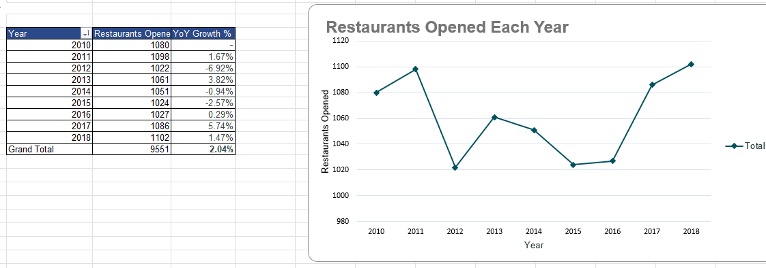
- Description:
A table with Year, Restaurants Opened, and YoY Growth %, along with a line chart showing the trend. The data shows a dip in 2012 (1,022) and peaks in 2011 (1,098) and 2018 (1,102).

Question 8: What is the total number of restaurants in India in the price range of 4?

Solution:

Final Answer (if any):
There are exactly 388 restaurants in India that fall under price range 4.

Approach (if any):
I used the COUNTIFS function on the "Q-8 I Objective" sheet to count restaurants where Country_Name = "India" AND Price_range = 4.
Formula used:
=COUNTIFS(Country_Name, "India", Price_range, 4)
Result: 388 restaurants.
Additionally, a breakdown of all price ranges in India shows:
• Price Range 1: 4,295 restaurants (49.6%)
• Price Range 2: 2,858 restaurants (33.0%)
• Price Range 3: 1,111 restaurants (12.8%)
• Price Range 4: 388 restaurants (4.5%)
• Total India: 8,652 restaurants

Charts & Tables (if any):
- Table / Chart Name:
India Price Range Distribution
- Description:
Table showing the COUNTIFS result for India with Price Range 4 (388 restaurants), along with a full breakdown of all 4 price tiers in India with their counts, percentages, average costs, and average ratings.

Question 9: What is the average number of voters for the restaurants in each country according to the data?

Solution:

Final Answer (if any):
Indonesia has the highest average voters per restaurant at approximately 772, followed by United Arab Emirates (494) and Turkey (431). India, despite having the most restaurants, averages only about 137 votes per restaurant. The overall global average is about 157 votes per restaurant.

Approach (if any):
I created a Pivot Table on the "Q-9 I Objective" sheet that calculates the average of the Votes column grouped by Country_Name. The table also shows Total Votes and Restaurant Count for each country. A horizontal bar chart was created to compare the average votes across countries.

Charts & Tables (if any):
- Table / Chart Name:
Average Customer Votes per Restaurant by Country
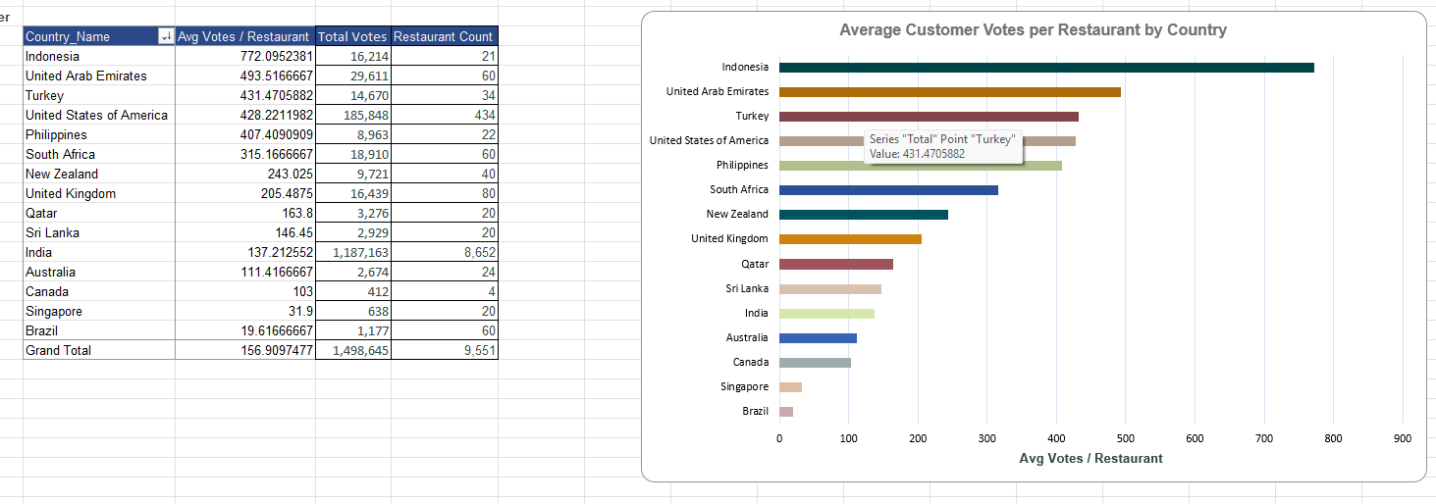
- Description:
A pivot table and horizontal bar chart ranking all 15 countries by their average votes per restaurant. Indonesia leads with ~772, followed by UAE (~494) and Turkey (~431). Brazil has the lowest average at ~20 votes.

Question 10: Calculate the average rating for all the restaurants that have price_range < 4 and provide online delivery. Use only the “IF” function, Logical Operators, and Aggregation functions to solve this problem. [Note: Don’t use Conditional aggregation in this question.]

Solution:

Final Answer (if any):
The average rating for restaurants with price_range < 4 and online delivery = Yes is 3.2738 out of 5.0 (across 2,398 qualifying restaurants).

Approach (if any):
As per the question requirement, I used only IF functions, logical operators, and aggregation functions (no AVERAGEIFS).
I created a helper column (Q10_Rating_Helper) in the Cleaned Data sheet using this formula:
=IF(AND(Price_range < 4, Has_Online_delivery = "Yes"), Rating, "")
This returns the Rating only when both conditions are met, and blank otherwise. Then I calculated the average of this helper column:
=AVERAGE(Q10_Rating_Helper_Range)
Result: 3.2738
The "Q-10 I Objective" sheet also shows a comparison across all 4 segments:
• Price < 4 & Online Delivery = Yes: 2,398 restaurants, Avg Rating 3.274
• Price < 4 & Online Delivery = No: 6,567 restaurants, Avg Rating 2.667
• Price = 4 & Online Delivery = Yes: 53 restaurants, Avg Rating 3.930
• Price = 4 & Online Delivery = No: 533 restaurants, Avg Rating 3.827

Charts & Tables (if any):
- Table / Chart Name:
Average Rating by Segment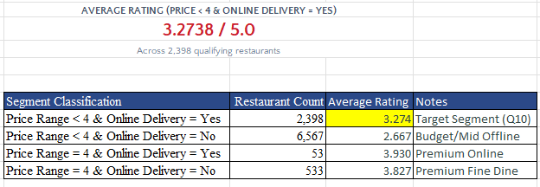

- Description:
Table showing the average rating for the target segment (Price < 4 & Online Delivery = Yes) as 3.2738, along with a comparison of all four price-delivery segments.

Question 11: Using Conditional formatting highlight the rows of restaurants that are located in the countries or cities that you’ve suggested to the management for opening new restaurants.

Solution:

Final Answer (if any):
Rows corresponding to the suggested countries (Canada, Qatar, Singapore, Sri Lanka, Indonesia, Philippines) have been highlighted using Conditional Formatting in the Raw Data sheet.

Approach (if any):
I applied Conditional Formatting in Excel with a custom formula-based rule. The formula used was:
=OR($U2="Canada", $U2="Qatar", $U2="Singapore", $U2="Sri Lanka", $U2="Indonesia", $U2="Philippines")
Where column U contains the Country_Name. This formula checks if the country in each row matches any of the 6 suggested countries. When TRUE, the entire row gets highlighted with a distinct background color, making it easy to visually identify these rows in the dataset.

Question 12: Create a new customized price column that consists of the abbreviation/symbol of the currency along with the Average_cost_for_two value. [Use string operations to do this task]

Solution:

Final Answer (if any):
A new "Customized Price" column (also named "Price_with_Currency") was created that combines the currency symbol with the Average_Cost_for_two value. For example: "Rs. 300", "$ 25", "Rp 150000", etc.

Approach (if any):
I used string concatenation in Excel to create the customized price column. The approach involved extracting the currency abbreviation from the Currency column and combining it with the cost value.
The general approach:
1. First, I identified the currency symbol/abbreviation for each currency type (e.g., "Rs." for Indian Rupees, "$" for Dollar, etc.).
2. Then I concatenated it with the Average_Cost_for_two value using string operations.
Example formula structure:
=MID(Currency, FIND("(", Currency)+1, FIND(")", Currency) - FIND("(", Currency) - 1) & " " & Average_Cost_for_two
This creates values like "Rs. 300", "$ 70", "Rp 150000" etc. The column is visible in both the "Cleaned Data" and "Data_1" sheets.

Question 13: How can you create an array formula in Excel or Google Sheets to count the number of restaurants listed that do not offer online delivery, are in the lowest price range, and have an average cost for two people less than or equal to 250 Indian Rupees?

Solution:

Final Answer (if any):
The count of restaurants meeting all three criteria is 1,685.

Approach (if any):
I used an array formula (SUMPRODUCT) on the "Q-13 I Objective" sheet to count restaurants satisfying all three conditions simultaneously:
Formula:
=SUMPRODUCT((Has_Online_delivery="No")*(Price_range=1)*(Average_Cost_for_two<=250)*(Currency="Indian Rupees(Rs.)"))
This multiplies three boolean arrays element-wise:
• Condition 1: Has_Online_delivery = "No"
• Condition 2: Price_range = 1 (lowest price range)
• Condition 3: Average_Cost_for_two <= 250
The step-by-step filtering breakdown:
1. Total Restaurants: 9,551
2. Online Delivery = "No": 7,100
3. Price Range = 1: 4,444
4. Average Cost <= 250 (in Indian Rupees): 1,838
5. All 4 conditions together: 1,685

Charts & Tables (if any):
- Table / Chart Name:
Array Formula Result
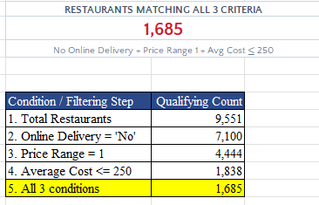
- Description:
Table showing the SUMPRODUCT array formula result (1,685) along with a step-by-step breakdown of how each condition progressively filters the dataset.

SUBJECTIVE QUESTIONS

Question 1: Suggest a few countries where the team can open newer restaurants with lesser competition. Which visualization/technique will you use here to justify the suggestions?

Solution:

Approach:
I analyzed the data by comparing the number of existing restaurants, average ratings, and average votes in each country. Countries with fewer existing restaurants (lower competition) but higher average ratings (strong customer satisfaction) are the best candidates for expansion. I used a bar chart to visually compare restaurant counts and ratings side by side.

Charts & Tables:
- Table / Chart Name:
Average Restaurant Rating by Suggested Country
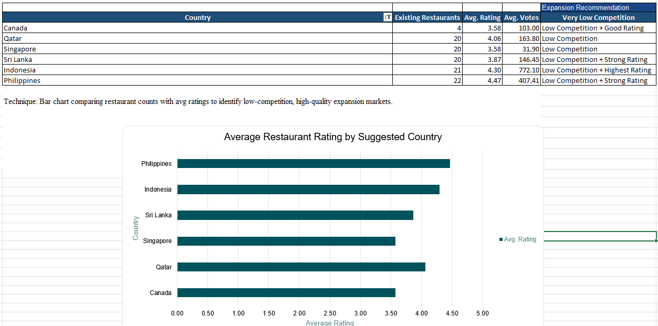
- Description:
A table showing 6 recommended countries with their existing restaurant counts, average ratings, average votes, and expansion recommendation tags. A horizontal bar chart compares the average ratings of these countries.

Insights:
• Canada has the lowest competition with only 4 restaurants, avg rating 3.58, and 103 avg votes.
• Philippines has the highest average rating (4.47) among all suggested countries with only 22 existing restaurants.
• Indonesia shows the best combination: only 21 restaurants, highest rating (4.30), and very high engagement (772 avg votes).
• Sri Lanka has a strong rating of 3.87 with just 20 restaurants.
• Qatar and Singapore both have 20 restaurants each, with Qatar having a higher rating (4.06 vs 3.58).

Recommendations:
• Prioritize expansion into Philippines and Indonesia first, as they show the strongest customer satisfaction with very low competition.
• Consider Sri Lanka and Qatar as secondary targets due to strong ratings and minimal existing competition.
• Canada, while having the fewest restaurants, has a relatively lower rating (3.58), so focus on premium quality to stand out.
• Use the bar chart comparison as a presentation tool for management to justify the expansion strategy.

Question 2: Come up with the names of States and cities in the suggested countries suitable for opening restaurants.

Solution:

Approach:
I drilled down into the recommended countries and extracted city-level data. For each country, I identified the cities with their existing restaurant counts, average ratings, and average costs. I sorted the cities by rating and competition level to find the most suitable ones for new restaurant openings.

Charts & Tables:
- Table / Chart Name:
Recommended Cities in Suggested Countries
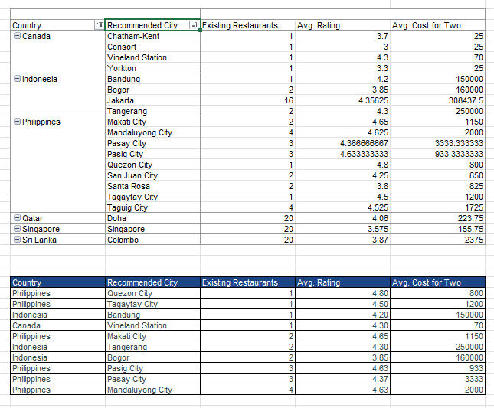
- Description:
A detailed table listing specific cities within each suggested country, showing their existing restaurant counts, average ratings, and average cost for two. Cities are grouped by country and sorted by suitability.

Insights:
• In Canada: Vineland Station has the highest rating (4.3) with just 1 restaurant. Chatham-Kent also shows promise with a 3.7 rating.
• In Indonesia: Jakarta is the largest market with 16 restaurants and an excellent avg rating of 4.36. Bandung (4.2) and Tangerang (4.3) have very low competition with only 1-2 restaurants each.
• In Philippines: Makati City (4.65 rating), Mandaluyong City (4.63), and Pasig City (4.63) all show outstanding ratings with minimal competition (2-4 restaurants each).
• In Qatar: Doha is the only city with 20 restaurants and a 4.06 rating.
• In Sri Lanka: Colombo has all 20 restaurants with a 3.87 avg rating.
• In Singapore: Singapore city has 20 restaurants with 3.58 avg rating.
• Note: State/province data is not available, so recommendations are city-level based on low competition and favorable ratings.

Recommendations:
• Start with Makati City and Mandaluyong City in the Philippines – they have the highest ratings (above 4.6) with very few competitors.
• In Indonesia, consider Bandung and Tangerang first for initial entry, then expand to Jakarta which is a bigger market.
• For Canada, Vineland Station offers a high-quality dining market.
• In Qatar and Sri Lanka, focus on Doha and Colombo respectively as they are the primary dining hubs.

Question 3: According to the countries you suggested, what is the current quality regarding ratings for restaurants that are open there?

Solution:

Approach:
I evaluated the rating distribution in each suggested country by calculating the average rating, minimum rating, maximum rating, and the percentage of restaurants rated 4.0 or above. This helps understand what level of quality customers in these countries expect.

Charts & Tables:
- Table / Chart Name:
Restaurant Rating Quality in Suggested Countries
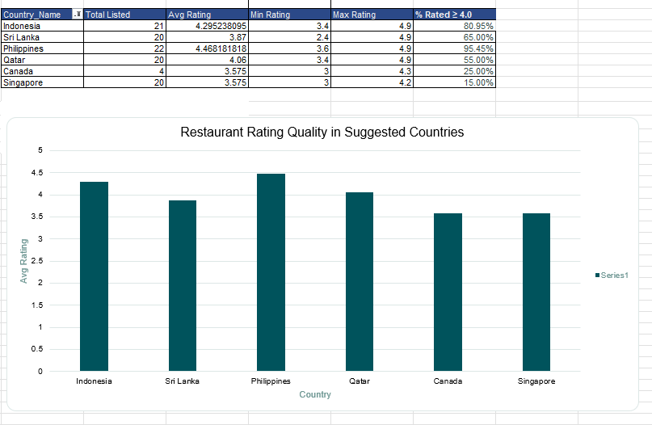
- Description:
A table showing each suggested country's total listed restaurants, average rating, min/max ratings, and percentage of restaurants rated ≥ 4.0. A bar chart compares the average ratings visually.

Insights:
• Philippines has the best rating quality: avg 4.47, with 95.45% of restaurants rated 4.0 or above. The minimum rating is 3.6, meaning even the lowest-rated restaurant is decent.
• Indonesia follows closely with avg 4.30 and 80.95% rated ≥ 4.0.
• Sri Lanka has a solid avg of 3.87 with 65% rated ≥ 4.0, though the min rating drops to 2.4, showing some variation.
• Qatar shows avg 4.06 with 55% rated ≥ 4.0.
• Canada (avg 3.58, 25% ≥ 4.0) and Singapore (avg 3.58, 15% ≥ 4.0) have lower quality benchmarks, meaning there's room for a high-quality entrant to stand out.

Recommendations:
• In Philippines and Indonesia, new restaurants must maintain exceptional quality since customers are used to highly-rated dining experiences.
• In Canada and Singapore, there's an opportunity to differentiate by offering premium quality, as the current rating bar is lower.
• Target a minimum rating of 4.0+ in all suggested countries to establish a strong brand reputation from the start.
• Focus on consistent food quality and service, as these countries have discerning diners who actively rate restaurants.

Question 4: Also, what is the current expenditure on food in the suggested countries, so we can keep our financial expenditure in control?

Solution:

Approach:
I analyzed the average cost for two people in each suggested country, along with the local currency, minimum and maximum costs, and classified each market into a pricing tier. This helps the team plan their financial strategy and menu pricing for each target country.

Charts & Tables:
- Table / Chart Name:
Food Expenditure Analysis in Suggested Countries
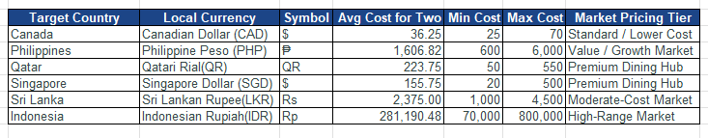
- Description:
A table displaying each target country with its local currency, symbol, average cost for two, min/max cost range, and market pricing tier classification.

Insights:
• Canada has the lowest average cost (CAD 36.25) with a range of $25-$70, classified as a Standard/Lower Cost market.
• Philippines (PHP 1,607) is a Value/Growth Market with costs ranging from ₱600 to ₱6,000.
• Qatar (QR 223.75) and Singapore (SGD 155.75) are Premium Dining Hubs with wider price ranges.
• Sri Lanka (LKR 2,375) is a Moderate-Cost Market with costs from Rs.1,000 to Rs.4,500.
• Indonesia (IDR 281,190) is a High-Range Market with costs from Rp.70,000 to Rp.800,000 – the nominal values are high due to the currency denomination.
• Costs vary significantly across markets, both in nominal terms and purchasing power.

Recommendations:
• Adopt a localized pricing strategy for each country rather than a one-size-fits-all approach.
• In Premium Dining Hub markets (Qatar, Singapore), position restaurants in the upper-mid range to match the premium brand image.
• In Value/Growth markets (Philippines), keep prices competitive while maintaining quality to capture market share.
• Use the avg/min/max cost data to set initial menu prices within the local market range and adjust based on customer response.
• Plan currency-adjusted budgets for each country's operations.

Question 5: Come up with the names of restaurants from the recommended states that are our biggest competitors and also those that are rated in the lower brackets, i.e. 1-2 or 2-3.

Solution:

Approach:
I identified two groups of restaurants in the recommended countries:
1. Biggest Competitors: Restaurants with the highest vote counts (indicating high popularity and traffic).
2. Low-Rated Restaurants: Those rated below 3.0, indicating poor customer satisfaction despite being in the market.
A bar chart was also created to visualize the top competitor votes by country.

Charts & Tables:
- Table / Chart Name:
Top Competitors and Low-Rated Restaurants
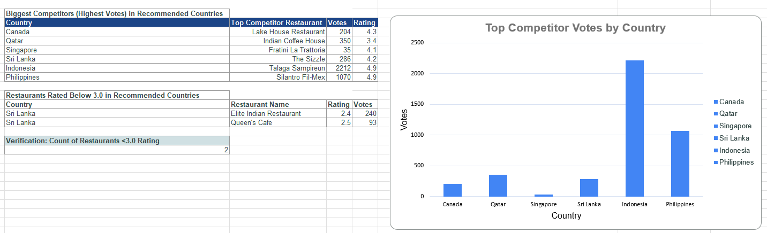
- Description:
Two tables: (1) Biggest Competitors showing the top-voted restaurant in each suggested country with their votes and ratings, and (2) Restaurants rated below 3.0 in the recommended countries. A bar chart visualizes the competitor vote counts.

Insights:
• Indonesia's top competitor, Talaga Sampireun, has 2,212 votes and a perfect 4.9 rating – this is a very strong player.
• Philippines' Silantro Fil-Mex also has 1,070 votes with a 4.9 rating.
• Qatar's Indian Coffee House has 350 votes but only a 3.4 rating, showing an opportunity to capture its customer base with better quality.
• Singapore's top competitor (Fratini La Trattoria) has only 35 votes and a 4.1 rating, meaning the market is less engaged.
• In Sri Lanka, there are 2 restaurants rated below 3.0: Elite Indian Restaurant (2.4 rating, 240 votes) and Queen's Cafe (2.5 rating, 93 votes). These represent weak competitors whose customers can be captured.

Recommendations:
• In Indonesia and Philippines, study the top competitors (Talaga Sampireun, Silantro Fil-Mex) to understand what makes them successful, and differentiate rather than directly competing.
• In Qatar, target the customer base of Indian Coffee House (350 votes but only 3.4 rating) by offering superior quality at the same price point.
• In Sri Lanka, directly compete against Elite Indian Restaurant and Queen's Cafe by offering better food quality and service to capture their existing but unsatisfied customers.
• Monitor competitor activity regularly and adjust strategies accordingly.

Question 6: Which cuisines should we focus on in the newer restaurants to get better feedback? Does the choice of cuisines affect the restaurant ratings?

Solution:

Approach:
I grouped the restaurants into broad cuisine categories and calculated the listing volume (number of restaurants) and average rating for each category. This helps identify which cuisines naturally receive higher ratings and which ones face more competition. A horizontal bar chart was created to compare ratings across cuisine types.

Charts & Tables:
- Table / Chart Name:
Average Restaurant Rating by Cuisine Category
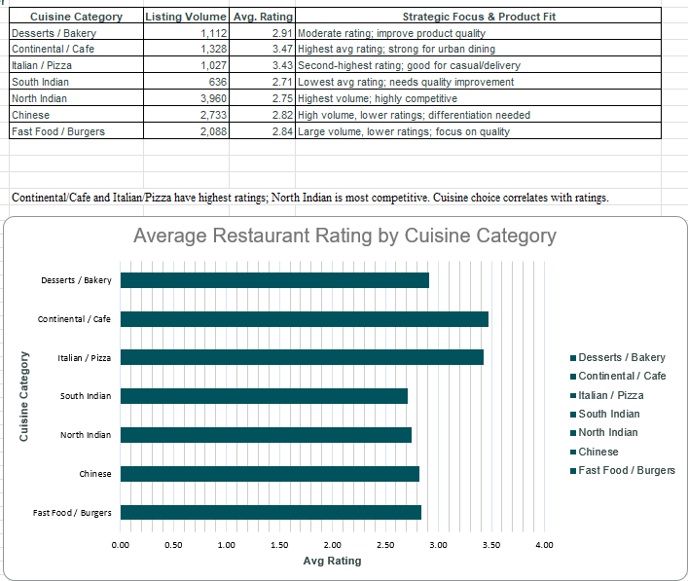
- Description:
A table showing 7 cuisine categories with their listing volume, average rating, and strategic focus recommendations. A horizontal bar chart compares the average ratings across all cuisine categories.

Insights:
• Continental/Cafe cuisine has the highest average rating at 3.47, making it the best-performing category for customer satisfaction.
• Italian/Pizza comes second with 3.43 average rating and is well-suited for casual dining and delivery.
• Desserts/Bakery has a moderate rating of 2.91 with 1,112 listings, suggesting room for quality improvement.
• North Indian is the most competitive category with 3,960 listings but a lower average rating of 2.75.
• South Indian has the lowest average rating (2.71) across 636 listings.
• Chinese (2.82) and Fast Food/Burgers (2.84) have high volume but below-average ratings.
• Yes, cuisine choice is strongly associated with restaurant ratings – there is a noticeable difference of about 0.76 points between the highest (Continental/Cafe at 3.47) and lowest (South Indian at 2.71) categories.

Recommendations:
• Focus on Continental, Cafe, and Italian/Pizza cuisines in newer restaurants as they consistently yield higher customer ratings.
• If offering North Indian cuisine, invest heavily in quality differentiation since the market is highly competitive with lower average ratings.
• Consider multi-cuisine restaurants that feature Continental and Italian options alongside local favorites.
• Avoid entering the South Indian category in new markets unless there is a clear quality advantage, as it has the lowest average ratings.

Question 7: According to our current data, should we go for online delivery and table booking? Does that affect the customer’s ratings?

Solution:

Approach:
I compared the average ratings of restaurants based on whether they offer Table Booking and Online Delivery services. I also looked at restaurants that offer both features together. A bar chart was created to visualize the impact of each service feature on ratings.

Charts & Tables:
- Table / Chart Name:
Average Rating by Service Capability
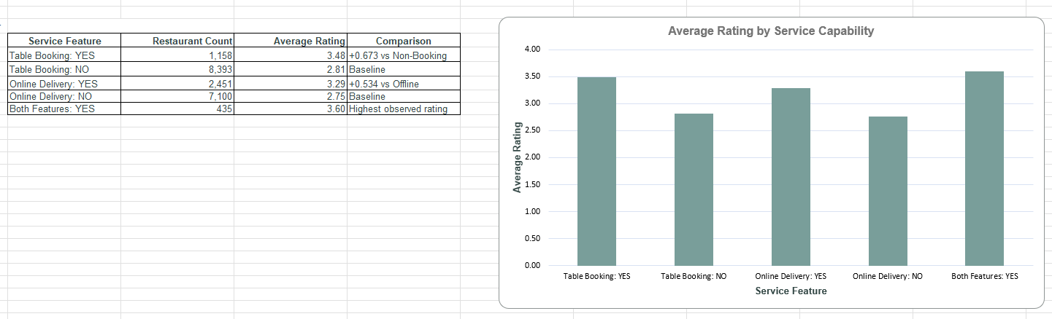
- Description:
A table showing 5 service feature categories with their restaurant counts, average ratings, and comparison values. A bar chart compares the average ratings for each service capability.

Insights:
• Table Booking makes a significant difference: restaurants with table booking average 3.48 rating vs. 2.81 without – an increase of +0.673.
• Online Delivery also helps: restaurants with delivery average 3.29 vs. 2.75 without – an increase of +0.534.
• The biggest finding: restaurants offering BOTH features together achieve the highest average rating of 3.60.
• Out of 9,551 restaurants, only 1,158 (12.1%) offer table booking and 2,451 (25.7%) offer online delivery.
• Only 435 restaurants offer both services, showing this is still an uncommon combination.

Recommendations:
• Absolutely implement both Table Booking and Online Delivery in all new restaurants. The data clearly shows both services correlate with higher customer ratings.
• Having both features together gives the highest rating advantage (3.60 avg), so prioritize launching with both services from day one.
• Since only 12.1% of restaurants currently offer table booking, this is a competitive differentiator that most competitors are missing.
• Invest in a reliable online ordering system and table reservation platform before opening new locations.

Question 8: Should the team keep the rate of cuisines higher? Will that affect the feedback? According to our data are the rates of cuisines and ratings, correlated?

Solution:

Approach:
I analyzed the correlation between price range (1 to 4) and average customer ratings. For each price tier, I calculated the restaurant count, average rating, and average votes per restaurant to understand if higher pricing is associated with better customer feedback.

Charts & Tables:
- Table / Chart Name:
Price Range vs Average Rating Analysis
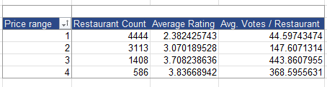
- Description:
A pivot table showing 4 price range tiers with their restaurant counts, average ratings, and average votes per restaurant. The data reveals a strong positive correlation between price and rating.

Insights:
• There is a clear positive correlation between price range and ratings:
– Price Range 1: Avg Rating 2.38 (4,444 restaurants)
– Price Range 2: Avg Rating 3.07 (3,113 restaurants)
– Price Range 3: Avg Rating 3.71 (1,408 restaurants)
– Price Range 4: Avg Rating 3.84 (586 restaurants)
• Higher-priced restaurants receive significantly better ratings. The difference between Price Range 1 and 4 is about 1.46 rating points.
• Average votes per restaurant also increase with price: Range 1 gets ~45 votes, Range 2 gets ~148, Range 3 gets ~444, and Range 4 gets ~369.
• This suggests customers associate higher prices with premium quality and tend to rate those restaurants more favorably.

Recommendations:
• Do not hesitate to position new restaurants in higher price tiers (Range 3 or 4). The data shows customers tend to give better ratings to pricier restaurants.
• Avoid the lowest price range (Range 1) unless there is a specific strategic reason, as it correlates with the lowest average ratings.
• If starting in a new market, aim for Price Range 3 as a sweet spot – it has a strong 3.71 average rating with good engagement (444 avg votes) and less competition than Range 1 and 2.
• Ensure that the higher pricing is backed by quality food, ambiance, and service to maintain positive customer feedback.

Question 9: What is the distribution of the number of restaurants of different price ranges in all the countries?

Solution:

Approach:
I calculated the percentage distribution of restaurants across the 4 price ranges globally. A pivot table was created to show the count and percentage of total for each price tier, and a bar chart was added for visual representation.

Charts & Tables:
- Table / Chart Name:
Distribution of Restaurants by Price Range
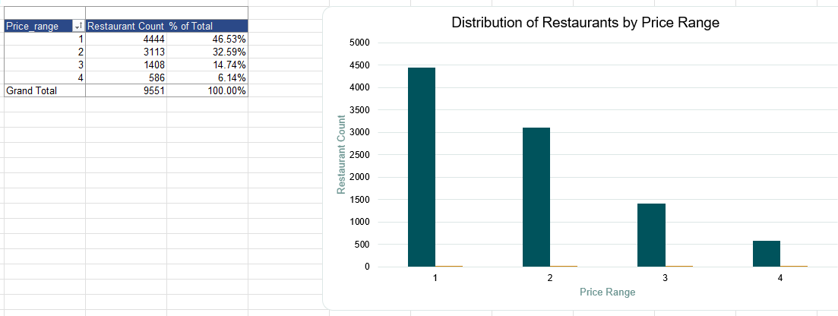
- Description:
A pivot table and bar chart showing the count and percentage of restaurants in each of the 4 price ranges. The chart clearly shows a bottom-heavy distribution with most restaurants in lower price ranges.

Insights:
• The market is heavily bottom-weighted:
– Price Range 1: 4,444 restaurants (46.53%)
– Price Range 2: 3,113 restaurants (32.59%)
– Price Range 3: 1,408 restaurants (14.74%)
– Price Range 4: 586 restaurants (6.14%)
– Grand Total: 9,551 restaurants (100%)
• Nearly 80% of all restaurants fall in the two lowest price ranges.
• The premium segment (Range 3 + Range 4) accounts for only about 21% of the market.
• Price Range 4 has the least competition with just 586 restaurants (6.14%).

Recommendations:
• The premium segment (Price Range 3 and 4) is significantly less crowded and offers higher ratings, making it an attractive market gap to exploit.
• Position new restaurants in Range 3 or 4 to face less competition while also benefiting from the positive price-rating correlation identified earlier.
• Avoid oversaturated Range 1 (nearly half the market) unless targeting a specific volume-based strategy.
• The 6.14% share of Range 4 represents a premium niche with high potential for differentiation and profitability.

Question 10: Explain your approach in brief for suggesting countries/cities in order to open new restaurants, if the objective and subjective questions would have not been given to assist you. [you have to give bullet pointers in order to answer this question]

Solution:

Approach:
If the objective and subjective questions were not given, my approach for suggesting countries/cities to open new restaurants would follow these steps:
• Step 1 – Data Collection & Cleaning: Gather the complete dataset, clean inconsistencies, handle missing values, and standardize formats.
• Step 2 – Market Size Analysis: Count the number of existing restaurants per country/city to identify markets with low competition.
• Step 3 – Rating Analysis: Calculate average ratings per country/city to find markets where customers are generally satisfied (high ratings mean customers appreciate dining out).
• Step 4 – Customer Engagement: Analyze average votes per restaurant to understand how actively customers engage with restaurants in each market.
• Step 5 – Cost Analysis: Study the average cost for two in each market to understand pricing expectations and plan financial budgets.
• Step 6 – Service Feature Analysis: Check the impact of table booking and online delivery on ratings to decide which services to offer.
• Step 7 – Cuisine Analysis: Identify which cuisines perform best in terms of ratings to decide the menu focus.
• Step 8 – Competitor Analysis: Identify the biggest competitors and weak players in target markets.
• Step 9 – Build Interactive Dashboard: Create a dashboard with KPIs, filters, and charts to enable continuous monitoring and data-driven decision-making.
• Step 10 – Final Recommendation: Combine all findings to shortlist the best countries and cities, and present the recommendations to management with supporting data visualizations.

Charts & Tables:
- Table / Chart Name:
Global Dashboard Overview
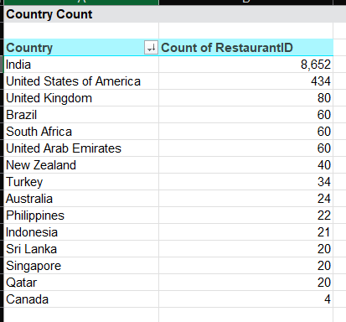
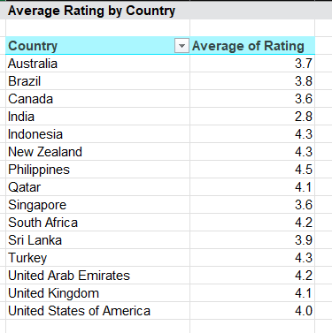
- Description:
Screenshots of the interactive Excel dashboard showing KPI cards (Total Restaurants: 9,551, Total Countries: 15, Average Rating: 2.89, Average Cost: 839, Total Votes: 1,498,645), pivot tables for Country Count, Average Rating by Country, Top 10 Cuisines, and Restaurants by Year.

Insights:
• By building a comprehensive dashboard, I was able to filter by country, track KPIs, and visualize trends over time.
• The dashboard provides a one-stop view of the entire dataset with interactive filters for country, price range, and year.
• Key KPIs at a glance: 9,551 total restaurants across 15 countries, average rating of 2.89, and total of 1,498,645 customer votes.
• The dashboard approach makes it easy to quickly identify patterns and opportunities without needing specific questions to guide the analysis.

Recommendations:
• Maintain an interactive data dashboard for continuous monitoring of restaurant performance across all markets.
• Key analytical steps to follow:
– Aggregate global data to find high-rating, low-competition zones.
– Analyze service features (Delivery/Booking) to optimize operations.
– Monitor price-to-rating correlations to maximize profitability.
– Track year-over-year trends to identify growing vs. declining markets.
• Update the dashboard regularly as new data comes in to keep recommendations current.
• Use the dashboard for quarterly business reviews and strategic planning sessions.

Evaluator Feedback Updates
Level 3 – Spreadsheet Basic Functionalities (Conditional Formatting)
As per the evaluator feedback, the "Raw Data" sheet has been updated with row-level conditional formatting that highlights entire rows based on the following key factors:
• Price Range = 4 (Premium): Highlighted in Light Purple (#E8D5E8). Formula: =$P2=4
• Rating ≥ 4.0 (High Rated): Highlighted in Light Green (#C6EFCE). Formula: =$S2>=4
• Average Cost for Two > 5,000 (Very Expensive): Highlighted in Light Orange (#FCE4D6). Formula: =$R2>5000
• Count of Restaurants ≥ 100 per Country (High Density, excluding India): Highlighted in Light Blue (#D6E4F0). Formula: =AND(COUNTIF($U:$U,$U2)>=100,$U2<>"India"). This highlights rows where the restaurant's country has 100 or more listed restaurants, excluding India (8,652 restaurants) which would overwhelm the visualization.
These rules apply to the entire data range ($A$2:$V$9552) on the Raw Data sheet, highlighting complete rows for easy identification.
Objective Question 11 – Recommended Countries Conditional Formatting
As per the original project requirement (Objective Question 11), an additional conditional formatting rule has been applied to highlight entire rows of restaurants located in the countries suggested for opening new restaurants:
• Recommended Countries: Canada, Qatar, Singapore, Sri Lanka, Indonesia, Philippines
• Highlighted in Light Yellow (#FFF2CC) with Dark Gold font.
• Formula: =OR($U2="Canada",$U2="Qatar",$U2="Singapore",$U2="Sri Lanka",$U2="Indonesia",$U2="Philippines")
This rule applies to the entire data range ($A$2:$V$9552) on the Raw Data sheet.
Level 6 – Data Summarization & Visualization (Dashboard Data Labels)
As per the evaluator feedback, appropriate data labels have been added to all charts on the "Dashboard" sheet to improve readability and ensure chart values are directly visible. For bar/line charts, value labels are shown. For pie/doughnut charts, percentage labels with category names are displayed.
Both Year-wise and Country slicers are present on the Dashboard and connected to the appropriate Pivot Tables and charts for interactive filtering.

