Supermarket Sales Analysis
Data Analytics Project

__________________________________________________

Prepared by: Manthan
September 2026

Table of Contents
1. Problem Statement
2. Dataset Description
3. Methodology / Steps Used for Analysis
4. Analysis Results
4.1 Product Analysis
4.2 Branch & City Analysis
4.3 Category Analysis
4.4 Payment Method Analysis
4.5 Customer Type Analysis
4.6 Gender Analysis
4.7 Rating Analysis
4.8 Monthly Trend Analysis
4.9 Correlation Analysis
5. Key Findings Summary
6. Business Recommendations
7. Conclusion

1. Problem Statement
The aim of this project is to analyze supermarket sales data and extract useful information about products, branches, categories, customers, payment methods, and customer ratings. We use Exploratory Data Analysis (EDA) to turn the raw sales records into findings the supermarket can act on, from inventory planning to customer satisfaction.

2. Dataset Description
The dataset contains 500 sales transactions from a supermarket chain operating across 4 branches in Indian cities. The data spans from January 2026 to July 2026.

Dataset Summary
Property | Value
Total Records | 500
Total Columns | 13
Date Range | January 2026 - July 2026
Branches | 4 (A-Jaipur, B-Delhi, C-Mumbai, D-Bengaluru)
Products | 20 unique products
Categories | 8 product categories
Missing Values | 0 (No missing data)
Duplicate Rows | 0

Column Descriptions
Column | Data Type | Description
Invoice ID | String | Unique transaction identifier
Date | DateTime | Transaction date
Branch | String | Branch code (A, B, C, D)
City | String | City name
Customer Type | String | Member or Normal
Gender | String | Male or Female
Product | String | Product name
Category | String | Product category
Quantity | Integer | Quantity purchased (1-10)
Unit Price | Float | Price per unit in INR
Payment | String | Payment method
Rating | Float | Customer rating (3.0-5.0)
Sales | Float | Total sale amount in INR

3. Methodology / Steps Used for Analysis

Step 1: Data Collection
Loaded the dataset from the Excel file (SUPER MARKET DATA.xlsx) using Python pandas library.

Step 2: Data Cleaning
Checked the data for missing values, duplicate rows, and incorrect data types. Verified that Sales = Quantity x Unit Price for all rows.

Step 3: Feature Engineering
Added derived columns — Month, Month_Name, and Day_of_Week — for time-based analysis.

Step 4: Grouping & Summarization
Grouped and summarized data using totals, counts, and averages across multiple dimensions: products, branches, categories, payment methods, customer types, and gender.

Step 5: Visualization
Created 12 professional charts using Matplotlib and Seaborn to compare and visualize the results clearly.

Step 6: Insights & Recommendations
Used the analysis results to derive actionable business recommendations for the supermarket.

4. Analysis Results

4.1 Product Analysis
The product analysis reveals which products generate the most and least revenue for the supermarket.

Top 5 Products by Total Sales
Rank | Product | Total Sales (INR)
1 | Cheese | 27,906.30
2 | Coffee | 27,694.87
3 | Shampoo | 27,497.48
4 | Cooking Oil | 21,525.06
5 | Tea | 17,681.59

Bottom 3 Products by Total Sales
Rank | Product | Total Sales (INR)
18 | Potato | 5,233.54
19 | Bread | 4,776.85
20 | Biscuits | 3,908.87

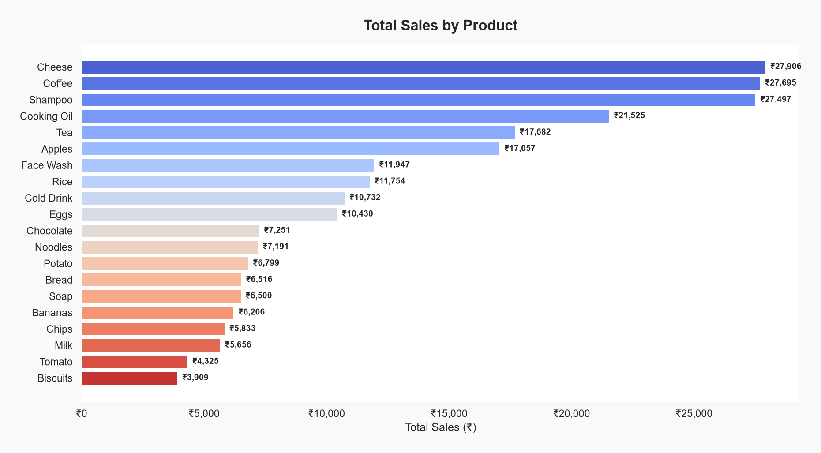
Figure 1: Total Sales by Product

4.2 Branch & City Analysis
Branch C located in Mumbai is the top-performing branch with the highest total sales and transaction count.
Branch | City | Total Sales (INR) | Avg Transaction (INR) | Transactions
C | Mumbai | 72,469.45 | 506.78 | 143
B | Delhi | 64,116.26 | 482.08 | 133
D | Bengaluru | 55,468.29 | 466.12 | 119
A | Jaipur | 52,357.08 | 498.64 | 105

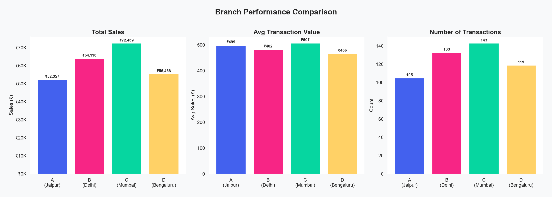
Figure 2: Branch Performance Comparison

4.3 Category Analysis
Beverages is the highest-selling category, followed by Personal Care and Dairy.
Category | Total Sales (INR) | Avg Transaction (INR) | Transactions
Beverages | 56,108.24 | 684.25 | 82
Personal Care | 45,943.96 | 629.37 | 73
Dairy | 43,992.00 | 646.94 | 68
Grocery | 40,470.47 | 493.54 | 82
Fruits | 23,263.17 | 528.71 | 44
Snacks | 16,992.97 | 226.57 | 75
Vegetables | 11,124.17 | 231.75 | 48
Bakery | 6,516.10 | 232.72 | 28

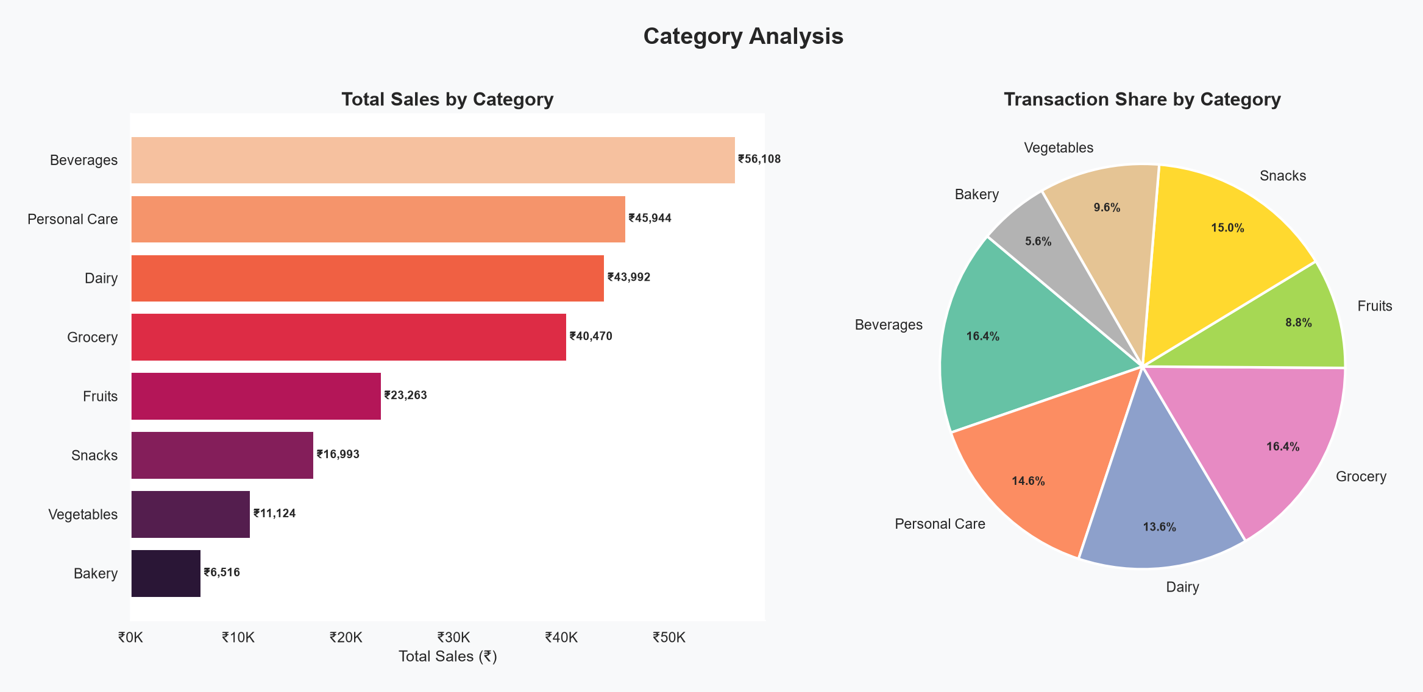
Figure 3: Category Analysis (Sales & Transaction Share)

4.4 Payment Method Analysis
UPI is the most popular payment method with 127 transactions, followed by Net Banking (126), Card (125), and Cash (122). UPI also leads in total sales.
Payment Method | Transactions | Total Sales (INR) | Avg Transaction (INR)
UPI | 127 | 67,910.33 | 534.73
Net Banking | 126 | 65,194.93 | 517.42
Card | 125 | 57,265.64 | 458.13
Cash | 122 | 54,040.18 | 442.95

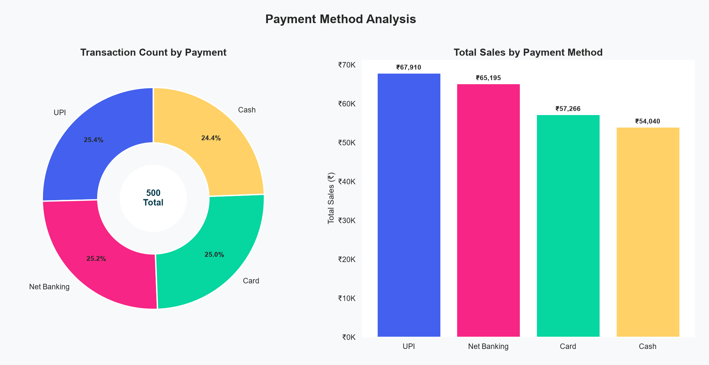
Figure 4: Payment Method Analysis

4.5 Customer Type Analysis
Members account for more transactions (296) than Normal customers (204), but Normal customers have a slightly higher average transaction value (INR 497.07 vs INR 483.14).
Customer Type | Transactions | Total Sales (INR) | Avg Transaction (INR)
Member | 296 | 1,43,009.30 | 483.14
Normal | 204 | 1,01,401.78 | 497.07

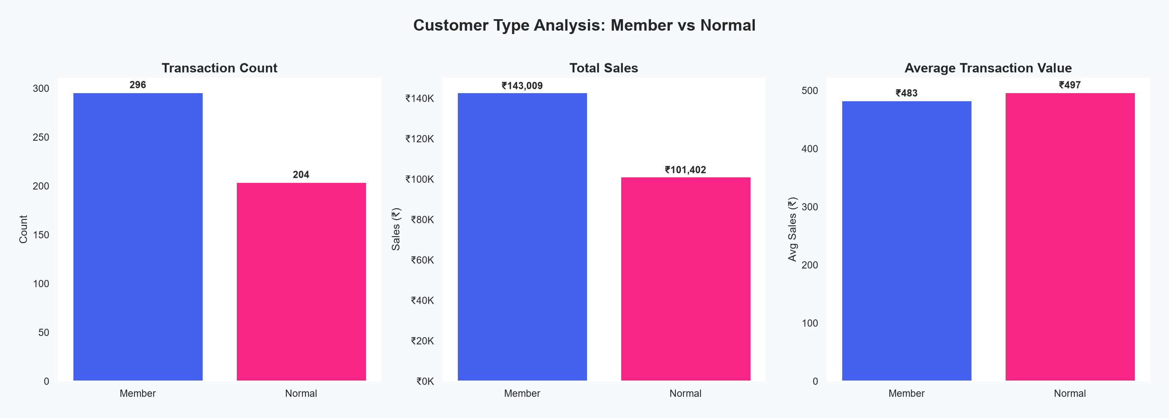
Figure 5: Customer Type Comparison

4.6 Gender Analysis
Sales are fairly balanced across genders. Female customers contributed INR 1,23,954.12 across 255 transactions, while Male customers contributed INR 1,20,456.96 across 245 transactions.

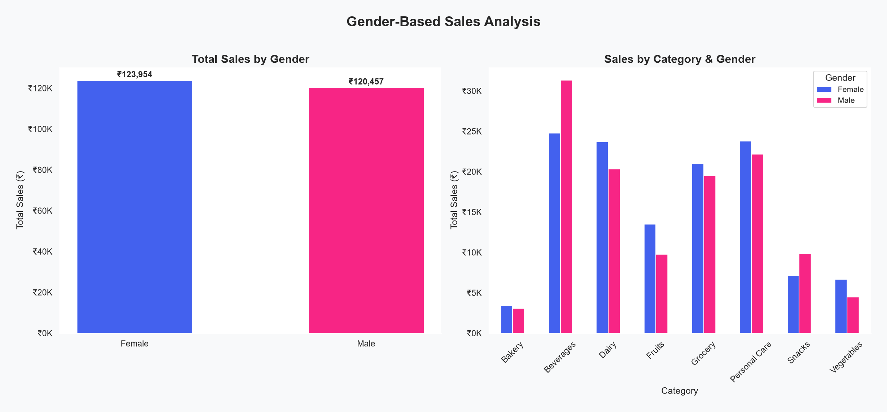
Figure 6: Gender-Based Sales Analysis

4.7 Rating Analysis
The average customer rating is 3.99 out of 5.0. Branch D (Bengaluru) has the highest average rating of 4.09, while Branch A (Jaipur) has the lowest at 3.84. Among categories, Bakery has the highest average rating (4.24).

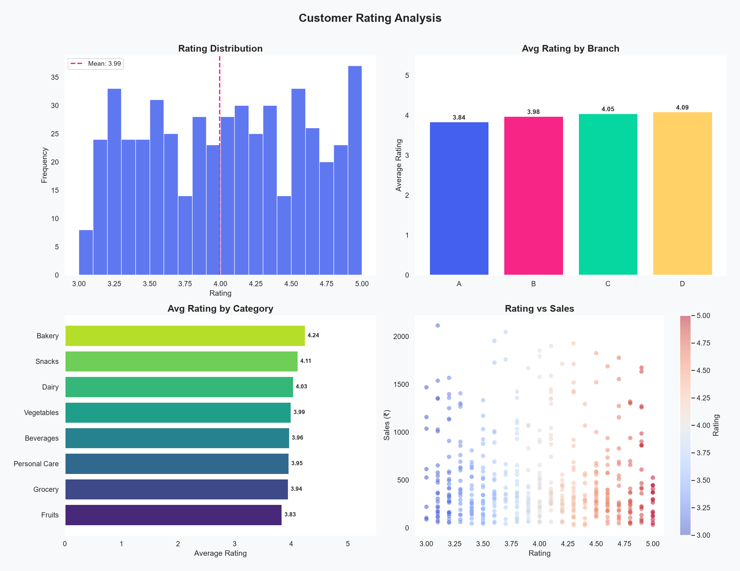
Figure 7: Customer Rating Analysis

4.8 Monthly Trend Analysis
April 2026 was the highest-performing month with total sales of INR 52,569.77 across 90 transactions. February had the lowest sales among the full months. July data is partial (only 7 transactions), as the data collection period ends in early July.

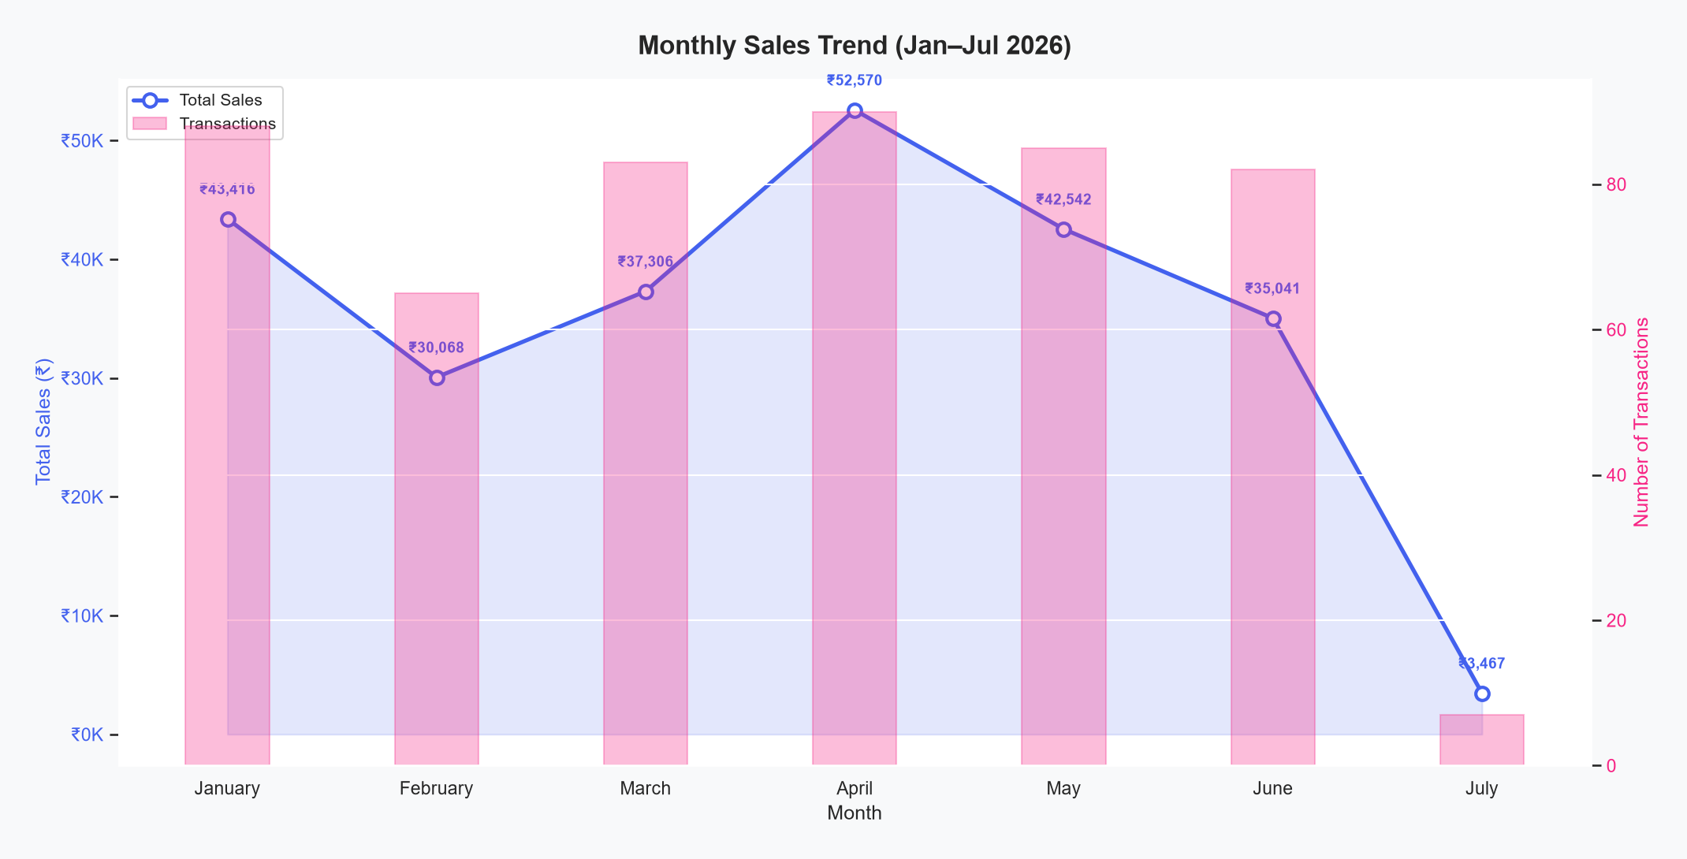
Figure 8: Monthly Sales Trend (Jan-Jul 2026)

4.9 Correlation Analysis
The correlation analysis shows that Sales has a strong positive correlation with both Unit Price (0.722) and Quantity (0.573), which is expected since Sales = Quantity x Unit Price. Rating has a very weak negative correlation with Sales (-0.047), indicating that ratings are independent of purchase amounts.

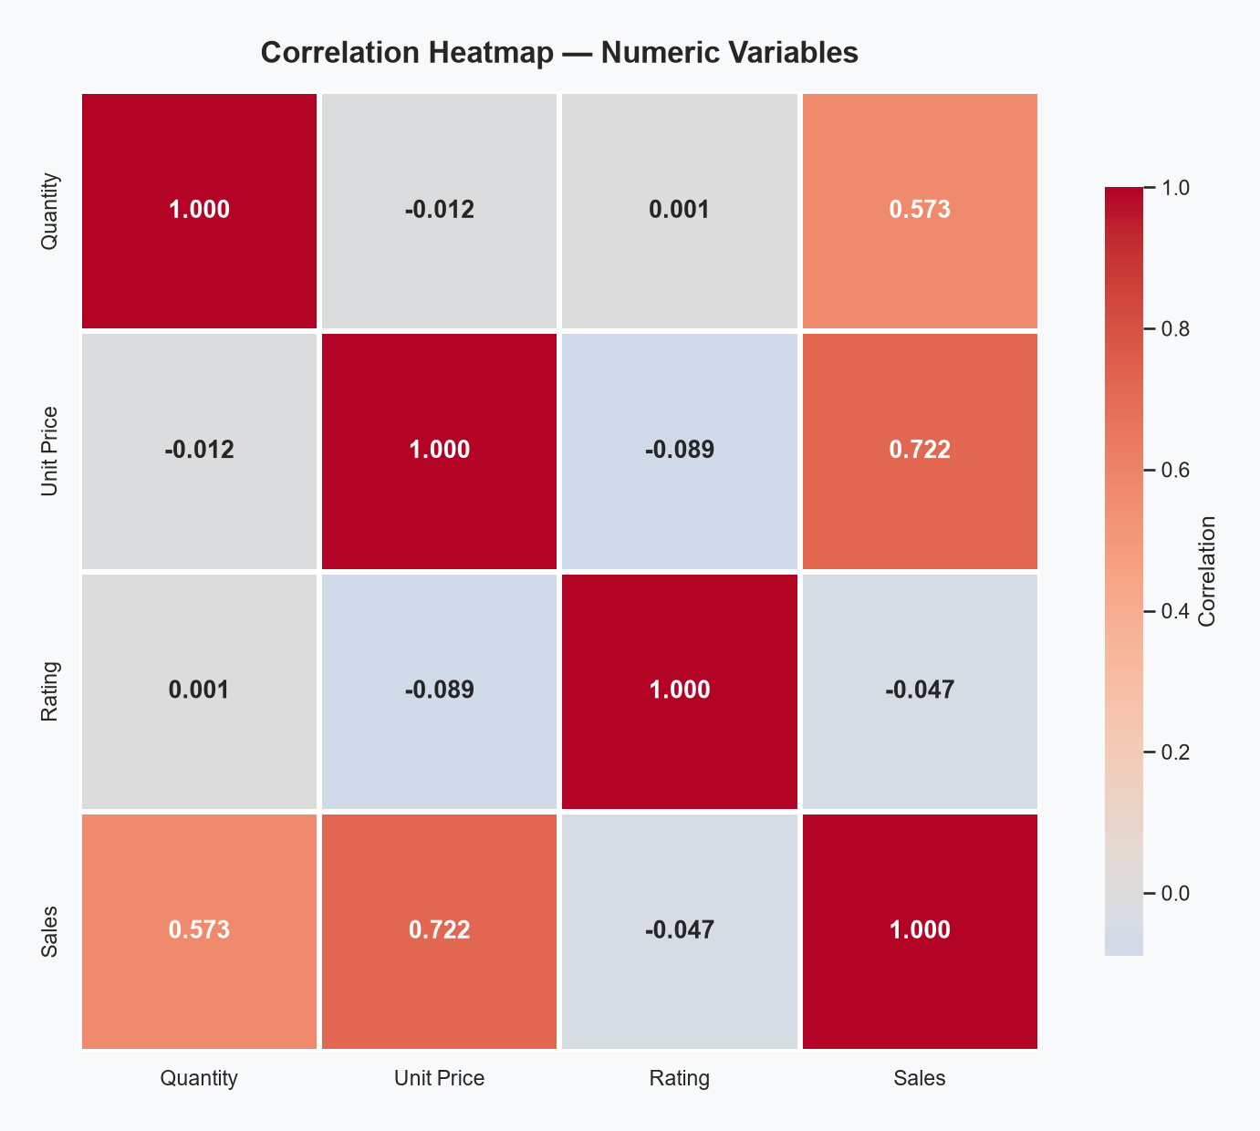
Figure 9: Correlation Heatmap

5. Key Findings Summary
Finding | Detail
Highest-Selling Product | Cheese generated the highest total sales of INR 27,906.30.
Best Performing Branch | Branch C (Mumbai) performed best with total sales of INR 72,469.45 across 143 transactions.
Top Category | Beverages had the highest total sales of INR 56,108.24 across 82 transactions.
Most Popular Payment | UPI was the most used payment method with 127 transactions, also generating the highest total sales.
Member vs Normal | Normal customers have a slightly higher average transaction (INR 497.07) compared to Members (INR 483.14).
Average Rating | The average customer rating was 3.99 out of 5.0, indicating generally positive satisfaction.
Monthly Peak | April 2026 was the peak sales month with INR 52,569.77 in total sales.
Gender Balance | Sales are nearly equally distributed between Male and Female customers.

6. Business Recommendations

1. Stock Optimization
Increase stock for high-selling products such as Cheese, Coffee, and Shampoo. Prioritize inventory for the top categories as well, starting with Beverages, followed by Personal Care and Dairy.

2. Branch Strategy
Study Branch C (Mumbai) to understand why it outperforms other branches. Replicate successful practices across branches A, B, and D.

3. Payment Infrastructure
Continue investing in UPI payment infrastructure as it is the most popular payment method. Ensure smooth digital payment processing across all branches.

4. Customer Loyalty Programs
Since Normal customers spend slightly more per transaction than Members, redesign membership benefits and loyalty rewards to incentivize higher spending among Members.

5. Rating Improvement
The average rating of 3.99/5 indicates room for improvement. Focus on customer service training, feedback mechanisms, and product quality to push ratings above 4.5.

6. Seasonal Planning
Use monthly trend data to plan promotions during low-sales months (February, March) and ensure sufficient inventory during peak months (April).

7. Conclusion
This project used Exploratory Data Analysis to turn supermarket sales data into a set of simple findings the business can act on. We analyzed 500 transactions across products, branches, categories, payment methods, customer types, and ratings, and the patterns that came out are clear enough to inform business decisions.
The analysis reveals that Cheese is the top-selling product, Branch C (Mumbai) is the strongest performer, Beverages dominate category sales, and UPI is the preferred payment method. Customer ratings average 3.99/5, showing general satisfaction with room for improvement.
These findings give the supermarket a practical starting point for planning inventory, learning from its strongest branch, and improving how it engages customers.

--- End of Report ---

