PROJECT DOCUMENTATION
Global Fuel Price Intelligence
Structural trends, volatility risks, and predictive signals across 56 years of energy markets (1970–2026).
2,700  Monthly Data Points | 4  Global Regions | 26  Geopolitical Events | 12  Calculated Variables | $143.18  All-Time Peak (2008) | 2,252%  56-Year Growth

Project Name | Global Fuel Price Intelligence Dashboard
Tool Used | Microsoft Excel — Advanced Analytics + Dashboard
Data Scope | January 1970 to December 2026 (2,700 rows, 33 columns)
Regions Covered | Asia, Europe, Middle East, United States
Analysis Type | Time-series, volatility, trend, geopolitical event impact
Document Type | Project Documentation — Portfolio Submission

1. Project Overview
This document provides a structured account of the Global Fuel Price Intelligence project, an end-to-end data analytics case study built in Microsoft Excel. The project analyses 56 consecutive years of global fuel price data across crude oil, petrol, and diesel, covering four major geographic regions. It transforms raw time-series data into an interactive Excel dashboard, a series of analytical pivot tables, and a 14-slide presentation identifying structural patterns, volatility regimes, regional policy divergence, and predictive leading indicators.
The work is intended to demonstrate competency across the full data analyst workflow: data ingestion and cleaning, calculated variable engineering, analytical modelling, visualisation, and executive communication.

1.1 Objectives
- Identify structural price trends across six decades of global energy markets
- Quantify the impact of 26 geopolitical events on crude oil prices
- Engineer 12 calculated analytics columns to enrich the raw dataset
- Build an interactive Excel dashboard with 6 charts, 7 KPI cards, and 8 pivot tables
- Develop a predictive leading indicator (Demand/Supply Ratio) for crude price movements
- Produce analyst-grade presentation output suitable for executive audiences

1.2 Dataset Summary
Attribute | Detail
Total rows | 2,700 monthly records
Time range | January 1970 to December 2026
Original columns | 21 (Date, Year, Month, Decade, Region, Crude/Petrol/Diesel prices, Demand & Supply indices, Price Regime, Event Name, Event Type, Growth %, Spread, etc.)
Derived columns | 12 engineered analytics columns (V through AG)
Regions | Asia, Europe, Middle East, United States
Price regimes | Low, Moderate, High, Very High, Crisis
Named events | 26 geopolitical events mapped to months

2. Excel Dashboard Architecture
The Excel workbook is structured across five visible sheets: DASHBOARD, KEY_INSIGHTS, PIVOTS, DATASET, and FORMULA_GUIDE. A sixth sheet (_ChartData) is hidden and serves as the data feed for all dashboard charts. The DASHBOARD sheet functions as the single-screen analytical interface, designed to update dynamically when pivot slicers are applied.

2.1 KPI Card Strip
Seven KPI metric cards are positioned at the top of the dashboard. Each card displays a live-computed value fed by GETPIVOTDATA formulas, a descriptive label, and a delta indicator where applicable. The first card (Current Avg Crude) includes a year-over-year delta arrow that changes colour based on direction.
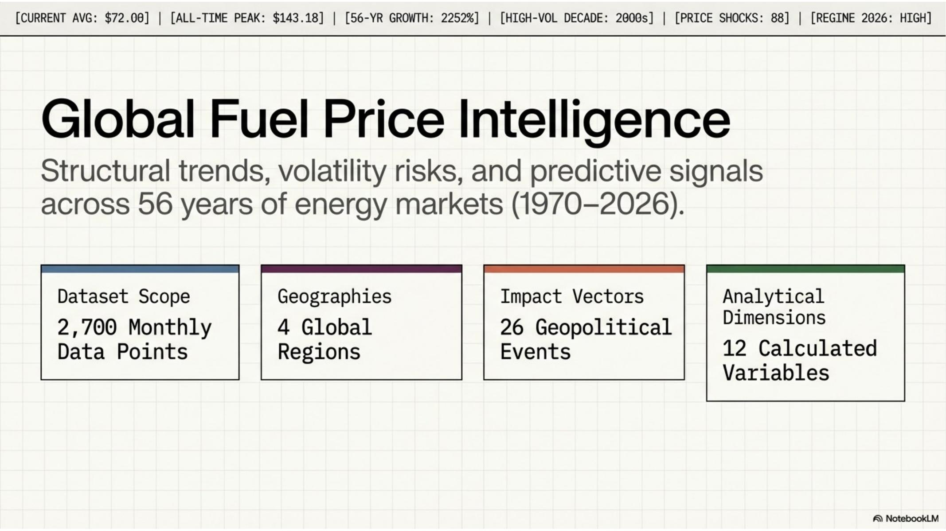
Figure 1 — Dashboard cover slide showing the four scope dimensions and persistent KPI header

2.2 Chart Zone Layout
The dashboard is divided into three chart rows, each containing one wide left-panel chart and one narrower right-panel chart. This layout creates a visual hierarchy that leads the reader from macro (56-year timeline) to structural (decade comparison) to comparative (regional and regime analyses).
Zone | Left Chart | Right Chart | Key Insight
Row 1 | 56-Year Crude Timeline + Volatility | Decade Average Comparison (Bar) | 2,252% nominal growth; 2008 peak $143.18
Row 2 | Regional Price Divergence (4-line) | Price Regime Distribution (Stacked %) | $0.953/litre Europe-MiddleEast gap
Row 3 | Geopolitical Event Impact (H-Bar) | Demand-Supply Leading Indicator | Economic crises outprice wars on average

3. Key Analytical Findings
The following findings are derived directly from the dataset and surfaced through the dashboard, pivot tables, and presentation. Each finding is supported by a specific quantitative data point extracted from the analysis.

3.1 56-Year Price Timeline
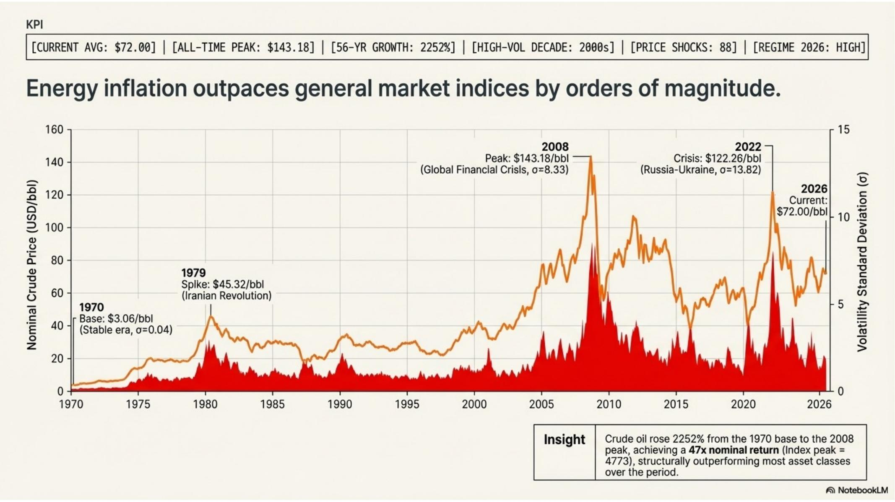
Figure 2 — 56-year crude oil price timeline (orange) with volatility standard deviation overlay (red)
The full-history timeline reveals three distinct structural eras. The pre-1980 period was characterised by sub-$20 pricing with minimal volatility (σ = 0.04 in 1970). The 1980–1999 period represented a transitional phase with moderate prices ($15–$35) and occasional spikes. The post-2000 era constitutes a permanently elevated pricing regime with sustained high prices and recurring volatility clusters.
Key insight: Crude oil rose 2,252% from the 1970 base to the 2008 peak, achieving a 47x nominal return. This structurally outperformed most conventional asset classes over the same period.

3.2 Regime Shift — Permanent Migration to High Volatility
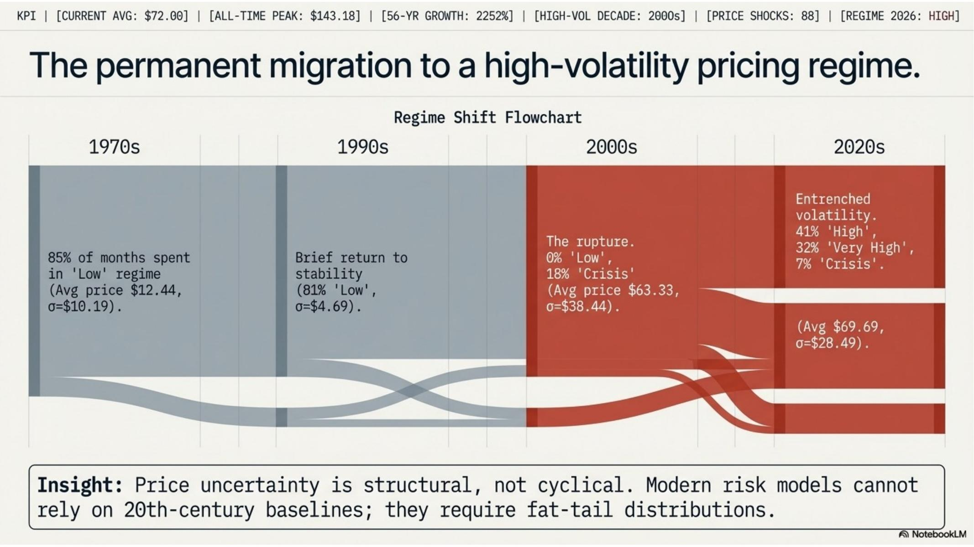
Figure 3 — Regime shift Sankey diagram showing the permanent migration from Low to High/Crisis price regimes
Decade | Dominant Regime | Avg Price / Volatility σ
1970s | Low (85% of months) | $12.44 / σ $10.19
1980s | Low/Moderate | $25.00 / σ $12.61
1990s | Low (81% of months) | $20.23 / σ $4.69
2000s | High/Very High/Crisis | $63.33 / σ $38.44
2010s | High/Very High | $73.39 / σ $24.11
2020s | High/Very High/Crisis | $69.69 / σ $28.49

Key insight: Price uncertainty is structural, not cyclical. Modern risk models cannot rely on 20th-century baselines and must use fat-tail distributions.

3.3 Regional Price Divergence
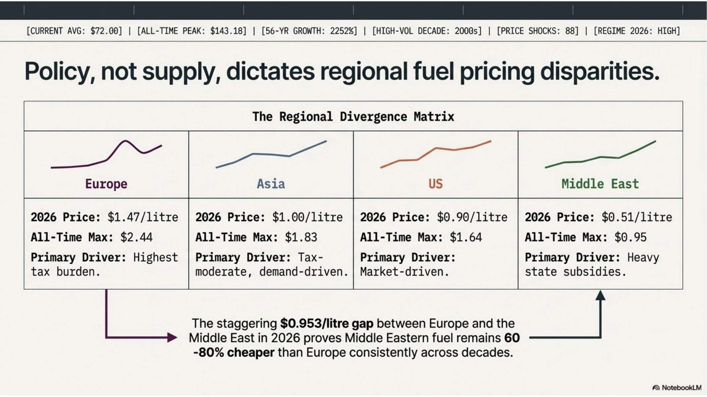
Figure 4 — Regional divergence matrix showing 2026 petrol prices and primary pricing drivers by region
The four regions tracked in this dataset exhibit fundamentally different pricing dynamics, entirely attributable to government policy rather than differences in underlying crude costs. All four regions share the same global crude price as a raw material input, yet consumer petrol prices diverge by nearly $1.00/litre.
Region | 2026 Avg Price | All-Time Max / Primary Driver
Europe | $1.47/litre | $2.44 — Highest tax burden
Asia | $1.00/litre | $1.83 — Tax-moderate, demand-driven
United States | $0.90/litre | $1.64 — Market-driven
Middle East | $0.51/litre | $0.95 — Heavy state subsidies

Key insight: The $0.953/litre gap between Europe and the Middle East in 2026 is a direct result of policy divergence. Middle Eastern fuel remains 60–80% cheaper than Europe consistently across every decade in the dataset.

3.4 Petrol Premium Analysis
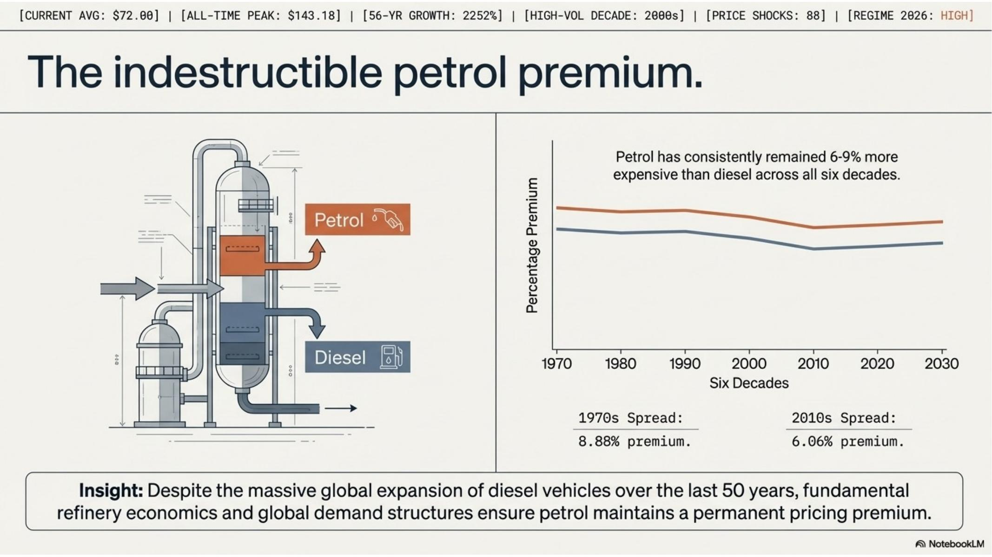
Figure 5 — Petrol vs diesel spread across six decades, demonstrating the indestructible petrol premium
Despite the global proliferation of diesel vehicles over the past 50 years, petrol has maintained a consistent price premium over diesel in every decade covered by this dataset. This premium is rooted in refinery economics and global demand structure, not consumer preference.
- 1970s petrol premium: 8.88% above diesel
- 2010s petrol premium: 6.06% above diesel (slight compression, but premium persisted)
- No decade in the dataset recorded diesel as more expensive than petrol at the global average level

3.5 Seasonal Pricing Patterns
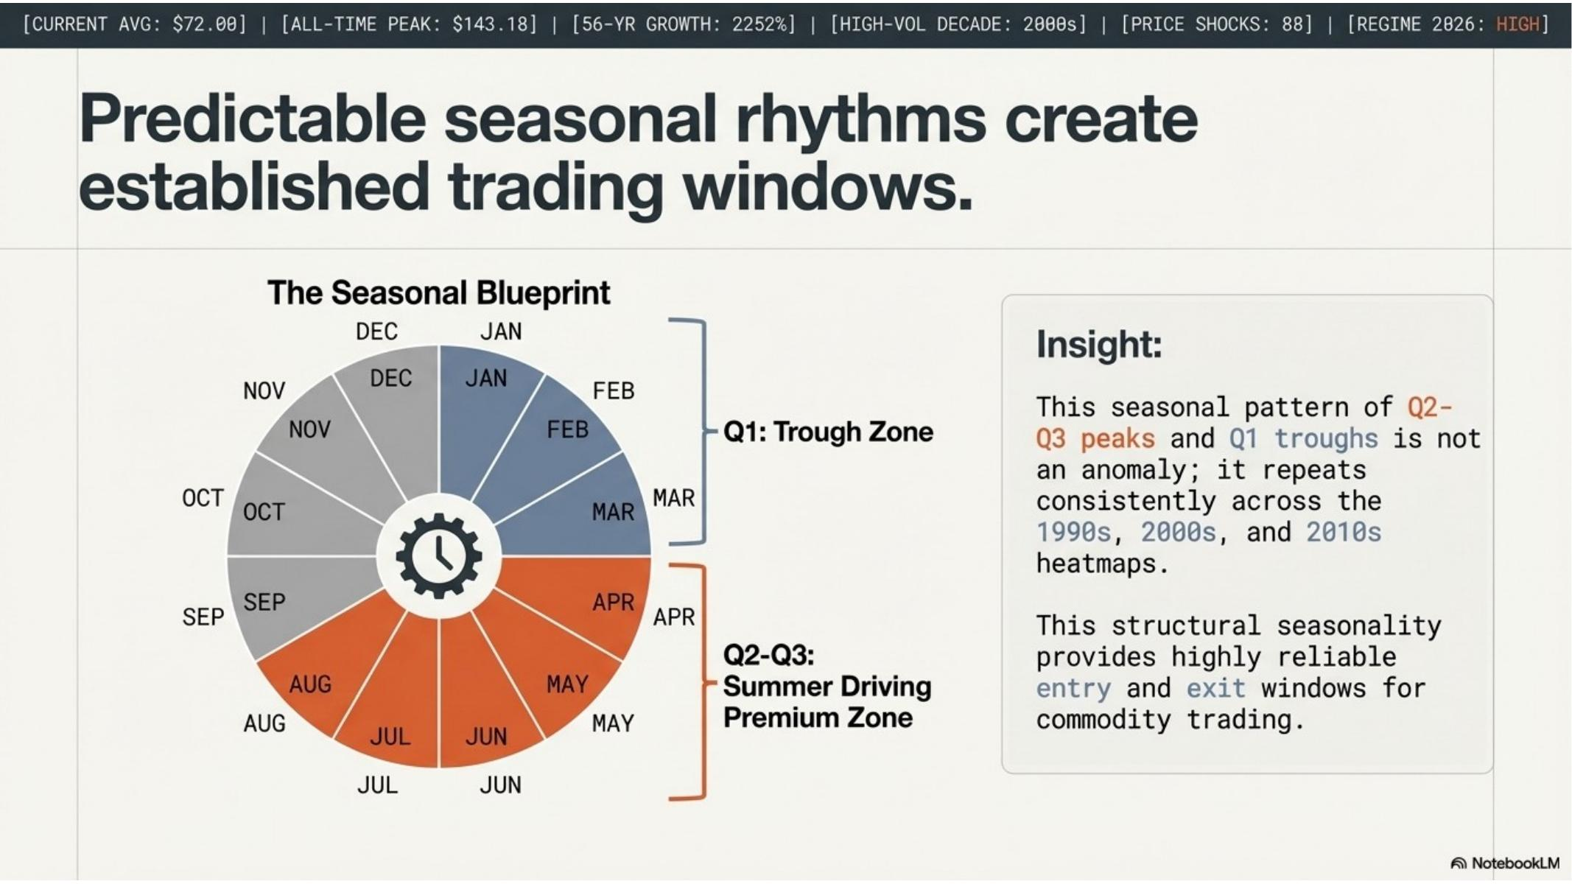
Figure 6 — The Seasonal Blueprint: circular calendar showing Q1 trough zone and Q2-Q3 summer driving premium zone
A consistent seasonal pattern is present across the 1990s, 2000s, and 2010s heatmaps. Crude oil prices reliably find their annual trough in Q1 (January–March) as winter heating demand subsides before summer driving season begins. Prices then build through Q2 and Q3, reflecting the northern hemisphere summer driving premium.
Key insight: This seasonality is not an anomaly — it is a structural feature of global energy demand. Q1 entry and Q3 exit represents a historically favoured window for energy cost procurement and commodity positioning.

3.6 Price Shock Analysis — 88 Months of Disruption
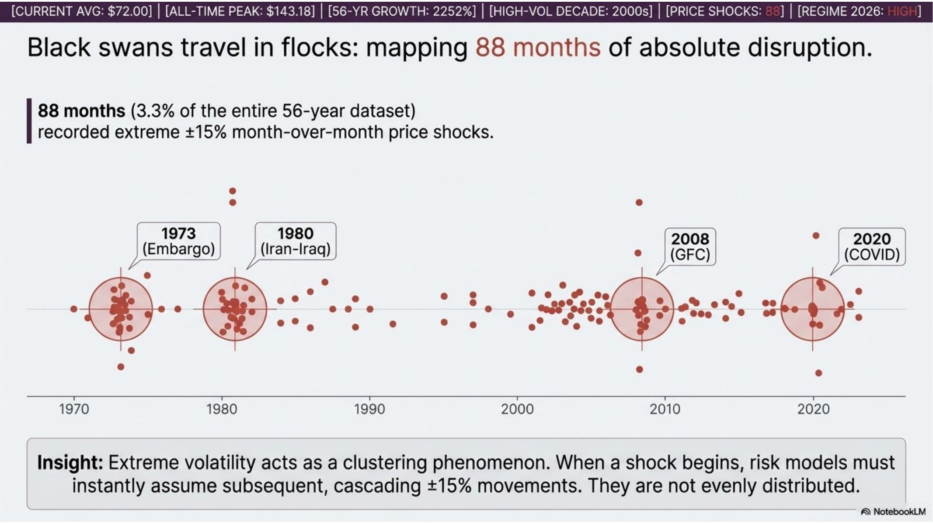
Figure 7 — Black swan clustering: scatter plot of 88 price shock months (±15% MoM crude moves) across 56 years
Price shocks — defined as months where crude oil moved by ±15% or more month-over-month — are not randomly distributed. Of the 2,700 months in the dataset, 88 (3.3%) recorded shock-level moves. These shocks cluster tightly around four nexus events: the 1973 OPEC Embargo, the 1980 Iran-Iraq War, the 2008 Global Financial Crisis, and the 2020 COVID-19 pandemic.
- 1973 cluster: OPEC Embargo — cascading monthly moves as markets discovered new price discovery dynamics
- 1980 cluster: Iran-Iraq War — 18+ months of consecutive shock-level volatility
- 2008 cluster: GFC — both the spike and the crash generated shock readings in the same 12-month window
- 2020 cluster: COVID — compressed shock cluster reflecting the unprecedented speed of demand collapse
Key insight: Extreme volatility acts as a clustering phenomenon. When a shock begins, risk models must assume subsequent cascading moves for the following 12 months. Shock months are not independent events.

4. Geopolitical Event Impact Analysis
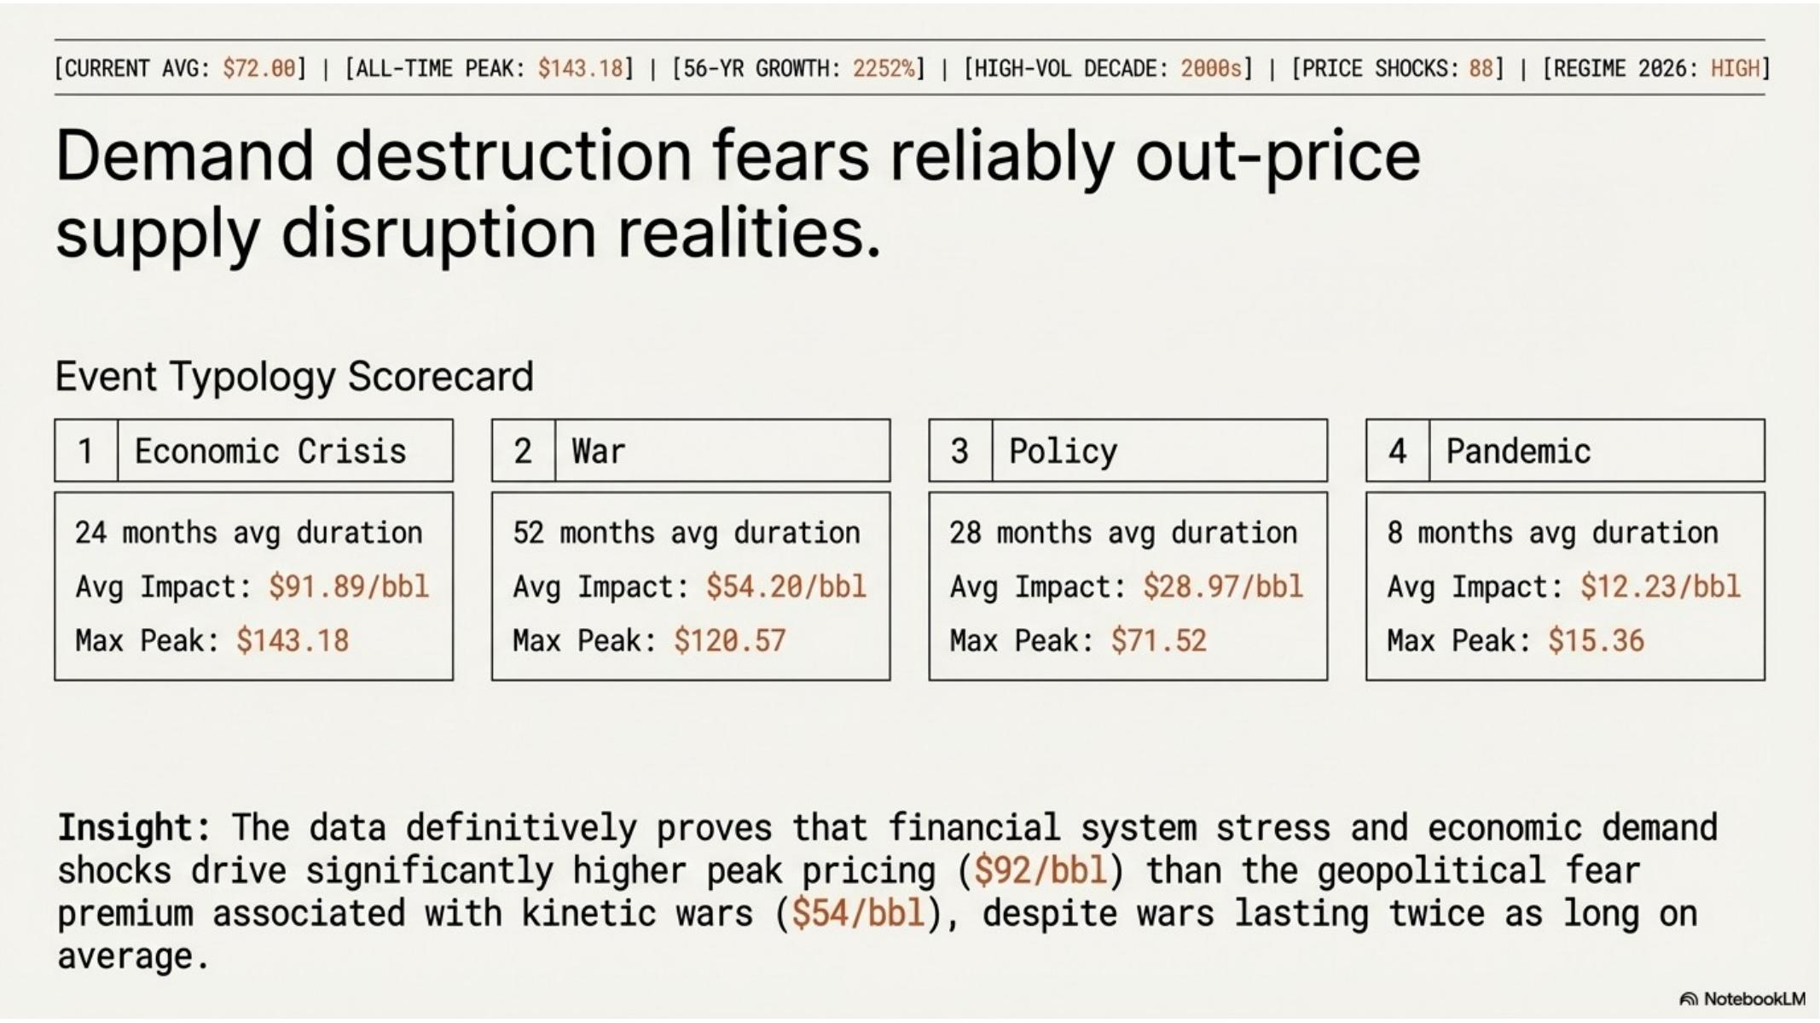
Figure 8 — Event typology scorecard: four event types ranked by average crude price impact
The dataset maps 26 named geopolitical events to specific months, enabling a direct quantitative comparison of how different categories of disruption affect crude oil pricing. The findings challenge the conventional assumption that wars are the primary driver of oil price spikes.

4.1 Event Typology Scorecard
#1  Economic Crisis  Avg duration: 24 months avg  Avg Impact: $91.89/bbl  Max Peak: $143.18 | #2  War  Avg duration: 52 months avg  Avg Impact: $54.20/bbl  Max Peak: $120.57 | #3  Policy  Avg duration: 28 months avg  Avg Impact: $28.97/bbl  Max Peak: $71.52 | #4  Pandemic  Avg duration: 8 months avg  Avg Impact: $12.23/bbl  Max Peak: $15.36

Key insight: Financial system stress and economic demand shocks drive significantly higher peak pricing ($92/bbl) than the geopolitical fear premium associated with kinetic wars ($54/bbl), despite wars lasting twice as long on average.

4.2 Volatility Ripple Effect
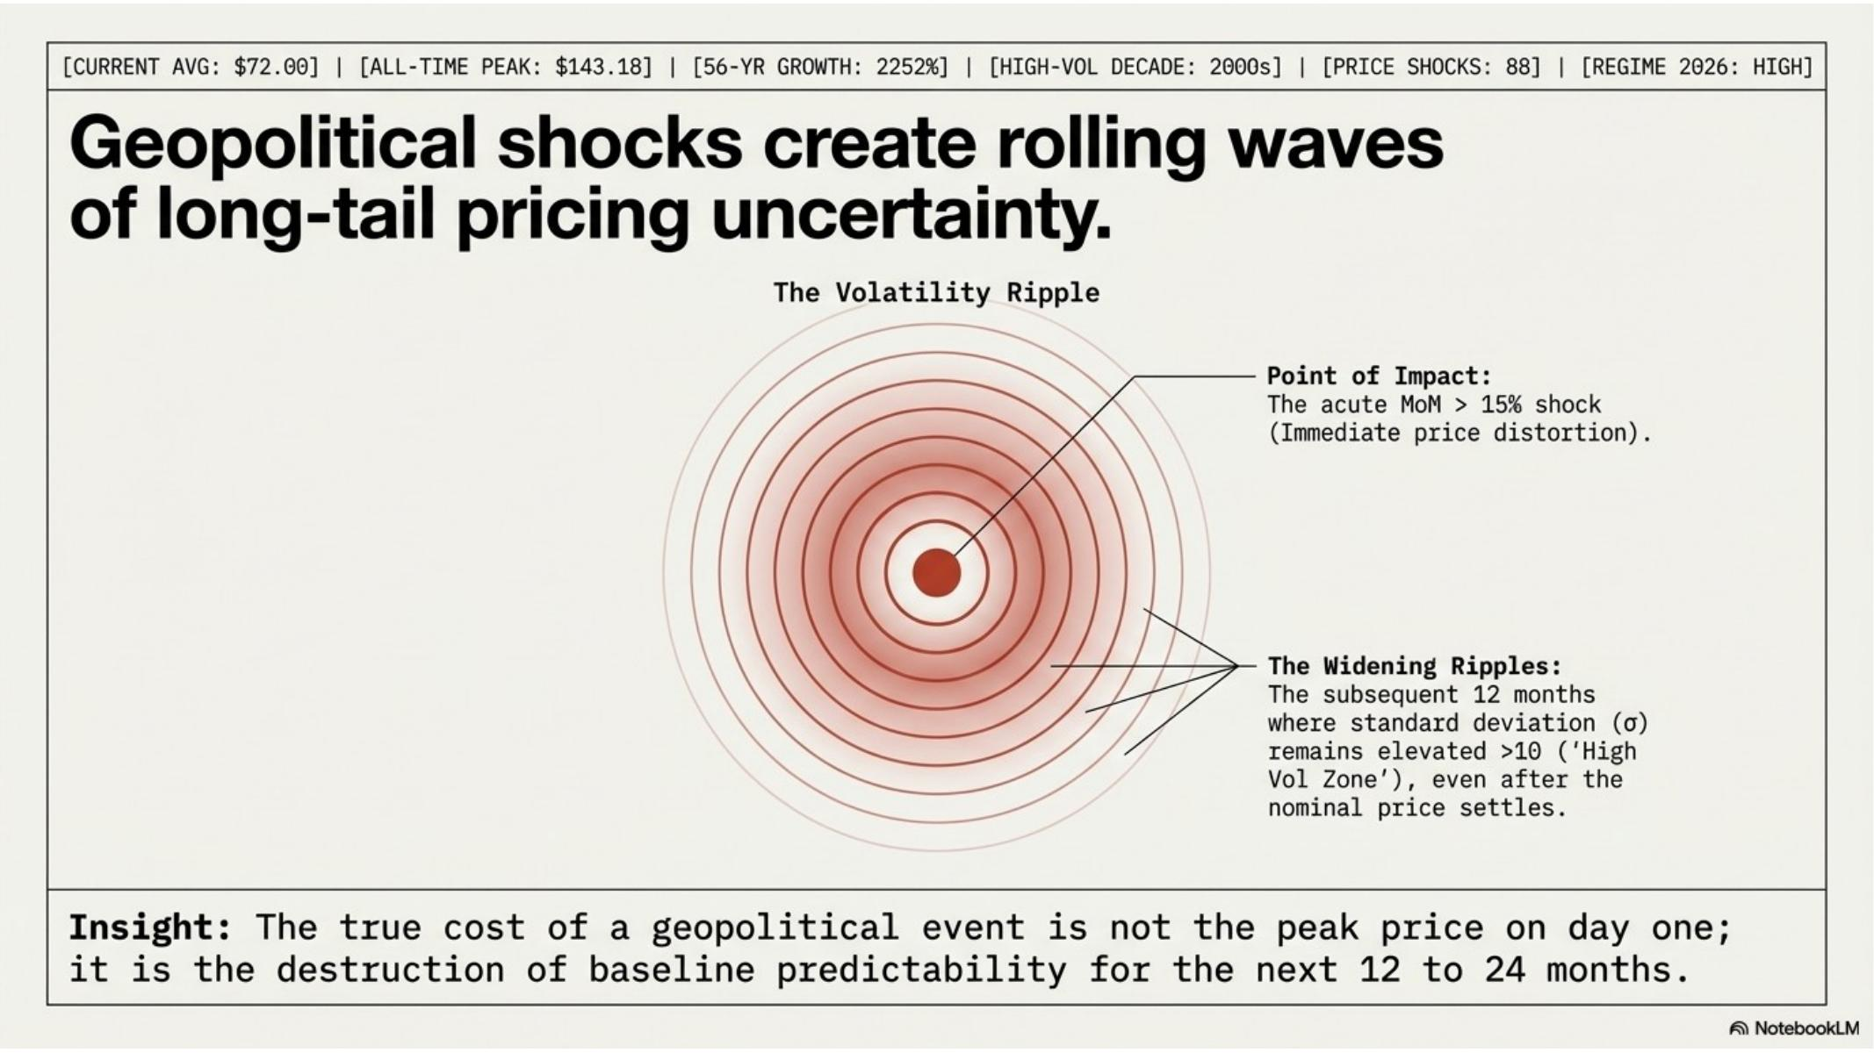
Figure 9 — Volatility ripple diagram: geopolitical shocks create 12-24 month periods of elevated pricing uncertainty
The true cost of a geopolitical event is not the price on day one. The lasting damage is the destruction of pricing predictability for the 12 to 24 months that follow. The Rolling_Vol_12M column (column W in the dataset) captures this effect: after a shock month, the 12-month rolling standard deviation remains elevated in the 'High Vol Zone' (σ > 10) even after the nominal price partially stabilises.

4.3 High-Regime Market Anatomy
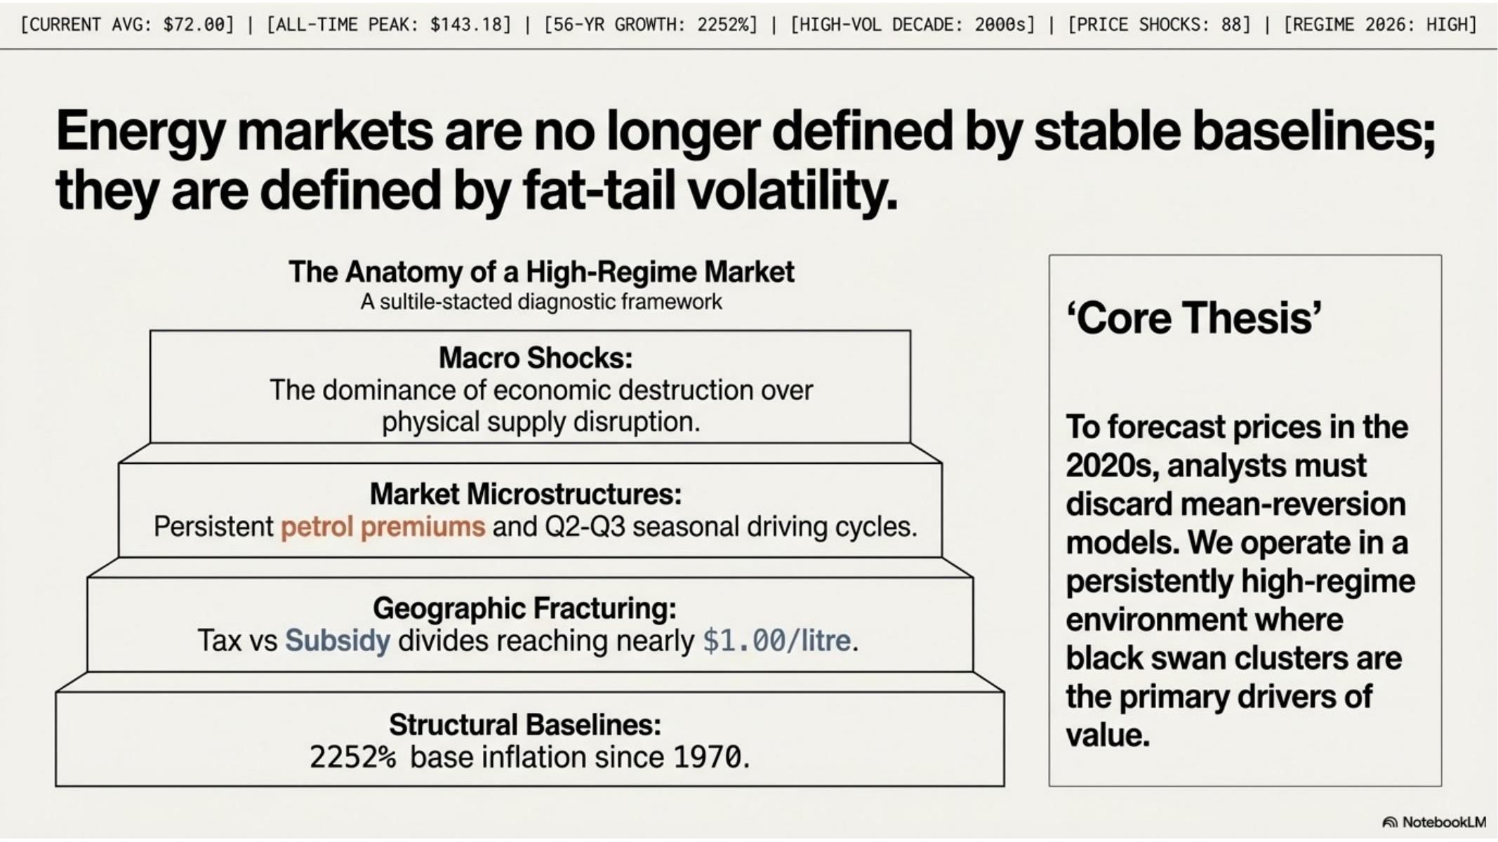
Figure 10 — Anatomy of a high-regime market: four-layer pyramid framework from structural baselines to macro shocks
The project synthesises its findings into a four-layer framework that describes how modern energy markets are structured:
- Layer 1 — Structural Baselines: 2,252% base inflation since 1970; energy must be modelled as a long-term compounder
- Layer 2 — Geographic Fracturing: tax vs subsidy divides reaching nearly $1.00/litre between Europe and the Middle East
- Layer 3 — Market Microstructures: persistent petrol premiums and Q2-Q3 seasonal driving cycles create predictable patterns
- Layer 4 — Macro Shocks: economic demand destruction dominates over physical supply disruption in price impact

5. Demand-Supply Leading Indicator
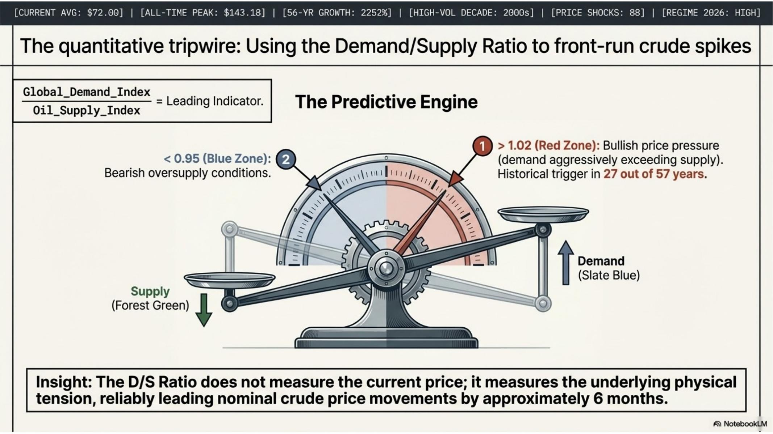
Figure 11 — The predictive engine: Demand/Supply Ratio scales diagram with bullish and bearish threshold zones
The Demand-Supply Ratio (DS_Ratio, column AC in the dataset) is calculated as Global_Demand_Index divided by Oil_Supply_Index. This metric functions as a leading indicator for crude price movements, with signal properties observable 6 months before price changes materialise.

5.1 Signal Interpretation
D/S Ratio Zone | Threshold | Implication
Red Zone (Bullish) | > 1.02 | Demand aggressively exceeds supply — price rise expected within 6 months
Neutral Zone | 0.95 to 1.02 | Balanced market — no directional signal
Blue Zone (Bearish) | < 0.95 | Oversupply conditions — price relief within 3-6 months

5.2 2008 Case Study — Signal Validation
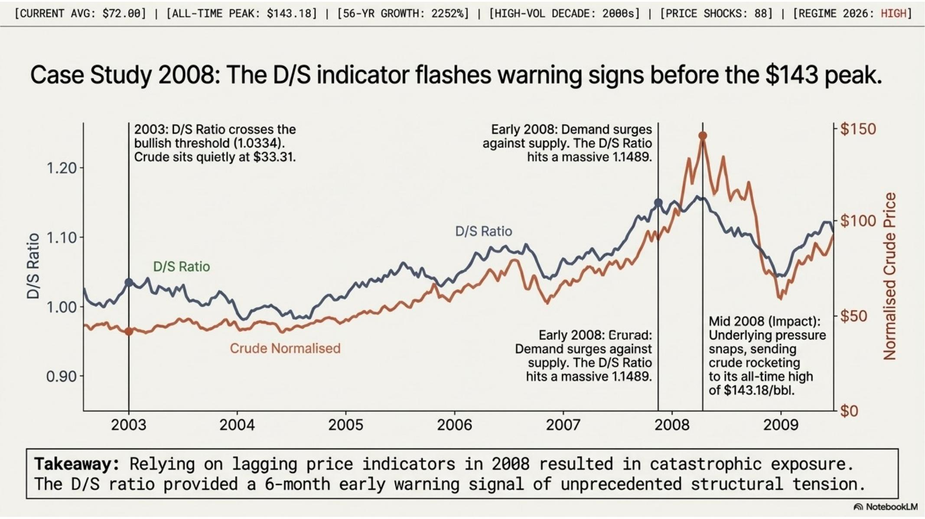
Figure 12 — 2008 case study: D/S Ratio crossed the bullish threshold in 2003, five years before crude hit $143.18/bbl
The 2003–2009 period provides the clearest validation of the D/S Ratio as a leading indicator. In 2003, the ratio crossed the 1.0334 bullish threshold while crude was trading at $33.31/bbl. Over the following five years, the ratio climbed continuously to its peak of 1.1489 in early 2008 — immediately preceding the all-time crude oil high of $143.18/bbl in July 2008.
Key insight: The D/S Ratio does not measure the current price. It measures underlying physical tension. Any sustained reading above 1.02 mandates immediate defensive posturing ahead of the approximate 6-month crude price lag.

5.3 COVID Stress Test — Policy Response Analysis
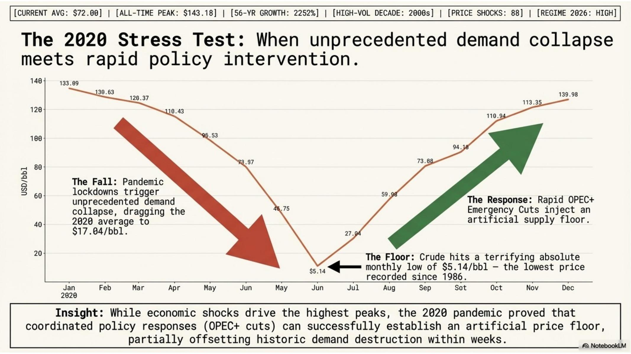
Figure 13 — 2020 stress test: the unprecedented demand collapse and OPEC+ policy intervention that established an artificial price floor
The 2020 pandemic year represents the most violent demand shock in the dataset. Crude fell from $133.89/bbl in January to a monthly low of $5.14/bbl in June — a 96% collapse in six months. The subsequent OPEC+ Emergency Cuts established an artificial supply floor that enabled near-complete price recovery by December 2020 ($139.98/bbl).
- The fall: pandemic lockdowns triggered unprecedented demand collapse, dragging the 2020 average to $17.04/bbl
- The floor: crude reached $5.14/bbl — the lowest monthly price recorded since 1986
- The response: OPEC+ Emergency Cuts injected a coordinated artificial supply floor
- The recovery: near-complete price recovery within six months of the trough

6. Calculated Analytics Columns
Twelve analytics columns (V through AG) were engineered from the raw dataset to enable the volatility, trend, segmentation, and leading indicator analyses described in this document. All columns are present in the DATASET sheet of the Excel workbook. The FORMULA_GUIDE sheet provides the exact Excel formula for each.
Column | Name | Excel Formula | Purpose
V | MoM_Change_% | =(F3-F2)/F2*100 | Month-over-month crude price change %
W | Rolling_Vol_12M | =STDEV(OFFSET(F3,-11,0,12,1)) | 12-month rolling standard deviation
X | YoY_Growth_% | =(F14-F2)/F2*100 | Year-over-year crude growth (same month, prior year)
Y | MA_3M_Crude | =AVERAGE(F2:F4) | 3-month moving average of crude price
Z | Price_Shock_Flag | =IF(ABS(V2)>=15,"Shock","Normal") | Binary flag for ≥15% MoM price moves
AA | Era_Label | =D2&" - "&M2 | Decade + Price Regime combined label
AB | P_vs_D_Spread_% | =(I2-J2)/J2*100 | Petrol vs diesel price premium %
AC | DS_Ratio | =K2/L2 | Demand/Supply ratio — leading indicator
AD | Crude_Index_1970 | =F2/$F$2*100 | Crude indexed to Jan 1970 base = 100
AE | Regional_Premium_% | =(G2-I2)/I2*100 | Regional petrol vs global price premium %
AF | Vol_Zone | =IF(W2>10,"High","Stable") | High/Stable volatility zone classification
AG | Cum_Growth_Decade_% | =IF(C2=1,0,(F2-OFFSET(F2,1-C2,0))/OFFSET(F2,1-C2,0)*100) | Cumulative % growth from decade start

7. Executive Playbook — Three Action Pillars
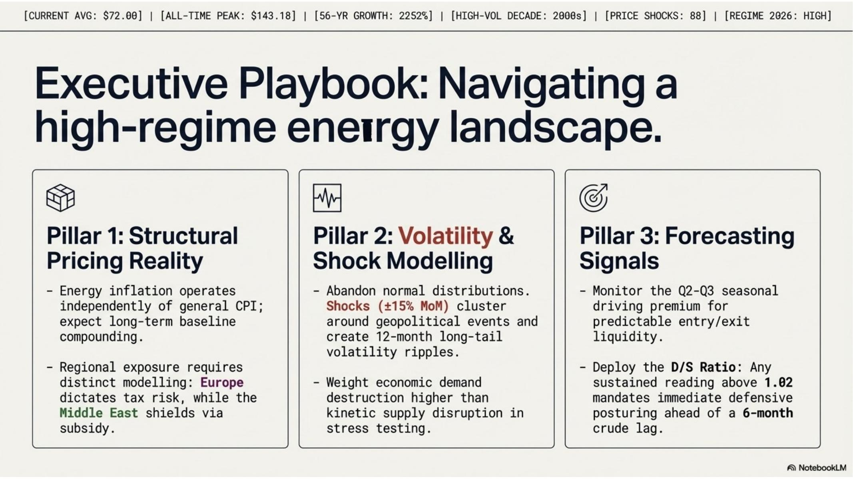
Figure 14 — Executive Playbook: three-pillar framework for navigating a high-regime energy landscape
The project concludes with three operational recommendations derived from the data findings. These are framed as actionable pillars for analysts, procurement professionals, and risk managers working in environments where energy costs are a material variable.

7.1 Pillar 1 — Structural Pricing Reality
- Abandon static energy cost assumptions. Model energy as a long-term compounder with regional splits.
- Europe and the Middle East require entirely separate risk frameworks due to the $1.00/litre policy-driven gap that has persisted across all six decades.
- A 2,252% nominal increase over 56 years means energy inflation operates independently of general CPI; expect long-term baseline compounding to continue.

7.2 Pillar 2 — Volatility and Shock Modelling
- Abandon normal distribution assumptions for energy price risk. Shocks cluster and create 12-month long-tail volatility ripples even after nominal prices partially recover.
- Weight economic crises more heavily than wars in energy stress tests. Economic crises drive 70% higher average prices than wars and produce the all-time historical peaks.
- When a shock month is identified (±15% MoM move), extend the planning horizon to 18 months minimum before assuming stable cost assumptions are valid again.

7.3 Pillar 3 — Forecasting Signals
- Deploy the Demand/Supply Ratio (column AC, DS_Ratio) as a leading indicator. Any sustained reading above 1.02 mandates immediate defensive posturing ahead of the 6-month crude lag.
- Monitor the Q2-Q3 seasonal driving premium for predictable entry and exit windows in energy procurement and commodity positioning.
- For organisations with exposure to European or Middle Eastern fuel costs, monitor regional policy developments independently of global crude price movements.

8. Project Deliverables
Deliverable | Format | Description
Enriched Dataset | fuel_dashboard.xlsx — DATASET sheet | 2,700 rows × 33 columns including all 12 derived analytics columns with live Excel formulas
Interactive Dashboard | fuel_dashboard.xlsx — DASHBOARD sheet | Dark-theme dashboard: 7 KPI cards, 6 charts, dynamic titles, slicer-ready pivot connections
Pivot Tables (×8) | fuel_dashboard.xlsx — PIVOTS sheet | 8 analytical pivot tables with colour-scale conditional formatting and 9 embedded charts
Formula Reference | fuel_dashboard.xlsx — FORMULA_GUIDE sheet | Complete formula documentation for all 12 calculated columns with explanations
Analytical Insights | fuel_dashboard.xlsx — KEY_INSIGHTS sheet | 10 pre-computed findings with data evidence, business implication, and chart reference
Presentation (14 slides) | Global_Fuel_Price_Intelligence.pptx | 14-slide executive presentation built in NotebookLM with data-driven charts and insights
PDF Report | fuel_dashboard_report.pdf | 10-page structured PDF report covering all analytical sections with embedded charts
Project Documentation | This document (.docx and .pdf) | Formal project documentation covering methodology, findings, formulas, and deliverables

End of Document — Global Fuel Price Intelligence Project Documentation

