|  |
| --- |
|  |

# Steps :-

1. Press Alt + F11 keys to display Microsoft Visual Basic for Applications window.

2. Click Insert > Module, and paste below VBA code to the new Module window.

Private Function StrToPsd(ByVal Txt As String) As Long

'UpdatebyEncryptforExcel20151225

    Dim xVal As Long

    Dim xCh As Long

    Dim xSft1 As Long

    Dim xSft2 As Long

    Dim I As Integer

    Dim xLen As Integer

    xLen = Len(Txt)

    For I = 1 To xLen

        xCh = Asc(Mid$(Txt, I, 1))

        xVal = xVal Xor (xCh * 2 ^ xSft1)

        xVal = xVal Xor (xCh * 2 ^ xSft2)

        xSft1 = (xSft1 + 7) Mod 19

        xSft2 = (xSft2 + 13) Mod 23

    Next I

    StrToPsd = xVal

End Function

Private Function Encryption(ByVal Psd As String, ByVal InTxt As String, Optional ByVal Enc As Boolean = True) As String

    Dim xOffset As Long

    Dim xLen As Integer

    Dim I As Integer

    Dim xCh As Integer

    Dim xOutTxt As String

    xOffset = StrToPsd(Psd)

    Rnd -1

    Randomize xOffset

    xLen = Len(InTxt)

    For I = 1 To xLen

        xCh = Asc(Mid$(InTxt, I, 1))

        If xCh >= 32 And xCh <= 126 Then

            xCh = xCh - 32

            xOffset = Int((96) * Rnd)

            If Enc Then

                xCh = ((xCh + xOffset) Mod 95)

            Else

                xCh = ((xCh - xOffset) Mod 95)

                If xCh < 0 Then xCh = xCh + 95

            End If

            xCh = xCh + 32

            xOutTxt = xOutTxt & Chr$(xCh)

        End If

    Next I

    Encryption = xOutTxt

End Function

Sub EncryptionRange()

    Dim xRg As Range

    Dim xPsd As String

    Dim xTxt As String

    Dim xEnc As Boolean

    Dim xRet As Variant

    Dim xCell As Range

    On Error Resume Next

    xTxt = ActiveWindow.RangeSelection.Address

    Set xRg = Application.InputBox("Select a range:", "Encrypt for Excel", xTxt, , , , , 8)

    Set xRg = Application.Intersect(xRg, xRg.Worksheet.UsedRange)

    If xRg Is Nothing Then Exit Sub

    xPsd = InputBox("Enter password:", "Encrypt")

    If xPsd = "" Then

        MsgBox "Password cannot be empty", , " Encrypt for Excel"

        Exit Sub

    End If

    xRet = Application.InputBox("Type 1 to encrypt cell(s);Type 2 to decrypt cell(s)", "Encrypt for Excel", , , , , , 1)

    If TypeName(xRet) = "Boolean" Then Exit Sub

    If xRet > 0 Then

        xEnc = (xRet Mod 2 = 1)

        For Each xCell In xRg

            If xCell.Value <> "" Then

                xCell.Value = Encryption(xPsd, xCell.Value, xEnc)

            End If

        Next

    End If

End Sub

3. Then press**F5** key to execute the VBA, and a dialog pops out for selecting cells to encrypt. See screenshot:  
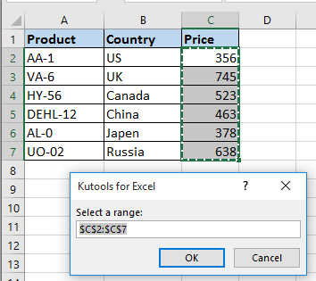

4. Then click **OK** and enter password for the encrypted cells in another popped out dialog. See screenshot:  
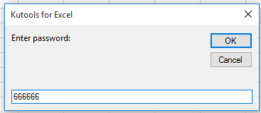

5. Click **OK**, and then in the third dialog, type 1 to encrypt selected cells, if you want to decrypt cells, enter 2. See screenshot:  
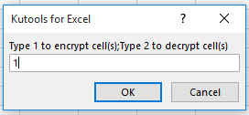

6. Click **OK**, and the selected cells are encrypted. See screenshot:  
