STUDENT PG RENT ANALYSIS AND PREDICTION
Experiment 12 — Data Science Mini Project

1. Abstract
This project demonstrates a data-science workflow for comparing paying-guest (PG) accommodation near a college. It studies monthly rent in relation to distance, room-sharing capacity, accommodation category, and facilities. A Random Forest Regression model estimates rent, while Logistic Regression classifies listings as affordable or expensive relative to the dataset median. The project includes a CSV dataset, Python analysis, visualizations, and model evaluation.

2. Problem Statement
Students relocating for education often need a practical way to compare PG accommodation. Rent alone does not describe value: distance from college, number of room sharers, Wi-Fi, laundry, meals, air conditioning, security, and accommodation category may all matter. The objective is to summarize these factors and demonstrate prediction and classification techniques.

3. Objectives
- Inspect and summarize PG rent and accommodation attributes using Pandas and NumPy.
- Visualize rent distribution, rent versus distance, and average rent by sharing capacity.
- Build a regression model to estimate monthly rent per person.
- Classify listings into dataset-relative Affordable and Expensive categories.
- Demonstrate a reproducible, real-world problem-solving workflow.

4. Dataset Description
The supplied CSV has 80 illustrative rows and 12 columns. Important fields include Monthly_Rent_Rs, Distance_km, Sharing_Capacity, Current_Residents, Accommodation_Type, and binary facility indicators. IMPORTANT: these are synthetic demonstration records, not verified local listings. Replace them with real, permissionfully collected data before drawing conclusions about the local market.
Column | Description
Monthly_Rent_Rs | Monthly rent per person in Rs.
Distance_km | Distance from college in kilometres
Sharing_Capacity | Number of people sharing a room
Accommodation_Type | Boys, Girls, or Co-ed
WiFi / Laundry / Meals_Included / AC / Security | 1 = available; 0 = unavailable

5. Tools and Concepts
Python; Pandas for CSV loading and tabular analysis; NumPy for numeric operations; Matplotlib for plots; Scikit-learn for preprocessing, train-test splitting, Random Forest Regression, Logistic Regression, and evaluation metrics.
This project can connect to common earlier laboratory concepts such as Python variables and data types, operators, conditional statements, loops, functions, lists/data structures, file handling, NumPy arrays, Pandas DataFrames, descriptive statistics, and plotting. Adapt this mapping to the exact titles of Experiments 1–11 in your syllabus.

6. Methodology
- Read the CSV file and validate required columns.
- Compute mean, median, minimum, maximum, accommodation counts, and grouped rent averages.
- Set the affordability threshold to the median rent: at or below median = Affordable; above median = Expensive.
- Split features into training and test subsets with a fixed random seed.
- Impute missing values, scale numeric features, and one-hot encode accommodation type.
- Train Random Forest Regression and evaluate with MAE, RMSE, and R-squared.
- Train Logistic Regression and evaluate accuracy and the classification report.
- Generate three graphs and optionally prompt the user to estimate rent for a new listing.

7. Visualizations
Figure 1. Distribution of monthly rent, with the median threshold.
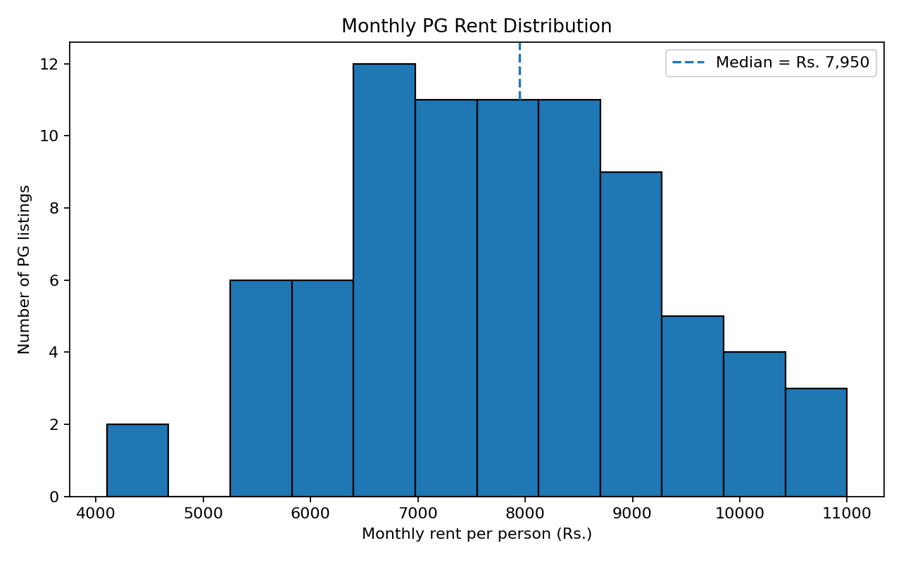
Figure 2. Rent compared with distance from college by accommodation category.
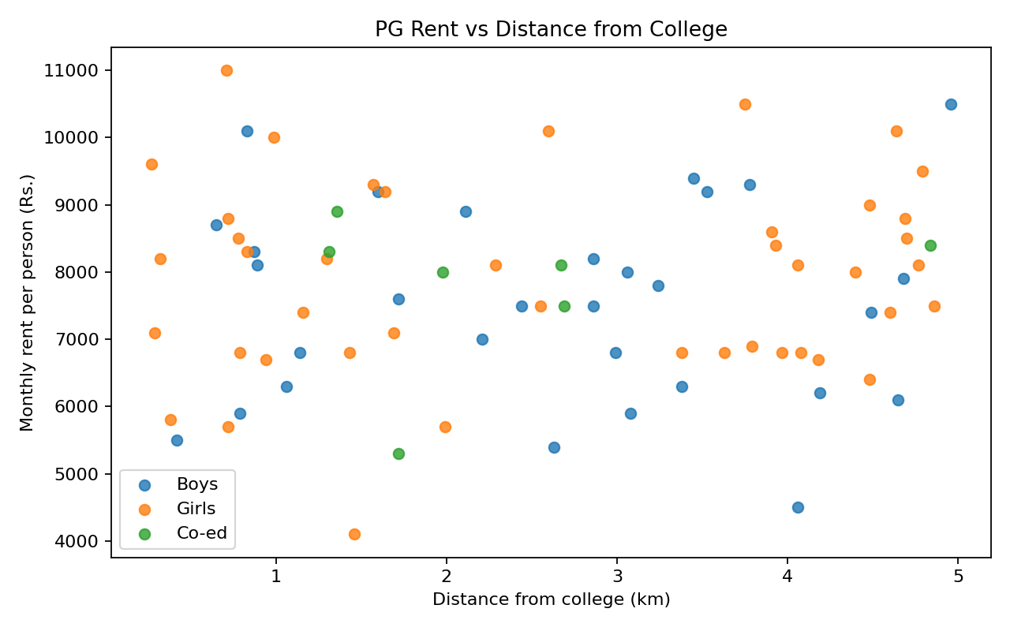
Figure 3. Average rent for different room-sharing capacities.
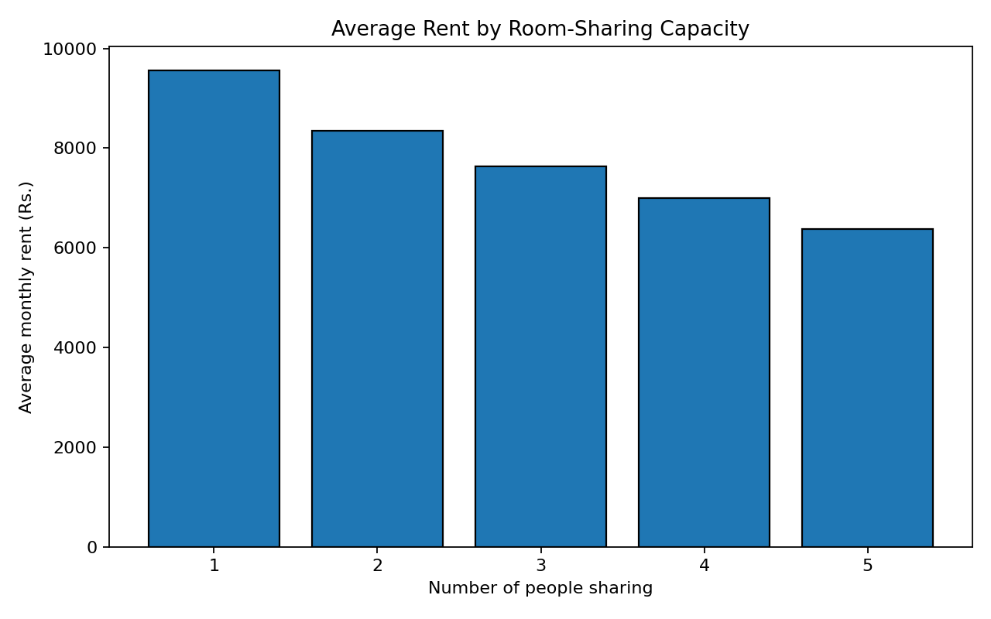

8. Model Evaluation
When main.py runs, it prints the test-set Mean Absolute Error (MAE), Root Mean Squared Error (RMSE), and R-squared for regression, as well as accuracy and precision/recall/F1 for classification. The exact values depend on the dataset and installed library versions; use the values printed by your own run in the final presentation. Do not report invented performance figures.

9. How to Run
Install Python 3.9+ and run: pip install pandas numpy matplotlib scikit-learn
Then, from the project folder, run: python main.py
The program prints summary statistics and evaluation metrics, saves three PNG plots in the graphs folder, and offers an optional interactive prediction.

10. Expected Outcome
The program provides a summary of the supplied listings, visual evidence of rent patterns, a rent estimate for a user-described listing, and a relative affordability label. More room sharers may reduce per-person rent in many settings, while facilities may add cost; the supplied data should be treated as illustrative rather than evidence of actual local pricing.

11. Limitations and Future Scope
- The included dataset is synthetic and cannot establish real local prices or model reliability.
- The median-based label is relative to the dataset and does not represent a universal affordability threshold.
- The dataset omits deposits, electricity charges, food quality, curfew/rules, property condition, and listing date.
- Future work can collect verified listings over time, add facilities and total monthly cost, compare multiple algorithms, tune models, and validate on fresh real data.

12. Conclusion
The mini project combines data cleaning, exploratory analysis, visualization, regression, and classification in one reproducible Python program. It shows how data science can support student accommodation comparisons while emphasizing that dependable real-world results require accurate, current data.

