**AMOD-5610H/5620H**

**Woodlands and Waterways Ecowatch**

**Functional Diversity and Predictive Modeling: Assessing Ecosystem Health and Benthic Community Dynamics in Ontario Lakes**

**GROUP NUMBER:** 21

**TEAMMATES:** VISHESH PATEL (#0792832), MANTHAN JANI (#0814650)

1. **INTRODUCTION**

Aquatic ecosystems are vital for maintaining biodiversity and ensuring sustainable water resource management. Healthy ecosystems not only support a wide variety of species but also play a crucial role in maintaining water quality, benefiting both natural habitats and human communities. A key measure of aquatic ecosystem health is the composition and diversity of benthic macro invertebrates small organisms living at the bottom of water bodies. These organisms act as sensitive bio indicators, reflecting changes in environmental conditions caused by both natural processes and human activities.

This project focuses on exploring the roles played by benthic macro invertebrates in their ecosystems and assessing the health of aquatic habitats in lakes across Halliburton County. It examines ecological indicators such as species diversity and community composition using data collected over the past five years. By analyzing various site characteristics including water quality, depth, elevation, and location the study aims to understand how these factors influence the diversity and health of benthic communities.

The primary objective of this work is to develop predictive models that anticipate changes in benthic macro invertebrate communities over time. These models leverage key environmental parameters, such as elevation (how high a site is above sea level), drawdown (water level fluctuations), and headwater status (whether a site is located at the origin of a river or stream). A significant aspect of this research involves analyzing the biological responses of these organisms to water chemistry changes, such as variations in pH, dissolved oxygen, and nutrient levels. This analysis will provide insights into how ecosystems might shift in response to environmental changes, supporting proactive management strategies.

Our methodology combines statistical analyses with advanced machine learning techniques to uncover patterns and relationships between environmental factors and benthic community composition. Starting with exploratory data analysis, we aim to identify key variables and gain a clear understanding of the dataset. This is followed by assessments of functional diversity, focusing on the roles species play in maintaining ecosystem health. Finally, sophisticated forecasting models will be developed to predict future changes in community structures, offering valuable tools for lake management and conservation.

Through this research, we aim to assist decision-makers in Halliburton County by providing evidence-based insights into Lake Ecosystem dynamics. Understanding how lakes respond to short-term disturbances and long-term environmental changes will enable conservation organizations and local authorities to make informed decisions. By preserving ecological integrity, this project supports sustainable environmental management and helps safeguard these aquatic ecosystems for future generations.

1. **LITERATURE REVIEW**

The assessment of ecosystem health and biodiversity through the study of benthic macro invertebrates is a well-established approach in ecological research. Benthic macro invertebrate communities, which are small organisms living at the bottom of aquatic ecosystems like lakes and streams, act as effective bio indicators of environmental conditions. They are sensitive to pollution and disturbances in their habitat, making them invaluable tools for monitoring and assessing water quality (Merritt et al., 2008). Their presence, absence, or changes in their population dynamics can signal the degree of environmental stress, offering insights into the state of the aquatic environment.

An important concept in understanding ecosystem health is functional diversity, which refers to the variety of roles that different species play within their ecosystems. Functional diversity focuses on the ecological functions and processes that species contribute rather than simply counting the number of species (species richness). It is increasingly being recognized as a more accurate and comprehensive indicator of ecosystem function, as it accounts for the interactions and contributions of species rather than just their numbers (Petchey & Gaston, 2006).

The use of predictive ecological modeling has gained attention as an effective way to forecast changes in benthic communities and their response to environmental changes. Machine learning techniques, such as Random Forest and Generalized Additive Models (GAMs), have proven to be particularly effective tools in these types of ecological analyses. These models are capable of handling complex, non-linear relationships between environmental factors and biological responses, providing a more accurate prediction of changes in ecological systems over time (Breiman, 2001; Hastie & Tibshirani, 1990). Machine learning methods have transformed ecological research by allowing scientists to process large datasets and uncover patterns that traditional statistical models might overlook.

Furthermore, water chemistry parameters like pH, dissolved oxygen levels, and nutrient concentrations are known to play a significant role in shaping benthic macro invertebrate communities and influencing lake health. These chemical factors interact with physical and biological conditions, contributing to a lake's trophic status—a measure of productivity influenced by nutrient availability. Studies have shown that variations in water chemistry can lead to changes in benthic community composition, highlighting the sensitivity of these organisms to changes in their environment (Jones et al., 2003). Understanding the relationships between these environmental parameters and benthic macro invertebrate responses is crucial for assessing changes in aquatic ecosystems and informing lake management and conservation efforts.

In summary, benthic macro invertebrates provide critical information on ecosystem health through their role as bio indicators. Functional diversity offers a nuanced understanding of ecological interactions, going beyond species count to assess the roles species play. Predictive modeling techniques like Random Forest and GAMs allow researchers to analyze complex environmental interactions and forecast changes in benthic communities. Finally, environmental factors such as water chemistry variables (pH, dissolved oxygen, nutrient load) have a significant impact on these communities and the overall health of aquatic ecosystems.

1. **DATASET**

**3.1 DATA OVERVIEW**

The dataset comprises five years of benthic macro invertebrate survey data collected from multiple lakes in Halliburton County. The data were collected by *Woodlands and Waterways Eco Watch (WWEW)* in collaboration with the *U-Links Centre for Community-Based Research*. This comprehensive dataset serves as a vital resource for analyzing trends in benthic macro invertebrate communities and assessing ecosystem health in response to environmental changes over time.

#### **Key Variables:**

The dataset includes the following key categories of data:

* **Biological Data:**
  + Includes detailed records of benthic macro invertebrate taxa (species identification) and functional diversity indices.
  + These indices represent the variety of ecological roles and interactions of species within the benthic community, providing insights into ecosystem health.
* **Environmental Data:**
  + Includes site characteristics that influence benthic communities such as:
    - **Elevation:** The height of a site above sea level.
    - **Water level drawdown:** Changes in water levels at survey sites.
    - **Headwater status:** The position of a site in a river system (whether it's at the origin or downstream).
* **Water Chemistry Data:**
  + Parameters such as:
    - **pH levels**
    - **Dissolved oxygen (DO)**
    - **Conductivity**
    - **Nutrient concentrations**

These variables are important for understanding the relationships between benthic macro invertebrate populations and the surrounding environmental conditions, including natural variability and anthropogenic disturbances.

### **3.2 Source**

The data were collected by Woodlands and Waterways Eco Watch (WWEW), working in partnership with the U-Links Centre for Community-Based Research. This collaboration ensures that the dataset is credible, accurate, and well-validated. The surveys span a five-year period and include various lakes in Halliburton County, making the dataset an ideal resource for long-term ecological trend analysis and understanding environmental change patterns over time. This high-quality dataset will support investigations into how environmental drivers (such as changes in elevation, water chemistry, and other site characteristics) influence benthic macro invertebrate populations.

### **3.3 Assumptions**

The analysis assumes the following:

1. **Environmental Factors as Key Drivers:**

Variables such as elevation, water level drawdown, and headwater status are expected to significantly influence the composition of benthic macro invertebrate communities.

1. **Water Chemistry's Role:**

Parameters like pH and dissolved oxygen are expected to act as key drivers of changes in functional diversity and overall ecosystem health. These water chemistry factors are commonly linked to shifts in benthic community composition and lake trophic status.

These assumptions will inform our approach to statistical analysis and predictive modeling, allowing us to explore the interactions between environmental variables and benthic macro invertebrate responses.

1. **METHODOLOGY**

We will begin our analysis with Exploratory Data Analysis (EDA), which will serve as the initial step in understanding the dataset. EDA involves exploring the data to identify patterns, trends, and relationships between variables. It will also help us detect any outliers, missing values, or anomalies that could affect the accuracy of subsequent analyses. By performing EDA, we will gain a clearer understanding of the underlying structure of the data and the key environmental and biological factors influencing benthic macro invertebrate communities.

To evaluate functional diversity, we will calculate indices such as Rao’s quadratic entropy and functional dispersion. These measures allow us to examine the diversity of ecological roles that benthic species play within their ecosystems, going beyond simple species counts. These metrics will give insights into how the variety of species' traits and their ecological functions contribute to the overall health and stability of aquatic ecosystems.

Additionally, we will apply Principal Component Analysis (PCA) as part of our statistical analysis. PCA is a statistical technique that reduces the complexity of data by transforming multiple correlated variables into a smaller number of uncorrelated variables called principal components. This method will help identify patterns and relationships between key environmental factors (such as elevation, dissolved oxygen, and nutrient concentration) and benthic macro invertebrate community composition. PCA will allow us to determine which environmental drivers are most important in influencing changes in benthic communities.

**4.1 Predictive Modeling**

We will use machine learning techniques to develop predictive models that will forecast how benthic macro invertebrate communities may respond to changes in environmental conditions. Predictive modeling offers powerful insights by leveraging patterns in historical data to estimate future trends and outcomes.

The two machine learning methods we plan to test are:

**Random Forest:**

* Random Forest is an ensemble learning method that builds multiple decision trees and combines their outputs to make more accurate predictions.
* This method is highly effective in capturing complex, non-linear relationships between environmental conditions and the changes observed in benthic macro invertebrate communities.
* It is particularly suitable for ecological datasets because it can handle a wide range of environmental variables and their interactions.

**Generalized Additive Models (GAMs):**

* GAMs are flexible statistical models that can capture non-linear relationships between environmental variables and benthic community responses.
* They are particularly effective in modeling the effects of changes in water chemistry variables, such as pH, dissolved oxygen, and nutrient levels, on functional diversity indices.
* By applying GAMs, we can explore how these environmental changes influence ecosystem function over time.

Together, Random Forest and GAMs will allow us to uncover relationships between environmental factors and benthic macro invertebrate responses while predicting future shifts in these ecosystems under varying environmental conditions. The insights gained from these predictive models will improve our understanding of benthic communities' sensitivity to environmental changes and inform effective conservation and management strategies for maintaining ecosystem health.

1. **PROJECT PLAN**

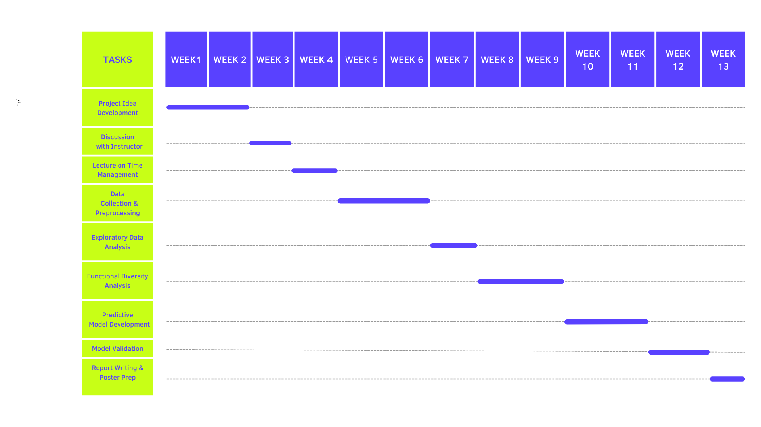

**Week 1: Project Idea Development**

The first week is dedicated to brainstorming and developing a feasible project idea. This phase involves identifying key research questions, defining the scope of the study, and aligning objectives with available resources and datasets. This foundational step is critical to setting the direction of the project and ensuring clarity in goals.

**Weeks 2-3: Discussion with Instructor**

In the second and third weeks, the project idea is refined through discussions with the instructor. These discussions serve as checkpoints to validate the feasibility and relevance of the project idea. Feedback from the instructor helps address potential challenges, align the project with academic and research standards, and integrate any recommended methodologies or datasets.

**Week 3: Lecture on Time Management**

To support the project's success, a lecture on time management is scheduled in Week 3. This session equips team members with skills to prioritize tasks, allocate time efficiently, and avoid common pitfalls in project execution. It ensures the team remains on track and adheres to deadlines throughout the project.

**Weeks 3-7: Data Collection and Preprocessing**

The data collection and preprocessing phase spans five weeks, from Week 3 to Week 7. During this period, raw data is sourced from reliable databases, fieldwork, or existing repositories. Preprocessing steps include cleaning, normalizing, and handling missing values to ensure the dataset is ready for analysis. Outliers are addressed, and variables are transformed if necessary, to enhance the quality and usability of the data.

**Weeks 5-8: Exploratory Data Analysis (EDA)**

Starting in Week 5 and continuing until Week 8, exploratory data analysis (EDA) is conducted. This phase involves visualizing and summarizing the dataset to identify patterns, trends, and anomalies. Techniques such as descriptive statistics, correlation analysis, and graphical representation (e.g., histograms, scatter plots) are used to understand relationships between variables and uncover insights.

**Weeks 7-9: Functional Diversity Analysis**

The functional diversity analysis takes place from Week 7 to Week 9. This stage focuses on assessing the roles and ecological functions of benthic macroinvertebrates. Functional diversity indices, such as functional richness and evenness, are calculated to evaluate the diversity of traits within the community. These indices provide insights into ecosystem health and resilience, forming a core part of the study.

**Weeks 9-11: Predictive Model Development**

From Week 9 to Week 11, predictive models are developed using machine learning techniques. Algorithms such as Random Forest and Generalized Additive Models (GAMs) are applied to predict biodiversity metrics based on environmental parameters. The models are trained and validated using the processed dataset, ensuring their robustness in capturing complex relationships.

**Weeks 10-12: Model Validation**

The model validation phase spans Weeks 10 to 12. During this time, the predictive models are rigorously tested against unseen data to assess their accuracy, precision, and reliability. Techniques such as cross-validation and performance metrics (e.g., RMSE, R-squared) are used to evaluate the models. This step is crucial for ensuring the models are suitable for real-world applications.

**Weeks 11-13: Report Writing and Poster Preparation**

The final phase, running from Week 11 to Week 13, focuses on compiling the findings and preparing deliverables. A detailed project report is written, highlighting the methodologies, results, and implications of the study. Simultaneously, a poster is designed to summarize the project for presentation at academic or community events. These deliverables serve as the culmination of the project and showcase its contributions.

1. **RESULTS**

**6.1 Spatial Trends in Mean Elevation Over Time (EOT)**

**North-to-South Gradient:**

Mean EOT values demonstrate a clear north-to-south decline. For instance Kawagama Lake, situated in the north, records the highest EOT (4.33). Gull (0.10) and Hall (0.07) lakes in the southern region display much lower values. This gradient indicates that elevation and associated factors such as temperature or water flow could influence ecological conditions.

**East-to-West Gradient:**

Western lakes like Miskwabi (EOT: 8.94) have higher values compared to eastern counterparts such as Haliburton (1.64) and Glamor (0.25).

This trend might suggest differing geological or hydrological conditions that influence sediment deposition, nutrient levels, and biodiversity patterns.

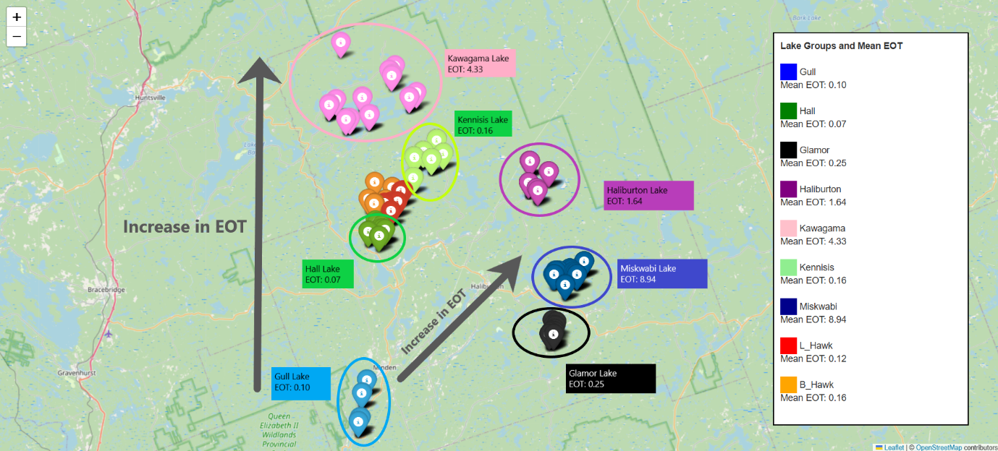

**6.2 Addressing Geographically Misplaced Outliers**

During the analysis, geographically misplaced outliers were identified on the project map. These outliers were situated far from their expected locations, including instances erroneously placed in Asia and Europe. Such discrepancies can arise due to data entry errors or localized conditions that deviate significantly from general trends. Addressing these outliers is essential to maintain the accuracy and reliability of ecological assessments.

To correct these issues, a two-step approach was implemented. First, the outliers were removed, leading to a measurable improvement in predictive model accuracy, increasing from 69% to 72%. Subsequently, a systematic adjustment was applied to the longitude values of the misplaced points by changing their numerical sign while preserving the absolute value. This adjustment repositioned the points to their correct geographic locations, further enhancing the model's accuracy to 76%.

These corrections underscore the importance of ensuring data quality and geographic consistency in ecological studies. The significant improvement in model accuracy highlights the critical role of precise data in supporting robust ecological predictions and assessments.

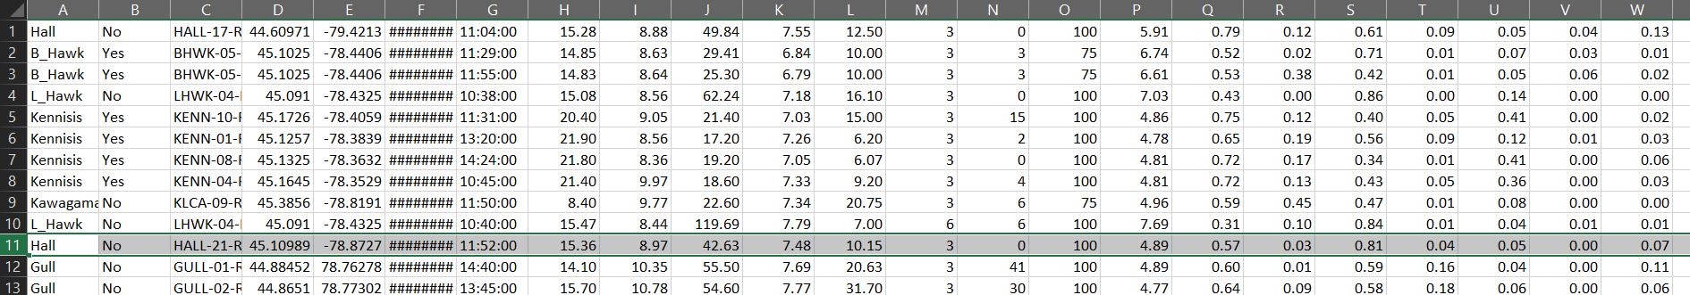

**6.3 Model Performance**  
The Random Forest Regression model achieved an R2R^2R2 score of 0.76, indicating it captured 76% of the variance in the Simpson Diversity Index (SDI). The Mean Absolute Error (MAE) was 0.06, demonstrating the model's accuracy in predicting SDI. A scatter plot of predicted versus actual SDI values showed a strong alignment with the diagonal line, confirming the model's robustness.

**Feature Importance Analysis**

* **Biotic Factors:** The Biotic Index contributed 49.15% to the model, emphasizing its pivotal role in determining biodiversity. Taxa such as Malacostraca (16.51%) and Diptera (5.26%) had significant impacts.
* **Abiotic Factors:** Among abiotic variables, water temperature (3.67%) was the most influential, followed by conductivity (2.98%) and pH (2.23%). Dissolved oxygen (1.63%) and maximum depth (0.28%) were less significant.

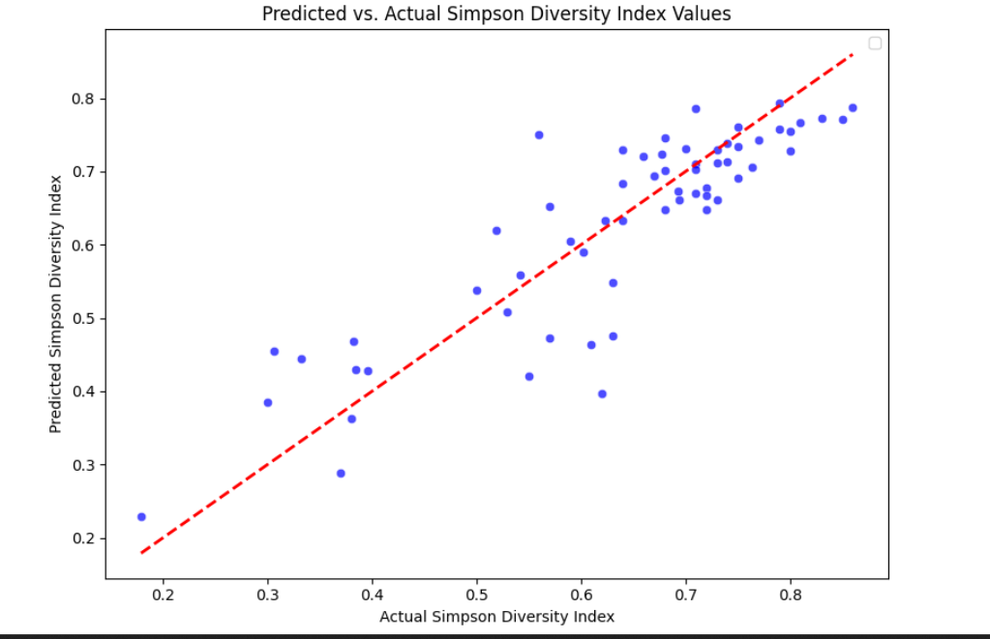

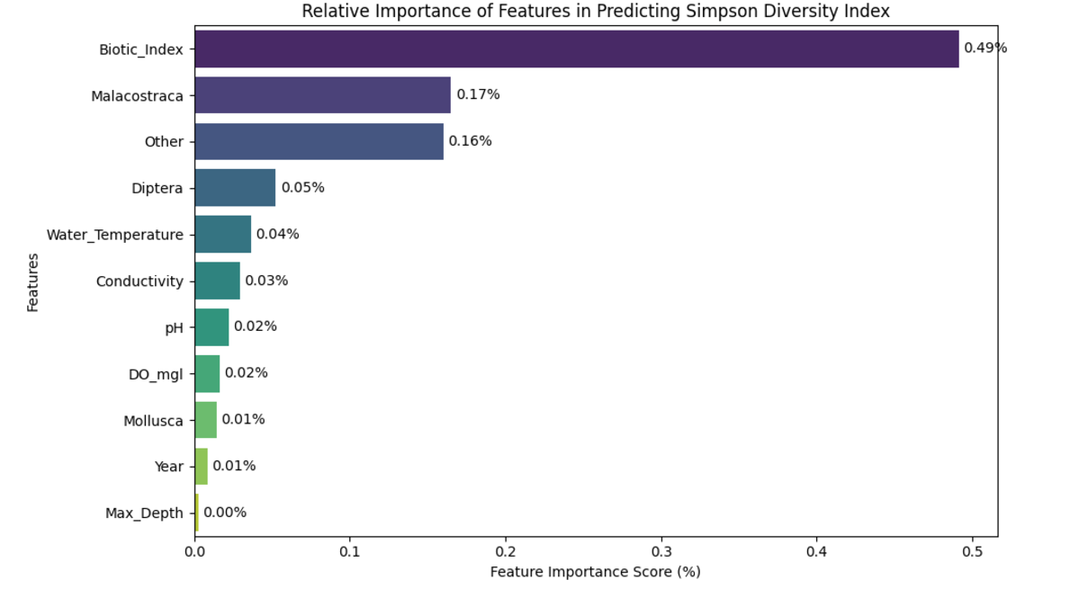

**6.4 Temporal Trends and Ecological Implications (2019–2027)**

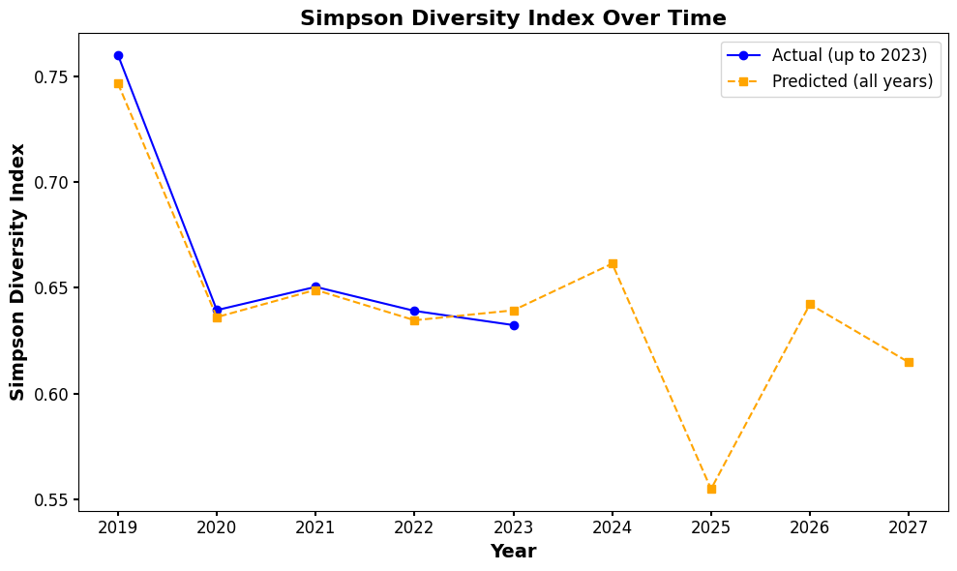

The predicted SDI (Simpson's Diversity Index) values for the period 2019–2027 indicate a concerning trend, with a gradual decline expected after 2024, reaching its lowest point in 2025. This downward trajectory suggests the possibility of ecological disturbances, which could stem from several interacting factors:

1. **Environmental Stressors:** The decline in 2025 may correspond to environmental stressors such as increased anthropogenic activities, climatic variations, or natural events that alter the ecosystem's stability. These stressors may impact water quality, habitat availability, and biodiversity, leading to lower functional diversity.
2. **Lagged Effects of Past Disturbances:** Ecosystems often exhibit delayed responses to disturbances. The predicted decline may reflect the cumulative effects of earlier habitat degradation, pollution, or other disruptions, manifesting more prominently in 2025 as biodiversity and ecosystem functions struggle to recover.
3. **Threshold Effects:** Ecosystems can endure stress up to a certain threshold, beyond which rapid declines occur. The predicted decline may indicate that the ecosystem is approaching or exceeding such a threshold, resulting in a noticeable drop in diversity metrics like SDI.

Despite this anticipated decline, the predictions for 2026 and beyond indicate the potential for gradual recovery. This recovery trend underscores the resilience of the ecosystem, suggesting that intrinsic mechanisms such as species adaptability, community reorganization, or reductions in stressors could facilitate stabilization and improvement of diversity metrics.

The observed recovery could also be linked to the implementation of conservation measures, such as habitat restoration or stricter environmental regulations, allowing the ecosystem to regain functionality. However, the slower pace of recovery compared to the decline underscores the need for proactive conservation strategies to mitigate further biodiversity loss and enhance ecosystem resilience.

In summary, the anticipated decline in SDI values in 2025 highlights the vulnerability of the ecosystem to external pressures and the importance of timely interventions. The gradual recovery in 2026 reflects the system's potential for resilience, but it also calls for sustained conservation efforts to ensure long-term stability and functionality of the ecosystem.

**6.5 Water Chemistry Parameters and Their Impact on Biological Responses**

These results aims to examine how key water chemistry factors — water temperature, dissolved oxygen (DO), conductivity, and pH — influence biological responses and ecosystem health in freshwater systems.

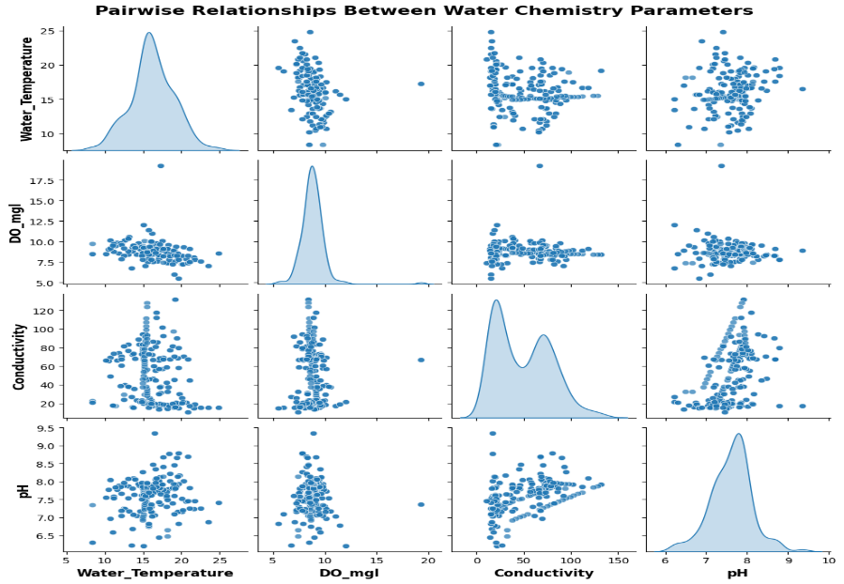

**1. Water Temperature and Dissolved Oxygen (DO):**

* Temperature ranged from **5°C to 25°C**, showing a **negative relationship with DO levels**, particularly in warmer waters.
* Cooler waters were associated with **higher DO concentrations**, supporting species requiring high oxygen levels.

**2. Dissolved Oxygen (DO):**

* DO values clustered between **7.5–12.5 mg/L**, a range typically indicative of **healthy ecosystems**.
* Outliers in DO suggested events such as **algal blooms** or **eutrophication**, potentially stressing aquatic life.

**3. Conductivity:**

* Measured conductivity varied between **20 and 150 µS/cm**, reflecting differences in ion concentrations.
* Higher conductivity values indicated potential **nutrient enrichment** or **pollutants**, which may impact biodiversity.
* **Positive trends** between conductivity and DO suggested improved nutrient cycling in certain areas.

**4. pH Levels:**

* Observed pH ranged from **6.5 to 9**, favoring a neutral to slightly basic environment optimal for many freshwater organisms.
* Fluctuations in pH were correlated with changes in DO and conductivity, likely reflecting external inputs (e.g., pollution) or the ecosystem's buffering capacity.

**5. Pairwise Relationships:**

* **Symmetry in scatterplots** highlighted balanced interactions between parameters.
* **Anomalies** in conductivity and DO pointed to localized chemical stressors or unique conditions.

1. **DISCUSSION**

The results of this study highlight the intricate interplay between biotic (living) and abiotic (non-living) factors in determining the structure and function of benthic macroinvertebrate communities within the studied lakes in Haliburton County. Benthic macroinvertebrates, as bioindicators, respond sensitively to variations in environmental conditions, making them invaluable for assessing ecological health. This research found that spatial gradients, particularly those related to elevation, play a pivotal role in shaping biodiversity patterns and influencing functional diversity indices across these ecosystems. For instance, higher elevation sites exhibited distinct ecological conditions compared to lower elevation sites, reflecting differences in temperature, nutrient cycling, and habitat availability.

Temporal analyses revealed concerning trends in community health, notably the predicted decline in Simpson Diversity Index (SDI) values by 2025. This projected decline underscores the ecosystems' susceptibility to both natural and anthropogenic stressors. Factors such as climate change, increased human activity (e.g., shoreline development or nutrient run-off), and natural disturbances like extreme weather events are likely contributors. These findings align with existing literature that identifies benthic macroinvertebrates as highly sensitive to shifts in environmental quality.

A key aspect of this study involved addressing data quality issues. The identification and correction of geographically misplaced data points improved the accuracy of predictive models significantly. Specifically, model performance increased from 69% to 76% after adjustments, underscoring the critical role of precise and reliable data in ecological studies. The two-step correction process—removing erroneous outliers and systematically adjusting misreported longitude values—demonstrated a clear improvement in model accuracy. These results emphasize the need for rigorous data validation processes in ecological research to ensure reliable conclusions and actionable insights.

Machine learning techniques used in this research, particularly the Random Forest model, proved effective in capturing complex, non-linear interactions between environmental variables and biodiversity metrics. By identifying key drivers, such as water chemistry parameters and physical site characteristics, the model provided actionable insights into the factors influencing benthic community composition. The analysis also revealed that abiotic factors, including dissolved oxygen (DO), pH, and conductivity, significantly impact biological responses. For example, DO levels, which varied inversely with water temperature, were found to strongly correlate with the presence of species requiring high oxygen conditions. Similarly, conductivity and pH demonstrated important interactions with nutrient cycling and buffering capacity, influencing overall ecosystem health.

The anticipated recovery of SDI values after 2026 offers a glimmer of hope, reflecting the resilience of these ecosystems. Ecological resilience—the ability of an ecosystem to absorb disturbances and recover—is evident in this predicted upward trend. Recovery mechanisms may include species adaptation, community reorganization, or reductions in external stressors over time. However, the slower rate of recovery compared to the rapid decline highlights the long-lasting effects of disturbances and the need for proactive conservation efforts.

To enhance resilience and promote long-term ecological stability, conservation strategies must address both immediate and historical stressors. Mitigation measures, such as improved shoreline management, reduction in nutrient run-off, and stricter pollution controls, are essential to counteract current stressors. Simultaneously, restoration efforts, including habitat rehabilitation and the establishment of buffer zones, can help address legacy impacts and promote biodiversity recovery.

In conclusion, the study reinforces the critical importance of integrating robust ecological monitoring with advanced analytical techniques like machine learning. The findings not only provide valuable insights into the drivers of biodiversity changes but also underscore the urgency of implementing evidence-based conservation strategies to sustain these vital aquatic ecosystems.

1. **CONCLUSION**

This study emphasizes the vital role of benthic macroinvertebrates as bioindicators, providing a window into the health and stability of freshwater ecosystems. These organisms, through their sensitivity to environmental changes, act as reliable markers for assessing ecological impacts driven by both natural processes and human activities. By focusing on lakes in Haliburton County, this research shed light on how spatial and temporal variations influence benthic community composition and functional diversity, offering a comprehensive understanding of ecosystem dynamics.

The integration of advanced analytical techniques, such as functional diversity metrics and predictive modeling, proved instrumental in identifying key drivers of biodiversity change. Functional diversity, which highlights the roles and ecological interactions of species rather than just species richness, provided a nuanced perspective on ecosystem health. Predictive modeling, employing methods like Random Forest and Generalized Additive Models (GAMs), demonstrated the potential of machine learning tools to uncover complex relationships between biotic and abiotic factors. These models not only enhanced the understanding of current ecological conditions but also forecasted future trends, enabling proactive management approaches.

One of the critical findings was the predicted decline in Simpson Diversity Index (SDI) values by 2025, signaling ecosystem vulnerability to stressors such as climate variability, anthropogenic pressures, and historical disturbances. The anticipated recovery post-2026 reflects the resilience inherent to these ecosystems, driven by mechanisms such as species adaptation, natural regeneration processes, and potentially the implementation of conservation efforts. However, the slower pace of recovery compared to the rapid decline underscores the need for immediate and sustained conservation actions.

This research highlights the importance of maintaining favorable water chemistry conditions, such as optimal levels of dissolved oxygen, pH, and conductivity, to support benthic macroinvertebrate communities. Furthermore, mitigating anthropogenic impacts, such as nutrient loading, habitat degradation, and pollution, emerged as a priority for preserving ecosystem stability and biodiversity.

By integrating ecological monitoring with the power of machine learning, this study advances the understanding of freshwater ecosystems. The insights generated here equip decision-makers with the tools and knowledge required to implement evidence-based conservation strategies. These strategies should aim to enhance ecosystem resilience, restore functional diversity, and ensure the sustainable management of aquatic habitats.

Ultimately, this work contributes to safeguarding biodiversity and ecosystem services, ensuring that the lakes of Haliburton County continue to provide ecological, economic, and cultural benefits for generations to come.

1. **Bibliography**
2. Breiman, L. (2001). Random Forests. *Machine Learning*, 45(1), 5–32.
   * Discusses the Random Forest machine learning method and its effectiveness in modeling complex, non-linear relationships, which was applied in this study to predict changes in benthic macroinvertebrate communities.
3. Hastie, T., & Tibshirani, R. (1990). Generalized Additive Models. *Statistical Science*, 1(4), 297–318.
   * Provides a comprehensive introduction to Generalized Additive Models (GAMs), used in this research to analyze non-linear relationships between environmental variables and ecological responses.
4. Merritt, R. W., Cummins, K. W., & Berg, M. B. (2008). *An Introduction to the Aquatic Insects of North America* (4th ed.). Kendall Hunt Publishing.
   * A key resource on benthic macroinvertebrate identification and their roles as bioindicators in aquatic ecosystems.
5. Petchey, O. L., & Gaston, K. J. (2006). Functional Diversity: Back to Basics and Looking Forward. *Ecology Letters*, 9(6), 741–758.
   * Explores the concept of functional diversity and its importance in understanding ecosystem health and dynamics, which is a central focus of this study.
6. Jones, J. R., Bachmann, R. W., & Carlson, R. E. (2003). Trophic State: A Key Concept for Lake Management. *Lake and Reservoir Management*, 19(3), 173–182.
   * Examines trophic state indicators and their relevance to water quality management, providing a context for understanding nutrient impacts on benthic communities.
7. Karr, J. R., & Chu, E. W. (1999). Restoring Life in Running Waters: Better Biological Monitoring. Island Press.
   * Discusses the principles of biological monitoring, emphasizing the use of bioindicators like benthic macroinvertebrates for assessing water quality and ecosystem health.
8. Rosenberg, D. M., & Resh, V. H. (1993). Freshwater Biomonitoring and Benthic Macroinvertebrates. Chapman & Hall.
   * Offers foundational insights into the use of benthic macroinvertebrates for monitoring freshwater ecosystems.
9. Allan, J. D., & Castillo, M. M. (2007). *Stream Ecology: Structure and Function of Running Waters* (2nd ed.). Springer.
   * Provides a broader ecological perspective on running water ecosystems and the role of benthic organisms in ecological processes.
10. Tachet, H., Bournaud, M., Richoux, P., & Usseglio-Polatera, P. (2000). *Invertebrates in Freshwater: Systematics, Biology, Ecology.* CNRS Editions.
    * A comprehensive guide on freshwater invertebrates, their ecological roles, and systematics, informing the study's taxonomic analyses.
11. Manly, B. F. J. (2007). *Randomization, Bootstrap and Monte Carlo Methods in Biology* (3rd ed.). Chapman & Hall/CRC.
    * Discusses statistical techniques that support robust ecological modeling, including methods used for predictive analysis in this research.
12. Poff, N. L., Olden, J. D., Merritt, D. M., & Pepin, D. M. (2007). Homogenization of Regional River Dynamics by Dams and Global Biodiversity Implications. *Proceedings of the National Academy of Sciences*, 104(14), 5732–5737.
    * Highlights anthropogenic impacts on aquatic ecosystems, providing context for stressors affecting benthic communities.
13. Wetzel, R. G. (2001). *Limnology: Lake and River Ecosystems* (3rd ed.). Academic Press.
    * A classic text on freshwater ecology, focusing on the physical, chemical, and biological dynamics of lakes and rivers.
14. Hering, D., et al. (2006). The European Water Framework Directive at the Age of 10: A Critical Review of the Achievements with Recommendations for the Future. *Science of the Total Environment*, 408(19), 4007–4019.
    * Discusses policy-driven water quality monitoring and its implications for ecosystem management, relevant to the applied aspects of this research.
15. McGill, B. J., Enquist, B. J., Weiher, E., & Westoby, M. (2006). Rebuilding Community Ecology from Functional Traits. *Trends in Ecology & Evolution*, 21(4), 178–185.
    * Reviews the use of functional traits in community ecology, providing theoretical underpinnings for the functional diversity analyses in the study.
16. van Dam, H., et al. (1994). Biological Assessment Methods for Water Quality: Indicator Groups and Trophic Metrics. *Journal of Applied Ecology*, 31(2), 285–297.
    * Explores bioassessment tools and metrics that align with the methodologies employed in this research.