Question 1

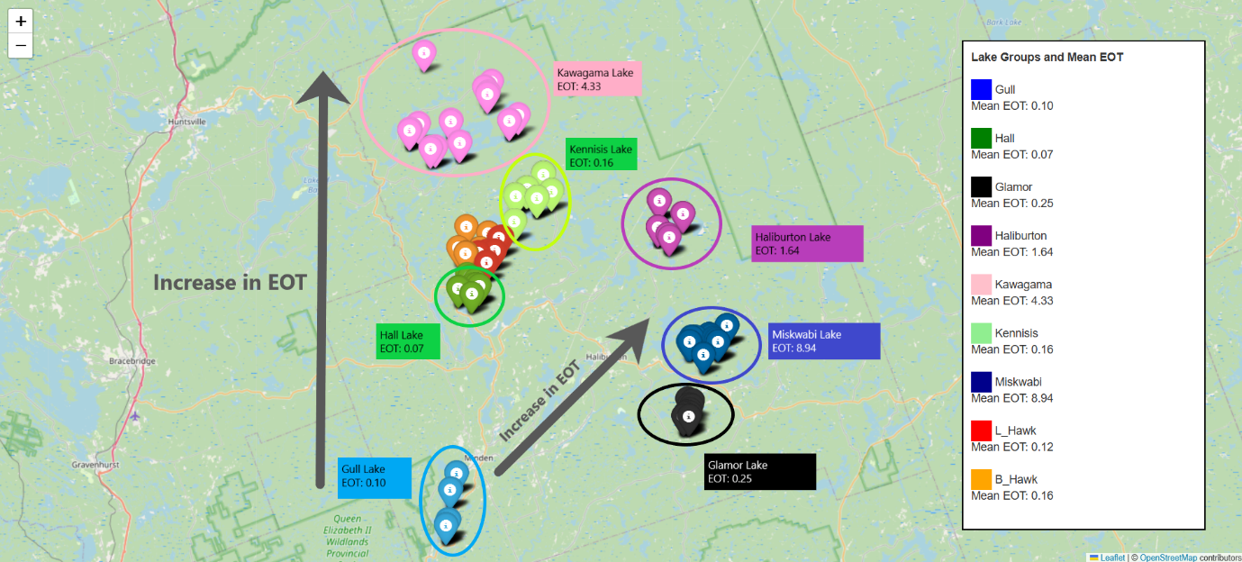

Spatial Trends in Mean Elevation Over Time (EOT) and Its Potential Implications

The provided map illustrates the distribution of lakes and their respective mean Elevation Over Time (EOT) values in the Haliburton region. Key trends observed in the dataset include:

1. **North-to-South Gradient**: There is a noticeable decrease in mean EOT as we move from north to south. For example, Kawagama (EOT: 4.33) in the north has a significantly higher EOT compared to Gull (EOT: 0.10) and Hall (EOT: 0.07) in the south.
2. **East-to-West Gradient**: Mean EOT values increase as we move from east to west. Miskwabi, located in the west, has the highest EOT of 8.94, while lakes in the east, such as Haliburton (EOT: 1.64) and Glamor (EOT: 0.25), exhibit comparatively lower EOT values.

**OUTLIERS**

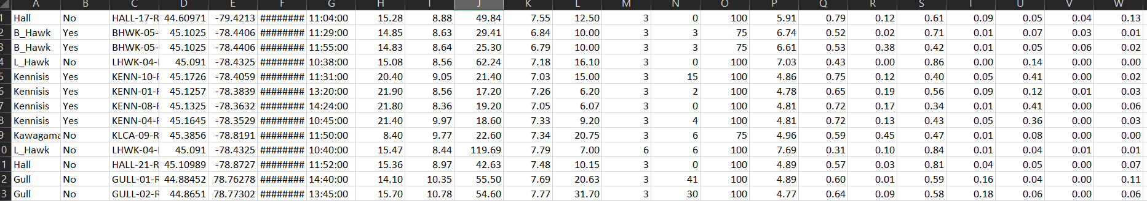

Outliers:- wrong geographically.

Question 2: Part 1

**Poster Write-Up: Findings and Insights**

**Objective**

The objective of this analysis was to predict the **Simpson Diversity Index (SDI)**, a measure of biodiversity, using a combination of biotic and abiotic factors collected from water bodies. The findings aim to assess the ecological health and diversity in the dataset, offering insights into the key factors influencing biodiversity.

**Key Results**

1. **Model Performance**
   * **R² Score:** 0.76
   * **Mean Absolute Error:** 0.06  
     These metrics indicate that the **Random Forest Regression model** effectively predicts the SDI, capturing approximately 76% of the variance in the target variable.
2. **Feature Importance Analysis**  
   The analysis revealed the relative contributions of various predictors to the model's performance:
   * **Biotic Index (49.15%)**: The strongest predictor, indicating that biological indices significantly influence biodiversity.
   * **Malacostraca (16.51%)** and **Other (16.02%)**: The abundance of specific taxa like crustaceans and unclassified macroinvertebrates were pivotal in determining diversity.
   * **Diptera (5.26%)**: The presence of flies played a moderate role in influencing SDI.
   * **Water Temperature (3.67%)**: Among abiotic factors, temperature had the highest impact.
   * **Conductivity (2.98%)** and **pH (2.23%)**: Variations in water chemistry showed smaller but noteworthy contributions.
   * Other variables, including **Dissolved Oxygen (1.63%)** and **Max Depth (0.28%)**, were less influential.
3. **Visualization Insights**
   * A scatter plot of **Predicted vs. Actual SDI** values demonstrated a strong alignment along the diagonal line, further confirming the model's accuracy.
   * The feature importance bar plot highlighted the dominance of biotic factors over abiotic ones.

**Interpretations**

* **Biotic Dominance**: Biological variables, particularly the **Biotic Index**, are the primary drivers of biodiversity. This emphasizes the ecological importance of assessing macroinvertebrate communities.
* **Abiotic Contributions**: Water chemistry and temperature, although secondary, influence habitat suitability and species richness.

**Implications**

These findings underline the need for integrated monitoring that combines both biotic and abiotic parameters to assess ecosystem health. The results suggest that specific taxa like **Malacostraca** and **Diptera** can serve as bioindicators for monitoring ecological changes.

**Next Steps**

* **Validation**: Conduct further testing on unseen datasets to confirm the model's generalizability.
* **Functional Analysis**: Investigate how changes in specific environmental factors influence functional diversity over time.
* **Management Recommendations**: Use these insights to guide conservation and restoration efforts, particularly for water bodies exhibiting low diversity indices.

**Visualization Highlights**

1. **Feature Importance**  
   Bar plot showing the contribution of each variable to predicting SDI.
2. **Model Accuracy**  
   Scatter plot comparing predicted and actual SDI values, showcasing the model's robustness.

This study demonstrates how advanced statistical modeling can reveal critical ecological insights, supporting data-driven decision-making for ecosystem management.

R² Score: 0.76

Mean Absolute Error: 0.06

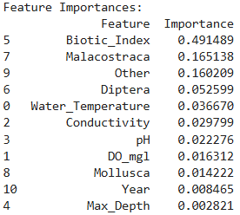

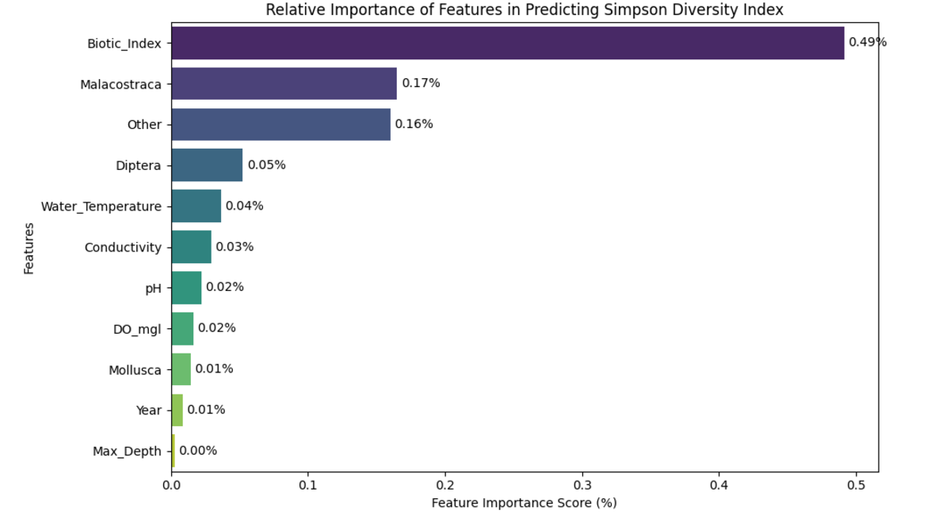

**Prediction for Simpson index over time till the year 2027**

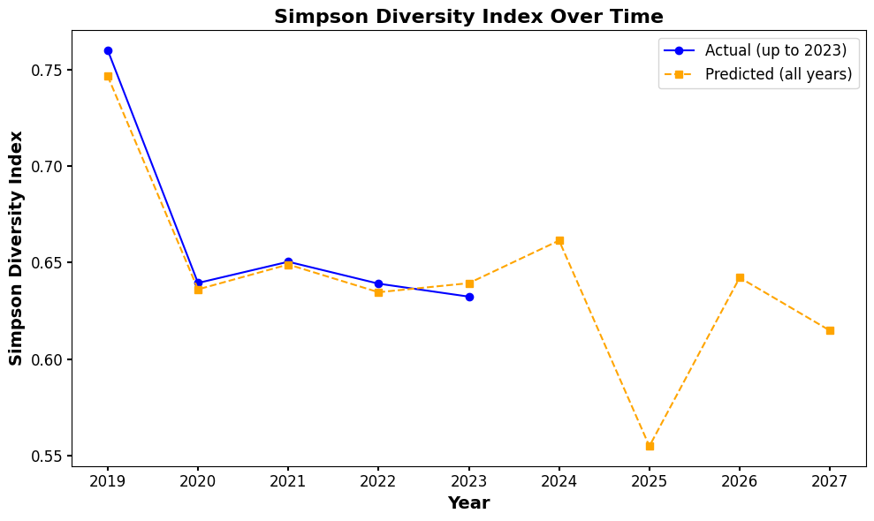

**Analysis of Temporal Trends in Simpson Diversity Index**  
The predicted trends in the Simpson Diversity Index (SDI) over the years (2019–2027) reveal key insights into the ecological health of monitored lakes. As shown in the graph, actual and predicted SDI values align closely, reflecting the model's robustness in capturing temporal biodiversity patterns.

The observed decrease in the Simpson Diversity Index after 2024 highlights potential ecological disturbances. This decline could be driven by factors such as habitat degradation, pollution, or climate variability affecting species richness and evenness. The steady recovery during earlier years suggests that ecosystems may be resilient under favorable conditions, but the downward trend in later years warrants further investigation into causal drivers, such as changes in water quality, land use, or species invasions.

**Implications of the Trend:**

1. **Benefits:**
   * These predictive trends help identify periods of biodiversity stress, allowing for targeted conservation actions.
   * Early recognition of a declining trend empowers stakeholders to mitigate threats proactively.
2. **Hindrances:**
   * A persistent decline in SDI could indicate a loss of ecosystem services provided by these water bodies, such as water purification and habitat stability.
   * It reflects reduced ecological resilience, potentially leading to trophic imbalances and increased vulnerability to external pressures.

**Call to Action:**  
A collaborative effort is essential to address the factors driving biodiversity loss. Monitoring programs should incorporate variables like nutrient loading, invasive species, and climatic parameters to better understand long-term ecological shifts.

Question 2 part 2) **Interest in pairing biological response factors to water chemistry**

**Introduction:**  
Understanding the relationship between water chemistry parameters and biological responses is essential for monitoring aquatic ecosystems. This study examines key water chemistry factors — water temperature, dissolved oxygen (DO), conductivity, and pH — to identify patterns that influence biological processes in freshwater systems.

**Key Findings from Analysis:**

1. **Water Temperature and Dissolved Oxygen (DO):**
   * Temperature varies between 5°C and 25°C, influencing DO levels. Warmer waters tend to hold less oxygen, which could affect species reliant on higher oxygen concentrations. A negative relationship between temperature and DO is observed, particularly in warmer ranges.
   * Cooler waters maintain higher DO, favorable for oxygen-demanding aquatic life.
2. **Dissolved Oxygen and Biological Viability:**
   * DO concentrations cluster around 7.5–12.5 mg/L, a range that typically supports healthy aquatic ecosystems. Outliers in DO may indicate stress events like algal blooms or eutrophication.
3. **Conductivity as a Measure of Water Quality:**
   * Conductivity spans from 20 to 150 µS/cm, reflecting variations in ion concentrations. Higher conductivity may indicate nutrient-rich conditions or pollutants affecting species diversity.
   * Potential positive relationships between conductivity and DO suggest regions with better nutrient cycling.
4. **pH Stability and Ecosystem Health:**
   * pH levels (6.5–9) suggest a generally neutral to slightly basic environment, ideal for many freshwater organisms. Variations in pH may correlate with changes in DO and conductivity, highlighting buffering capacity or external inputs (e.g., acid rain or pollution).
5. **Emerging Patterns in Pairwise Relationships:**
   * Symmetry in scatterplots highlights balanced interactions between factors, while anomalies in conductivity or DO suggest localized stress or unique chemical conditions.
   * Correlations between pH and DO or conductivity imply interconnected chemical processes driving biological responses.

**Conclusion:**  
The interplay of water chemistry parameters provides insight into the conditions that sustain aquatic life. Patterns observed here underline the importance of maintaining balanced temperature, DO, pH, and conductivity levels to support biological health. Future work should expand this analysis by integrating species-specific responses to these water chemistry parameters.

**Implications for Ecosystem Monitoring:**  
The relationships identified in this study can serve as indicators for water quality management. Regular monitoring of these parameters can help predict biological outcomes and guide conservation efforts in freshwater ecosystems.

