Batch – B
Name: | Kakadiya Manthan R.
ID NO: | 25AIML024
Subject: | AIUE203:WEB TECHNOLOGY

Practical : 1
Problem Statement :
StudentHub is a web portal developed to help students and faculty manage academic activities online.
Objectives :
- create a simple StudentHub portal for students.
- provide important student information in one place.
- allow students to register and login.
- provide a student dashboard.
- display events and student profile.
- provide contact, FAQ, and feedback options.
- provide an admin panel for managing the portal.
User Roles :
● Student
● Faculty
● Admin
Key Features :
- Student Registration – New students can create an account.
- Login System – Students can securely log in.
- Student Dashboard – Shows important student information in one place.
- Events – Displays upcoming college events.
- Student Profile – Students can view their personal details.
- Feedback – Students can submit feedback.
- FAQ – Provides answers to common questions.
- Contact Us – Allows students to contact the college/team.
- Admin Panel – Admin can manage the portal.
- Logout – Allows users to securely log out.
Site Map : -
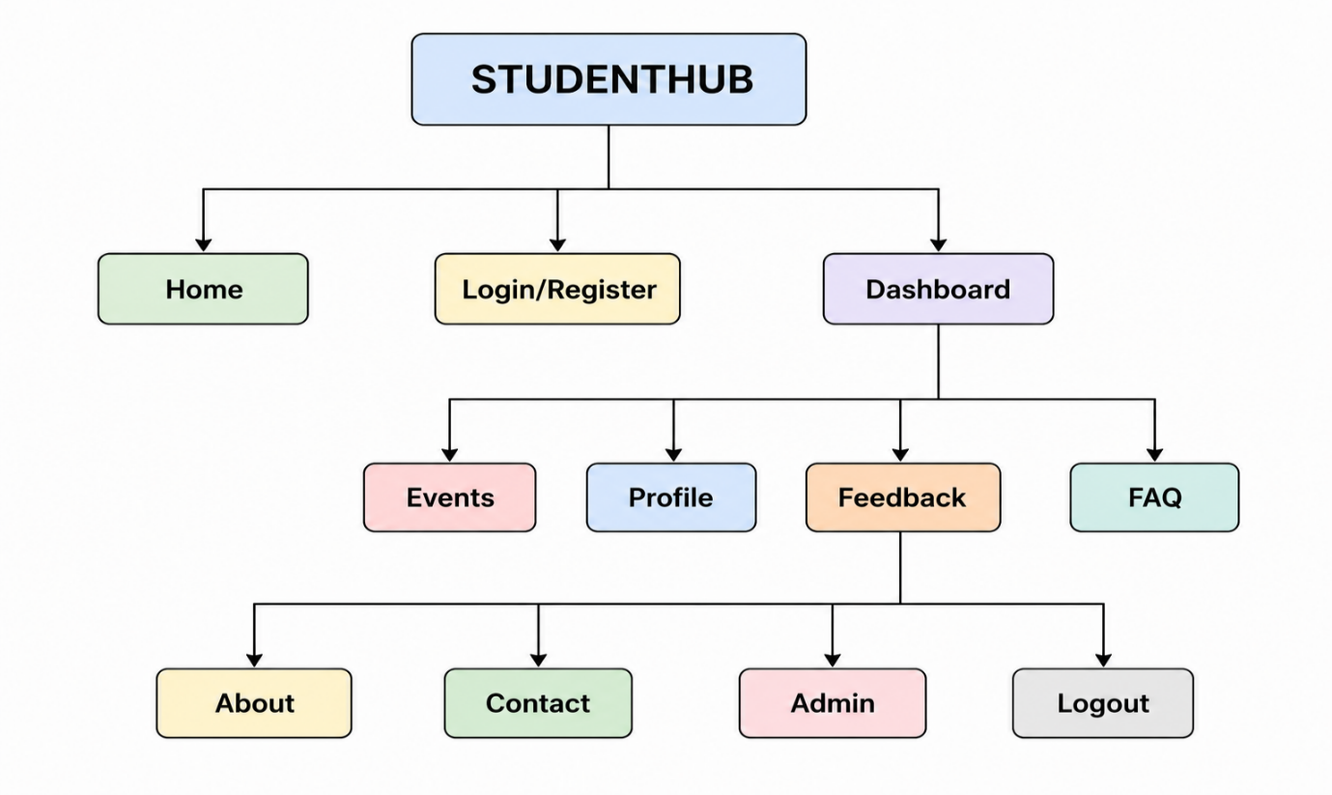

Wirefram :-
Home page :-
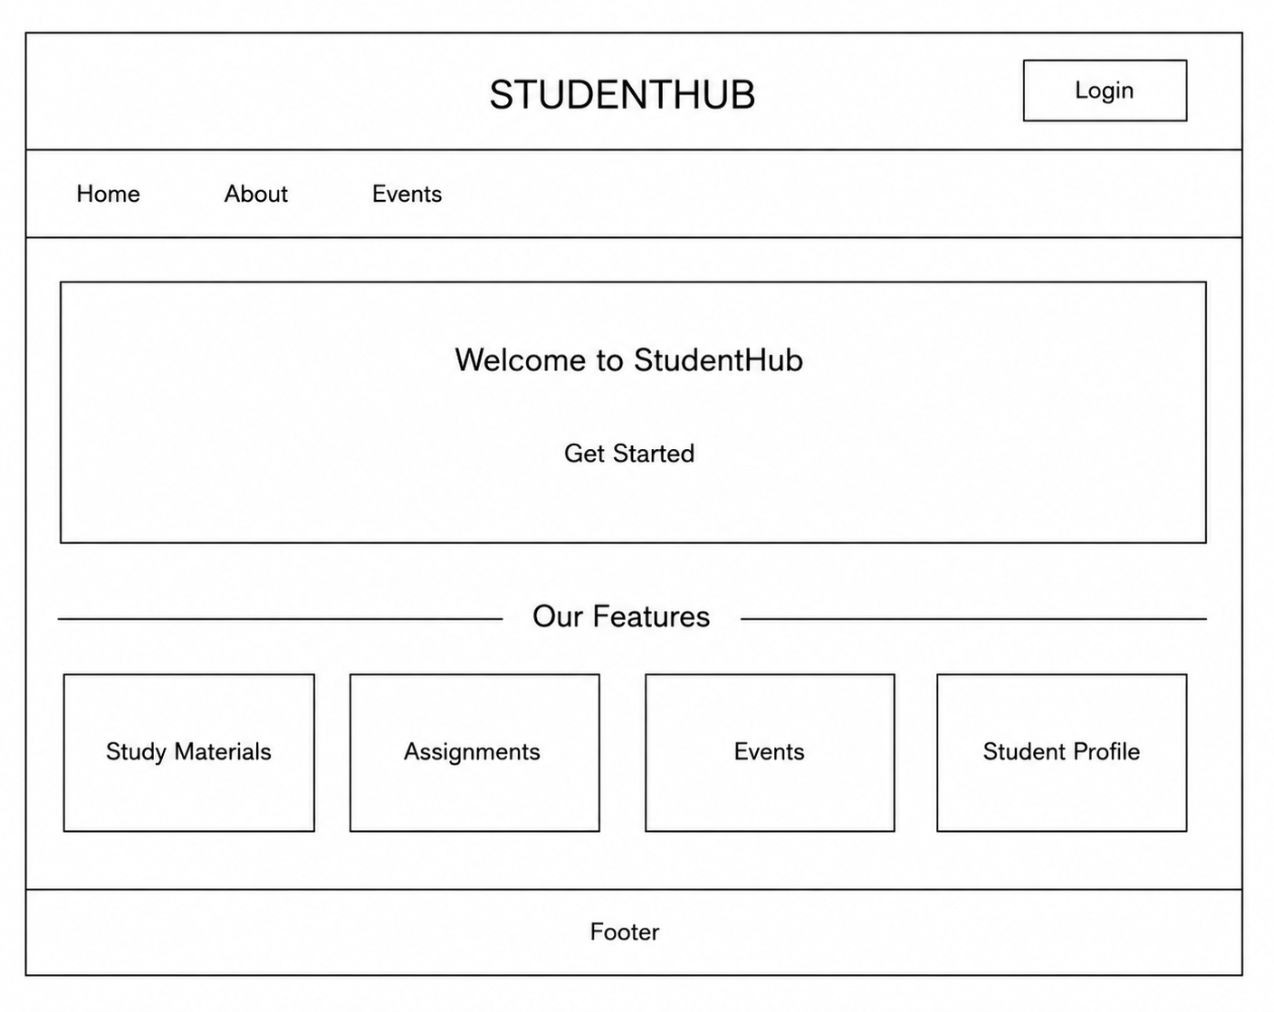

Login page :-
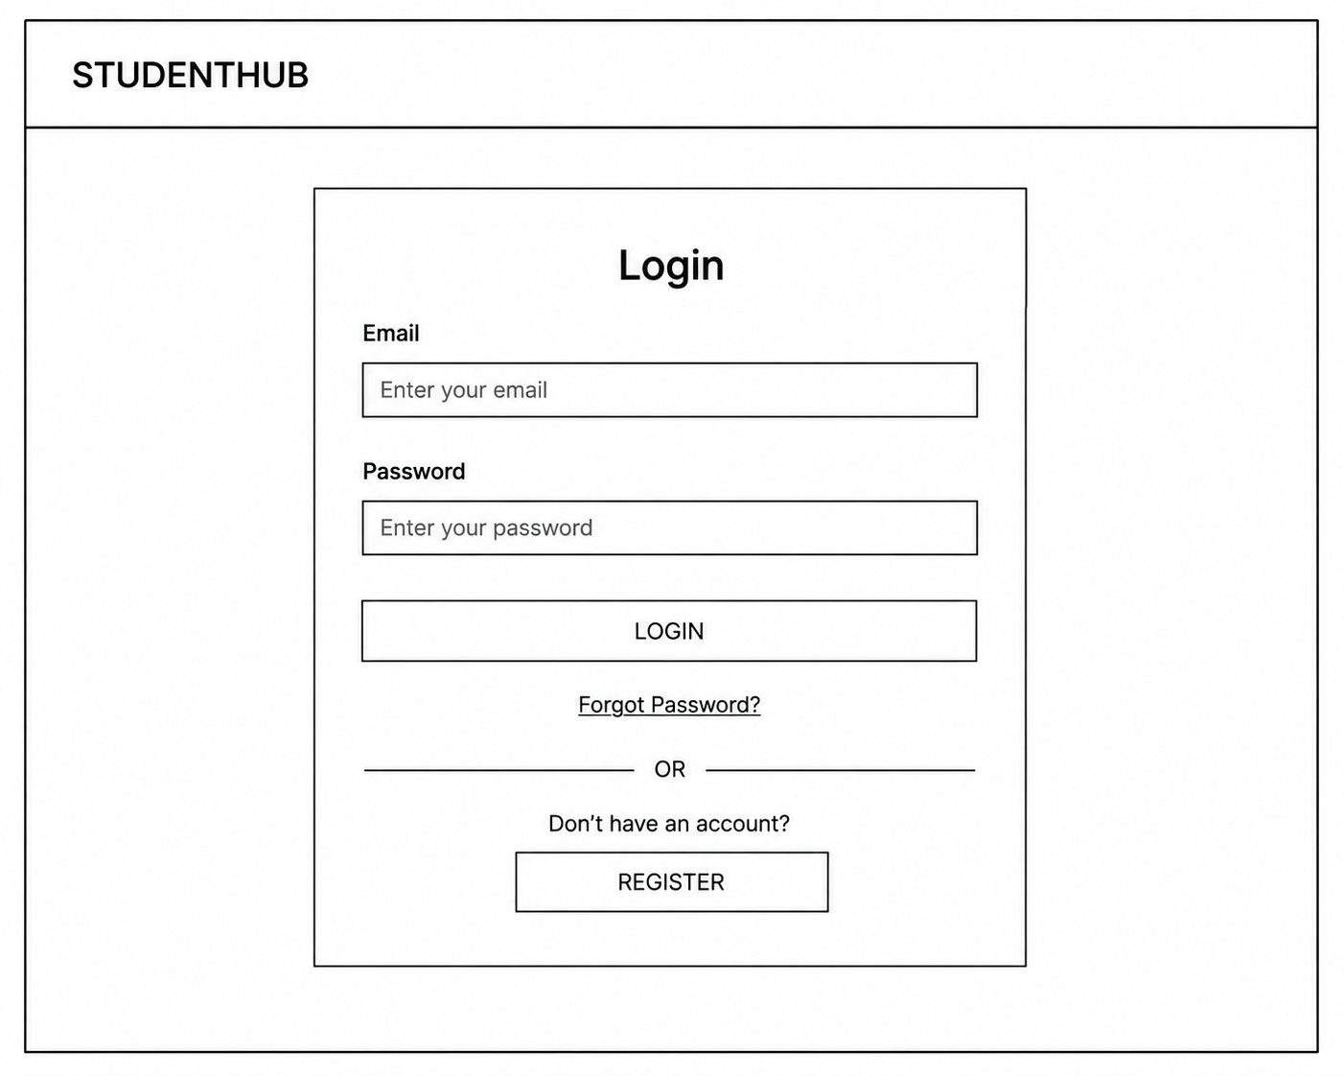

GITHUB LINK :- https://github.com/manthankakadiya/WEB-T

Practical : 2
Folder structure :-
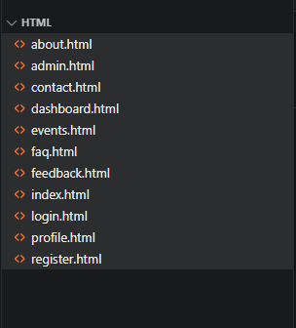

Git hub link :- https://github.com/manthankakadiya/WEB-T
Home page
Source  Code:- | <!DOCTYPE html>  <html lang="en">  <head>  <meta charset="UTF-8">  <meta name="viewport" content="width=device-width, initial-scale=1.0">  <title>StudentHub - Home</title>  </head>  <body>  <header>  <h1>StudentHub</h1>  <nav aria-label="Main Navigation">  <a href="index.html">Home</a> |  <a href="about.html">About</a> |  <a href="register.html">Register</a> |  <a href="login.html">Login</a> |  <a href="dashboard.html">Dashboard</a> |  <a href="events.html">Events</a> |  <a href="profile.html">Profile</a> |  <a href="contact.html">Contact</a> |  <a href="admin.html">Admin</a> |  <a href="faq.html">FAQ</a> |  <a href="feedback.html">Feedback</a>  </nav>  </header>  <main>  <section>  <h2>Welcome to StudentHub</h2>  <p>A platform for students to connect, learn and participate in events.</p>  </section>  </main>  <footer>  <p>&copy; 2026 StudentHub</p>  </footer>  </body>  </html>
 | 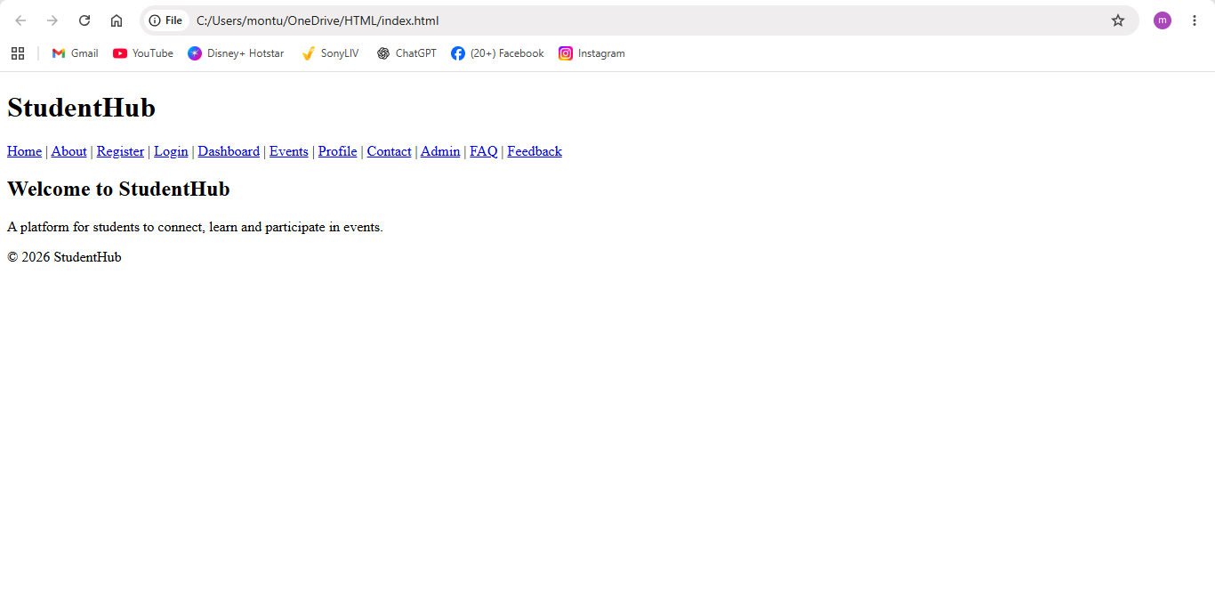

About.html
Source  Code :- | <!DOCTYPE html>  <html lang="en">  <head>  <meta charset="UTF-8">  <meta name="viewport" content="width=device-width, initial-scale=1.0">  <title>About - StudentHub</title>  </head>  <body>  <header>  <h1>About StudentHub</h1>  <nav aria-label="Main Navigation">  <a href="index.html">Home</a> |  <a href="about.html">About</a> |  <a href="contact.html">Contact</a>  </nav>  </header>  <main>  <section>  <h2>Who We Are</h2>  <p>StudentHub is a platform designed to help students communicate and participate in college activities.</p>  </section>  </main>  <footer>  <p>&copy; 2026 StudentHub</p>  </footer>  </body>  </html>
 | 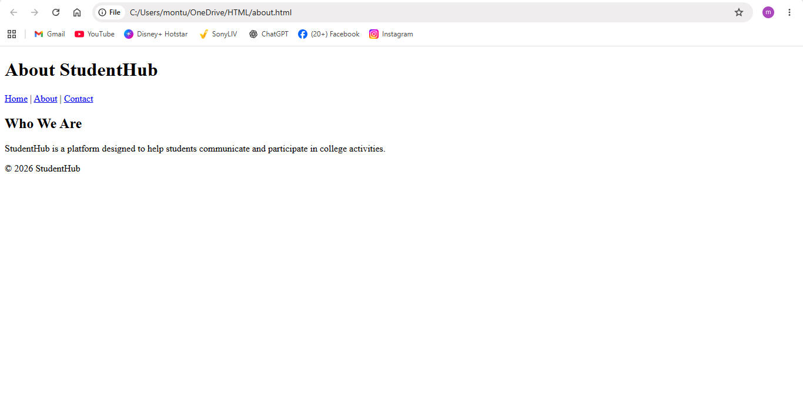

Registration.html
Source  Code : | <!DOCTYPE html>  <html lang="en">  <head>  <meta charset="UTF-8">  <meta name="viewport" content="width=device-width, initial-scale=1.0">  <title>Register - StudentHub</title>  </head>  <body>  <header>  <h1>Student Registration</h1>  </header>  <main>  <section>  <h2>Create Account</h2>  <form>  <label for="name">Name:</label>  <input type="text" id="name" name="name" required>  <br><br>  <label for="email">Email:</label>  <input type="email" id="email" name="email" required>  <br><br>  <label for="password">Password:</label>  <input type="password" id="password" name="password" required>  <br><br>  <button type="submit">Register</button>  </form>  </section>  </main>  <footer>  <p>&copy; 2026 StudentHub</p>  <a href="index.html">Go to Home Page</a>  </footer>  </body>  </html>
 | 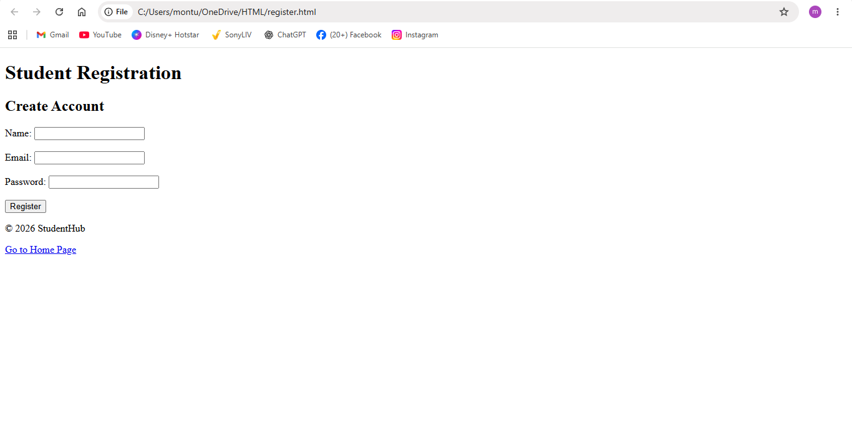

Login.html
Source  Code : |  | <!DOCTYPE html>  <html lang="en">  <head>  <meta charset="UTF-8">  <meta name="viewport" content="width=device-width, initial-scale=1.0">  <title>Login - StudentHub</title>  </head>  <body>  <header>  <h1>StudentHub Login</h1>  </header>  <main>  <section>  <h2>Login</h2>  <form>  <label for="email">Email:</label>  <input type="email" id="email" name="email" required>  <br><br>  <label for="password">Password:</label>  <input type="password" id="password" name="password" required>  <br><br>  <button type="submit">Login</button>  </form>  </section>  </main>  <footer>  <p>&copy; 2026 StudentHub</p>  <a href="index.html">Go to Home Page</a>  </footer>  </body>  </html>
 | 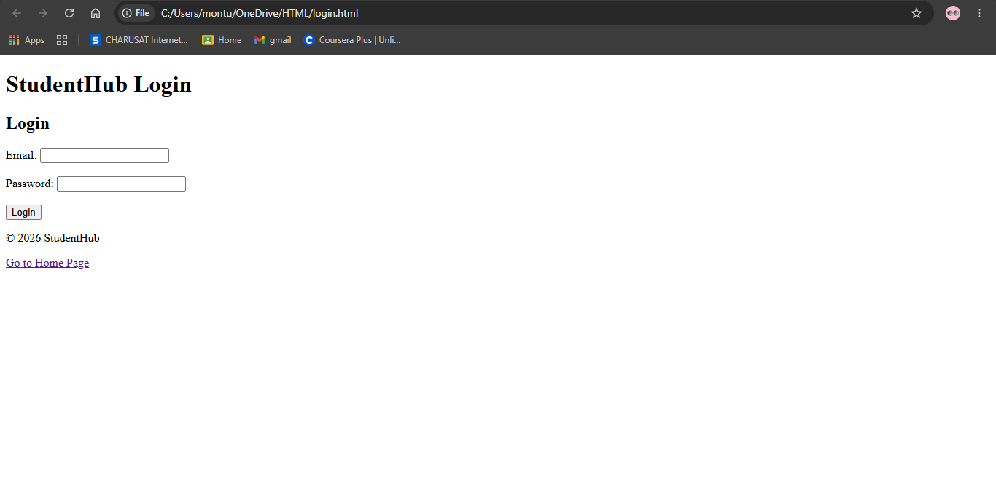

Dashboard.html
Source  Code :- | <!DOCTYPE html>  <html lang="en">  <head>  <meta charset="UTF-8">  <meta name="viewport" content="width=device-width, initial-scale=1.0">  <title>Dashboard - StudentHub</title>  </head>  <body>  <header>  <h1>Student Dashboard</h1>  <nav aria-label="Dashboard Navigation">  <a href="profile.html">Profile</a> |  <a href="events.html">Events</a> |  <a href="index.html">Logout</a>  </nav>  </header>  <main>  <section>  <h2>Welcome Student</h2>  <p>View your activities, events and profile.</p>  </section>  </main>  <footer>  <p>&copy; 2026 StudentHub</p>  </footer>  </body>  </html>
 | 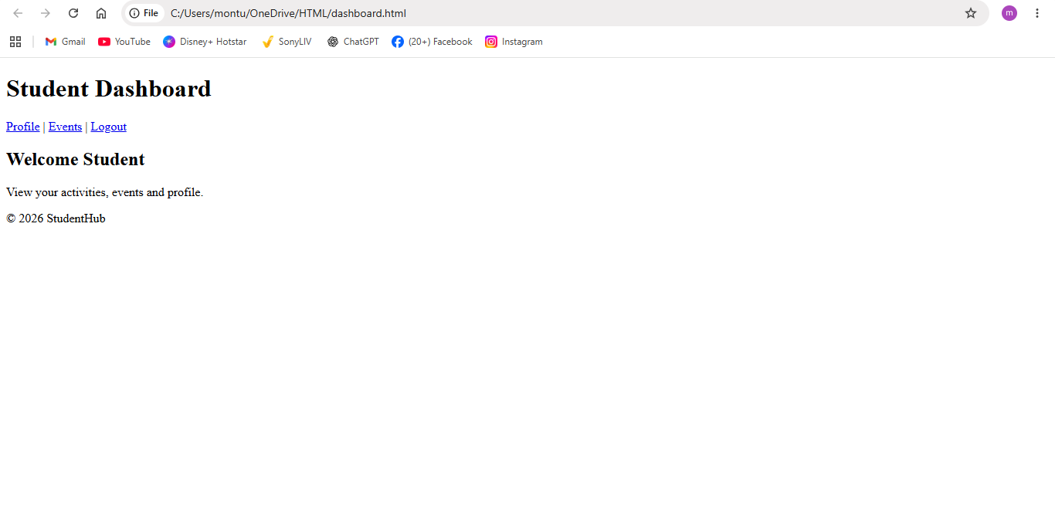

Events.html
Source  Code : | <!DOCTYPE html>  <html lang="en">  <head>  <meta charset="UTF-8">  <meta name="viewport" content="width=device-width, initial-scale=1.0">  <title>Events - StudentHub</title>  </head>  <body>  <header>  <h1>StudentHub Events</h1>  <nav aria-label="Main Navigation">  <a href="index.html">Home</a> |  <a href="dashboard.html">Dashboard</a> |  <a href="contact.html">Contact</a>  </nav>  </header>  <main>  <section>  <h2>Upcoming Events</h2>  <article>  <h3>Web Development Workshop</h3>  <p>Date: 15 August 2026</p>  </article>  <article>  <h3>Sports Day</h3>  <p>Date: 20 August 2026</p>  </article>  </section>  </main>  <footer>  <p>&copy; 2026 StudentHub</p>  </footer>  </body>  </html>
 | 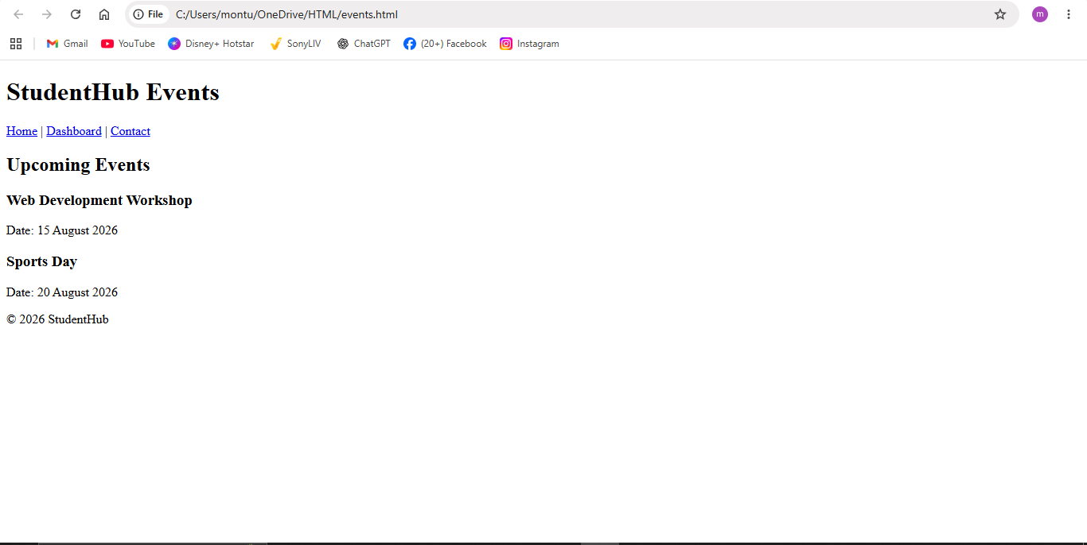

Profile.html
Source code : | <!DOCTYPE html>  <html lang="en">  <head>  <meta charset="UTF-8">  <meta name="viewport" content="width=device-width, initial-scale=1.0">  <title>Profile - StudentHub</title>  </head>  <body>  <header>  <h1>Student Profile</h1>  <nav aria-label="Profile Navigation">  <a href="dashboard.html">Dashboard</a> |  <a href="index.html">Home</a>  </nav>  </header>  <main>  <section>  <h2>My Profile</h2>  <p><strong>Name:</strong> Student Name</p>  <p><strong>Email:</strong> student@example.com</p>  <p><strong>Course:</strong> Computer Science</p>  </section>  </main>  <footer>  <p>&copy; 2026 StudentHub</p>  </footer>  </body>  </html>
 | 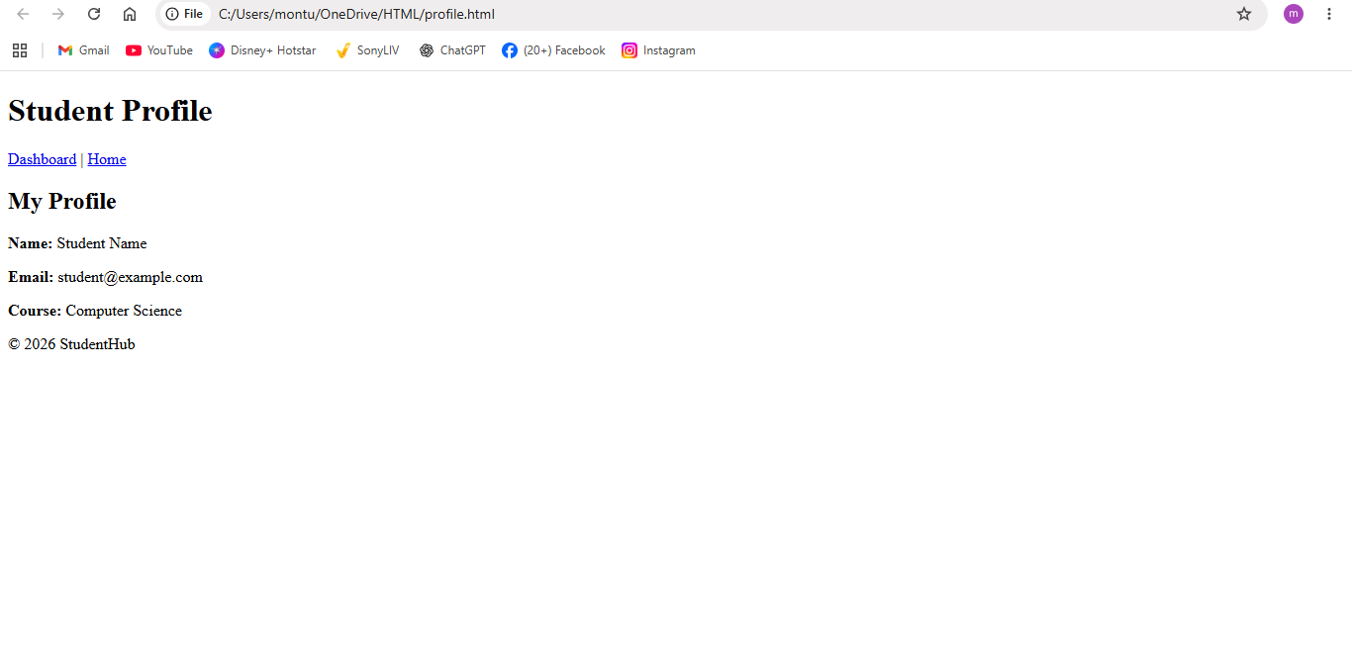

Admin.html
Source code:- | <!DOCTYPE html>  <html lang="en">  <head>  <meta charset="UTF-8">  <meta name="viewport" content="width=device-width, initial-scale=1.0">  <title>Admin - StudentHub</title>  </head>  <body>  <header>  <h1>Admin Panel</h1>  <nav aria-label="Admin Navigation">  <a href="dashboard.html">Dashboard</a> |  <a href="events.html">Events</a> |  <a href="index.html">Logout</a>  </nav>  </header>  <main>  <section>  <h2>Manage StudentHub</h2>  <ul>  <li>Manage Students</li>  <li>Manage Events</li>  <li>View Feedback</li>  </ul>  </section>  </main>  <footer>  <p>&copy; 2026 StudentHub</p>  </footer>  </body>  </html>
 | 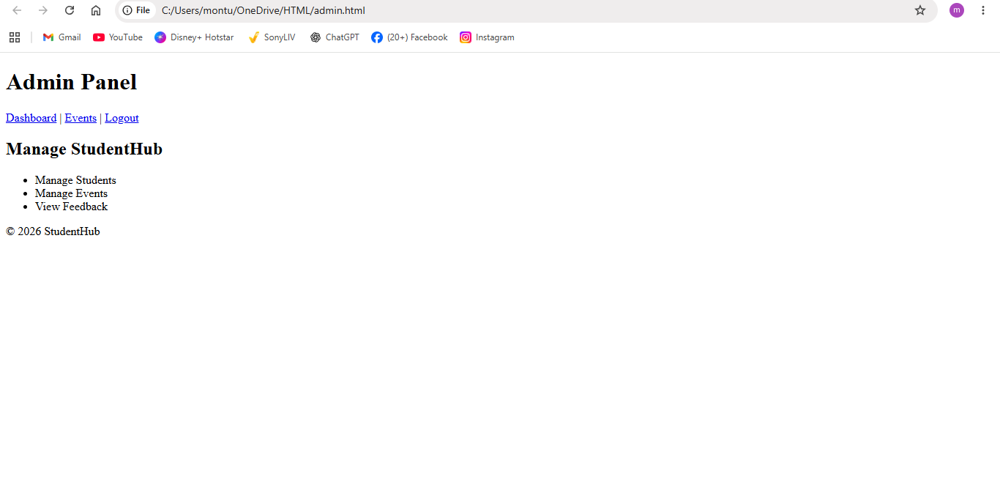

Contacts.html
Source  Code: | <!DOCTYPE html>  <html lang="en">  <head>  <meta charset="UTF-8">  <meta name="viewport" content="width=device-width, initial-scale=1.0">  <title>Contact - StudentHub</title>  </head>  <body>  <header>  <h1>Contact StudentHub</h1>  </header>  <main>  <section>  <h2>Contact Us</h2>  <form>  <label for="name">Name:</label>  <input type="text" id="name" required>  <br><br>  <label for="message">Message:</label>  <textarea id="message" rows="5" cols="30"></textarea>  <br><br>  <button type="submit">Send Message</button>  </form>  </section>  </main>  <footer>  <p>&copy; 2026 StudentHub</p>  </footer>  </body>  </html>
 | 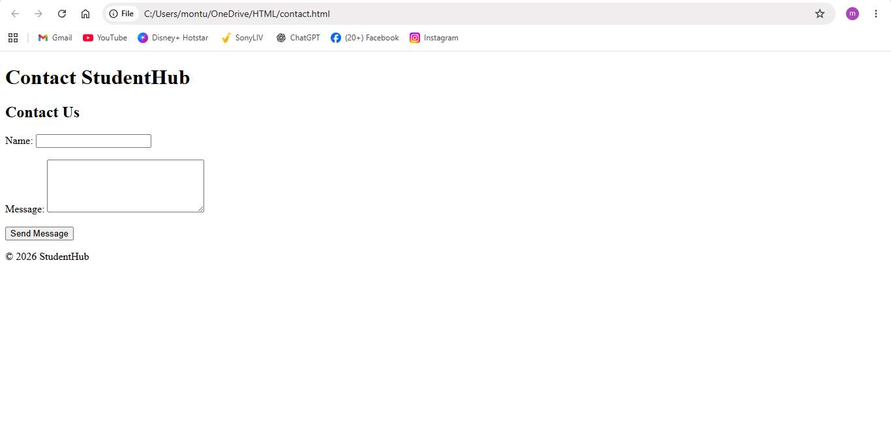

Faq.html
Source  Code: | <!DOCTYPE html>  <html lang="en">  <head>  <meta charset="UTF-8">  <meta name="viewport" content="width=device-width, initial-scale=1.0">  <title>FAQ - StudentHub</title>  </head>  <body>  <header>  <h1>Frequently Asked Questions</h1>  <nav aria-label="Main Navigation">  <a href="index.html">Home</a> |  <a href="contact.html">Contact</a> |  <a href="feedback.html">Feedback</a>  </nav>  </header>  <main>  <section>  <h2>FAQ</h2>  <article>  <h3>What is StudentHub?</h3>  <p>StudentHub is a platform for students.</p>  </article>  <article>  <h3>How can I register?</h3>  <p>Click on the Register page and fill in the form.</p>  </article>  </section>  </main>  <footer>  <p>&copy; 2026 StudentHub</p>  </footer>  </body>  </html>
 | 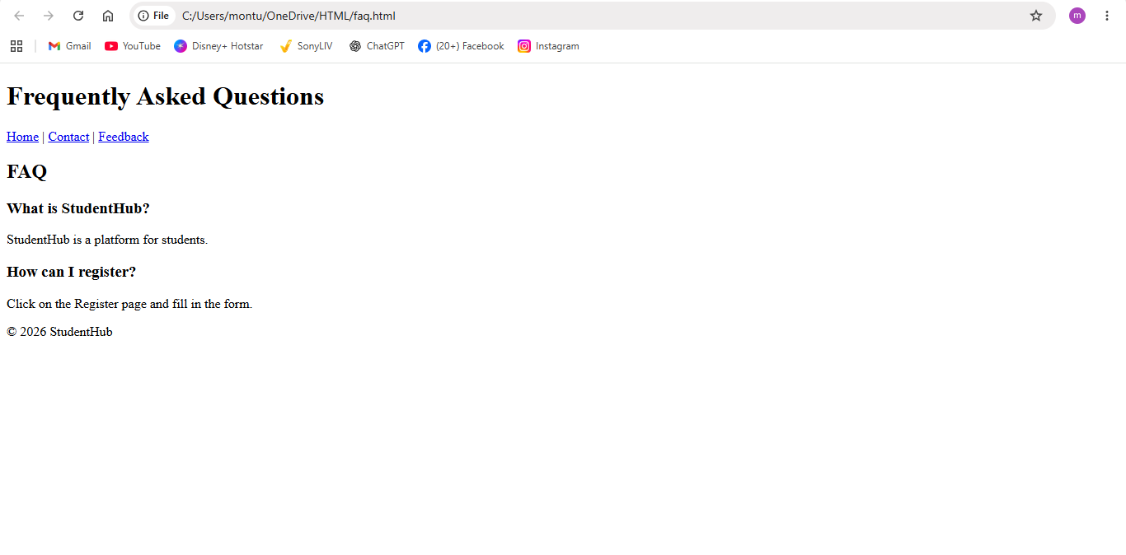

Fedback.html
Source code: | <!DOCTYPE html>  <html lang="en">  <head>  <meta charset="UTF-8">  <meta name="viewport" content="width=device-width, initial-scale=1.0">  <title>Feedback - StudentHub</title>  </head>  <body>  <header>  <h1>Student Feedback</h1>  </header>  <main>  <section>  <h2>Give Your Feedback</h2>  <form>  <label for="name">Name:</label>  <input type="text" id="name" required>  <br><br>  <label for="feedback">Feedback:</label>  <textarea id="feedback" rows="5" cols="30"></textarea>  <br><br>  <button type="submit">Submit Feedback</button>  </form>  </section>  </main>  <footer>  <p>&copy; 2026 StudentHub</p>  </footer>  </body>  </html>
 | 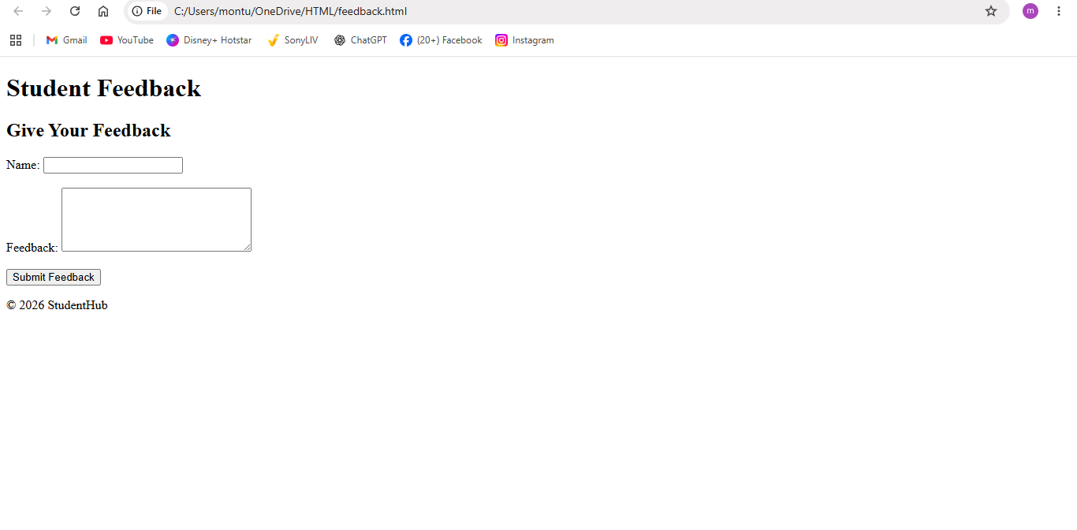

Practical : 3

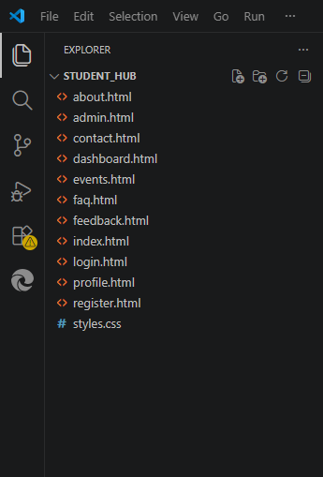

Gihub link :- https://github.com/manthankakadiya/WEB-T

CSS CODE:-
CODE :- | :root {  --green: #2c6e49;  --green-dark: #1f5237;  --green-light: #e8f3ec;  --gold: #d4a24c;  --bg: #eef2f5;  --card: #ffffff;  --text: #222222;  --text-soft: #5a6a63;  --border: #e2e6ea;  --radius: 10px;  --shadow-sm: 0 2px 8px rgba(0, 0, 0, 0.05);  --shadow-md: 0 8px 24px rgba(31, 82, 55, 0.12);  --transition: 0.2s ease;  }  * {  box-sizing: border-box;  }  html {  scroll-behavior: smooth;  }  body {  margin: 0;  font-family: 'Segoe UI', Arial, Helvetica, sans-serif;  background: var(--bg);  color: var(--text);  line-height: 1.6;  animation: fadeIn 0.4s ease both;  }  ::-webkit-scrollbar {  width: 10px;  }  ::-webkit-scrollbar-track {  background: var(--bg);  }  ::-webkit-scrollbar-thumb {  background: var(--green);  border-radius: 10px;  }  a {  color: var(--green);  text-decoration: none;  transition: color var(--transition);  }  a:hover {  color: var(--green-dark);  text-decoration: underline;  }  :focus-visible {  outline: 2px solid var(--gold);  outline-offset: 3px;  border-radius: 4px;  }  @keyframes fadeIn {  from { opacity: 0; }  to { opacity: 1; }  }  @keyframes slideUp {  from { opacity: 0; transform: translateY(14px); }  to { opacity: 1; transform: translateY(0); }  }  @keyframes popIn {  from { opacity: 0; transform: scale(0.92); }  to { opacity: 1; transform: scale(1); }  }  header {  background: linear-gradient(135deg, var(--green), var(--green-dark));  color: #fff;  padding: 1.4rem 1.5rem;  box-shadow: var(--shadow-md);  position: relative;  overflow: hidden;  }  header::after {  content: "";  position: absolute;  top: -60%;  right: -10%;  width: 260px;  height: 260px;  background: radial-gradient(circle, rgba(212, 162, 76, 0.35), transparent 70%);  pointer-events: none;  }  header h1 {  margin: 0 0 0.7rem;  font-size: 1.8rem;  font-weight: 700;  letter-spacing: 0.2px;  position: relative;  }  nav {  font-size: 0.95rem;  position: relative;  }  nav a {  display: inline-block;  color: #fff;  padding: 0.35rem 0.7rem;  margin-right: 0.3rem;  border-radius: 999px;  transition: background var(--transition), transform var(--transition);  }  nav a:hover {  background: rgba(255, 255, 255, 0.18);  text-decoration: none;  transform: translateY(-2px);  }  main {  max-width: 850px;  margin: 2rem auto;  padding: 0 1.2rem;  }  section {  background: var(--card);  border: 1px solid var(--border);  border-radius: var(--radius);  padding: 1.75rem 2rem;  margin-bottom: 1.5rem;  box-shadow: var(--shadow-sm);  transition: box-shadow var(--transition), transform var(--transition);  animation: slideUp 0.45s ease both;  }  section:hover {  box-shadow: var(--shadow-md);  transform: translateY(-2px);  }  h2 {  margin-top: 0;  color: var(--green-dark);  border-bottom: 2px solid var(--green-light);  padding-bottom: 0.6rem;  margin-bottom: 1.1rem;  position: relative;  }  h2::before {  content: "";  display: inline-block;  width: 8px;  height: 8px;  background: var(--gold);  border-radius: 50%;  margin-right: 0.5rem;  }  section p {  color: var(--text-soft);  }  section p strong {  color: var(--green-dark);  }  main section:has(article) {  display: block;  }  main section > article {  border: 1px solid #eee;  border-left: 4px solid var(--green);  border-radius: 8px;  padding: 1rem 1.1rem;  margin-bottom: 1rem;  background: #fbfcfa;  transition: transform var(--transition), box-shadow var(--transition), border-color var(--transition);  animation: popIn 0.35s ease both;  }  main section > article:hover {  transform: translateX(4px);  border-left-color: var(--gold);  box-shadow: var(--shadow-sm);  }  article h3 {  margin: 0 0 0.3rem;  font-size: 1.05rem;  color: var(--green-dark);  }  article p {  margin: 0;  color: #666;  font-size: 0.9rem;  }  main ul {  list-style: none;  padding: 0;  display: grid;  grid-template-columns: repeat(auto-fit, minmax(180px, 1fr));  gap: 0.7rem;  }  main ul li {  background: var(--green-light);  border: 1px solid var(--border);  border-radius: 8px;  padding: 0.9rem 1rem;  font-weight: 600;  color: var(--green-dark);  transition: background var(--transition), transform var(--transition);  }  main ul li:hover {  background: #dcefe3;  transform: translateY(-2px);  }  body:has(#password) main {  display: flex;  justify-content: center;  margin-top: 3rem;  }  body:has(#password) section {  width: 100%;  max-width: 380px;  text-align: center;  padding: 2.2rem 2rem;  animation: popIn 0.4s ease both;  }  body:has(#password) h2 {  border-bottom: none;  font-size: 1.4rem;  }  body:has(#password) h2::before {  display: none;  }  body:has(#password) form {  text-align: left;  margin: 0 auto;  max-width: 100%;  }  form {  display: flex;  flex-direction: column;  max-width: 360px;  }  label {  font-weight: 600;  font-size: 0.85rem;  color: #333;  margin-bottom: 0.3rem;  }  input,  textarea {  padding: 0.65rem 0.75rem;  margin-bottom: 1.1rem;  border: 1.5px solid #d5dade;  border-radius: 6px;  font-size: 0.95rem;  width: 100%;  background: #fff;  transition: border-color var(--transition), box-shadow var(--transition);  }  input:hover,  textarea:hover {  border-color: var(--green);  }  input:focus,  textarea:focus {  outline: none;  border-color: var(--green);  box-shadow: 0 0 0 3px rgba(44, 110, 73, 0.15);  }  textarea {  resize: vertical;  }  button[type="submit"] {  background: linear-gradient(135deg, var(--green), var(--green-dark));  color: #fff;  border: none;  border-radius: 6px;  padding: 0.7rem 1.5rem;  font-size: 0.95rem;  font-weight: 600;  cursor: pointer;  align-self: flex-start;  transition: transform var(--transition), box-shadow var(--transition);  }  button[type="submit"]:hover {  transform: translateY(-2px);  box-shadow: 0 6px 14px rgba(31, 82, 55, 0.3);  }  button[type="submit"]:active {  transform: translateY(0);  }  body:has(#password) button[type="submit"] {  align-self: stretch;  }  footer {  text-align: center;  padding: 1.2rem;  color: var(--text-soft);  font-size: 0.85rem;  }  footer a {  display: inline-block;  margin-top: 0.3rem;  font-weight: 500;  }  @media (max-width: 600px) {  main {  margin: 1.2rem auto;  }  form, input, textarea {  max-width: 100%;  }  body:has(#password) section {  max-width: 100%;  }  main ul {  grid-template-columns: 1fr;  }  }  @media (prefers-reduced-motion: reduce) {  html { scroll-behavior: auto; }  *, *::before, *::after {  animation: none !important;  transition: none !important;  }  }

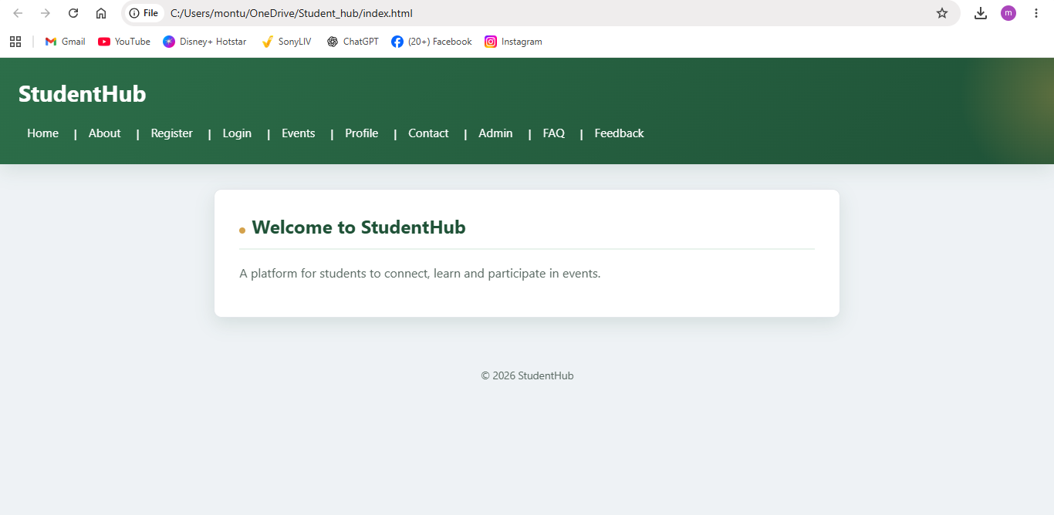
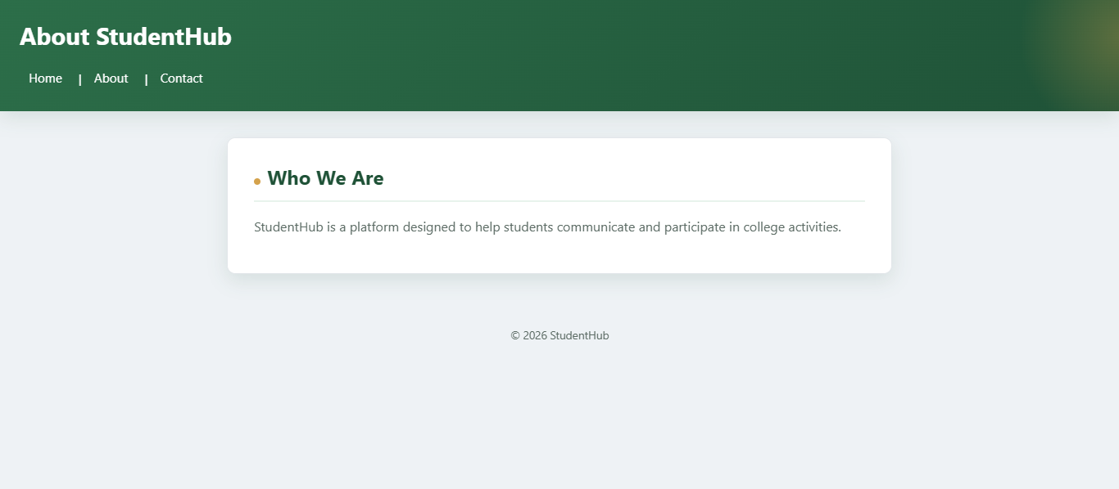
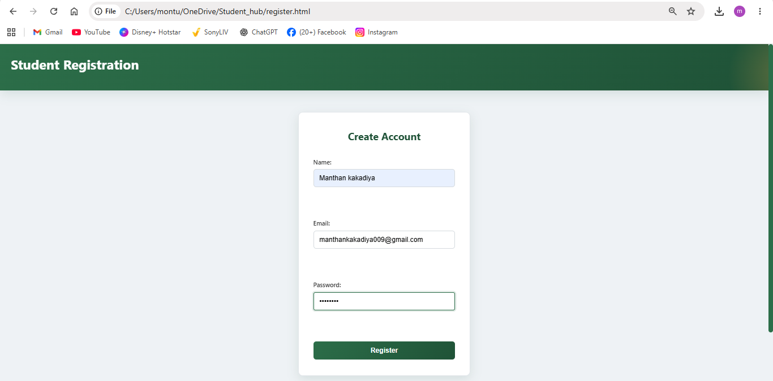
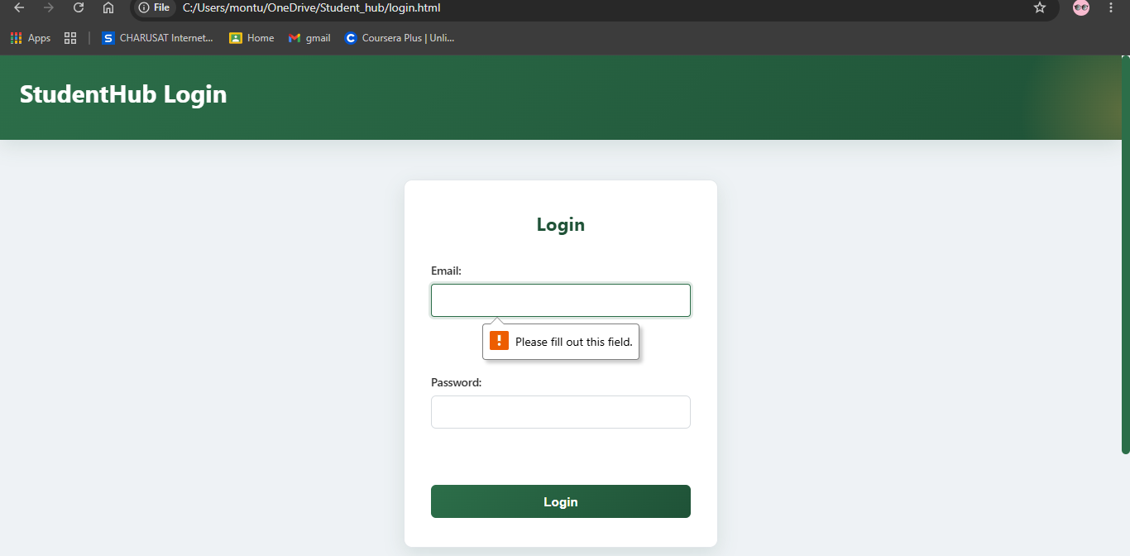
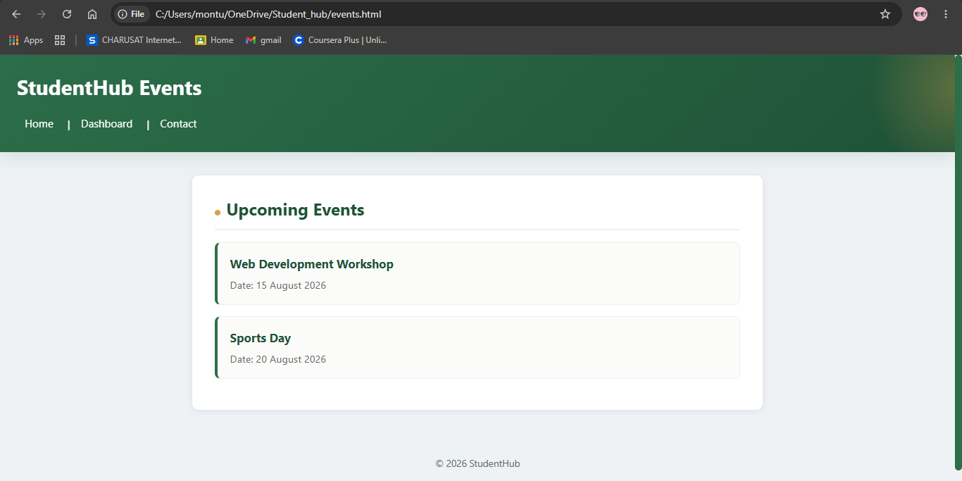
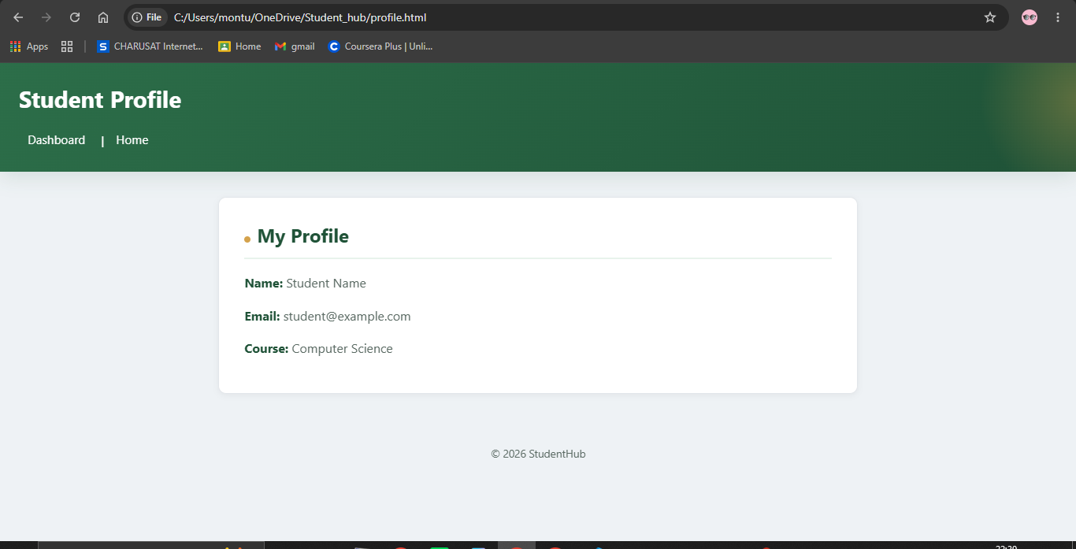
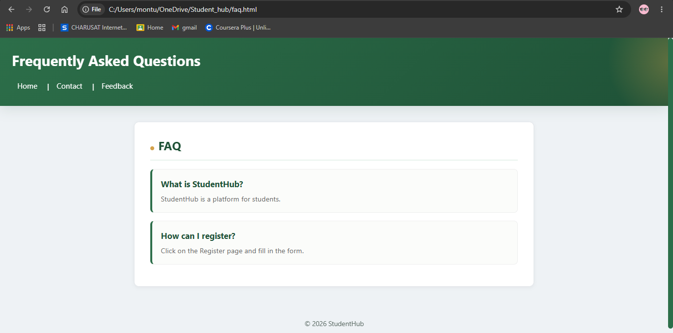
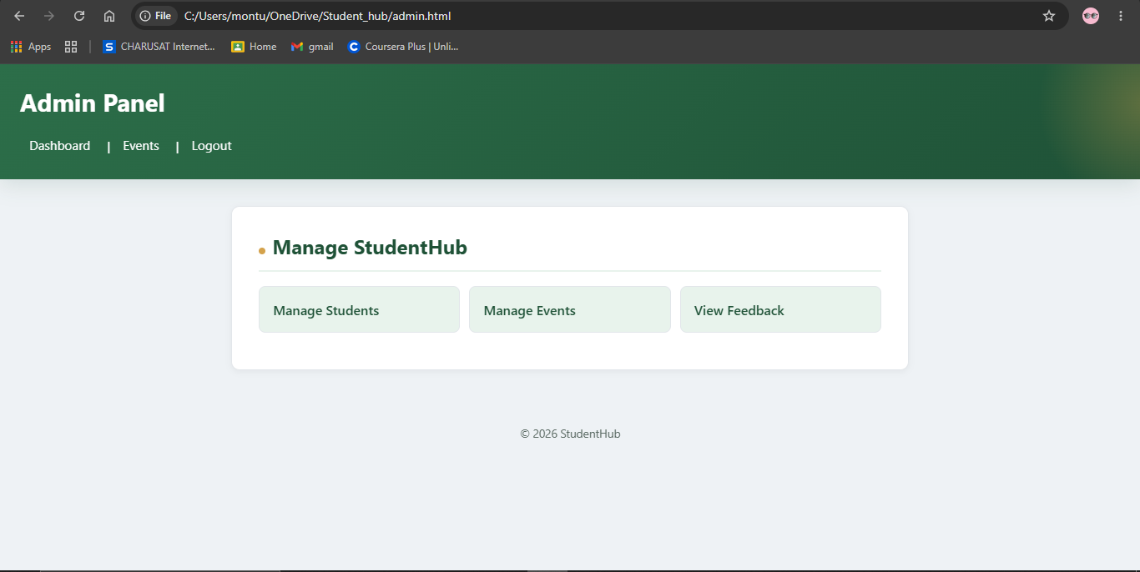

Practical : 5
Registartion  _validation.js | document.addEventListener("DOMContentLoaded", function () {  var form = document.getElementById("registration-form");  if (!form) return;  var successBox = document.getElementById("reg-success-message");  var PATTERNS = {  name: /^[A-Za-z]+(?:['-][A-Za-z]+)*(?:\s+[A-Za-z]+(?:['-][A-Za-z]+)*)+$/,  email: /^[a-zA-Z0-9._%+-]+@[a-zA-Z0-9.-]+\.[a-zA-Z]{2,}$/,  mobile: /^[2-9][0-9]{9}$/,  password:  /^(?=.*[a-z])(?=.*[A-Z])(?=.*\d)(?=.*[@$!%*?&#^()_+=-])[A-Za-z\d@$!%*?&#^()_+=-]{8,}$/  };  var fields = [  {  input: document.getElementById("reg-name"),  error: document.getElementById("reg-name-error"),  validate: function (value) {  value = value.trim();  if (value === "") {  return "Full name is required.";  }  if (!PATTERNS.name.test(value)) {  return "Please enter your first and last name using letters only.";  }  return "";  }  },  {  input: document.getElementById("reg-email"),  error: document.getElementById("reg-email-error"),  validate: function (value) {  value = value.trim();  if (value === "") {  return "Email address is required.";  }  if (!PATTERNS.email.test(value)) {  return "Please enter a valid email address, e.g. name@gmail.com.";  }  return "";  }  },  {  input: document.getElementById("reg-mobile"),  error: document.getElementById("reg-mobile-error"),  validate: function (value) {  value = value.trim();  if (value === "") {  return "Mobile number is required.";  }  if (!PATTERNS.mobile.test(value)) {  return "Please enter a valid 10-digit mobile number.";  }  return "";  }  },  {  input: document.getElementById("password"),  error: document.getElementById("password-error"),  validate: function (value) {  if (value === "") {  return "Password is required.";  }  if (!PATTERNS.password.test(value)) {  return "Password must contain 8+ characters, uppercase, lowercase, number and special character.";  }  return "";  }  },  {  input: document.getElementById("confirm-password"),  error: document.getElementById("confirm-password-error"),  validate: function (value) {  var password = document.getElementById("password").value;  if (value === "") {  return "Please confirm your password.";  }  if (value !== password) {  return "Passwords do not match.";  }  return "";  }  }  ];  function validateField(field) {  if (!field.input || !field.error) {  return true;  }  var message = field.validate(field.input.value);  field.error.textContent = message;  if (message !== "") {  field.input.classList.add("invalid");  field.input.classList.remove("valid");  field.input.setAttribute("aria-invalid", "true");  return false;  } else {  field.input.classList.remove("invalid");  field.input.classList.add("valid");  field.input.setAttribute("aria-invalid", "false");  return true;  }  }  function validateGender() {  var gender =  form.querySelector('input[name="gender"]:checked');  var error =  document.getElementById("reg-gender-error");  if (!gender) {  error.textContent = "Please select your gender.";  return false;  }  error.textContent = "";  return true;  }  function validateTerms() {  var terms =  document.getElementById("reg-terms");  var error =  document.getElementById("reg-terms-error");  if (!terms.checked) {  error.textContent =  "Please accept the Terms & Conditions.";  return false;  }  error.textContent = "";  return true;  }  fields.forEach(function (field) {  if (!field.input) return;  field.input.addEventListener("blur", function () {  validateField(field);  });  field.input.addEventListener("input", function () {  if (  field.input.classList.contains("invalid") ||  field.input.classList.contains("valid")  ) {  validateField(field);  }  });  });  form  .querySelectorAll('input[name="gender"]')  .forEach(function (radio) {  radio.addEventListener("change", validateGender);  });  var termsCheckbox =  document.getElementById("reg-terms");  if (termsCheckbox) {  termsCheckbox.addEventListener(  "change",  validateTerms  );  }  form.addEventListener("submit", function (e) {  e.preventDefault();  var allValid = true;  var firstInvalidElement = null;  fields.forEach(function (field) {  if (!field.input) return;  var valid = validateField(field);  if (!valid && firstInvalidElement === null) {  firstInvalidElement = field.input;  }  if (!valid) {  allValid = false;  }  });  var genderValid = validateGender();  if (!genderValid) {  allValid = false;  if (!firstInvalidElement) {  firstInvalidElement =  form.querySelector('input[name="gender"]');  }  }  var termsValid = validateTerms();  if (!termsValid) {  allValid = false;  if (!firstInvalidElement) {  firstInvalidElement = termsCheckbox;  }  }  if (!allValid) {  if (successBox) {  successBox.textContent = "";  successBox.classList.remove("show");  }  if (firstInvalidElement) {  firstInvalidElement.focus();  }  return;  }  var name =  document  .getElementById("reg-name")  .value  .trim();  var firstName =  name.split(" ")[0];  alert(  "🎉 Registration Successful!\n\n" +  "Welcome to StudentHub, " +  firstName +  "!"  );  if (successBox) {  successBox.textContent =  "🎉 Registration successful! Welcome to StudentHub, " +  firstName +  ".";  successBox.classList.add("show");  }  form.reset();  fields.forEach(function (field) {  if (!field.input) return;  field.input.classList.remove(  "valid",  "invalid"  );  field.input.removeAttribute(  "aria-invalid"  );  });  });  });

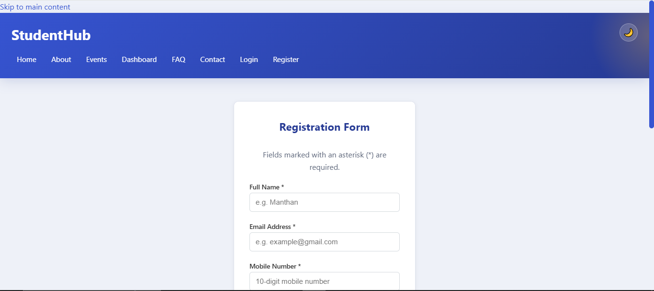

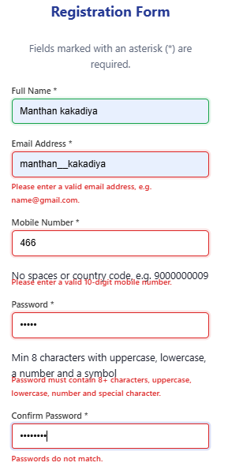

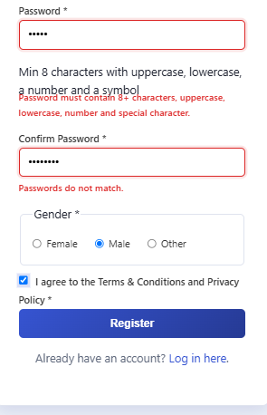

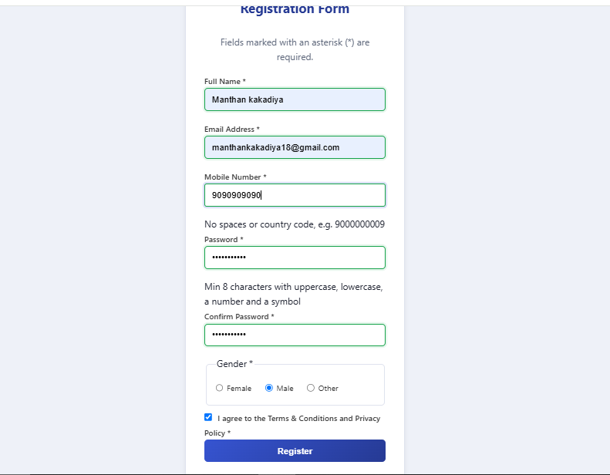

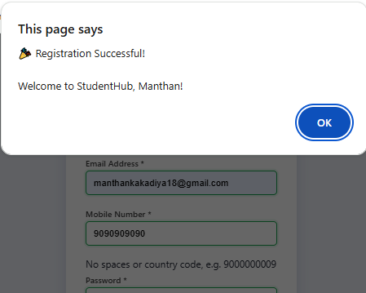

Practical : 6
Objective:
To fetch external JSON data using the Fetch API and dynamically display event information on a web page. Implement search, category filtering, sorting, and pagination using JavaScript array methods.

Theory:
JSON (JavaScript Object Notation) is a lightweight format used to store and exchange data.
The Fetch API is used in JavaScript to retrieve data from external files such as JSON files.
In this practical:
- fetch() is used to load events.json.
- response.json() converts the response into JavaScript data.
- filter() is used for searching and category filtering.
- sort() is used to arrange events by name.
- slice() is used for pagination.
- forEach() is used to display each event.
- catch() is used to handle errors.
- DOM methods are used to display the data on the webpage.

Code:
Event.html
<!DOCTYPE html>
<html lang="en">
<head>
<link rel = "stylesheet" href = "C:\Users\montu\OneDrive\Student_hub\styles.css">
<meta charset="UTF-8">
<meta name="viewport" content="width=device-width, initial-scale=1.0">
<title>Events - StudentHub</title>
<style>

body {
font-family: Arial;
margin: 30px;
}

h1 {
text-align: center;
}

input, select, button {
padding: 8px;
margin: 5px;
}

.event {
border: 1px solid black;
padding: 10px;
margin: 10px;
}

</style>
</head>
<body>
<header>
<h1>StudentHub Events</h1>
<nav aria-label="Main Navigation">
<a href="index.html">Home</a> |
<a href="dashboard.html">Dashboard</a> |
<a href="contact.html">Contact</a>
</nav>
</header>
<h1>College Events</h1>

<!-- Search -->
<input type="text" id="search" placeholder="Search event">

<!-- Filter -->
<select id="category">

<option value="All">All</option>
<option value="Workshop">Workshop</option>
<option value="Seminar">Seminar</option>
<option value="Competition">Competition</option>

</select>

<!-- Sort -->
<button onclick="sortEvents()">
Sort by Name
</button>

<!-- <hr> -->

<div id="output">Loading...</div>

<br>

<!-- Pagination -->
<button onclick="previousPage()">
Previous
</button>

<button onclick="nextPage()">
Next
</button>

<script>

let events = [];
let page = 1;
let perPage = 5;

// Fetch JSON data
fetch("events.json")
.then(response => response.json())
.then(data => {
events = data;
displayEvents();

})

.catch(error => {
document.getElementById("output").innerHTML =
"Error loading data";
});

// Display events
function displayEvents() {

let searchText = document.getElementById("search") .value.toLowerCase();
let category =document.getElementById("category").value;
// Search
let result = events.filter(function(event) {
return event.name .toLowerCase() .includes(searchText);

});

// Filter
if (category != "All") {
result = result.filter(function(event) {
return event.category == category;
});

}

// Pagination
let start = (page - 1) * perPage;
let end = start + perPage;
let pageData = result.slice(start, end);

// Display
let output = "";

pageData.forEach(function(event) {
output +="<div class='event'>" + "<h3>" + event.name + "</h3>" +
"<p>Category: " + event.category + "</p>" +
"<p>Date: " + event.date + "</p>" +
"</div>";

});

document.getElementById("output")
.innerHTML = output;

}

// Search
document.getElementById("search")
.addEventListener("input", function() {
page = 1;
displayEvents();
});

// Filter
document.getElementById("category").addEventListener("change", function() {
page = 1;
displayEvents();
});

// Sort
function sortEvents() {
events.sort(function(a, b) {
return a.name.localeCompare(b.name);

});

displayEvents();
}

// Next page
function nextPage() {
page++;
displayEvents();
}

// Previous page
function previousPage() {
if (page > 1) {
page--;
displayEvents();
}
}

</script>
<footer>
<p>&copy; 2026 StudentHub</p>
</footer>
<script src="script.js"></script>
</body>
</html>

Event.json
[
{
"name": "AI Workshop",
"category": "Workshop",
"date": "20-08-2026"
},
{
"name": "Hackathon",
"category": "Competition",
"date": "22-08-2026"
},
{
"name": "Flutter Workshop",
"category": "Workshop",
"date": "25-08-2026"
},
{
"name": "Coding Contest",
"category": "Competition",
"date": "28-08-2026"
},
{
"name": "Web Seminar",
"category": "Seminar",
"date": "01-09-2026"
},
{
"name": "Python Workshop",
"category": "Workshop",
"date": "03-09-2026"
},
{
"name": "Tech Talk",
"category": "Seminar",
"date": "05-09-2026"
},
{
"name": "Java Contest",
"category": "Competition",
"date": "08-09-2026"
},
{
"name": "Cyber Security Workshop",
"category": "Workshop",
"date": "10-09-2026"
},
{
"name": "AI Seminar",
"category": "Seminar",
"date": "12-09-2026"
},
{
"name": "Code Hackathon",
"category": "Competition",
"date": "15-09-2026"
},
{
"name": "Cloud Workshop",
"category": "Workshop",
"date": "18-09-2026"
},
{
"name": "Data Science Seminar",
"category": "Seminar",
"date": "20-09-2026"
},
{
"name": "Web Design Contest",
"category": "Competition",
"date": "22-09-2026"
},
{
"name": "JavaScript Workshop",
"category": "Workshop",
"date": "25-09-2026"
}
]

Output:
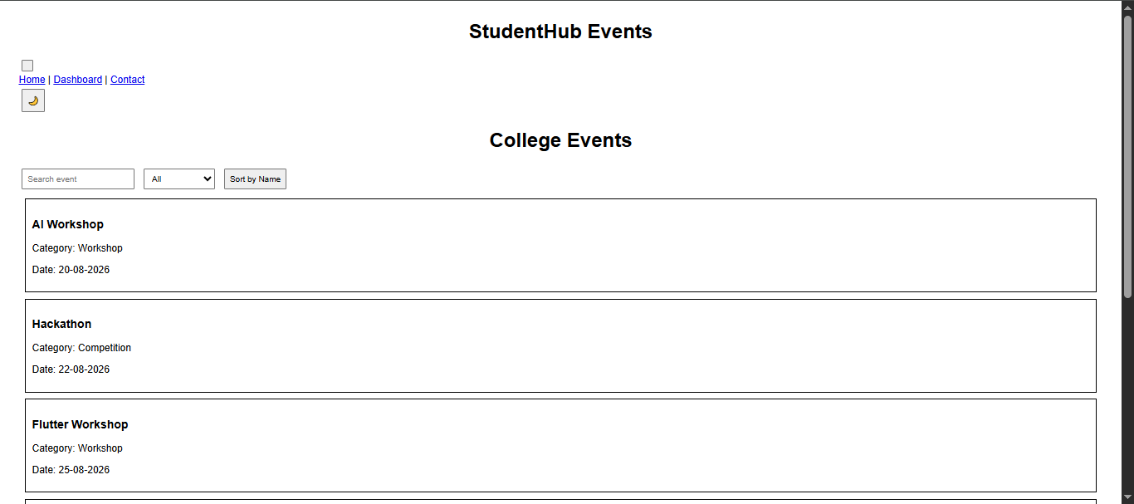
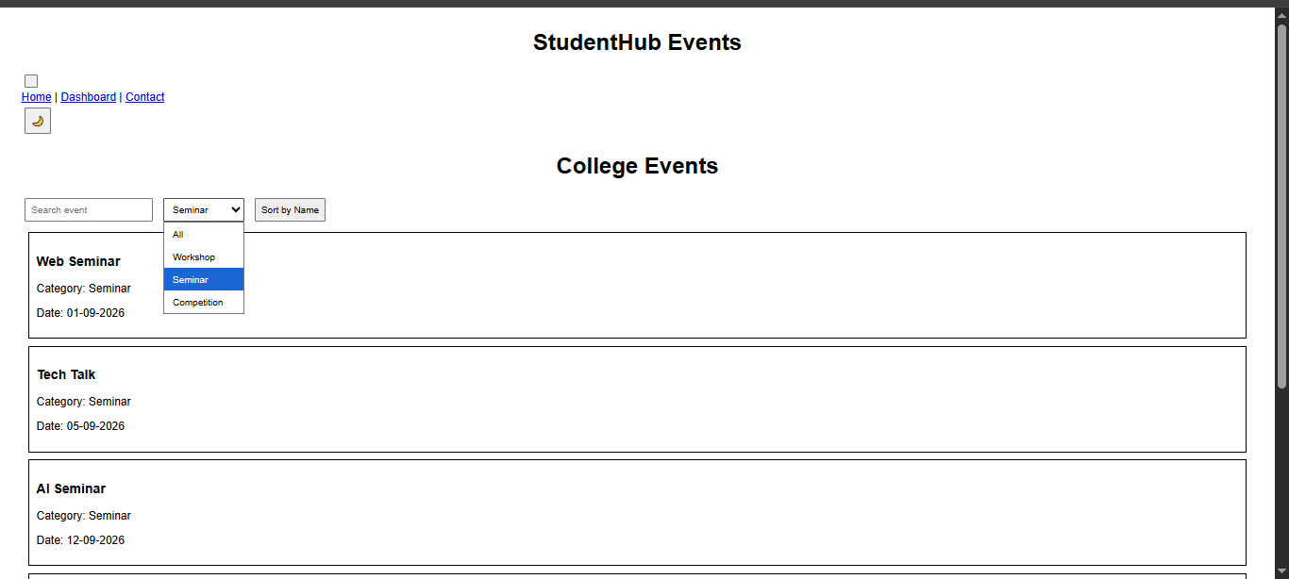
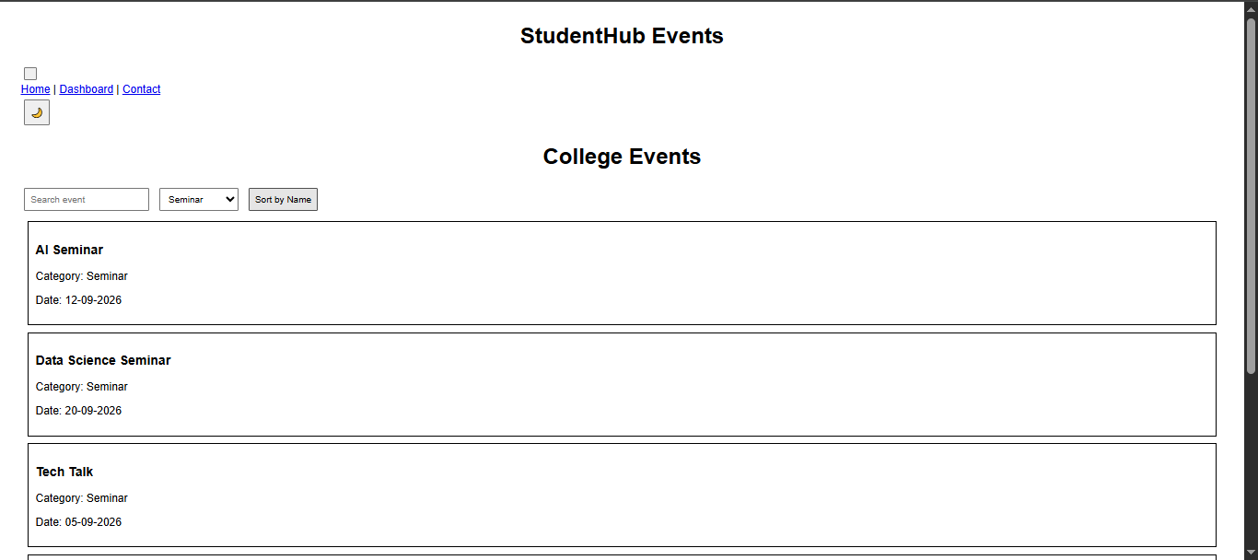
Learning Outcome:
After completing this practical, students will be able to:
- Fetch external JSON data using the Fetch API.
- Parse JSON data using response.json().
- Dynamically render data on a webpage.
- Use filter() for search and filtering.
- Use sort() for sorting data.
- Use slice() for pagination.
- Handle loading and error states.
- Develop dynamic and reusable frontend views.

Practical : 7
Objective:
To process registration form data using PHP, perform server-side validation and sanitization, and store the submitted data safely in a CSV file. The practical also displays appropriate success and error messages.
Theory:
PHP is a server-side scripting language used to process data submitted through web forms.
In this practical, the form uses the POST method to send user data to the PHP program. The submitted data is validated on the server side before it is stored.
The following validations are performed:
- Name should contain only letters and spaces.
- Email should be in a valid email format.
- Mobile number should contain exactly 10 digits.
- Password should contain at least 6 characters.
- Empty fields are not accepted.
- User input is sanitized using trim(), stripslashes() and htmlspecialchars().
- Valid data is stored in a CSV file using fopen() and fputcsv().
- Password is stored using password_hash() instead of plain text.
- Success and error messages are displayed to the user.

Code:
<?php
$nameErr="";
$emailErr="";
$mobileErr ="";
if (isset($_POST['submit'])){
if(empty($_POST["name"])){
$nameErr="name is required";
}
else{
$name = filterdata($_POST["name"]);
if(!preg_match("/^[a-zA-Z-']*$/",$name)){
$nameErr =" only letters and white space allowed";
}
}
if(empty($_POST["email"])){
$emailErr="email is required";
}
else{
$email = filterdata($_POST["email"]);
if(!filter_var($email,FILTER_VALIDATE_EMAIL)){
$emailErr = "Invalid Email Format";
}
}
if(empty($_POST["phone"])){
$mobileErr="Mobile is required";
}
else {
$mobile = filterdata($_POST["phone"]);
if(!preg_match("/^[0-9]{10}+$/",$mobile)){
$mobileErr = "Invalid Format";
}
}
}
function filterdata($data){
$data = trim($data);
$data = stripslashes($data);
$data = htmlspecialchars($data);
return $data;
}
?>
<html>
<head>
<title>form validation</title>
</head>
<body>
<div class="container">
<form method="post">
<input type="text" name="name" placeholder="enter your name" value=<?php if(isset($_POST['name'])){echo $_POST['name'];}?>><br><br>
<p><?php echo $nameErr;?></p>
<input type="email" name="email" placeholder="enter your email" value="<?php if(isset($_POST['email'])) {echo $_POST['email'];}?>"><br><br>
<p><?php echo $emailErr;?><p>
<input type="phone" name="phone" placeholder="enter your phone" value="<?php if(isset($_POST['phone'])) {echo $_POST['phone'];}?>"><br><br>
<p><?php echo $mobileErr;?><p>
<input type="password" name="password" placeholder="*********"><br><br>
<input type="submit" name="submit" value="SUBMIT"><br>
</form>
</div>
</body>
</html>
Output:
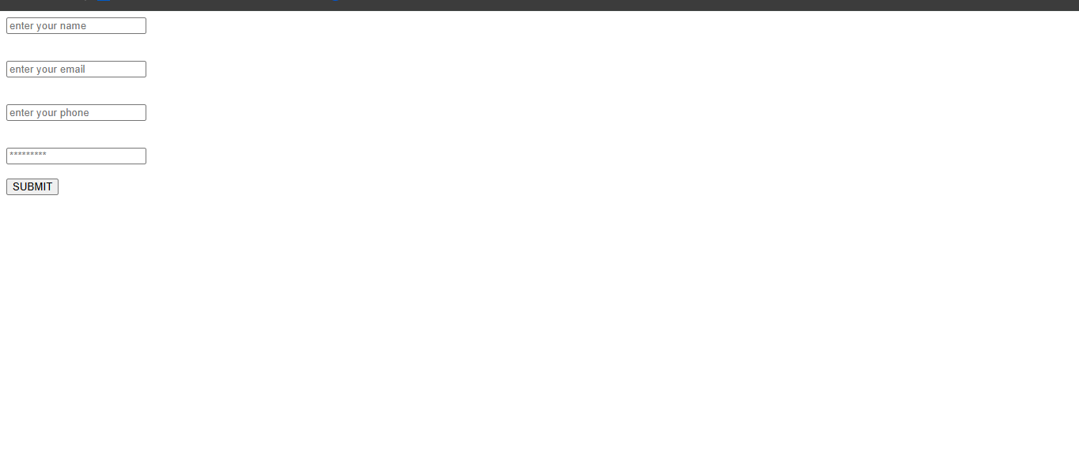
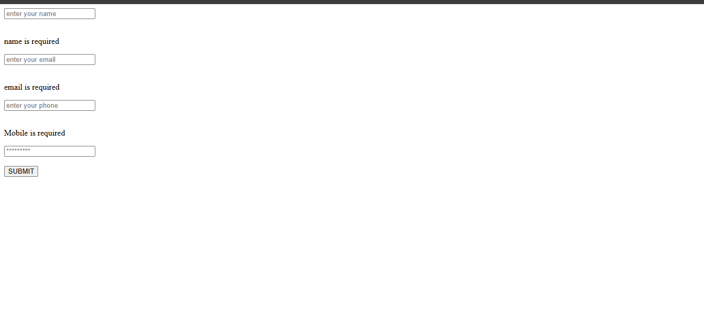

Learning Outcome:
After completing this practical, students will be able to:
- Create and process PHP forms.
- Handle form data using the POST method.
- Perform server-side validation.
- Sanitize user inputs.
- Validate names, emails, mobile numbers and passwords.
- Store submitted data in a CSV file.
- Display success and error messages.
- Understand basic server-side form processing.

PRACTICAL: 8

Objective:
To design a MySQL database schema, create an ER model, and establish connectivity between PHP and MySQL.

Theory:
A database schema defines the structure of a database, including tables, fields, primary keys, and relationships. An ER (Entity-Relationship) model represents entities and their relationships graphically. PHP can connect to MySQL using mysqli to insert, retrieve, and manage data.

Code:
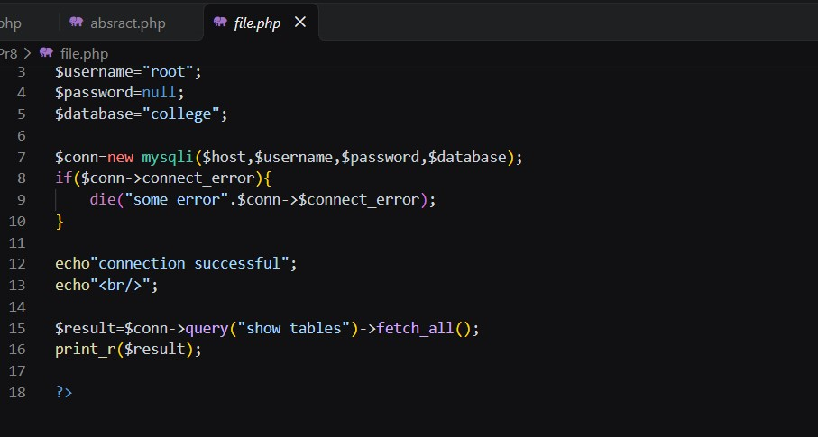
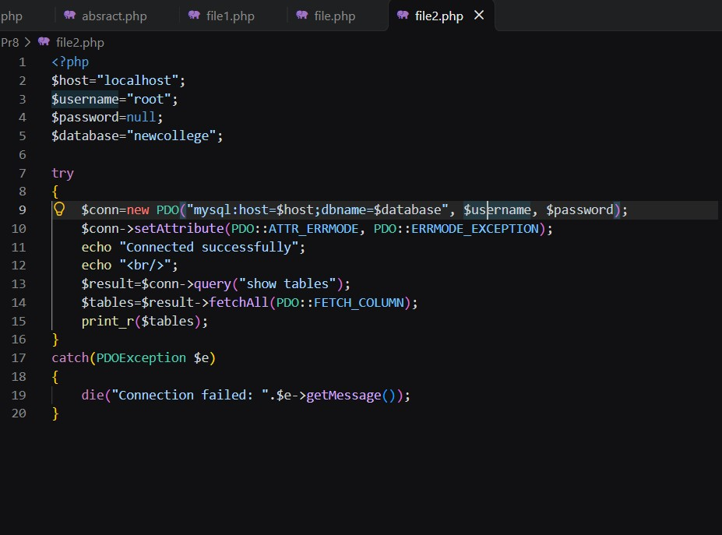

Output:

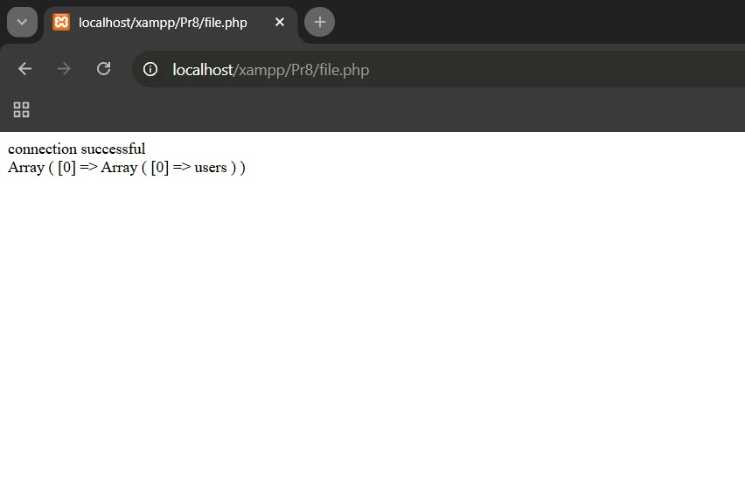

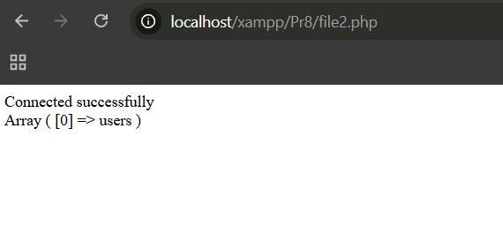

Learning Outcome:
- Learned to design a MySQL database schema.
- Learned to identify entities, attributes, and relationships.
- Learned to create primary and foreign keys.
- Learned to connect PHP with MySQL.
- Learned basic database connectivity using mysqli.

References:
- MySQL Official Documentation
- PHP Official Documentation
- W3Schools – MySQL
- W3Schools – PHP MySQL Database Connection

PRACTICAL: 9

Objective:
To create a secure user registration system using PHP and MySQL with duplicate email checking and password hashing.

Theory:
User registration stores user details in a database. Email uniqueness prevents duplicate accounts, while password hashing protects passwords from being stored as plain text. PHP provides password_hash() for secure password hashing.

Code:

<?php
session_start();

require_once "db_connect.php";

$error_message = "";

if ($_SERVER["REQUEST_METHOD"] == "POST") {
$email = trim($_POST["email"]);
$password = $_POST["password"];

if (empty($email) || empty($password)) {
$error_message = "Please enter both email and password!";
} else {
$stmt = $conn->prepare("SELECT id, name, email, password FROM users WHERE email = ?");
$stmt->bind_param("s", $email);
$stmt->execute();
$result = $stmt->get_result();

if ($result->num_rows === 1) {
$user = $result->fetch_assoc();

if (password_verify($password, $user["password"])) {
$_SESSION["user_id"] = $user["id"];
$_SESSION["user_name"] = $user["name"];

header("Location: dashboard.html");
exit;
} else {
$error_message = "Incorrect password! Please try again.";
}
} else {
$error_message = "No account found with this email!";
}

$stmt->close();
}
}
?>
<!DOCTYPE html>
<html lang="en">
<head>
<meta charset="UTF-8">
<meta name="viewport" content="width=device-width, initial-scale=1.0">
<title>Login - StudentHub</title>
<link rel="stylesheet" href="styles.css">
<style>
.alert-error {
background-color: #ffe6e6;
color: #d93025;
padding: 10px;
border-radius: 5px;
margin-bottom: 15px;
border: 1px solid #f5c6cb;
}
</style>
</head>
<body>

<header>
<h1>StudentHub Login</h1>
</header>

<main>
<section>
<h2>Login</h2>

<?php if (!empty($error_message)): ?>
<div class="alert-error"><?php echo htmlspecialchars($error_message); ?></div>
<?php endif; ?>

<form action="login.php" method="POST">
<label for="email">Email:</label><br>
<input type="email" id="email" name="email" required><br><br>

<label for="password">Password:</label><br>
<input type="password" id="password" name="password" required><br><br>

<button type="submit">Login</button>
</form>

<p>Don't have an account? <a href="register.php">Register here</a>.</p>
</section>
</main>

<footer>
<p>&copy; 2026 StudentHub | <a href="index.html">Go to Home Page</a></p>
</footer>

</body>
</html>

Output:
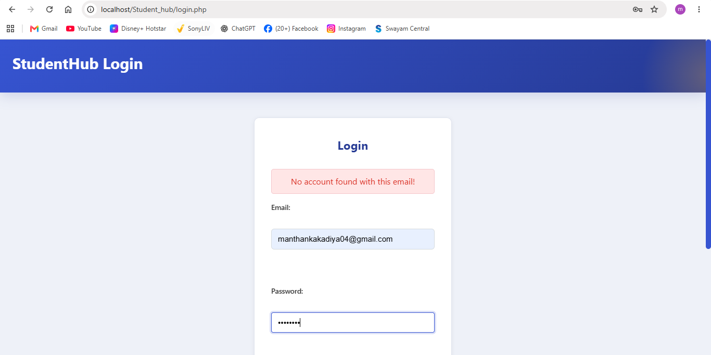

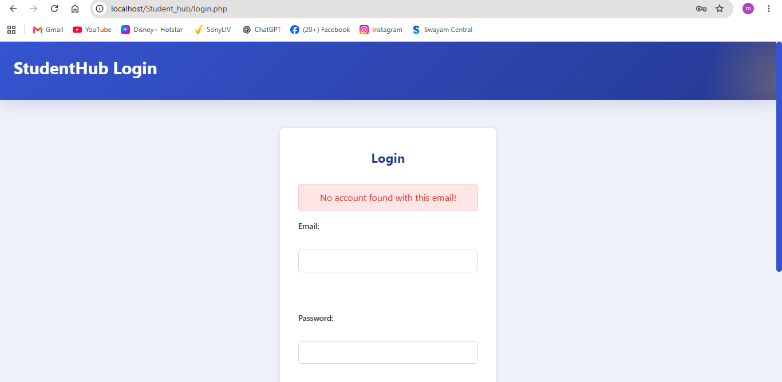

Learning Outcome:
- Learned secure user registration.
- Learned MySQL database insertion.
- Learned duplicate email checking.
- Learned password hashing using password_hash().
- Learned PHP-MySQL connectivity.

References:
- PHP Official Documentation
- MySQL Official Documentation
- W3Schools – PHP MySQL
- PHP password_hash() Documentation

PRACTICAL: 10

Objective

To develop a secure login system using PHP and MySQL with password hashing, role-based access for Admin and Student, session management, and automatic session timeout.

THEORY
The secure login system uses PHP to authenticate users and MySQL to store user details. Passwords are stored as hashed values using password_hash() and verified using
password_verify(). PHP sessions maintain the user's login state and role. The system also provides logout functionality and automatically expires sessions after five minutes of inactivity.

CODE :

<?php
session_start();

require_once "db_connect.php";

$error_message = "";

if ($_SERVER["REQUEST_METHOD"] == "POST") {
$login_input = trim($_POST["username"] ?? $_POST["email"] ?? "");
$password = $_POST["password"] ?? "";

if (empty($login_input) || empty($password)) {
$error_message = "Please enter both username/email and password!";
} else {
$sql = "SELECT id, name, username, email, password, role FROM users WHERE username = ? OR email = ? LIMIT 1";
$stmt = $conn->prepare($sql);
$stmt->bind_param("ss", $login_input, $login_input);
$stmt->execute();
$result = $stmt->get_result();

if ($result && $result->num_rows === 1) {
$user = $result->fetch_assoc();

if (password_verify($password, $user["password"])) {
$_SESSION["user_id"] = $user["id"];
$_SESSION["user_name"] = $user["name"];
$_SESSION["user_role"] = $user["role"];

if ($user["role"] === "admin") {
header("Location: admin.html");
} else {
header("Location: dashboard.html");
}
exit;
} else {
$error_message = "Incorrect password! Please try again.";
}
} else {
$error_message = "No account found with this username or email!";
}

$stmt->close();
}
}
?>
<!DOCTYPE html>
<html lang="en">
<head>
<meta charset="UTF-8">
<meta name="viewport" content="width=device-width, initial-scale=1.0">
<title>Login - StudentHub</title>
<link rel="stylesheet" href="styles.css">
<style>
.login-container {
display: flex;
flex-wrap: wrap;
gap: 25px;
justify-content: center;
align-items: flex-start;
margin-top: 20px;
}
.login-card {
flex: 1;
min-width: 280px;
max-width: 420px;
background: #fff;
padding: 24px;
border-radius: 8px;
box-shadow: 0 2px 10px rgba(0,0,0,0.08);
border: 1px solid #e0e0e0;
}
.test-details-card {
flex: 1;
min-width: 260px;
max-width: 340px;
background: #fdfdfd;
padding: 24px;
border-radius: 8px;
box-shadow: 0 2px 10px rgba(0,0,0,0.08);
border: 1px solid #d0d7de;
text-align: center;
}
.test-details-card h3 {
margin-top: 0;
font-size: 1.25rem;
color: #111;
font-weight: 700;
margin-bottom: 20px;
}
.test-section {
margin-bottom: 20px;
padding-bottom: 15px;
border-bottom: 1px dashed #ccc;
}
.test-section:last-child {
border-bottom: none;
margin-bottom: 0;
padding-bottom: 0;
}
.test-section h4 {
margin: 0 0 6px 0;
font-size: 1.1rem;
font-weight: 700;
color: #222;
}
.test-section p {
margin: 4px 0;
font-size: 0.95rem;
color: #333;
}
.quick-fill-btn {
margin-top: 8px;
background-color: #0066cc;
color: white;
border: none;
padding: 6px 12px;
border-radius: 4px;
cursor: pointer;
font-size: 0.85rem;
}
.quick-fill-btn:hover {
background-color: #004c99;
}
.alert-error {
background-color: #ffe6e6;
color: #d93025;
padding: 10px 14px;
border-radius: 5px;
margin-bottom: 16px;
border: 1px solid #f5c6cb;
font-weight: 500;
}
</style>
</head>
<body>

<header>
<h1>StudentHub Login</h1>
<nav aria-label="Main navigation">
<a href="index.html">Home</a>
<a href="events.html">Events</a>
<a href="login.php" aria-current="page">Login</a>
<a href="register.php">Register</a>
</nav>
</header>

<main id="main-content">
<div class="login-container">

<section class="login-card">
<h2>Account Login</h2>

<?php if (!empty($error_message)): ?>
<div class="alert-error"><?php echo htmlspecialchars($error_message); ?></div>
<?php endif; ?>

<form action="login.php" method="POST">
<div class="field-row">
<label for="username">Username or Email:</label>
<input type="text" id="username" name="username" placeholder="e.g. admin or student" required
value="<?php echo isset($_POST['username']) ? htmlspecialchars($_POST['username']) : ''; ?>">
</div>

<div class="field-row">
<label for="password">Password:</label>
<input type="password" id="password" name="password" placeholder="Enter your password" required>
</div>

<br>
<button type="submit">Login</button>
</form>

<p style="margin-top: 18px;">Don't have an account? <a href="register.php">Register here</a>.</p>
</section>

<aside class="test-details-card" aria-label="Test Credentials">
<h3>Test Login Details</h3>

<div class="test-section">
<h4>Admin</h4>
<p>Username: <strong>admin</strong></p>
<p>Password: <strong>admin123</strong></p>
<button type="button" class="quick-fill-btn" onclick="fillCredentials('admin', 'admin123')">Auto-fill Admin</button>
</div>

<div class="test-section">
<h4>Student</h4>
<p>Username: <strong>student</strong></p>
<p>Password: <strong>student123</strong></p>
<button type="button" class="quick-fill-btn" onclick="fillCredentials('student', 'student123')">Auto-fill Student</button>
</div>
</aside>

</div>
</main>

<footer>
<p>&copy; 2026 StudentHub | <a href="index.html">Go to Home Page</a></p>
</footer>

<script>
function fillCredentials(user, pass) {
document.getElementById('username').value = user;
document.getElementById('password').value = pass;
}
</script>

</body>
</html>

Output :
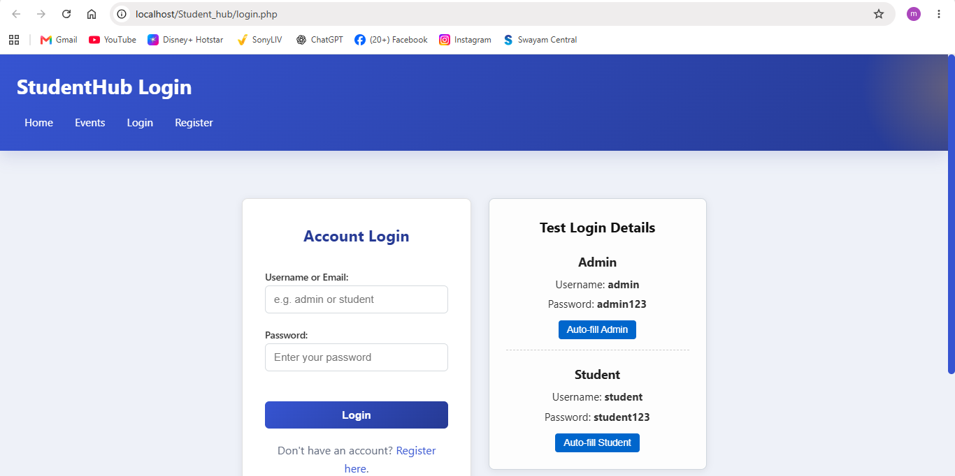
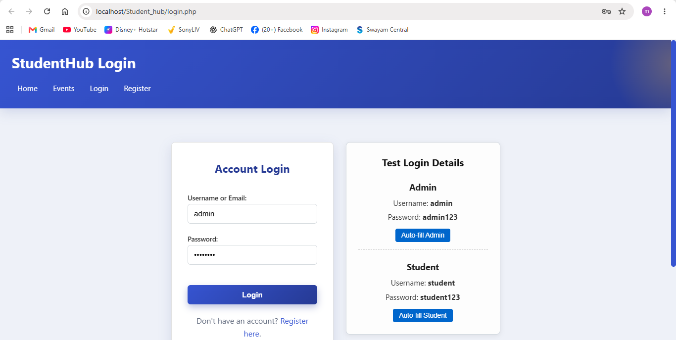

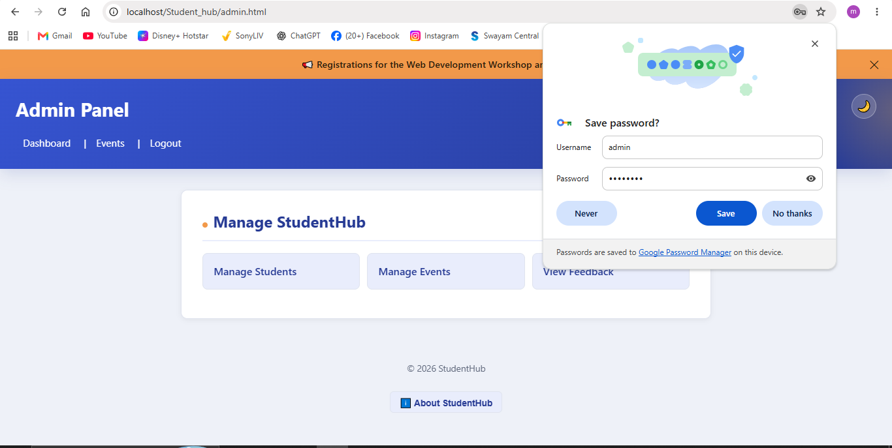
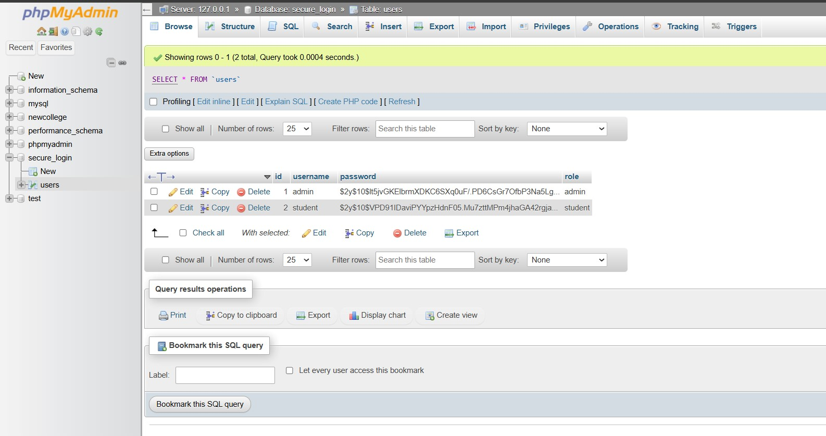

Learning Outcome:
- Learned to implement a secure login system using PHP and MySQL.
- Understood how to authenticate users using hashed passwords and password verification.
- Implemented role-based access control for Admin and Student users.
- Learned to manage user sessions, regenerate session IDs, and securely log out users.
- Implemented automatic session expiration after five minutes of inactivity.

PRACTICAL: 10

Objective

To develop a secure login system using PHP and MySQL with password hashing, role-based access for Admin and Student, session management, and automatic session timeout.

THEORY
The secure login system uses PHP to authenticate users and MySQL to store user details. Passwords are stored as hashed values using password_hash() and verified using
password_verify(). PHP sessions maintain the user's login state and role. The system also provides logout functionality and automatically expires sessions after five minutes of inactivity.

CODE :

<?php
session_start();

require_once "db_connect.php";

$error_message = "";

if ($_SERVER["REQUEST_METHOD"] == "POST") {
$login_input = trim($_POST["username"] ?? $_POST["email"] ?? "");
$password = $_POST["password"] ?? "";

if (empty($login_input) || empty($password)) {
$error_message = "Please enter both username/email and password!";
} else {
$sql = "SELECT id, name, username, email, password, role FROM users WHERE username = ? OR email = ? LIMIT 1";
$stmt = $conn->prepare($sql);
$stmt->bind_param("ss", $login_input, $login_input);
$stmt->execute();
$result = $stmt->get_result();

if ($result && $result->num_rows === 1) {
$user = $result->fetch_assoc();

if (password_verify($password, $user["password"])) {
$_SESSION["user_id"] = $user["id"];
$_SESSION["user_name"] = $user["name"];
$_SESSION["user_role"] = $user["role"];

if ($user["role"] === "admin") {
header("Location: admin.html");
} else {
header("Location: dashboard.html");
}
exit;
} else {
$error_message = "Incorrect password! Please try again.";
}
} else {
$error_message = "No account found with this username or email!";
}

$stmt->close();
}
}
?>
<!DOCTYPE html>
<html lang="en">
<head>
<meta charset="UTF-8">
<meta name="viewport" content="width=device-width, initial-scale=1.0">
<title>Login - StudentHub</title>
<link rel="stylesheet" href="styles.css">
<style>
.login-container {
display: flex;
flex-wrap: wrap;
gap: 25px;
justify-content: center;
align-items: flex-start;
margin-top: 20px;
}
.login-card {
flex: 1;
min-width: 280px;
max-width: 420px;
background: #fff;
padding: 24px;
border-radius: 8px;
box-shadow: 0 2px 10px rgba(0,0,0,0.08);
border: 1px solid #e0e0e0;
}
.test-details-card {
flex: 1;
min-width: 260px;
max-width: 340px;
background: #fdfdfd;
padding: 24px;
border-radius: 8px;
box-shadow: 0 2px 10px rgba(0,0,0,0.08);
border: 1px solid #d0d7de;
text-align: center;
}
.test-details-card h3 {
margin-top: 0;
font-size: 1.25rem;
color: #111;
font-weight: 700;
margin-bottom: 20px;
}
.test-section {
margin-bottom: 20px;
padding-bottom: 15px;
border-bottom: 1px dashed #ccc;
}
.test-section:last-child {
border-bottom: none;
margin-bottom: 0;
padding-bottom: 0;
}
.test-section h4 {
margin: 0 0 6px 0;
font-size: 1.1rem;
font-weight: 700;
color: #222;
}
.test-section p {
margin: 4px 0;
font-size: 0.95rem;
color: #333;
}
.quick-fill-btn {
margin-top: 8px;
background-color: #0066cc;
color: white;
border: none;
padding: 6px 12px;
border-radius: 4px;
cursor: pointer;
font-size: 0.85rem;
}
.quick-fill-btn:hover {
background-color: #004c99;
}
.alert-error {
background-color: #ffe6e6;
color: #d93025;
padding: 10px 14px;
border-radius: 5px;
margin-bottom: 16px;
border: 1px solid #f5c6cb;
font-weight: 500;
}
</style>
</head>
<body>

<header>
<h1>StudentHub Login</h1>
<nav aria-label="Main navigation">
<a href="index.html">Home</a>
<a href="events.html">Events</a>
<a href="login.php" aria-current="page">Login</a>
<a href="register.php">Register</a>
</nav>
</header>

<main id="main-content">
<div class="login-container">

<section class="login-card">
<h2>Account Login</h2>

<?php if (!empty($error_message)): ?>
<div class="alert-error"><?php echo htmlspecialchars($error_message); ?></div>
<?php endif; ?>

<form action="login.php" method="POST">
<div class="field-row">
<label for="username">Username or Email:</label>
<input type="text" id="username" name="username" placeholder="e.g. admin or student" required
value="<?php echo isset($_POST['username']) ? htmlspecialchars($_POST['username']) : ''; ?>">
</div>

<div class="field-row">
<label for="password">Password:</label>
<input type="password" id="password" name="password" placeholder="Enter your password" required>
</div>

<br>
<button type="submit">Login</button>
</form>

<p style="margin-top: 18px;">Don't have an account? <a href="register.php">Register here</a>.</p>
</section>

<aside class="test-details-card" aria-label="Test Credentials">
<h3>Test Login Details</h3>

<div class="test-section">
<h4>Admin</h4>
<p>Username: <strong>admin</strong></p>
<p>Password: <strong>admin123</strong></p>
<button type="button" class="quick-fill-btn" onclick="fillCredentials('admin', 'admin123')">Auto-fill Admin</button>
</div>

<div class="test-section">
<h4>Student</h4>
<p>Username: <strong>student</strong></p>
<p>Password: <strong>student123</strong></p>
<button type="button" class="quick-fill-btn" onclick="fillCredentials('student', 'student123')">Auto-fill Student</button>
</div>
</aside>

</div>
</main>

<footer>
<p>&copy; 2026 StudentHub | <a href="index.html">Go to Home Page</a></p>
</footer>

<script>
function fillCredentials(user, pass) {
document.getElementById('username').value = user;
document.getElementById('password').value = pass;
}
</script>

</body>
</html>

Output :

Learning Outcome:

- Learned to implement a secure login system using PHP and MySQL.
- Understood how to authenticate users using hashed passwords and password verification.
- Implemented role-based access control for Admin and Student users.
- Learned to manage user sessions, regenerate session IDs, and securely log out users.
- Implemented automatic session expiration after five minutes of inactivity.

Practical :12

Objective:
To develop a web-based Event Management System using PHP and MySQL that allows users to add, view, update, and delete event records, upload event posters, and validate uploaded files for type and size to ensure secure file handling.
Theory:
The Student Management System uses PHP to process student data and MySQL to store records. It allows users to add new students, view student details, edit existing records, and delete students. Prepared SQL statements help prevent SQL injection, while search and filter options make it easier to find students by name, email, or course.
Code:
<?php
session_start();
require_once "db_connect.php";

$success_msg = "";
$error_msg = "";

$upload_dir = __DIR__ . "/uploads/posters/";
if (!is_dir($upload_dir)) {
mkdir($upload_dir, 0755, true);
}

if (isset($_GET['delete_id'])) {
$delete_id = intval($_GET['delete_id']);

if ($delete_id > 0) {
$get_stmt = $conn->prepare("SELECT poster FROM events WHERE id = ?");
$get_stmt->bind_param("i", $delete_id);
$get_stmt->execute();
$res = $get_stmt->get_result();

if ($res && $row = $res->fetch_assoc()) {
if (!empty($row['poster']) && file_exists($upload_dir . $row['poster'])) {
unlink($upload_dir . $row['poster']);
}
}
$get_stmt->close();

$del_stmt = $conn->prepare("DELETE FROM events WHERE id = ?");
$del_stmt->bind_param("i", $delete_id);
if ($del_stmt->execute() && $del_stmt->affected_rows > 0) {
$success_msg = "Event and associated poster deleted successfully!";
} else {
$error_msg = "Failed to delete event, or event not found.";
}
$del_stmt->close();
}
}

function upload_event_poster($file, &$error_msg, $upload_dir) {
if (!isset($file) || $file['error'] === UPLOAD_ERR_NO_FILE) {
return null;
}

if ($file['error'] !== UPLOAD_ERR_OK) {
$error_msg = "File upload failed with error code: " . $file['error'];
return false;
}

$max_size = 2 * 1024 * 1024;
if ($file['size'] > $max_size) {
$error_msg = "File is too large! Maximum allowed poster size is 2 MB.";
return false;
}
$query .= " AND category = ?";
$params[] = $filter_cat;
$types .= "s";
}

$query .= " ORDER BY event_date ASC";

$stmt = $conn->prepare($query);
if (!empty($params)) {
$stmt->bind_param($types, ...$params);
}
$stmt->execute();
$events_result = $stmt->get_result();
?>
<!DOCTYPE html>
<html lang="en">
<head>
<meta charset="UTF-8">
<meta name="viewport" content="width=device-width, initial-scale=1.0">
<title>Event Management System - StudentHub</title>
<link rel="stylesheet" href="styles.css">
<style>
.container {
max-width: 1100px;
margin: 20px auto;
padding: 0 15px;
}
.card {
background: #fff;
padding: 24px;
border-radius: 8px;
box-shadow: 0 2px 10px rgba(0,0,0,0.06);
margin-bottom: 25px;
border: 1px solid #dfe3ee;
}
.filter-bar {
display: flex;
flex-wrap: wrap;
gap: 12px;
margin-bottom: 20px;
align-items: center;
background: #f8f9fa;
padding: 16px;
border-radius: 8px;
border: 1px solid #e9ecef;
}
.filter-bar input[type="text"], .filter-bar select {
padding: 8px 12px;
border: 1px solid #ced4da;
border-radius: 6px;
font-size: 0.95rem;
}
.filter-bar button {
padding: 8px 16px;
background-color: #3654d1;
color: white;
border: none;
border-radius: 6px;
cursor: pointer;
font-weight: 600;
}
.filter-bar a.reset-btn {
padding: 8px 14px;
background-color: #6c757d;
color: white;
border-radius: 6px;
text-decoration: none;
font-size: 0.9rem;
}
.data-table {
width: 100%;
border-collapse: collapse;
margin-top: 15px;
}
.data-table th, .data-table td {
padding: 12px 14px;
text-align: left;
border-bottom: 1px solid #e2e8f0;
vertical-align: middle;
}
.data-table th {
background-color: #f1f5f9;
color: #1e293b;
font-weight: 600;
}
.data-table tr:hover {
background-color: #f8fafc;
}
.poster-thumb {
width: 60px;
height: 60px;
object-fit: cover;
border-radius: 6px;
border: 1px solid #cbd5e1;
background-color: #f1f5f9;
display: flex;
align-items: center;
justify-content: center;
font-size: 0.75rem;
color: #64748b;
}
.btn-edit {
background-color: #f59e0b;
color: white;
padding: 6px 12px;
border-radius: 4px;
text-decoration: none;
font-size: 0.85rem;
margin-right: 5px;
}
.btn-delete {
background-color: #ef4444;
color: white;
padding: 6px 12px;
border-radius: 4px;
text-decoration: none;
font-size: 0.85rem;
}
.alert-success {
background-color: #dcfce7;
color: #166534;
padding: 12px 16px;
border-radius: 6px;
margin-bottom: 20px;
border: 1px solid #bbf7d0;
font-weight: 500;
}
.alert-error {
background-color: #fee2e2;
color: #991b1b;
padding: 12px 16px;
border-radius: 6px;
margin-bottom: 20px;
border: 1px solid #fecaca;
font-weight: 500;
}
.badge-cat {
display: inline-block;
padding: 4px 10px;
border-radius: 12px;
font-size: 0.85rem;
background: #e0e7ff;
color: #3730a3;
font-weight: 600;
}
.form-grid {
display: grid;
grid-template-columns: repeat(auto-fit, minmax(220px, 1fr));
gap: 15px;
margin-bottom: 15px;
}
.form-grid label {
display: block;
margin-bottom: 5px;
font-weight: 600;
font-size: 0.9rem;
}
.form-grid input, .form-grid select, .form-grid textarea {
width: 100%;
padding: 9px;
border: 1px solid #cbd5e1;
border-radius: 6px;
}
</style>
</head>
<body>

<header>
<h1>StudentHub - Event Management System</h1>
<nav aria-label="Main Navigation">
<a href="admin.html">Admin Home</a> |
<a href="students.php">Students</a> |
<a href="events.php" aria-current="page">Events</a> |
<a href="login.php">Logout</a>
</nav>
</header>

<main class="container">

<?php if (!empty($success_msg)): ?>
<div class="alert-success">&#10004; <?php echo htmlspecialchars($success_msg); ?></div>
<?php endif; ?>

<?php if (!empty($error_msg)): ?>
<div class="alert-error">&#9888; <?php echo htmlspecialchars($error_msg); ?></div>
<?php endif; ?>

<section class="card">
<h2><?php echo $edit_event ? 'Edit Event Record' : 'Add New Event'; ?></h2>

<form action="events.php" method="POST" enctype="multipart/form-data">
<input type="hidden" name="action" value="<?php echo $edit_event ? 'edit' : 'add'; ?>">
<?php if ($edit_event): ?>
<input type="hidden" name="event_id" value="<?php echo $edit_event['id']; ?>">
<input type="hidden" name="existing_poster" value="<?php echo htmlspecialchars($edit_event['poster'] ?? ''); ?>">
<?php endif; ?>

<div class="form-grid">
<div>
<label for="name">Event Name *</label>
<input type="text" id="name" name="name" required placeholder="e.g. AI & Robotics Hackathon"
value="<?php echo htmlspecialchars($edit_event['name'] ?? ''); ?>">
</div>

<div>
<label for="category">Category *</label>
<select id="category" name="category" required>
<option value="Workshop" <?php echo ($edit_event['category'] ?? '') === 'Workshop' ? 'selected' : ''; ?>>Workshop</option>
<option value="Competition" <?php echo ($edit_event['category'] ?? '') === 'Competition' ? 'selected' : ''; ?>>Competition</option>
<option value="Seminar" <?php echo ($edit_event['category'] ?? '') === 'Seminar' ? 'selected' : ''; ?>>Seminar</option>
<option value="Other" <?php echo ($edit_event['category'] ?? '') === 'Other' ? 'selected' : ''; ?>>Other</option>
</select>
</div>

<div>
<label for="event_date">Event Date *</label>
<input type="date" id="event_date" name="event_date" required
value="<?php echo htmlspecialchars($edit_event['event_date'] ?? ''); ?>">
</div>

<div>
<label for="poster">Event Poster (JPG, PNG, WEBP, GIF &le; 2MB)</label>
<input type="file" id="poster" name="poster" accept=".jpg,.jpeg,.png,.webp,.gif">
<?php if (!empty($edit_event['poster']) && file_exists($upload_dir . $edit_event['poster'])): ?>
<small style="color: #64748b;">Current: <a href="uploads/posters/<?php echo htmlspecialchars($edit_event['poster']); ?>" target="_blank">View Poster</a></small>
<?php endif; ?>
</div>
</div>

<div style="margin-bottom: 15px;">
<label for="description" style="display:block; margin-bottom:5px; font-weight:600; font-size:0.9rem;">Event Description</label>
<textarea id="description" name="description" rows="3" placeholder="Provide details, schedule, or prerequisites..." style="width:100%; padding:9px; border:1px solid #cbd5e1; border-radius:6px;"><?php echo htmlspecialchars($edit_event['description'] ?? ''); ?></textarea>
</div>

<button type="submit" style="padding: 10px 20px; background-color: #3654d1; color: white; border: none; border-radius: 6px; cursor: pointer; font-weight: 600;">
<?php echo $edit_event ? 'Update Event' : 'Add Event'; ?>
</button>

<?php if ($edit_event): ?>
<a href="events.php" style="margin-left: 10px; color: #64748b; text-decoration: underline;">Cancel Edit</a>
<?php endif; ?>
</form>
</section>

<section class="card">
<h2>Events Directory</h2>

<form action="events.php" method="GET" class="filter-bar">
<input type="text" name="search" placeholder="Search event by name or description..."
value="<?php echo htmlspecialchars($search_query); ?>" style="flex: 1; min-width: 240px;">

<select name="category">
<option value="">All Categories</option>
<option value="Workshop" <?php echo $filter_cat === 'Workshop' ? 'selected' : ''; ?>>Workshop</option>
<option value="Competition" <?php echo $filter_cat === 'Competition' ? 'selected' : ''; ?>>Competition</option>
<option value="Seminar" <?php echo $filter_cat === 'Seminar' ? 'selected' : ''; ?>>Seminar</option>
<option value="Other" <?php echo $filter_cat === 'Other' ? 'selected' : ''; ?>>Other</option>
</select>

<button type="submit">Search & Filter</button>

<?php if (!empty($search_query) || !empty($filter_cat)): ?>
<a href="events.php" class="reset-btn">Reset</a>
<?php endif; ?>
</form>

<table class="data-table">
<thead>
<tr>
<th>Poster</th>
<th>Event Name</th>
<th>Category</th>
<th>Date</th>
<th>Description</th>
<th>Actions</th>
</tr>
</thead>
<tbody>
<?php if ($events_result && $events_result->num_rows > 0): ?>
<?php while ($row = $events_result->fetch_assoc()): ?>
<tr>
<td>
<?php if (!empty($row['poster']) && file_exists($upload_dir . $row['poster'])): ?>
<a href="uploads/posters/<?php echo htmlspecialchars($row['poster']); ?>" target="_blank">
<img src="uploads/posters/<?php echo htmlspecialchars($row['poster']); ?>" alt="Poster" class="poster-thumb">
</a>
<?php else: ?>
<div class="poster-thumb">No Poster</div>
<?php endif; ?>
</td>
<td><strong><?php echo htmlspecialchars($row['name']); ?></strong></td>
<td><span class="badge-cat"><?php echo htmlspecialchars($row['category']); ?></span></td>
<td><?php echo date("d M Y", strtotime($row['event_date'])); ?></td>
<td style="max-width: 260px; font-size: 0.9rem; color: #475569;">
<?php echo htmlspecialchars($row['description'] ?? 'No description provided.'); ?>
</td>
<td>
<a href="events.php?edit_id=<?php echo $row['id']; ?>" class="btn-edit">Edit</a>
<a href="events.php?delete_id=<?php echo $row['id']; ?>" class="btn-delete"
onclick="return confirm('Are you sure you want to delete this event and its poster?');">Delete</a>
</td>
</tr>
<?php endwhile; ?>
<?php else: ?>
<tr>
<td colspan="6" style="text-align: center; color: #64748b; padding: 24px;">
No events found matching your search or filter criteria.
</td>
</tr>
<?php endif; ?>
</tbody>
</table>
</section>
</main>
<footer>
<p>&copy; 2026 StudentHub</p>
</footer>
</body>
</html>

Output:
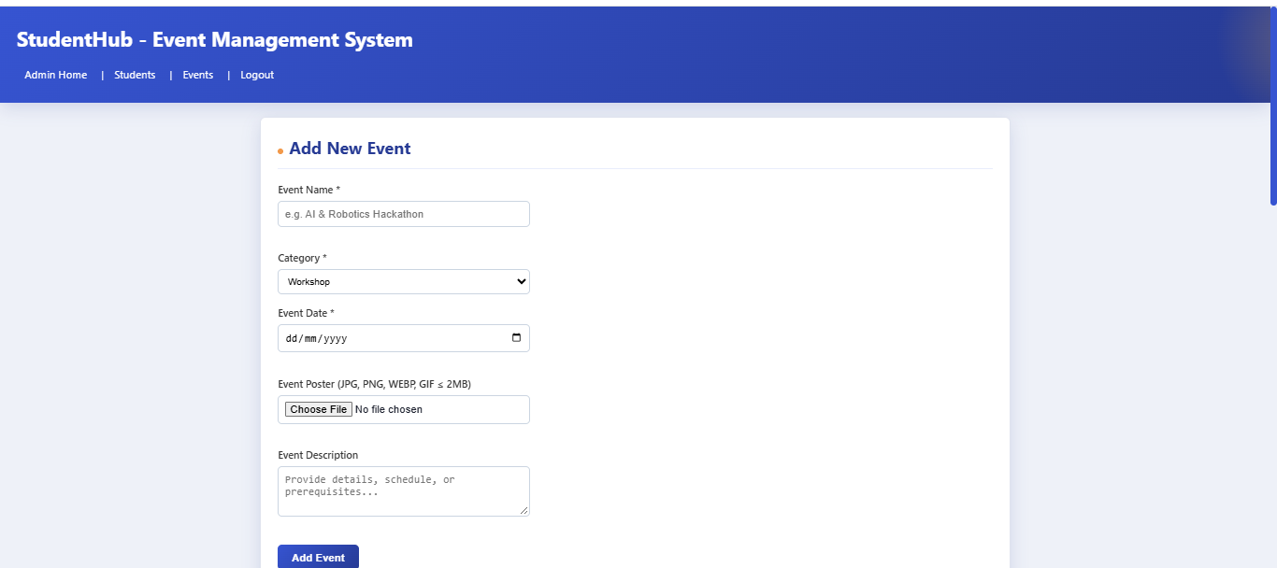
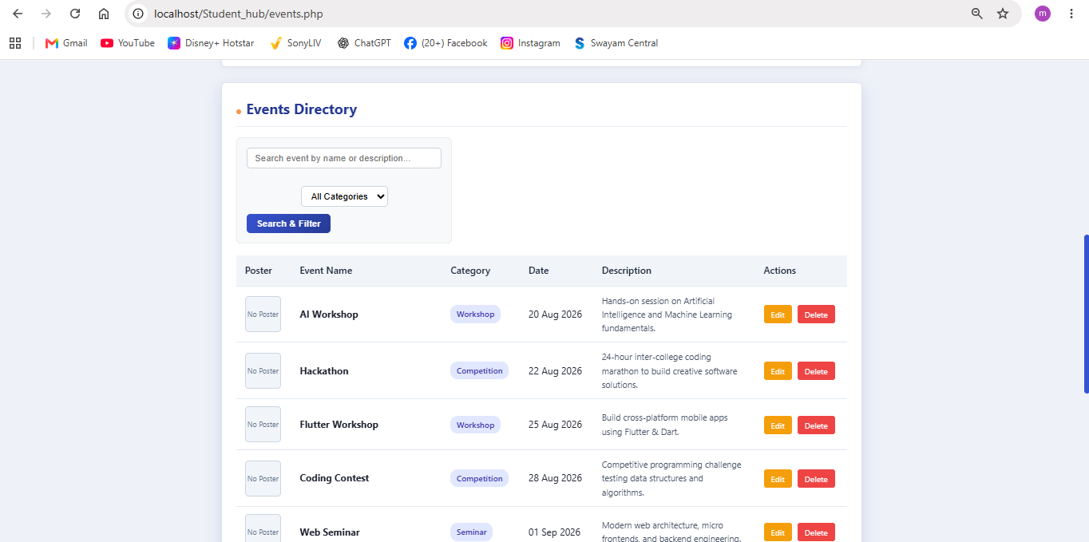
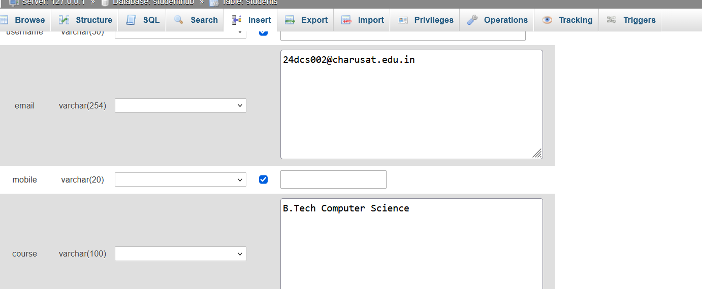
Learning outcome:

Learned how to implement add, update, and delete functionalities using database operations. Understood how to connect the user interface with the database. Learned to validate poster uploads based on file type and size. Gained knowledge of displaying success and error messages and handling errors effectively.

Practical : 13

Objective:
To develop a simple Student Management System using PHP and MySQL by creating JSON API endpoints and consuming them through JavaScript Fetch API. The system performs CRUD (Create, Read, Update, Delete) operations asynchronously without reloading the webpage.

Theory:
API (Application Programming Interface):
An API acts as a bridge between the frontend and backend. It allows JavaScript to communicate with PHP and retrieve or send data to the MySQL database.
JSON (JavaScript Object Notation):
JSON is a lightweight data format used to exchange information between the frontend and backend. PHP can convert database records into JSON using json_encode().
Fetch API:
The JavaScript Fetch API sends HTTP requests to the PHP backend and receives responses without reloading the webpage.

CRUD Operations:
- Create: Add new student details to the database.
- Read: Retrieve and display student records.
- Update: Modify existing student information.
- Delete: Remove student records from the database. HTTP Methods:
- GET – Retrieve student records.
- POST – Insert a new student.
- PUT – Update student details.
- DELETE – Delete a student record.

PHP and MySQL:
PHP handles API requests and communicates with the MySQL database to perform database operations.

Code:
API(Students.php):

<?php
header("Content-Type: application/json");

include '../db.php';

$method = $_SERVER['REQUEST_METHOD'];

// READ - Get all students if ($method == "GET") {

$result = mysqli_query($conn, "SELECT * FROM students");

$students = [];

while ($row = mysqli_fetch_assoc($result)) {
$students[] = $row;
}

echo json_encode($students);

}

// CREATE - Add student elseif ($method == "POST") {

$data = json_decode(file_get_contents("php://input"), true);

$name = $data['name'];
$email = $data['email'];
$course = $data['course'];

$sql = "INSERT INTO students (name, email, course) VALUES (?, ?, ?)";

$stmt = mysqli_prepare($conn, $sql); mysqli_stmt_bind_param($stmt, "sss", $name, $email, $course);

if (mysqli_stmt_execute($stmt)) {
echo json_encode(["message" => "Student added successfully"]);
} else {
echo json_encode(["message" => "Error adding student"]);
}
}

// UPDATE - Edit student elseif ($method == "PUT") {

$data = json_decode(file_get_contents("php://input"), true);

$id = $data['id'];
$name = $data['name'];
$email = $data['email'];
$course = $data['course'];

$sql = "UPDATE students SET name=?, email=?, course=? WHERE id=?";

$stmt = mysqli_prepare($conn, $sql); mysqli_stmt_bind_param($stmt, "sssi", $name, $email, $course, $id);

if (mysqli_stmt_execute($stmt)) {
echo json_encode(["message" => "Student updated successfully"]);
} else {
echo json_encode(["message" => "Error updating student"]);
}
}

// DELETE - Remove student elseif ($method == "DELETE") {

$data = json_decode(file_get_contents("php://input"), true);

$id = $data['id'];

$sql = "DELETE FROM students WHERE id=?";

$stmt = mysqli_prepare($conn, $sql); mysqli_stmt_bind_param($stmt, "i", $id);

if (mysqli_stmt_execute($stmt)) {
echo json_encode(["message" => "Student deleted successfully"]);
} else {
echo json_encode(["message" => "Error deleting student"]);
}
}

else {
echo json_encode(["message" => "Invalid request method"]);
}

mysqli_close($conn);
?>

Index.php:

<!DOCTYPE html>
<html>
<head>
<title>Student Management System</title>

<link rel="stylesheet" href="style.css">
</head>
<body>

<div class="container">

<h1>Student Management System</h1>

<h2>Add Student</h2>

<form id="studentForm">

<input type="hidden" id="studentId">

<label>Student Name:</label>
<input type="text" id="name" placeholder="Enter student name" required>

<label>Email:</label>
<input type="email" id="email" placeholder="Enter email" required>

<label>Course:</label>
<input type="text" id="course" placeholder="Enter course" required>

<button type="submit" id="submitBtn">Add Student</button>

</form>

<p id="message"></p>

<h2>Student List</h2>

<table>
<thead>
<tr>
<th>ID</th>
<th>Name</th>
<th>Email</th>
<th>Course</th>
<th>Actions</th>
</tr>
</thead>

<tbody id="studentList">
<!-- Student records will appear here -->
</tbody>
</table>

</div>

<script src="script.js"></script>

</body>

</html>

Output:
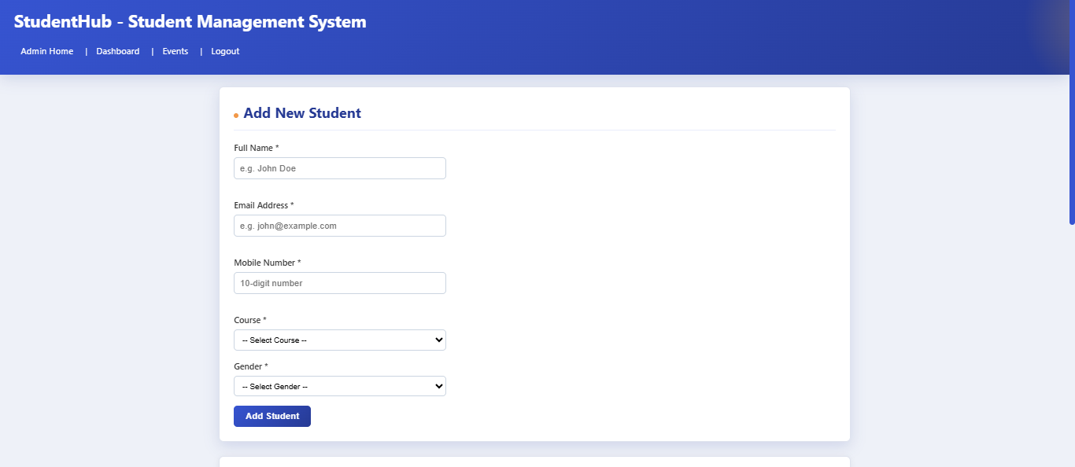

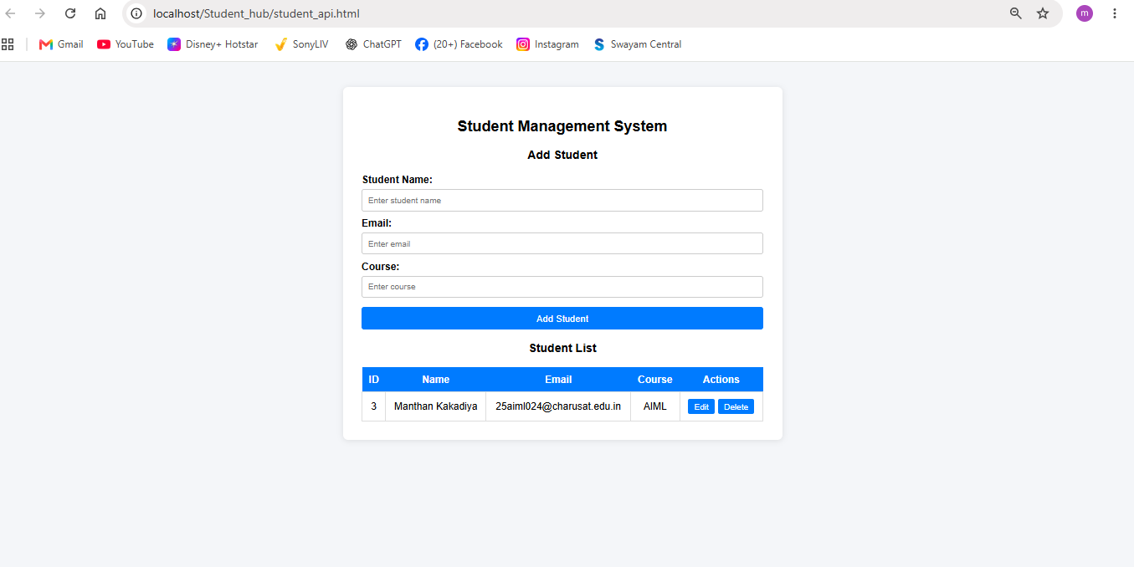
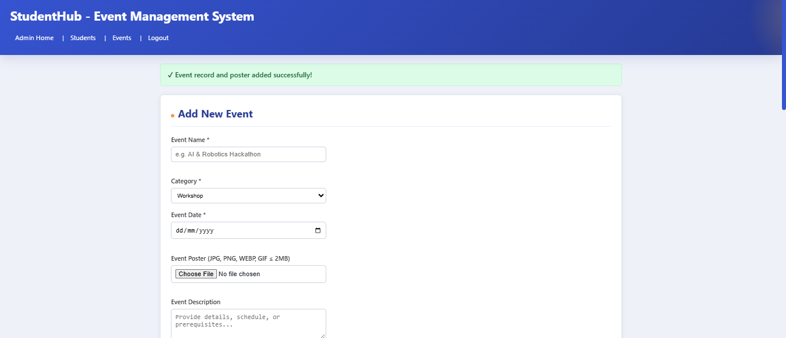
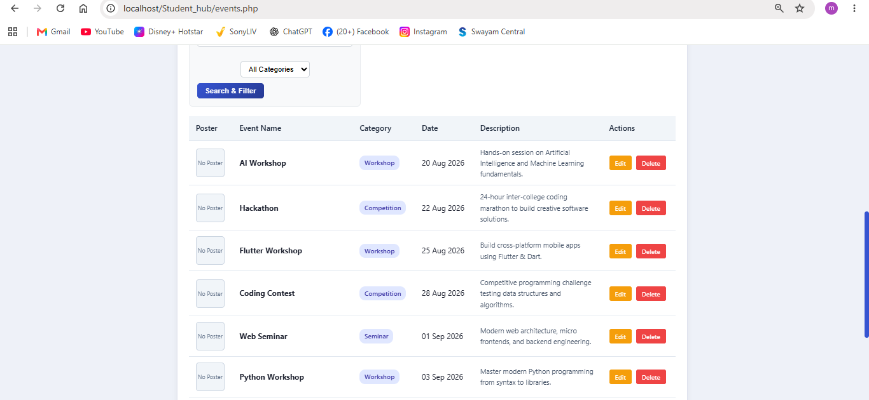
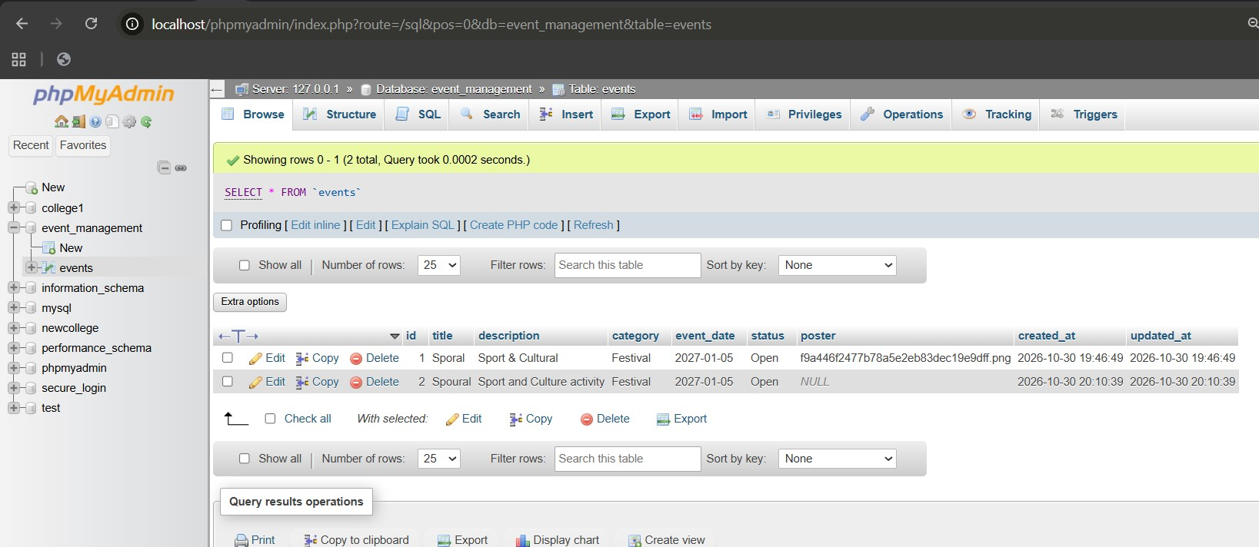

Learning Outcome:
After completing this practical, we learned:
- How to create a PHP JSON API.
- How to connect PHP with a MySQL database.
- How to use JavaScript Fetch API for communication with the backend.
- How to exchange data using JSON format.
- How to use GET, POST, PUT and DELETE HTTP methods.
- How to perform asynchronous CRUD operations without reloading the webpag.

References:
- PHP Documentation – Sessions: https://www.php.net/manual/en/book.session.php
- PHP Documentation – Password Hashing: https://www.php.net/manual/en/ref.password.php
- PHP Documentation – MySQLi: https://www.php.net/manual/en/book.mysqli.php
- MySQL Documentation: https://dev.mysql.com/doc/
- MDN Web Docs – HTTP Cookies: https://developer.mozilla.org/en-US/docs/Web/HTTP/Cookies

Practical : 14
Objective:
Admin Dashboard with Role-Based Access Control, Dynamic Menu, and Audit Log Problem
Definition Develop an admin dashboard that displays user statistics, student count, event count and latest registrations. Restrict access to admin users onlyand show dynamic menu options based on role.

Theory:
The system uses PHP and MySQL to develop an admin dashboard that displays important information such as user statistics, student count, event count, and the latest registrations. RoleBased Access Control (RBAC) is used to restrict dashboard access to authorized administrators only.
Code:

<?php
session_start();
require_once "db_connect.php";

if (!isset($_SESSION["user_role"])) {
$_SESSION["user_name"] = "Administrator";
$_SESSION["user_role"] = "admin";
}

$user_role = $_SESSION["user_role"];
$user_name = $_SESSION["user_name"];

if ($user_role !== "admin") {
header("Location: login.php");
exit;
}

$student_count = $conn->query("SELECT COUNT(*) AS total FROM students")->fetch_assoc()["total"];
$event_count = $conn->query("SELECT COUNT(*) AS total FROM events")->fetch_assoc()["total"];
$user_count = $conn->query("SELECT COUNT(*) AS total FROM users")->fetch_assoc()["total"];
$log_count = $conn->query("SELECT COUNT(*) AS total FROM audit_logs")->fetch_assoc()["total"];

$recent_students = $conn->query("SELECT id, name, email, course FROM students ORDER BY id DESC LIMIT 5");
$recent_logs = $conn->query("SELECT id, user_name, action, ip_address, created_at FROM audit_logs ORDER BY id DESC LIMIT 5");
?>
<!DOCTYPE html>
<html>
<head>
<title>Admin Dashboard</title>
<style>
body {
font-family: Arial, sans-serif;
background: #f0f2f5;
margin: 0;
padding: 0;
}
header {
background: #007bff;
color: white;
padding: 15px 30px;
display: flex;
justify-content: space-between;
align-items: center;
}
header h1 {
margin: 0;
font-size: 22px;
}
nav a {
color: white;
text-decoration: none;
margin-left: 20px;
font-weight: bold;
}
nav a:hover {
text-decoration: underline;
}
.container {
max-width: 1050px;
margin: 30px auto;
padding: 0 20px;
}
.stats-grid {
display: grid;
grid-template-columns: repeat(4, 1fr);
gap: 20px;
margin-bottom: 30px;
}
.stat-card {
background: white;
padding: 20px;
border-radius: 8px;
box-shadow: 0 2px 8px rgba(0,0,0,0.08);
text-align: center;
border-top: 4px solid #007bff;
}
.stat-card h3 {
margin: 0 0 10px 0;
color: #555;
font-size: 15px;
}
.stat-card .number {
font-size: 32px;
font-weight: bold;
color: #007bff;
}
.section-card {
background: white;
padding: 25px;
border-radius: 8px;
box-shadow: 0 2px 8px rgba(0,0,0,0.08);
margin-bottom: 25px;
}
.section-card h2 {
margin-top: 0;
font-size: 18px;
color: #333;
border-bottom: 2px solid #f0f2f5;
padding-bottom: 10px;
}
table {
width: 100%;
border-collapse: collapse;
margin-top: 10px;
}
th {
background: #007bff;
color: white;
padding: 10px;
text-align: left;
font-size: 14px;
}
td {
border-bottom: 1px solid #ddd;
padding: 10px;
font-size: 14px;
color: #333;
}
.badge {
background: #28a745;
color: white;
padding: 4px 8px;
border-radius: 4px;
font-size: 12px;
}
</style>
</head>
<body>

<header>
<h1>Admin Dashboard (Welcome, <?php echo htmlspecialchars($user_name); ?>)</h1>
<nav>
<?php if ($user_role === "admin"): ?>
<a href="admin_dashboard.php">Dashboard</a>
<a href="student_api.html">Manage Students</a>
<a href="events.php">Manage Events</a>
<a href="login.php">Logout</a>
<?php else: ?>
<a href="dashboard.html">My Dashboard</a>
<a href="events.php">Browse Events</a>
<a href="login.php">Logout</a>
<?php endif; ?>
</nav>
</header>

<div class="container">

<div class="stats-grid">
<div class="stat-card">
<h3>Total Students</h3>
<div class="number"><?php echo $student_count; ?></div>
</div>
<div class="stat-card">
<h3>Total Events</h3>
<div class="number"><?php echo $event_count; ?></div>
</div>
<div class="stat-card">
<h3>Registered Users</h3>
<div class="number"><?php echo $user_count; ?></div>
</div>
<div class="stat-card">
<h3>Audit Actions</h3>
<div class="number"><?php echo $log_count; ?></div>
</div>
</div>

<div class="section-card">
<h2>Latest Student Registrations</h2>
<table>
<thead>
<tr>
<th>ID</th>
<th>Student Name</th>
<th>Email Address</th>
<th>Course</th>
</tr>
</thead>
<tbody>
<?php while ($row = $recent_students->fetch_assoc()): ?>
<tr>
<td>#<?php echo $row["id"]; ?></td>
<td><strong><?php echo htmlspecialchars($row["name"]); ?></strong></td>
<td><?php echo htmlspecialchars($row["email"]); ?></td>
<td><span class="badge"><?php echo htmlspecialchars($row["course"]); ?></span></td>
</tr>
<?php endwhile; ?>
</tbody>
</table>
</div>

<div class="section-card">
<h2>System Audit Log (Admin Activities)</h2>
<table>
<thead>
<tr>
<th>ID</th>
<th>User</th>
<th>Action Performed</th>
<th>IP Address</th>
<th>Timestamp</th>
</tr>
</thead>
<tbody>
<?php while ($log = $recent_logs->fetch_assoc()): ?>
<tr>
<td>#<?php echo $log["id"]; ?></td>
<td><?php echo htmlspecialchars($log["user_name"]); ?></td>
<td><?php echo htmlspecialchars($log["action"]); ?></td>
<td><?php echo htmlspecialchars($log["ip_address"]); ?></td>
<td><?php echo $log["created_at"]; ?></td>
</tr>
<?php endwhile; ?>
</tbody>
</table>
</div>

</div>

</body>
</html>

Output :
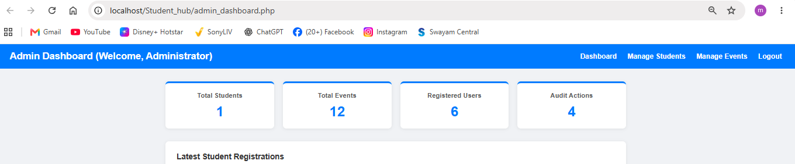
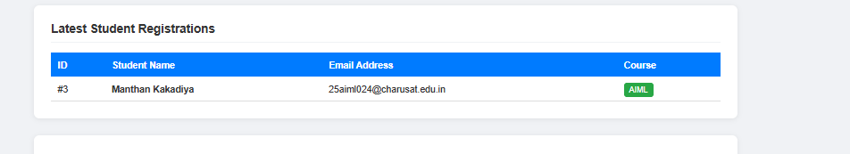
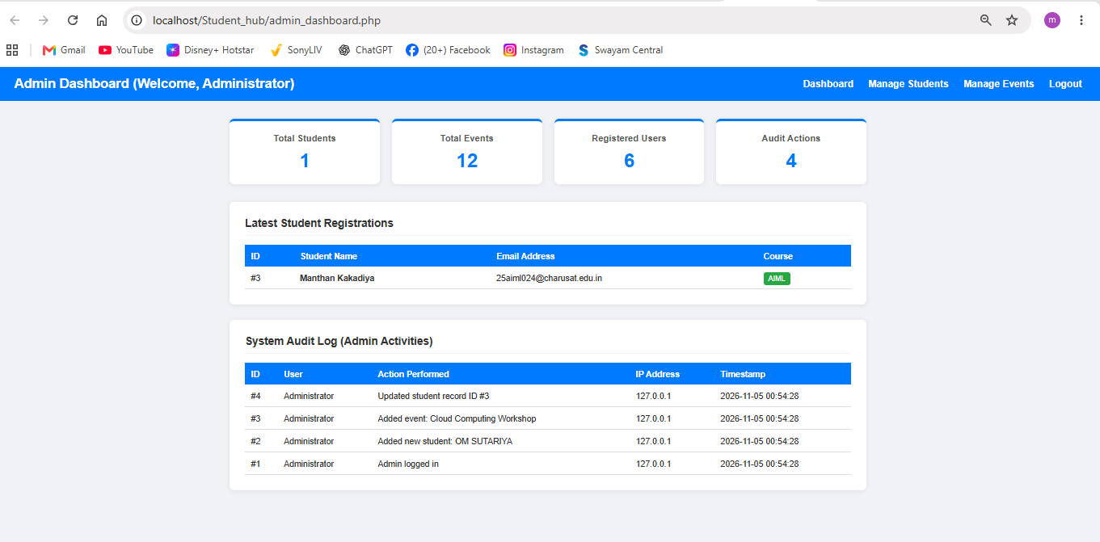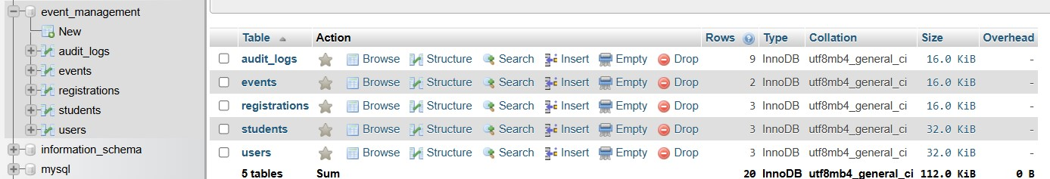

Learning Outcome:

- Develop an administrative dashboard using PHP and MySQL.
- Retrieve and display dynamic statistics using SQL queries.
- Implement Role-Based Access Control (RBAC).
- Create dynamic navigation menus based on user roles.
- Restrict access to authorized users using PHP sessions.
- Implement audit logging to maintain records of user activities.
- Manage Active/Inactive user account status.
- Display monthly registration statistics using graphical charts.
- Implement secure password storage using password hashing.

References:

- PHP Official Documentation: https://www.php.net/manual/en/
- MySQL Reference Manual: https://dev.mysql.com/doc/
- Bootstrap Documentation: https://getbootstrap.com/docs/
- Chart.js Documentation: https://www.chartjs.org/docs/
- W3Schools PHP Tutorial: https://www.w3schools.com/php/

GITHUB LINK :-
https://github.com/manthankakadiya/WEB-T

