**Star Schema:**



**ETL Execution Instructions**

Paste the DDL scripts given in SQLyog and execute.

Setup ETL environment by editing Kettle properties file and add the directory for DIR_SOURCE_FILES.

Execute the main job named main-admission-job.kjb.

**Note:- The Analysis Findings are in the DDL scripts and Analytics folder**  “**Tableau Analytics.pdf**”

**Below is the screenshot of successful execution to load dimension tables.**

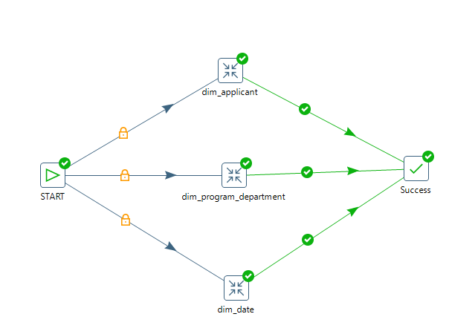

**Below is the screenshot of successful execution to denormoralize the required tables.**

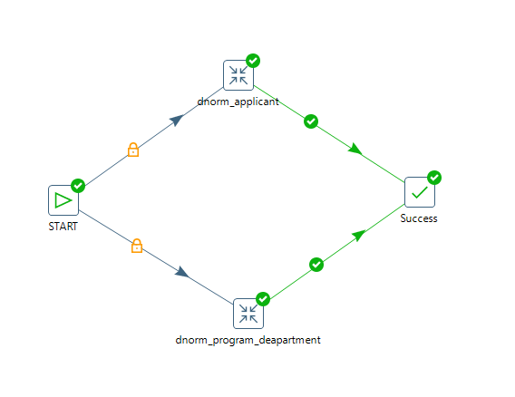

**Below is the screenshot of successful execution to load fact tables.**

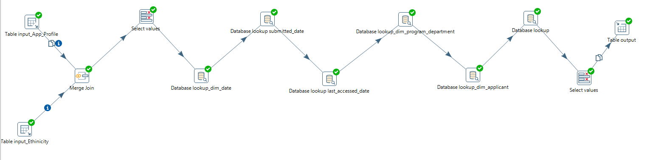

**Below is the screenshot of successful execution of main job.**

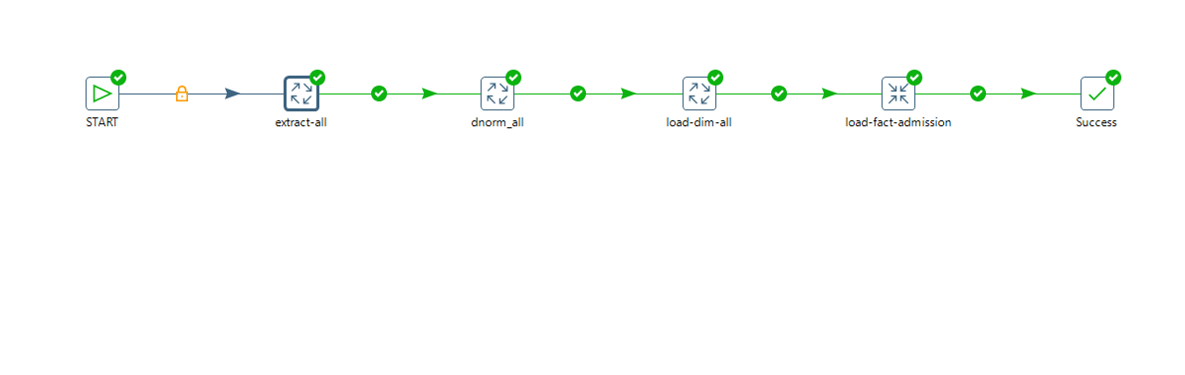

**Below screenshot shows sample dataset of fact table.**

