**Experiment No: 3**

**Interfacing Temperature Sensor LM35**

Name of the Student: ___**Manthan Khawse**  Div. **C**  Roll No. 0**3_**

**Aim**: To interface temperature sensor LM35 with Node MCU

**Components Required:**

1. Node MCU – 1
2. Micro USB Cable – 1
3. PC/Laptop – 1
4. Connecting Wires
5. Bread Board – 1
6. LM35 – 1

**Software Required:**

Arduino IDE

Theory:

In this experiment, we will see how to connect temperature sensor LM35 with**Node MCU** and how to measure temperature using analog pin of ESP8266 Node MCU. In general, an LM35 is a temperature sensor which is designed specifically to measure the hotness or coldness of an object.

LM35 is a precision IC temperature sensor with its output proportional to the temperature (in °C).

With LM35, the temperature can be measured more accurately than compared to the thermistor.

In this experiment, LM35 is used to measure the Room Temperature.

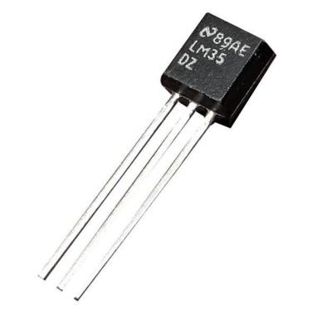

LM35 temperature sensor

LM35 is a temperature sensor that can measure temperature in the range of -55°C to 150°C.

It is a 3-terminal device that provides an analog voltage proportional to the temperature. The higher the temperature, the higher is the output voltage.

The output analog voltage can be converted to digital form using ADC so that a microcontroller can process it.

**Procedure:**

Step 1: Make the circuit diagram on bread board according to connection diagram shown below. **Pin 1** of the LM35 goes into **+3.3v[3V3 Pin]** of the Node MCU. **Pin 2** of the LM35 goes into Analog Pin [**A0]** of the Node MCU. **Pin 3** of the LM35 goes into Ground Pin (**GND**) of the Node MCU.

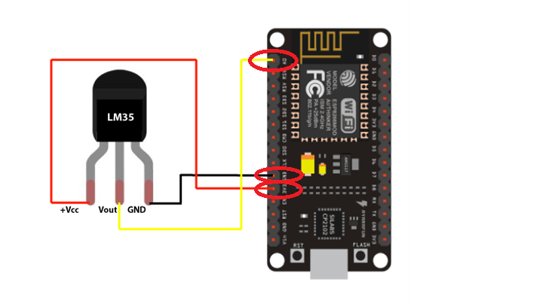

Before getting the Celsius reading of the temperature The analog output voltage from LM35 must first be read from the Vout pin of LM35.This will be the raw value divided by 1024 times 3300. It is divided by 1024 because a span of 1024 occupies 3.3v. Here we get the ratio of the raw value to the full span of 1024 and then multiply it by 3300 to get the millivolt value. Since the output pin can give out a maximum of 3.3 volts (1024), 1024 represents the possible range it can give out.

Step 2: Connect Node MCU to PC / Laptop with the help of micro USB cable

Step 3: Open new Sketch, Go to file ----> New

Step 4: Write following code in new sketch

//initializes/defines the output pin of the LM35 temperature sensor

int outputpin = A0;

//this sets the ground pin to LOW and the input voltage pin to high

void setup ()

{

Serial.begin(9600);

//Setting the baud rate for Serial Monitor Communication

}

void loop() //main loop

{

int analogValue = analogRead(outputpin);

float millivolts = (analogValue/1024.0) * 3300; //3300 is the voltage provided by NodeMCU

float celsius = millivolts/10;

Serial.print("in DegreeC= ");

Serial.println(celsius);

//---------- Here is the calculation for Fahrenheit ----------//

float fahrenheit = ((celsius * 9)/5 + 32);

Serial.print(" in Farenheit= ");

Serial.println(fahrenheit);

delay(1000);

}

Step 5: Save the new sketch by appropriate name in a folder on your PC / Laptop

Step 6: Upload the sketch on Node MCU. Go to Sketch ----> Upload

Step 7: Observe the output by clicking on Serial Monitor icon on the upper right corner of Arduino IDE. [Room Temperature]

Step 8: Hold LM35 tightly in your hand and observe the change in the temperature reading sensed by it.

**Practice:**

1. Interface LM35 and Buzzer both, to Node MCU. Modify the sketch such that buzzer should beep after temperature increases or decreases beyond certain value

**PHOTOS:**

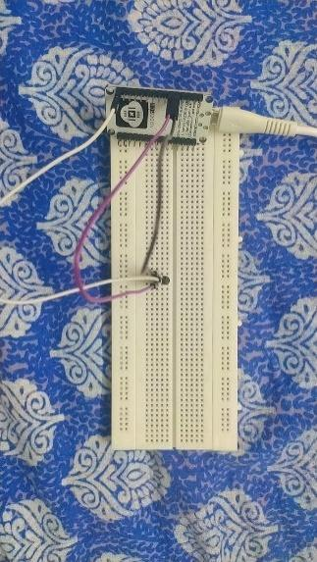 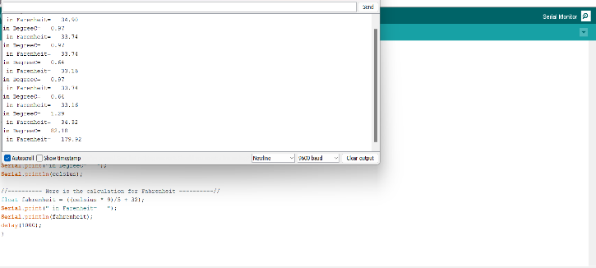

**Conclusion:**

In conclusion, interfacing the LM35 temperature sensor with the Node MCU effectively demonstrated real-time temperature measurement. The sensor’s data was accurately read and processed, highlighting the Node MCU's capabilities in handling analog inputs. This experiment showcased the practical application of the LM35 and the potential for further enhancements, such as integrating multiple sensors or adding automated features.