**Manthan Kasle- 230945920041**

**npm init**

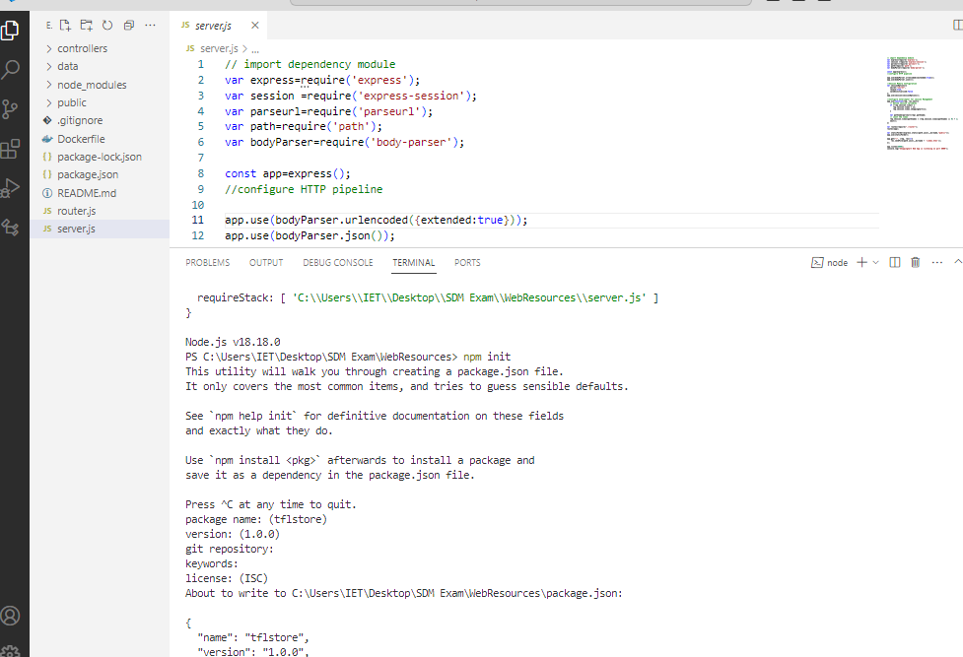

**npm install**

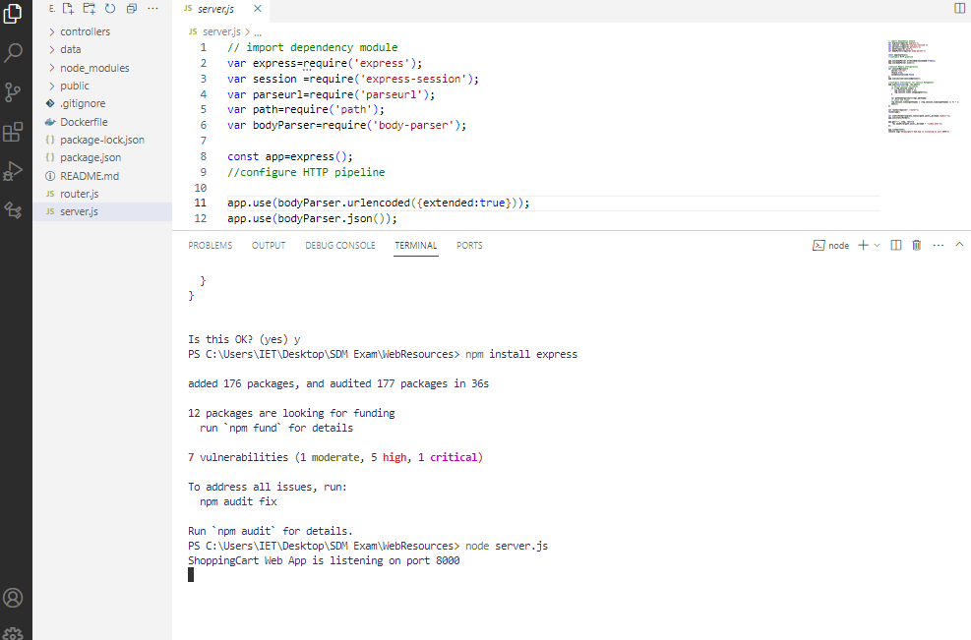

**npm install express**

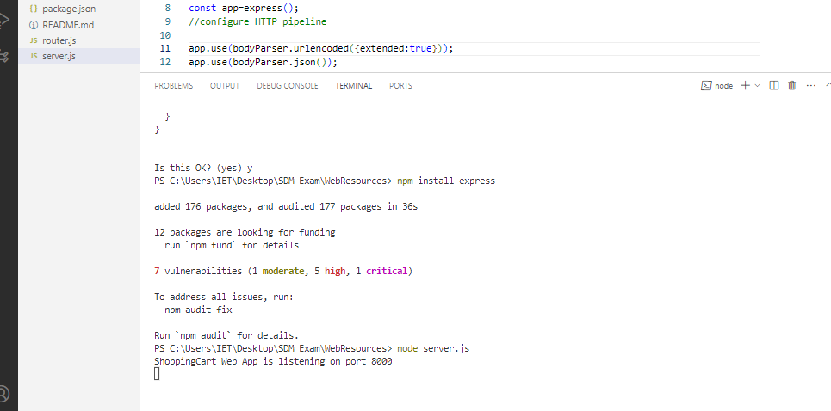

**node server.js**

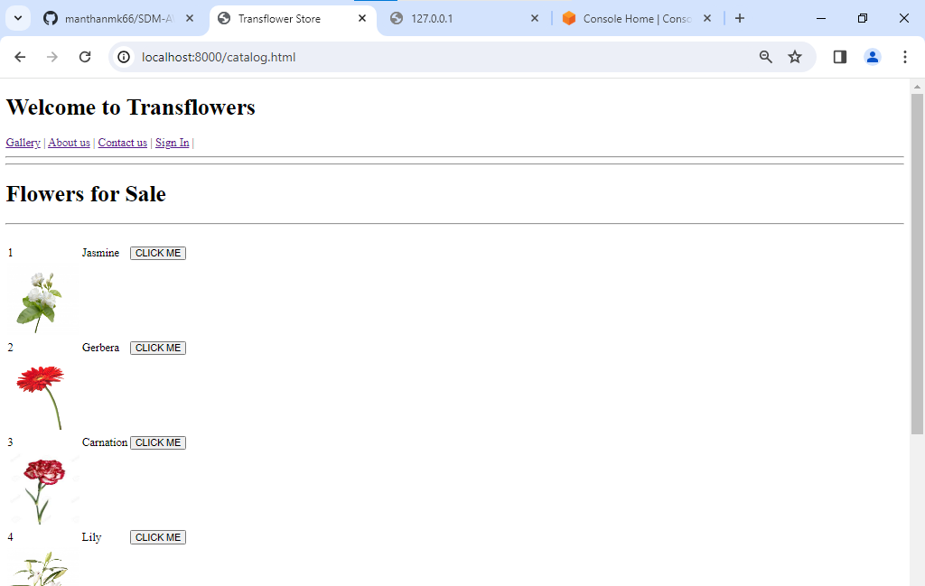

**Git clone** [**https://github.com/manthanmk66/SDM-AWS.git**](https://github.com/manthanmk66/SDM-AWS.git)

**Git add .**

**Git commit –m “Added”**

**Git push**

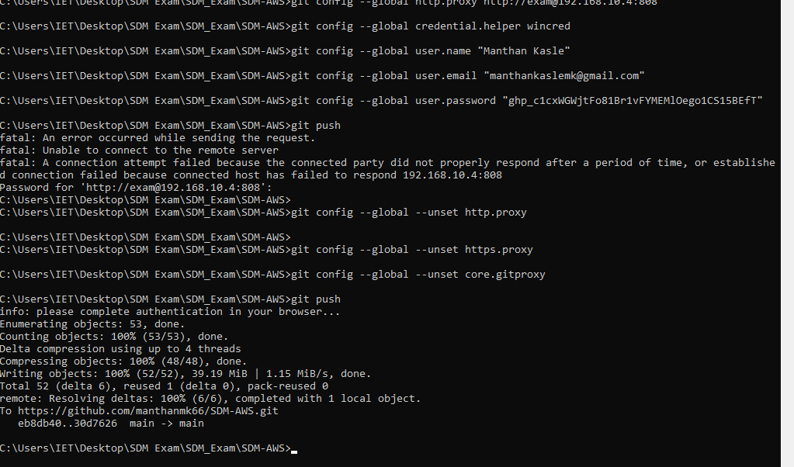

**AWS EC2 Instance**

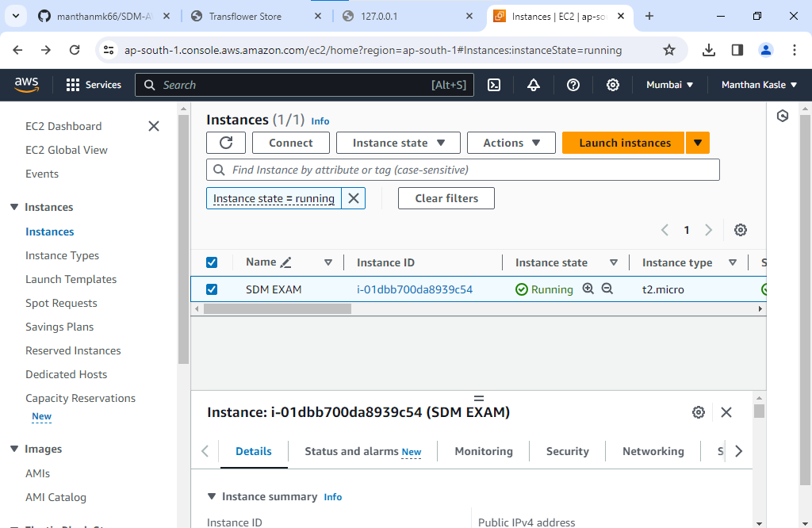

**Security**

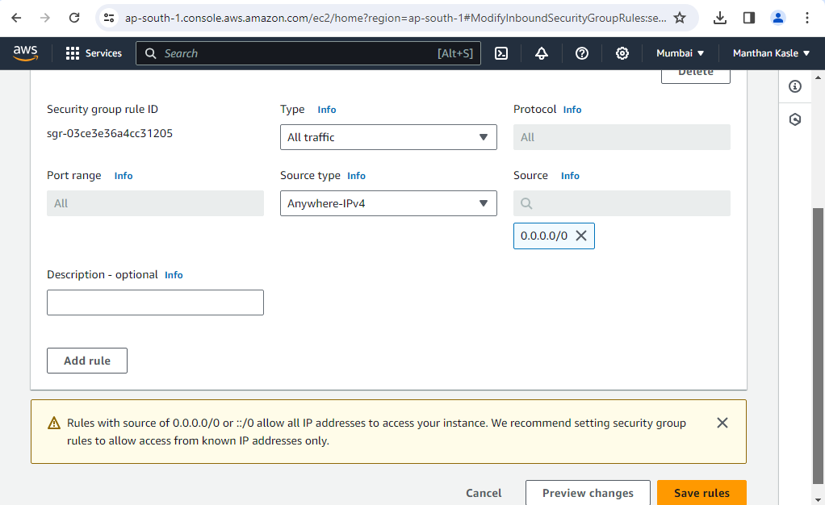

**Sudo apt update**

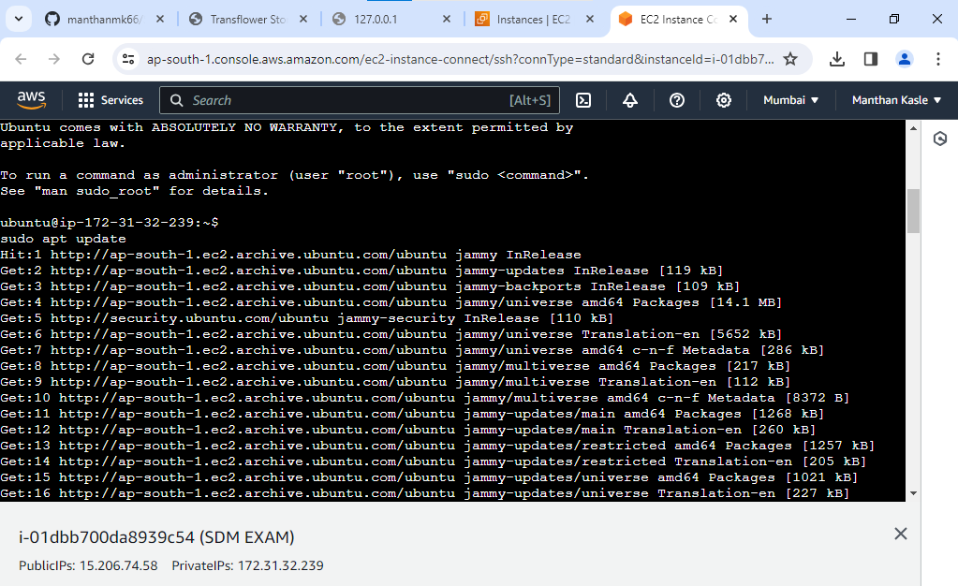

**git clone** [**https://github.com/manthanmk66/SDM-AWS.git**](https://github.com/manthanmk66/SDM-AWS.git)

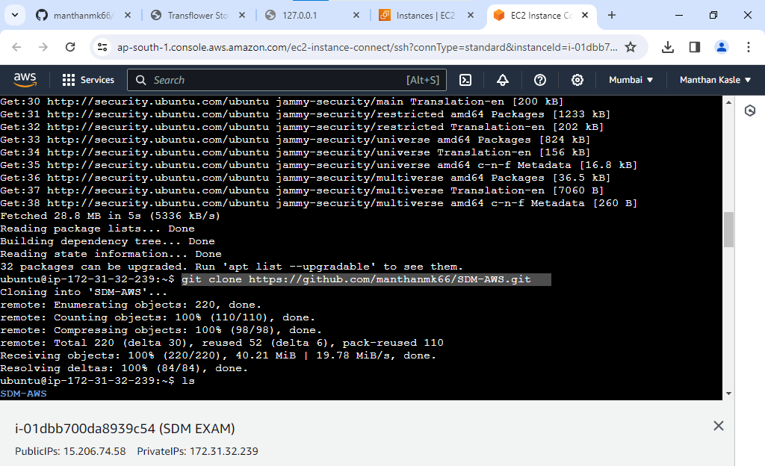

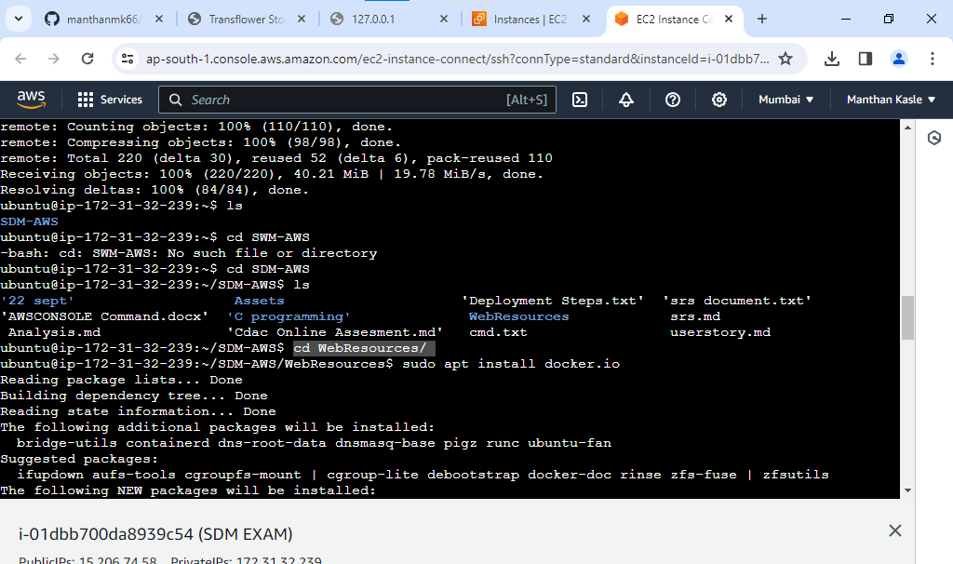

**sudo apt install docker.io**

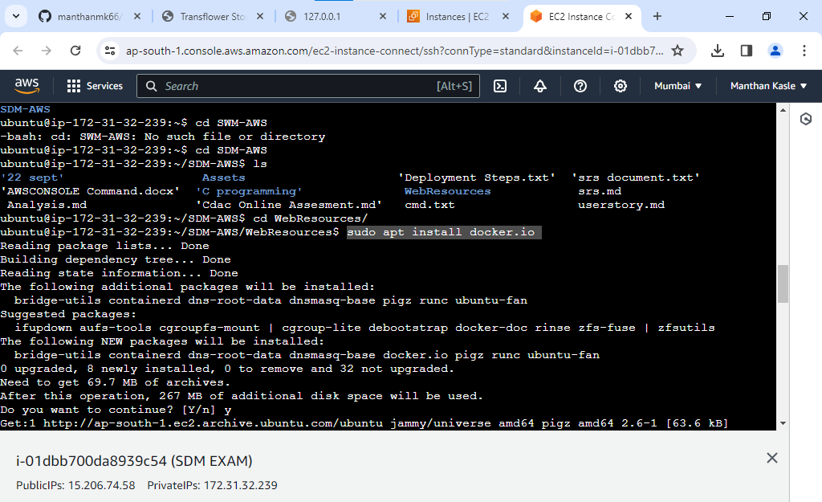

**sudo systemctl --type=service --state=running**

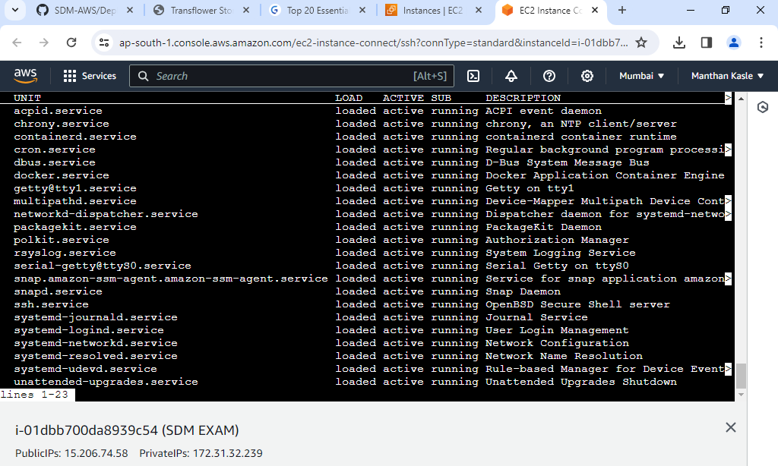

**sudo docker build -t fabrikam .**

**sudo docker images**

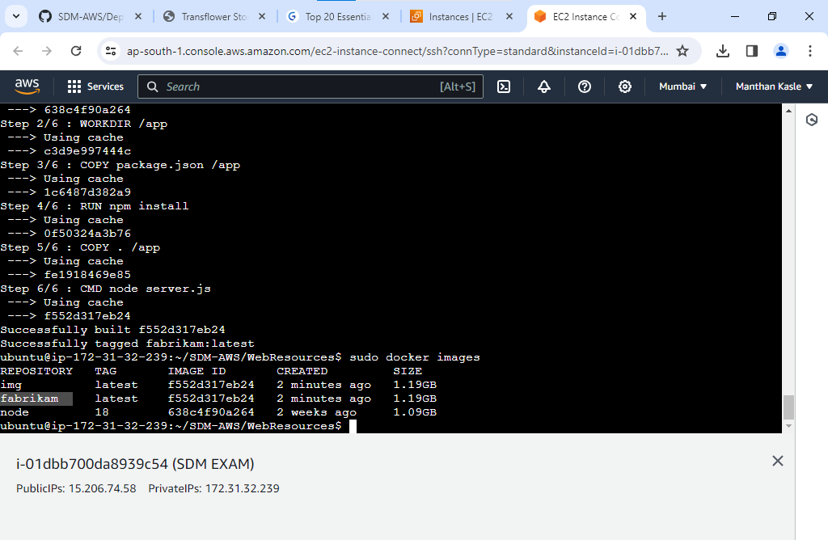

**sudo docker run -d -p 8000:8000 fabrikam**

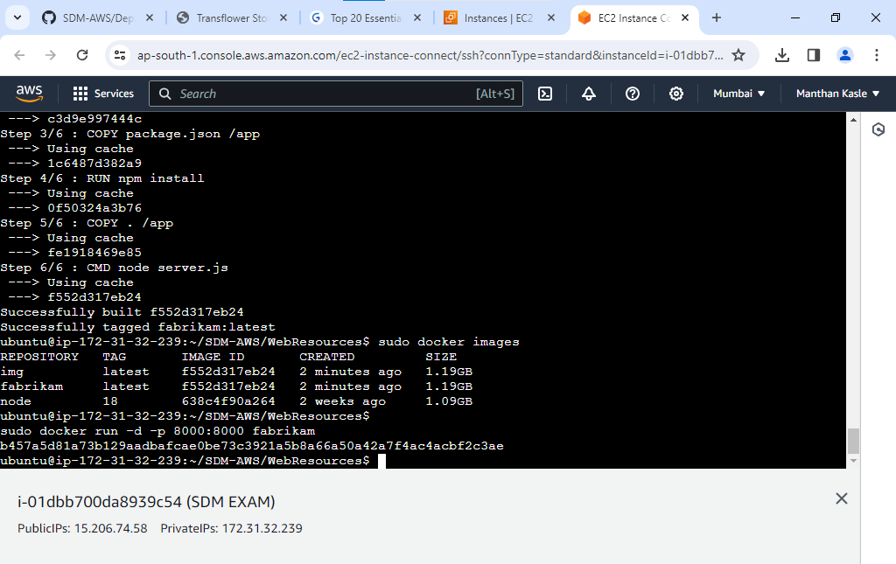

**Deployed**

[**http://15.206.74.58:8000/catalog.html**](http://15.206.74.58:8000/catalog.html)

