Data set of Hepatitis cancer

Description of data set

- Number of rows in data 200
- Number of features in data 4 (ie Alcoho,Cirrhosis,Obesity,Smoking)

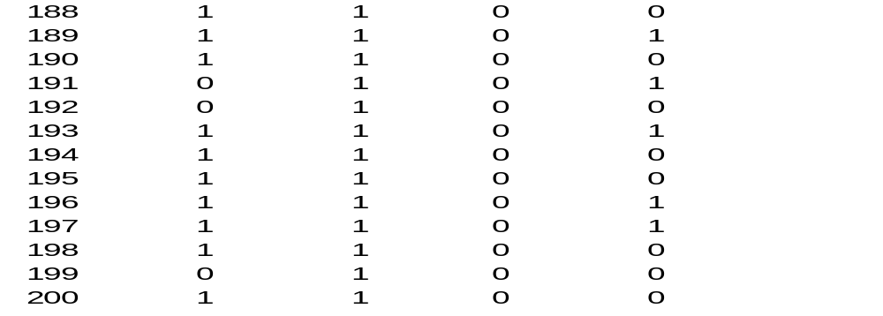

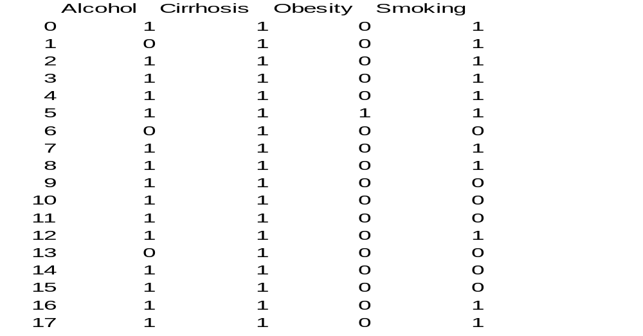

Frequency distribution Table
X | Frequency
1 | 22
2 | 147
3 | 183
4 | 330
5 | 239
6 | 169
7 | 92

Frequency Distribuition Graph

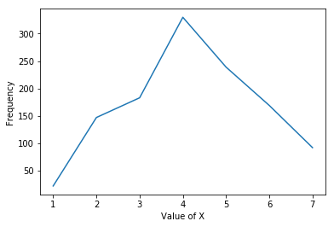

Probability distribution table

Xi | Probability Pi | Xi*Pi | Xi^2*Pi
1 | 0.018612521150592216 | 0.018612521150592216 | 0.01861252115059
2 | 0.12436548223350254 | 0.24873096446700507 | 0.49746192893401014
3 | 0.1548223350253807 | 0.46446700507614214 | 1.3934010152284264
4 | 0.27918781725888325 | 1.116751269035533 | 4.467005076142132
5 | 0.20219966159052452 | 1.0109983079526226 | 5.054991539763113
6 | 0.14297800338409475 | 0.8578680203045685 | 5.147208121827411
7 | 0.077834179357022 | 0.544839255499154 | 3.813874788494078

Mean =Σxi*Pi
Mean=4.262267343485617

n=1182
Median=X(n/2)
Median=3

Mode=max(Frequency)
Mode=4

Variance=E(x^2)-Mean^2
Variance=20.392554991539765-18.166345688
Standard Deviation=sqrt(Variance)=1.49185524908

Probability density function

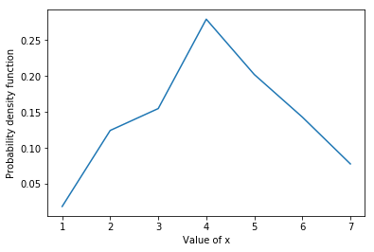

Probability Distribution function

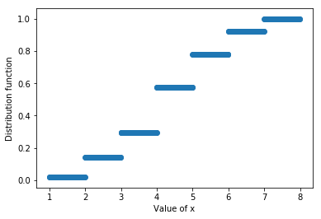

Programing language used python 2.7

import pandas as pd
import numpy as np
import matplotlib.pyplot as plt
import math

data=pd.read_csv('hccdata.csv')

temp={"alcohol":data['Alcohol'],"ciirhosis":data['Cirrhosis'],"smoking":data['Smoking'],"obesity":data['Obesity']}

numberOfAlcoholi=np.sum(temp['alcohol'])
numberOfCiirhosis=np.sum(temp['ciirhosis'])
numberOfSmoking=np.sum(temp['smoking'])
numberOfObesity=np.sum(temp['obesity'])

print "Numner of Alcoholic people "+str(numberOfAlcoholi)
print "Numner of Ciirhosis people "+str(numberOfCiirhosis)
print "Numner of Smoking people "+str(numberOfSmoking)
print "Numner of Obesed people "+str(numberOfObesity)

#ferquency table
labels=['alcohol','ciirhosis','smoking','obesity']
freq=[numberOfObesity,numberOfAlcoholi,numberOfCiirhosis,numberOfAlcoholi+numberOfCiirhosis,numberOfAlcoholi+numberOfSmoking,numberOfAlcoholi+numberOfObesity,numberOfSmoking]
x=[1,2,3,4,5,6,7]
freq=np.array(freq,dtype=float)

probability=freq/np.sum(freq)
print("X Probability")
print("-----------------")
for i in range(freq.shape[0]):
print(str(x[i])+" | "+str(probability[i]))

plt.plot(x,freq)
plt.xlabel("Value of X")
plt.ylabel("Frequency")
plt.show()

#mean median mode
mean=0.0
meadian=0.0
mode=0.0

for i in range(freq.shape[0]):
mean=mean+x[i]*probability[i]
cf=[]
t=0
for i in range(freq.shape[0]):
t=t+freq[i]
cf.append(t)
n=cf[6]

for i in range(freq.shape[0]-1):
if(n/2>cf[i] and n/2<cf[i+1]):
median=i
median=x[median]

t=freq[0]

for i in range(1,freq.shape[0]):
if(t<freq[i]):
t=freq[i]
mode=i
mode=x[mode]

plt.plot(x,probability)
plt.ylabel("Probability density function")
plt.xlabel("Value of x")
plt.show()

temp=[]
for i in range(freq.shape[0]):
for j in range(100):
temp.append([x[i]+j*0.01,cf[i]/np.sum(freq)])

temp=np.array(temp)
plt.scatter(temp.T[0],temp.T[1])
plt.ylabel("Distribution function")
plt.xlabel("Value of x")
plt.show()

print("Mean "+str(mean))
print("Median "+str(median))
print("Mode "+str(mode))

#variance
var=0.0
sd=0.0
for i in range(freq.shape[0]):
var=var+x[i]*x[i]*probability[i]

var=var-mean*mean
sd=math.sqrt(var)

print("Variance "+str(var))
print("Standard deviation "+str(sd))

Output

Numner of Alcoholic people 147
Numner of Ciirhosis people 183
Numner of Smoking people 92
Numner of Obesed people 22

X Probability
-----------------
1 | 0.018612521150592216
2 | 0.12436548223350254
3 | 0.1548223350253807
4 | 0.27918781725888325
5 | 0.20219966159052452
6 | 0.14297800338409475
7 | 0.077834179357022

Mean 4.262267343485617
Median 3
Mode 4
Variance 2.225632084195823
Standard deviation 1.49185524908

