**Step 1: Extraction of data from SQL Database using SQL queries**

* Extract the average temperature of the city ‘Bangalore’ in the country ‘India’ for all the years using the SQL query:

**select * from city_data where city = 'Bangalore' and country = 'India';**

* Extract the global average temperature using the following SQL query:

**select * from global_data;**

* Extract the average temperature of the country ‘India’ for all the cities combined using the following SQL query:

**select year, AVG(avg_temp) from city_data where country = 'India' group by year order by year;**

**Step 2: Collating all information in Excel:**

* Collate the average temperature data from global, country wise (India) and city wise (Bangalore) in a single Excel spreadsheet in 3 different columns, alongside the year.
* The moving average for the global data, country data and city data is calculated over a period of 10 years using the formula AVERAGE() in excel.

*Note:*

* *The average temperature data is not available for Country (India) and City (Bangalore) from 1750 to 1795 and from 1808 to 1812. Also, data is unavailable for city Bangalore for years 1863 and 1864.*

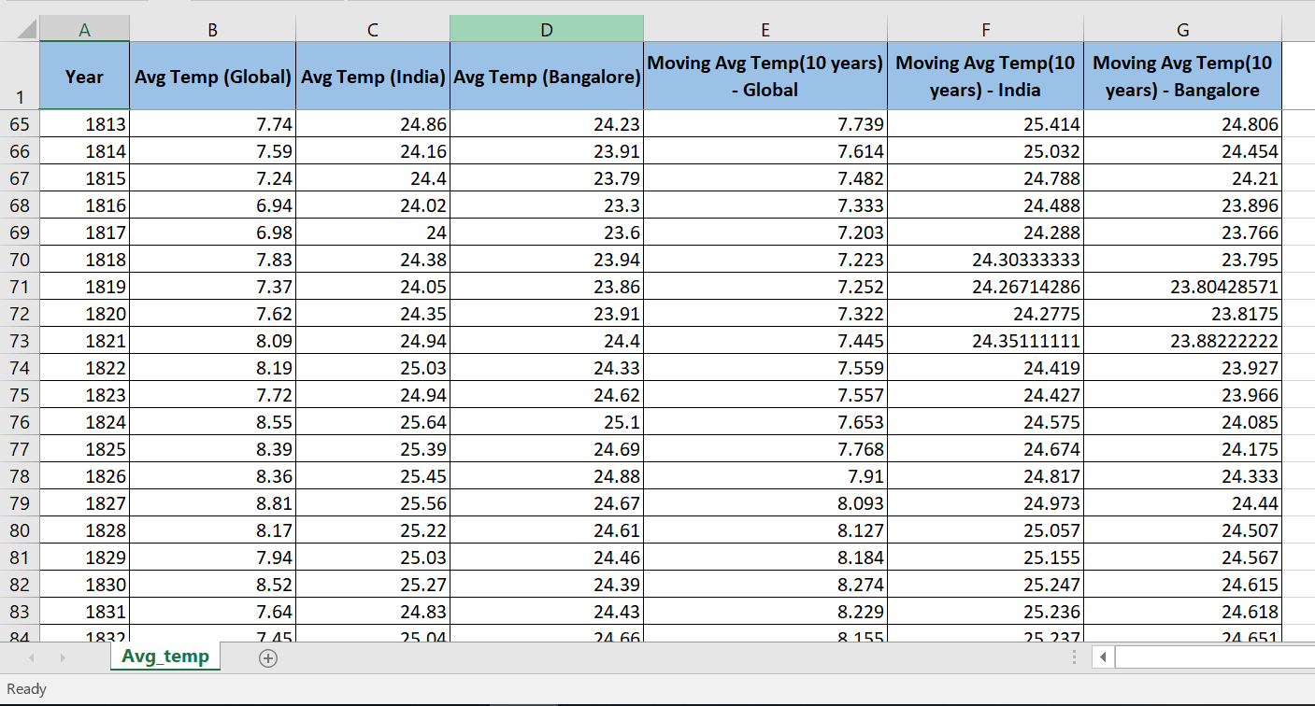

**Step 3: Plotting a Line chart in Microsoft Excel**

* The collated moving average temperatures of the globe, India and Bangalore are plotted in a “Line plot” in excel as shown below.
* All axes titles, legends and chart titles are added for better interpretation.

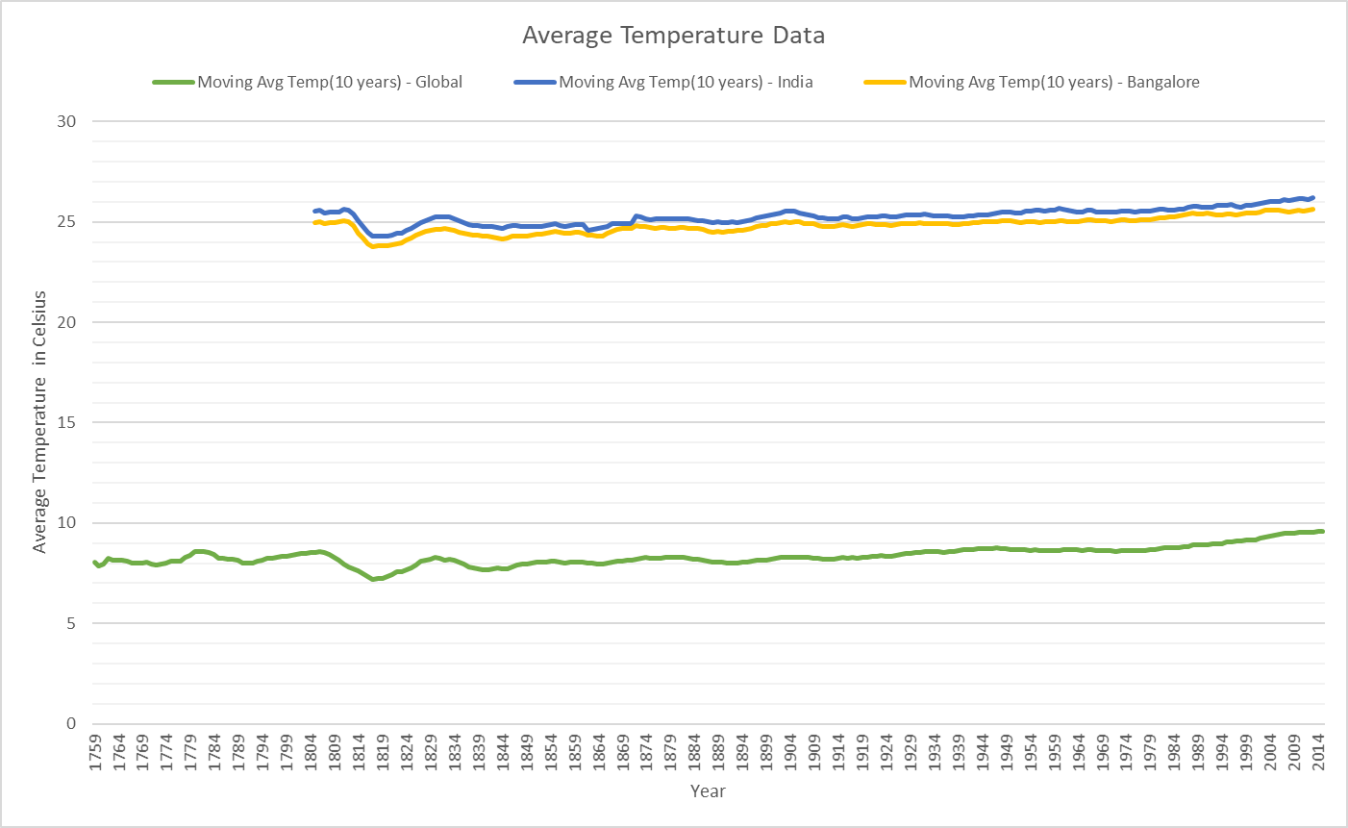

**Step 4: Interpretation of the plotted data**

* The average temperature of Bangalore and India as a country in general is close to 20 degrees Celsius higher than the global average temperature at any given year.
* There has been a temperature drop of close to 2 degrees Celsius from 1809 to 1819 and the temperature rose back up by 2 degrees Celsius from 1819 to 1829. This trend is observed globally as well as in India and Bangalore specifically.
* The average temperature of Bangalore is very slightly lower (Close to 1 degree Celsius) than the overall average temperature of all other cities in India at any given year.
* The average temperature of the world is seen increasing almost linearly by 1 degrees Celsius from around 1979 to 2015. This trend is observed in Bangalore and India in general too. This is equivalent of 1 degree rise in temperature for every 35 years. If this trend continues, then around the year 2365, the average temperature of the globe would be around 20 degrees Celsius and the average temperature of Bangalore and India would be around 36 degrees Celsius.