**2nd NED Board Flash Steps**

**(1)** Connect micro USB to device, press KYPD_PWR key and the device is booted.

**(2)** echo 1 > /sys/class/power_supply/battery/input_suspend

- failed: permission error

**(3)** Wait for normal boot then Connect NED to a computer by USB-C.

**(4)** Verify that adb can see it with adb devices

Output:



**(5)** cd to the directory where we unzipped the image

**(6)** ./flash_all.py -p -w -f

Output: 

We have fixed this issue using below steps:

* adb kill-server
* sudo adb start-server
* Detached and attached the device and connect it again

**(7)** ./flash_all.py -p -w -f

Input: N

**(8)** ./flash_all.py -p -w -f

Input: Y

**(10)** After ~45 minutes, same screen will be displayed on device as per below

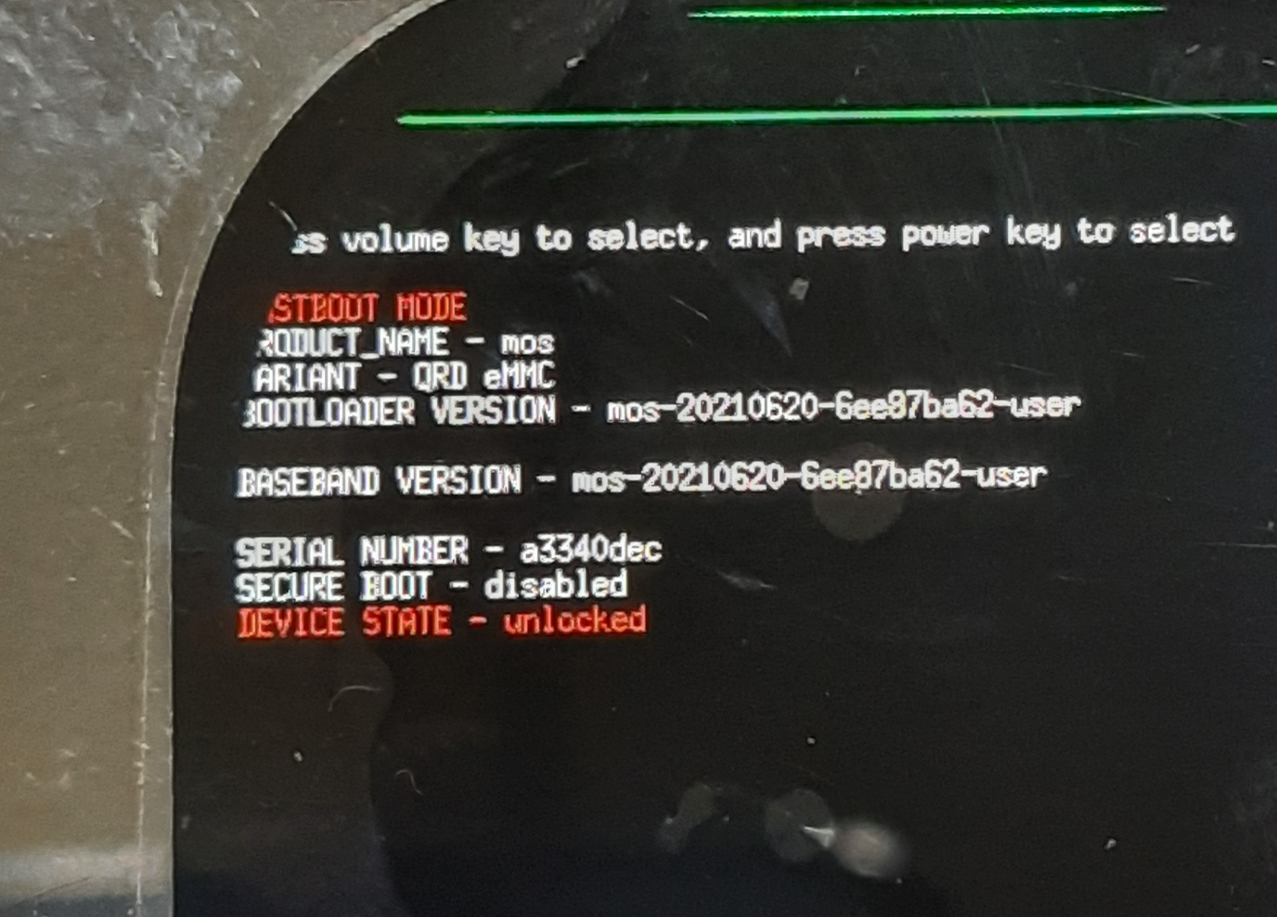

**(11)** From other terminal, we have checked device status using “sudo fastboot devices” command.

Device is in fastboot mode.

**(12)** Try to flash remaining commands manually as per below,

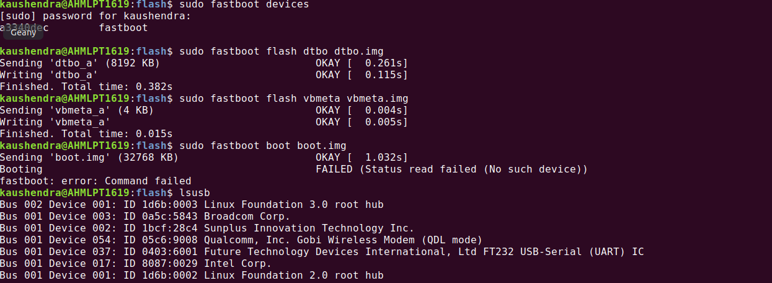

Device is in QDL mode