**NED BoArd**

Step 1: Connect USB-Type-B with Power Socket and USB-Type-C to Host Machine and press power button to turn on the NED board.

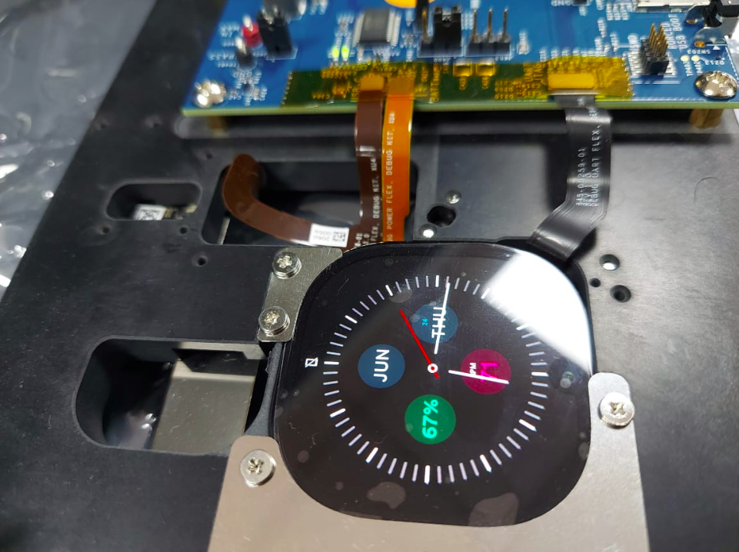

Step 2:get the adb of the Board using below commands.

$sudo adb start-server

$adb devices

$adb root

$adb shell

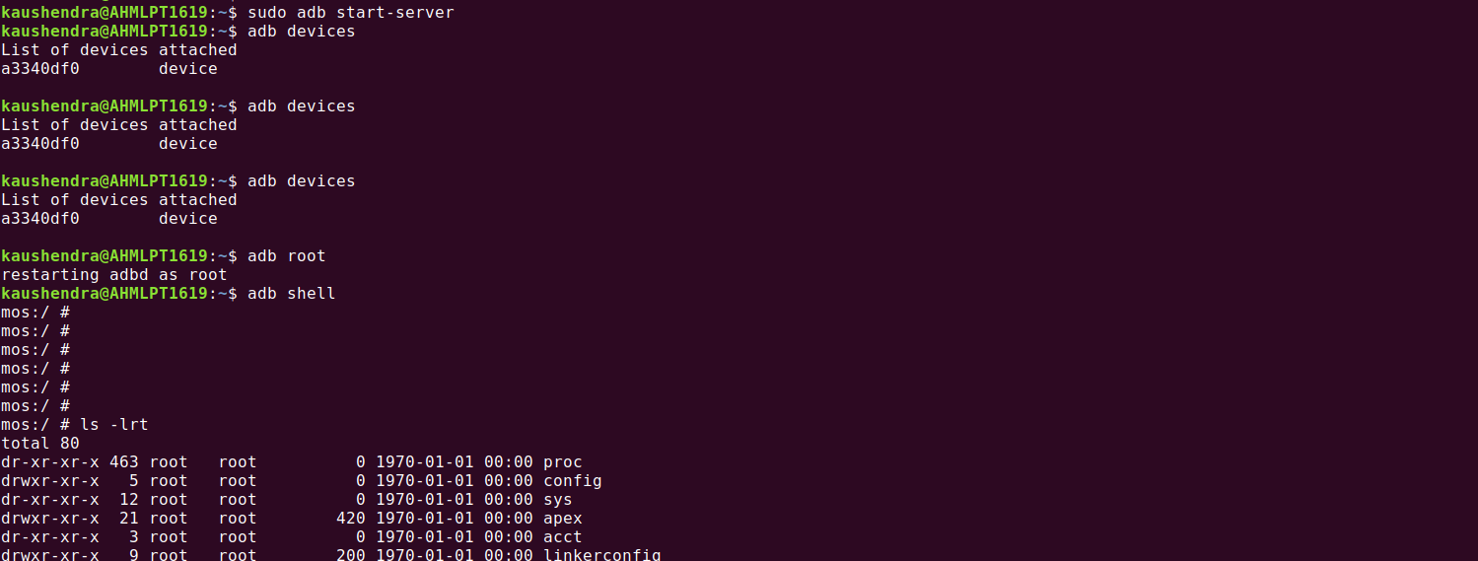

Step 3: use the tinycap utility to generate an audio file.

$ tinycap filename -T timeout



Note: we found error while capturing the audio,need help to understand this scenario.

Step 5: Running the audio file over the board.

$tinyplay file_name_audio

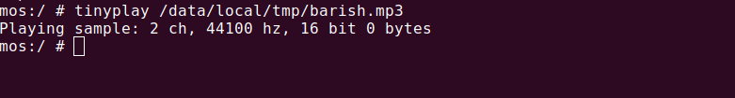

Note:we are not able to hear any audio while playing

Step 6: Checking audiocapture binary over NED Board :

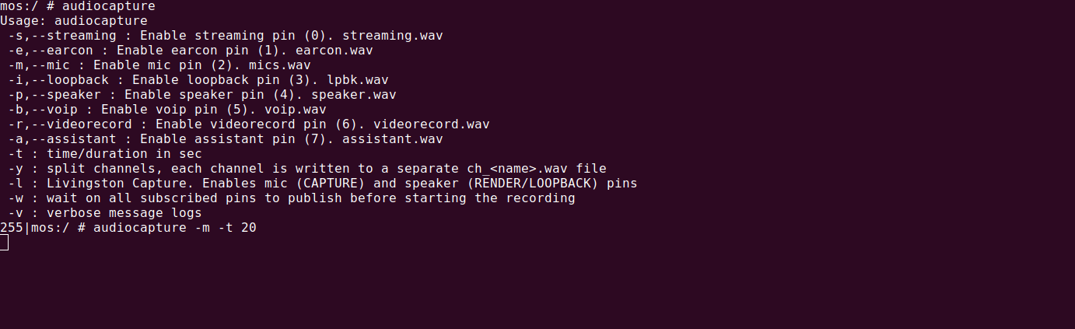

Note: we need your help to understand how to use this utility and commands and their responses.

We Need the below document

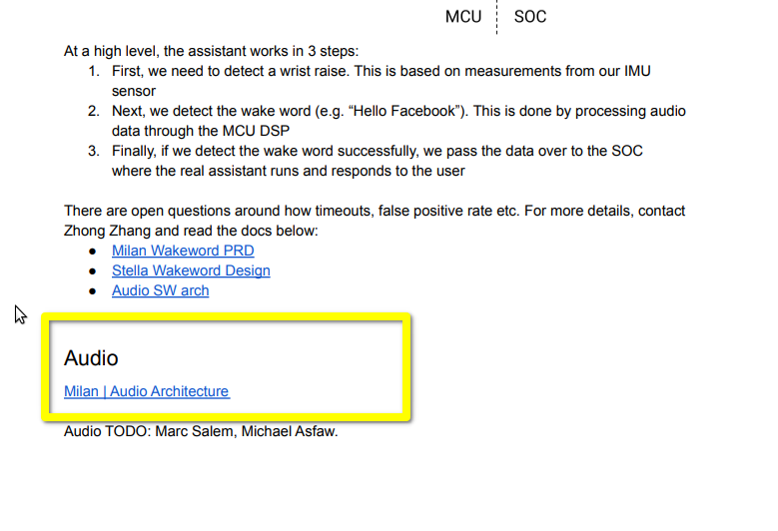

Note: We tried to run the Sound recoder.apk also finds bugs using this,like file not getting generated.