**QFIL RECOVERY Steps**

Note: We had referred Recovery-Mode-Instructions.pdf and Unbricking-POC-Wiki.pdf

Download latest SDK Platform Tools : [https://developer.android.com/studio/releases/platform-tools#downloads](https://developer.android.com/studio/releases/platform-tools" \l "downloads)

Step 1: Found the NED Board under QDL Mode

If there is no sign of life on display and the device is completely bricked (it might enumerate

in QDL mode) Hence we checked QDL Mode,after plugging power and usb cables to the NED.

Command: $lsusb

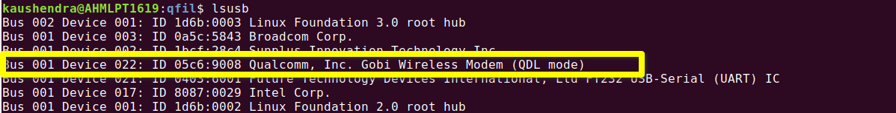

Step 2: Downloaded and unzip the qfil package supplied.



Step 3: Run the flash qfil package script supplied on ubuntu-18.04, and process get stuck at below level.

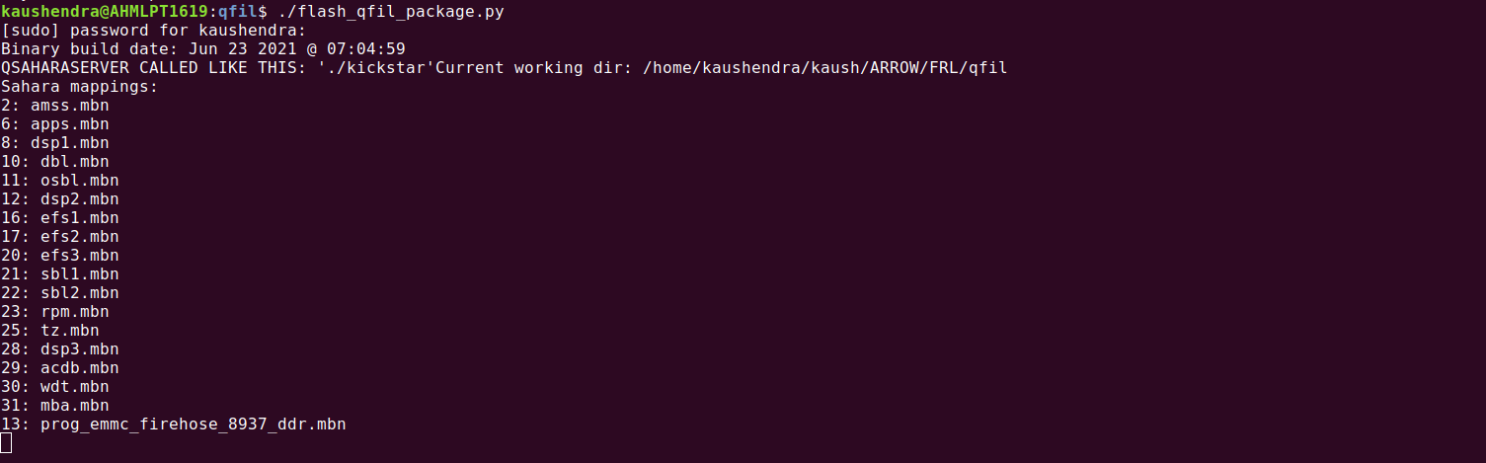

Note:

1.We waited for approx 40mins.

2. tried command with python, python3 and without explicitly calling python also by ./flash_qfil_package.py

What we debug:

1. In ubuntu 18.04(Laptop):- we need to connect power cable in Power socket followed by USB-Type-C cable to laptop within seconds and run the script

$sudo python flash_qfil_package.py

this gives below error due to break in data transfer.

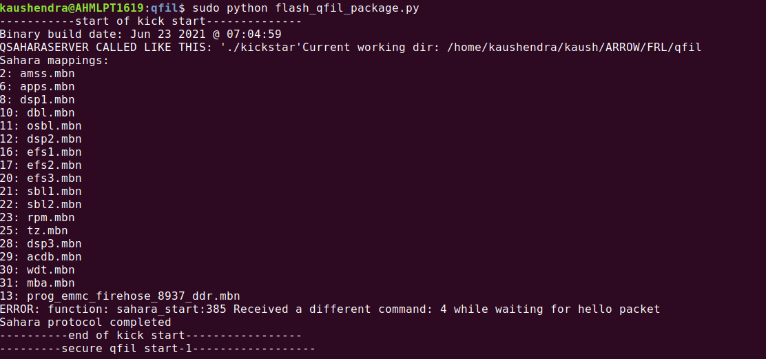

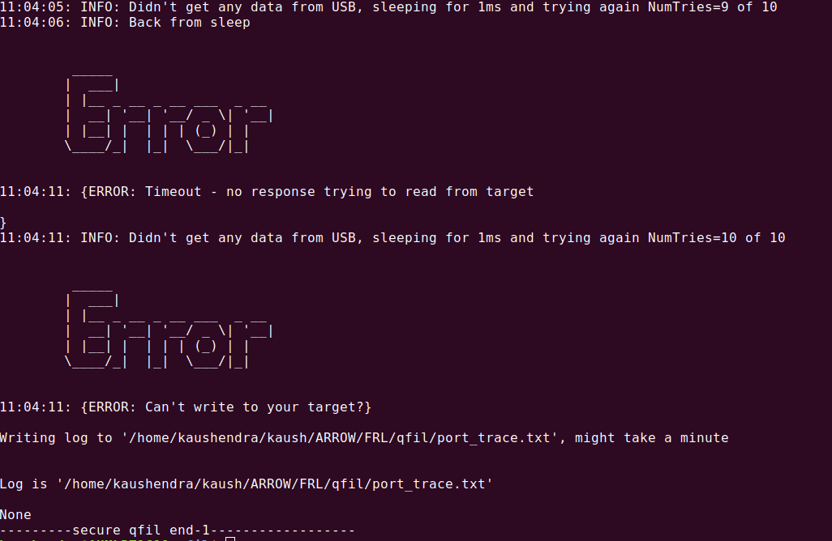

2. In ubuntu 16.04(Desktop):-we connect power cable in Power socket followed by USB-Type-C cable and run the script ,we sucessfully able to do QFIL Recovery.

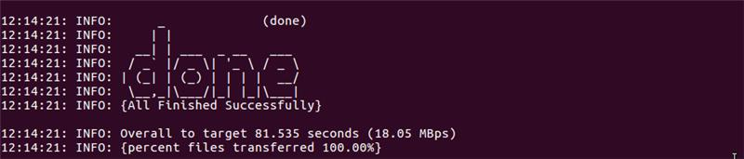

we get the below Display Screen up and running on device.

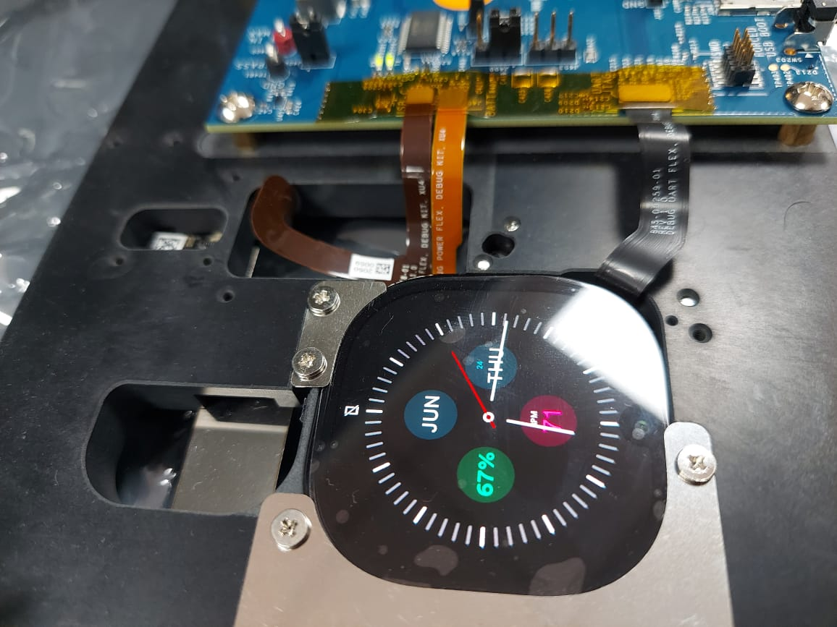

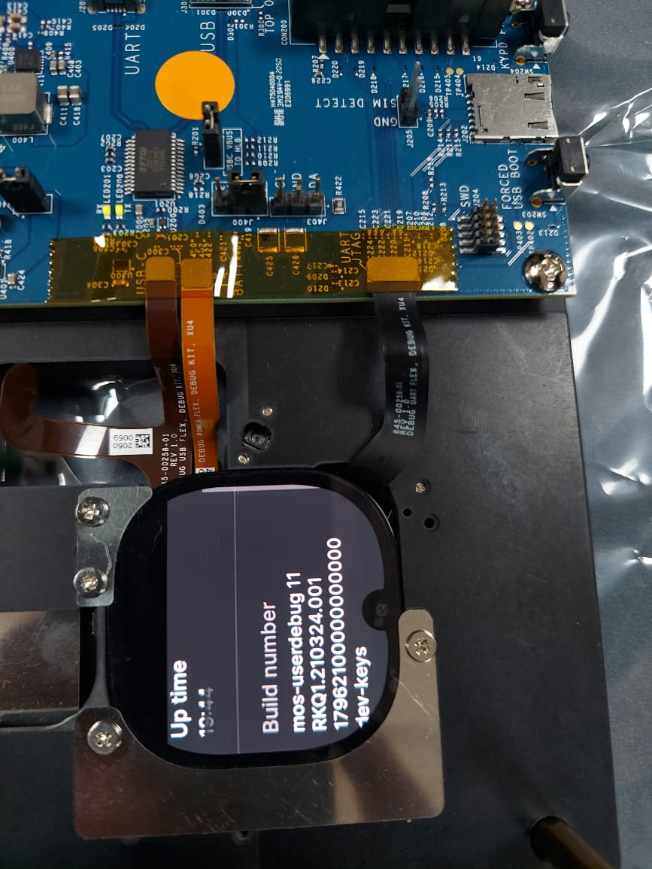Step 4: Verified the build version with the supplied one on Display mos_userdebug_qfil_20210624115017_1796210.0.0_1198747717223310.zip

Findings/Query : Not able to get the adb node after connecting USB-Type-C cable.

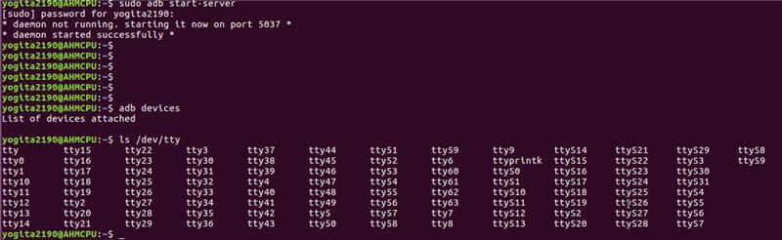

**FASTBOOT MODE FLASH Steps**

Step 1:force it into fastboot mode, by powering down the board, then holding down the camera button while you press the power button and get the device into fastboot mode as depicted in below screenshot.

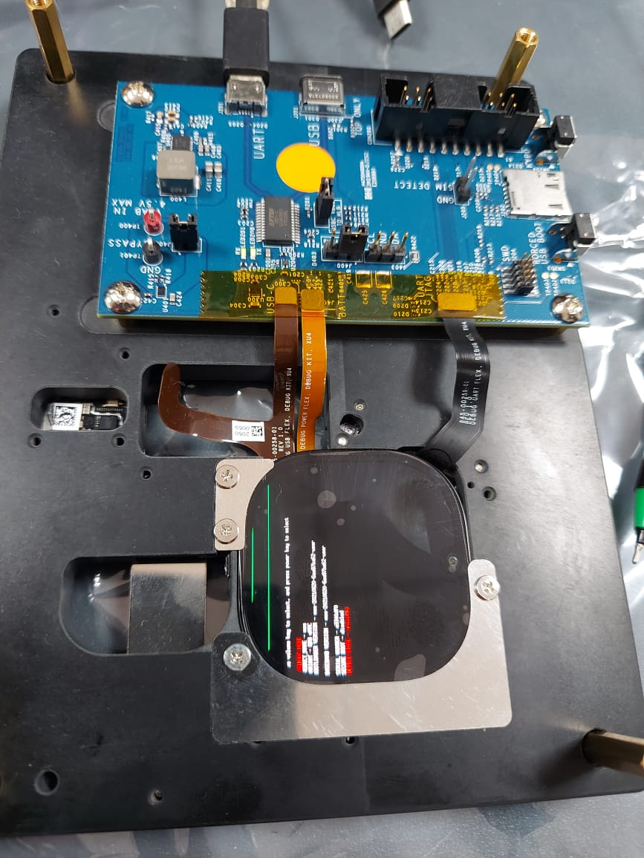

Step 2: try to get fastboot devices and add permission in andriod rules.

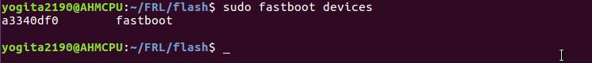

$ sudo sh -c "echo 'SUBSYSTEM==\"usb\", ATTR{idVendor}==\"a334\", MODE=\"0666\", GROUP=\"plugdev\"' >> /etc/udev/rules.d/51-android.rules"

$sudo service udev restart

Step 3: try to flash in fastboot mode as per given instruction and observe below error using package

mos_userdebug_fastboot_20210624114930_1796210.0.0_884352385503801.zip.

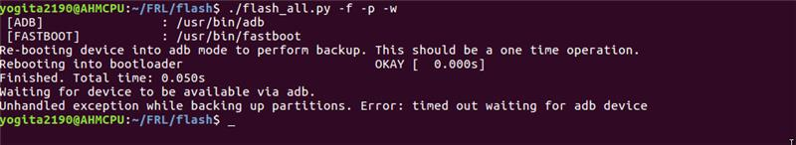

Step 4: we commented the looking for adb_device function as a work around for the issue.

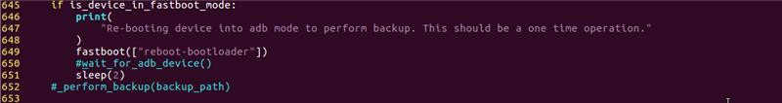

Step 5: Now we tried the device flashing in fastboot mode using below command and gets results depicted in screenshot shown below.

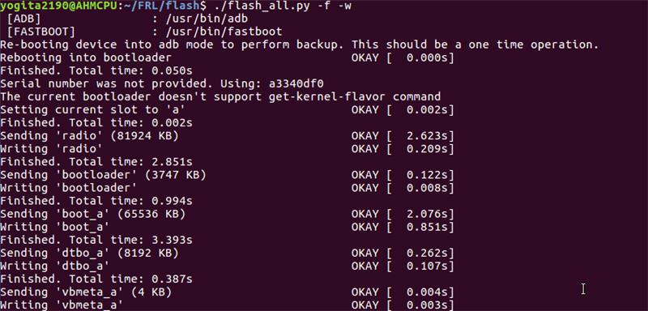

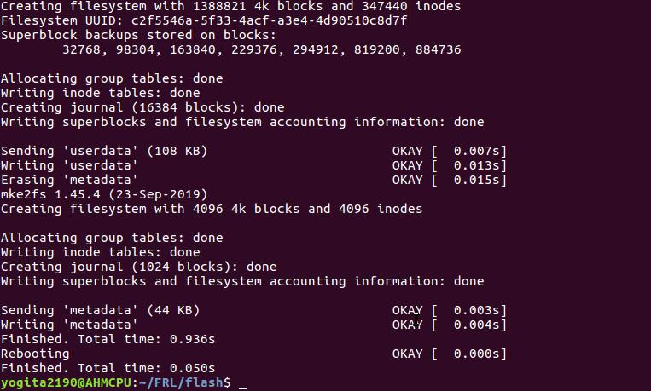

step 6: We observe the Board boots up and get the display up and running.

Step 7: However ,we tried to look for device using adb devices ,but didn’t get the node enabled here in the particular build provided

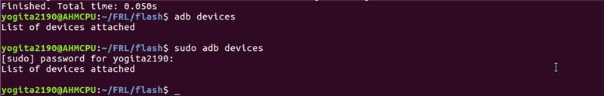

Note: We tried to enable the developer mode and enabled USB-Debugging option .

**Cross Compile for Andriod ARMv7 Steps**

Step 1: Boot the Board and Connect USB-Type-C cable and get the adb of the Board.

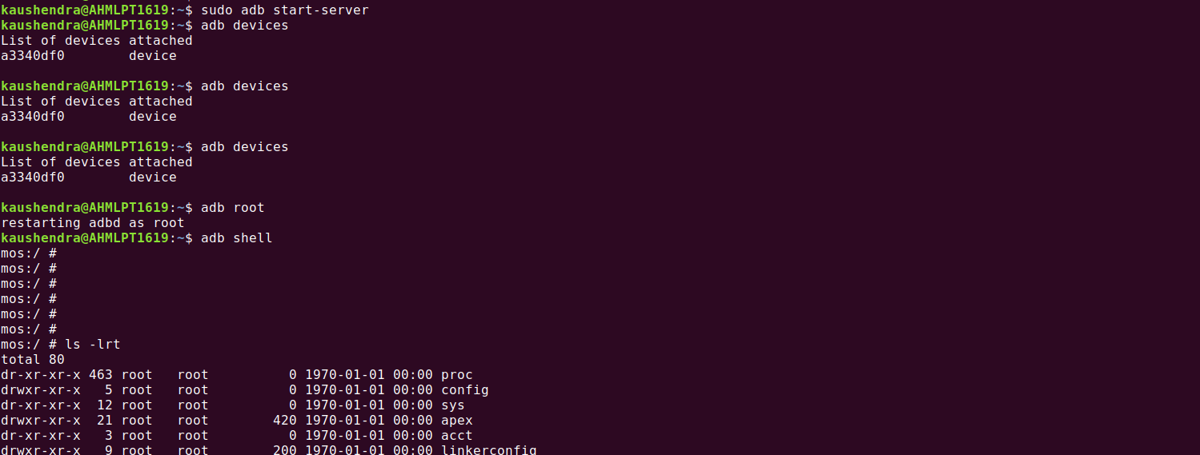

Step 2: Boot the Board and Connect USB-Type-C cable and get the adb of the Board.