**SOC Implementation**

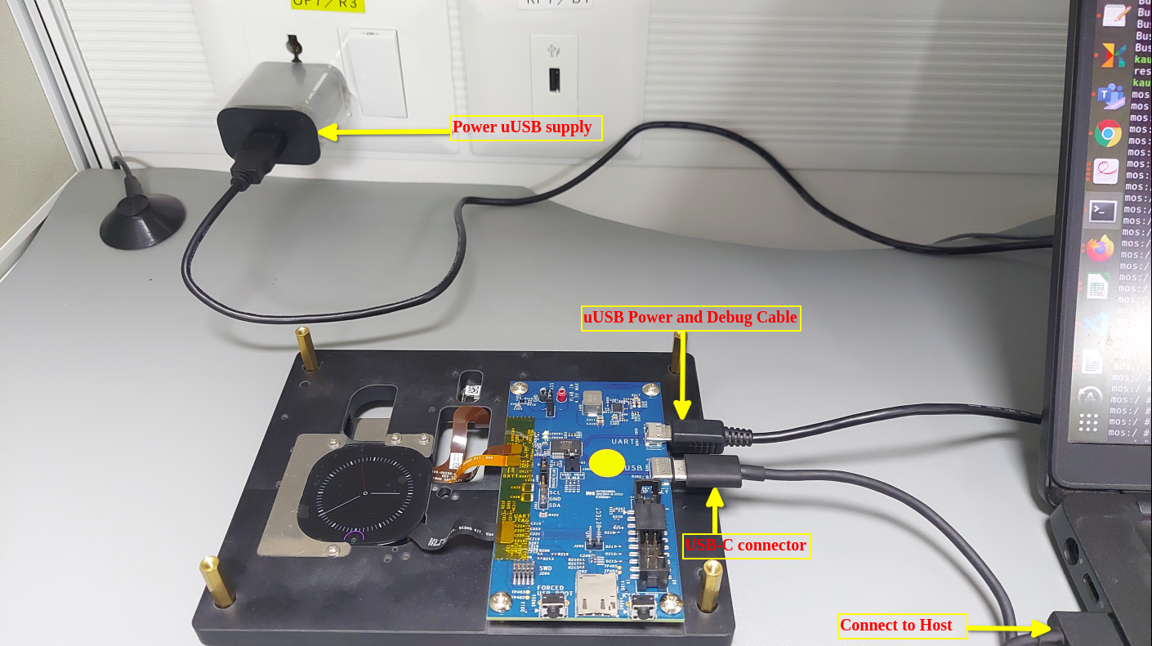

Startup Init Script :

/home/admin/mos/device/oculus/mos/rootdir/etc

Android services:

Facebook Service:

/home/admin/mos/frameworks/base/services/core/java/com/facebook/wearable

commandrouter service:

/home/admin/mos/vendor/oculus/software/services/commandrouter

sensor implemenation:

/home/admin/mos/vendor/oculus/sensorHal/

BLUECAPTURE UTILITY RUNNING

Step 1: Connect USB-Type-B with Power Socket and USB-Type-C to Host Machine and press

power button to turn on the NED board

Step 2:get the adb of the Board using below commands.

$sudo adb start-server

$adb devices

$adb root

$adb shell

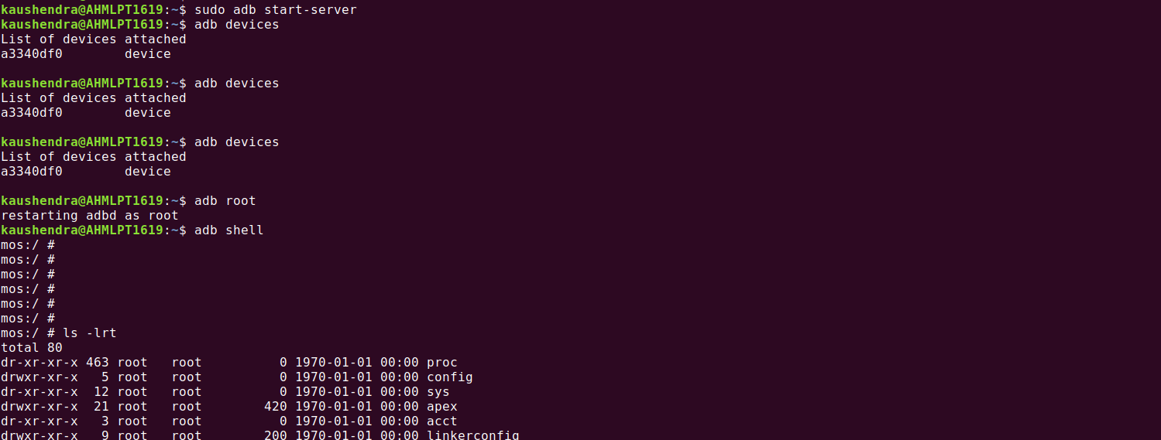

Step 3: Open another terminal to access bleucapture utility through adb using below command.

$adb logcat -v color | grep -i bluecapture

Step 4: run the bluecapture utility on board for sensor data access as given below.

$bluecapture -a -v

Usage: bluecapture

-a : start ALS streaming

-c : start ALT streaming

-v : print logging to console

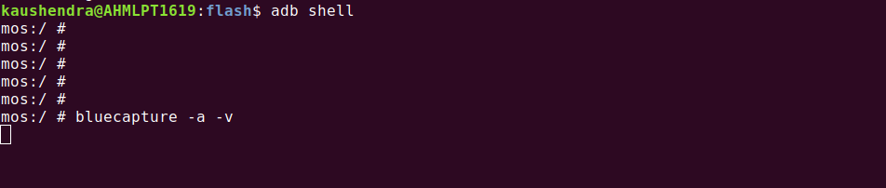

Step 5: Verified the Bluecapture logs using below command.



Step 6: We found a warning displaying the mismatch of topics from SOC and MCU side.

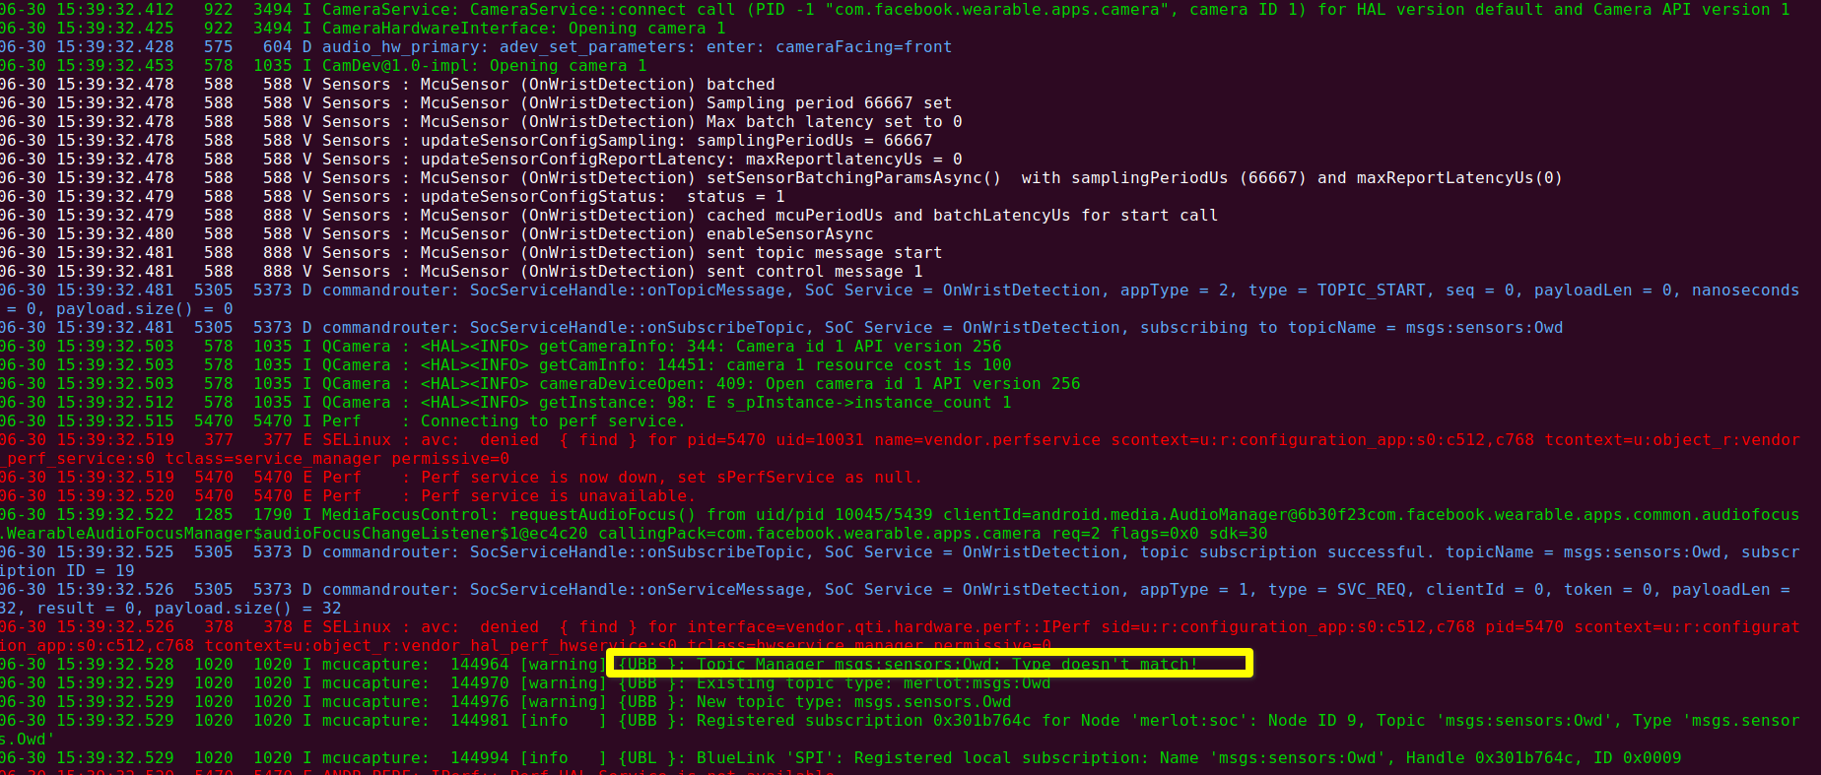

AUDIOCAPTURE UTILITY RUNNING

Step 1: we tried to run the audio-test using audiocapture utility

$audiocapture

Usage: audiocapture

-s,--streaming : Enable streaming pin (0). streaming.wav

-e,--earcon : Enable earcon pin (1). earcon.wav

-m,--mic : Enable mic pin (2). mics.wav

-i,--loopback : Enable loopback pin (3). lpbk.wav

-p,--speaker : Enable speaker pin (4). speaker.wav

-b,--voip : Enable voip pin (5). voip.wav

-r,--videorecord : Enable videorecord pin (6). videorecord.wav

-a,--assistant : Enable assistant pin (7). assistant.wav

-t : time/duration in sec

-y : split channels, each channel is written to a separate ch_<name>.wav file

-l : Livingston Capture. Enables mic (CAPTURE) and speaker (RENDER/LOOPBACK) pins

-v : verbose message logs

$audiocapture -m -v

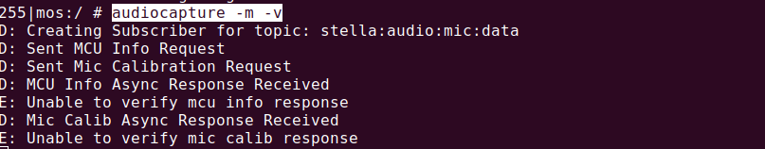

Step 2: Verified the audiocapture logs using below command

