VISVESVARAYA TECHNOLOGICAL UNIVERSITY
Jnana Sangama, Belagavi-590018.


A Mini Project Report on
“Evolv-Integrated Task Management for Better Productivity”

Submitted in the partial fulfillment of the requirement for the award of degree of Bachelor of Engineering
In
Computer Science and Engineering
By
Karthika M Nair (1OX22CS080)
Imthiyaz K (1OX22CS071)
Nikhil N V (1OX22CS116)
Pragya M S (1OX22CS122)
Under the guidance of
Ms Manjula L, Assistant Professor


Department of Computer Science and Engineering
THE OXFORD COLLEGE OF ENGINEERING
Bommanahalli, Bangalore 560068
2024-2025

THE OXFORD COLLEGE OF ENGINEERING
Hosur Road, Bommanahalli, Bengaluru-560068
(Affiliated to VISVESVARAYA TECHNOLOGICAL UNIVERSITY, Belagavi)
Department of Computer Science and Engineering

CERTIFICATE

Certified that the Mini Project work entitled “Evolv-Integrated Task Management for Better Productivity” carried out by Karthika M Nair (1OX22CS080), Imthiyaz K (1OX22CS071), Nikhil NV (1OX22CS116), Pragya MS (1OX22CS122) bonafide students of The Oxford College of Engineering, Bengaluru in partial fulfillment for the award of Degree of Bachelor of Engineering in Computer Science and Engineering of the Visvesvaraya Technological University, Belagavi, during the year 2024-2025. It is certified that all corrections/suggestions indicated for the assessment have been incorporated in the report deposited in the departmental library. The Mini project report has been approved as it satisfies the academic requirements in respect of Mini Project work prescribed for the said Degree.

Manjula L
Assistant Professor, TOCE
Dr. E.Saravanakumar
Prof. & Head Dept of CSE, TOCE
Dr. H N Ramesh Principal,TOCE

THE OXFORD COLLEGE OF ENGINEERING
Hosur Road, Bommanahalli, Bengaluru-560068
(Affiliated to VISVESVARAYA TECHNOLOGICAL UNIVERSITY, Belagavi)
Department of Computer Science and Engineering

DECLARATION

Karthika M Nair, Imthiyaz K, Pragya MS, Nikhil NV the students of 5th Semester B.E, at the Department of Computer Science and Engineering, The Oxford College of Engineering, Bengaluru declare that the Mini project work entitled “Integrated Task Management for Better Productivity” has been carried out by us and submitted in partial fulfillment of the course requirements for the award of degree in Bachelor of Engineering in Computer Science and Engineering discipline of Visvesvaraya Technological University, Belagavi during the academic year 2024- 2025. Further, the matter embodied in the report has not been submitted previously by anybody for the award of any degree or diploma to any other university.

Name USN Signature

Karthika M Nair (1OX22CS080)
Imthiyaz K (1OX22CS071)
Nikhil NV (1OX22CS116)
Pragya MS (1OX22CS122)

ACKNOWLEDGEMENT

The satisfaction and euphoria that accompany the successful completion of any task would be incomplete without the mention of people who made it possible whose constant guidance and encouragement crowned our effort with success. We consider ourselves proud to be a part of The Oxford family, the institution that stood by the way in all our endeavors. We have a great pleasure in expressing my deep sense of gratitude to the founder chairman Late Sri S. Narasa Raju and to our chairman Dr.S.N.V.L. Narasimha Raju for providing me with a great infrastructure and well- furnished labs. We would like to express my gratitude to Dr. H N Ramesh, Principal, The Oxford College of Engineering for providing us with a congenial environment and surrounding to work in. Our hearty thanks to Dr. E. Saravanakumar, Professor and Head, Department of Computer Science and Engineering, The Oxford College of Engineering for her encouragement and support. Guidance and deadlines play a very important role in successful completion of the project report on time. We convey our gratitude to Prof. Manjula L, Assistant Professor, Department of Computer Science and Engineering for having constantly monitored the completion of the Mini Project Report and setting up precise deadlines. We also thank them for their immense support, guidance, specifications, and ideas without which the Mini Project report would have been incomplete. Finally, a note of thanks to the Department of Computer Science and Engineering, both teaching and non- teaching staff for their cooperation extended to us.

Karthika M Nair(1OX22CS080) Imthiyaz K(1OX22CS071) Nikhil N V(1OX22CS116) Pragya M S(1OX22CS122)

ABSTRACT

This project aims to develop a comprehensive productivity application that integrates multiple essential tools for better organization and management. The platform combines note-taking, task management, budget tracking, event planning, and AI-powered voice assistance into one seamless solution.

The task management feature prioritizes tasks based on urgency and provides location-based reminders to ensure users complete tasks at the right place and time. For instance, users can set reminders to pick up groceries when passing a store. This reduces the chances of forgetting tasks and increases efficiency in managing daily responsibilities.

The event planner monitors key dates, such as exams or deadlines, and sends timely notifications to help users prepare in advance. This feature ensures users are well-organized and never miss important commitments. The budget tracker, on the other hand, focuses on helping users monitor expenses and achieve financial goals by keeping a record of spending and offering insights into budgeting.

The AI-powered voice assistant enhances usability by allowing users to interact with the application using voice commands. This makes it easier to add tasks, check reminders, or get budget updates without navigating complex menus. The assistant adds a personalized touch, making the app more intuitive and accessible.

Overall, the application is designed as a one-stop solution for improving productivity and managing everyday tasks. It simplifies planning, reduces stress, and helps users stay on top of their responsibilities with the support of advanced yet easy-to-use features.

CONTENTS

SL NO. | CONTENTS | PAGE NO.
1 | Introduction | 7
2 | Problem statement | 8-10
3 | Objectives | 11-12
4 | System Architecture | 13-17
5 | Implementation | 18-30
6 | Results | 31-34
7 | Conclusion | 35
8 | Future Enhancements | 36-37
9 | References | 38

- INTRODUCTION
In the modern era of fast-paced living, the need for efficient task management has never been greater. Individuals often juggle multiple responsibilities—be it work-related tasks, personal appointments, or social obligations. Managing these diverse tasks without a reliable tool often leads to missed deadlines, confusion, and stress.
The Evolv web application aims to address these challenges by integrating multiple productivity features into one cohesive platform. The application is designed to combine note-taking, task management, budget tracking, event planning, and AI-powered voice assistance to streamline personal and professional tasks. By prioritizing tasks based on urgency and providing location-based reminders, Evolv helps users stay organized and meet deadlines efficiently.
With the addition of an intelligent event planner and integration with a budget tracker, the platform provides a holistic solution to daily organizational needs. AI assistance helps users manage their tasks hands-free, further boosting productivity. Ultimately, Evolv's goal is to not only assist in managing daily tasks but also to revolutionize the way people organize and plan their lives through cutting-edge technology.

PROBLEM STATEMENT
In today’s world, the demand for digital tools to manage personal and professional tasks has skyrocketed. As the complexity of daily responsibilities grows, individuals often struggle to keep up with the mounting list of tasks, deadlines, appointments, and goals. Traditional methods, such as handwritten to-do lists, are ineffective in managing the multifaceted nature of modern-day productivity. This is where a task manager browser application like Evolv, similar to Notion, becomes critical.
A task manager integrated into a web browser is particularly needed for several reasons:
- Fragmented Productivity Tools
Individuals today use multiple applications to manage different aspects of their daily lives—email, calendar, to-do lists, financial tracking, and project management. However, the lack of an integrated solution means that users have to juggle between different tools. For example, users may need to switch between their email app, a calendar for events, a to-do list for tasks, and a budgeting tool for financial planning. This fragmentation can cause confusion, inefficiency, and missed tasks. A browser-based task manager like Evolv brings everything under one roof, ensuring that users have a seamless experience without the need to constantly jump between apps.
- Accessibility and Portability
A browser-based application offers unparalleled accessibility. With Evolv, users can access their tasks, notes, and reminders from any device with a browser and an internet connection. This contrasts with traditional desktop apps or mobile apps that require specific installations and devices. The browser-based approach makes it possible for users to stay on top of their tasks and responsibilities whether they are at home, in the office, or on the go. The cloud-based synchronization ensures that users can access their data across multiple devices, eliminating the need for manual syncing.
- Real-Time Updates and Notifications
One of the key pain points in traditional task management systems is the lack of real-time updates. If someone misses a deadline or forgets a crucial task, the consequences can be dire. A browser-based task manager solves this by providing real-time updates, reminders, and location-based notifications. For instance, Evolv can remind users of important tasks when they are near a location relevant to the task (such as a grocery store or office). This feature integrates location awareness, ensuring that tasks related to specific places are never missed, providing timely and intelligent notifications.
- Task and Project Management at Scale
As users’ responsibilities grow, so do the tasks they need to manage. Whether it's a professional project, a personal goal, or a list of errands, keeping track of multiple tasks and their respective deadlines becomes increasingly complex. Evolv offers a scalable solution that enables users to manage tasks of all sizes. This includes features like prioritization, task categorization, and event planning. For example, urgent tasks can be marked in high priority, while less critical tasks can be placed in low priority. This allows users to focus on the tasks that matter most, helping reduce the overwhelming feeling caused by large to-do lists.
- Lack of AI and Automation in Existing Tools
Most traditional task managers are static; they require manual input and lack the ability to adapt to user needs over time. A significant limitation of many task management systems is that they don’t offer automated suggestions or smart notifications based on user behavior. A browser-based task manager like Evolv integrates AI-powered voice assistance that allows users to interact with the system through voice commands. Additionally, the system could learn from user behavior and offer intelligent suggestions, such as reminding a user to complete tasks based on location, time of day, or previous habits. This adds a layer of personalization and efficiency that traditional tools lack.
- Integration with Other Digital Tools
In modern productivity systems, integration with other services is essential. Many task managers exist in isolation, lacking the ability to integrate with calendar apps, email platforms, or financial management tools. Evolv can address this by allowing seamless integration with popular calendar applications (such as Google Calendar), email systems, and budgeting tools. This integration eliminates the need for users to manually enter events or track expenses separately. For instance, if an email comes in with a deadline, it can be automatically added to the user’s task list, providing a truly connected productivity system.
- Collaborative and Team Functionality
In a business or team setting, effective collaboration is key to productivity. A browser-based system can help teams stay organized by allowing task-sharing and real-time collaboration. While Evolv is designed for personal productivity, it can be expanded to include features like task delegation, team notes, and shared calendars, making it an excellent tool for both personal and team use. It ensures that everyone in a team is on the same page, reducing miscommunication and confusion about project statuses and deadlines.
- User-Centric Design with Minimal Effort
The design and user experience of task managers often determine their adoption. Many traditional task managers are clunky, difficult to navigate, or too complicated for everyday use. Evolv addresses this by offering an intuitive design that makes task management easy. Users can quickly add, update, and prioritize tasks, set reminders, or create notes, all with minimal effort. The AI voice assistant further enhances this by allowing users to issue commands through speech, making it easier for users to interact with the app hands-free.
- Cost Efficiency
Many users are hesitant to pay for multiple apps that handle different productivity tasks. With Evolv, users get an all-in-one solution that is cost-effective. The browser-based nature of the tool reduces development and maintenance costs, and the inclusion of features like local storage ensures that the app can be used efficiently even in low-resource environments. Users benefit from a feature-rich productivity system without having to subscribe to multiple, expensive services.

OBJECTIVES
.
The objectives of Evolv are designed to enhance individual productivity by addressing the challenges users often face in managing personal tasks, appointments, and budgets. Below is a detailed look at each of the core objectives, including how Evolv simplifies task management and integrates innovative features to improve user experience:
- To Create a Unified Platform for Task Management
The central goal of Evolv is to create a single platform where users can manage all their personal responsibilities. Whether it's tasks, notes, budget tracking, or event planning, Evolv eliminates the need for users to switch between multiple applications. By integrating all essential tools into one unified platform, the app ensures that users stay organized and have everything they need in one place.
- To Incorporate AI-Powered Voice Assistance
One of the standout features of Evolv is the AI-powered voice assistant. This tool allows users to add tasks, set reminders, and track progress simply by speaking. This feature greatly simplifies the task management process, especially for those moments when multitasking or hands-free operation is preferred. Users can add tasks while driving, cooking, or during other activities without needing to interact directly with the screen.
- To Enable Location-Based Reminders
A unique and highly valuable feature of Evolv is its location-based reminder system. Often, individuals find themselves in situations where they forget important tasks while on their way to other places. For example, a user may leave home for groceries but forget to pick up items they need. With Evolv, location reminders ensure users receive personalized alerts when they are near specific locations related to their tasks.
This feature eliminates the need to turn around and go back to complete a task, offering users peace of mind and improving overall productivity. The location-awareness feature is designed to help users stay efficient in their day-to-day activities by offering timely reminders based on their geographical location.
- To Provide Advanced Event Planning Features
Evolv includes an intelligent event planner that helps users track important personal events. Whether it’s a birthday, a doctor’s appointment, or a project deadline, the event planner ensures that users never miss important events by offering countdowns, reminders, and notifications. This feature is essential for individuals who juggle multiple deadlines and commitments, ensuring that they stay on top of upcoming events.
- To Integrate Budget Tracking for Financial Organization
Evolv also integrates a budget tracker that allows users to manage their personal finances. Users can input expenses and income, set monthly budget limits, and track their spending habits over time. This feature includes visual tools like graphs and charts, providing a clear overview of the user’s financial health. This tool is perfect for individuals who want to make smarter financial decisions and stay within their budget limits.
- To Ensure an Intuitive and Accessible User Experience
A core principle of Evolv is to make the app as user-friendly as possible. The design is simple, intuitive, and easy to navigate, ensuring that users can quickly access the various features without feeling overwhelmed. The app aims to reduce the learning curve that typically comes with more complex productivity tools. Evolv is designed to be accessible to everyone, no matter their level of tech-savviness.
- To Enable Customization and Personalization
Personalization is at the heart of Evolv. The app allows users to customize their experience by adjusting various settings. From task prioritization to notification preferences, users can tailor the app to fit their specific needs. Whether it’s choosing the color code for tasks, adjusting voice assistant settings, or tweaking reminder intervals, Evolv ensures that each user’s productivity system is unique to them, maximizing efficiency and satisfaction.

4. PROPOSED SYSTEM ARCHITECTURE

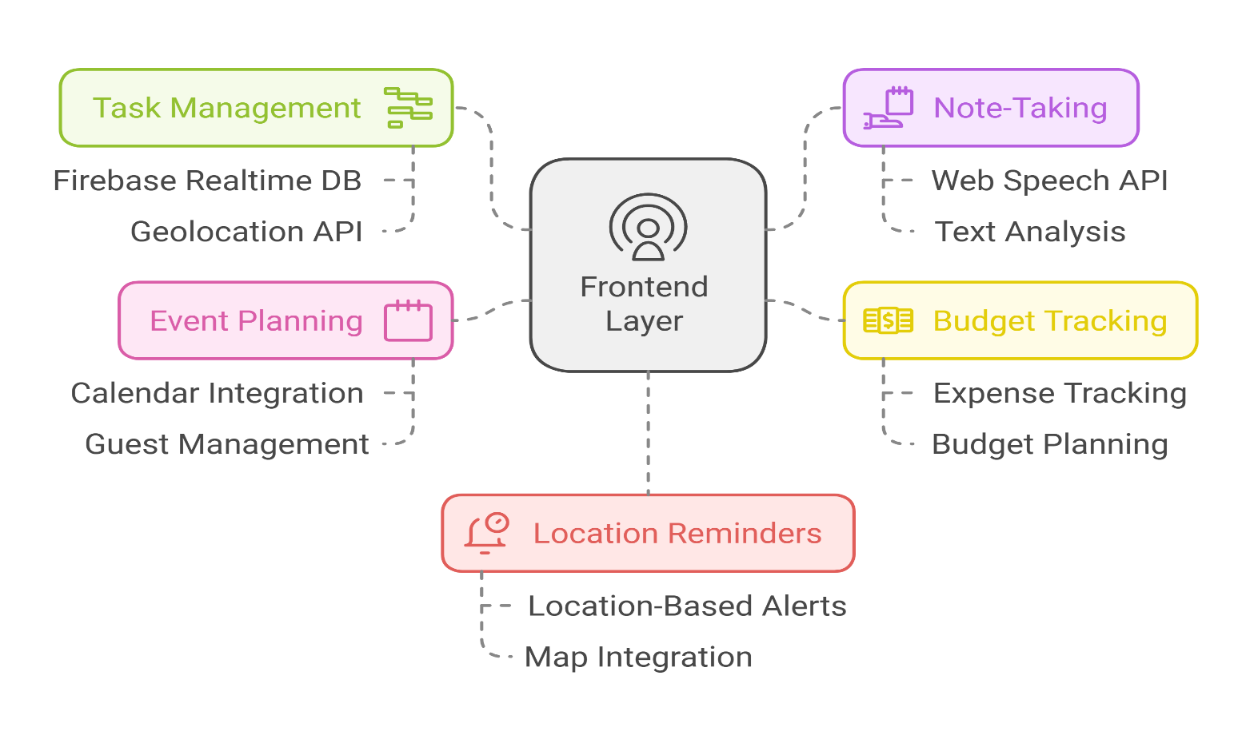

1. Frontend (User Interface)
Purpose:
The frontend of the Evolv application provides an intuitive and responsive interface that interacts with the backend components. It focuses on presenting data that is session-specific, ensuring users can perform tasks like task management, location-based reminders, and event planning in a seamless and interactive manner. Since the system is session-based, all data is temporary and cleared when the session ends.
Technologies:
- HTML for structuring the page and displaying dynamic content.
- CSS for styling and making the application visually appealing.
- JavaScript for making the page interactive, such as updating the task list, receiving notifications, and interacting with other features.
- React or Vue.js for building dynamic user interfaces that allow real-time updates to tasks, events, and reminders.
Components:
- Dashboard:
This is the central hub where users can see their active tasks, upcoming events, and budget tracking for the current session. The dashboard is updated dynamically as the user interacts with the application.
- Task Management:
Allows users to create, update, and prioritize tasks. Users can mark tasks as completed, set deadlines, and organize tasks based on urgency. Since the application is session-based, tasks are only visible and editable during the session.
- Location-based Reminders:
Users can manage reminders for tasks that are dependent on specific locations. For example, users may set a reminder to buy groceries when passing a store. The system tracks the user’s location in real-time and triggers notifications when the user is near the designated location. This data is only maintained during the session and is discarded afterward.
- Event Planner:
The event planner allows users to manage important events like meetings, exams, or appointments. The planner will send notifications when an event is nearing. Events are stored temporarily for the session and are used to send timely reminders.
- Voice Assistance:
The voice assistant lets users interact with the application through voice commands. Users can create tasks, ask for reminders, or inquire about upcoming events. It offers a more hands-free experience for managing tasks and reminders within the session.

2. Session Management
Purpose:
Session management is a key component that ensures the user's data is only stored temporarily while they are actively using the application. As the app does not use a persistent database, the session storage is used to save user-specific data like tasks, events, and preferences only during the session. Once the user logs out or closes the browser, all session data is cleared, ensuring that no personal data is stored permanently.
Technologies:
- localStorage or sessionStorage for storing data temporarily in the user’s browser.
- Session Cookies for handling user authentication.
Components:
- Session Storage:
This component temporarily saves tasks, events, location reminders, and other session-specific data in the browser. The data is cleared as soon as the session ends, ensuring no trace remains after the session is terminated.
- Session-based Authentication:
When a user logs in, their authentication data is temporarily stored within the session, using either session cookies or tokens like JWT (JSON Web Tokens). This ensures secure, user-specific data handling during the session.
3. Geolocation and Notification System
Purpose:
The geolocation and notification system allows Evolv to remind users of tasks based on their location. For instance, if a user needs to buy groceries while traveling, the app will track their GPS location and trigger a reminder when they are near a grocery store. Since this is session-based, the system only operates while the session is active, and the data related to location is discarded afterward.
Technologies:
- Google Maps API to fetch location data and handle geolocation tracking.
- Web Push Notifications to send alerts when the user approaches a specified location.
Components:
- Geolocation Tracking:
This component tracks the user’s real-time location through the browser’s GPS or mobile device GPS. It’s updated continuously during the session.
- Location Reminders:
Once the system detects that the user is near a location that has been assigned a task reminder, a notification is triggered. This system only stores the reminder’s location data temporarily during the session, so no data is saved after the session ends.

4. AI Integration (Voice Assistance)
Purpose:
The AI integration allows users to interact with Evolv through voice commands. It processes natural language input and converts it into actions, such as adding tasks, setting location-based reminders, or checking upcoming events. The AI voice assistant enhances the user experience by providing a hands-free approach to managing tasks and reminders.
Technologies:
- Google Maps API for location based reminder
- Web Speech API for voice recognition and synthesis.
Components:
- Voice Command Processing:
This component listens to the user’s voice commands and processes them into actionable tasks. For example, the user can say, “Add a task to buy groceries at the store,” and the system will create the task with location-based reminders.
- AI-based Task Management:
AI suggests tasks based on the user’s preferences, past behavior, or current session activities. The system could suggest urgent tasks based on time, proximity, or importance.

5. Session Security
Purpose:
Session security ensures that all data within the session is securely stored and that unauthorized access is prevented. It uses secure connections and authentication tokens to maintain user privacy while the session is active.
Technologies:
- HTTPS to secure all communication between the user and the server.
- Session Cookies or JWT Tokens for session authentication.
Components:
- Session Authentication:
Upon logging in, the user is authenticated through session cookies or JWT tokens. This ensures that only the authenticated user can access and modify session data.
- Data Encryption:
To protect the user’s data during transmission, HTTPS is used to encrypt all communication between the client (browser) and the server. This prevents third parties from intercepting sensitive information.

5.IMPLEMENTATION
HTML SCRIPT
h1, h2{<!DOCTYPE html>
<html lang="en">
<head>
<meta charset="UTF-8">
<meta name="viewport" content="width=device-width, initial-scale=1.0">
<title>Your Personal Organizer</title>
<link rel="stylesheet" href="index.css"> <!-- Link to your CSS file -->

<link rel="stylesheet" href="https://cdnjs.cloudflare.com/ajax/libs/font-awesome/6.0.0-beta3/css/all.min.css"> <!-- Font Awesome for icons -->
</head>
<body>

<!-- Navigation Bar -->
<nav class="navbar">
<ul>
<li><a href="voice.html"><i class="fa fa-microphone"></i> Voice Assistant</a></li>
<li><a href="todo.html"><i class="fa fa-check-circle"></i> To-Do List</a></li>
<li><a href="budget.html"><i class="fa fa-credit-card"></i> Budget Tracker</a></li>
<li><a href="gratitude.html"><i class="fa fa-heart"></i> Gratitude List</a></li>
<li><a href="events.html"><i class="fa fa-calendar"></i> Event Countdown</a></li>
</ul>
</nav>

<!-- Hero Section -->
<section class="hero">
<h1 class="glowing-text"> EVOLV </h1>
<h1>Welcome to Your Personal Organizer</h1>
<p>Manage your tasks, budget, gratitude, and events all in one place.</p>
<button class="cta-button" onclick="window.location.href='todo.html'">
<span>Get Started </span>👉
</button>
</section>

<!-- Features Section -->
<section class="features">
<h2 class="features-heading">Features</h2>
<div class="feature-cards-container">
<div class="feature-card">
<h3>To-Do List</h3>
<p>Keep track of your tasks and never miss a deadline.</p>
<a href="todo.html" class="cta-button">View To-Do List</a>
</div>
<div class="feature-card">
<h3>Budget Tracker</h3>
<p>Manage your finances and stay on top of your budget.</p>
<a href="budget.html" class="cta-button">View Budget Tracker</a>
</div>
<div class="feature-card">
<h3>Gratitude List</h3>
<p>Reflect on what you're grateful for each day.</p>
<a href="gratitude.html" class="cta-button">View Gratitude List</a>
</div>
<div class="feature-card">
<h3>Event Countdown</h3>
<p>Keep track of important events and their countdowns.</p>
<a href="events.html" class="cta-button">View Event Countdown</a>
</div>
<div class="feature-card">
<h3>Check Location</h3>
<p>Know if you are near your desired location</p>
<button onclick="getLocation()">Check My Location</button>
</div>
</div>
</section>

<!-- Voice Assistant Section -->
<section id="voice-assistant">
<iframe src="voice.html" width="100%" height="600px" style="border:none;"></iframe>
</section>

<footer>
<p>© 2024 Evolv Hub</p>
</footer>
<script src="script.js"></script>
<script defer src="js/theme.js"></script>
<script defer src="js/location.js"></script>
</body>
</html>

CSS SCRIPT

/* General body styling with pastel gradient background in shades of blue */
body {
font-family: Arial, sans-serif;
margin: 0;
padding: 0;
background: linear-gradient(to bottom right, #cce7ff, #a2c8f4); /* Soft blue gradient */
color: #333;
background-attachment: fixed; /* Keeps background fixed */
}

/* Container Styling */
.container {
max-width: 800px;
margin: auto;
background: white;
padding: 20px;
border-radius: 8px;
box-shadow: 0 2px 10px rgba(0, 0, 0, 0.1);
}

/* Header styles */

color: white; /* Set all headings to white */
text-align: center;
font-weight: bold;
text-shadow: 0 0 15px rgba(27, 23, 23, 0.6); /* Glowing effect */
}

/* Form input fields */
input, select {
padding: 10px;
margin: 5px 0;
width: calc(100% - 22px);
border-radius: 4px;
border: 1px solid #90cdf4; /* Light blue border */
background-color: #f0f9ff; /* Very light blue background */
}

/* Button styles with pastel blue and contrasting coral color */
button, .cta-button {
padding: 12px 30px;
background-color: #0a5575; /* Light blue */
color: rgb(219, 218, 224);
border: none;
cursor: pointer;
border-radius: 5px;
transition: background-color 0.3s ease;
}

button:hover, .cta-button:hover {
background-color: #0ea5e9; /* Darker blue on hover */
}

/* List styles */
ul {
list-style-type: none;
padding: 0;
}

/* List item styling */
li {
padding: 10px;
border-bottom: 1px solid #ddd;
background-color: #f3f9ff; /* Soft light blue background */
border-radius: 5px;
}

/* To-Do List specific styles */
#todo-list li {
display: flex;
justify-content: space-between;
align-items: center;
padding: 10px;
border-bottom: 1px solid #ddd;
}

.completed {
text-decoration: line-through;
color: #aaa;
}

/* Navbar with pastel blue */
.navbar {
background-color: #00182c; /* Strong blue */
padding: 10px;
position: sticky; /* Sticky navbar */
top: 0;
z-index: 1000;
width: 100%;
box-shadow: 0 4px 6px rgba(0, 0, 0, 0.1);
}

.navbar ul {
list-style-type: none;
padding: 0;
display: flex;
justify-content: center; /* Center navbar links */
margin: 0;
}

.navbar li {
margin-right: 20px;
}

.navbar a {
color: black;
text-decoration: none;
font-size: 18px;
font-weight: bold;
display: flex;
align-items: center;
transition: all 0.3s ease;
}

.navbar a:hover {
color: #010041; /* Yellow color when hovered */
transform: scale(1.1); /* Slightly enlarge the link */
}

.navbar a:active {
color: #022b27; /* Active color (when clicked) */
transform: scale(0.95); /* Shrink the link slightly */
}

/* Footer with pastel styling */
footer {
text-align: center;
padding: 5px;
color: black;
position: relative;
}

/* Hero Section */
.hero {
position: relative;
width: 100%;
height: 50vh;
background: radial-gradient(circle, rgba(0,0,0,1) 0%, rgba(0,0,0,0.5) 70%), url('main.png'); /* Galaxy background image */
background-size: cover;
background-position: center;
display: flex;
flex-direction: column;
justify-content: center;
align-items: center;
color: rgb(255, 255, 255);
overflow: hidden;
}

/* Galaxy Stars Animation */
.hero::before {
content: "";
position: absolute;
top: 0;
left: 0;
width: 100%;
height: 100%;
background: url('https://www.transparenttextures.com/patterns/stardust.png') repeat; /* Starry texture */
pointer-events: none;
animation: moveStars 100s linear infinite;
}

/* Starry sky effect */
@keyframes moveStars {
0% { background-position: 0 0; }
100% { background-position: 100% 100%; }
}

/* Hero Heading */
.hero h1 {
font-size: 3rem;
font-weight: bold;
margin-bottom: 20px;
text-shadow: 0 0 15px rgba(27, 23, 23, 0.6); /* Soft glowing text */
}

/* Hero Button */
.hero .cta-button {
padding: 12px 30px;
background-color: #ff6f61;
color: white;
font-size: 1rem;
border: none;
border-radius: 5px;
cursor: pointer;
text-transform: uppercase;
letter-spacing: 1px;
transition: background-color 0.3s ease;
}

.hero .cta-button:hover {
background-color: #ff4d3f;
}

/* Features Section */
.features {
text-align: center;
padding: 50px 20px;
background-image: url('feature.png');
border-radius: 10px;
box-shadow: 0 10px 20px rgba(0, 0, 0, 0.1);
animation: fadeInUp 1.5s ease-out;
}

/* Feature Cards */
.feature-cards-container {
display: flex;
justify-content: center;
gap: 20px;
flex-wrap: wrap;
margin: 0 auto;
}

.feature-card {
background: #ffffff;
border-radius: 12px;
padding: 20px;
box-shadow: 0 4px 10px rgba(0, 0, 0, 0.1);
flex: 1 1 250px;
text-align: center;
margin-bottom: 20px;
transition: transform 0.3s ease, box-shadow 0.3s ease;
}

.feature-card:hover {
transform: translateY(-10px); /* Slight hover lift effect */
box-shadow: 0 12px 20px rgba(0, 0, 0, 0.2); /* Stronger shadow on hover */
}

/* Feature Card Button */
.feature-card button {
padding: 12px 25px;
background-color: #0288d1;
color: white;
border: none;
cursor: pointer;
border-radius: 5px;
transition: background-color 0.3s;
}

/* Feature Card Button hover */
.feature-card button:hover {
background-color: #388e3c;
}

/* Mobile responsiveness */
@media (max-width: 768px) {
body {
font-size: 16px;
}

h1, h2 {
font-size: 1.5rem; /* Adjust heading sizes for mobile */
}

.cta-button, button, input, select {
font-size: 14px; /* Smaller text size on mobile */
}

.navbar ul {
flex-direction: column; /* Stack navbar links vertically on smaller screens */
align-items: center;
}

.navbar li {
margin-bottom: 10px;
}

.container {
width: 90%; /* More flexible width for mobile screens */
}

.hero {
padding: 40px 20px;
}

.feature-card {
flex: 1 1 100%; /* Stack feature cards on smaller screens */
}
}

/* Animations */
@keyframes fadeInUp {
0% {
opacity: 0;
transform: translateY(20px);
}
100% {
opacity: 1;
transform: translateY(0);
}
}

/* Additional Small Enhancements */
button:focus, .cta-button:focus {
outline: none;
box-shadow: 0 0 0 2px rgba(255, 152, 0, 0.6); /* Focus ring for accessibility */
}

a {
transition: color 0.3s ease;
}

a:hover {
color: #ffeb3b; /* Hover color change */
}

/* Glowing Text */
.glowing-text {
font-size: 3rem; /* Adjust text size as needed */
font-weight: bold; /* Bold for emphasis */
color: #ffffff; /* White text color */
text-align: center; /* Centering the text */
text-shadow: 0 0 5px #ffffff, 0 0 10px #ffffff, 0 0 15px #ffffff, 0 0 20px #ffffff, 0 0 30px #ffffff, 0 0 40px #ffffff, 0 0 50px #ffffff;
/* The text-shadow property defines multiple layers of glowing in white */
animation: glow-animation 2.5s ease-in-out infinite alternate; /* Animation for glowing effect */
}

/* Keyframes for glowing animation */
@keyframes glow-animation {
0% {
text-shadow: 0 0 5px #ffffff, 0 0 10px #ffffff, 0 0 15px #ffffff, 0 0 20px #ffffff, 0 0 30px #ffffff, 0 0 40px #ffffff, 0 0 50px #ffffff;
}
50% {
text-shadow: 0 0 10px #ffffff, 0 0 20px #ffffff, 0 0 30px #ffffff, 0 0 40px #ffffff, 0 0 50px #ffffff, 0 0 60px #ffffff, 0 0 70px #ffffff;
}
100% {
text-shadow: 0 0 5px #ffffff, 0 0 10px #ffffff, 0 0 15px #ffffff, 0 0 20px #ffffff, 0 0 30px #ffffff, 0 0 40px #ffffff, 0 0 50px #ffffff;
}
}

RESULTS

Dashboard

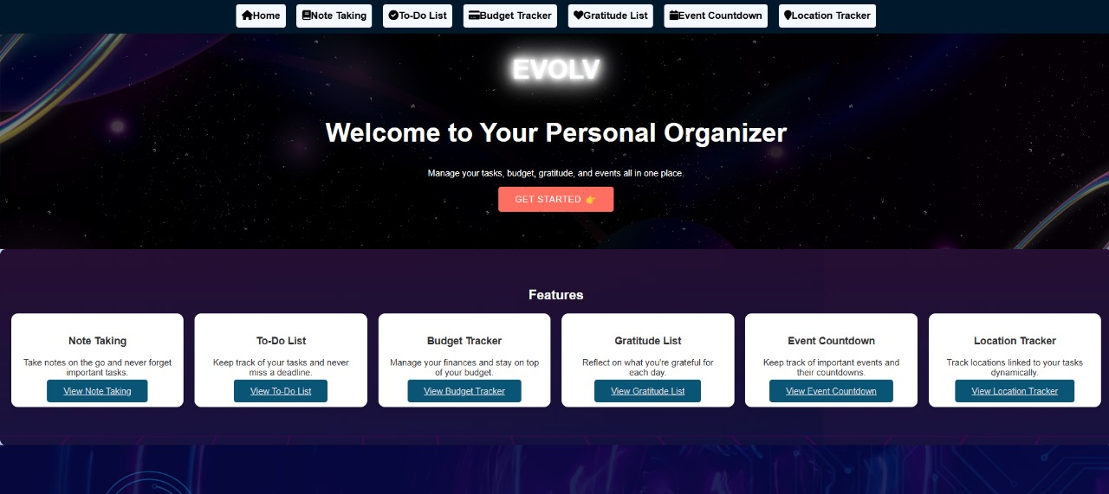

Note-Taking
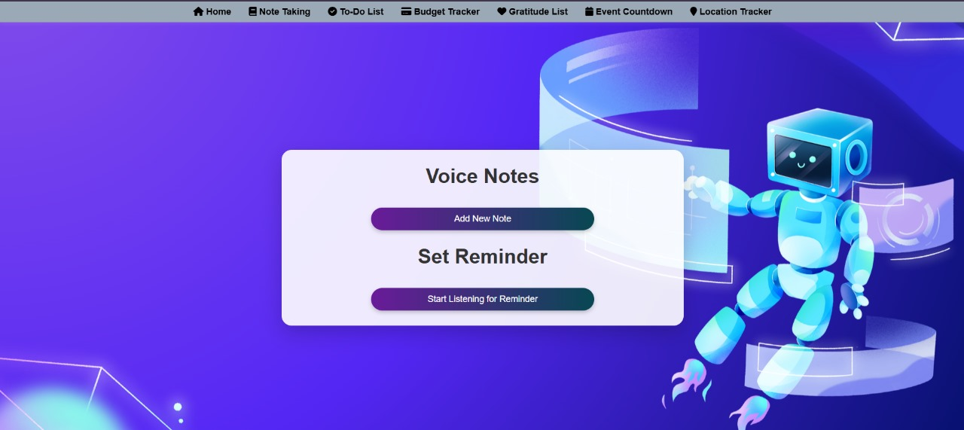

To-Do List
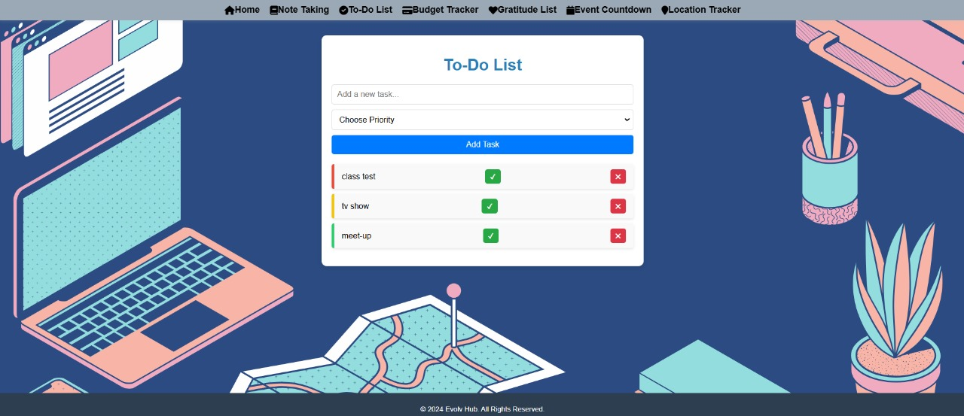

Budget Tracker
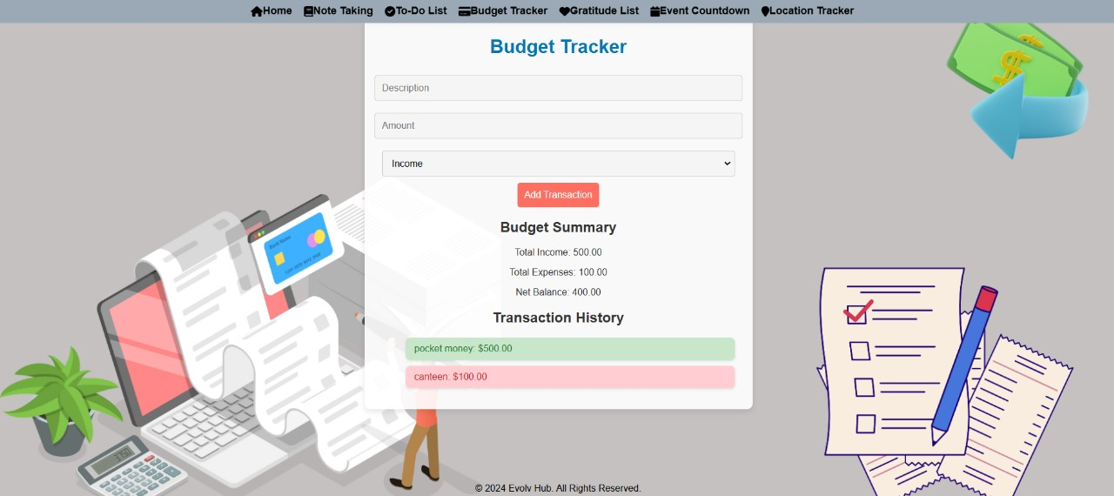

Gratitude List
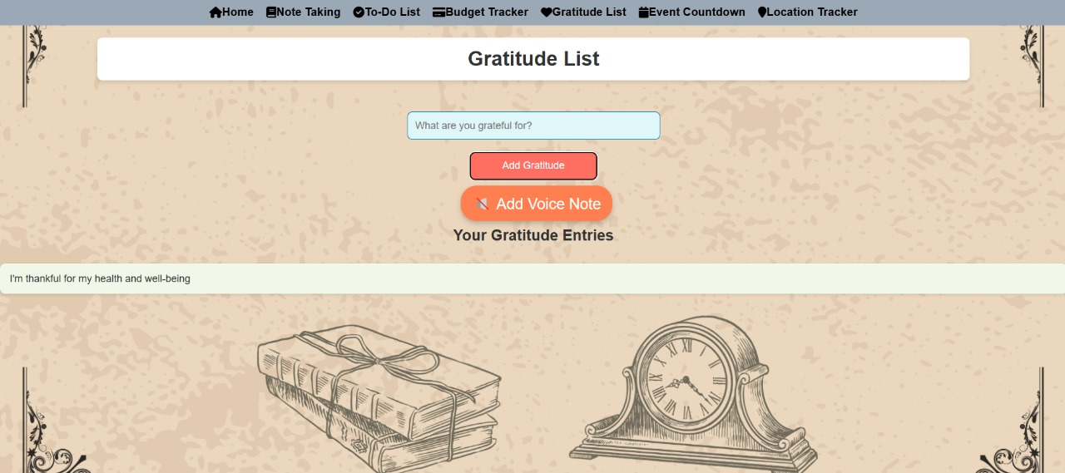

Event Planner
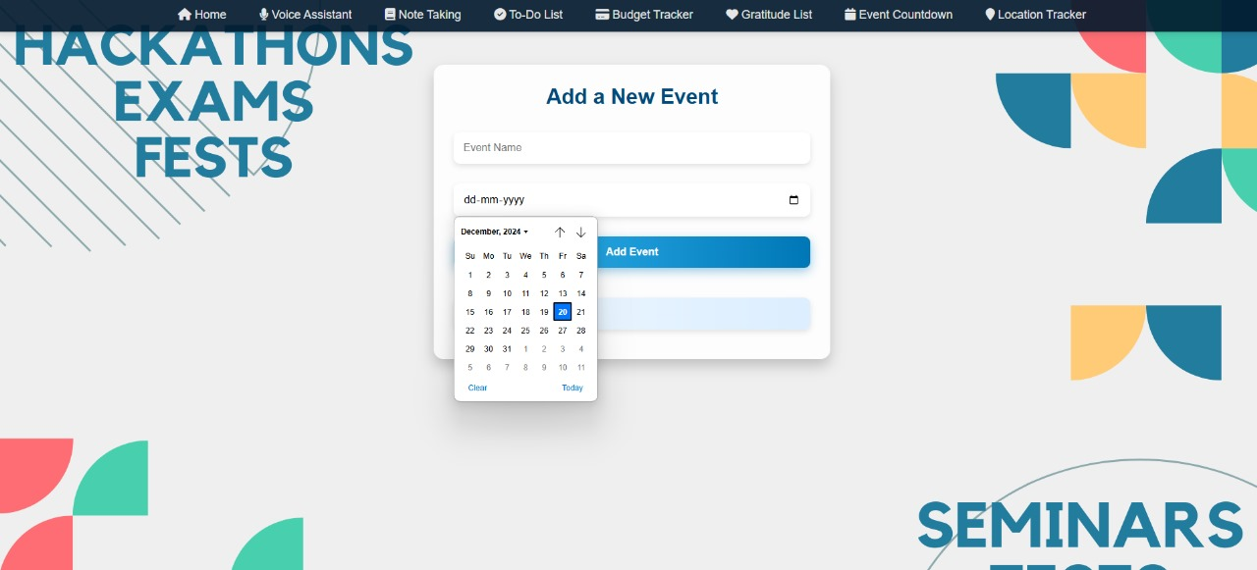

Location Based Task Reminder
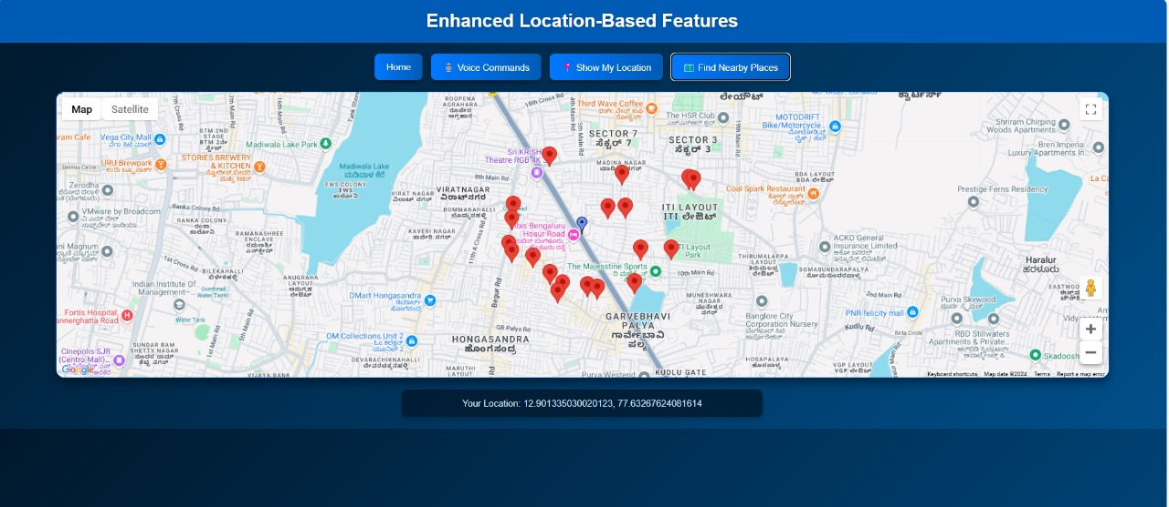

CONCLUSION

In today’s fast-paced world, managing tasks and responsibilities has become increasingly complex. People juggle work commitments, personal errands, social events, and financial planning on a daily basis. Without an integrated system, keeping track of everything becomes overwhelming, leading to missed deadlines, incomplete tasks, and increased stress. Evolv provides a comprehensive solution by combining task management, event planning, budget tracking, and AI-powered voice assistance into one user-friendly platform.
The key to Evolv's success lies in its seamless integration of multiple features. By offering a unified platform, users no longer need to rely on different apps for each task. Location-based notifications ensure that users never forget essential tasks when they are near relevant locations, such as grocery stores or offices. This context-aware reminder system enhances productivity by providing timely alerts that are tailored to the user's real-life circumstances.
The AI-powered voice assistant further simplifies task management by allowing hands-free operation, perfect for users on the go or those multitasking. Cross-device synchronization ensures that tasks, notes, reminders, and other information are always up to date, whether the user is at home, at work, or traveling.
Overall, Evolv empowers individuals to manage their time better, improve their financial health, and stay on top of their events and responsibilities. By integrating multiple productivity tools into a single, accessible platform, Evolv removes the complexity of task management, offering an efficient and intelligent solution for everyday life. As we continue to live in an increasingly digital world, tools like Evolv will be essential for staying organized, productive, and stress-free.

FUTURE ENHANCEMENTS

Future Enhancements
Although Evolv already integrates several powerful features, there are numerous possibilities for future enhancements that could further improve its usefulness and adaptability for individual users:
- Cross-Platform Mobile App Development
While Evolv is currently accessible via web browsers, a dedicated mobile application for both iOS and Android devices could provide a more tailored experience. This would allow users to manage their tasks and receive location-based notifications on the go, even more seamlessly, and with enhanced portability.
- AI-Based Task Recommendations
Integrating machine learning to analyze user behavior and task patterns could lead to AI-driven task recommendations. This feature could suggest tasks based on factors like the user’s past behavior, location, or even the time of day, making task management even more intuitive and proactive.
- Integration with Calendar Applications
A future enhancement could involve deeper integration with popular calendar services like Google Calendar and Outlook, allowing users to seamlessly sync their events and deadlines with Evolv. This would create a more cohesive productivity ecosystem, eliminating the need for multiple scheduling tools.
- Advanced Financial Analytics
Evolv’s budget tracker could be expanded to include more advanced analytics. Features like spending trends, predictive budgeting, and financial goal tracking would offer users greater insights into their financial health, helping them make informed decisions and plan better for the future.
- Offline Functionality with Cloud Sync
Enhancing offline functionality would ensure that users can continue using Evolv even without an active internet connection. Once the connection is restored, cloud synchronization would automatically update the user’s data across devices, ensuring a smooth transition from offline to online use.
- Personalized User Interface Themes
A future enhancement could include customizable UI themes, allowing users to personalize the app’s appearance based on their preferences. From light/dark mode to color schemes and font adjustments, these changes would make Evolv more engaging and adaptable to different user tastes.
- Smart Home Integration
As smart homes continue to gain popularity, integrating Evolv with smart home devices like Amazon Alexa, Google Assistant, or Apple HomeKit could further enhance user convenience. Users could add tasks, set reminders, or check progress simply by speaking to their smart home assistant.
- Improved Voice Assistant with Natural Language Processing (NLP)
Expanding the capabilities of the AI voice assistant with more advanced NLP features would enable the assistant to understand and process complex commands with greater accuracy. This could include tasks like parsing long lists of instructions or interpreting commands in conversational language, making it more user-friendly.

REFERENCES

- https://developer.mozilla.org/en-US/docs/Web/API/Window/localStorage
- https://developer.mozilla.org/en-US/docs/Web/API/Geolocation_API
- https://developer.mozilla.org/en-US/docs/Web/JavaScript/Reference/Global_Objects/Date
- https://developer.mozilla.org/en-US/docs/Web/JavaScript/Guide/Working_with_Objects

