 | Pimpri Chinchwad Education Trust’s  Pimpri Chinchwad College of Engineering (PCCOE)  (An Autonomous Institute)  Affiliated to Savitribai Phule Pune University (SPPU)  ISO 21001:2018 Certified by TUV SUD

BREAST CANCER
DIAGNOSIS
Machine Learning Case Study
Formative Assessment 02
Advanced Data Science [MCA33PE17]
MCA · SYMCA · Academic Year 2026–2027 · Semester I
Under the guidance of Prof. Prakash Ukhalkar

Educational analysis using the Breast Cancer Wisconsin (Diagnostic) dataset
Executive summary
This study builds a reproducible classification workflow for distinguishing malignant from benign tumours using 30 measurements extracted from digitised fine-needle-aspirate images. Four algorithms were trained, compared using stratified cross-validation, tuned with GridSearchCV, and evaluated once on an untouched test set.
Indicator | Result
Dataset | 569 records · 30 numeric features · 2 classes
Validation design | 80/20 stratified split · 5-fold CV on training data
Selected model | SVM · tuned F1 0.976 · ROC-AUC 0.998
Clinical screening view | 1 of 42 malignant cases missed on the test set
Deployment | Four saved joblib pipelines consumed by app.py

The tuned SVM is the recommended model for this educational comparison. Logistic Regression is a close, more interpretable alternative. These results are not a clinical validation and must not be used as a diagnostic tool.
1. Problem and dataset
The objective is to predict whether a breast tumour is malignant or benign from measurements of a digitised fine-needle-aspirate image. The Breast Cancer Wisconsin (Diagnostic) dataset is loaded through scikit-learn so the notebook and Streamlit application use the same source and feature order.
- 569 samples and 30 numeric features; 212 malignant (37.3%) and 357 benign (62.7%).
- The 30 columns represent 10 nucleus measurements, each summarised by mean, standard error, and worst value.
- The target encoding is 0 = malignant and 1 = benign. Precision, recall, and F1 are interpreted for malignant as the positive class.
- The dataset is suitable for a compact case study because it is documented, numeric, moderately imbalanced, and small enough for fair model tuning.
2. Exploratory data analysis
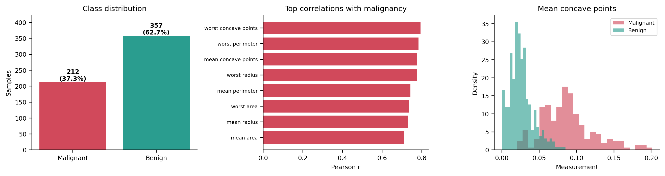
Figure 1. Class balance, strongest feature correlations with malignancy, and a representative class-wise distribution.
- Data quality is high: there are no missing values or duplicate rows, and all features are numeric.
- Size and concavity are the clearest signals. Median mean area is 932 for malignant cases versus 458 for benign cases; mean concave points are approximately 3.7 times larger for malignant cases.
- 21 of 435 feature pairs have absolute correlation above 0.90, mainly because radius, perimeter, and area describe related geometry.
- IQR screening flags 608 values across 171 rows. These observations are retained because unusually large or irregular tumours can carry genuine clinical signal.
- Feature scales vary substantially, so standardisation is important for Logistic Regression and SVM.
3. Preprocessing and experimental design
Stage | Decision and rationale
Missing values | Median SimpleImputer is included in every pipeline as a deployment safeguard.
Scaling | StandardScaler is used for Logistic Regression and SVM; tree models are left unscaled.
Leakage control | Imputer and scaler are inside Pipeline and are fitted only on training folds.
Split | Stratified 80% training / 20% test split with random_state = 42.
Selection metric | Malignant-class F1-score for GridSearchCV, balancing missed cancers and false alarms.

The test set remains untouched during model selection. This makes the final test metrics a cleaner estimate of performance on unseen records, although one split is still subject to sampling variation.
4. Models, cross-validation, and tuning
The study compares Logistic Regression, Decision Tree, Random Forest, and Support Vector Machine. Each model is evaluated with stratified 5-fold cross-validation on the training data before GridSearchCV searches its parameter grid using malignant-class F1.
Model | Train accuracy | CV accuracy | CV F1 | CV recall
Logistic Regression | 0.989 | 0.978 ± 0.010 | 0.970 ± 0.013 | 0.965 ± 0.029
Decision Tree | 1.000 | 0.916 ± 0.018 | 0.892 ± 0.024 | 0.924 ± 0.035
Random Forest | 1.000 | 0.963 ± 0.018 | 0.951 ± 0.023 | 0.959 ± 0.030
SVM | 0.985 | 0.969 ± 0.015 | 0.958 ± 0.021 | 0.953 ± 0.040

Table 1. Baseline cross-validation results on the training split; mean ± standard deviation is shown for CV metrics.
Model | Search combinations | Best parameters | CV F1 gain
Logistic Regression | 10 | {'C': 0.1, 'class_weight': None} | +0.0057
Decision Tree | 56 | {'criterion': 'entropy', 'max_depth': 4, 'min_samples_leaf': 5} | +0.0255
Random Forest | 36 | {'max_depth': None, 'min_samples_split': 2, 'n_estimators': 300} | +0.0027
SVM | 16 | {'C': 10, 'gamma': 0.01} | +0.0085

Table 2. GridSearchCV configuration and improvement in cross-validated malignant-class F1.
5. Final results on the unseen test set
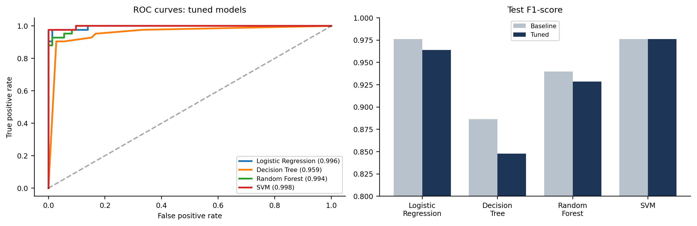
Figure 2. Tuned ROC curves and baseline-versus-tuned malignant-class F1 scores.
Model | Accuracy | Precision | Recall | F1 | ROC-AUC | Missed | False alarms
SVM | 0.982 | 0.976 | 0.976 | 0.976 | 0.998 | 1 | 1
Logistic Regression | 0.974 | 0.976 | 0.952 | 0.964 | 0.996 | 2 | 1
Random Forest | 0.947 | 0.929 | 0.929 | 0.929 | 0.994 | 3 | 3
Decision Tree | 0.877 | 0.780 | 0.929 | 0.848 | 0.959 | 3 | 11

Table 3. Tuned-model performance on 114 unseen test records. Malignant is the positive class; the best row is highlighted.
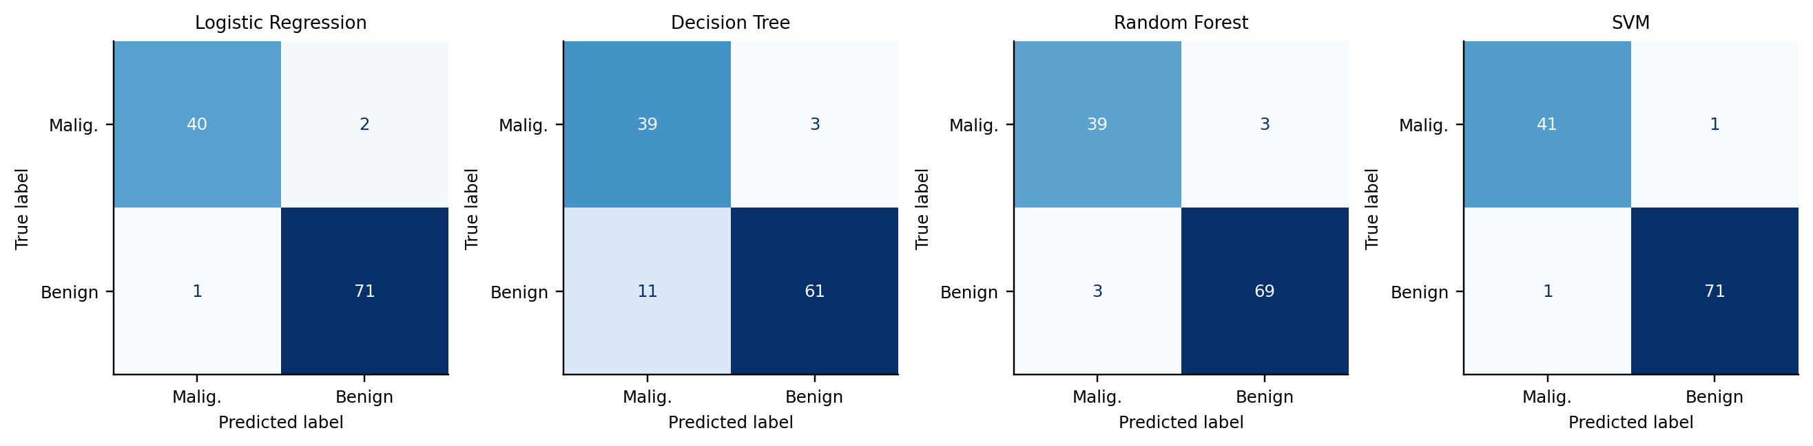
Figure 3. Confusion matrices for the tuned models; rows are actual classes and columns are predicted classes.
6. Interpretation
- The tuned SVM is the strongest overall result: F1 = 0.976, ROC-AUC = 0.998, with one malignant case missed and one false alarm on the test set.
- Logistic Regression is a close second and offers a simpler coefficient-based explanation of how standardised measurements influence the prediction.
- The smooth models outperform the single Decision Tree because the standardised feature space is close to linearly separable, whereas axis-aligned tree splits need many local decisions.
- Random Forest reduces the variance of a single tree, but its tuned test F1 remains below the two smooth models for this split.
- The tuned Decision Tree improves cross-validation F1 but still produces the most false alarms on the test set, illustrating why accuracy alone is not sufficient for this problem.
- With only 42 malignant test cases, one changed prediction moves recall by about 2.4 percentage points. The ranking should therefore be read with the CV results, not in isolation.
7. Streamlit deployment
The four tuned pipelines are saved as joblib files with their preprocessing steps included. feature_names.joblib preserves the expected input order, and summary.json stores the comparison tables used by the report. app.py loads these same files and exposes a form for the 30 measurements, model predictions, malignant probabilities, consensus output, and comparison views.
Artifact | Purpose
logistic_regression.joblib | Tuned Logistic Regression pipeline
decision_tree.joblib | Tuned Decision Tree pipeline
random_forest.joblib | Tuned Random Forest pipeline
svm.joblib | Tuned SVM pipeline
feature_names.joblib | Input-column order for deployment
summary.json | CV, tuning, baseline, and tuned test results
Live Streamlit app: https://ds-breast-cancers.streamlit.app
Educational demo – predictions are not a medical diagnosis.
8. Limitations and conclusion
This is an educational machine-learning demonstration, not a medical diagnostic system. The study uses one historical dataset, one held-out test split, and no external validation cohort. Real clinical deployment would require prospective validation, calibration, fairness analysis, clinical oversight, and regulatory review.
Overall, the workflow demonstrates a complete and leakage-controlled data science process: acquisition, EDA, preprocessing, cross-validation, hyperparameter tuning, evaluation, interpretation, model persistence, and Streamlit deployment. For this dataset and split, the tuned SVM provides the best balance of malignant recall, F1, and ROC-AUC.

