RubriQ — Output Screens
Captured from the running system, one screen per stage of the flow
The screens below follow the order in which the system is used: a user signs in, a guide sets up a subject and publishes a rubric, a student reads that rubric and submits against it, the submission is evaluated, the guide reviews and approves, and the result is reported and exported. Each figure names the stage it belongs to and what it is evidence of.
Figures
Fig. 1 The authentication gate · Stage 1 — Signing in
Fig. 2 What is waiting for the guide · Stage 2 — Faculty dashboard
Fig. 3 The published rubric, frozen · Stage 2 — Rubric builder
Fig. 4 The next deadline, and where each review stands · Stage 3 — Student dashboard
Fig. 5 The rubric is shown before the upload box · Stage 3 — Student submission
Fig. 6 One row per student, one column per criterion · Stage 5 — Review grid
Fig. 7 The cohort, and the department's grading scale · Stage 7 — Reports

1. The authentication gate
Stage 1 — Signing in
The only way into the system. Sign-in is through the institute's Google account, and the address is checked against the permitted domain on the server after Google returns it. The role — faculty or student — is then resolved from a list held by the institution, so a user cannot choose their own.
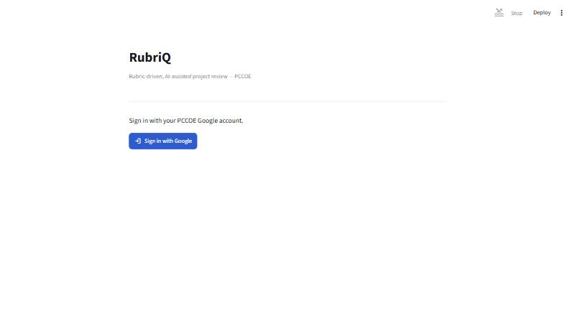
Fig. 1 — The authentication gate

2. What is waiting for the guide
Stage 2 — Faculty dashboard
Sixty-seven enrolled students and eighty-five rows awaiting a decision across both reviews. Each line under “Waiting on you” is a link to the page that resolves it. The progress bar below reports forty-nine of sixty-seven approved for the selected review.
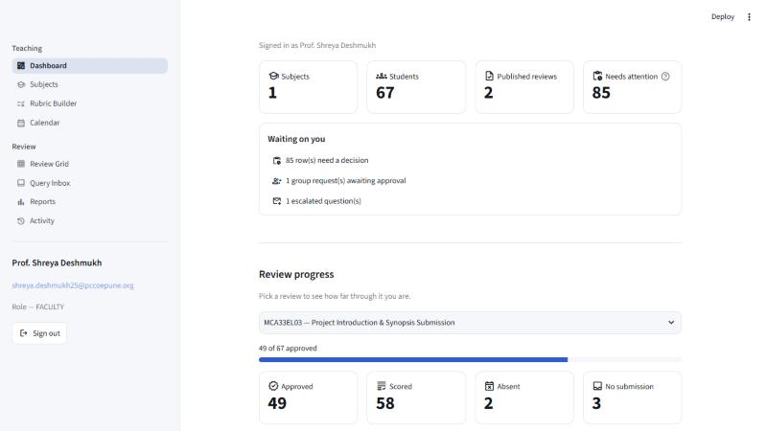
Fig. 2 — What is waiting for the guide

3. The published rubric, frozen
Stage 2 — Rubric builder
The department's five criteria with the evidence each expects, and the two that are mandatory. The version is marked published and frozen: it cannot be edited in place, and the only way forward is “Edit as new version”, which leaves work already graded against this version valid.
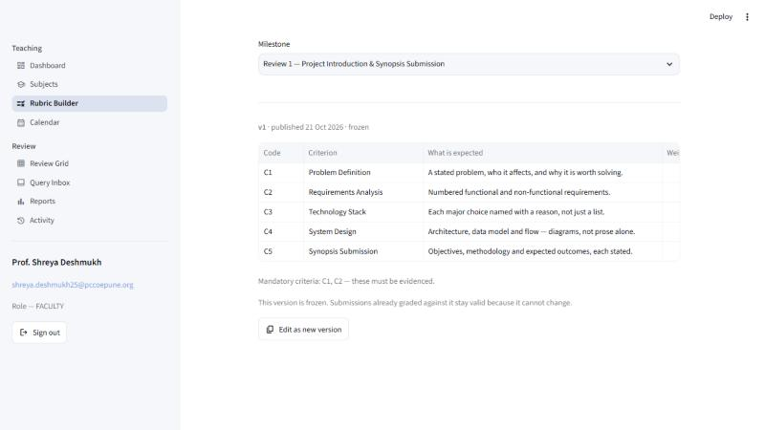
Fig. 3 — The published rubric, frozen

4. The next deadline, and where each review stands
Stage 3 — Student dashboard
The countdown answers the question the page is opened to ask. Below it, each review carries its own status — submitted at version one, or not yet submitted — so the student never has to work it out from a date.
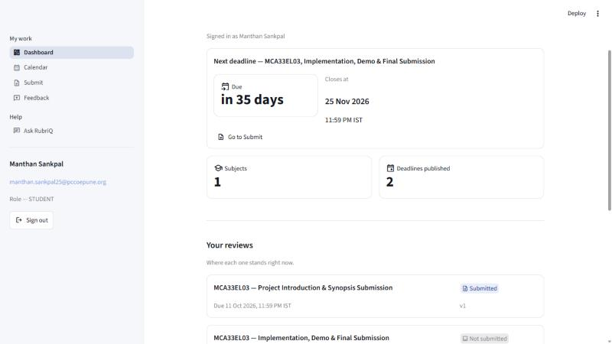
Fig. 4 — The next deadline, and where each review stands

5. The rubric is shown before the upload box
Stage 3 — Student submission
The central idea of the project, visible in one screen. “What you are being marked on” appears above “Your submission”, so the student reads the criteria before choosing a file rather than after being marked. The notice above it states the consequence of the deadline having passed before anything is confirmed.
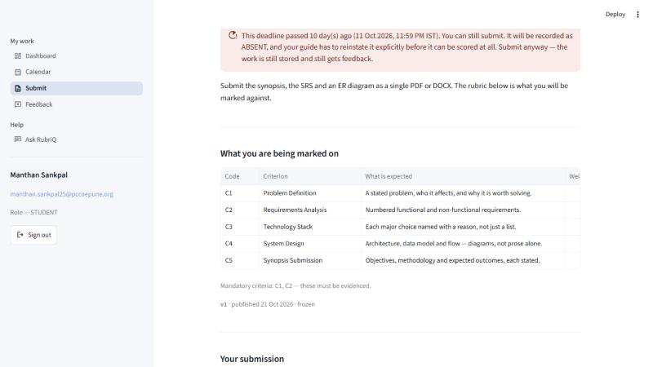
Fig. 5 — The rubric is shown before the upload box

6. One row per student, one column per criterion
Stage 5 — Review grid
The centrepiece. Sixty-seven rows, eighteen flagged as needing a decision, forty-nine already approved. The status column distinguishes an estimate awaiting approval from an absence and from a student who never submitted — a non-submitter keeps a row rather than disappearing from the list.
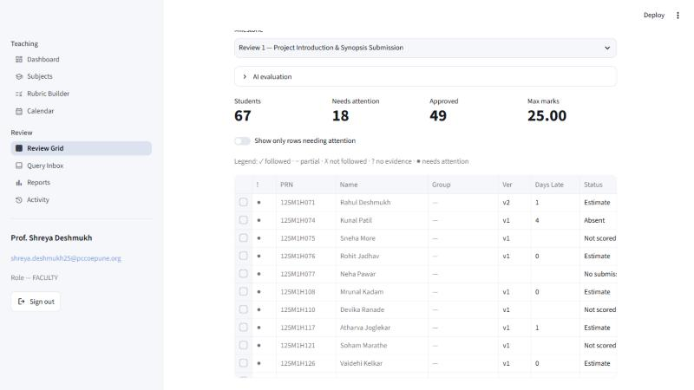
Fig. 6 — One row per student, one column per criterion

7. The cohort, and the department's grading scale
Stage 7 — Reports
The distribution of marks out of twenty-five, with absent students excluded because an absence is a status and not a mark of zero. Below it the department's published bands — Excellent, Good, Satisfactory, Needs Improvement, Poor — applied to this review's marks.
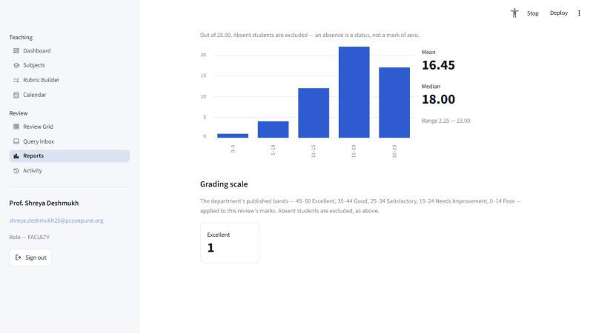
Fig. 7 — The cohort, and the department's grading scale

