# Kubernetes

## Kubernetes

### Agenda

#### What is Kubernetes?

* Advantages of Kubernetes
* Kubernetes Architecture
* Kubernetes Components
* Kubernetes Cluster Setup
* Kubernetes Objects
* Demo

What is Kubernetes?

* Kubernetes is an orchestration engine and open-source platform for managing containerized applications.
* Responsibilities include container deployment, scaling & descaling of containers & container load balancing.
* Actually, Kubernetes is not a replacement for Docker, But Kubernetes can be considered as a replacement for Docker Swarm, Kubernetes is significantly more complex than Swarm, and requires more work to deploy.
* Born in **Google** ,written in Go/Golang. Donated to CNCF(Cloud native computing foundation) in 2014.
* Kubernetes v1.0 was released on **July 21, 2015.**

#### Current stable release v1.14.0.

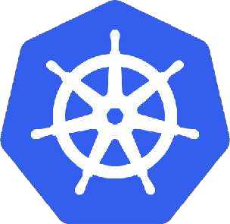

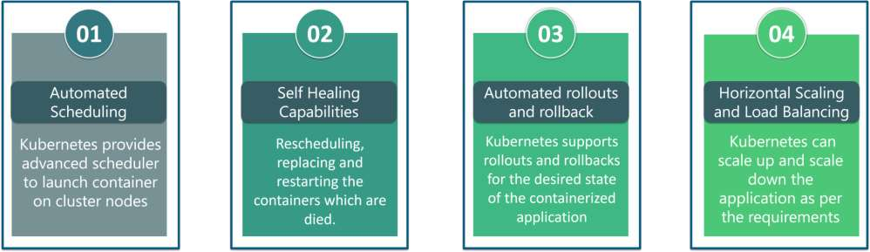

The features of Kubernetes, are as follows:

* **Automated Scheduling:** Kubernetes provides advanced scheduler to launch container on cluster nodes based on their resource

requirements and other constraints, while not sacrificing availability.

* **Self Healing Capabilities:** Kubernetes allows to replaces and reschedules containers when nodes die. It also kills containers that don’t

respond to user-defined health check and doesn’t advertise them to clients until they are ready to serve.

* **Automated rollouts & rollback:** Kubernetes rolls out changes to the application or its configuration while monitoring application health

to ensure it doesn’t kill all your instances at the same time. If something goes wrong, with Kubernetes you can rollback the change.

* **Horizontal Scaling & Load Balancing:** Kubernetes can scale up and scale down the application as per the requirements with a simple

command, using a UI, or automatically based on CPU usage.



1. **Service Discovery & Load balancing**

With Kubernetes, there is no need to worry about networking and communication because Kubernetes will automatically assign IP addresses to

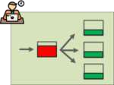containers and a single DNS name for a set of containers, that can load-balance traffic inside the cluster.

1. **Storage Orchestration**

With Kubernetes, you can mount the storage system of your choice. You can either opt for local storage, or choose a public cloud provider such as

GCP or AWS, or perhaps use a shared network storage system such as NFS, iSCSI, etc.

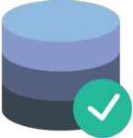

#### Kubernetes Architecture

##### Kubernetes implements a cluster computing background, everything works from inside a ***Kubernetes***

***Cluster***. This cluster is hosted by one node acting as the ‘master’ of the cluster, and other nodes as

‘nodes’ which do the actual ‘containerization‘. Below is a diagram showing the same.

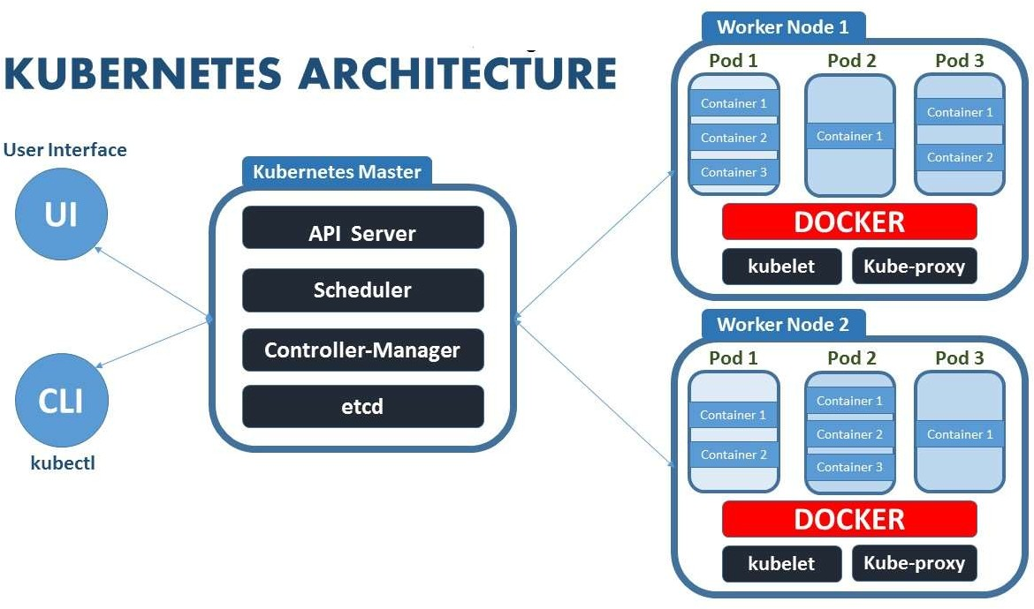

Kubernetes Components

Web UI (Dashboard)

Dashboard is a web-based Kubernetes user interface. You can use Dashboard to deploy containerized applications to a

Kubernetes cluster, troubleshoot your containerized application, and manage the cluster itself along with its available resources.

Kubectl

Kubectl is a command line configuration tool (CLI) for Kubernetes used to interact with master node of kubernetes. Kubectl has a

config file called kubeconfig, this file has the information about server and authentication information to access the API Server.

**Master Node**

The master node is responsible for the management of Kubernetes cluster. It is mainly the entry point for all administrative tasks. It handles the orchestration of the worker nodes. There can be more than one master node in the cluster to check for fault tolerance.

**Master Components**

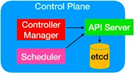It has below components that take care of communication, scheduling and controllers.

API Server:

Kube API Server interacts with API, Its a frontend of the kubernetes control plane. Communication

center for developers, sysadmin and other Kubernetes components

Scheduler

Scheduler watches the pods and assigns the pods to run on specific hosts.

Controller Manager:

Controller manager runs the controllers in background which runs different tasks in Kubernetes cluster. Performs

cluster-level functions (replication, keeping track of worker nodes, handling nodes failures…).

Some of the controllers are,

1. Node controller - Its responsible for noticing and responding when nodes go down.
2. Replication controllers - It maintains the number of pods. It controls how many identical copies of a pod should be running

somewhere on the cluster.

1. Endpoint controllers joins services and pods together.
2. Replicaset controllers ensure number of replication of pods running at all time.
3. Deployment controller provides declarative updates for pods and replicasets.
4. Daemonsets controller ensure all nodes run a copy of specific pods.
5. Jobs controller is the supervisor process for pods carrying out batch jobs

###### etcd

etcd is a simple distribute key value store. kubernetes uses etcd as its database to store all cluster datas. some of the data stored in etcd is job scheduling information, pods, state information and etc.

**Worker Nodes**

* Worker nodes are the nodes where the application actually running in kubernetes cluster, it is also know as minion.

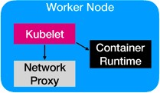These each worker nodes are controlled by the master node using kubelet process.

* Container Platform must be running on each worker nodes and it works together

with kubelet to run the containers, This is why we use Docker engine

and takes care of managing images and containers.

* We can also use other container platforms like CoreOS, Rocket.

###### Node Components

Kubelet

* Kubelet is the primary node agent runs on each nodes and reads the container manifests which ensures that containers are running and healthy.
* It makes sure that containers are running in a pod. The kubelet doesn’t manage containers which were not created by Kubernetes.

Kube-proxy

* kube-proxy enables the Kubernetes service abstraction by maintaining network rules on the host and performing connection

forwarding.

* It helps us to have network proxy and load balancer for the services in a single worker node. Worker nodes can be exposed to internet

via kubeproxy.

Container Runtime

* Each node must have a container runtime, such as Docker, rkt, or another container runtime to process instructions from the master

server to run containers.

## Installation

#### Different ways to install Kubernetes

Play-with-k8s Google Kubernetes Engine(GKE) [https://labs.play-with-k8s.com](https://labs.play-with-k8s.com/).

Minikube Amazon EKS

kubeadm Azure Kubernetes Service (AKS)

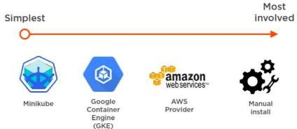

Check required ports

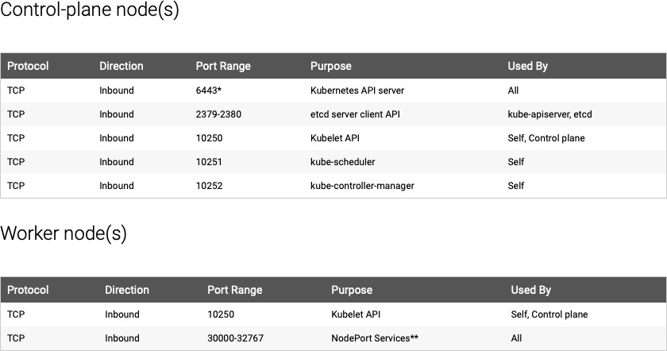

Kubernetes Objects

* Kubernetes Objects are persistent entities in the Kubernetes system. Kubernetes uses these entities to represent the state of

your cluster.

* A Kubernetes object is a “record of intent”–once you create the object, the Kubernetes system will constantly work to ensure

that object exists.

* To work with Kubernetes objects–whether to create, modify, or delete them–you’ll need to use the Kubernetes API. When you

use the kubectl command-line interface, for example, the CLI makes the necessary Kubernetes API calls for you.

The basic Kubernetes objects include:

* + Pod
  + Replication Controller
  + ReplicaSet
  + DaemonSet
  + Deployment
  + Service
  + Volume
  + Job

#### POD

* A Pod always runs on a **Node.**
* A pod is the smallest building block or basic unit of scheduling in Kubernetes.
* In a Kubernetes cluster, a pod represents a running process.
* Inside a pod, you can have one or more containers. Those containers all share a unique network IP, storage, network and any

other specification applied to the pod.

* 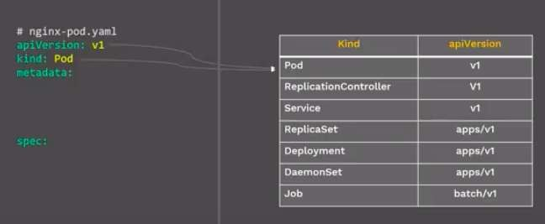Pods abstract network and storage away from the underlying container.
* This lets you move containers around the cluster more easily.
* Each Pod has its unique IP Address within the cluster.
* 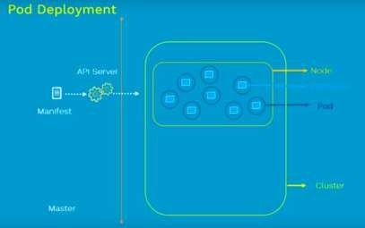Any data saved inside the Pod will disappear without

a persistent storage.

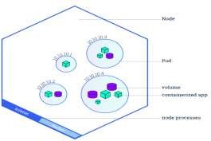

apiVersion: v1

**kind: Pod metadata:**

**name: nginx-pod**

**labels:**

**app: nginx spec: containers:**

**- name: first-container image: nginx**

**ports:**

**- containerPort: 80**

**Command**

kubectl apply –f pod.yml

**Pod Lifecycle**

#### Make a Pod reuqest to API server using a local pod defination file

* The API server saves the info for the pod in ETCD
* The scheduler finds the unscheduled pod and shedules it to node.
* Kubelet running on the node, sees the pod sheduled and fires up docker.
* Docker runs the container
* The entire lifecycle state of the pod is stored in ETCD.

**Pod Concepts**

* Pod is ephemeral(lasting for a very short time) and won’t be rescheduled to a new node once it dies.
* You should not directly use Pod for deployment, Kubernetes have controllers like Replica Sets, Deployment, Deamon sets to keep pod alive.

**Kubernetes Labels and Selectors**

**Labels**

* When One thing in k8s needs to find another things in k8s, it uses labels.
* Labels are key/value pairs attached to Object
* You can make your own and apply it.
* it’s like tag things in kubernetes

For e.g.

labels:

app: nginx role: web env: dev

**Selectors**

* Selectors use the label key to find a collection of objects matched with same value
* It’s like Filter, Conditions and query to your labels

For e.g.

selectors: env = dev app != db

release in (1.3,1.4)

* Labels and Selectors are used in many places like Services, Deployment and we will see now in Replicasets

## Replication Controller

* Replication Controller is one of the key features of Kubernetes, which is responsible for managing the pod lifecycle. It is

responsible for making sure that the specified number of pod replicas are running at any point of time.

* A Replication Controller is a structure that enables you to easily create multiple pods, then make sure that that number of

pods always exists. If a pod does crash, the Replication Controller replaces it.

* Replication Controllers and PODS are associated with labels.
* Creating “RC” with count of 1 ensure that a POD is always available.

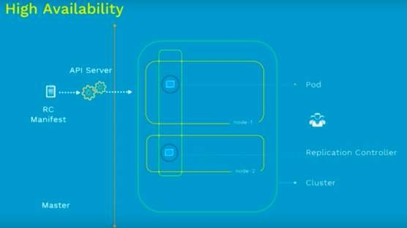

Command

kubectl apply –f rc.yml

apiVersion: v1

kind: ReplicationController

metadata:

name: nginx-rc

spec:

replicas: 2 selector:

app: nginx template: metadata:

name: nginx

labels:

app: nginx spec: containers:

- name: nginx image: nginx ports:

- containerPort: 80

## ReplicaSet

* ReplicaSet is the next-generation Replication

Controller.

* The only difference between a *ReplicaSet* and

a *Replication Controller* right now is the selector

support.

* ReplicaSet supports the new set-based selector requirements as described in the labels user guide whereas a Replication Controller only supports equality-based selector requirements.

kubectl apply –f rs.yml

kubectl scale rs nginx-replicaset --replicas 3

apiVersion: apps/v1 kind: ReplicaSet metadata:

name: nginx-replicaset spec:

replicas: 2 selector: matchLabels:

app: nginx-rs-pod

matchExpressions:

- key: env operator: In values:

- dev template: metadata:

labels:

app: nginx-rs-pod

env: dev spec: containers:

- name: nginx image: nginx ports:

- containerPort: 80

## DaemonSet

A *DaemonSet* make sure that all or some kubernetes Nodes run a copy of a Pod.

When a new node is added to the cluster, a Pod is added to it to match the rest of the nodes and when a node is removed from

the cluster, the Pod is garbage collected.

Deleting a DaemonSet will clean up the Pods it created.

# Daemon Set apiVersion: apps/v1 kind: DaemonSet metadata:

name: nginx-ds

spec:

selector: matchLabels:

app: nginx-pod

template:

metadata:

name: nginx-pod

labels:

app: nginx-pod spec: nodeSelector:

name: node1 containers:

* name: webserver image: nginx ports:
  + containerPort: 80

**Command**

kubectl apply –f daemonset.yml

## Kubernetes Objects

Deployment

In Kubernetes, Deployment is the recommended way to deploy Pod or RS, simply because of

the advance features it comes with.

Below are some of the key benefits.

* + - Deploy a RS.
    - Updates pods (PodTemplateSpec).
    - Rollback to older Deployment versions.
    - Scale Deployment up or down.
    - Pause and resume the Deployment.
    - Use the status of the Deployment to determine state of replicas.
    - Clean up older RS that you don’t need anymore.

kubectl scale deployment ***[DEPLOYMENT_NAME]*** --replicas ***[NUMBER_OF_REPLICAS]***

kubectl rollout status deployment nginx-deployment

kubectl get deployment

kubectl set image deployment nginx-deployment nginx-container=nginx:latest --record

*kubectl get replicaset*

kubectl rollout history deployment nginx-deployment

kubectl rollout history deployment nginx-deployment **--revision**=1

kubectl rollout undo deployment nginx-deployment --to-revision=1

apiVersion: apps/v1 kind: Deployment metadata:

name: nginx

spec:

replicas: 3

strategy:

type: Recreate selector: matchLabels:

app: nginx template: metadata:

labels:

app: nginx spec: containers:

* + name: nginx image: nginx:1.7.9 ports:

- containerPort: 80

## Kubernetes Objects

### Deployment Strategies

There are several different types of deployment strategies you can take advantage of depending on your

goal.

### Rolling Deployment

The rolling deployment is the standard default deployment to Kubernetes. It works by slowly, one by one, replacing pods of the previous version of your application with pods of the new version without any cluster downtime.

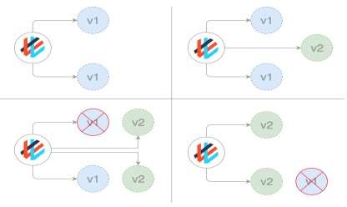A rolling update waits for new pods to become ready before it starts scaling down the old ones. If there is a problem, the rolling update or deployment can be aborted without bringing the whole cluster down. In the YAML definition file for this type of deployment, a new image replaces the old image.

# Deployments Rolling

Update

apiVersion: apps/v1 kind: Deployment metadata:

name: nginx-deployment

spec:

replicas: 2 strategy:

type: RollingUpdate

rollingUpdate: maxSurge: 1

maxUnavailable: 1

minReadySeconds: 30 selector: matchLabels:

app: nginx template: metadata:

name: nginx-pod labels:

app: nginx spec: containers:

* name: nginx-container image: nginx:1.7.9 ports:
  + containerPort: 80

## Kubernetes Objects

### Deployment Strategies Recreate

* In this type of very simple deployment, all of the old pods are killed all at once and

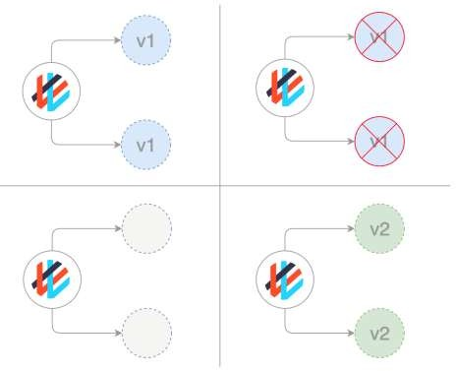get replaced all at once with the new ones.

apiVersion: apps/v1 kind: Deployment metadata:

name: nginx spec:

replicas: 3

strategy:

type: Recreate selector: matchLabels:

app: nginx template: metadata:

labels:

app: nginx spec: containers:

- name: nginx image: nginx:1.7.9 ports:

- containerPort: 80

**Deployment Strategies**

**Blue/ Green (or Red / Black) deployments**

In a blue/green deployment strategy (sometimes referred to as red/black) the old version of the application (green) and the new version (blue) get deployed at the same time. When both of these are deployed, users only have access to the green; whereas, the blue is available to your QA team for test automation on a separate service or via direct port- forwarding.

After the new version has been tested and is signed off for release, the service is switched to the blue version with the

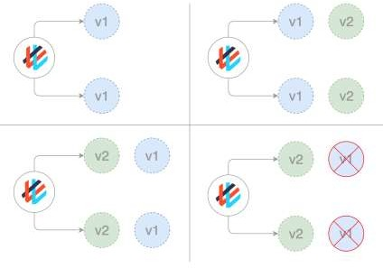old green version being scaled down:

apiVersion: v1 kind: Service metadata:

name: awesomeapp

spec:

selector:

app: awesomeapp

version: "02"

**Service**

A service is responsible for making our Pods discoverable inside the network or exposing them to the internet. A Service identifies Pods by its LabelSelector.

**Types of services available:**

***ClusterIP*** – Exposes the service on a cluster-internal IP. Service is only reachable from within the cluster. This is the default Type.

# Service Cluster IP apiVersion: v1 kind: Service metadata:

name: my-internal-service

spec: selector: app: nginx

type: ClusterIP ports:

- name: http port: 80

targetPort: 80

protocol: TCP

Service

POD

POD

POD

Cluster

***NodePort*** – Exposes the service on each Node’s IP at a static port. A ClusterIP service, to which the NodePort service will route, is automatically created. You’ll be able to contact the NodePort service, from outside the cluster, by using “<*NodeIP*>:<*NodePort*>”.

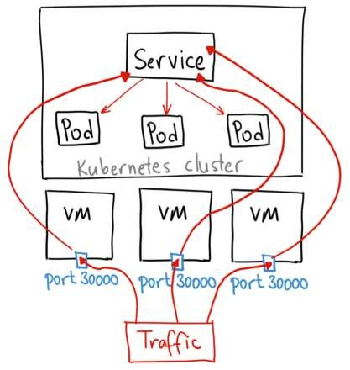apiVersion: v1 kind: Service metadata:

name: my-nodeport-service

spec:

selector:

app: nginx-rs-pod type: NodePort ports:

- name: http

port: 80

targetPort: 80

nodePort: 30036 protocol: TCP

***LoadBalancer*** – Exposes the service externally using a cloud provider’s load balancer. NodePort and ClusterIP services, to

which the external load balancer will route, are automatically created.

If you are using a custom Kubernetes Cluster

(using minikube, kubeadm or the like). In this case, there is no LoadBalancer integrated (unlike AWS EKS or Google Cloud). With this default setup, you can only use [NodePort](https://kubernetes.io/docs/concepts/services-networking/service/#type-nodeport).

Configure Load Balancer Externally.

apiVersion: v1 kind: Service metadata:

name: nginxservice

labels:

app: nginx spec:

ports:

- port: 80

targetPort: 80 protocol: TCP selector:

app: nginx

type: LoadBalancer

***Ingress*** – *Kubernetes Ingress is a resource to add rules for routing traffic from external sources to the services in the*

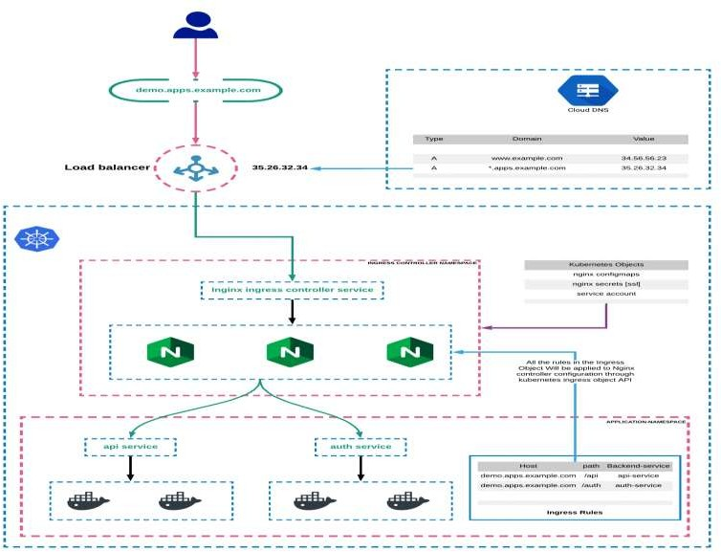*kubernetes cluster.*

Kubernetes Ingress:

Kubernetes Ingress is a native kubernetes resource where you can have rules to route traffic from an external source to service endpoints residing inside the cluster. It requires an ingress controller for routing the rules specified in the ingress object.

Kubernetes Ingress Controller

Ingress controller is typically a proxy service deployed in the cluster. It is nothing but a [kubernetes deployment](https://devopscube.com/kubernetes-deployment-tutorial/) exposed to a service. Following are the ingress controllers available for kubernetes.

Following are the ingress controllers available for kubernetes. Nginx Ingress Controller ([Community](https://github.com/kubernetes/ingress-nginx) & [From Nginx Inc](https://github.com/nginxinc/kubernetes-ingress)) [Traefik](https://github.com/containous/traefik)

[HAproxy](https://www.haproxy.com/blog/haproxy_ingress_controller_for_kubernetes/) [Contour](https://github.com/heptio/contour)

[GKE Ingress Controller](https://github.com/kubernetes/ingress-gce)

# Questions ?