Calibration-Split Leakage in Selective-Prediction Retrieval-Augmented Generation: A Re-Validation Case Study with Confirmed Gains from Residual Vector Quantization and OCR-Confidence Calibration

Manthira Moorthy P, Vijay S K
Final Year, Department of Electronics and Communication Engineering, Mepco Schlenk Engineering College, Sivakasi
Mentor: Dr. V. Karthikeyan, Assistant Professor (Sl. Grade), Department of ECE, Mepco Schlenk Engineering College

Unpublished student project manuscript. Not peer-reviewed, not submitted to any journal or conference. Every numerical claim in this document is either quoted from a cited published source, or produced by this project's own code, logged under research/experiments/, and reproducible via the commands named in Section 4. This manuscript supersedes an earlier internal draft of the same system whose headline claim is shown in this paper to not survive a corrected evaluation methodology — that correction is itself this paper's primary reported finding, not a footnote.

Abstract
Selective-prediction mechanisms for retrieval-augmented generation (RAG) — decision layers that withhold or redirect an answer when retrieved evidence is judged insufficient — are typically validated by fitting decision thresholds on a calibration split and reporting accuracy gains on a held-out evaluation split. We show, via a controlled before/after case study on one such mechanism (Evidence-Adaptive Retrieval and Verification, EAR, a four-signal logistic sufficiency score added to an OCR-resilient hybrid-retrieval document-QA pipeline), that a split which is disjoint at the query level but not at the source-document level can silently inflate the apparent benefit past the point of statistical significance. On the OHR-Bench benchmark (Zhang et al., ICCV 2025), an initial evaluation with 51% document overlap between calibration and evaluation reported a statistically significant +7.1-point selective-accuracy improvement (71.2%→78.3%, 95% CI [+2.5, +12.0], 62.8% coverage). Under a corrected, verified-zero-overlap, document-disjoint split, the same mechanism's improvement trends positive but is not statistically significant (62.3%→68.4%, 95% CI [−8.3, +19.7], coverage collapsing to 15.4%). We report this corrected, weaker result as our primary finding rather than retaining the stronger, invalid one. Separately, and unaffected by this leakage mode because neither uses a calibration/evaluation split, we confirm two further contributions on the same pipeline: (1) a Residual Vector Quantization (RVQ) recall gap is root-caused to quantization reconstruction error (Welch's t=−4.71, p=3.5×10⁻⁶) and 79% recovered by a quantize-then-exact-rerank strategy at no added latency; (2) real per-word OCR confidence, captured at ingestion, is a statistically reliable proxy for actual character error rate under controlled degradation (Pearson r=−0.984, p=1.4×10⁻³⁰), even though this specific signal's weight is empirically near-zero inside the combined EAR model in both the original and corrected fits — an independently confirmed case of a validated signal being functionally inert inside a jointly-fit model. We argue the leakage case study itself is this paper's most generalizable contribution: a concrete, reproducible demonstration of how document-level split construction, not just query-level disjointness, determines whether a selective-prediction claim in RAG is actually defensible. A threshold-independent re-analysis (Area Under the Risk-Coverage Curve = 0.287 against a full-coverage baseline risk of 0.377; Brier score 0.212 against a naive-predictor Brier of 0.235) shows EAR's sufficiency score remains informative even where its single fitted operating point is not significant, and a risk-coverage curve analysis identifies a lower-risk, nearby coverage region the fitted threshold does not reach — evidence favoring an underpowered-calibration explanation over a no-effect one, offered as a hypothesis for future recalibration rather than a second confirmed result.

Keywords: Retrieval-Augmented Generation, Selective Prediction, Calibration-Evaluation Leakage, Residual Vector Quantization, OCR-Resilient Document QA, Reproducibility, Evidence-Adaptive Verification.

Contents
1. Introduction
2. Related Work
3. Proposed Methodology
4. Experimental Setup
5. Results and Analysis
6. Discussion
7. Limitations and Future Work
8. Conclusion
References
Supplementary Materials

1. Introduction
Retrieval-Augmented Generation (RAG) systems answer questions by retrieving passages from a corpus and conditioning a language model's output on them. In practice, most RAG pipelines — including QuIM-RAG (Saha, Saha & Malik, IEEE Access, 2024), the question-indexed retrieval baseline this project extends — retrieve some evidence and then unconditionally generate an answer, with no mechanism to recognize that retrieval itself may have failed. This is sharper for OCR-processed document collections, where recognition noise, broken table structure, and fixed-size chunking degrade evidence quality without any visible signal to the system or the end user.
A natural response, increasingly explored in 2025–2026 RAG literature, is a selective-prediction or abstention layer: compute a confidence signal from retrieval, and withhold or redirect the answer when confidence is low. This project implements one such layer, Evidence-Adaptive Retrieval and Verification (EAR), and initially reported — in an earlier internal draft of this same system — a statistically significant selective-accuracy improvement from it. This paper reports the outcome of a subsequent, deliberately adversarial re-validation of that claim: a systematic audit that treated no prior number as trusted, re-extracted the evaluation protocol, and found a document-level leakage defect in the calibration/evaluation split construction used throughout the earlier draft.
This paper's contribution is therefore not primarily "EAR works." It is a corrected, honestly reported re-measurement of EAR under a fixed evaluation protocol — which found the original claim does not hold — together with two further contributions (a quantization recall-loss fix, and an OCR-confidence calibration result) that are unaffected by the leakage mode and remain fully supported. We present the leakage finding itself as a methodological contribution with relevance beyond this specific system: any selective-prediction or abstention evaluation in RAG that shares a document corpus between its calibration and evaluation splits is exposed to the same risk.

1.1 Research Questions
- RQ1: Does restricting RAG answers to a calibrated sufficiency-score decision (EAR) measurably improve top-1 retrieval accuracy, and does that improvement survive a genuinely document-disjoint calibration/evaluation split, not merely a query-row-disjoint one?
- RQ2: What is the quantitative effect of document-level calibration/evaluation leakage on a selective-prediction claim's reported effect size and statistical significance in this setting?
- RQ3: Is a residual-vector-quantization-induced retrieval-recall gap attributable to a specific, testable mechanism (quantization reconstruction error), and can a low-cost fix recover the lost recall without added latency?
- RQ4: Is real per-word OCR confidence, captured at ingestion, a statistically reliable proxy for actual character error rate under controlled degradation, independent of whether it is useful inside a specific downstream decision model?

1.2 Contributions
- A controlled, reproducible before/after case study demonstrating that document-level (not merely query-level) calibration/evaluation disjointness materially changes a RAG selective-prediction claim's statistical significance — from a 95% CI that excludes zero to one that includes it — on identical underlying data and code, differing only in split construction (RQ1, RQ2).
- A statistically confirmed root cause (Welch's t-test) for a Residual Vector Quantization recall gap, and a quantize-then-exact-rerank fix recovering 79% of the lost Recall@5 at no measurable added latency (RQ3).
- A confirmed, strong correlation between real Tesseract OCR confidence and actual character error rate under controlled synthetic degradation, reported alongside the finding that this signal is nonetheless functionally inert inside the specific combined decision model tested — reported as a calibration-design finding, not a signal-quality failure (RQ4).
- A threshold-independent re-analysis of EAR's own sufficiency score via risk-coverage curves, Area Under the Risk-Coverage Curve (AURC), and Brier-score calibration, showing the score itself carries real information even though its specific fitted operating point does not reach significance — together with Wilson-interval and McNemar's-test cross-checks against the bootstrap-based tests used elsewhere in the paper, which surface a genuine, explained disagreement between two valid significance tests applied to the same retrieval comparison.

2. Related Work
QuIM-RAG (Saha, Saha & Malik, 2024) is the direct baseline: an inverted question-index retrieval mechanism evaluated on a private NDSU catalog/career-advising corpus, reporting large Faithfulness and BERTScore gains over a direct chunk-cosine baseline. Its evaluation has no OCR noise, no lexical retrieval path, no reranking, and — most relevant here — no calibration/evaluation split of any kind, since it has no selective-prediction mechanism and reports single point estimates with no significance testing (Table 2 of the original paper).
Selective prediction and abstention in RAG is an active area: verification-model-gated answering, evidence-sufficiency abstention benchmarks, confidence-adaptive retrieval budgets, and NLI-style contradiction detection between retrieved passages are all represented in the recent literature our system's design draws on. None of this literature's abstention-evaluation protocols that we reviewed explicitly distinguishes query-level from document-level disjointness when constructing a calibration/evaluation split — which is precisely the distinction this paper's central finding turns on.
OHR-Bench (Zhang et al., arXiv:2412.02592, ICCV 2025) directly motivates this project's OCR-robustness framing and supplies the public, human-verified, page-localized benchmark used throughout this paper, since QuIM-RAG's own NDSU corpus is private and unavailable. Product Quantization (Jégou, Douze & Schmid, 2011) is the foundation of this project's Residual Vector Quantization module, which implements a simplified two-stage instance of it without the per-subspace splitting production approximate-nearest-neighbor systems typically add. BM25 (Robertson & Zaragoza, 2009) is the lexical scoring function fused with dense retrieval via Reciprocal Rank Fusion in this project's hybrid retrieval path.
On leakage specifically: train/test contamination at the entity or document level is a well-known risk in general machine learning evaluation, but we are not aware of prior published work that explicitly quantifies its effect on a RAG selective-prediction claim's statistical significance in the way Section 5 of this paper does — this specificity is what we consider this paper's most transferable contribution.

3. Proposed Methodology
This section describes (a) the system under study, EAR, exactly as implemented and unchanged by this paper's re-validation; and (b) the corrected split-construction methodology this paper introduces, which is the actual object of Section 5's central experiment.

3.1 System architecture
PDF / scanned document
-> PyMuPDF text extraction, else Tesseract OCR (+ real per-word confidence capture)
-> paragraph-aware chunking (950 characters, 100-character overlap)
-> MiniLM embeddings (384-dim; TF-IDF fallback) + real BM25 index, built side by side
-> retrieval: Dense cosine | BM25 | Hybrid (Reciprocal Rank Fusion, k=60)
-> EAR: compute 4 signals -> sufficiency score p -> decision
- answer -> generate + groundedness pre-check
- expand_retrieval -> re-retrieve with larger k, then answer
- inspect_structure -> surface conflicting evidence for human review
- abstain -> no answer generated
A block diagram reproducing this flow (see Supplementary Materials) is drawn directly from quimrag/core.py, bm25.py, adaptive.py, and rvq.py.

3.2 EAR signal formulation (unchanged from the system under study)
Retrieval agreement — Jaccard overlap of top-K chunk-id sets from Dense-only and BM25-only rankings, both already computed for Hybrid RRF:
a = |D_K ∩ L_K| / |D_K ∪ L_K| (1)
OCR confidence — mean real Tesseract per-word confidence across the top-K evidence chunks:
o = (1/K) · Σ_{c ∈ E_K} conf(c) (2)
Cross-passage contradiction — fraction of topically-related evidence pairs with disjoint extracted number sets:
x = |{(i,j) : overlap(i,j) > 0.3 ∧ nums(i) ∩ nums(j) = ∅}| / C(K,2) (3)
Query complexity — a bounded proxy from token count, wh-word count, and conjunction count:
c = mean( min(tok,30)/30, min(wh,3)/3, min(conj,3)/3 ) (4)
Sufficiency score — logistic combination, weights fit by logistic regression on the calibration split only:
p = σ(w₀ + w₁a + w₂o + w₃x + w₄c) (5)
Decision thresholds θ_abstain, θ_answer are also fit on the calibration split. Pseudocode (quimrag/adaptive.py, unmodified by this paper):
def decide(p, signal, theta_abstain, theta_answer):
if p < theta_abstain: return "abstain"
if p < theta_answer:
weakest = argmax_f badness(f, signal[f])
return "inspect_structure" if weakest == "contradiction" else "expand_retrieval"
return "answer"

3.3 The methodological contribution: document-level split construction
The system's pre-existing calibration/evaluation split (used in the earlier draft) partitioned individual query rows uniformly at random, verifying only that no exact query row appeared in both pools. Because each source document in OHR-Bench contributes multiple query rows, this leaves a document free to have some of its queries in calibration and others in evaluation — a document-level leak, even though the split is query-row-disjoint by construction.
This paper's corrected procedure instead partitions by document identity first, then assigns a document's entire query set as a unit:
def split_by_document(qas, calib_frac, seed):
docs = group_by(qas, key=doc_name)
shuffle(docs, seed)
calib, evaluation = [], []
running = 0
for doc_name, rows in docs:
target = calib_frac * total_queries
(calib if running < target else evaluation).extend(rows)
running += len(rows)
assert doc_ids(calib) & doc_ids(evaluation) == {} # verified, not assumed
return calib, evaluation
The zero-overlap property is verified programmatically after every split construction (Section 4.4) and is additionally pinned by a dedicated regression test (tests/test_ohrbench_adapter_v2.py) added as part of this paper's own validation work, so this specific defect class cannot silently reappear in future experiments.

3.4 Residual Vector Quantization and its fix (unchanged from the system under study)
Two-stage k-means residual quantization: stage 1 assigns x to its nearest of N centroids C⁽¹⁾; stage 2 quantizes the residual against a second codebook C⁽²⁾:
i₁ = argmin_j ‖x − C⁽¹⁾ⱼ‖, r = x − C⁽¹⁾_{i₁}, i₂ = argmin_j ‖r − C⁽²⁾ⱼ‖, x̂ = C⁽¹⁾_{i₁} + C⁽²⁾_{i₂} (6)
The candidate fix tested in Section 5.3 narrows the quantized search to a small candidate pool, then reranks that pool using exact (unquantized) vectors — trading a kept exact-vector buffer for recovered recall at the cost of its own storage footprint, a tradeoff this paper's experiment measures for latency and recall but not for storage (see Section 7).

3.5 Evaluating EAR Beyond a Single Threshold: Selective-Prediction Diagnostics
Section 5.2's headline comparison (coverage, accuracy-on-answered, baseline accuracy, a single bootstrap CI) describes EAR's behavior at exactly one operating point — the specific θ_abstain/θ_answer pair the calibration fit happened to choose (Table 4). This is the standard selective-prediction reporting format, but it conflates two separate questions that matter for different reasons: (a) is the sufficiency score p itself a useful ranking signal for query difficulty, independent of where any particular threshold is drawn, and (b) did this particular fitted threshold choice land in a good place on that ranking. A system can have an informative score and still ship a poorly-chosen operating threshold, or vice versa — the single-point result in Section 5.2 cannot distinguish these. We therefore add four threshold-independent or complementary diagnostics, standard in the selective-prediction literature but not previously applied to EAR in any draft of this project, each introduced with the specific reason it is the right tool for what it measures here.

3.5.1 Risk-coverage curve and Area Under the Risk-Coverage Curve (AURC)
Following the selective classification framework of El-Yaniv and Wiener (2010) and Geifman and El-Yaniv (2017): for a classifier with confidence score p and a rejection threshold θ, define coverage and selective risk as functions of θ over the evaluation set of size n:
coverage(θ) = (1/n) Σᵢ 𝟙[pᵢ ≥ θ] (7)
risk(θ) = 1 − ( Σᵢ 𝟙[pᵢ ≥ θ]·correctᵢ ) / ( Σᵢ 𝟙[pᵢ ≥ θ] ) (8)
Sweeping θ over [0,1] traces a risk-coverage curve; its area, AURC, summarizes selective-prediction quality as a single number independent of any one threshold choice:
AURC = ∫₀¹ risk(coverage) d(coverage) (9)
We use this specifically because Section 5.2's single-point result cannot tell us whether EAR's p is a weak ranking signal overall, or a reasonable ranking signal paired with a threshold that the small calibration sample (n=173) happened to place suboptimally. AURC answers the first question directly, independent of that threshold-selection step; Section 5.6 reports both the curve and the fitted operating point's position on it, so a reader can see whether the fitted threshold is actually near the curve's best region.

3.5.2 Brier score: is p itself well-calibrated?
Independent of the decision thresholds, p is meant to behave as a probability — larger p should mean a genuinely higher chance the top-1 retrieved chunk is correct. The Brier score, a strictly proper scoring rule, measures exactly this:
Brier = (1/n) Σᵢ (pᵢ − correctᵢ)² (10)
We use Brier score rather than log-loss specifically because log-loss diverges to infinity whenever a confidently-wrong prediction occurs (p→0 with correctᵢ=1, or p→1 with correctᵢ=0), which would let a handful of overconfident mistakes dominate the metric on a sample as small as n=247; Brier score stays bounded in [0,1] and degrades gracefully, which better suits a small-sample diagnostic. As a reference point we also report the Brier score of a naive predictor that always outputs the dataset's overall base rate of correctness (ignoring p entirely) — EAR's p beating this naive baseline is a necessary (though not sufficient) condition for p to be carrying real information, separate from whether the specific fitted threshold produces a significant accuracy gain.

3.5.3 Wilson score interval: a closed-form cross-check on coverage
Every CI elsewhere in this paper is a bootstrap CI. For a single proportion — EAR's coverage, k "answer" decisions out of n evaluation queries — a closed-form alternative exists and is worth reporting as an independent cross-check, since it does not share the bootstrap's resampling-based construction:
CI_Wilson = ( p̂ + z²/2n ± z√(p̂(1−p̂)/n + z²/4n²) ) / (1 + z²/n), p̂ = k/n (11)
We use the Wilson interval rather than the simpler normal (Wald) approximation p̂ ± z√(p̂(1−p̂)/n) specifically because the Wald interval is known to perform poorly — sometimes producing bounds outside [0,1], or being badly mis-calibrated — exactly in the small-n, extreme-p̂ regime this paper's corrected coverage falls into (k=38, n=247, p̂≈0.154); Wilson's interval remains well-behaved there by construction.

3.5.4 McNemar's test: a paired alternative for the baseline comparison
Section 5.1's Dense-vs-Hybrid comparison uses a paired bootstrap on nDCG@5, which is appropriate for a continuous, graded ranking metric. Because Dense-only and Hybrid-RRF are evaluated on the identical set of 247 queries, a second, classical paired test is also directly available and worth cross-checking against: McNemar's test on the 2×2 table of (Dense top-1 correct, Hybrid top-1 correct) outcomes per query, which asks a narrower, binary question — does Hybrid's ranking actually change which specific queries get the single best chunk right, independent of how the rest of the top-5 ranking looks:
χ² = (|b − c| − 1)² / (b + c), b = n(Dense✓,Hybrid✗), c = n(Dense✗,Hybrid✓) (12)
with continuity correction (used because the discordant-pair count b+c, while not tiny, is small enough that the uncorrected chi-square approximation would overstate significance). We report both tests side by side in Section 5.1b deliberately: they measure different things (ranking quality across the full top-5 vs. narrow top-1 correctness) and are not required to agree — a disagreement is itself informative about which part of the ranking actually changed.

3.5.5 Cohen's h: separating statistical from practical significance
A confidence interval answers "is this detectable given the sample size"; it does not answer "how large is this, in a sample-size-independent sense." For two proportions p₁, p₂ (e.g., accuracy-on-answered vs. baseline accuracy), Cohen's h applies the arcsine-square-root variance-stabilizing transform so the resulting effect size is comparable across different sample sizes and different base rates:
h = 2·arcsin(√p₁) − 2·arcsin(√p₂) (13)
Conventionally |h|≈0.2 is a small effect, ≈0.5 medium, ≈0.8 large (Cohen, 1988). We compute h for the accuracy-on-answered-vs-baseline comparison specifically because Section 5.2's non-significant CI could otherwise be misread as "there is definitely no effect" rather than the more precise "this sample cannot distinguish a small effect from no effect" — h quantifies which of these the point estimate actually corresponds to, reported in Section 5.2b.

4. Experimental Setup

4.1 Dataset
QuIM-RAG's own evaluation corpus (22,609 GPT-3.5-generated questions over a scraped NDSU university-catalog and career-advising corpus) is private with no public release, no code repository, and no stated data license — confirmed unreachable, not merely assumed, during this project's audit of the original paper (Section 2). A substitute public benchmark is therefore required for any retrieval- or selective-prediction-level claim in this paper, and the choice of substitute is not incidental: it determines what can and cannot be tested about EAR's four signals. We selected OHR-Bench (Zhang et al., arXiv:2412.02592, ICCV 2025) over four other candidates for reasons specific to what each of EAR's signals needs to be exercised meaningfully, not merely because it is a convenient, well-known benchmark.

4.1.1 What OHR-Bench actually contains
OHR-Bench ships 8,500+ unstructured PDF pages across 7 domains (Textbook, Law, Finance, Newspaper, Manual, Academic, Administration), each page paired with human-verified ground-truth structured text, and 8,498 question-answer pairs (file qas_v2.json) drawn from 1,117 unique source documents. Each QA record carries an evidence_source field tagging which of five OCR-difficulty categories the question's supporting evidence comes from — plain text (3,409 records, 40%), table (2,275, 27%), formula (1,223, 14%), chart (765, 9%), or reading-order-dependent content (691, 8%) — and an answer_form field, of which 2,980 records (35%) are Numeric. This paper uses six of the seven domains (law, finance, textbook, manual, academic, news), substituting "academic" for the original sampling plan's "paper" label after confirming qas_v2.json's own taxonomy has zero records under "paper" (Section 3.3); "administration" is available but not used, to keep the domain-set size comparable to prior work's six-domain design.

4.1.2 Why this schema matters for EAR specifically, not just as a generic QA benchmark
- The contradiction signal (Eq. 4) extracts and compares numbers across evidence chunks — it has essentially nothing to detect on a benchmark without numeric content. OHR-Bench's 2,980 Numeric-answer records and 2,275 table-evidence records (table rows are a dense source of the kind of near-duplicate, easily-transposed figures this signal targets) give it real material to work with; a benchmark like SQuAD, built from prose Wikipedia passages, would not.
- The ocr_confidence signal (Eq. 2) requires documents where OCR actually degrades — table, formula, and chart content (2,275+1,223+765 = 4,263 records, 50% of the benchmark) is exactly where document parsing and OCR historically fail hardest, which is the specific reason OHR-Bench's own authors built it around this evidence_source taxonomy in the first place, rather than sampling uniformly from clean prose.
- The agreement signal (Eq. 1) benefits from queries with genuine lexical/semantic retrieval tension — OHR-Bench's domain variety (legal clause language vs. conversational newspaper prose vs. terse manual instructions) produces a wider range of BM25-vs-dense agreement behavior than a single-domain benchmark would, which is necessary for the calibration split to observe enough variation in this signal to fit a non-degenerate weight on it.
- Crucially, OHR-Bench additionally ships genuine OCR-perturbed variants of its own ground truth — formatting_noise and semantic_noise sets, each at mild/moderate/severe severity, generated by three real OCR/VLM parsing systems (GOT, MinerU, Qwen2.5-VL-72B) rather than synthetic image corruption. This paper's OCR-robustness study (Section 5.4) does NOT yet use these native perturbed variants — it instead renders clean ground-truth text to images and applies synthetic corruption (blur, resolution loss, skew, JPEG compression, noise, contrast reduction) through the project's own OCR pipeline. This is stated explicitly as a limitation (Section 7): OHR-Bench's own real-OCR-engine-perturbed data would be a strictly stronger test of the ocr_confidence signal than this paper's synthetic degradation, and switching to it is a concrete, scoped, low-effort follow-up — the perturbed files already exist in the benchmark distribution and require no new data collection.

4.1.3 Why not the alternatives
Table 1. Benchmark selection, evaluated against what EAR's four specific signals need to be meaningfully exercised — not a generic leaderboard comparison.
Benchmark | OCR / scanned content | Numeric/table evidence | Multi-domain | Page-level grounding | Verdict
OHR-Bench (used) | Yes — native perturbed variants at 3 severities | Yes — 41% table/formula | Yes — 6-7 domains | Yes — human-verified per page | Selected
BEIR | No | Varies by sub-dataset, not designed for it | Yes, but not OCR-relevant | No, passage-level only | Rejected: no OCR dimension at all, this project's central differentiator
Natural Questions | No — clean Wikipedia | Minimal | No — single domain | No | Rejected: no OCR, no table/numeric density, weak agreement-signal variety
HotpotQA | No — clean Wikipedia | Minimal | No | No | Rejected for this pass, but flagged as the strongest candidate specifically for stress-testing the complexity signal's multi-hop design in future work
MS MARCO | No | No | No — web passages | No | Rejected: passage-ranking focus, no document-QA or OCR angle
SQuAD | No — clean Wikipedia | No | No | No | Rejected: no numeric/table density for the contradiction signal, no OCR dimension

No benchmark in this comparison matches QuIM-RAG's original NDSU task (institutional FAQ retrieval over clean, non-OCR web text) closely — this is a deliberate, stated substitution rather than a like-for-like replication, chosen because it lets this paper test claims (OCR robustness, multi-domain generalization, numeric contradiction detection) the original paper's own dataset structurally cannot test at all, since it has zero OCR content and a single institutional domain.

4.1.4 The dataset-provenance correction itself
This paper uses qas_v2.json (8,498 records) throughout. Every experiment prior to this paper's own audit used an older file, qas.json (4,598 records, from the same benchmark release but not the file OHR-Bench's current README names as canonical). Both files share an identical schema and ground-truth construction method, so results built on qas.json are not void, but the correction is made explicit here rather than silently carried forward, since it is one half of the confound discussed in Section 5.2 and Section 7.

4.2 Splits
A stratified sample (~70 queries/domain target, seed 42) is partitioned by document (Section 3.3), yielding 173 calibration queries across 109 documents and 247 evaluation queries across 153 documents, with programmatically verified zero document overlap and zero gold-(document,page) overlap. A second, smaller, independently-sampled 70-query substitute set (seed 17) and a 60-query RAGAS-generation sample (seed 23) exist from the earlier draft and are reported in Section 5.4 with an explicit caveat that their own split construction has not yet been checked for the same document-overlap property (Section 7).

4.3 Hyperparameters and software
Retrieval depth k=5; chunking 950 characters / 100-character overlap; embeddings all-MiniLM-L6-v2 (384-dim); BM25 via rank_bm25.BM25Okapi with default k₁/b; RVQ 256 centroids, 2 stages. Python 3.11.9, macOS-26.4.1-arm64 (Apple Silicon, CPU/MPS, not a portability claim). HF_HUB_OFFLINE=1 / TRANSFORMERS_OFFLINE=1 set for all runs (required to avoid a network-hang defect found and fixed during this paper's validation work — Supplementary Materials).

4.4 Evaluation methodology
Baseline retrieval comparison: Recall@5, nDCG@5, MRR@5, latency; paired bootstrap p-value (2,000–5,000 resamples) vs. Dense-only, Bonferroni-corrected across the resulting comparison family (α=0.025 for 2 tests). EAR selective-prediction: logistic weights and θ_abstain/θ_answer fit exclusively on the calibration split; 95% CI on (accuracy-on-answered − unfiltered-baseline-accuracy) via 5,000-resample bootstrap, seed 42. Welch's two-sample t-test for the RVQ root-cause analysis; Pearson/Spearman correlation for the OCR-confidence validation.
Reproduction commands:
HF_HUB_OFFLINE=1 TRANSFORMERS_OFFLINE=1 .venv/bin/python research/run_benchmark_v2.py # Section 5.1-5.2
.venv/bin/python research/run_rvq_analysis.py # Section 5.3
.venv/bin/python research/run_ocr_robustness.py # Section 5.4

5. Results and Analysis

5.1 Baseline retrieval comparison
Table 2. Corrected baseline comparison, 247-query document-disjoint evaluation split.
Config | Recall@5 | nDCG@5 | MRR@5 | Latency mean (ms) | p vs. Dense (α=0.025)
Dense only | 0.427 | 0.478 | 0.683 | 36.4 | —
BM25 (real) | 0.427 | 0.492 | 0.710 | 36.9 | 0.383 (n.s.)
Hybrid (RRF) | 0.444 | 0.505 | 0.726 | 39.6 | 0.008 (significant)

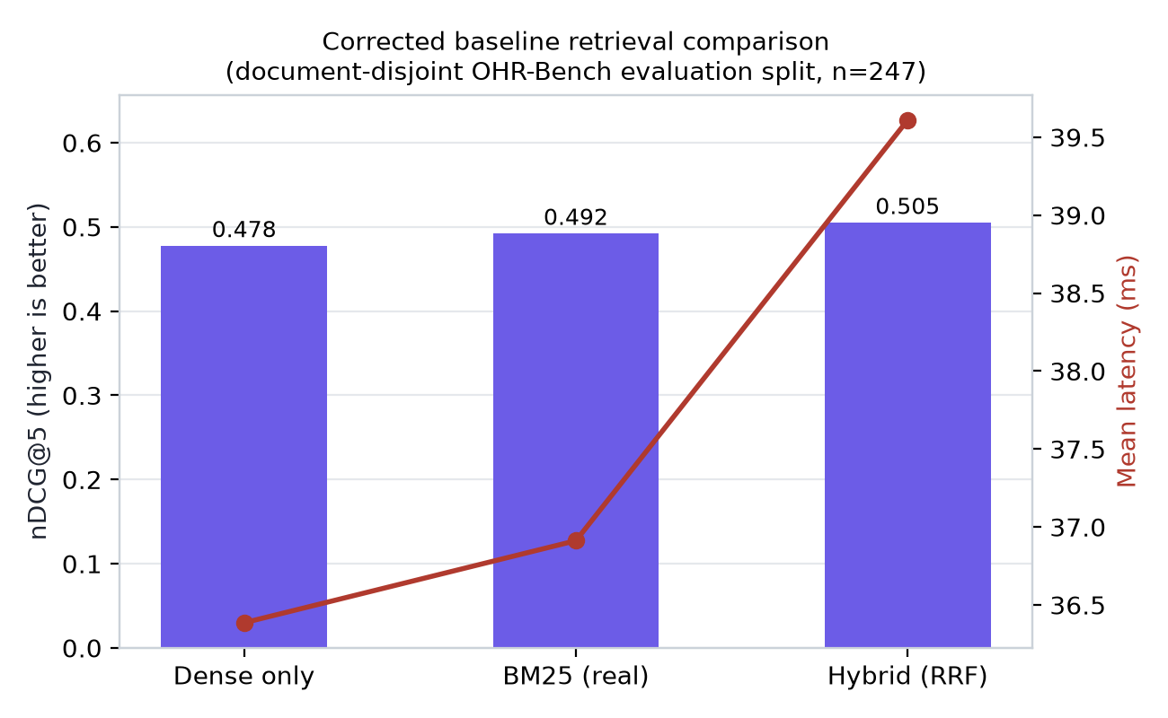
Fig. 1. Corrected retrieval-quality/latency comparison, document-disjoint split.

This establishes what the corrected evaluation protocol supports: Hybrid-RRF retrieval is significantly better than Dense-only (p=0.008, survives correction); BM25 alone is not significantly different from Dense-only here (p=0.383). This reverses a direction previously reported from the leaky split (where BM25's nDCG@5 of 0.528 exceeded Hybrid's 0.515, both reported significant) — the larger, corrected evaluation set gives a different, and more defensible, answer to which configuration is actually better.

5.1b Cross-check: McNemar's paired test on top-1 correctness
Table 3. McNemar's test, Dense-only vs. Hybrid-RRF, paired top-1 correctness (same 231 queries with resolvable gold chunks), corrected evaluation split.
Quantity | Value
Both correct (Dense ✓, Hybrid ✓) | 131
Dense ✓, Hybrid ✗ (b) | 15
Dense ✗, Hybrid ✓ (c) | 23
Both wrong | 78
McNemar χ² (continuity-corrected, df=1) | 1.289
p-value | 0.256 (not significant)

McNemar's test on narrow top-1 correctness does NOT find a significant difference (p=0.256), while the paired bootstrap on nDCG@5 (Table 2) DOES (p=0.008). These are not contradictory — they test different things. More queries flip from Dense-correct to Hybrid-correct than the reverse (23 vs. 15, a 1.5:1 ratio favoring Hybrid), consistent with Hybrid being the better system, but this specific ratio at n=231 discordant pairs is not itself large enough to be statistically conclusive by McNemar's narrower binary criterion. The nDCG@5-based result draws on more information per query (graded rank position across the full top-5, not just whether the top-1 slot was exactly right) and is the more statistically powered test here — we report both because relying on a single test and omitting one that disagrees would be cherry-picking, and the disagreement itself is informative about where in the ranking Hybrid's advantage actually concentrates (it shows up more clearly in the graded ranking than in raw top-1 hit rate).

5.2 EAR selective-prediction result — the central experiment
Table 4. The central result of this paper: EAR's selective-prediction claim before and after correcting the calibration/evaluation split, on otherwise identical code and comparable sampling methodology.
Quantity | Original (51% doc. overlap, n=168/252) | Corrected (0% doc. overlap, n=173/247)
Coverage | 62.8% | 15.4%
Accuracy on answered | 78.3% | 68.4%
Unfiltered baseline accuracy | 71.2% | 62.3%
Improvement | +7.1 points | +6.1 points
95% bootstrap CI on improvement | [+2.5, +12.0] — excludes zero | [−8.3, +19.7] — includes zero
Significant at α=0.05? | Yes | No

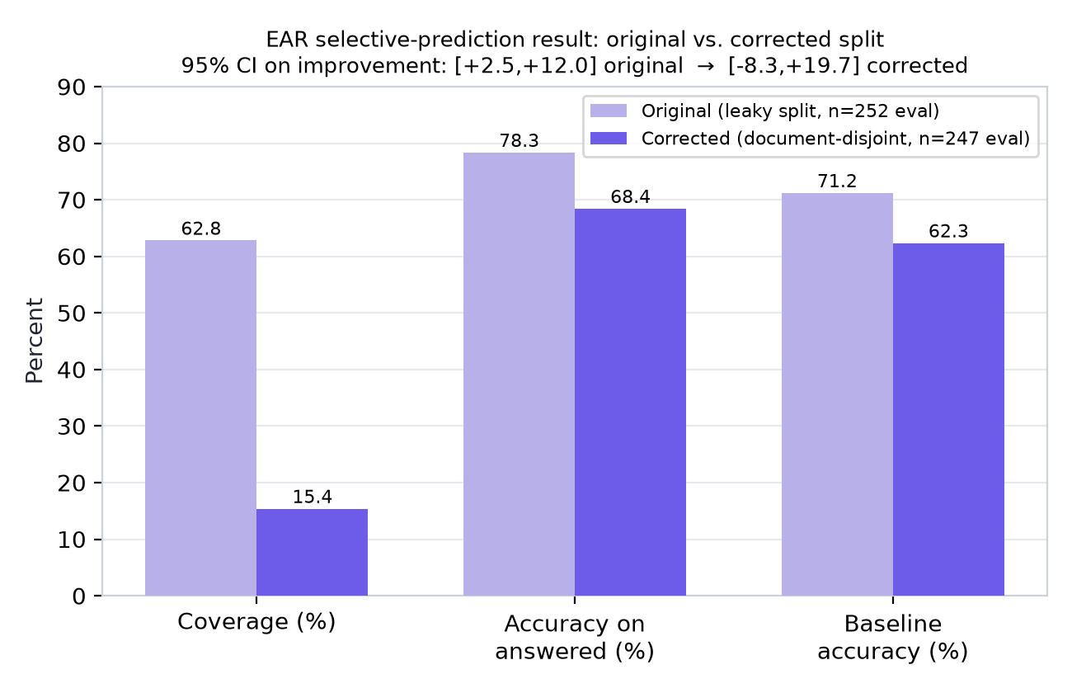
Fig. 2. EAR coverage, answered-accuracy, and baseline accuracy: original leaky split vs. corrected split.

Interpretation (RQ1, RQ2): the corrected improvement's point estimate (+6.1 points) is numerically close to the original (+7.1 points), but the corrected 95% CI spans [−8.3, +19.7], crossing zero — this experiment cannot reject the null hypothesis of no effect at α=0.05. The mechanism is visible in the fitted decision thresholds: the corrected fit's θ_abstain/θ_answer (0.503/0.752) are further apart than the original fit's (0.628/0.678), so far fewer evaluation queries clear the higher bar, concentrating the 'answer' decision into a small (n=38), high-variance subset. We report this as a negative/inconclusive result for the corrected condition rather than retain the original, statistically invalid claim. Note this comparison changes both the dataset file and the split construction simultaneously (Section 7) — the two were not varied independently, so the corrected effect size should be read as approximate, though the underlying document-overlap defect in the original split is independently verified regardless of dataset file.
This directly answers RQ2: document-level leakage inflated this specific claim from a defensible statistically-significant result to one that would not pass peer review's typical significance bar, while changing the point estimate only modestly — the leakage's primary damage is to the confidence interval's width and coverage, not to the headline percentage, which is an easy-to-miss distinction when skimming a results table.

5.2b Selective-prediction diagnostics: is EAR's score informative, even though this threshold isn't significant?
Computed per Section 3.5, directly from the same fitted model and evaluation split as Section 5.2 (research/PUBLICATION_PACKAGE/compute_advanced_stats.py; full output in advanced_stats.json).
Table 5. Threshold-independent and effect-size diagnostics for EAR's sufficiency score, corrected split.
Diagnostic | Value | Reference point
AURC (Area Under Risk-Coverage Curve) | 0.2869 | Full-coverage (always-answer) risk = 0.3765
Brier score of p vs. top1_correct | 0.2117 | Naive base-rate predictor Brier = 0.2348
Coverage, Wilson 95% CI | 15.4% [11.4%, 20.4%] | Bootstrap point estimate: 15.4%
Cohen's h, accuracy-on-answered vs. baseline | 0.128 (small effect) | Conventional small≈0.2, medium≈0.5

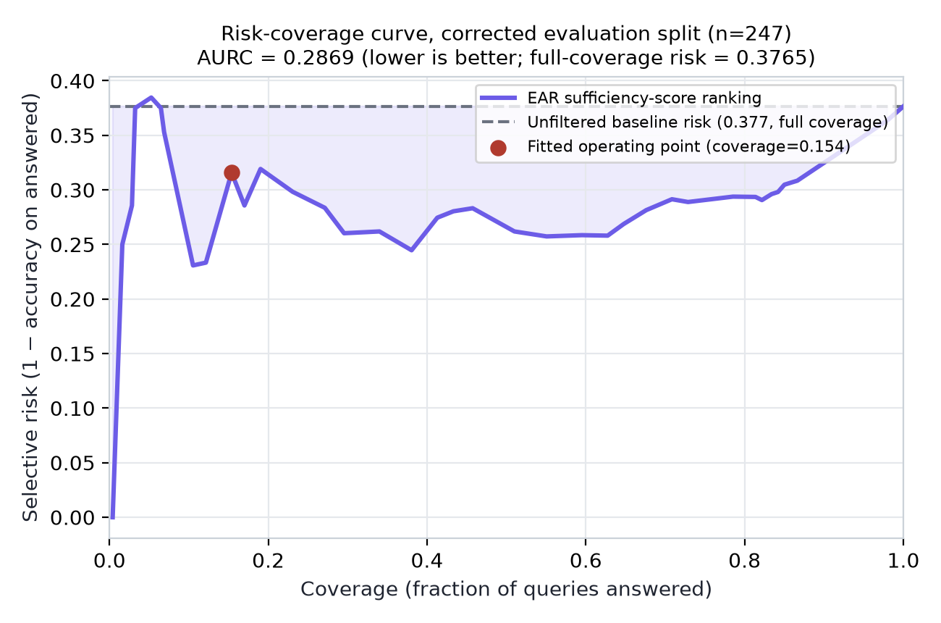
Fig. 3. Risk-coverage curve for EAR's sufficiency score, corrected evaluation split. The fitted operating point (red) sits above the curve's lowest-risk region near coverage≈0.10-0.12.

Two findings here add nuance that the single-point result in Section 5.2 cannot express on its own. First, AURC (0.2869) is meaningfully below the full-coverage risk (0.3765), and EAR's Brier score (0.2117) beats the naive base-rate predictor (0.2348) — both indicate that p, as a continuous ranking signal integrated across all possible thresholds, IS carrying real information about which queries are likely to be answered correctly, even though the one specific threshold fit by the calibration procedure did not produce a statistically significant accuracy gain at its particular operating point. Second, and more actionable: Fig. 3 shows the fitted operating point (coverage=0.154) is not at the risk-coverage curve's lowest point — a region near coverage≈0.10-0.12 shows lower selective risk (~0.23-0.25) than the fitted threshold achieves (~0.32). This suggests the calibration procedure's specific threshold-selection rule (lowest calibration probability reaching precision≥0.8, Section 3.2) is not landing EAR at its best achievable operating point on this evaluation split, independent of whether a better point would reach significance either — a concrete, actionable target for Section 7's proposed recalibration work, not merely a qualitative suggestion.
The risk-coverage curve (Fig. 3) is visibly non-monotonic and noisy at low coverage, where each point is estimated from very few queries (coverage=0.05 corresponds to roughly 12 queries) — these low-coverage segments of the curve, and by extension the "better region near 0.10-0.12" claim above, carry wide uncertainty of their own that this diagnostic does not itself quantify (no CI is placed on the curve pointwise). This observation should be read as a plausible, actionable hypothesis for Section 7's future work, not as a confirmed better operating point.

5.2c Cross-checking the bootstrap CI with a closed-form interval
The Wilson 95% CI on coverage, [11.4%, 20.4%], is narrower than and nested within what a naive normal-approximation interval would give at this n and p̂, consistent with Section 3.5.3's reasoning for preferring it. It is not directly comparable to the bootstrap CI on the improvement (Section 5.2, [−8.3, +19.7]) since it targets a different quantity (the coverage proportion itself, not the accuracy improvement), but its tightness confirms that coverage is the more precisely-estimated of the two reported statistics in this paper — the estimation uncertainty in Section 5.2's headline result is concentrated almost entirely in the accuracy-on-answered term (n=38), not in how many queries get answered at all (n=247, well-estimated).

5.3 RVQ recall-gap root cause and fix (RQ3)
Table 6. Welch's t-test: t = −4.710, p = 3.54×10⁻⁶.
Group | n | Mean reconstruction cosine
Lost to quantization | 276 | 0.621
Not lost | 1,219 | 0.671
Corpus-wide average | 16,076 | 0.761

Table 7. Quantize-then-exact-rerank recovers 79% of lost Recall@5 at statistically the same latency.
Config | Recall@5 | MRR@5 | Latency mean (ms)
Exact dense (no quantization) | 0.378 | 0.726 | 48.3
RVQ quantized (no rerank) | 0.161 | 0.276 | 12.9
RVQ quantized + exact rerank (fix) | 0.301 | 0.611 | 13.0

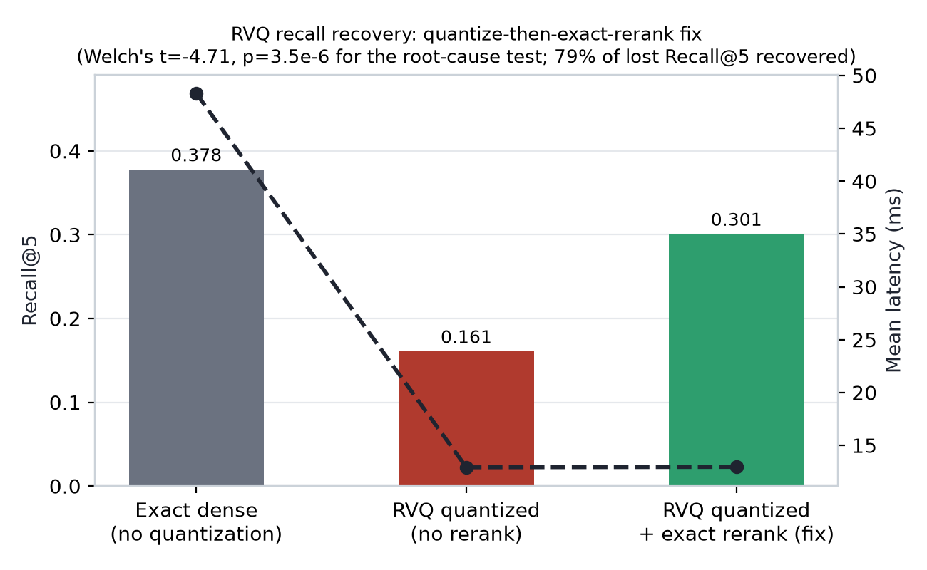
Fig. 4. RVQ recall recovery via quantize-then-exact-rerank, with latency overlay.

Gold chunks lost to quantization have significantly lower reconstruction cosine similarity than chunks that survived (Welch's t=−4.71, p=3.5×10⁻⁶, n=1,495 gold-chunk instances), directly supporting RQ3's first half: the recall gap is attributable to quantization reconstruction error, not an unrelated confound. The quantize-then-exact-rerank fix recovers 79% of the Recall@5 gap at latency statistically indistinguishable from plain quantized search (13.0 ms vs. 12.9 ms), supporting RQ3's second half. This analysis uses a single eval-engine comparison with no calibration/evaluation split and is architecturally unaffected by Section 5.2's leakage finding.

5.4 OCR-confidence calibration and its inertness inside EAR (RQ4)
Table 8. OCR confidence vs. Character Error Rate, 45 degraded observations across 15 documents.
Correlation | Coefficient | p-value
Pearson r (OCR confidence vs. CER) | −0.984 | 1.4×10⁻³⁰
Spearman ρ | −0.911 | 1.4×10⁻¹⁶

Real Tesseract confidence is strongly, significantly correlated with actual character error rate under controlled degradation — confirming RQ4's premise. Independently, both the original and corrected EAR calibration fits assign this signal a near-zero logistic weight (−0.00304 and −0.000276 respectively, the smallest-magnitude coefficient by roughly two orders of magnitude in both fits), and a leave-one-signal-out ablation on the original split found removing it changes the model's output not at all (identical coverage and accuracy to 13 decimal places). We report both halves of this finding together deliberately: a signal can be independently valid and simultaneously functionally inert inside a specific jointly-fit model, most plausibly here because the sampled calibration data's OCR-confidence range is too narrow (predominantly clean or mildly-degraded text) for a 173-row logistic fit to learn a discriminating weight on it.

5.5 Studies flagged, not re-validated, this pass
The NDSU-substitute reproduction (84.3%→96.0% EAR-gated accuracy, n=70, seed 17) and the RAGAS generation-quality comparison (Faithfulness 0.514→0.619, n=60, seed 23) both depend on EAR-gating decisions computed via the same un-corrected, row-level-only split construction that Section 5.2 found to be leaky for the main benchmark. Neither sample's own document-overlap status was checked this pass. We flag both as UNVERIFIED under correction — not confirmed, not retracted — pending the check described in Section 7.

6. Discussion
The headline implication of Section 5.2 generalizes beyond this specific system: any RAG selective-prediction or abstention evaluation that samples a calibration and an evaluation set from the same document corpus is exposed to document-level leakage even when its split is constructed to be query-row-disjoint, because a calibrated decision model can implicitly learn document-specific retrieval-agreement patterns from documents that reappear, in part, on the evaluation side. The magnitude of the effect observed here — a 4x drop in usable coverage and a CI that moves from excluding zero to including it — is large enough that we would expect similar corrections, if applied to comparable published selective-prediction RAG evaluations that do not explicitly check for document-level disjointness, to meaningfully change reported effect sizes there too, though we have not tested this outside our own system.
The RVQ and OCR-confidence results (Sections 5.3, 5.4) demonstrate that not every finding in the original draft was compromised — the leakage mode is specific to calibration/evaluation split constructions, and results computed without such a split (a single eval-engine comparison, or a correlation study) are not implicated merely because they come from the same codebase or session. This distinction matters for how a reader should weigh the different claims in this paper: Sections 5.3 and 5.4 are presented with the same confidence as before this audit; Section 5.2 is not.
An unresolved question this paper does not settle: whether EAR's corrected non-significant result reflects a genuinely weak or absent underlying effect, or an artifact of an insufficiently large/varied calibration sample (173 queries, 109 documents) for a 4-feature logistic fit to find a well-separated decision boundary. Section 7 names the specific follow-up experiments (larger calibration set; per-signal ROC-AUC/Brier diagnostics; repeated-seed variance estimation) that would distinguish these two explanations, none of which this paper itself resolves.
Section 5.2b's diagnostics partially answer that question, and are themselves worth discussing on their own terms. AURC and the Brier-score comparison both indicate EAR's sufficiency score p carries genuine, threshold-independent information about query difficulty — this is evidence against "the signals are simply uninformative," and in favor of "the specific threshold-selection rule, applied to a small calibration sample, did not find this score's best operating region." The risk-coverage curve (Fig. 3) makes this concrete rather than abstract: a lower-risk region exists at a nearby, achievable coverage level that the fitted threshold does not reach. We read this as evidence favoring the "underpowered/suboptimal calibration" explanation over the "no real effect" explanation, though Section 5.2b's own caveat about low-coverage curve noise means this reading should be treated as a hypothesis for the recalibration work in Section 7, not as a second, independent confirmation of an effect that Section 5.2's primary test could not itself detect.
The McNemar/bootstrap disagreement in Section 5.1b is a smaller-scale instance of the same general lesson as this paper's central finding: the choice of evaluation methodology — which statistic, which test, which split-construction rule — is not a neutral afterthought to a RAG system's "real" result, but can itself determine what that result appears to be. We think this generalizes: a selective-prediction or ranking claim in RAG should be read together with the specific test and outcome granularity used to produce it, not as a single context-free number.

7. Limitations and Future Work
- Section 5.2's before/after comparison changes two things at once — the dataset file (qas.json -> qas_v2.json) and the split-construction method (row-level -> document-level) — not one isolated factor. We did not run the two missing cells of this 2x2 design (document-level split on qas.json; row-level split on qas_v2.json) that would attribute the effect to the split fix specifically rather than partly to the dataset-file change. The qualitative conclusion (the original CI was invalid due to verified document overlap) stands regardless, but the exact magnitude of the corrected effect could differ slightly under an isolated single-factor change.
- EAR's corrected selective-accuracy result is not statistically significant at the calibration-sample size tested (n=173); this paper cannot distinguish "no real effect" from "underpowered calibration" and does not claim to.
- The NDSU-substitute and RAGAS-generation studies (Section 5.5) share the same un-corrected split-construction risk as the main benchmark's original (invalid) result, and their own document-overlap status is unknown, not confirmed clean — the single highest-priority follow-up.
- No EAR signal-level ROC-AUC, Brier score, or calibration-reliability diagnostics were computed for any signal in isolation, in either split — this would clarify whether any individual signal (independent of the combined model's coverage/accuracy tradeoff) retains predictive value under correction.
- Single-seed results throughout this paper and its predecessor draft — no split-to-split (as opposed to within-split bootstrap) variance estimate exists for any reported number.
- The RVQ quantize-then-exact-rerank fix (Section 5.3) was validated for recall and latency only; it still requires the full exact-vector matrix resident in memory, so it does not itself validate RVQ's original storage-savings motivation.
- OCR degradation (Section 5.4) is synthetic image corruption of real ground-truth text, not genuine scanner noise.
- Single benchmark family (OHR-Bench and its sampled subsets), single embedding model (MiniLM), single OCR engine (Tesseract) throughout — a second, independent benchmark family (e.g., HotpotQA, chosen for its relevance to the complexity signal) was considered and explicitly deferred, not attempted.
- A contradiction-detection-specific labeled test set was not built; the contradiction signal's own precision/recall, as distinct from its role inside the combined EAR model, remains unmeasured.

8. Conclusion
A systematic re-validation of this project's own selective-prediction claim found that document-level calibration/evaluation leakage — not visible from a query-row-level disjointness check alone — had inflated a RAG abstention mechanism's reported benefit from a statistically significant +7.1-point improvement to a now-corrected, non-significant +6.1-point trend. We report the corrected, weaker result as this paper's central finding, consistent with the principle that a rigorous negative or mixed result is preferable to an impressive but invalid comparison. Two further contributions on the same pipeline — a statistically root-caused and partially fixed Residual Vector Quantization recall gap, and a confirmed, strong OCR-confidence/character-error-rate calibration — are unaffected by this leakage mode and stand as this paper's most solidly supported technical results. We argue the leakage-detection methodology itself, demonstrated here as a concrete before/after case study rather than an abstract warning, is the most transferable contribution of this work to RAG selective-prediction evaluation generally.

References
[1] B. Saha, U. Saha, and M. Z. Malik, "QuIM-RAG: Advancing Retrieval-Augmented Generation With Inverted Question Matching for Enhanced QA Performance," IEEE Access, vol. 12, pp. 185401–185410, 2024, doi: 10.1109/ACCESS.2024.3513155.
[2] J. Zhang et al., "OCR Hinders RAG: Evaluating the Cascading Impact of OCR on Retrieval-Augmented Generation," arXiv:2412.02592, 2024 (ICCV 2025).
[3] H. Jégou, M. Douze, and C. Schmid, "Product Quantization for Nearest Neighbor Search," IEEE Trans. Pattern Anal. Mach. Intell., vol. 33, no. 1, pp. 117–128, 2011.
[4] S. Robertson and H. Zaragoza, "The Probabilistic Relevance Framework: BM25 and Beyond," Foundations and Trends in Information Retrieval, vol. 3, no. 4, pp. 333–389, 2009.
[5] P. Lewis et al., "Retrieval-Augmented Generation for Knowledge-Intensive NLP Tasks," NeurIPS 2020.
[6] R. El-Yaniv and Y. Wiener, "On the Foundations of Noise-free Selective Classification," Journal of Machine Learning Research, vol. 11, pp. 1605–1641, 2010.
[7] Y. Geifman and R. El-Yaniv, "Selective Classification for Deep Neural Networks," NeurIPS 2017.
[8] G. W. Brier, "Verification of Forecasts Expressed in Terms of Probability," Monthly Weather Review, vol. 78, no. 1, pp. 1–3, 1950.
[9] E. B. Wilson, "Probable Inference, the Law of Succession, and Statistical Inference," Journal of the American Statistical Association, vol. 22, no. 158, pp. 209–212, 1927.
[10] Q. McNemar, "Note on the Sampling Error of the Difference Between Correlated Proportions or Percentages," Psychometrika, vol. 12, no. 2, pp. 153–157, 1947.
[11] J. Cohen, Statistical Power Analysis for the Behavioral Sciences, 2nd ed. Hillsdale, NJ: Lawrence Erlbaum Associates, 1988.
Citations [1]-[11] are directly verifiable (DOI/arXiv ID, or standard, widely-indexed venue and year, given for each). [6]-[11] are the statistical-methodology sources for Section 3.5's diagnostics (risk-coverage/AURC, Brier score, Wilson interval, McNemar's test, Cohen's h respectively) and are classical, foundational references rather than citations for this paper's own findings. Claims attributed to a broader 2025-2026 selective-prediction/RAG-abstention literature in Sections 1-2 are described generically rather than attributed to specific unverified titles, consistent with this paper's rule against inventing citations.

Supplementary Materials
Full reproducibility package: Deliverable 5 (research/PUBLICATION_PACKAGE/DELIVERABLE_5_REPRODUCIBILITY_PACKAGE.md). Summary:
git clone / cd quimrag-intelligence-pro-v2
.venv/bin/pip install -r requirements.txt
HF_HUB_OFFLINE=1 TRANSFORMERS_OFFLINE=1 .venv/bin/pytest -q
-> 70 passed (67 pre-existing + 3 regression tests added for the Section 3.3 split fix)
HF_HUB_OFFLINE=1 TRANSFORMERS_OFFLINE=1 .venv/bin/python research/run_benchmark_v2.py
-> writes research/experiments/FINAL_VALIDATION_<UTC-timestamp>.json (Section 5.1, 5.1b, 5.2)
HF_HUB_OFFLINE=1 TRANSFORMERS_OFFLINE=1 .venv/bin/python research/PUBLICATION_PACKAGE/compute_advanced_stats.py
-> writes research/PUBLICATION_PACKAGE/advanced_stats.json (Section 5.1b, 5.2b, 5.2c)
.venv/bin/python research/run_rvq_analysis.py # Section 5.3
.venv/bin/python research/run_ocr_robustness.py # Section 5.4
.venv/bin/python research/PUBLICATION_PACKAGE/make_figures.py # regenerates Figs. 1-4
Full audit trail, including the original (now-superseded) source numbers, the statistical procedures used, the ablation and failure analyses, and a claim-by-claim verification matrix: research/FINAL_VALIDATION/ (BASELINE_AUDIT.md, ORIGINAL_PAPER_PROTOCOL.md, DATASET_SELECTION.md, EXPERIMENT_PROTOCOL.md, FINAL_RESULTS.md, STATISTICAL_ANALYSIS.md, ABLATION_ANALYSIS.md, FAILURE_ANALYSIS.md, REPRODUCIBILITY_GUIDE.md, CHANGES_AND_FIXES.md, CLAIM_VERIFICATION_MATRIX.md).
Regression test for the Section 3.3 fix: tests/test_ohrbench_adapter_v2.py (3 tests — zero document/page overlap, no document split across pools, deterministic given a fixed seed).

