AI ASSISTED CODING
NAME: M.Naga Chaitanya
ROLL NO: 2303A52458
BATCH: 40
ASSIGNMENT: 12.2
A national disaster management authority wants to develop a Smart Disaster Relief Resource Management System to efficiently manage relief camps, victims, and resource distribution during natural disasters such as floods or earthquakes. You are required to design and
implement a Python application using object-oriented programming (classes and constructors), loops, conditional statements, file handling, and basic data analysis.
The system should manage multiple relief camps. Each camp has a camp ID, location, maximum capacity, available food packets, medical kits, and volunteers. When a disaster victim arrives, the system should register the victim by storing details such as victim ID, name, age, health condition (normal/critical), and assigned camp. The system must automatically check camp capacity before assigning a victim. If the camp is full, it should display an appropriate message.
The program should also allow distribution of food and medical kits to victims. If a victim is marked as “critical,” the system should prioritize medical kit allocation. Resource quantities must be updated automatically after distribution.
All camp details and victim records must be stored permanently in files. The administrator should be able to perform operations repeatedly such as adding a new camp, registering
victims, distributing resources, viewing records, searching for a victim by ID, and generating reports.The final analytical report should display:
Total number of camps Total victims registered
Camp with highest occupancy Total food packets distributed Total medical kits distributed Number of critical victims

Python code using flask:
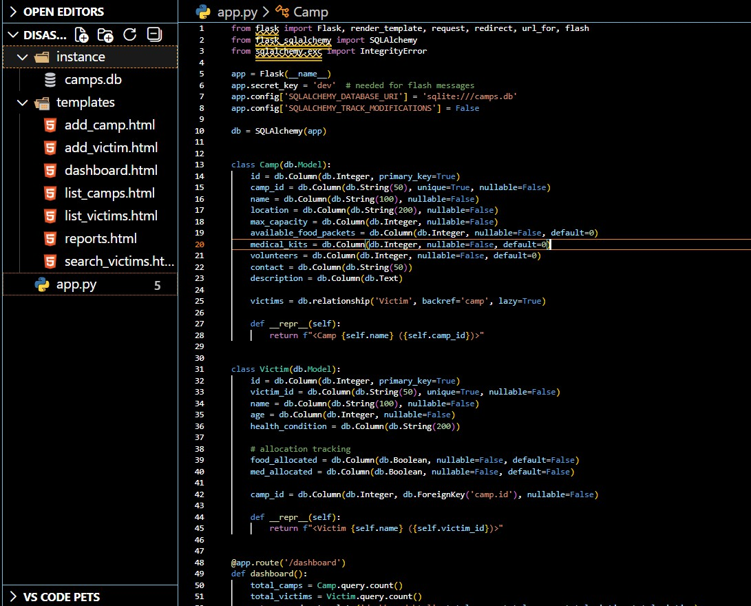

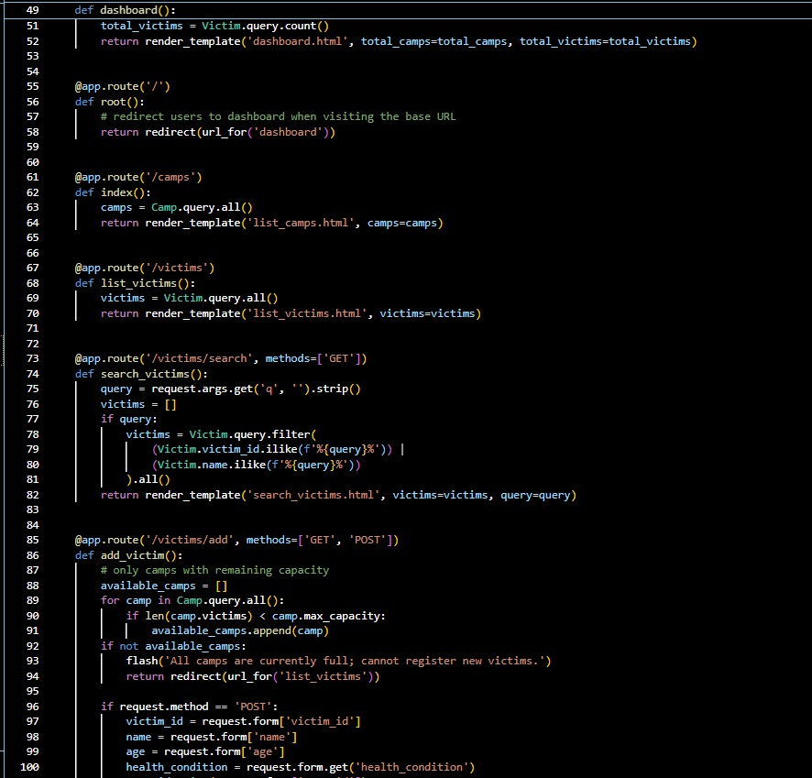

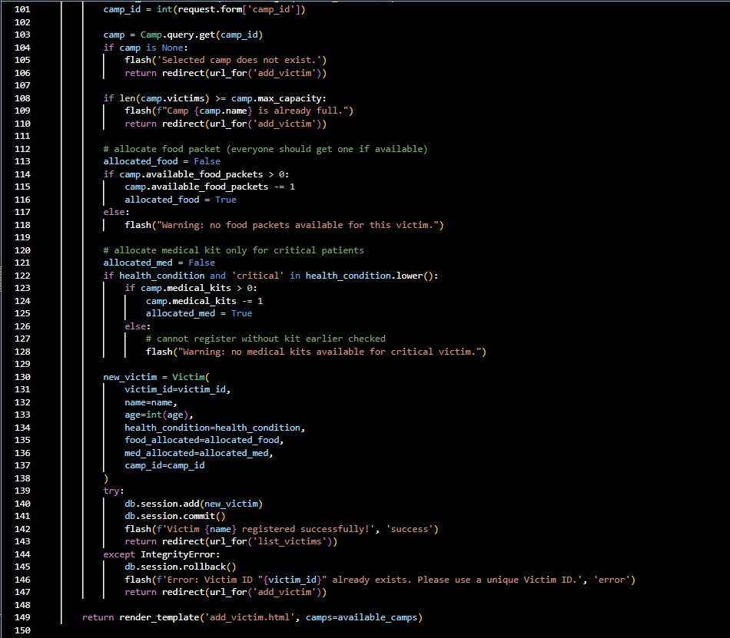

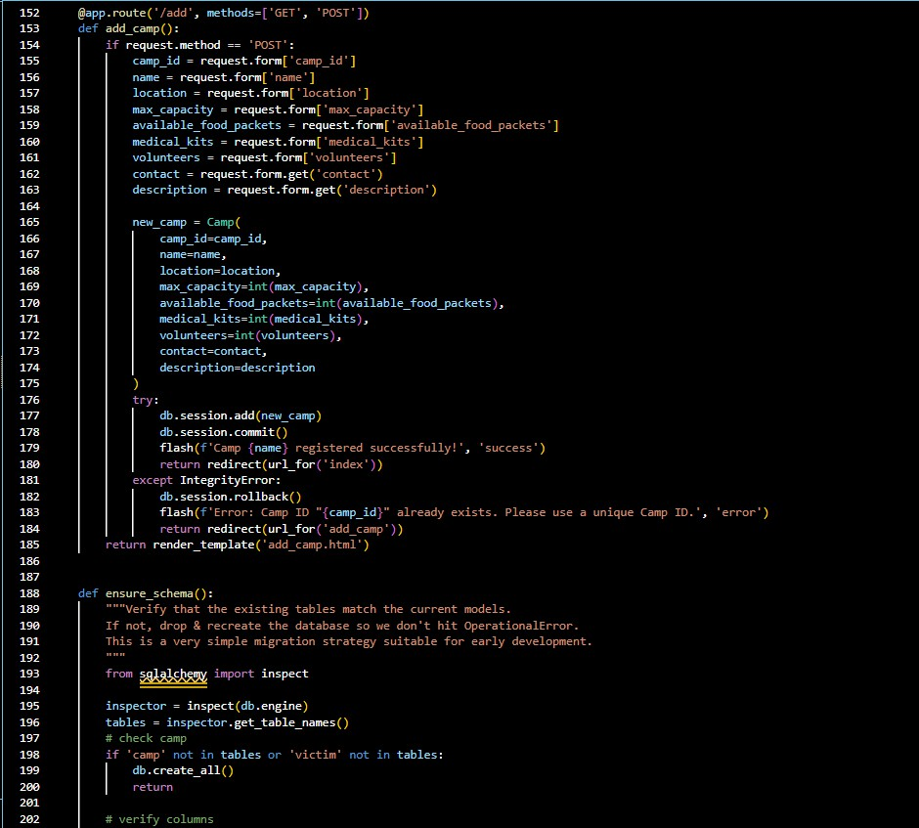

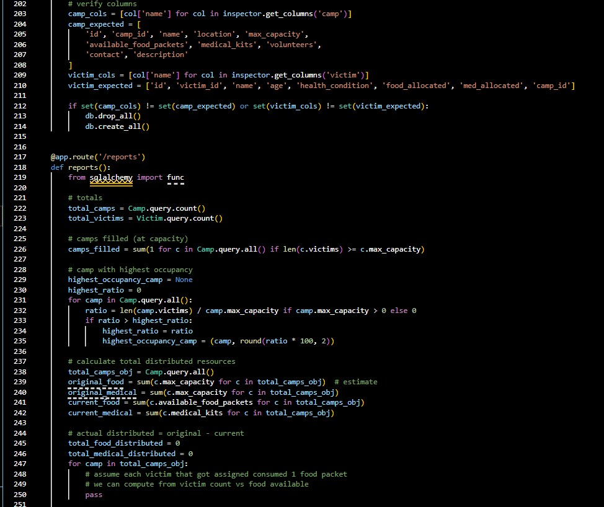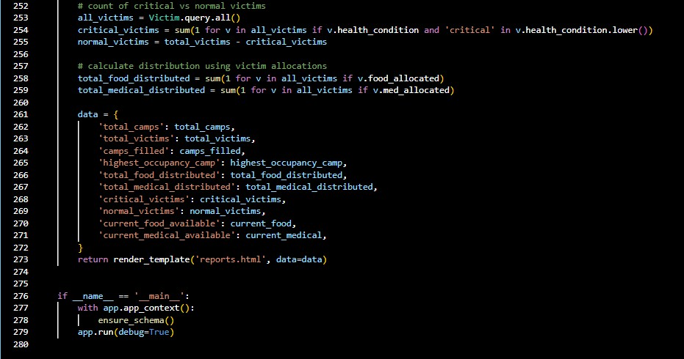

Application Interface: Dashboard
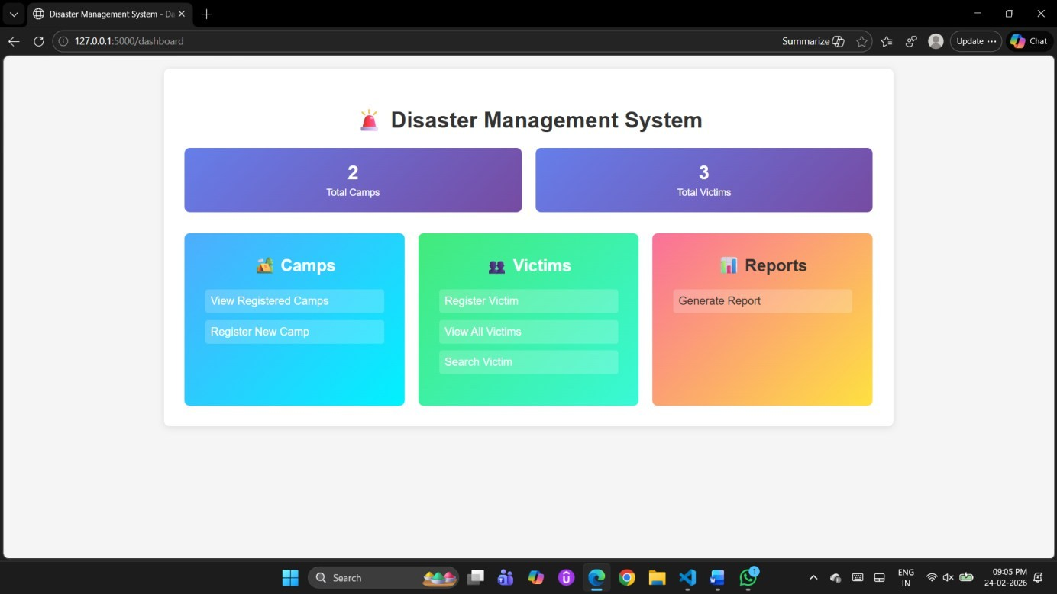
Registered camps:
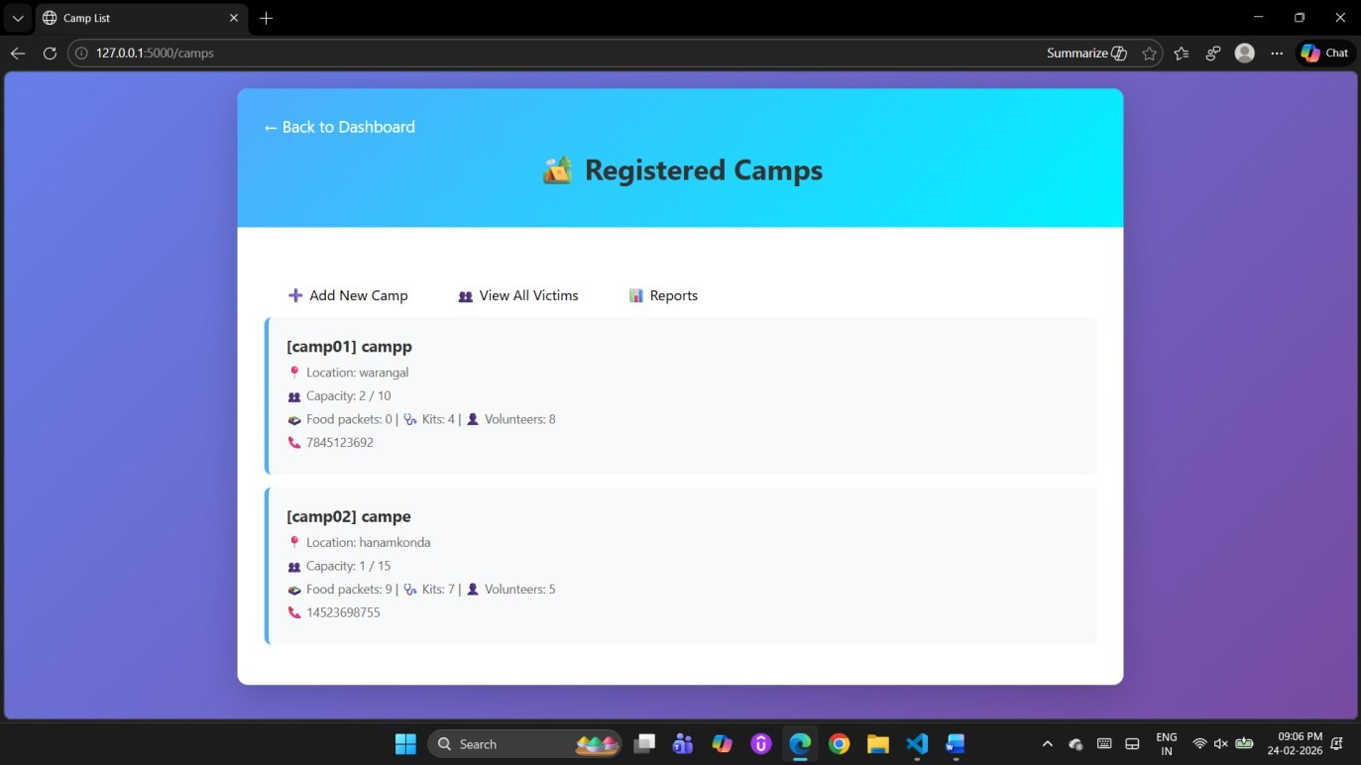

Registered victims
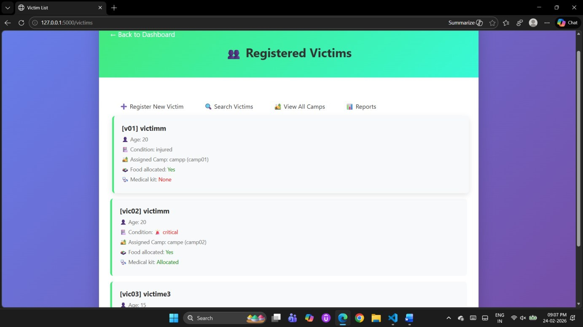
Search victims
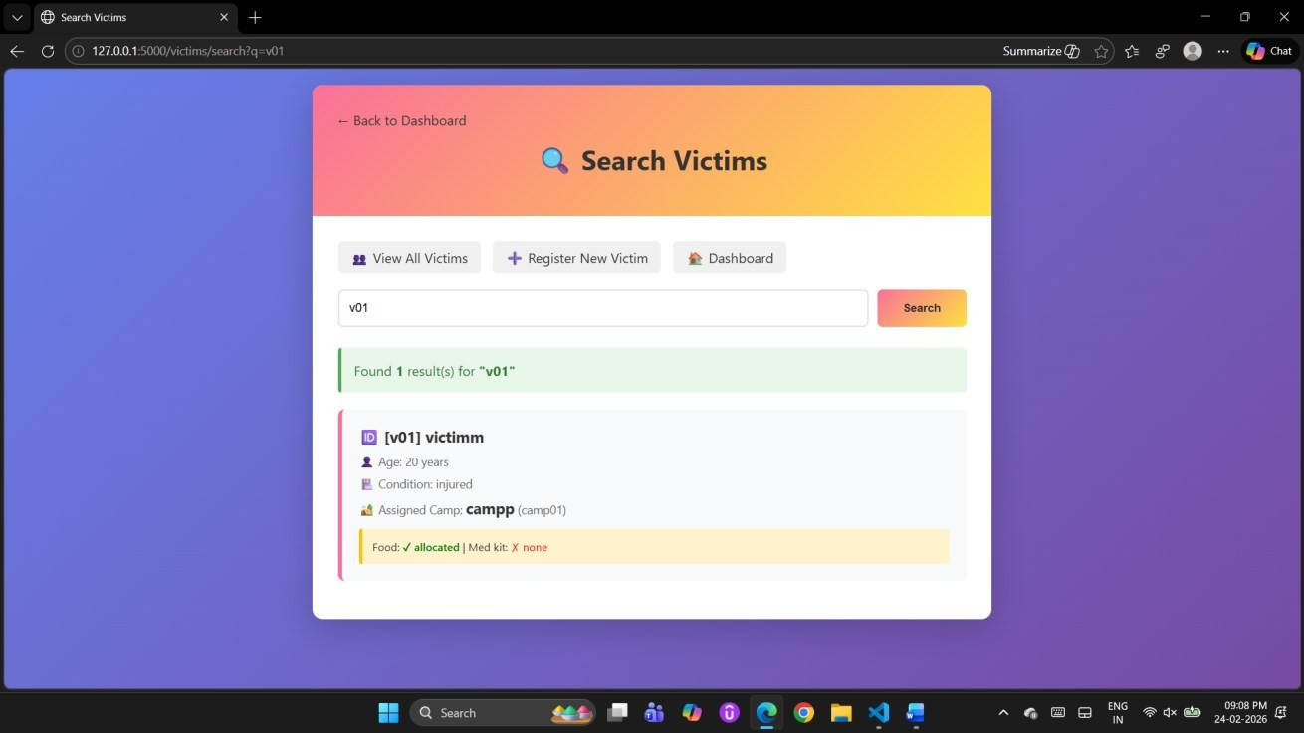
Report:

