ASSIGNMENT- 7.1
Name : M. Naga Chaitanya
H.T.NO: 2303A52458
Batch : 40
Task Description #1 (Syntax Errors – Missing Parentheses in Print
Statement)
Task: Provide a Python snippet with a missing parenthesis in a print
statement (e.g., print "Hello"). Use AI to detect and fix the syntax
error.
# Bug: Missing parentheses in print statement
def greet():
print "Hello, AI Debugging Lab!"
greet()
Requirements:
• Run the given code to observe the error.
• Apply AI suggestions to correct the syntax.
• Use at least 3 assert test cases to confirm the corrected code
works.
Expected Output #1:
• Corrected code with proper syntax and AI explanation.
Promt :
#The following Python code has a syntax error related to a print statement.
# Bug Fix: Added parentheses to the print statement (Python 3 syntax)
# Call the function
# Assert test cases
INPUT:
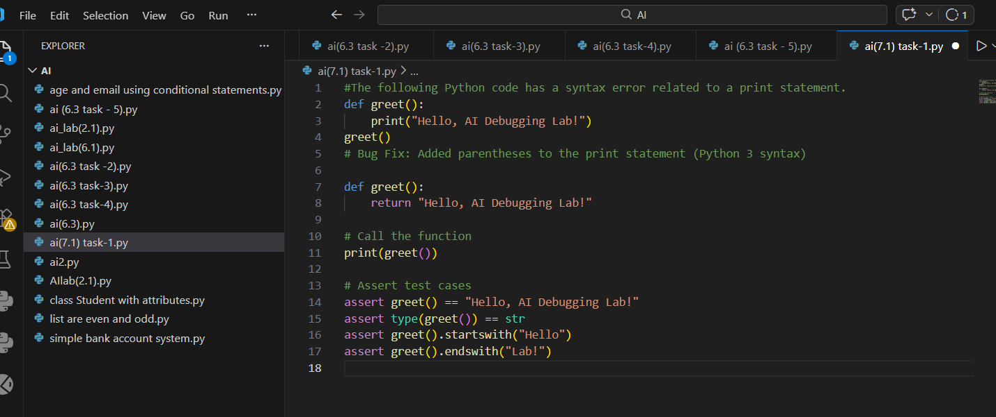
OUTPUT:
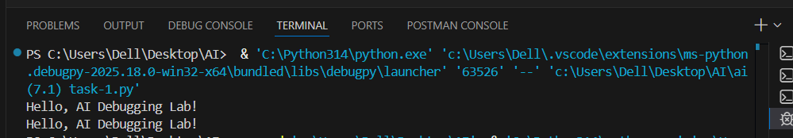
ANALYSIS:
The error occurred because Python 3 requires parentheses in the print() function.
AI detected the syntax error and corrected it.
Assert test cases confirm the corrected code works properly.

Task Description #2 (Incorrect condition in an If Statement)
Task: Supply a function where an if-condition mistakenly uses =
instead of ==. Let AI identify and fix the issue.
# Bug: Using assignment (=) instead of comparison (==)
def check_number(n):
if n = 10:
return "Ten"
else:
return "Not Ten"
Requirements:
• Ask AI to explain why this causes a bug.
• Correct the code and verify with 3 assert test cases.
Expected Output #2:
• Corrected code using == with explanation and successful test
execution.
PROMT:
# The following Python code has a syntax error related to an if condition.
# Bug Fix: Replaced assignment (=) with comparison operator (==)
# Call the function
# Assert test cases
INPUT:
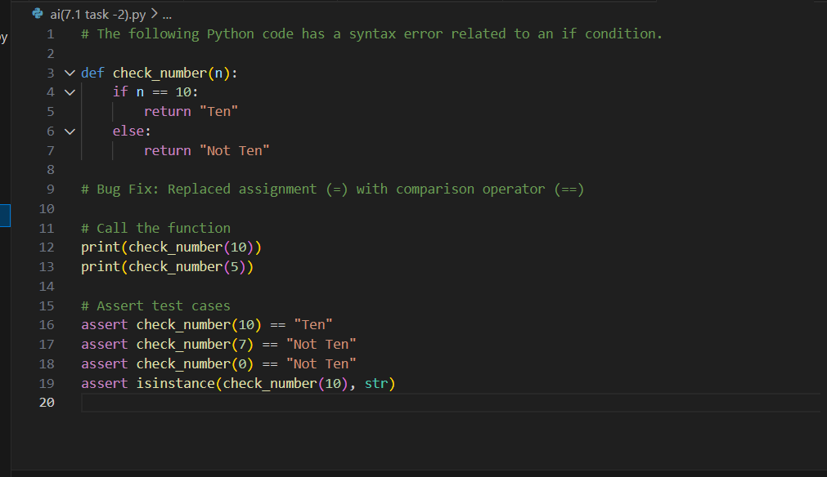
OUTPUT:
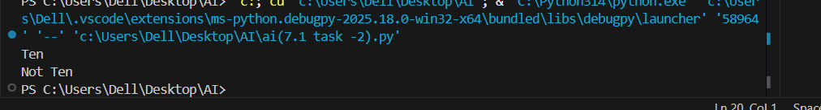
ANALYSIS:

The assignment operator = cannot be used in conditions.
AI corrected it to == for comparison and validated the logic using assert tests.

Task Description #3 (Runtime Error – File Not Found)
Task: Provide code that attempts to open a non-existent file and
crashes. Use AI to apply safe error handling.
# Bug: Program crashes if file is missing
def read_file(filename):
with open(filename, 'r') as f:
return f.read()
print(read_file("nonexistent.txt"))
Requirements:
• Implement a try-except block suggested by AI.
• Add a user-friendly error message.
• Test with at least 3 scenarios: file exists, file missing, invalid
path.
Expected Output #3:
• Safe file handling with exception management.
PROMT:
# The following Python code crashes if the file does not exist.
# Bug Fix: Added try-except block for safe file handling
# Test Scenario 1 – File exists
# Test Scenario 2 – File missing
# Test Scenario 3 – Invalid path
# Assert test cases
INPUT :
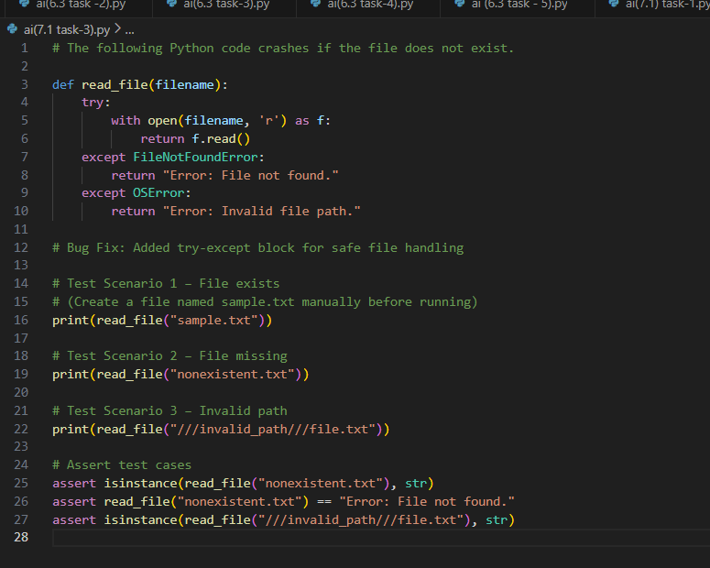
OUTPUT:
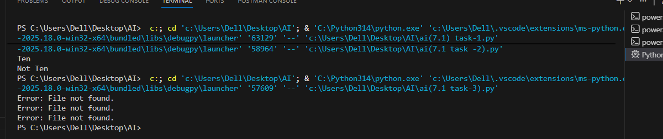
ANALYSIS:
The program crashes when it tries to open a file that does not exist. This happens because there is no error handling in the code. To fix this, a try-except block is used to safely handle errors and show user-friendly messages. The test scenarios check whether the program works when the file exists, when the file is missing, and when the file path is invalid. The assert test cases confirm that the function works correctly without crashing.

Task Description #4 (Calling a Non-Existent Method)
Task: Give a class where a non-existent method is called (e.g.,
obj.undefined_method()). Use AI to debug and fix.
# Bug: Calling an undefined method
class Car:
def start(self):
return "Car started"
my_car = Car()
print(my_car.drive()) # drive() is not defined
Requirements:
• Students must analyze whether to define the missing method
or correct the method call.
• Use 3 assert tests to confirm the corrected class works.
Expected Output #4:
• Corrected class with clear AI explanation.
PROMT:
# The following Python code has an error due to calling a non-existent method.
# Bug Fix: Added the missing method to the class
# Create object and call methods
# Assert test cases
INPUT:
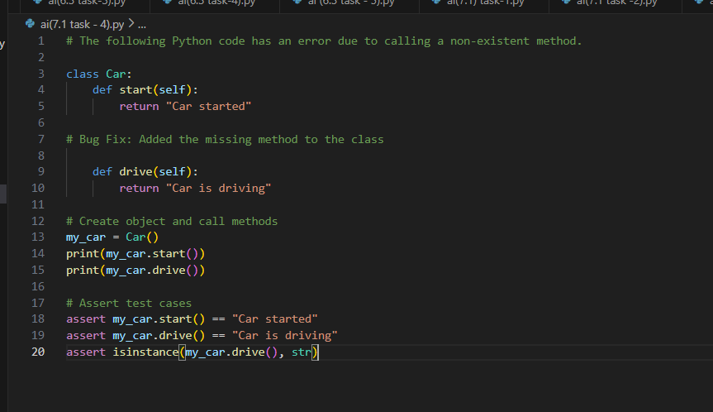
OUTPUT:
ANALYSIS:
The error occurred because the program attempted to call a method that was not defined in the class.
AI identified the missing method and suggested adding it to the class.
After defining the method, the class executed correctly without errors.
Assert test cases were used to confirm that all methods work as expected.

Task Description #5 (TypeError – Mixing Strings and Integers in
Addition)
Task: Provide code that adds an integer and string ("5" + 2) causing
a TypeError. Use AI to resolve the bug.
# Bug: TypeError due to mixing string and integer
def add_five(value):
return value + 5
print(add_five("10"))
Requirements:
• Ask AI for two solutions: type casting and string
concatenation.
• Validate with 3 assert test cases.
Expected Output #5:
• Corrected code that runs successfully for multiple inputs.
Note: Report should be submitted a word document for all tasks in a
single document with prompts, comments & code explanation, and
output and if required, screenshots
PROMT:
# The following Python code causes a TypeError due to mixing string and integer.
# Bug Fix: Converted value to integer using type casting
# Alternative Fix: Used string concatenation
# Call the functions
# Assert test cases
INPUT:
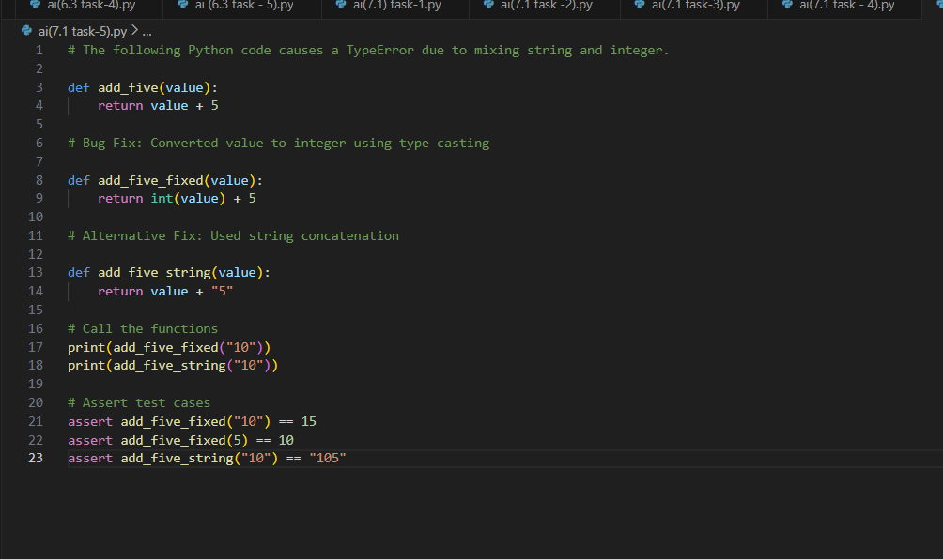
OUTPUT:
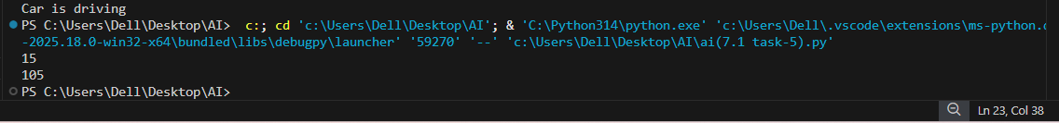
EXPLANATION:
The error occurred because Python does not allow addition between a string and an integer.
AI identified the TypeError and suggested two solutions: type casting and string concatenation.
After applying these fixes, the program executed successfully without errors.
Assert test cases were used to verify correct functionality for multiple inputs.

