Written Report

Morris Anthony

WEB322NBB

Date:12/11/2020

Heroku App : https://still-reef-54301.herokuapp.com/

My application covers all of the requirements listed in the assignment completely. The app shows the homepage as the first page which has a set of cards for information and promotion.

The navbar includes links to navigate to the other pages of the site which include:

a: The Listing Page – Has all the listings for the rooms without the booking tab( the booking tab only activates when users are logged in)

b) The Registration Page – Has the form for allowing users to login. Logging creates an entry in the database which is used throughout the website for reference

c) The Login Page- Allows registered users to login post validation. Users are led to their respective dashboard depending on whether they are admins or not.

The Bookings page allows logged in users to click on the login tab and book rooms. Once the users click on the booking button , the users are taken to the room details page which lets them choose check-in and checkout dates. Once the check-in checkout dates are selected, the users are then taken the checkout page which has the calculation for their total price.

I used bootstrap and handlebars to render pages. My assignment part 1 and 2 were entirely on vanilla JS and moved everything to Bootstrap and handlebars which took a considerable amount of time. I have a User.JS file which has the schemas for the rooms and the users and this file also contains all of the functions that are called in the server.js for the get and post routes.

The most difficult part of the assignment was getting and using data from the database and rendering it correctly on the database. Additionally the calculation for the room total took a lot of research. Overall I learnt a lot from the assignment about making a complete web application. Please refer to my screenshots posted below for each page.

Home Page:



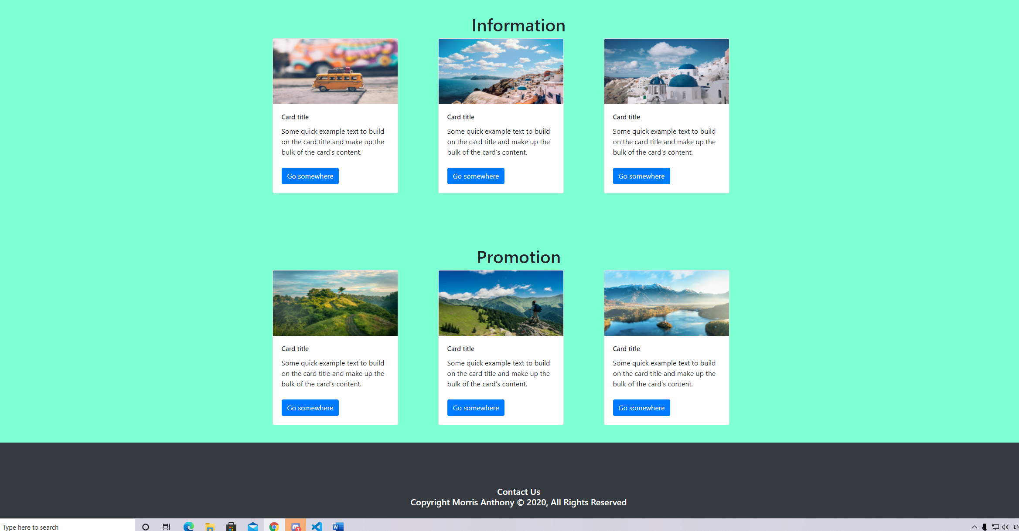

Room Listings with search tab for locations

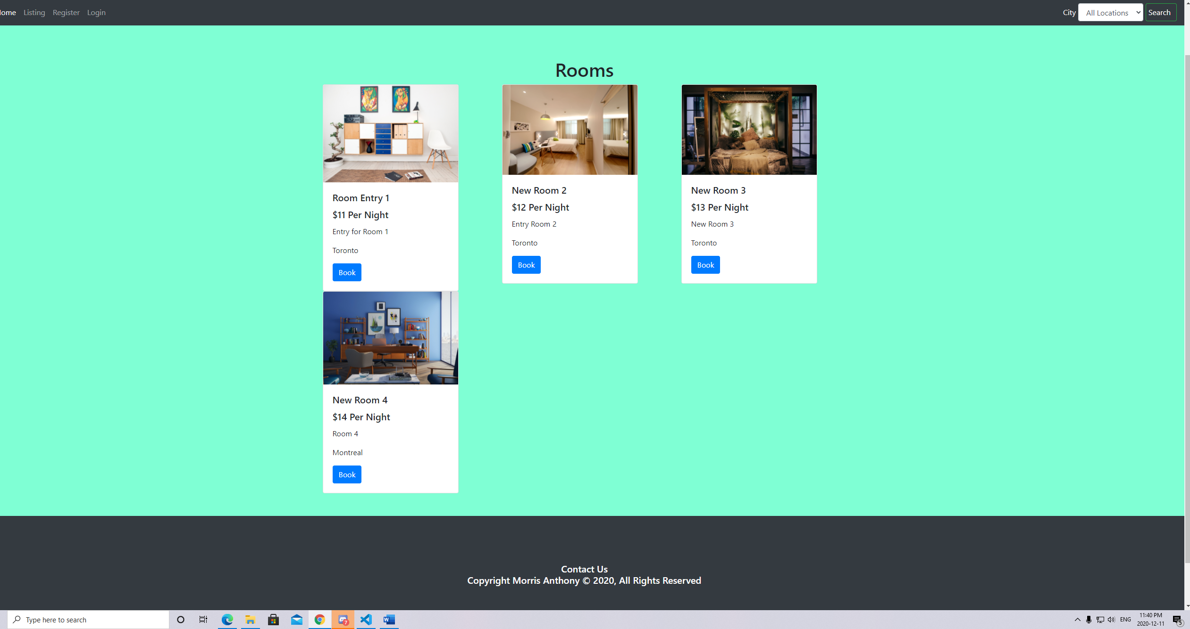

Room listings when Montreal is selected as a city

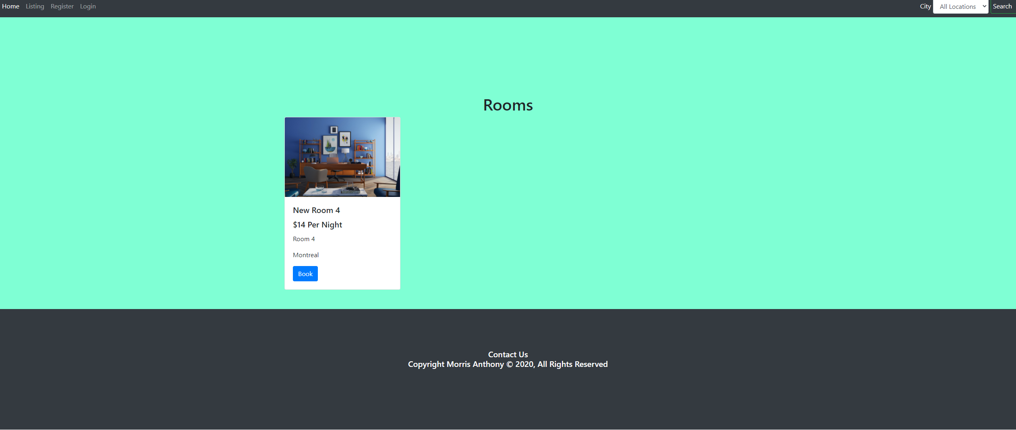

Registration Page



Login Page

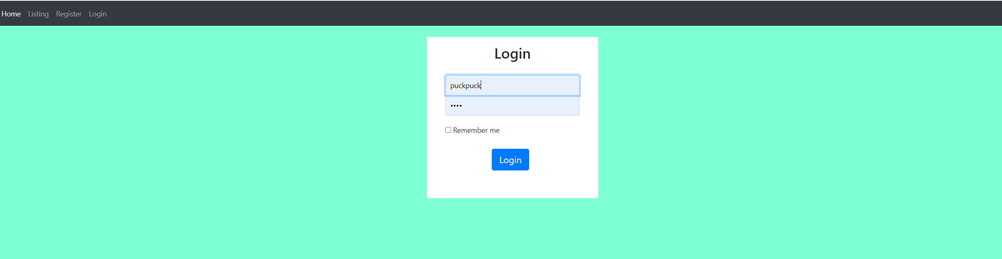

Admin Dashboard with update , delete and add room functionalities

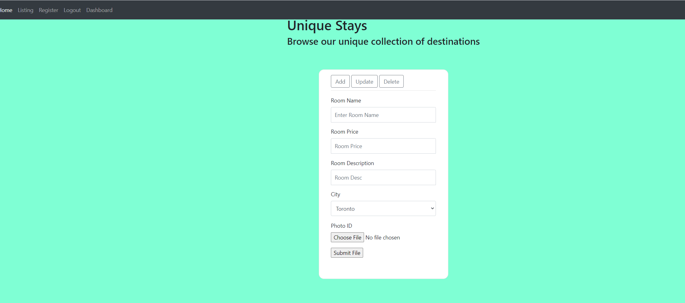

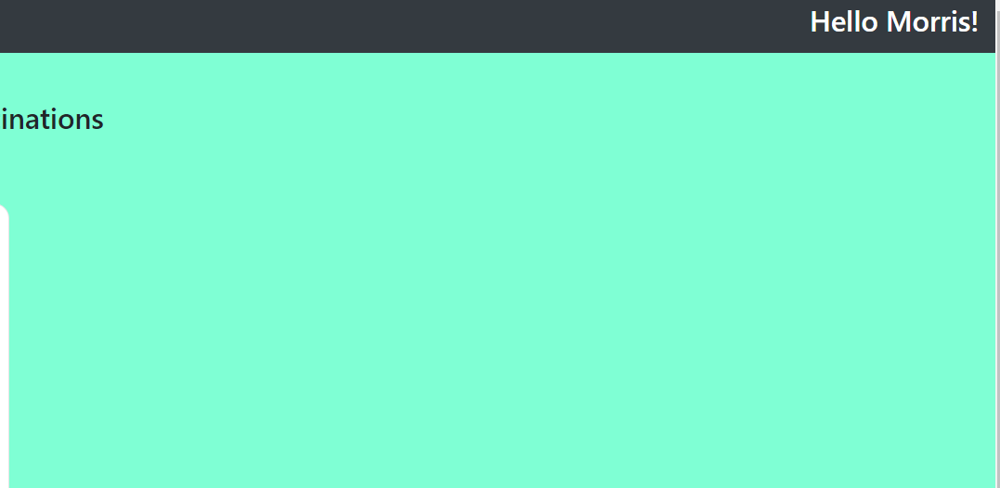

User Dashboard with username

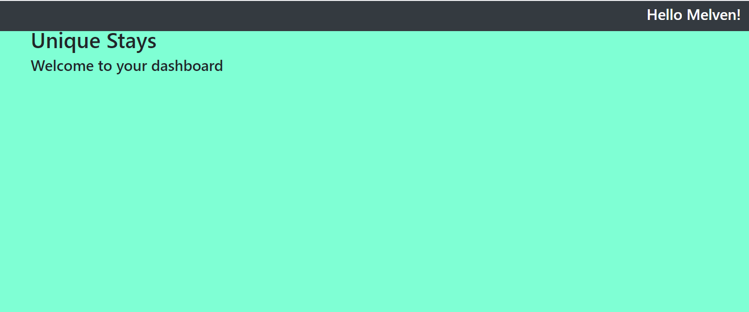

Book buttons activated for logged in user

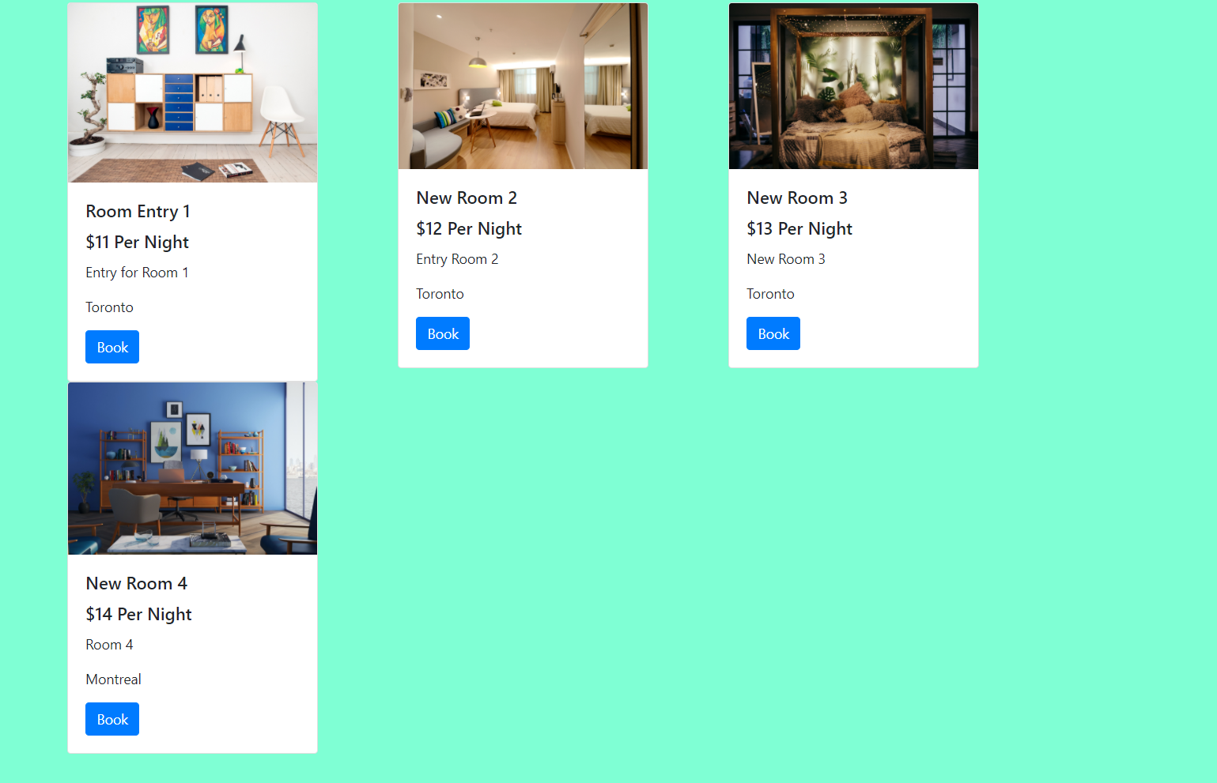

Room details page with check-in details

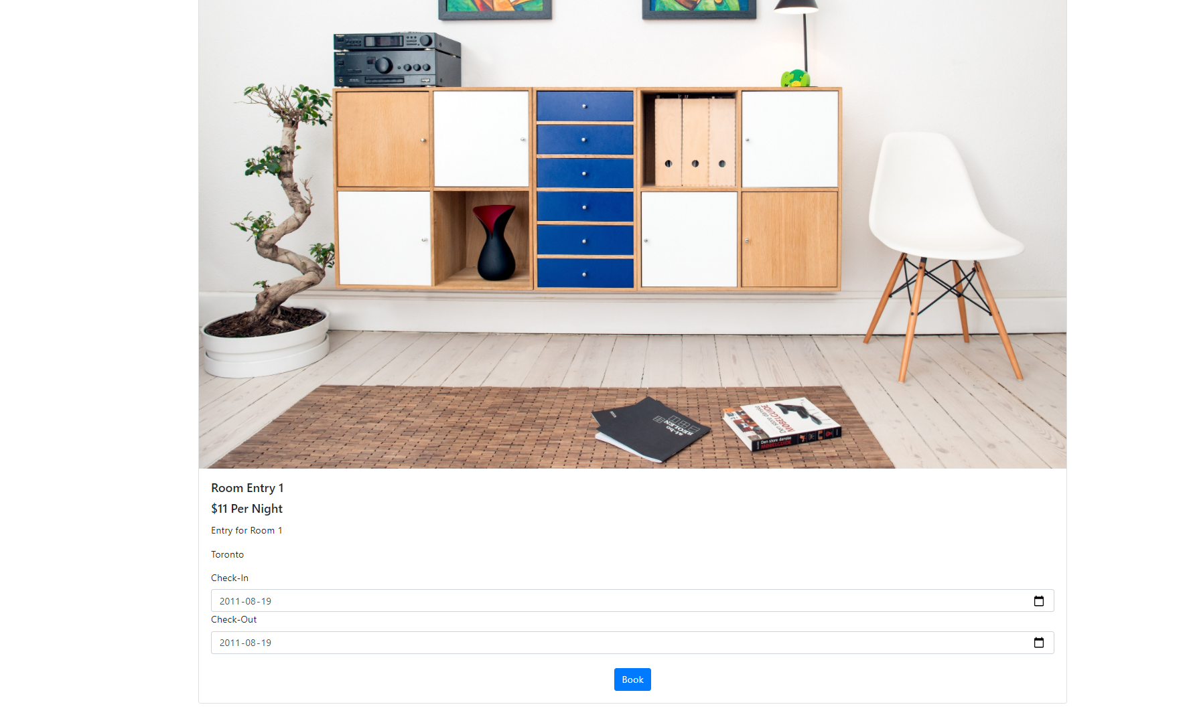

Checkout details with total price

