AN IDP PROJECT REPORT

on

**“ALUMNI MANAGENMENT SYSTEM”**

**Submitted**

**By**

|  |  |
| --- | --- |
| 211FA04334  Vamsi  221FA04182  Asritha | 221FA04084  Pranitha  221FA04546  Gnanesh |

*Under the guidance of*

***Mr. Pavan Kumar***

*Associate Professor*



**SCHOOL OF COMPUTING & INFORMATICS**

**DEPARTMENT OF COMPUTER SCIENCE & ENGINEERING**

**VIGNAN'S FOUNDATION FOR SCIENCE, TECHNOLOGY AND RESEARCH Deemed to be UNIVERSITY**

**Vadlamudi, Guntur.**

**ANDHRA PRADESH, INDIA, PIN-522213.**



**CERTIFICATE**

This is to certify that the Field Project entitled **“Alumni management system”** that is being submitted by 211FA04334 (Vamsi), 221FA04084(Pranitha), 221FA04182(Asritha) and 221FA04546(Gnanesh) for partial fulfilment of Field Project is a bonafide work carried out under the supervision of Mr. Pavan Kumar, Department of CSE**.**

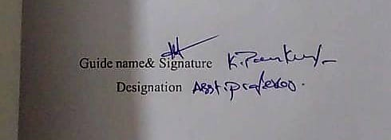 

HOD, CSE



**DECLARATION**

We hereby declare that the Field Project entitled “**Alumni Management System”** that is being submitted by 211FA04334 (Vamsi), 221FA04084(Pranitha), 221FA04182(Asritha) and 221FA04546(Gnanesh) in partial fulfilment of Field Project course work. This is our original work, and this project has not formed the basis for the award of any degree. We have worked under the supervision of Mr. Pavankumar, Department of CSE.

By

**211FA04334 (Vamsi),**

**221FA04084(Pranitha),**

**221FA04182(Asritha),**

**221FA04546(Gnanesh)**

**Abstract**

The Alumni Management System is a web-based platform designed to foster communication and engagement between alumni and the institution. It provides features such as discussion forums, job postings, event management, and alumni profile displays. The system ensures that alumni can stay connected with the college and contribute to its growth. Users can register, log in, and access information seamlessly. Event details and job postings are dynamically updated, allowing students to explore opportunities. A secure authentication system verifies user credentials and enables password management. The gallery feature showcases event highlights. The system is designed using modern web technologies for efficiency and scalability. This platform strengthens alumni networking, enhances information sharing, and promotes institutional development.

**TABLE OF CONTENTS**

LIST OF FIGURES …………………………………………………………7

1. INTRODUCTION ……………………………………………………….8

1.1 Introduction…………………………………………………………...9

1.2 Literature Survey……………………………………………………..10

1.2 Project Background…………………………………………………..10

1.3 Objective……………………………………………………………...10

1.4 Project Description……………………………………………………11

2. SOFTWARE REQUIREMENTS SPECIFICATION……………………..13

2.1 Requirement Analysis…………………………………………………14

2.2 Problem Statement…………………………………………………….14

2.3 Software Requirement Specification…………………………………..15

2.4 Software Requirements………………………………………………..15

2.5 Hardware Requirements……………………………………………….16

2.6 Functional Requirements (Modules)…………………………………..17

2.7 Non-Functional Requirements:………………………………………...18

2.8 External Interface Requirements……………………………………….18

2.9 Feasibility study………………………………………………………...19

3. ANALYSIS & DESIGN……………………………………………………20

3.1 Introduction…………………………………………………………….21

3.2 System Overview……………………………………………………….21

3.3 System Architecture…………………………………………………….21

3.4 Database Design………………………………………………………..22

4. MODELING………………………………………………………………..23

4.1 Design…………………………………………………………………..24

5. IMPLEMENTATION………………………………………………………26

5.1 Sample Code……………………………………………………………27

5.2 Screen Captures…………………………………………………………31

6. TESTING…………………………………………………………………...35

6.1 Software Testing………………………………………………………..36

6.2 Black box Testing………………………………………………………36

6.3 White box Testing………………………………………………………36

6.4 Performance Testing……………………………………………………36

6.5 Load Testing……………………………………………………………37

6.6 Manual Testing…………………………………………………………..37

7. RESULTS AND CHALLENGES…………………………………………...39

7.1 Results …………………………………………………………………..40

7.2 Challenges……………………………………………………………….41

8. CONCLUSION……………………………………………………………...42

8.1 Conclusions……………………………………………………………...42

8.2 Scope for future work……………………………………………………42

BIBLIOGRAPHY……………………………………………………………… 44

**LIST OF FIGURES**

|  |  |
| --- | --- |
| Figure 4-1 | Use Case Diagram for Alumni…………………………………….….24 |
| Figure 4-2 | Use Case Diagram for Admin………………………………………...25 |
| Figure 4-3 | Sequence Diagram for User 26 |
| Figure 4-4 | Data Flow Diagram 26 |
| Figure 4-5 | ER Diagram 27 |
| Figure 5-1  Figure 5-2  Figure 5-2  Figure 5-2  Figure 5-2  Figure 5-2 | Alumni Login…………………………………………………………32  Admin Login………………………………………………………….32  Admin Dashboard……………………………………………………..33  Events…………………………………………………………………33  Documents……………………………………………………………34  Messages………………………………………………………………34 |
|  |  |

**CHAPTER 1**

**INTRODUCTION**

## Introduction

The **Vignan University Alumni Portal** is a dynamic platform designed to strengthen the connection and interaction among the university's alumni community. It offers a variety of features including profile management, job boards, event management, discussion forums, and a photo gallery, all aimed at ensuring that graduates stay engaged with both their peers and the university.

Through structured interactions and resource-sharing, the portal supports professional networking, career growth, and active alumni involvement in university events and activities.

1. **Alumni:**

**View and Register for Events:**

Alumni can browse upcoming events such as reunions, webinars

or charity programs.

**Tracking:**

Alumni can track their participation in events, job postings, and mentorship programs.

#### Administrators:

View and verify alumni registration details. Edit or update incorrect information in alumni profiles.

**Agenda:**

The system aims to maintain an active relationship between alumni

Build and maintain connections with alumni for networking and mentoring opportunities. This responsive web-based application integrates various functionalities

## Literature Survey

Conducting a literature survey is a crucial step in the development process. Before building the system, it is essential to evaluate factors like feasibility, cost, and implementation challenges. Selecting the appropriate technology stack is critical for the efficiency and scalability of the platform. Developers also require external support, which can be obtained from experienced programmers, reference materials, and online resources.

* Modern web development technologies, such as React, TypeScript,

and Vite have been widely adopted for building scalable and

high-performance applications.

* Additional training on "**Version Control Systems**" has been

undertaken to ensure smooth collaboration and code management.

## Project Background

Many universities struggle to maintain a strong alumni network, leading to lost career opportunities and reduced engagement. Traditional methods, such as email updates and manual record-keeping, are inefficient and outdated. To address this, the Vignan University Alumni Portal leverages modern web technologies to offer an interactive

user-friendly platform that bridges the gap between students and alumni.

The project aims to strengthen alumni relations and create a lasting impact on students' professional growth.

**1.3 Objective**

The objective of this system is to streamline alumni-student interactions and

automate engagement activities. The portal should:

* Facilitate **profile management** for alumni and students.
* Enable **job postings** and **internship listings** to support career growth.
* Provide an **event management** system for alumni reunions and

university-hosted activities.

* Offer a **discussion forum** for networking, mentorship, and information

exchange.

* Implement **secure authentication** using role-based access control.
* Showcase achievements through the **"Peak Performers"** section.

## 1.4 Project Description

In this section all features in application are explained in brief.

#### Registration

1. Click on the "Register" tab

2. Fill in your personal details:

Track academic progress and receive structured feedback.

- Name (First and Last)

- Email address (preferably your original university email)

3. Create a username and password

- Select your graduation year and degree program

4. Submit the registration form

5. Verify your email address by clicking the link sent to your inbox

6. Complete your profile information.

2**)Login:**

1. Visit the login page

2. Enter your username and password

3. Select "Alumni" user type for regular access or "Admin" for administrator access

4. Click "Sign in"

**3) Alumni Users:**

Regular graduates with access to:

- Personal profile management

- Alumni directory searching

- Event registration

- Job board viewing

- Forum participation

- Gallery viewing

- Document access

- Messaging with other alumni

4) **Administrators:**

* **Manage Users**: Verify alumni and student profiles.
* **Monitor Content**: Ensure discussions, job posts.
* **Event Oversight**: Approve and promote alumni events.

The platform is hosted on a **cloud-based infrastructure**, ensuring high availability and

scalability. **PostgreSQL** is used for database management, while the frontend is built

using **React and TypeScript** for a smooth user experience.

**CHAPTER - 2**

**SOFTWARE REQUIREMENT SPECIFICATION**

# 

# SOFTWARE REQUIREMENTS SPECIFICATION

## Requirement Analysis

To ensure easy access and portability, the Vignan University Alumni Portal is designed as a web and mobile-responsive application As a part of this system, we are developing web-based software that allows data to be accessed and retrieved easily. The required documents for these processes are as follows.

1. Problem statement
2. Data flow diagrams
3. Use case diagram
4. Other UML diagrams.

The above-mentioned documents gives us a diagrammatical view of the system what we are going to develop.

## Problem Statement

Universities often struggle with alumni engagement due to lack of a centralized communication

platform. The problem revolves around:

* Difficulty in connecting alumni with students for mentorship

and job opportunities.

* Event management inefficiencies due to outdated communication methods.
* Lack of structured job listings and career growth opportunities within the

alumni network.

* Absence of a dedicated discussion forum for knowledge sharing.

The Vignan University Alumni Portal addresses these issues by offering

a centralized and mobile-friendly web platform.

**2.3 Functional Requirements**

1**. User Roles**

1. **Alumni & Students**
   * Sign up & Login (Secure authentication with session management).
   * Profile Management (Edit personal details, career status, and achievements).
   * Job Board (Post job/internship listings and apply for jobs).
   * Event Management (View, register for, and manage events).
   * Discussion Forums (Engage in professional and academic discussions).
   * Photo Gallery (Upload and view university event photos).
2. **Administrators**
   * User Management (Verify and manage alumni and student profiles).
   * Content Moderation (Monitor discussions, job postings, and events).
   * Event Oversight (Approve, edit, or promote events).

**2.4 Software Requirement Specification**

**2.4.1 Purpose**

This document details the purpose, features, and constraints of the Vignan

University Alumni Portal. The system should:

* Provide a responsive interface that works across desktop and mobile.
* Support real-time interactions via job postings, discussions, and event updates.
* Ensure secure authentication and role-based access control (RBAC).

**2.4.2 Scope of the Project**

The project involves creating a mobile-responsive website with two main user types:

1. **Alumni & Students**

Can register, log in, and manage profiles.

Can post jobs, apply for jobs, and attend events.

Can participate in discussions and network with peers.

1. **Administrators**

Manage user authentication and profile verification.

Moderate job postings, discussions, and events.

Ensure content security and compliance.

**2.4.3 Technologies Used**

Frontend (Mobile + Web)

* React.js + TypeScript (Frontend Framework).
* Vite (Build Tool).
* Tailwind CSS + Shadcn/UI (UI Styling & Components).
* Wouter (Lightweight Router for navigation).
* TanStack Query (State management & API handling).

Backend

* Node.js + Express.js (Server-side framework).
* TypeScript (For maintainable and scalable code).
* Drizzle ORM + PostgreSQL (Database management).
* Passport.js + Express-Session (Authentication & security).

Cloud & Deployment

* Cloud Platform: Azure (Preferred) or AWS.
* Database Hosting: PostgreSQL (Cloud-hosted).
* Storage: Cloud-based storage for media uploads**.**

**2.5** **Software & Hardware Requirements**

**Software Requirements**

|  |  |
| --- | --- |
| Component | Specification |
| Operating System | Windows 10+, macOS, Ubuntu, Android, iOS |
| Browser | Chrome, Firefox, Safari, Edge |
| Development Stack | React.js (Frontend), Node.js (Backend) |
| Database | PostgreSQL |
| Cloud Hosting | Azure, AWS |

*Table-1*

**Hardware Requirements**

|  |  |  |  |
| --- | --- | --- | --- |
| OS | Browser | Disk Space | RAM |
| Windows/macOS/Linux | Any Modern Browser | 250MB | 2GB+ |
| Android/iOS | Mobile Browser/App | 150MB | 2GB+ |

*Table-2*

**Server Requirements**

|  |  |  |  |  |
| --- | --- | --- | --- | --- |
| OS | Software | Processor | RAM | Disk Space |
| Ubuntu 20.04+ | Node.js, PostgreSQL, Express | Intel Xeon | 8GB+ | 50GB+ |

*Table-3*

**2.6 Functional Modules**

1. Alumni & Student Functionalities

1. Sign Up & Login
   * Secure authentication with email/OTP verification.
2. Profile Management
   * Update personal, professional, and academic details.
3. Job Board
   * Post jobs, apply for jobs, and receive notifications.
4. Event Management
   * View upcoming alumni events, register, and get updates.
5. Discussion Forum
   * Engage in discussions and seek mentorship.
6. Photo Gallery
   * View and upload images from university events.
7. Logout
   * Securely log out of the platform.

2. Admin Functionalities

1. User Management
   * Approve or reject user registrations.
2. Content Moderation
   * Monitor and remove inappropriate job listings or discussions.
3. Event Oversight
   * Approve or edit event listings.

**2.7 Non-Functional Requirements**

**2.7.1 Performance Requirements**

* The system must load within 3 seconds on mobile and desktop.
* Database queries should execute within 5 seconds.

**2.7.2 Design Constraints**

* Must be responsive and mobile-friendly.
* UI should follow Vignan University’s branding (peacock-themed).

**2.7.3 Standards Compliance**

* WCAG Accessibility Standards to ensure usability.
* Secure password storage (bcrypt hashing).

**2.7.4 Availability & Reliability**

* 99.9% uptime on cloud servers.
* Data backups every 24 hours.

**2.7.5 Portability**

* Compatible with mobile devices, tablets, and desktops.

**2.7.6 Security**

* Encrypted user authentication using Passport.js.
* Role-Based Access Control (RBAC) for different users.

**2.8 External Interface Requirements**

**2.8.1 User Interface**

* Mobile-responsive UI with easy navigation.
* Interactive dashboard for jobs, events, and discussions.

**2.8.2 Database Tables**

Users Table

* User ID, Name, Email, Phone, Role

Jobs Table

* Job ID, Title, Description, Company, Posted By

Events Table

* Event ID, Name, Date, Location, Description

Forum Table

* Post ID, Title, Author, Comments

**2.9 Feasibility Study**

* Helps Vignan University engage alumni and students effectively.
* Cost-effective cloud hosting and open-source tools.
* Uses scalable technologies with mobile support.
* Simple user-friendly UI with guided onboarding.

**CHAPTER 3**

***ANALYSIS & DESIGN***

**3.1 System Overview**

The system follows a client-server architecture and is developed using modern web technologies:

Frontend: React, TypeScript, Vite, Tailwind CSS, Shadcn/UI, Radix UI, Lucide React, TanStack Query, React Hook Form, Zod, Wouter.

Backend: Node.js, Express, TypeScript, Passport.js, Express Session, Crypto, Drizzle ORM, Drizzle Zod.

Database: Initially in-memory storage, planned migration to PostgreSQL.

Hosting: Cloud-based deployment with role-based access control (RBAC) for security.

**3.2 Architectural Design**The system follows a three-tier architecture:

1. Presentation Layer (Frontend): Handles user interface and interactions.
2. Business Logic Layer (Backend): Processes requests, applies validation, and enforces security.
3. Data Layer (Database): Stores alumni profiles, job postings, event details, and forum discussions.

Key attributes of the architecture:

* Secure authentication with Passport.js and session management.
* Role-based access control (RBAC) for user-specific functionalities.
* API communication using RESTful endpoints.
* Data validation with Zod to ensure consistency and security.
* Deployment flexibility with cloud hosting options.

**3.3 Database Design (PostgreSQL)**

**Alumni Table – Stores alumni details.**

|  |  |  |
| --- | --- | --- |
| Column Name | Type | Constraints |
| id | INT | PRIMARY KEY, AUTO INCREMENT |
| name | VARCHAR(50) | NOT NULL |
| email | VARCHAR(100) | UNIQUE, NOT NULL |
| phone | VARCHAR(15) | UNIQUE, NOT NULL |
| graduation_year | INT | NOT NULL |
| department | VARCHAR(50) | NOT NULL |
| profile_picture | TEXT | NULL |
| password_hash | TEXT | NOT NULL |

**Project Purpose:**

The primary goal of the Vignan University Alumni Portal is to establish a centralized

web-based platform for alumni to stay connected, share updates, engage in discussions, and contribute to the university’s growth. The system will facilitate authentication,

profile management, event organization, job postings, and more.

**Job Postings Table – Stores job postings made by recruiters.**

|  |  |  |
| --- | --- | --- |
| Column Name | Type | Constraints |
| id | INT | PRIMARY KEY, AUTO INCREMENT |
| title | VARCHAR(100) | NOT NULL |
| description | TEXT | NOT NULL |
| company | VARCHAR(100) | NOT NULL |
| location | VARCHAR(100) | NOT NULL |
| alumni_id | INT | FOREIGN KEY REFERENCES Alumni(id) |

***CHAPTER - 4***

***MODELING***

#### Use Case Diagram

In the Unified Modeling Language (UML), the use case diagram is a type of behavioral diagram defined by and created from a use-case analysis. It represents a graphical overview of the functionality of the system in terms of actors, which are persons, organizations or external system that plays a role in one or more interaction with the system. These are drawn as stick figures. The goals of these actors are represented as use cases, which describe a sequence of actions that provide something of measurable value to an actor and any dependencies between those use cases.

###### In this application there is only actor – soldier and below is the use case diagram of this application.

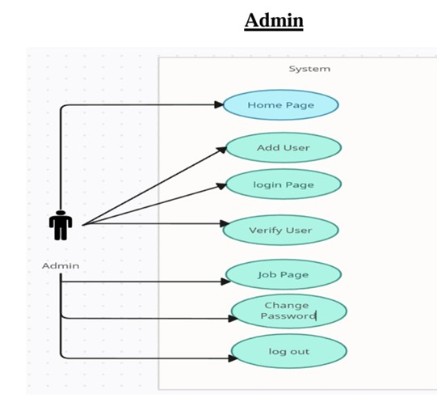

#### Sequence Diagram

UML sequence diagrams are used to show how objects interact in a given situation. An important characteristic of a sequence diagram is that time passes from top to bottom: the interaction starts near the top of the diagram and ends at the bottom (i.e. Lower equals later).

A popular use for them is to document the dynamics in an object-oriented system. For each key, collaboration diagrams are created that show how objects interact in various representative scenarios for that collaboration.

Sequence diagram is the most common kind of interaction diagram, which focuses on the message interchange between a number of lifelines.

The following nodes and edges are typically drawn in a UML sequence diagram: lifeline, execution specification, message, combined fragment, interaction use, state invariant, continuation, destruction occurrence.

#### 

**Data Flow Diagram:**

#### ER Diagram

An ER model is an abstract way to describe a database. Describing a database usually starts with a relational database, which stores data in tables. Some of the data in these tables point to data in other tables - for instance, your entry in the database could point to several entries for each of the phone numbers that are yours. The ER model would say that you are an entity, and each phone number is an entity, and the relationship between you and the phone numbers is 'has a phone number'. Diagrams created to design these entities and relationships are called entity–relationship diagrams or ER diagrams.

***CHAPTER - 5***

***IMPLEMENTATION***

## 5.IMPLEMENTATION

**5.1 Sample Code**

#### 5.1.1 Code for index page

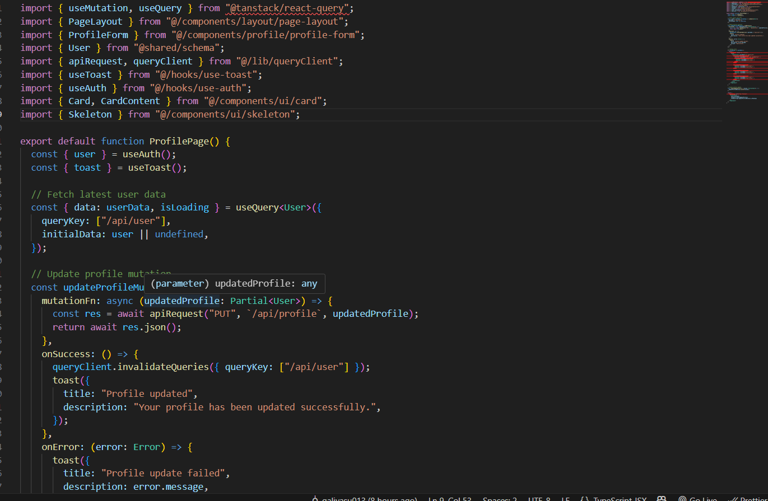

#### Code for admin login

* + 1. **code of alumni login**A computer screen with text

       AI-generated content may be incorrect.

**5.1.4 code for registration**

**Alumni Login**

Figure 5.1 Alumni Login

**Admin login**

Figure 5.2 Admin Login

**Admin Dashboard**

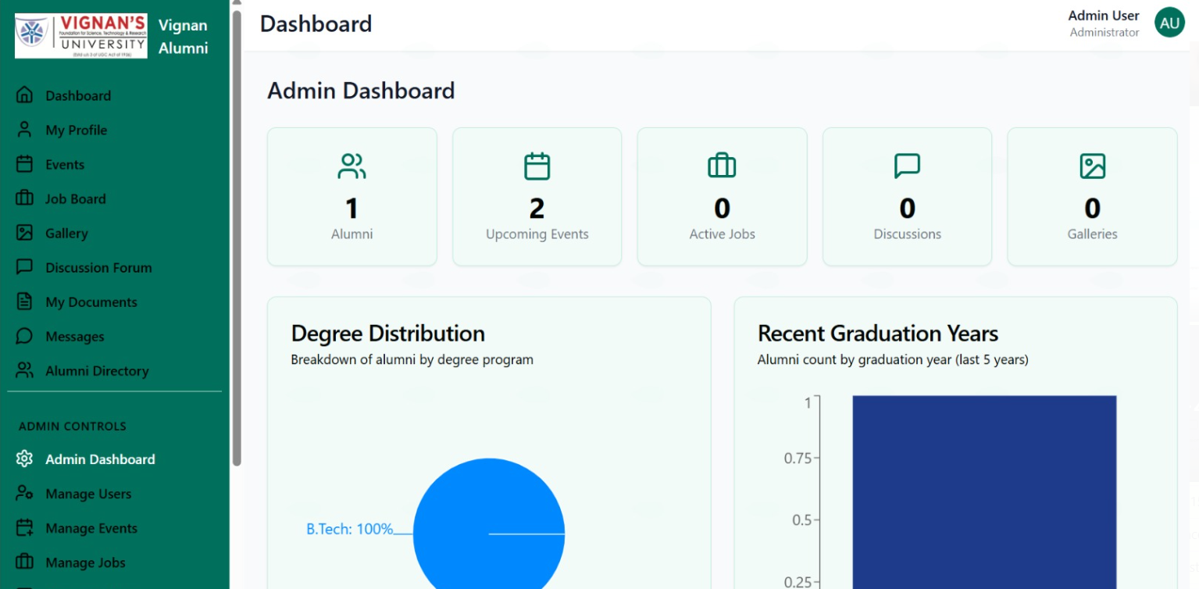

Figure 5.3 Admin Dashboard

**Events**

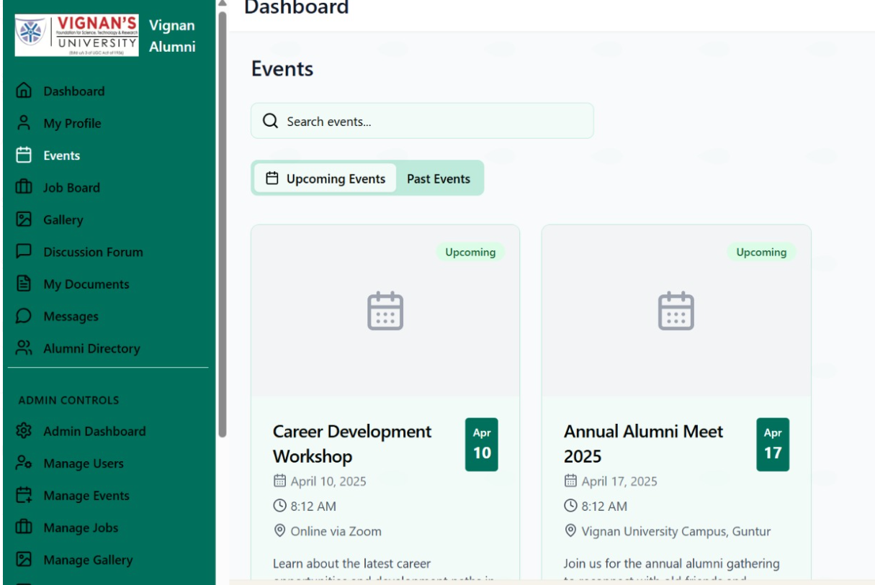

Figure 5.4 Events

**Documents**

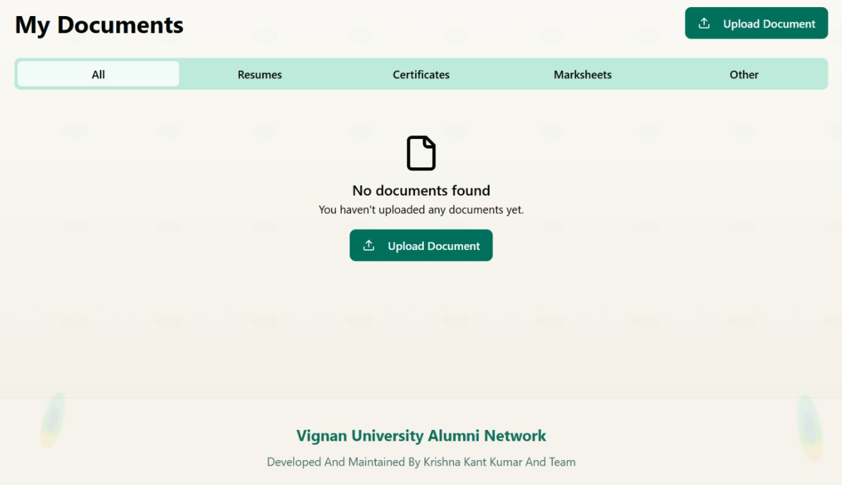

Figure 5.5 Documents

**Messages**

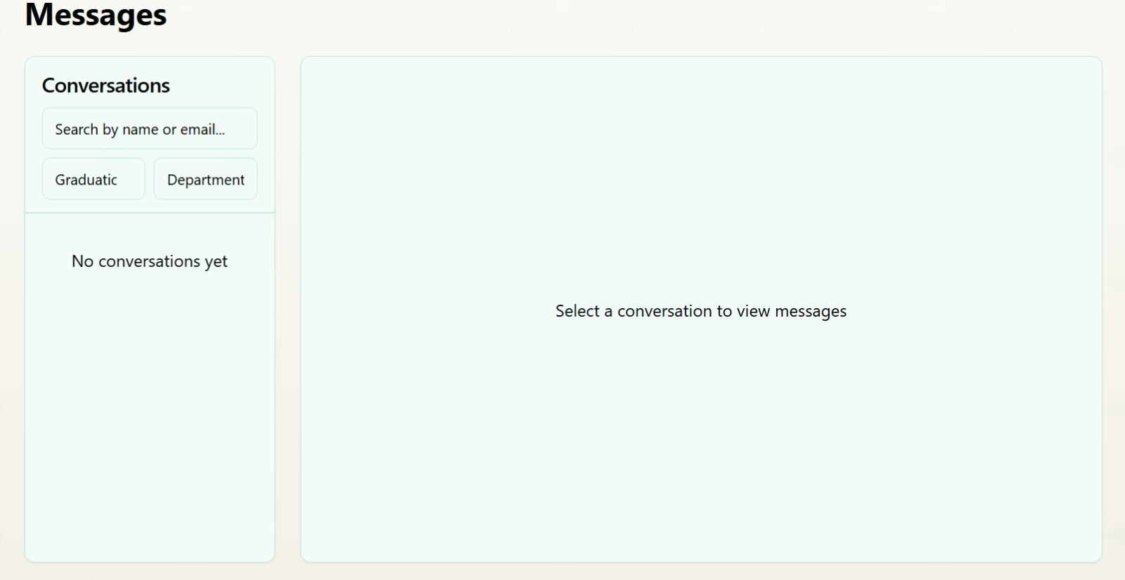

Figure 5.6 Messages

***CHAPTER - 6***

***TESTING***

*.*

**6.TESTING**

## 6.1 Software Testing

Software testing is the process of validating and verifying that a software application meets the technical requirements which are involved in its design and development. It is also used to uncover any defects/bugs that exist in the application. It assures the quality of the software. There are many types of testing software viz., manual testing, unit testing, black box testing, performance testing, stress testing, regression testing, white box testing etc. Among these performance testing and load testing are the most important one for an android application and next sections deal with some of these types.

## Black box Testing

Black box testing treats the software as a "black box” without any knowledge of internal implementation. Black box testing methods include: equivalence partitioning, boundary value analysis, all-pairs testing, fuzz testing, model-based testing, traceability matrix, exploratory testing and specification-based testing.

Common methods of black-box testing include:

* Equivalence Partitioning
* Boundary Value Analysis
* All-Pairs Testing
* Fuzz Testing

## 6.3 White box Testing

White box testing is when the tester has access to the internal data structures and algorithms including the code that implement these. This testing focuses on Data Flow, Control Flow, Logical Paths.

## 6.4 Performance Testing

Performance testing is executed to determine how fast a system or sub-system performs under a particular workload. It can also serve to validate and verify other quality attributes of the system such as scalability, reliability and resource usage.

For the Alumni Management System, performance testing will measure the response

time and scalability when multiple users are interacting with the system simultaneously.

## Load Testing

Load testing is primarily concerned with testing that can continue to operate under specific load, whether that is large quantities of data or a large number of users.

For the Alumni Management System, load testing will simulate multiple users accessing

the system at the same time (e.g., Alumni registering, posting jobs, attending events).

## Manual Testing

Manual Testing is the process of manually testing software for defects. Functionality of this application is manually tested to ensure the correctness. The test cases for Alumni Registration, Event Management, and Job Posting are manually tested,

among others.

**Sample Test Cases**

Test Case 1: Inserting New Alumni Profile

* Test Case Name: Inserting New Alumni Profile
* Description: If all fields for the alumni profile are correctly filled in.
* Expected Output: New Alumni Profile Created.

Test Case 2: Admin Managing Alumni Records

* Test Case Name: Admin Managing Alumni Profile
* Description: Admin updating the alumni records.
* Expected Output: Alumni Record Updated.

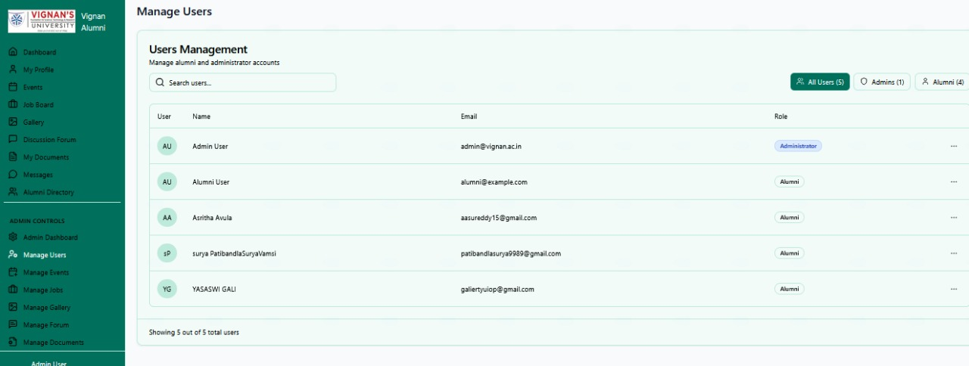

***CHAPTER - 7***

***RESULTS &CHALLENGES***

## 7.RESULTS AND CHALLENGES

## 7.1 Results

The Vignan University Alumni Portal successfully provides an interactive platform

for alumni to connect, engage, and contribute to the university community.

* Successfully developed a centralized Alumni Management System using the MERN stack.
* Enabled alumni to register, update profiles, and connect with fellow graduates.
* Admins can efficiently manage alumni data, post events, and share job opportunities.
* Implemented a secure login system to differentiate access for alumni and administrators.
* Improved alumni engagement through features like discussion forums, event registration, and media gallery.

The key functionalities of the system include:

1. User Roles & Access Control:
   * Alumni: Can register, update their profile, search for fellow alumni,

participate in discussions, and explore job opportunities.

* + Admin: Manages alumni data, moderates discussions, verifies job postings, and

oversees event management.

1. Authentication & Security:
   * Secure login and session management using Passport.js with encryption for user

credentials.

* + Role-based access control to ensure appropriate permissions.

1. Profile Management:
   * Alumni can update their personal and professional details, including

achievements and career progress.

1. Job Board:
   * Alumni and organizations can post job opportunities, and users can apply directly

through the platform.

1. Event Management:
   * The admin can create, update, and promote alumni-related events, while alumni

can RSVP and participate.

1. Discussion Forum:
   * Alumni can engage in meaningful discussions, share experiences, and seek

advice.

1. Photo Gallery:
   * Users can upload and view photos from past alumni events.
2. Peak Performers Section:
   * Highlights successful alumni, inspiring current students and fellow

graduates.

## 7.2 Challenges

* Understanding the diverse requirements of alumni, faculty, and administrative users
* Designing an intuitive and accessible interface across different user roles.
* Ensuring data privacy and security while managing alumni profiles and activities
* Handling real-time updates for event participation and job postings.
* Integrating and coordinating frontend and backend development using MERN

technologies.

***CHAPTER - 8***

***CONCLUSIONS & FUTURE WORK***

# 8.CONCLUSION

## Conclusions

The Alumni Management System was successfully developed to foster strong connections between alumni and current students. Despite initial challenges in integrating diverse features like events, job postings, and secure logins, the project offered valuable learning experiences. It required a solid understanding of user needs and full-stack implementation. Overcoming these hurdles made the process both insightful and rewarding. This project greatly enhanced our skills in building scalable and user-centric web applications.

## Scope for future work

The Alumni Management System can further be enhanced in the following ways:  
 • **Mobile App Integration** to allow easy access for alumni on the go.  
 • **Real-Time Chat and Networking** Features to encourage active alumni

interaction.  
 • **AI-Based Event and Job Recommendations** tailored to user profiles.  
 • **Multi-Language Support** to engage a globally diverse alumni base.  
 • **Integration with University Database** for accurate alumni tracking

and verification.

## Limitations

• The effectiveness of alumni engagement features depends on the accuracy and

Completeness of alumni data.  
 • Handling high traffic during major events or reunions may require performance

optimization and load balancing.  
 • Maintaining user privacy and securing sensitive data is crucial to ensure trust

and comply with data protection regulations.

# BIBLIOGRAPHY

[1] MongoDB, Inc. “MongoDB Open Source NoSQL Database” with no author  
[online] available at: <https://www.mongodb.com/>

[2] Node.js Foundation “Node.js JavaScript Runtime” with no author  
[online] available at: <https://nodejs.org/>

[3] Express.js “Fast, unopinionated web framework for Node.js” with no author  
[online] available at: <https://expressjs.com/>

[4] Meta Platforms, Inc. “React – A JavaScript Library for Building User Interfaces”

with no author [online] available at: <https://react.dev/>

[5] MongooseJS “MongoDB ODM for Node.js” with no author  
[online] available at: <https://mongoosejs.com/>

[6] Auth0 Inc. “Introduction to JSON Web Tokens (JWT)” with no author  
[online] available at: https://jwt.io/introduction/

[7] W3Schools “HTML, CSS, JavaScript Tutorials” with no author  
[online] available at: <https://www.w3schools.com/>

[8] FreeCodeCamp.org “MERN Stack Full Tutorial” with no author  
[online] available at: <https://www.freecodecamp.org/>

[9] GitHub, Inc. “Version Control for MERN Stack Projects” with no author  
[online] available at: <https://github.com/>

[10] OWASP Foundation “Security Guidelines for Web Applications” with no author  
[online] available at: <https://owasp.org/>