BSON

Поля таблицы products_rt в мантикоре
source products_attr : mysql_connect
{
sql_attr_uint = account_id
sql_attr_uint = feed_id
sql_attr_uint = brand_id
sql_attr_uint = google_product_category_id
sql_attr_uint = product_type_id
sql_attr_uint = price_strategy_id
sql_attr_uint = gs_position

sql_attr_float = quantity
sql_attr_float = clear_price
sql_attr_float = manual_price
sql_attr_float = cost_price
sql_attr_float = new_price

sql_attr_float = vat
sql_attr_float = shipping_price

sql_attr_string = price
sql_attr_string = products_in_stock
sql_attr_string = suggested_retail_price
sql_attr_string = link
sql_attr_string = image_link
sql_attr_string = availability
sql_attr_string = favorite
sql_attr_string = description

sql_field_string = title
sql_field_string = mpn
sql_field_string = gtin
sql_field_string = sku
sql_field_string = gid
sql_field_string = ean
sql_field_string = item_group_id

sql_attr_json = matchings_data
sql_attr_json = labels_data
sql_attr_json = custom_labels_data
sql_attr_json = dismiss_matchings_data
sql_attr_json = soft_deleted_matchings_data
sql_attr_json = recommendations_data
sql_attr_json = google_analytics_data
sql_attr_json = price_strategies_data
sql_attr_json = dynamic_tag_data
sql_attr_json = custom_filters
sql_attr_json = stored_properties
}

У продуктов есть конкуренты они хранятся в json полях, например matchings_data
{
"ids": [
117909,
117914,
117911,
117903,
117902,
117913,
117907,
117908,
117912,
117904,
117910,
117906,
117905
],
"count": 13,
"median": 369.99,
"average": 360.053076923,
"max_diff": 11.28,
"min_diff": -20.27,
"domain_ids": [
22,
26,
27,
36,
37,
40,
42,
43,
44,
45,
71,
83,
125
],
"competitors": [
{
"id": 117909,
"link": "https://www.notino.dk/dermalogica/daily-skin-health-hydrating-mask-for-very-dry-skin/p-488486/",
"price": "370,00 kr.",
"domain": "notino.dk",
"currency": "kr",
"quantity": 1,
"domain_id": 22,
"price_diff": 0,
"clear_price": 370,
"availability": "in stock",
"normal_price": null,
"sitemap_type": "googleShopping",
"delivery_price": "49",
"price_diff_clear": 0,
"last_change_price": null
},
{
"id": 117914,
"link": "https://www.signatura.dk/dermalogica-skin-hydrating-masque-75-ml.html",
"price": "360,00 kr.",
"domain": "signatura.dk",
"currency": "kr",
"quantity": 1,
"domain_id": 26,
"price_diff": -2.7,
"clear_price": 360,
"availability": "in stock",
"normal_price": null,
"sitemap_type": "googleShopping",
"delivery_price": "29",
"price_diff_clear": -2,
"last_change_price": null
},
{
"id": 117911,
"link": "https://billigvoks.dk/dermalogica-skin-hydrating-masque-75-ml",
"price": "360,00 kr.",
"domain": "billigvoks.dk",
"currency": "kr",
"quantity": 1,
"domain_id": 27,
"price_diff": -2.7,
"clear_price": 360,
"availability": "in stock",
"normal_price": null,
"sitemap_type": "googleShopping",
"delivery_price": "33",
"price_diff_clear": -2,
"last_change_price": null
},
{
"id": 117903,
"link": "http://www.proshop.dk/Ansigtspleje/Dermalogica-Skin-Hydrating-Masque/3012852",
"price": "351,00 kr.",
"domain": "proshop.dk",
"currency": "kr",
"quantity": 1,
"domain_id": 36,
"price_diff": -5.14,
"clear_price": 351,
"availability": "out of stock",
"normal_price": null,
"sitemap_type": "googleShopping",
"delivery_price": "29",
"price_diff_clear": -5,
"last_change_price": null
},
{
"id": 117902,
"link": "https://www.beautycos.dk/dermalogica-skin-hydrating-masque-75-ml",
"price": "314,00 kr.",
"domain": "beautycos.dk",
"currency": "kr",
"quantity": 1,
"domain_id": 37,
"price_diff": -15.14,
"clear_price": 314,
"availability": "out of stock",
"normal_price": null,
"sitemap_type": "googleShopping",
"delivery_price": "free",
"price_diff_clear": -15,
"last_change_price": null
},
{
"id": 117913,
"link": "https://www.coolshop.dk/produkt/dermalogica-skin-hydrating-masque-75-ml/AJ65D9",
"price": "339,00 kr.",
"domain": "coolshop.dk",
"currency": "kr",
"quantity": 1,
"domain_id": 40,
"price_diff": -8.38,
"clear_price": 339,
"availability": "in stock",
"normal_price": null,
"sitemap_type": "googleShopping",
"delivery_price": "free",
"price_diff_clear": -8,
"last_change_price": null
},
{
"id": 117907,
"link": "https://salling.dk/skoenhed/hudpleje/ansigtspleje/ansigtsmasker/dermalogica-skin-hydrating-masque/p-256870/",
"price": "370,00 kr.",
"domain": "salling.dk",
"currency": "kr",
"quantity": 1,
"domain_id": 42,
"price_diff": 0,
"clear_price": 370,
"availability": "in stock",
"normal_price": null,
"sitemap_type": "googleShopping",
"delivery_price": "39",
"price_diff_clear": 0,
"last_change_price": null
},
{
"id": 117908,
"link": "https://www.magasin.dk/skin-hydrating-masque-75-ml./sqnr9ygrawq.html",
"price": "370,00 kr.",
"domain": "magasin.dk",
"currency": "kr",
"quantity": 1,
"domain_id": 43,
"price_diff": 0,
"clear_price": 370,
"availability": "in stock",
"normal_price": null,
"sitemap_type": "googleShopping",
"delivery_price": "delivery",
"price_diff_clear": 0,
"last_change_price": null
},
{
"id": 117912,
"link": "https://nicehair.dk/dermalogica-skin-hydrating-masque-75-ml.html",
"price": "370,00 kr.",
"domain": "nicehair.dk",
"currency": "kr",
"quantity": 1,
"domain_id": 44,
"price_diff": 0,
"clear_price": 370,
"availability": "in stock",
"normal_price": null,
"sitemap_type": "googleShopping",
"delivery_price": "29",
"price_diff_clear": 0,
"last_change_price": null
},
{
"id": 117904,
"link": "https://www.gucca.dk/dermalogica-ansigtsmaske-skin-hydrating-masque-75-ml-p477516",
"price": "399,95 kr.",
"domain": "gucca.dk",
"currency": "kr",
"quantity": 1,
"domain_id": 45,
"price_diff": 8.09,
"clear_price": 399.95,
"availability": "in stock",
"normal_price": null,
"sitemap_type": "googleShopping",
"delivery_price": "39.95",
"price_diff_clear": 9,
"last_change_price": null
},
{
"id": 117910,
"link": "https://www.cocopanda.dk/product/3014837",
"price": "295,00 kr.",
"domain": "careofcarl.dk",
"currency": "kr",
"quantity": 1,
"domain_id": 71,
"price_diff": -20.27,
"clear_price": 295,
"availability": "out of stock",
"normal_price": null,
"sitemap_type": "manualCompetitors",
"delivery_price": "29",
"price_diff_clear": -20,
"last_change_price": null
},
{
"id": 117906,
"link": "https://shopbetter.dk/shop/product/moisturizing-facial-mask-dermalogica-greyline-75-ml_275562?cvt=GMC",
"price": "369,99 kr.",
"domain": "shopbetter.dk",
"currency": "kr",
"quantity": 1,
"domain_id": 83,
"price_diff": 0,
"clear_price": 369.99,
"availability": "in stock",
"normal_price": null,
"sitemap_type": "googleShopping",
"delivery_price": "free",
"price_diff_clear": 0,
"last_change_price": null
},
{
"id": 117905,
"link": "https://swedishface.dk/dermalogica-skin-hydrating-masque-75ml",
"price": "411,75 kr.",
"domain": "swedishface.dk",
"currency": "kr",
"quantity": 1,
"domain_id": 125,
"price_diff": 11.28,
"clear_price": 411.75,
"availability": "in stock",
"normal_price": null,
"sitemap_type": "googleShopping",
"delivery_price": "49",
"price_diff_clear": 12,
"last_change_price": null
}
],
"median_diff": 0,
"price_color": "red-price",
"average_diff": -2.69,
"domain_prices": {
"22": {
"quantity": 1,
"price_diff": 0,
"clear_price": "370.00",
"price_ratio": 100
},
"26": {
"quantity": 1,
"price_diff": -2.7,
"clear_price": "360.00",
"price_ratio": 97.2972972972973
},
"27": {
"quantity": 1,
"price_diff": -2.7,
"clear_price": "360.00",
"price_ratio": 97.2972972972973
},
"36": {
"quantity": 1,
"price_diff": -5.14,
"clear_price": "351.00",
"price_ratio": 94.86486486486486
},
"37": {
"quantity": 1,
"price_diff": -15.14,
"clear_price": "314.00",
"price_ratio": 84.86486486486487
},
"40": {
"quantity": 1,
"price_diff": -8.38,
"clear_price": "339.00",
"price_ratio": 91.6216216216216
},
"42": {
"quantity": 1,
"price_diff": 0,
"clear_price": "370.00",
"price_ratio": 100
},
"43": {
"quantity": 1,
"price_diff": 0,
"clear_price": "370.00",
"price_ratio": 100
},
"44": {
"quantity": 1,
"price_diff": 0,
"clear_price": "370.00",
"price_ratio": 100
},
"45": {
"quantity": 1,
"price_diff": 8.09,
"clear_price": "399.95",
"price_ratio": 108.09459459459458
},
"71": {
"quantity": 1,
"price_diff": -20.27,
"clear_price": "295.00",
"price_ratio": 79.72972972972973
},
"83": {
"quantity": 1,
"price_diff": 0,
"clear_price": "369.99",
"price_ratio": 99.99729729729732
},
"125": {
"quantity": 1,
"price_diff": 11.28,
"clear_price": "411.75",
"price_ratio": 111.2837837837838
}
},
"domain_summary": {
"in_stock": [
22,
26,
27,
40,
42,
43,
44,
45,
83,
125
],
"account_id": 16,
"product_id": 970745,
"out_of_stock": [
36,
37,
71
],
"price_leader": [
71
],
"red_products": [
71
],
"green_products": [],
"orange_products": [
22,
26,
27,
36,
37,
40,
42,
43,
44,
83
],
"yellow_products": [
22,
42,
43,
44,
45,
83,
125
],
"price_leader_solo": 71,
"price_leader_count": 1,
"price_leader_multi": [],
"product_clear_price": 370,
"min_competitor_price": 295,
"domain_summary_settings": {
"red_products": -20,
"price_changes": 7,
"green_products": 20,
"orange_products": {
"to": 0,
"from": -20
},
"yellow_products": {
"to": 20,
"from": 0
}
},
"price_leader_solo_account": 0,
"price_leader_multi_account": 0,
"price_leader_solo_competitor": 71,
"price_leader_multi_competitor": []
},
"with_new_price": 1,
"product_quantity": 1,
"without_new_price": 0,
"cheapest_competitor": {
"id": 117913,
"link": "https://www.coolshop.dk/produkt/dermalogica-skin-hydrating-masque-75-ml/AJ65D9",
"price": "339,00 kr.",
"domain": "coolshop.dk",
"currency": "kr",
"quantity": 1,
"domain_id": 40,
"price_diff": -8.38,
"clear_price": 339,
"availability": "in stock",
"normal_price": null,
"sitemap_type": "googleShopping",
"delivery_price": "free",
"price_diff_clear": -8,
"last_change_price": null
},
"product_clear_price": "370",
"competitors_availability": {
"in stock": [
22,
26,
27,
40,
42,
43,
44,
45,
83,
125
],
"hasInStock": "yes",
"out of stock": [
36,
37,
71
],
"hasOutOfStock": "yes"
},
"competitors_manual_matches": {
"countActiveManualMatches": 1
}
}

Ниже на скринах то как выглядят фильтра, красным отметил вкладки фильтрации именно по КОНКУРЕНТАМ, то есть по json массиву matchings_data.competitors. После выбора каждой галочки на любой из вкладок фильтра — фасеты пересчитываются.

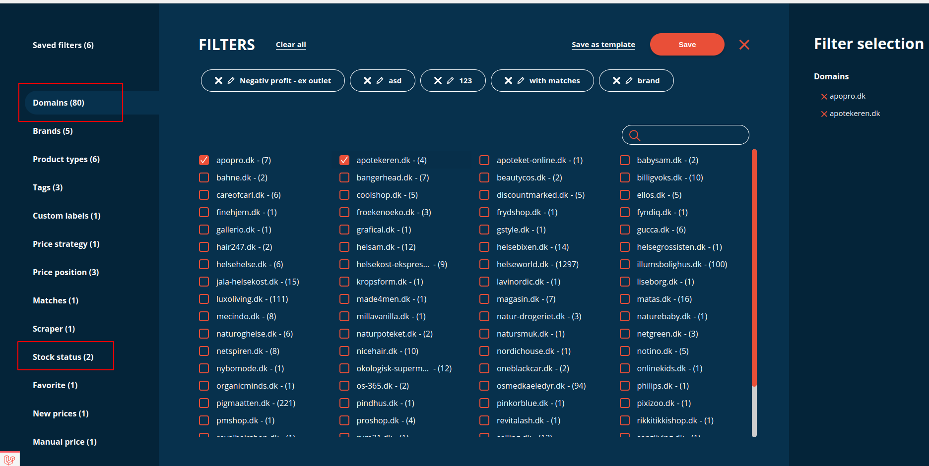
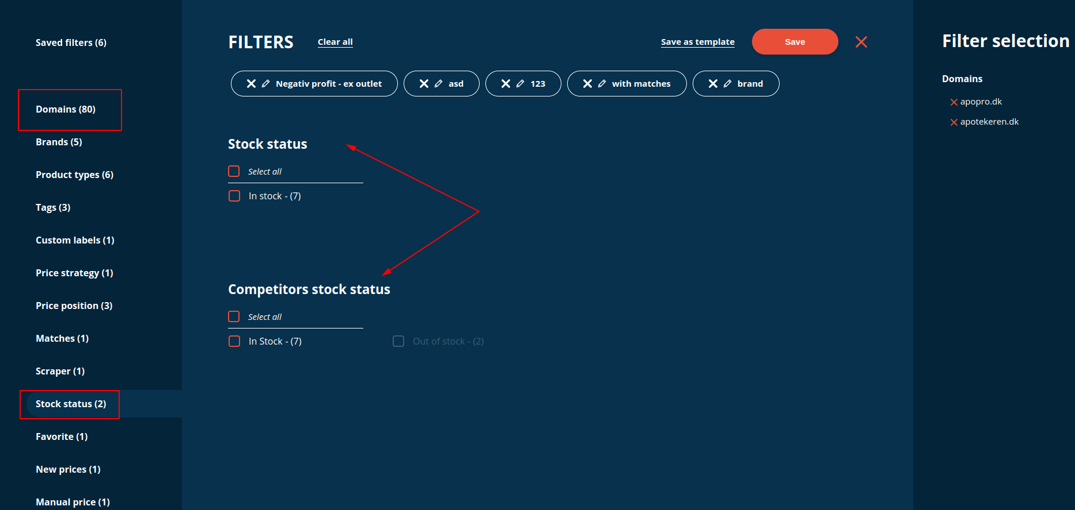
Пример запроса
SELECT id, title, clear_price, cost_price, vat, gtin, quantity, new_price, link, image_link, brand_id, availability, products_in_stock, manual_price, shipping_price, favorite, price_strategy_id, price_strategy_id,
matchings_data.count as matchings_data_count,
matchings_data_count > 0 as hasmatch,
matchings_data.competitors[0].domain_id as first_competitor,
matchings_data.price_color as color_price_btn,
matchings_data.average as average_price,
matchings_data.median as median_price,
matchings_data.ids as matchings_data_ids,
IF((clear_price * 100) / (vat + 100) = 0, 0, ((clear_price * 100) / (vat + 100) - cost_price) / ((clear_price * 100) / (vat + 100)) * 100) as gross_margin,
IF((new_price * 100) / (vat + 100) = 0, 0, ((new_price * 100) / (vat + 100) - cost_price) / ((new_price * 100) / (vat + 100)) * 100) as new_gross_margin,
(clear_price * 100) / (vat + 100) - cost_price as gross_profit,
(new_price * 100) / (vat + 100) - cost_price as new_gross_profit,
stored_properties.strategy_minimum_price as strategy_minimum_price,
google_analytics_data.180.cost as cost,
google_analytics_data.180.conversion_rate as conversion_rate,
INTEGER(google_analytics_data.180.visitors) as visitors,
INTEGER(google_analytics_data.180.sales) as sales,
INTEGER(google_analytics_data.180.quantity) as number_of_sales,
INTEGER(google_analytics_data.180.clicks) as clicks,
google_analytics_data.180.profit_without_vat_x100 as profit,
google_analytics_data.weeks_on_hand as weeks_on_hand,
google_analytics_data.last_sale_date as last_sale_date,
dynamic_tag_data,
gid,
DOUBLE(min(DOUBLE(IF(matchings_data.domain_prices['20'] IS NOT NULL, quantity / matchings_data.domain_prices['20'].quantity * matchings_data.domain_prices['20'].clear_price, 999999999)),DOUBLE(IF(matchings_data.domain_prices['25'] IS NOT NULL, quantity / matchings_data.domain_prices['25'].quantity * matchings_data.domain_prices['25'].clear_price, 999999999)))) as _min, DOUBLE(min(IF(matchings_data.domain_prices['20'] IS NOT NULL, matchings_data.domain_prices['20'].price_diff , 999999999),IF(matchings_data.domain_prices['25'] IS NOT NULL, matchings_data.domain_prices['25'].price_diff , 999999999))) as _min_competitor_diff,
IF (
DOUBLE(_min_competitor_diff) > ABS(0.000000), 1, IF (
DOUBLE(_min_competitor_diff) >= -ABS(0.000000) AND DOUBLE(_min_competitor_diff) <= ABS(0.000000), 0, INTEGER(-1)
)
) as price_status,
INTEGER(matchings_data.count) as diff,
IN(matchings_data.competitors_availability['in stock'], 20,25) as competitorsAvailability_json_contains633c24796e74b,
(IF(matchings_data.domain_prices['20'] IS NOT NULL AND IN(matchings_data.competitors_availability['in stock'], 20), 1, 0)+IF(matchings_data.domain_prices['25'] IS NOT NULL AND IN(matchings_data.competitors_availability['in stock'], 25), 1, 0)) as competitors_count,
IN(matchings_data.domain_ids, 20,25) as matchingsData_domainIds_json_contains633c24796e8b0

FROM products_rt

WHERE account_id = 16 AND
competitorsAvailability_json_contains633c24796e74b > 0 AND
matchingsData_domainIds_json_contains633c24796e8b0 > 0 AND
matchings_data.competitors_availability.hasInStock = 'yes'
ORDER BY hasmatch DESC, diff DESC LIMIT 0, 10 OPTION max_matches = 2000

FACET matchings_data.domain_ids LIMIT 0, 2000
FACET labels_data.ids LIMIT 0, 2000
FACET product_type_id LIMIT 0, 2000
FACET brand_id LIMIT 0, 2000
FACET favorite ORDER BY favorite ASC
FACET price_status as _price_status ORDER BY _price_status ASC
FACET custom_labels_data.values LIMIT 0, 2000
FACET price_strategy_id LIMIT 0, 2000
FACET matchings_data IS NOT NULL as has_match ORDER BY matchings_data.count ASC
FACET IF(manual_price > 0, 1, 0) as has_manual_price
FACET IF(new_price > 0, 1, 0) as has_new_prices
FACET IF(availability = 'out of stock', 0, IF(availability = 'preorder', 1, 2)) as stock_status
FACET dynamic_tag_data.ids LIMIT 0, 2000
FACET matchings_data.competitors_availability.hasInStock AS alias_competitorsavailabilityinstock
FACET matchings_data.competitors_availability.hasOutOfStock AS alias_hasoutofstockcompetitors
FACET matchings_data.competitors_manual_matches.hasActiveManualMatches AS alias_has_active_manual_matches
FACET soft_deleted_matchings_data.hasSoftDeletedManualMatches AS alias_has_soft_deleted_manual_matches
FACET IN(matchings_data.competitors_availability['in stock'], 20,25) AS alias
FACET IN(matchings_data.competitors_availability['out of stock'], 20,25) AS competitorsoutofstockbydomains
FACET matchings_data.competitors_availability['in stock'] LIMIT 0, 2000
FACET INTEGER(competitors_count) LIMIT 0, 9999999999
FACET 1
Проблемы возникают когда необходимо считать счетчики для конкурентов которые хранятся в json полях. Для этого мы добавляем избыточные данные(поля ids, domain_prices, competitors_availability) в matchings_data, например
"competitors_availability": {
"in stock": [
22,
26,
27,
40,
42,
43,
44,
45,
83,
125
],
значения — это айдишники доменов, потом по ним дополнительно считается фасет
FACET IN(matchings_data.competitors_availability['in stock'], 20,25) AS alias
И ищется пересечение с результатами фасета для всех domain_id но уже на пхп.
FACET matchings_data.domain_ids LIMIT 0, 2000
Чем больше таких фильтров — тем сложнее и запутаннее становится.

Чтоб избавиться от этих замудренных штук я попробовал фильтровать json через UDF.
Сделал функцию для фильтрации JSON массива конкурентов, обычный перебор на либе cJSON
JSON_FILTER([json массив], {критерии по коротым фильтровать}) — возвращает строчный отфильтрованный массив обьектов

Использование — добавляем в селект
JSON_FILTER(matchings_data.competitors, {„domain_id“: [20, 25]}) as filtered_competitors

{„domain_id“: [20, 25]} набирается в зависимости от того что наклацал юзер в фильтрах

В filtered_competitors получается отфильтрованный json массив конкурентов подходят по domain_id.

Затем в чтоб фильтровать продукты по выбранным критериям конкурентов уже в идеале использовать LENGTH()

то есть
WHERE LENGTH(filtered_competitors) > 0

Но здесь LENGTH() не сработает, так как то что вернулось из JSON_FILTER — является JSON строкой, а ей нужен BSON.

1)Вот где сработала бы каст-функция TO_BSON() если это возможно конечно.
WHERE LENGTH(TO_BSON(filtered_competitors)) > 0

2)Второе ее применение в фасетах
Я сделал функцию которая из json массива обьектов соберет значения по ключу
JSON_ARRAY_AGG_BY_KEY(filtered_competitors, „domain_id“) - результат - „[20, 25]“

В идеале это будет выглядеть как-то так
FACET TO_BSON(JSON_ARRAY_AGG_BY_KEY(filtered_competitors, „domain_id“)) as domainsFacet
FACET TO_BSON(JSON_ARRAY_AGG_BY_KEY(filtered_competitors, „availability“)) as competitorsStockStatusFacet

То есть мы подставляем в фасет не весь набор domain_id, который кстати есть в matchings_data.domain_ids, а сразу отфильтрованные значения и не нужны будут доп фасеты для счетчиков и потом перебор их на пхп.

