Initial Set of ‘Use Cases’

All the scripts and data files are in the directory:

/SNS/users/sdashare/

I will move this to a more suitable shared directory or repository if needed.

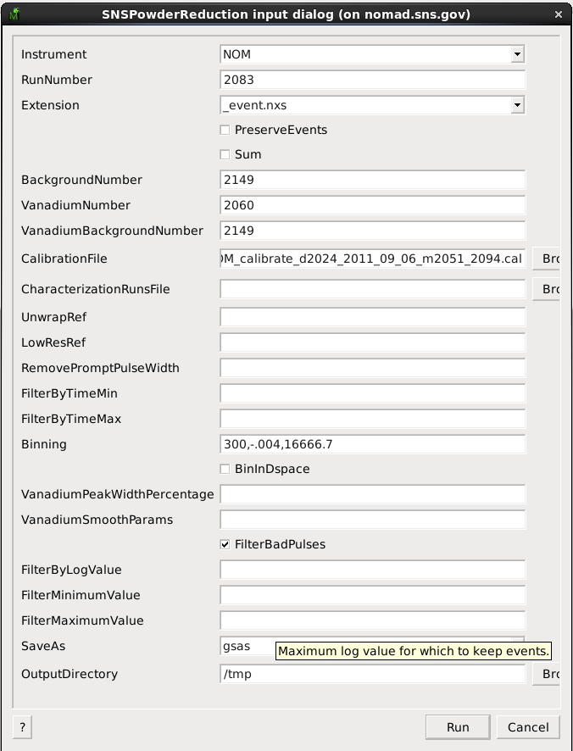
NOMAD reduction

Running on nomad.sns.gov takes a very long time (>30 minutes).

To Run:
- Start Mantid
- Start SNSPowderReduction algorithm
- Enter Parameters:

The data file in this case is 2.1Gb but the normalization file (vanadium) is about 6.5Gb. These sizes are compressed HDF5.
A further case is for when we have a sample with texture, which would mean that it would be necessary to transform the data into individual pixel spectra and then regroup spectra. We do not have a method for doing this at the moment, but given current timings for NOMAD reduction this would take an extreme amount of time.

Contact Person for more information : Peter Peterson

TOPAZ Bragg reduction

This currently takes 76 minutes on an 8 core machine with 16GB RAM.

To Run:
- Start Mantid
- Open the Python Script Window (View->Script Window or F3 / Command-3)
- Enter the follow script:

#!/usr/bin/env python
import os
from MantidFramework import mtd
mtd.initialise()
import datetime
starttime = datetime.datetime.now()

SNSSingleCrystalReduction(Instrument="TOPAZ",SampleNumbers="3680:3685",BackgroundNumber="3686",VanadiumNumber="3676",Binning="3000,-0.004,15500",LinearScatteringCoef="0.372",LinearAbsorptionCoef="0.011",Radius="0.1",PowerLambda="4",IsawUBFile="lsintSapphire3680.mat",ISAWPeaksFile="intSapphire.peaks",SaveAs="hkl",OutputFile="DetCal.hkl")

elapsedtime = datetime.datetime.now() - starttime
print "total time to run", str(elapsedtime)

4) Execute->Execute All

Contact Person for more information : Vickie Lynch

Creating a Large Multi-Dimensional Workspace

This script describes the process by which several runs of a single-crystal diffraction
experiment might be combined into one large multi-dimensional workspace (MDWorkspace).

A typical TOPAZ SCD run will have e.g. 8-12 runs. The same principle could be applied to an inelastic experiment (CNCS, SEQUOIA or ARCS), which might have dozens or up to 200 runs to sum together.

The code for this can be run in a similar way to the previous example.

First part of the algorithm:
Converting each run from detector space to 3D reciprocal space, and save them to separate files.

The loop over each run could easily be split into completely separate nodes.

Alternatively, if the script were to run right after the completion of each run, then the output MDWorkspace files would already be ready to use

# List of the TOPAZ run numbers to load
runs = range(3007,3008)

# Keep a list of all the filenames, for use in later MergeMD
all_filenames = []

# This look can be split over several nodes:
for run in runs:
# Note: For each run, you need to be able to fit all the data in memory.
# This example is 50 Million events, using up:
# 1 GB in the TOPAZ_NXS workspace and 1.7 GB in the TOPAZ_MD workspace.
# There are ways to do it with file-backed, but this is much slower.

# This loads the event data in detector space; takes ~ 30 seconds
LoadEventNexus(Filename='TOPAZ_' + str(run) + '_event.nxs',OutputWorkspace='TOPAZ_NXS',CompressTolerance='0.1')

# This creates the desired output MDorkspace in reciprocal space; takes no time
CreateMDWorkspace(Dimensions='3', Extents='-5,5,-5,5,-5,5', Names='Q_sample_x,Q_sample_y,Q__sample_z', Units='A,A,A',
SplitInto='5',SplitThreshold='2000',MaxRecursionDepth='3',
MinRecursionDepth='3', OutputWorkspace='TOPAZ_MD')

# This converts from detector space to reciprocal space; takes ~ 30 seconds
# It is this algorithm that would be different for the case of inelastic
# scattering.
ConvertToDiffractionMDWorkspace(InputWorkspace='TOPAZ_NXS', OutputWorkspace='TOPAZ_MD', OutputDimensions='Q (sample frame)',LorentzCorrection='1')

# Saves the MDWorkspace to a NXS file; takes ~ 45 seconds.
# This is required by the MergeMD step.
SaveMD(InputWorkspace='TOPAZ_MD', Filename='TOPAZ_'+str(run)+'_MD.nxs')
# Save filename for later
all_filenames.append('TOPAZ_'+str(run)+'_MD.nxs')

Second part of the algorithm: Merging.

The N runs were saved to MDWorkspaces with a common box structure.
Now, each run will be added together into one possibly very large MDWorkspace.

This next line uses a file-backed output workspace (TOPAZ_HUGE.nxs) which
significantly slows down the process.

Processing 1 billion events (about 20 runs) takes 25-30 minutes. Data is being
read from disk and written out to disk continually to avoid overwhelming the available
memory.

MergeMD(Filenames=','.join(all_filenames), OutputFilename='TOPAZ_HUGE.nxs', OutputWorkspace='TOPAZ_HUGE')

How to parallelize the merging:

It is possible, through inspection of the TOPAZ_*_MD.nxs files, to know exactly how many events are in each box (3D coordinate).

I can imagine splitting the OUTPUT workspace onto N separate nodes, where each node has sufficient memory to hold all the events for its region of space. Each node would have a 'partial' workspace. Loading all the data into physical memory would be significantly faster when merging.

By distributing the data across multiple nodes in this way, any future operations on the data would be much faster (without requiring a shared memory machine with a TB of memory!). It is common for people to focus in on a small space of the data for processing, therefore, the data should probably be spread evenly or randomly so as to also spread CPU load evenly.

A 'master' workspace would need to be able to coordinate between all the nodes, in, e.g. a rebinning operation.

Each node would return its contribution to the binning, which would then have to be summed into a total bin. An open question for me is how to do such a synchronization....

Contact Person for more information: Janik Zikovsky (for this example) or Stuart Campbell (for extension to inelastic case)

Processing multiple Inelastic runs.

This script is used to process a large number (50 -> 200) of individual measurements, each at a different sample rotation, into a collection of individual reduced data files (NXSPE - HDF5 based or SPE/PHX - ASCII based). Rather than having a large number of discrete angle steps, it is also possible to just have a single measurement that is split up by the logged angle to form the ‘discrete’ steps.

In the future this will be replaced with an approach similar to the “Creating a Large Multi-Dimensional Workspace” use case above.

I haven’t included the file in this document as it is quite large, but it is called loopscript_12meV.py in the shared directory and it can be run from within Mantid in the same way as all the previous scripts.

Contact Person for more information: Andrei Savici or Stuart Campbell

