

Mantid Framework
Tessella Project Number 5315
Architectural Design Document

Tessella Support Services plc
E-mail: info@tessella.com | www.tessella.com
Group Head Office: Abingdon
3 Vineyard Chambers, Abingdon, Oxfordshire, OX14 3PX, UK
Tel: +44 (0)1235 555511
Fax: +44 (0)1235 553301

Document Control
This document is under document control. All members of the distribution list will receive updated copies whenever alterations are made.

Contributors
Person | Role | Company | Contribution
Nick Draper | Author | Tessella
Laurent Chapon | Reviewer | Tessella

Document Approval
Person | Role | Company

Distribution
Person | Role | Company
Laurent Chapon | Supervising Officer | Rutherford Appleton Laboratories
Notes Projects Database 5315 |  | Tessella
Mantid SVN repository |  | Rutherford Appleton Laboratories

Revision History
Issue | Author | Date | Description
V1.R1.M0 | Nick Draper | 14-Sep-2007 | 1st version written
V1.R1.M1 | Nick Draper | 04-Oct-2007 | Updated to emphasize that the memory management aspects will only be employed if the host operating systems virtual memory management is inadequate.
V1.R1.M2 | Nick Draper | 05-Oct-2007 | Added details to the sample, environment and history data objects. Cross reference to SRD completed.
V1.R2.M0 | Nick Draper | 23-Jan-2009 | Updated to account for changes, scripting and GUI section expanded.
V1.R2.M1 | Nick Draper | 11-Nov-2009 | Updated Third Party software section

References
Ref. | Document | Date | Details and Version
[BC] | Business Case | 11-May-2007 | Version 1.0  http://www.mantidproject.org/images/c/c2/Business_Case_V2.pdf
[DT-UR] | Dunstan Thomas Requirements Specification | 03-Dec-2006 | Version 0.1  http://www.mantidproject.org/images/c/c2/Requirements_RAQuest.pdf
[URD] | User Requirements | 12-Jul-2007 | User Requirements Document - V1.R1.M0
[SRD] | Software Requirements | 12-Jul-2007 | Software Requirements Document - V1.R1.M0
[MW-DDD] | Managed Workspace Detailed Design Document | 01-Dec-2008 | Managed Workspace Detailed Design Document V1.R1.M2
[Geometry XML]. | Mantid Geometry Primitives | 01-Dec-2008 | Mantid Geometry and XML tags
[GAUDI-ADD] | GAUDI Architecture Design Document | 24-Nov-1998 | Version 1.0  http://lhcb-comp.web.cern.ch/lhcb-comp/Meetings/offline/pdf/add.pdf
[UML] | UML Distilled 2nd Edition by M Fowler | 2000 | UML Distilled 2nd Edition by M Fowler, Addison-Wesley, (Tessella ref: 1861)

Table of Contents
1 Introduction 5
1.1 Purpose of this Document 5
1.2 Scope of this Document 5
1.3 Context of this Issue 5
1.4 Definition of Terms 5
2 Document Overview and Design Techniques 6
3 System Overview 7
3.1 Overview and Context 7
3.2 Architecture Summary 8
3.3 Interfaces Overview 10
3.4 Plug in architecture 10
3.5 Configuration files 11
4 Algorithms and the Algorithm Factory 11
4.1 Algorithm Factory 12
4.2 Algorithm 12
5 Geometry 13
5.1 Approaches for Computational Geometry 13
5.2 Mantid’s Approach to Geometry 14
5.3 Separation of Shape from Position 14
6 Transient Data Service 16
6.1 Sample Data Service 17
6.2 Detector Data Service 17
6.3 Managed Data Service 17
6.4 Analysis Data Service 18
7 Data Objects and Workspaces 18
7.1 Data Objects 18
7.2 Workspaces 19
7.3 Workspace Implementations 19
7.4 Workspace Memory Management 20
8 Command line and Scripting Interface 20
9 Visualization Tool 21
10 Security Sub-system 21
11 Data Access Layer 22
11.1 Class Descriptions 22
11.2 Data Storage 23
12 Third-Party Software 24
13 Design Scenarios 25
13.1 User running a simple algorithm using the Mantid interface 25
14 System-Wide Features 26
14.1 Language 26
14.2 On-line help 26
14.3 Error-Handling 26
14.4 Automated Debugging, Testing and Diagnostics 26
14.5 Statutory and Regulatory 26
15 Development Environment 26
16 Cross-Reference to Software Requirements 27

Introduction

Purpose of this Document
This document describes the design of the Mantid Framework.
It is based on the system specified in the Software Requirements Document [SRD]
It has formed the basis of the planning of the development phase and will then be updated at the end of the development to act as a guide for maintaining the system.

Scope of this Document
These requirements cover the development of the Mantid Framework and an associated Visualisation tool but not the Analysis applications which will be developed in a later project.
This document will describe the architectural design, detailed design such as methods on individual classes will be documented using DOxygen documentation.

Context of this Issue
This is the second revision of the ADD and has been updated to reflect the architectural decisions made since the previous revision.

Definition of Terms

ADD | The Architectural Design Document (this document), the high level design document for the entire system.
URD | The User Requirements Document, records the users’ requirements for the system.
SRD | The Software Requirements Document, specifies the behaviour of the software system.
API | Application Programming Interface, defines the interface through which two programs may interact.

Document Overview and Design Techniques
This document presents the architecture of the Mantid framework as follows:

- Section 3 contains an overview of the architecture of the framework together with a description of its basic functionality.
- Section 4 details the architecture of the algorithms and the algorithms factories.
- Section Error: Reference source not found describes the Mantid approach to geometry and the definition of virtual instruments.
- Section 6 provides further details on the data services.
- Section 7 explains the data objects and the workspace concept that will provide structure to the data analysis objects.
- Section 8 describes the command line & scripting interface.
- Section 9 describes the visualization tool.
- Section 10 details the security sub system, or more specifically why a security system is not needed in the Mantid framework.
- Section 11 describes the data access layer in more detail.
- Section 12 provides a list of the third party software that will be used within and during construction of the Mantid framework.
- Section 13 describes usage scenarios to help to define how the different components interact together
- Section 14 covers any system wide features such as help facilities and automated testing.
- Section 15 describes the development and build environments.

An object-oriented approach has been used with diagrams produced in UML notation [UML]. All components are modelled with UML class diagrams, sequence diagrams are used to describe the processing of example operations.

System Overview

Overview and Context
This diagram shows the context of Mantid data analysis framework. The shaded areas will be further detailed in the later sections of this document.
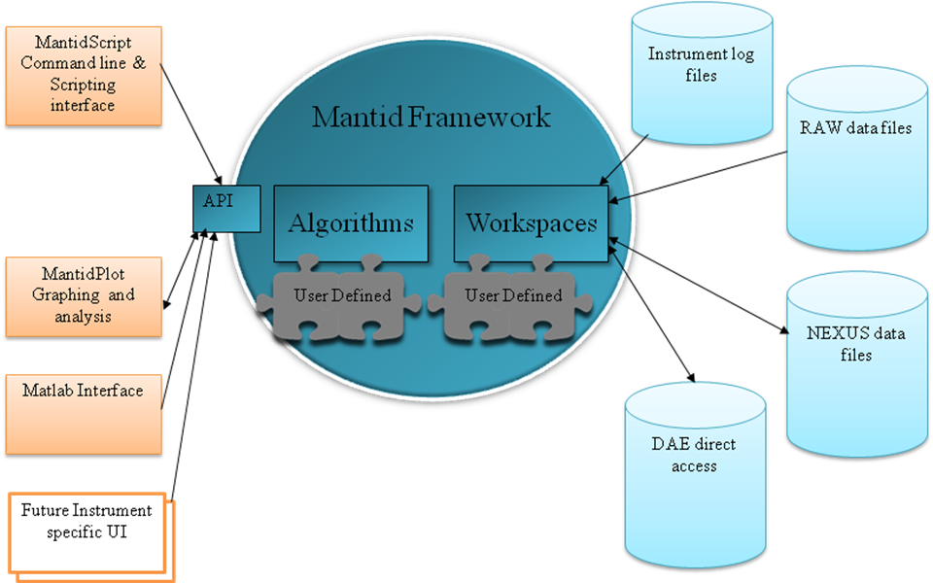

Inputs
The Mantid framework has two main groups of inputs. The first is through the API which will accept commands and requests for data objects from the user interfaces or user written scripts. The second is from various files that contain the data to be processed. Initially supported formats will be RAW files together with their related log files, NEXUS data files, and direct data access from the instrument data acquisition electronics. Further formats may be supported through the plug-in architecture as required.

Major System Functionality
The Mantid framework provides a skeleton for all of the data reduction and analysis of neutron scattering experiments. The framework contains a structured data repository and a collection of services to make the writing and execution of algorithms as simple as possible. The framework will provide a collection of standard algorithms as well as allowing users to add there own through a user created plug-ins.

Outputs
NeXus data files will be the main route of outputting data from the application. This has been chosen as it is an open format across the neutron scattering community and it can store the detector and sample information in an extensible way alongside the data. Again the support of output file formats will be extensible through the plug-in architecture. It will also be possible to access the data objects contained within the framework through the API and therefore it will also be possible the extract data through this route.

Architecture Summary
The Mantid framework itself will provide the middle and data tiers for processing neutron scattering data. It is designed to support several different user interfaces including the command line and interactive graphical user interfaces, which will be created as part of this project. One of the prime requirements of the design is that it is easily extendable through its plug in architecture to support future data analysis algorithms and different file formats.
As part of the requirements and design effort for this project two candidate architectures were investigated and evaluated for use as the basis of the Mantid framework. The candidate architectures investigated were the GAUDI architecture from the LHCb team at CERN and the other was the architecture developed for the in house PC-COLETTE application used for data analysis for the LOQ instrument. The notes from these investigations can be found on the Mantid project wiki.
As a result of these investigations the architecture will be based on GAUDI [GAUDI-ADD] but with several alterations.
These are primarily:
- The event loop inherent in the architecture will be removed and replaced by a more flexible analysis workflow.
- All internal links to the ROOT, HBOOK and GEANT4 software packages will be removed, and replaced where necessary by light weight implementations with greater relevance to the neutron scattering community. Integration to these packages may be maintained through the support of defined file formats.
- The Converter architecture used for implicit loading and saving of data to persistent stores will be replaced by explicit algorithms specialised to load and persist data.
- Initial tests will determine if the use of the operating systems virtual memory will provide acceptable performance when working with large datasets. If this does not perform well enough then a new type of temporary data service will be created called a Managed Data Service that will actively manage the memory use of the objects contained within it.
- Alteration of the Job Options mechanism to split the system wide settings from the algorithms settings and workflow.
The primary packages of the framework are as follows:
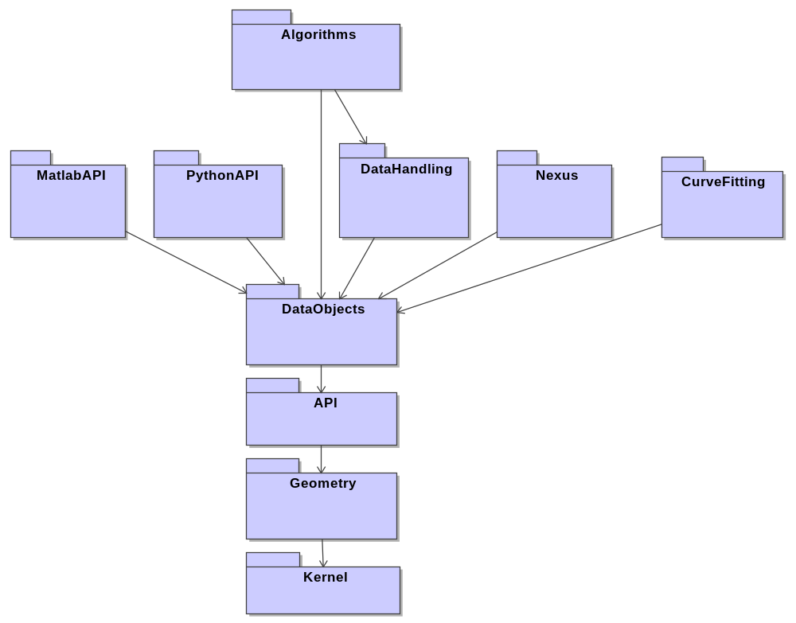

Algorithms
The algorithms package is where the real data processing occurs in the framework. All the algorithms implement a standard set of generic interfaces which allow specific algorithms to be called without knowing what they do. Algorithms may in turn call further algorithms allowing complex algorithms to be broken down into simpler tasks.

Data Handling
This package is similar to that of the algorithms Package except that it is specialised in containing algorithms which load and save the data to a persistent store, also algorithms that input or override detector or sample data in the data store.

NeXus and CurveFitting
These are again examples of further libraries of algorithms that are loaded at run time through the plug-in system. These algorithms have been separated from the main body due to the external dependencies of these particular algorithms.

MatlabAPI and PythonAPI
These packages contain the specific programming interfaces used for interaction through the Python scripting language or Matlab.

Data Objects
The framework will come with a collection of related objects that are designed to describe the data structures used at ISIS. This contains data objects to contain standard data structures such as 1D and 2D histograms and Table structured data. Users will be able to define their own data objects through the plug-in architecture.

API
The C++ programming interface is through the API package, this contains many of the vital classes for interaction with the framework. Most of the complexity of the system can be avoided if desired by using the FrameworkManager class. This also contains the abstract definitions for Algorithms and Workspaces which allows there use without knowing exactly which algorithm or workspace you are using.

Framework Manager
This is manages the operation of the framework and is responsible for the following tasks.
- Providing the majority of the API to the framework. Simple methods available on the Framework Manager class will act as a façade to the majority of the internal classes of the Mantid Framework.
- Initialising the framework and Loading any plug-in libraries at start-up.
- Creating and executing algorithms and services as required.
- Coordinating parse mode checks of algorithms commands or scripts. When in parse mode the framework will check the parameter settings of each algorithm by initialising each in turn, but will not actually execute the algorithm.

Geometry
The framework can hold a full virtual geometry of the instrument, allowing the algorithms to interact dynamically with the instrument geometry. This allows the algorithms to be instrument independent and to handle moving parts within instruments. These will be described further section 5.

Kernel
The Kernel code provides useful services to all of the higher packages within Mantid, including:
- The plug-in mechanism for extending the framework.
- The run time logging framework.
- Property classes and validation classes used throughout the system to provide a flexible way of handling user input.
- The ConfigurationService for handling run time configuration variables.
- Support for units and unit conversions.
- Base classes for the Data Services and Dynamic Factories.

Data Services
The transient data stores are the in memory repository of data objects that are used by or created by the algorithms. There will initially be two data stores, an Instrument Data Service, and a Analysis Data Service. The data is separated based on the expected lifetime. Generally a series of analysis runs will be performed for the same Instrument. However it is possible that some aspects of a detector will change within an analysis period. These will be described by masks on top of the values in the Instrument Data Service. These will be described further section 6.

Interfaces Overview
The Mantid framework will like GAUDI [GAUDI-ADD], use interfaces to define the interaction between major components. The interfaces for each section will be detailed in the relevant section.

Plug in architecture
The Mantid framework will use a plug in architecture that will allow users to extend the framework by defining there own algorithms, data objects or services. This will be based on the existing plug in architecture in GAUDI with the following alterations.
- Any libraries found in the Plug-ins directories will be loaded by default during the initialisation of the framework.
- The plug-in directories will be defined in the configuration file.

To create a plug-in the user must perform the following steps:
- Create a shared library including the shared header files of the Mantid API.
- Within each new service or algorithm include a call to the macro DECLARE_ALGORITHM or DECLARE_WORKSPACE as appropriate.
- Compile the library and place it in the plug-ins directory.
- On restarting the framework the new plug-in should be loaded and the user created objects available.

Configuration files
The framework will utilise an xml based configuration file to define various configurable parameters for the operation of the framework. This will define the following parameters.
- The directories to search for Plug-ins libraries to load.
- The amount of memory the framework is allowed to use.
- The base data directory for loading local data files from.
- The base data output directory.
- The temporary data store location that the framework may use to temporarily move data out of the system memory.
- The logging service settings.

Algorithms and the Algorithm Factory
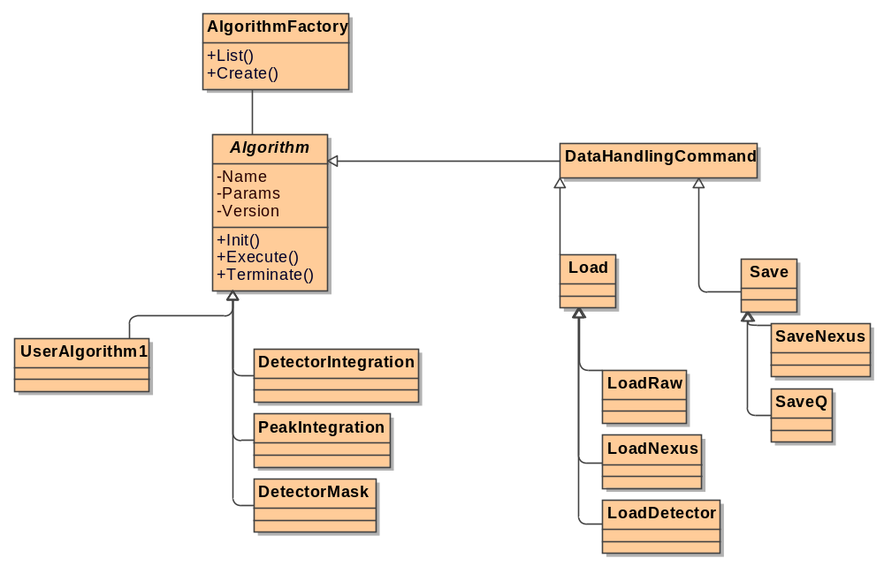

Algorithm Factory
The algorithm factory is responsible for creating instances of algorithm classes on request. This will be used by the framework manager as well as in Algorithms themselves to allow them to create sub-algorithms that can be used to subdivide complex algorithms for simplicity, reuse or performance.
The ‘Abstract Factory’ pattern (“Design Patterns” by E. Gamma et al, Tessella Ref: 2025) will be used to provide a single object creation service for the all of the algorithms and data persistency commands of in the Mantid Framework. During the loading of each plug in library and algorithms contained within them will be registered with the factory using the REGISTER_AGORITHM macro, this will allow user created algorithms to be accessed through the same mechanism. Requests can either specify the name of an algorithm or provide both the name and a specific version. Requests not specifying a version will always return the most recent version. Requests that do specify a version will return the version requested, however if a more recent version is available then a warning will be output on the message service.

Interfaces
The AlgorithmFactory class supports the following interface.
- IAlgorithmFactory – To provide access to
  - Add and remove algorithms from the list of available to the factory.
  - List all of the available algorithms
  - Find algorithms based on a partial name string
  - Create an instance of a specified algorithm
  - Check the existence of a specified algorithm.

Algorithm
The algorithm object provides the support structure for all of the real computational code in the Mantid Framework. Any code that the user would like to be executed on data within the framework must be contained in a class that is inherited from the base Algorithm Class.
Algorithms may be executed by the direct request of a user through the Framework Manager API or they may be instantiated and executed by parent algorithms organising several child algorithms to perform a more complex analysis.
The ‘Command’ pattern (“Design Patterns” by E. Gamma et al, Tessella Ref: 2025) will be used to provide a simple, consistent interface for the all of the algorithms and data persistency commands of in the Mantid Framework. This will allow the framework to handle all algorithms through a single interface.
Generally the job of an algorithm will be to take some data from the Analysis Data Service, alter it in some way and to place the altered data back into the store. The base algorithm class supports this by automatically acquiring the input workspace and storing the output afterwards, as well as providing further support by validating algorithm properties and managing the use of sub-algorithms.

Algorithm properties
Each algorithm may have a list of various properties that are required to configure how the algorithm will function. Examples of this for a simple integration of time bins for 2D spectra would be the max and minimum time bin to include in the integration.
All algorithms will include one these parameters as a minimum (although most will have both).
- InputWorkspace – A workspace within the Analysis Data Service to the main input data for the Algorithm. If a value is provided for this then the workspace will be retrieved by the base algorithm class and provided to be used in the parent algorithm.
- OutputWorkspace – A name for a new workspace to be stored within the Analysis Data Service to containing the resulting output data of the Algorithm.

Data Handling commands
Data Handling commands such as loading and saving data to and from persistent stores will be defined as implementations of the algorithm class themselves allowing them to be created by the Algorithm Factory, and process Algorithm options in the same way as any other algorithm. In addition to loading and saving data to persistent data stores it is envisaged that Data Handling commands will also be provided to add or override detector, sample or sample environment data within the data store.
The data handling commands will be executed just like any other algorithms either by direct execution in response to a request by a user, or by being nested within another algorithm. It is however expected that several of the user interfaces may provide facilities to automate the running of a workflow of analysis algorithms with different input and output files each time, in which case the requisite algorithm options for the load and save commands would be changed for each iteration.
High level Load and Save commands will be included that will implement a ‘Facade’ pattern (“Design Patterns” by E. Gamma et al, Tessella Ref: 2025) will to hide the complexity of selecting the correct command for the common file types. Where possible these high level commands will imply the required specific data handling command based on the file type then pass the processing onto the specific command. This will simplify the data handling of different file types without preventing the users accessing a specific implementation directly should they wish.
Further details of the data access layer will be provided in section 11.

Interfaces
The Algorithm class supports the following interfaces.
- IAglorithm – To provide an interface to control the execution and initialisation of the algorithm.
- IPropertyManager – To provide a consistent mechanism to get and set the internal values to be used by the implementation of an algorithm.

Geometry

Approaches for Computational Geometry
One of the main aims of the Mantid project was to store the full virtual instrument geometry of all of the important components of an instrument. There are two main approaches to representing geometry within software. One is to store a triangular mesh representation of each object, and the other is to use the underlying surface equations of objects to represent them. The figure below shows a simple sphere represented in both approaches and the computational path of an incident neutron together with its reflection for each.
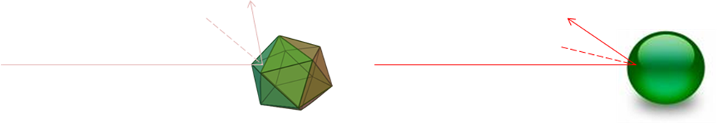
Mesh Based
Surface Based
This highlights one of the disadvantages of the mesh based approach, where imperfections in the triangulated approximation of the surface can significantly alter the results of calculations. A study we performed suggested that for a triangulated sphere to acceptable approximate a real sphere it would need to be created from 1000 triangles and at this scale performance of simple intersection calculations can increase significantly. Of course the surface based approach also has its weaknesses; one is that while simple surface equations exist to describe many primitive shapes it is not easy to provide equations to define more complex shapes used in real life instruments, the other is that visualization techniques used in computer graphic hardware are designed for mesh based geometry, making the efficient visualization of surface based geometry a difficult problem.

Mantid’s Approach to Geometry
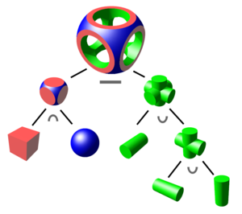
Mantid primarily uses surface based geometry to define the instrument internally for reasons of computational speed and accuracy, but we have taken various approaches to minimise or eliminate the problems associated with this approach. We have designed the system to allow for the use of Constructive Solid Geometry (CSG, show in the diagram to the right) to build complex objects through the use of Boolean intersection, union and difference operations on various primitives. This has proved to be both powerful, but also well understood by users.
In order to solve the problem of visualising these surface-based CSG objects efficiently we taken a hybrid approach to leverage the benefits of both approaches to geometry. As mentioned earlier Mantid stores the instrument components as a construction of surface base primitives formed together using CSG. This representation is used for the definition of the instrument and also for calculations. When we need to visualise the instrument we convert our surface based representation to a triangulated mesh representation using a triangulation library such as the GNU triangulated surface library or the OpenCascade library. This allows the use of standard OpenGL techniques to efficiently visualise the instrument.

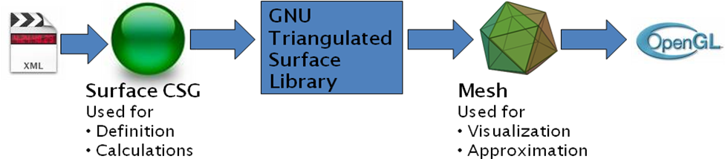

Separation of Shape from Position
Most of the instruments that will be modelled in Mantid will comprise of thousands of individual elements, but most of them will have the same shape. For example the GEM instrument, the majority of the detector elements are the same box shape as each other. In Merlin for example there are 250,000 separate elements, but only 2 distinct shapes. This can be used both to save memory as well as improve performance.
Therefore in Mantid we separate the definition of a components shape from the definition of each components location and orientation.
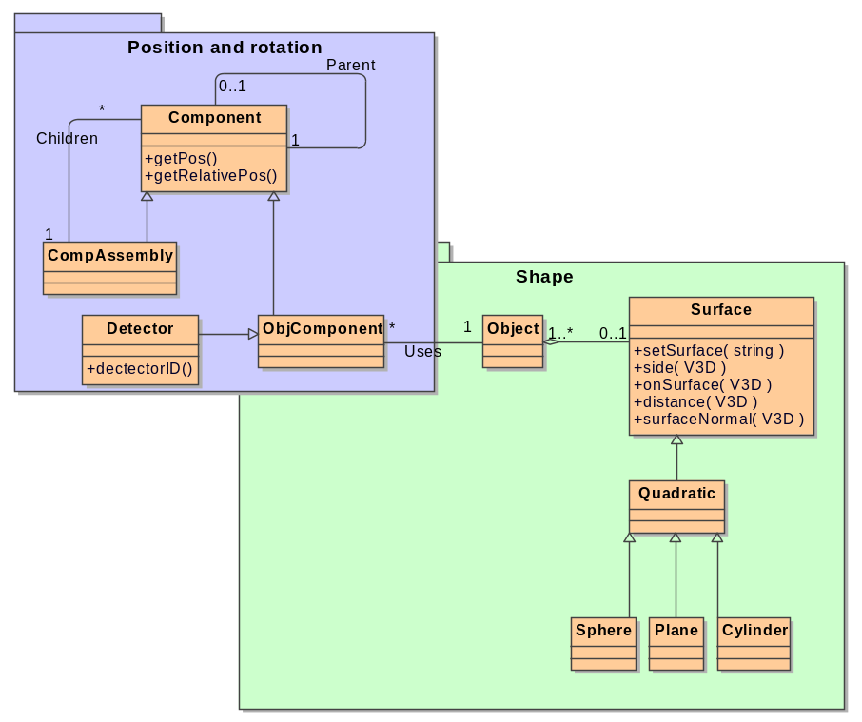
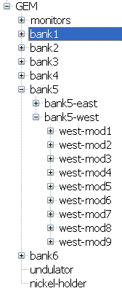
The position and rotation of each component are defined by the component, and component assembly classes. These form a Composite Pattern (“Design Patterns” by E. Gamma et al, Tessella Ref: 2025), allowing for the structure of an instrument to be defined in a tree (an example for the GEM instrument is shown to the right). Each components position and rotation are stored relative to that of its parent in the tree. This make it very easy if a motor in an instrument was to move a whole bank of detectors, you need only to alter the position of the ComponentAssembly defining the bank and all of its children would automatically be updated.
Any component of the instrument that has a real physical shape is defined by an ObjectComponent this class hold a pointer to the object class that defines the shape of the object. As this class refers to the object (shape) class via a pointer many ObjectComponent classes in different locations can share a single Object class. The ObjectComponent class provides a facade to the operations on the Object class and alters the input and ouput parameters of each method to take into account the position and rotation of that particular ObjectComponent.
The Shape of each component is defined using the object and surface classes. As mentioned earlier the object class combines the surfaces to make the final shape through boolean operations using Constructive Solid Geometry (CSG). The various surface classes embody the surface equations that define the surface and various methods that can operate on them.

Data Services
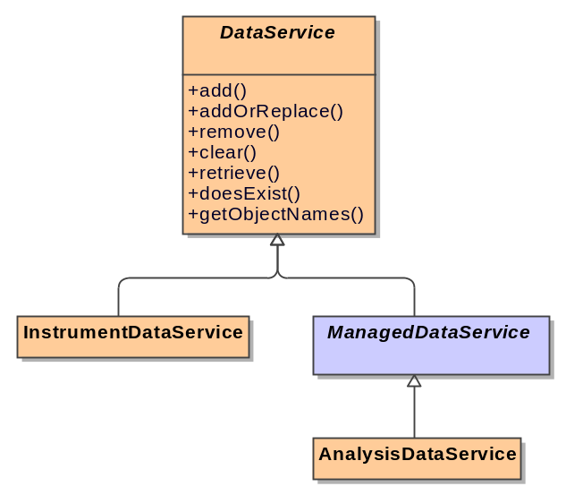
In-memory data objects that are not local to a single algorithm will be owned within the framework by a data service. There will be multiple separate data services within the framework for storing different types of data, mainly separated by the lifetime of the objects within them. Initially we will have two data services.
- An analysis data service for storing the input and output data from the algorithms and data handling commands. This will be referred to as the Analysis Data Service.
- A sample and sample environment data service for maintaining single copies of the base sample and sample environment data, these will generally be referenced by several workspaces in the analysis data service. This will be referred to as the Sample Data Service.
  - An instrument data service that will maintain the detector geometry and wiring references. This will be referred to as the Instrument Data Service.
While the concept of the data service is taken from GAUDI there will be some simplifications.
- The data within the Mantid data stores will be maintained as a list of data objects accessible by an object name rather than a tree structure as used in GAUDI. This is to simplify the use of the framework by removing the need of the users to understand the structure within the data service.
- While the framework will not prevent direct access, the main user interface to the Instrument Data Service will be through specific Data Handling Commands for writing and through the workspace objects (see section 7.2) for reading the data. This will create a simpler interface for clients through a single data service and the workspace objects contained within it.
The following key points of the transient data service will be retained from the GAUDI framework.
- Data Identification. All of the items within a data service will have an identifier allowing the items within to be referred to by a client.
- Data Ownership. Data objects that are placed within a service are owned by the data service. Once an object has been created by an algorithm and registered into a service the algorithm is no longer responsible for the deletion of that object.

Detector Data Service
The detector data service will be responsible for maintaining and providing access to detector data objects. These will store the detector geometry as well as the wiring references required to link a detector number to the physical detector element.

Managed Data Service
The Data services may have to contain large amounts of data the will in themselves exceed the physical memory available on the computer. Tests during the early iterations of this project have shown that relying on the host operating systems support this through the use of virtual memory will result in poor performance and reliability. The managed data service coloured in blue is provided to describe the approach that will be taken if the further memory management is required.
The Managed data service is a specialised data service that adds memory management functionality. This data service will check on the amount of memory that has been consumed so far by the data store whenever a new object is registered within it. If the amount of memory used exceeds the acceptable limit (which will be defined in the application configuration file) then the managed data service will look for DataObjects that it contains that are suitable to be temporarily moved out to persistent storage.
To select suitable DataObject to remove from the system memory the following steps will be considered.
- The DataObject must have only one reference held against it. This reference will be owned by the Managed Data Service itself and proves that it is not in active use by any other code within the framework.
- Those DataObjects that have only one reference will be ordered by the time that they were last requested from the data service and those requested least recently will be selected for removal.
Sufficient DataObjects will be selected for removal until the memory usage drops below the acceptable limit.
When a DataObject has been selected for removal one of the following two paths will be taken depending if the DataObject has been loaded from, or saved to, a persistent data store as its last operation.
- If the DataObject is a direct unmodified copy from a persistent data store then it will not be persisted again, simply removed from memory.
- If the DataObject has been modified by an algorithm since it was last saved, then a default Data Handling Command will be used to store the DataObject to a temporary location within a persistent data store, and the object will be removed from memory.
In both cases a Placeholder Object will be placed within the data service to represent the DataObject that has been removed. This will hold sufficient information for the Managed Data Service to restore the object if it is requested.
The Managed Data Store will maintain a list of all of the temporary data it has created on the persistent data store and will remove them when it is reinitialised or finalized.

Analysis Data Service
The Analysis data service is a (managed) data service that is specialized to store instances of the workspace object and anything that derives from it. This is the primary data service that the users will interact with either through writing scripts or directly through the API. The base algorithm class in association with workspace properties performs the majority of the interactions with this data service so that specific algorithms do not have to.

Sample Data is not supported by a data service
While sample data will often be shared between workspaces there is no need to store the sample data if all of the workspaces that share it should be deleted. Therefore this data structure can be maintained by shared pointers and does not require a data service.

Workspaces
Workspaces will be used inside the framework to provide some structure to the Data Services and simplify users access to the experimental and analysis data.

Workspace Contents
In addition to the experimental data a workspace contains several other important collections of information.
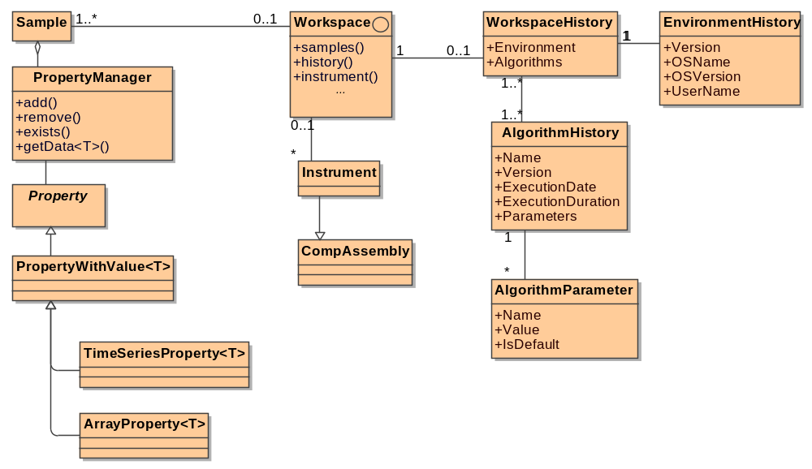

Samples
The Sample class reuses the same PropertyManager class as the base algorithm class. This provides a simple but highly extensible collection of data may be stored in this object relating to either the sample or sample environment. The PropertyManager class essentially comprises of a keyword string keyed map storing and providing access to an extensible choice of underlying Property objects. A range of specific properties have been be created for storing Time series data, arrays and single values, further specific properties will be created as the need arises.
While the concept of these classes allows them to store any object under any key, each concrete implementation of this class will provide a list of the common key strings implemented as constant of the class, to simplify there usage and encourage consistency. If required the classes may also provide specific accessor properties to access commonly stored data items.

Instrument
The instrument class is the top level class for the instrument tree described in section 5. As such it inherits from the ComponentAssembly class but extends this with several methods for storing and retrieving items from the instrument tree.

History
The History classes provide contains much more defined data and does not require the same flexibility of the sample and environment data; therefore it will be implemented in a simple, less abstract manner. The history object itself will comprise of an EnvironmentHistory that will store information about the Mantid and host environment, and an ordered collection of AlgorithmHistory objects that will detail each running of an algorithm that occurred to make up this workspace.
The AlgorithmHistory objects will in addition to holding the details of the algorithm will also store information about the all the properties that were set for the running of the algorithm. This should provide sufficient information for the analysis to be rerun at a later date.

Workspace Types
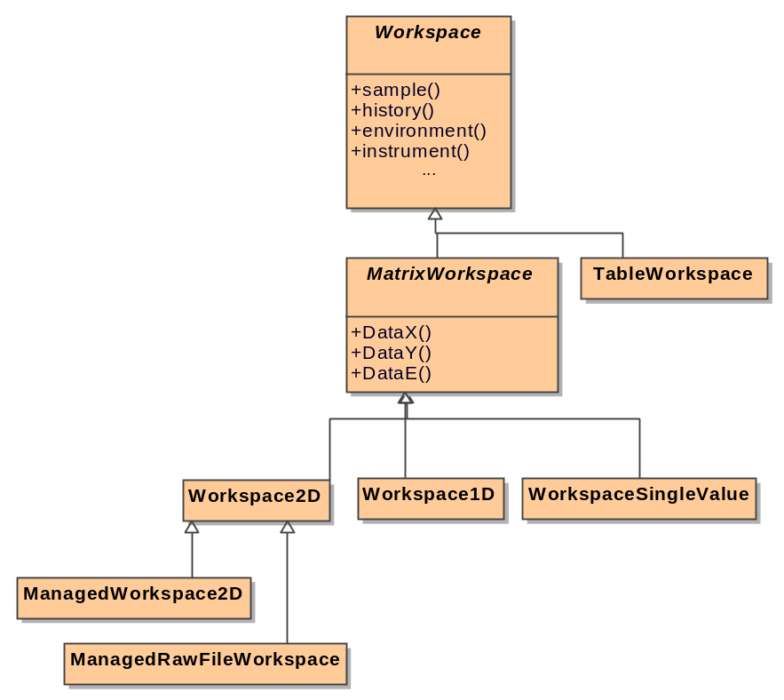
Workspaces will provide the base object for the Analysis Data Service. The workspace is an abstract base class that provides lots of functionality through links to the Sample, Sample environment and Detector data object.
The workspace object will be the primary data object for both the input and output of data to algorithms. If a particular algorithm can only work with a specific type of workspace then it will test its input workspace at the beginning of its execution an cast the reference upwards as necessary.
The MatrixWorkspace abstract class build on the workspace class and add a common form of data access methods for a collection of workspace types.

Workspace Implementations
There will be several concrete implementations of the workspace object each designed to hold a different type of data or perform additional functionality.

TableWorkspace
This workspace holds a variable length list of tuples (rows within a table). The number of columns and the content of the columns of the tuples is variable making this a very flexible data type at the expense of memory usage and ease of use. An example of data that this might be used for is the output of a peak finding algorithm. The table workspace does not itself inherit from MatrixWorkspace as the data access methods that would impose would not make sense for this data structure.

WorkspaceSingleValue
The single value workspace can hold a single numeric value as its internal data.

Workspace1D (removed)
This workspace is specialised to hold a 1D histogram together with error information if appropriate. This would be the most common workspace used for loading a single spectra.

Workspace2D
This workspace is specialised to hold a 2D histogram together with error information if appropriate. This would be the most common workspace used for loading a small or medium sized raw file into.
Prior to release 3.2, we had specialised data structures to handle the situation where the system was close to running out of physical memory. Now that we support solely 64 bit builds, we can rely on system swap memory to fulfil this function.

ManagedWorkspace2D (removed prior to release 3.2)
This is a specialization of the 2D workspace that can handle raw files that are larger than the available memory space. It operates using a an uncompressed binary file containing the data together with a collection of in memory buffers to optimise performance. The detailed design of this workspace is detailed in the ManagedWorkspace detailed design document [MW-DDD]. This allows large workspaces that exceed the amount of memory available to be operated on seamlessly, at the expense of some performance.

ManagedWorkspaceRawFile (removed prior to release 3.2)
This is a variant of the ManagedWorkspace2D, but instead of using a large uncompressed binary file as the underlying data store it uses the original RAW file. As such it can only be used when first loading a raw file, and would be inherently read only. If the use modifies this workspace through some algorithm the workspace converts the underlying data store to that of a ManagedWorkspace2D in order to allow updates.

Command line and Scripting Interface
Mantid uses the Python scripting language as a scripting interface and also to provide an interactive command line interface. The use of a single tool to provide both the scripting interface as well as the command line interface will ensure the syntax compatibility of both methods. We have selected Python for the following reasons:
- Python uses an elegant but easy to learn and read syntax.
- Python is easy to use language that is designed to be ‘natural’ to understand making it an excellent choice for rapid prototyping of new algorithms etc.
- Python provides an interactive mode of single line interpretation making it suitable for use as a command line interface.
- There are several scientific libraries available in Python should we choose to use them. Examples include SciPy, NumPy, PyGSL and PyROOT.
- Python can be easily extended using C or C++.
- The API of the Mantid framework can be easily exported to Python using BOOST.Python.
- Python runs on Windows, Linux, MacOS and many brands of Unix.
- Python is released under an open source license and is free to use both as a scripting language but also to embed into your applications.
Through the use of BOOST.Python to provide python bindings to the Mantid API the users will have full access to the functionality of the framework, including:
- Creating and executing algorithms as well as reading and setting the properties of the algorithms.
- Use of all of the available services within the Mantid Framework.
- Access to all of the DataObjects on the temporary data stores.
- The ability to access load and save data onto persistent data stores using Data Handling Commands.
- Creating new algorithms purely within Python by inheriting from the Mantid Algorithm class. These python algorithms will be able to be used within the Mantid framework just like a native C++ algorithm. This will allow rapid prototyping of algorithm code.

Scripting for an Extensible Framework
Mantid is written to be extensible through a plugin system that can extend the algorithms available at run time. When the framework starts up it reads all libraries in the defined plugins directory and includes any algorithms or workspaces it finds and makes them available just like any other algorithms. This flexibility can make it more difficult to write an effective API for the framework, as the list of algorithms and their required inputs is not known until run time. Mantid initially took the approach of providing a very generic API, where to run an algorithm you called a method specifying the name of the algorithm in a string and all of the required inputs in another string
For example:
mantid.exec(“LoadRaw”,”ws1;c:\myFiles\ins001.raw”)
This was far from ideal as it mixed the algorithm’s list of inputs into a single string that had to be parsed to extract the information. It was also not well received by users who were unused to object oriented development or such an abstract approach. The users wanted to be able to call a command directly by it name rather through another object or method.
Mantid solves this problem by writing a specfic API at run time, just before it is needed. Once a user starts up the scripting API (either Python or Matlab) the framework writes out a simplified API once all of the plug-ins have been loaded. At this point the framework knows all of the algorithms and their parameters and can create specific methods for each one, in addition help can be created for each algorithm to detail the required inputs. This provides the much simpler interface the users desired.
For example:
LoadRaw(“ws1”,”c :\myFiles\ins001.raw”)

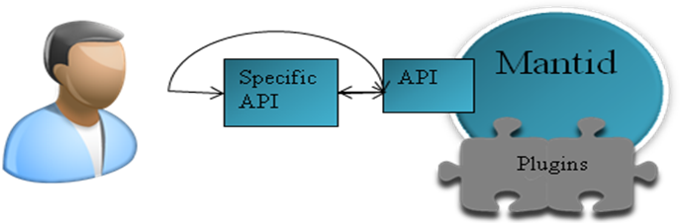
Initial Call forces the writing of the specific API
Subsequent calls

Scripting within the Visualization tool
The visualization tool is described in the next section, but it has also been developed to support python scripting. A script window is available within the program that includes code colouring and execution capabilities. When operating within the visualization tool the scripting language API is also extended to support the following:
- The ability to invoke the Algorithm parameter input dialog boxes, simply by adding the keyword Dialog to the end of the algorithm name (i.e. LoadRaw(...) becomes LoadRawDialog(...)). This allows scripts to easily request user input when required.
- The ability to create and interact with many of the windows and graphing tools within the visualization tool.
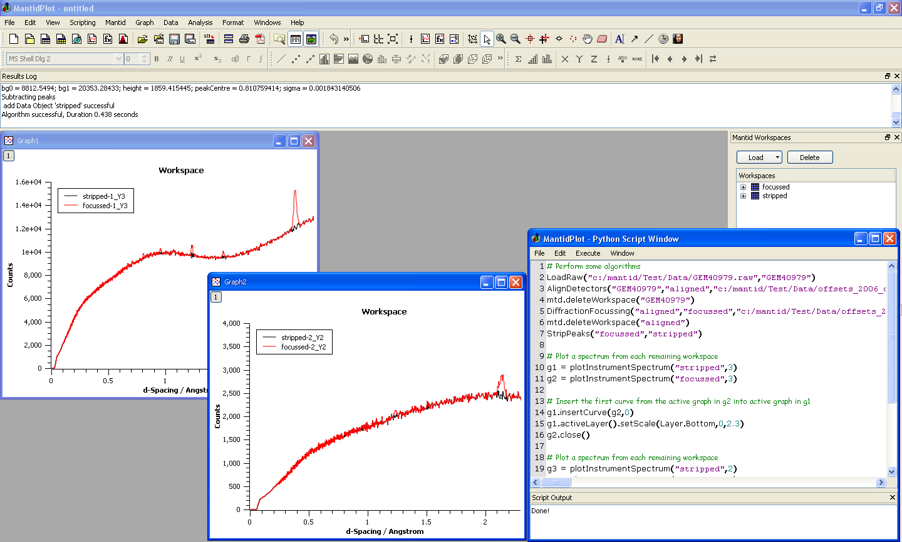

Visualization Tool – MantidPlot

QtiPlot
The visualization tool is called MantidPlot and is built upon the open source project QtiPlot (http://soft.proindependent.com/qtiplot.html). QtiPlot is a well featured data analysis and scientific plotiing tool bearing significant similarities in functionality and look and feel to Origin. QtiPlot is developed on top of the following software libraries.
- QT – a cross platform user interface building framework
- Qwt – a selection of 1D and 2D graphing tools for QT
- QwtPlot3D – A plotting library for 3D plots using OpenGL
- GSL – a scientific library including curve fitting etc
- muParser – a math parser
- Python 2.5 – the python scripting language.
- PyQT – python bindings for QT

MantidPlot extensions
Mantid Plot has extended QtiPlot in many areas.

Running Algorithms, importing workspaces and plotting workspace data
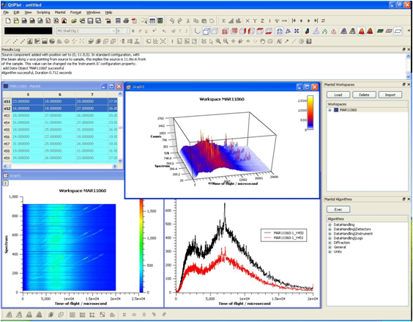
Mantid have added two dockable windows that give access to run all of the algorithms and access all of the Workspaces in the Analysis Data Store.
When running any of the algorithms a parameter input window is dynamically generated including suitable input controls for each parameter and automatic validation of the user input. When running the user has the choice to run the algorithm in the background or watch the progress interactively.
The workspace matrix displays and graphs update dynamically should the data they contain change. This has been implemented using the Boost and QT signal and slot event mechanism.

Instrument View
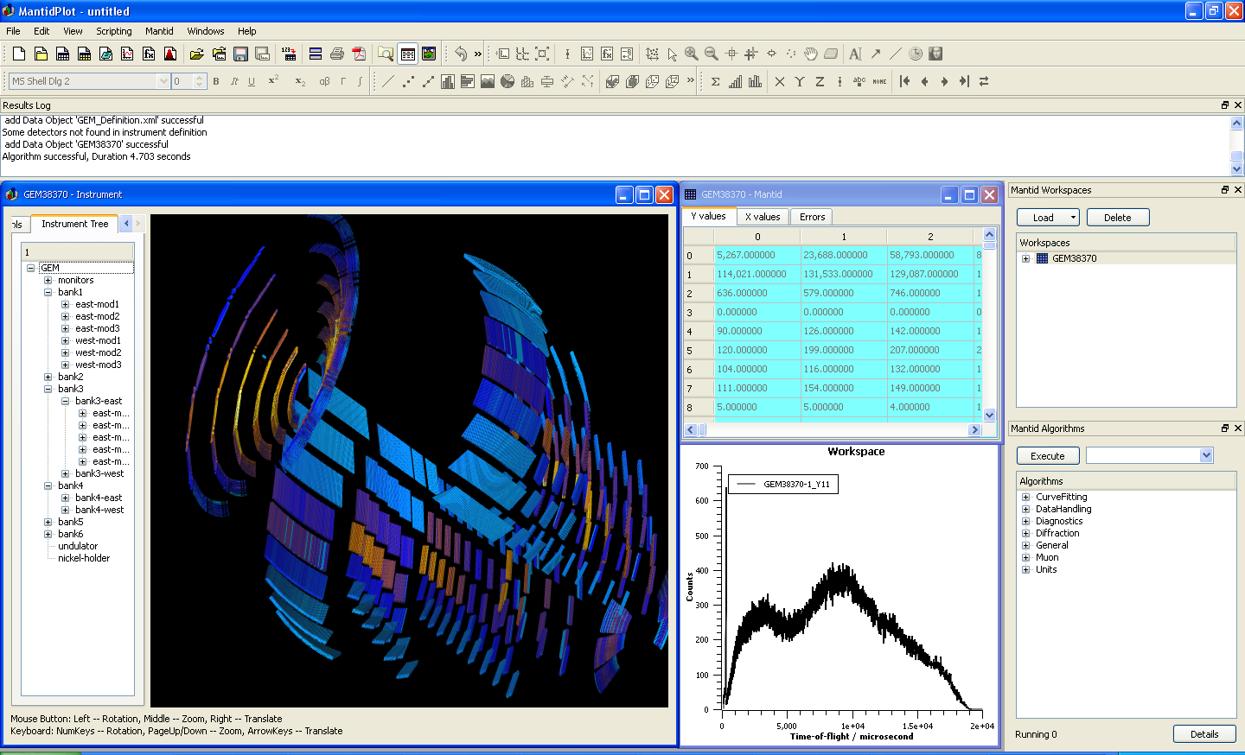
A new display window has been added to QtiPlot that provides a 3D visualization of the instrument using OpenGL. This uses the instrument geometry data to construct the instrument in 3D and colours the detectors with the data within the Workspace. The interface allows users to navigate around the instrument, either freeform using the mouse or by using the instrument tree view. The instrument view also support picking functionality to display further details or 1D graphs from detectors selected in the instrument view.

Security Sub-system
The framework itself provides no security functionality, the data protection is provided by other systems controlling access to the ISIS data archive.
For users external to ISIS the framework will perform operations only on files that have been obtained and can be accessed directly on the file system.
For internal users the framework will also allow files to be retrieved from the ISIS data archive if the required file share is accessible. Internal users will be defined by whether the file share is accessible.

Data Access Layer

Class Descriptions
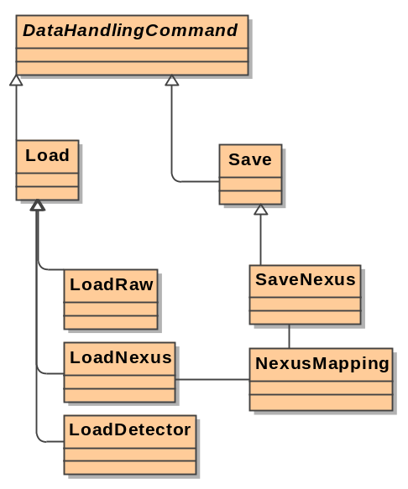
The Data handling commands introduced in section 4.2.2 together with a few helper classes will comprise the data access layer of the Mantid Framework.

Load & Save Data Handling Commands
The Load and Save commands will provide a simple façade to the specific Load and Save commands described in the next section. These algorithms will inspect the target file (or filename for the Save command) before instantiating the appropriate specific load or save command and using that to perform the operation. The result of this is that in the majority of situations the users must merely use the simple Load or Save commands and the framework will use the appropriate specific command. This will however not prevent the user from directly using one of the specific commands should they wish.

Specific Load… and Save… Data Handling Commands
The specific load and save commands are responsible for actually loading and saving the contents of analysis workspaces to persistent storage. These command will be used internally by the Framework for dynamic memory management as well as through direct calls from the user. As with all Commands and Algorithms that create a workspace as an output, Load commands are responsible for creating the new workspace and for registering it with the Analysis Data Store.
In situations where the framework provides both Loading and Saving commands for the same persistent format then the common information relating as to how to map the data between the persistent format and the workspace format will be maintained in a Mapping class that can be used by both commands (for an example see the NexusMapping object in the previous diagram).

LoadInstrument

Data Storage

Raw Files
Raw files are the standard output data format of the ISIS target station 1 instrument data acquisition system. They are a binary file using a simple compression algorithm to achieve a nearly 4-1 compression of the neutron counts in the file.
The format and compression used in this file type are described here http://svn.mantidproject.org/mantid/trunk/Code/Pilot/GAUDI/ISISCnv/libget/libget.txt.

Nexus Files
The Nexus file format is an XML file format that is attempting to provide a standard data interchange format between Neutron facilities. The specification is not yet finalised and is controversial among some instrument scientists, however it has been suggested that all of the output files from ISIS target station 2 instruments will be Nexus files (as opposed to Raw files) and therefore the mantid framework will support this.
One further advantage of the Nexus files is that the structure allows much more detailed sample and detector data to be stored than is possible in Raw files.
The website http://www.nexusformat.org/ (perhaps only accessible from inside RAL) describes the format.
As well as being used as a flat file xml format the NEXUS format specifies that it may also be encased within a HDF4 or HDF5 compressed format to reduce disk storage. The HDF formats are a compressed format provided by the HDF group http://hdf.ncsa.uiuc.edu/
HDF5 may be more suitable for handling large files as it has support for partial file access.

Instrument XML files
The geometry of the various instruments are defined in instrument definition files. The format while defined has yet to be documented. Some documentation for the use of xml tags to define shapes is has been documented [Geometry XML].

Third-Party Software
The following third party software may be included within or during development of the Mantid Framework.
Name | Reason | License | Reference
GAUDI v19r3 | Much of the structure of the framework is based on sections of the GAUDI framework. | Free | http://proj-gaudi.web.cern.ch/proj-gaudi/
QT 4 | To provide a high quality cross platform user interface | GPL | http://trolltech.com/products/qt
Python 2.5.4 | To provide a cross platform scripting and command line interface. | Free | http://www.python.org/
BOOST.  1.34.1 | To provide a simple but powerful binding interface between the API and python. Also used for Boost signals and shared pointers | BOOST | http://www.boost.org/
POCO 1.3.1 | To provide Logging and cross platform files access and signals. | BOOST | http://pocoproject.org/
GSL 1.10 | Scientific library including function optimisation | GPL | http://www.gnu.org/software/gsl/
Doxygen | To provide code documentation. | GPL | http://www.doxygen.org/
CxxTest | To provide a framework for unit testing | LGPL | http://cxxtest.sourceforge.net/
Qtiplot | To provide histogram charting in QT | GPL | http://soft.proindependent.com/qtiplot.html
Trac 0.10.4 | Work item and bug tracking | BSD | http://trac.edgewall.org/
Subversion 1.4.4 | Source code control | Free | http://subversion.tigris.org/
SIP | Python wrapper generation | GPL | http://www.riverbankcomputing.co.uk/software/sip/intro
PyQT | Python wrapper for QT | GPL | http://www.riverbankcomputing.co.uk/software/pyqt/intro
QScintilla | Editing control for Qt | GPL | http://www.riverbankcomputing.co.uk/software/qscintilla/intro

Design Scenarios

User running a simple algorithm using the Mantid interface
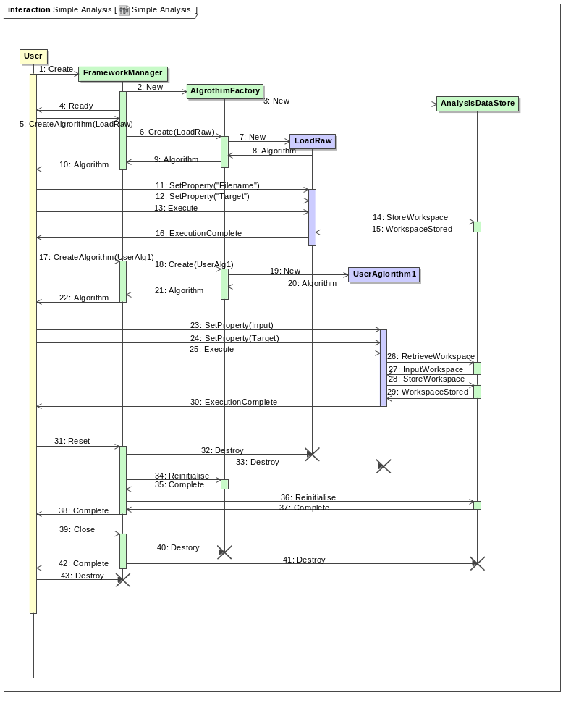
This sequence diagram shows the interaction of the major objects of the Mantid framework during a simple user interaction. The diagram shows the following users steps from there point of view:
- Creating a new instance of the Mantid API
- Creating, setting properties for and executing the LoadRaw algorithm.
- Creating, setting properties for and executing the UserAlg1 algorithm.
- Resetting the framework to clear all the data repositories (and remaining algorithms instances).
- Closing the Framework to release resources.

System-Wide Features
A number of design issues apply to the system as a whole, and cannot be isolated to a single component. Such things include:

Language
The mantid framework will not provide multi language support and will be written in the English language.

On-line help
The API will provide a simple listing of the possible commands that is supports through a simple help command. Each object factory (eg. The algorithm and service factories) will be able to list all of the objects that it can create.
The viewing tool will provide a single help page encapsulated within the program to explain the major features, further help may be available on the Mantid wiki if a connection to the internet is available.

Error-Handling
Expected errors will be handled as close to the source of the code as is practical, all exceptions will be logged to the message service and where possible corrective action will be taken. If the exception cannot be rectified then it will be rethrown to higher level error handling routines.
A top level error handling routine will catch and log all unhandled exceptions and log them before exiting the framework.

Automated Debugging, Testing and Diagnostics
The code will record events with various different statuses and the application will have an option to select which status events are logged.
The major methods of classes will have their own automatic self-checking tests using the CxxTest framework to enable frequent, extensive unit tests to be run throughout development. Each Algorithm will have a unit test to ensure the expected results given a standard set of input data.

Statutory and Regulatory
Tessella is not aware of any Regulatory and Statutory requirements relating to this project although we have not carried out any specific investigation to confirm this. It is the customer’s responsibility to advise us if there are such issues that need to be addressed.

Development Environment
The framework will be developed using the C++ programming language, using the GCC (version 4.2) as the reference compiler. It is possible that during later releases we will also compile using the MSVC++ compiler (version 8.0) for improved performance on windows environments.
Eclipse will be the preferred development environment due to the cross platform compatibility and the availability of plug-ins for both QT and CxxTest.

Cross-Reference to Software Requirements
This section shows how the design satisfies the software requirements.
SRD Section | ADD Section | Comments
S4.1.1 | 4,4.1,4.2,3.4
S4.1.2 | 4.2.1
S4.1.3 | 4.2 | The algorithm base class will abstract away the job of retrieving and storing workspaces.
S4.1.4 | 4.1
S4.1.5 | 12,14.3
S4.1.6 | 4.2,15 | Fortran wrapping is not explicitly mentioned in the document, but an example will be provided.
S4.1.7 |  | Parsing an algorithm – This has not been detailed in the document, but it intended that a switch in the base algorithm class will allow this by no actually running the overridden exec function.
S4.2.1 | 3.2.1 | The API section of this document needs to be further detailed. The envisaged main objects exposed in the API are the Framework Manager, the Workspaces and the base algorithm class.
S4.2.2 | 3.2.1 | See above
S4.2.3 |  | Events: the use of events needs to be detailed when the method for implementing them has been decided.
S4.3.1 | 8
S4.3.2 | 8
S4.4.1 | 3.4
S4.4.2 | 3.4
S4.4.3 | 3.4
S4.4.4 | 3.4
S4.4.5 | 3.4
S5.1.1 | 8
S5.1.2 | 8
S5.1.3 | 8
S5.1.4 | 8
S5.2.1 | 9 | The visualization tool needs further definition
S5.2.2 | 9 | The visualization tool needs further definition
S5.2.3 | 9 | The visualization tool needs further definition
S5.2.4 | 9 | The visualization tool needs further definition
S5.2.5 | 9 | The visualization tool needs further definition
S5.2.6 | 9 | The visualization tool needs further definition
S5.2.7 | 9 | The visualization tool needs further definition
S5.2.8 | 9 | The visualization tool needs further definition
S5.2.9 | 9 | The visualization tool needs further definition
S6.1.1  S6.1.2  S6.1.3  S6.1.4  S6.1.5 | 4 | The details of the specific algorithms will be detailed in the TRAC tickets created for there implementation not here.
S7.1.1 | 7.1.2 | Details on Geometry need to be added
S7.1.2 | 7.1.2
S7.1.3 | 7.1.1
S7.1.4 | 7.1.1
S7.1.5 | 7.3.5
S7.1.6 | 7.1.3
S7.1.7 | 7.2,6.4
S8.1.1 | 11.1.2,11.2.1
S8.1.2 | 11.1.2,11.2.1 | The functionality of the LoadLog data handling command will be called within the LoadRaw command.
S8.1.3 | 11.1.2,11.2.2
S8.1.4 |  | Will not be included initially.
S8.1.5 |  | This is a functional detail of the LoadRaw command.  It may be worth adding a section on it as it does quite a lot.
S8.1.6 | 11.2.2
S8.1.7 | 11.1.1 | Accessing Data from the DAE, this will be implemented as a LoadDAE command. Perhaps this needs detailing.
S9.1.1 | 15 | Support on both Windows XP SP2 and linux(Fedora), this needs to be spelled out in it’s own system wide section.
S9.1.2 |  | Linux min specification, not specifically covered
S9.1.3 |  | Windows min specification, not specifically covered
S9.2.1  S9.2.2  S9.2.3 |  | Documentation requirements
S9.3.1 |  | Performance requirement, to be included in the system test.
S9.3.2 | 6.3, 7.4 | Memory management requirement
S9.3.3 | 6.3, 7.4 | Memory management requirement
S9.3.4 |  | GPGPU requirement, The plug in dll support and user extensible algorithm libraries would allow a user to add a GPGPU processing library is required.
S9.3.5 |  | Asynchronous algorithm support optional requirement. This would need to be provided through the use of additional methods and event in the algorithm base class.
S9.4.1 | 14.4
S9.5.1 |  | Linux install package
S9.5.2 |  | Windows install package
S9.5.3 |  | Source code available
S9.7.1 |  | No framework requirement for a network or ISIS connection.

