Tessella Project Number: 5951
Tessella plc 26 The Quadrant, Abingdon Science Park, Abingdon, Oxfordshire, OX14 3YS, UK
T: +44 (0)1235 555511 | F: +44 (0)1235 553301 | E: info@tessella.com | www.tessella.com

Client: Rutherford Appleton Laboratory

Mantid
Workspace Locking Design Document



Document Control
This document is under document control. All members of the distribution list will receive updated copies whenever alterations are made. All other copies are uncontrolled.

Document Owner
Name | Role | Company
Nicholas Draper | Owner | Tessella

Document Approval
The following are required to approve this document. Their approval signifies that the document is fit for purpose and approved for use. .
Name | Approval Role | Company
Janik Zhikovsky | Subject Expert | ORNL

Distribution
Name | Role | Company
Mantid Git repository | Filing | GitHub

Revision History
Author | Issue | Date | Description
Janik Zikovsky | V1.R1.M0 | 09/23/10 | 1st version written

References
Document | Ref | Date | Details & Issue
Architectural Design Document | [ADD] | 11-Nov-2009 | V1.R2.M1
Table of Contents
1 Introduction 4
1.1 Purpose of this Document 4
1.2 Scope of this Document 4
1.3 Context of this Issue 4
1.4 Definition of Terms 4
2 Detailed Design 5
2.1 Overview and Context 5
2.2 Scenarios 5
2.2.1 Scenario 1 – One display and a script 5
2.2.2 Scenario 2 – Multiple displays and one update 5
2.2.3 Scenario 3 – Multiple simultaneous algorithms 5
2.2.4 Scenario 4 – A long running script, simultaneous algorithm and a display 5
3 Proposed solution 5
3.1 Lock types 5
3.1.1 Read Lock 5
3.1.2 Write Lock 5
3.1.3 Script Lock 6
3.2 Implementation 6
3.3 Worked Scenarios 6
3.3.1 Scenario 1 – One display and a script 6
3.3.2 Scenario 2 – Multiple displays and one update 7
3.3.3 Scenario 3 – Multiple simultaneous algorithms 7
3.3.4 Scenario 4 – A long running script, simultaneous algorithm and a display 8

Introduction

Purpose of this Document
This document describes the design of the Workspace locking component of the Mantid Framework.
It is based on the design specified in the Architectural Design Document [ADD]
It will form the basis of the development of this aspect of the framework and act as a guide for maintaining the system.

Scope of this Document

These requirements cover the development of the Workspace locking aspect of the Mantid Framework.

Context of this Issue
This is the first draft of the WL-DDD derived from the ADD and after internal review will be updated and used as a basis for the development of the system.

Definition of Terms
ADD | The Architectural Design Document (this document), the high level design document for the entire system.
URD | The User Requirements Document, records the users’ requirements for the system.
SRD | The Software Requirements Document, specifies the behaviour of the software system.
API | Application Programming Interface, defines the interface through which two programs may interact.

Detailed Design

Overview and Context
It is apparent that with the scenarios above that some form of locking of access to workspaces is required, particularly as volumes get larger and operations slower. However it is worth noting at this point that this issue has not been raised directly by our users yet, and therefore we need to be careful not to over engineer a solution to an issue that has not become a problem yet.
On the other hand it is worth thinking the potential solution through, any locking will affect performance of Mantid and it is essential that this is minimised by correctly designing the locking mechanism to prevent unnecessary waiting for a lock. Currently there are certain scenarios that would allow simultaneous operations to interfere with algorithms or displays resulting in incorrect data.

Scenarios

Scenario 1 – One display and a script
- One display needs to update
- A script of updates to the same workspace

Scenario 2 – Multiple displays and one update
- two displays needs to update
- an algorithm

Scenario 3 – Multiple simultaneous algorithms
- two simultaneous algorithms trying to alter the same workspace

Scenario 4 – A long running script, simultaneous algorithm and a display
- A script of updates to the same workspace
- A simultaneous algorithm trying to update the same workspace
- A display showing the workspace

Proposed solution

Lock types

Read Lock
A read lock prevents write locks or script locks being put in place for this workspace, but it does not prevent other read locks being taken. This is intended to ensure that any displays or algorithms get a consistent read of the data of a workspace.
Uses of a Read Lock:
- All algorithms would take a read lock on all input workspace, and release at the end of execution
- All viewers would take a read lock while updating, and release as soon as it has finished reading data

Write Lock
Write locks prevent any other lock being taken out on a workspace. Write locks should be released as soon as the algorithm has stored it’s workspace.
Uses of a write lock:
- All algorithms would take out a write lock on all output or inout workspaces. This should be released as part of the Store() command. This will entail passing the lock object to the ADS, as the lock really wants to be released in between the BeforeUpdate notification and the AfterUpdateNotiifcation it sends.

Script Lock
This concept is to allow script to reserve a name within the ADS for use just within a script, and not allow any write locks that are not created as part of the script. However there remains several issues around lock ownership, and passing the key to algorithm calls within a script that need to be ironed out. Scenario 4 is an example of the need for this.

Implementation
If we do not consider the script lock for now a good candidate for implementation id the Boost read/write lock.
http://www.boost.org/doc/libs/1_34_1/doc/html/thread/concepts.html#thread.concepts.ReadWriteLock
using the TimedReadWriteLock to allow for waiting for a lock (with timeout).

Worked Scenarios
Pictures generated using ArgoUML with file WorkspaceLocking.zargo

Scenario 1 – One display and a script
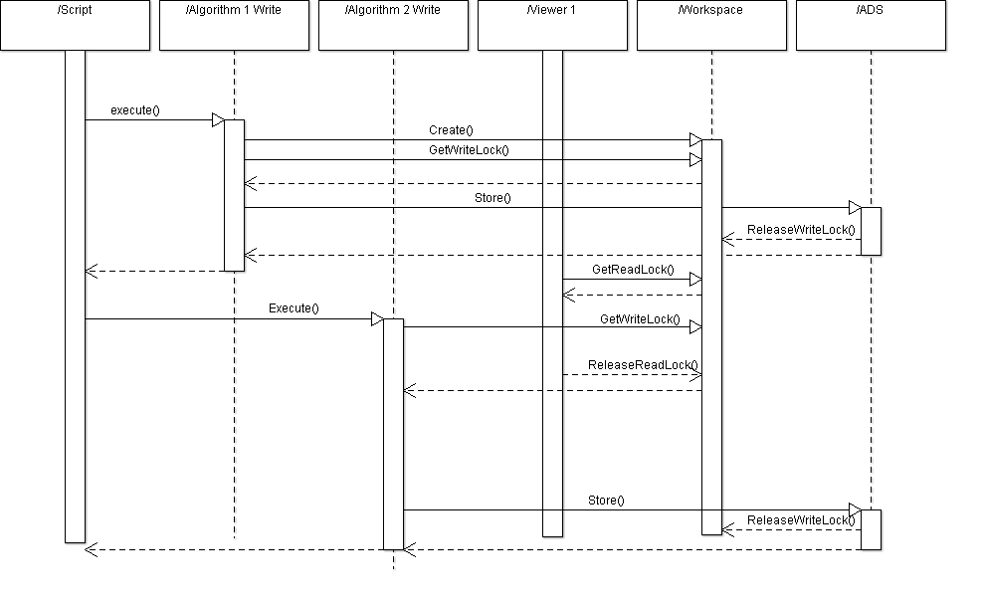

Scenario 2 – Multiple displays and one update
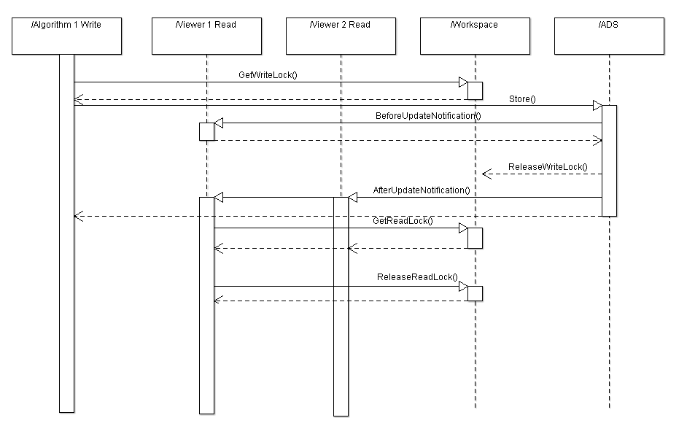

Scenario 3 – Multiple simultaneous algorithms

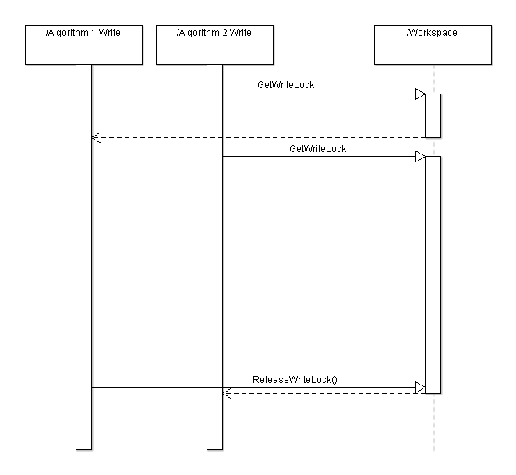

Scenario 4 – A long running script, simultaneous algorithm and a display
I’m not happy about this one

