Summary and explanation of existing Horace plot commands

Data plotting commands
Command (dimensionality) | Application | Frequency of use
plot (all) | Wrapper to most commonly used plotting function for each dimensionality of dataset | High
dd (1) | Plot markers, errorbars, interconnecting lines. Replaces existing current 1d plot window (if one exists that has not been kept), or creates a new one | High (One of the 2 most common ways to plot data)
pd (1) | Plot markers, errorbars, interconnecting lines. Overplots in existing 1d plot window (if one exists, otherwise creates a new one) | High (very useful if you want to plot more than one dataset on the same axes)
dh (1) | Plot histogram, replacing current 1d plot window | Low (historical from Genie)
ph (1) | Plot histogram, overplotting current 1d plot window, if one exists | Low (historical from Genie)
dl (1) | Plot lines (but not markers or errorbars) connecting points. Replaces existing 1d plot window | Medium (Good for plotting simulation curves, rather than data)
pl (1) | Plot lines (but not markers or errorbars) connecting points, overplotting current 1d plot window | High (frequently used for plotting a fit on top of some data)
dm (1) | Plot markers (but not lines or errorbars) for points, replacing existing 1d plot window | Low (occasionally used if you want to hand craft a particular plot style for a publication quality figure)
pm (1) | Plot markers (but not lines or errorbars) for points, overplotting on existing 1d plot window | Low (occasionally used for hand crafting a plot style for publication quality figure)
dp (1) | Plot markers and errorbars (but not lines), replacing existing 1d plot window | Very high (“plot” command is an alias to this function. i.e. the default 1d plot routine for data in Horace)
pp (1) | Plot markers and errorbars (but not lines), overplotting on existing 1d plot window | High (very useful for plotting more than one dataset on the same axes in the default Horace style)
de (1) | Plot errorbars (but not markers or lines), replacing existing 1d plot window | Low (only used in rare cases for hand crafting publication quality figure)
pe (1) | Plot errorbars (but not markers or lines), overplotting in existing 1d plot window | Low (only used in rare cases for hand crafting publication quality figure)
ploc (1) | Plot line (but nor markers or errorbars), over existing plot window (which may not be 1d) | Medium (useful for plotting a calculated dispersion curve on top of a colormap Q-E slice from data)
pmoc (1) | Plot markers (but not lines or errorbars) over existing plot window (which may not be 1d) | Low (can do the opposite of above, so plot a calculated colormap then overplot some measured points on a dispersion curve)
phoc (1) | Plot histogram over existing plot window (which may not be 1d) | Very low
peoc (1) | Plot errorbars (but not lines or markers) over existing plot window (which may not be 1d) | Very low
mp (array of 1d) | Multiplot an array of 1d objects. Like running a for-loop with pp. | Medium
sp (array of 1d) | Stem plot an array of 1d objects | Very low
da (2) | Area colormap plot of 2d data | Very high (“plot” command is an alias to this for 2d data)
ds (2) | Surface plot of 2d data | Medium
sliceomatice (3) | Sliceomatic UI opened for 3d data plotting | Very high (“plot” command is an alias to this for 3d data)
sliceomatic_overview (3) | Sliceomatic UI opened for 3d, with camera angle chosen so that view is from above. Similar to slice view in Mantid | Medium (useful for looking at elastic Bragg peaks measured during an inelastic Horace experiment)

Plot modification commands
Command | Application | Frequency of use
acolor <r,g,b,c,m,k,y> | Set color of subsequent plots (so type first, then make a plot) | High
aline <-,--,-.,:> | Set line style of subsequent plots (solid line, dashed line, dash-dot line, dotted line) | Medium (useful for showing more than 1 fit to the same data in a publication figure)
amark <'+', 'o', '*', '.', 'x', 's', 'd', '^', 'v', '>', '<', 'p', 'h'> | Set marker style of subsequent plots (plus, circle, star, dot, cross, square, diamond, triangle up, triangle down, triangle right, triangle left, pentagram, hexagon) | High (useful for distinguishing different dataset that have been overplotted)
lx, ly, lx <low, high> | Set upper and lower limits for x, y, z (color) axes in current figure window. With no arguments reverts to defaults | Very high (used almost all the time)
linx/liny/linz | Choose the x,y,z axes to be linear scaled for subsequent plots (this is the default in Horace) | Medium
logx/logy/logz | Choose the x,y,z, axes to be log scaled for subsequent plots | Medium
xycursor | Place cross-hairs on a plot and prompt to write x, y, (x,y) or text to be written at a mouse click | Low
keep_figure | Store figure, so next execution of plot command (e.g. dp) creates a new additional figure, rather than replacing this one | High
make_current | Turn a kept figure back to being the current active plot window | Medium
Matlab plot commands | Lots of these, e.g. title, xlabel, ylabel, text, legend, line, positioning of ticks, etc | Very high (very important to be able to script creation of complicated plots, e.g. for publication, so that they can be easily customised and reproduced)

Example #1: da, lx, ly, lz, xlabel, ylabel, text, line, tick locations
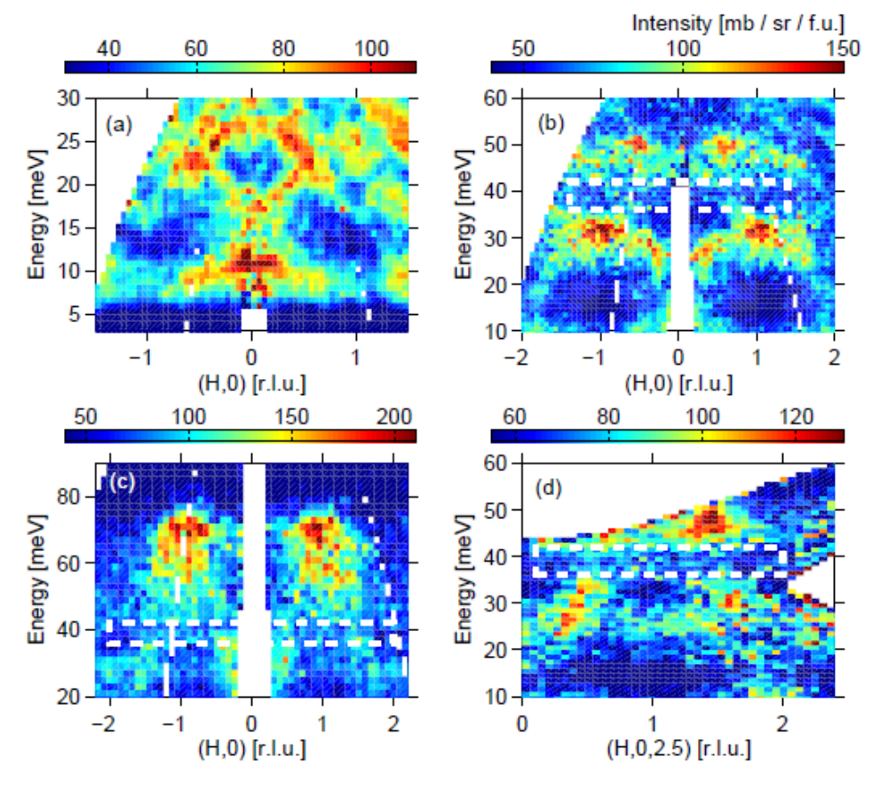
Example #2: dp, pl, acolor aline, legend, text, xlabel, ylabel, tick positioning, lx, ly
