Tessella Project Number: 6466
Tessella plc 26 The Quadrant, Abingdon Science Park, Abingdon, Oxfordshire, OX14 3YS, UK
T: +44 (0)1235 555511 | F: +44 (0)1235 553301 | E: info@tessella.com | www.tessella.com

Client: ISIS

Visualisation and Analysis Mantid Extensions
Architectural Design Document


Document Control
This document is under document control. All members of the distribution list will receive updated copies whenever alterations are made. All other copies are uncontrolled.

Document Owner
Name | Role | Company
Owen Arnold | Owner | Tessella

Document Approval
The following are required to approve this document. Their approval signifies that the document is fit for purpose and approved for use.
Name | Approval Role | Company
Nick Draper | Project Manager | Tessella

Distribution
Name | Role | Company
Mantid project repository | Filing | ISIS
Notes Projects Database 6466 | Filing | Tessella

Revision History
Author | Issue | Date | Description
Owen Arnold |  | 02-Aug-2010 | 1st version written

References
Document | Ref | Date | Details & Issue
Software Requirements | [SRD] | 01-Nov-2008 | NPD/xxxx/SR/SRD V1.R1.M0

Table of Contents
1 Introduction 5
1.1 Purpose of this Document 5
1.2 Scope of this Document 5
1.3 Context of this Issue 5
1.4 Definition of Terms 5
2 System Overview 5
2.1 Overview and Context 5
2.2 Interfaces Overview 6
3 Multi Dimensional Workspaces 7
3.1 Introduction 7
3.2 Interfaces 7
3.3 Component-Dependent Subsections 7
4 Visualisation 8
4.1 Introduction 8
4.2 Interfaces 9
4.3 Visualisation Implementation 10
5 Rebinning 14
5.1 Introduction 14
5.2 Interfaces 14
5.3 Component-Dependent Subsections 14
6 Simulation and Fitting GUI and Command Line 14
6.1 Introduction 14
6.2 Interfaces 14
6.3 Component-Dependent Subsections 15
7 Job Submission 15
7.1 Introduction 15
7.2 Interfaces 15
8 System Wide Features 16
8.1 Language 16
8.2 On-line help 16
8.3 Error-handling 16
8.4 Automated Debugging, Testing and Diagnostics 16
8.5 Build Systems 17
8.6 Speed and Capacity 17
8.7 Statutory and Regulatory 17
9 Cross-Reference to User Requirements 17
10 Third-Party Software 19
11 Appendix A: Common Designs 20
12 Appendix B: Dimension selection UI Mockup 22
13 Appendix C: Simple Visualization UI Mockup 23

Introduction

Purpose of this Document
This document describes the design of the visualisation and analysis extension application. The original ADD for Mantid may be accessed at: https://svn.mantidproject.org/mantid/trunk/Documents/Design/Architecture Design Document.doc This ADD is based on the system specified in the Software Requirements Document [SRD] https://svn.mantidproject.org/mantid/trunk/Documents/Requirements/Visualisation_and_Analysis/Visualisation_and_Analysis_URD.doc . It will form the basis of the planning of the development phase and will then be updated at the end of the development to act as a guide for maintaining the system.

Scope of this Document
This document is an extension to the original Mantid [ADD] to cover visualisation and analysis enhancements to the original system.

Context of this Issue
This is the first draft of the ADD and after internal review will be updated and released to the customer.

Definition of Terms

ADD | The Architectural Design Document (this document), the high level design document for the entire system.
URD | The User Requirements Document, records the users’ requirements for the system.
SRD | The Software Requirements Document, specifies the behaviour of the software system.
FR | Feasibility report on visualisation technologies
PD | Proposal Document
MADD | Mantid Architectural Design Document

System Overview

Overview and Context
This solution is a response to the problems identified in the [PD] and specific user requirements described in the [URD]. Briefly, this system has two high level objectives. Firstly it must allow rapid visualisation and analysis of extremely large datasets such as those produced by the LET and WISH instruments. Secondly, it must consolidate existing tools and knowledge from existing bespoke developments (such as Horace) into the Mantid framework. This second objective is aimed at creating a one-stop-shop facility for all analysis.
The system is generally designed to explore and operate upon multidimensional workspaces (MDWorkspaces described in section 3) generated by Mantid. The system is specifically geared to handle large volumes of data. Aspects of the system are direct extensions to the original Mantid platform and are built into that environment. Visualisation aspects of the system are developed against VisIt and use secondary modules to communicate with the Mantid framework. Other third party library developments operate in a similar way.

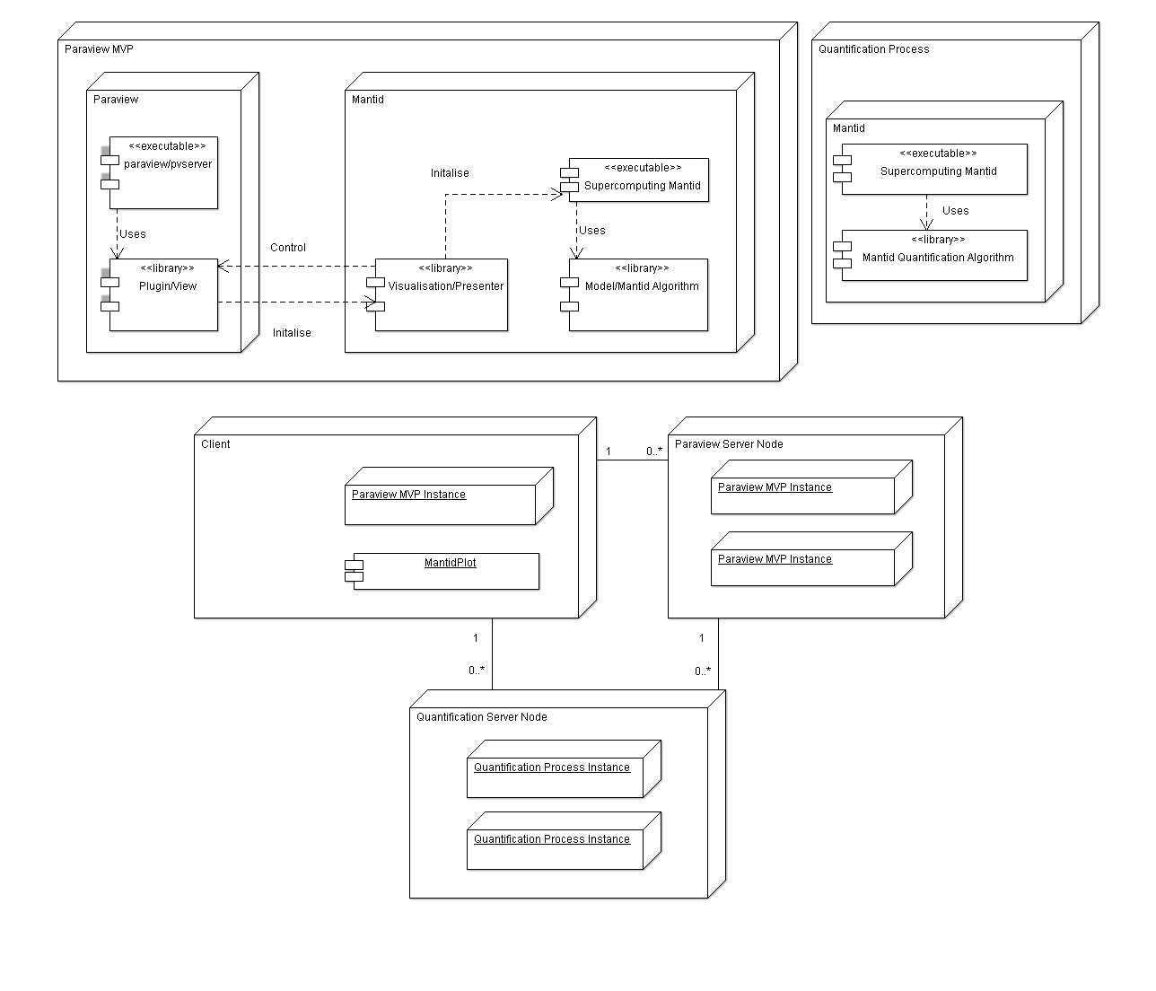
Figure 1: Deployment diagram depicting major system components.

Inputs
The system operates upon data derived from or loaded by the Mantid framework. These will be processed into multidimensional workspaces [MDworkspaces] which will form the primary data object for all of the visualization and analysis operations within these toolkit extensions.

Outputs
The major system output are MDworkspaces derived from the original input, upon which, multiple operations have been performed. In general many of the operations will be cutting and slicing operations to reduce the dimensionality of the original data and highlight areas of interest within the data. These will also allow quantification tasks, particularly the simulation and optimisation of models against recorded data.

The visualisation extensions will support 3D and 4D viewing of the data together with the ability to plot 2D and multiple 1D graphs of subsets of the data. It will also be possible to output elements of the 3D and 4D views using screenshots and video files.

Interfaces Overview
This should describe the interfaces between
- Visualisation and Mantid
  - Provision of binned data
  - Selection of data for Quantitative analysis
- Mantid and Back end Mantid analysis

Multi Dimensional Workspaces

Introduction
Multidimensional workspace (MDWorkspace) is a new kind of MANTID workspace, intended to represent the signal, obtained from neutron and, in general, generic diffraction instruments in reciprocal space with additional dimensions, representing the changes of the signal with the changes of conditions of an experiment.
The simplest example is the workspace describing a single measurement on an inelastic instrument. In this case we have the neutron scattering signal in the reciprocal space of a crystal and its change with the input (indirect geometry) or output (chopper instrument) energy. In case of scattering by a crystal the workspace has 3 (reciprocal space) + 1(excitation energy) dimensions.
Different measurements performed on an inelastic instrument cover various parts of the reciprocal space of the sample of interest and need to be combined into single 3D+1 workspace in case of position-sensitive detector and diffraction on a crystal, 2D+1 workspace for non-position-sensitive detectors and into 2D workspace for powder diffraction. The data, similar to data containing in a single workspace are produced by MSLICE before 2D visualisation.
Additional dimensions arise if user analyses the changes of the signal with the changes of some external parameter e.g. pressure, the sample’s temperature, input or output polarisation etc.
- The input data to build the workspace are the processed and normalized neutron counts from one or more neutron measurements (SPE data) plus the instrument description. Currently this information is present in MANTID Nexus workspace and is planned to be present in NxSpe workspace.
- The reciprocal space is the feature of a crystal lattice, so the workspace has to contain information about the crystal lattice and the orientation of the crystal in the instrument frame of coordinates plus possible changes of these parameters as function of the experimental conditions. The changes of the conditions are described by an additional workspace dimension.
- An algorithm, which process 1) and 2) using the model of the neutron scattering or diffraction, which is specific to the specific instrument or set of instruments or instrument models, is used to convert neutron scattering or diffraction data into N-D workspace. The algorithm will transform the signal from each physical detector of the instrument into its image in the reciprocal space.
As the information described by points 1) and 2) may be used both for visualisation and simulation, it has to be stored in the workspace. A typical experiment on MARI provides ~200 energy measurements for ~36000 detectors. 200 typical experiments produce 1,5G data points, with each data point describing signal, error and 3 components of momentum and energy, providing typical 40 GB dataset. Newer instruments are expecting to produce datasets which are from 10 to 100 times bigger. Such data sizes define constrains on the physical format of the MDWorkspace. It has to be binary (HDF based), mainly located on high performance HDD and optimized for fast random binary access.
The UML diagram of the visualisation workspace is presented on the Figure 2.
The main components of the workspace are:
- AllGeometry. It provides N-Dimensional reference frame for visualisation and analysis operations and allows combining and comparing different runs on the single framework.
- Geometry. It is specific workspace geometry, which is used for visualisation and analysis. It describes current size and shape of the data and its dimensions, including the dimensions which are integrated. It changes as the result of operations as user tries to look at the reciprocal space from different points of view and selects for analysis different dimensions and different parts of the space.
- ImageInformation. M-Dimensional (M<=N) array of data representing signals and errors calculated for the selected area of the reciprocal space as function of the selected dimensions. Each physical pixel of the instrument may contribute into 0, one or more (up to 2^{M}) pixels of the ImageInformation and each pixel of the ImageInformation can be build from data, obtained from part, one or number of physical pixels of the instrument.
- PixelsInformation. The array of the signals and errors obtained from each physical pixel in each experiment contributing into workspace or from physical model of the scattering or diffraction. In addition to that it may contain the coordinates of the pixel in the reciprocal space (in AllGeometry system of coordinates), but this information has to be selected on the basis of the balance between the efficiency to calculate such information and the memory requests. It is possible that the single pixel information format may be different for different instrument models.
- InstrumentDescription. The data about the construction of the instrument, which allows building PixelsInformation and ImageInformation or ImageInformation directly. This information is currently referred by MANTID matrix workspace and consists of:
- Shared pointer to instrument description which is in general common for all experiments, contributing into the workspace.
- Workspace Parameters which change from experiment to experiment and can in some extend modify parts of a)
- Run logs, providing the information about all measured parameters of the experiment
As the size of b) and c) is negligible in comparison with the instrument description all information from points b) and c) for each contributing run is copied into the MDWorkspace. There is also the possibility to write different versions of a) although usually most contributing runs refer to the same copy of the instrument description.
In analysing real experiment data instrument description together with information from b) allows to identify the location of real pixels in the reciprocal space of the crystal using relatively simple model of the diffraction, when in simulation it provides data to build resolution function for a model instrument.
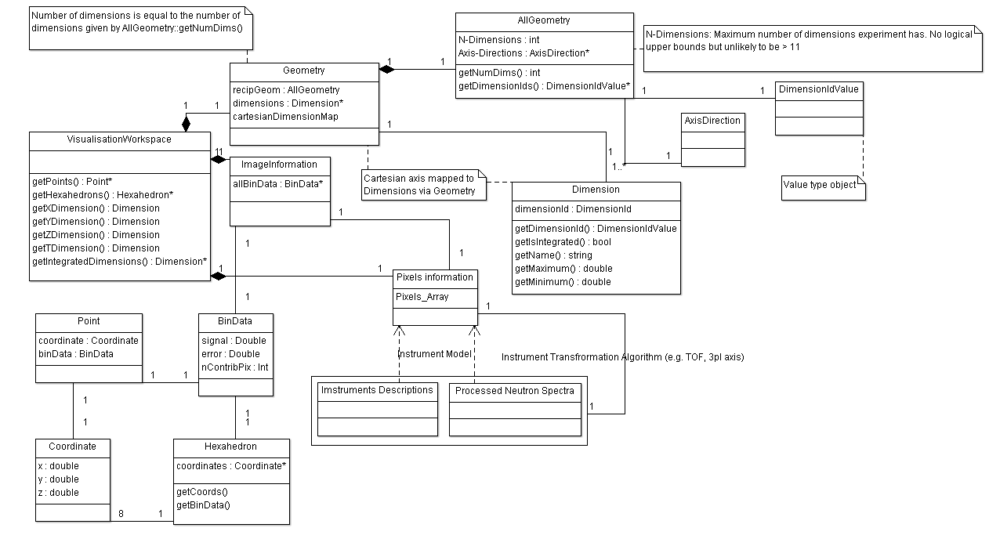
Figure 2 Visualisation and analysis workspace.
We assume that the ImageInformation can be placed into the memory and the PixelsInformation is mainly HDD based.

Generic multidimensional workspace is obtained in one or two steps. Second step is optional.
First step involves running instrument description algorithm in case of processing data from real experiments or scattering model and instrument model (instrument resolution function model) in case of building a workspace from simulation data. A rebinning algorithm runs after that to obtain ImageInformation from PixelsInformation.
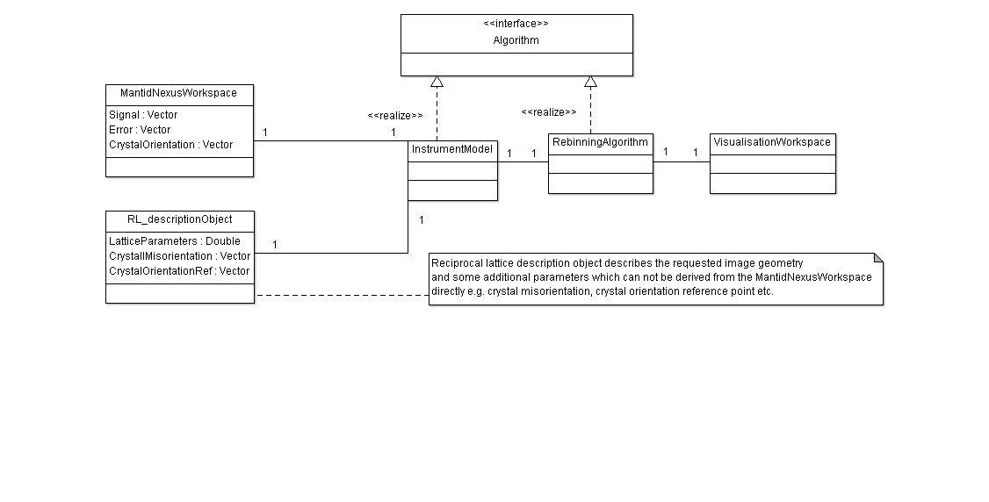
Figure 3 Building visualisation workspace from Mantid Nexus Workspace
Second step includes combining number of workspaces together with or without extending the number of workspace dimensions. In the first case it is simple arrays augment operation when in the second it involves running one of the rebinning algorithms.
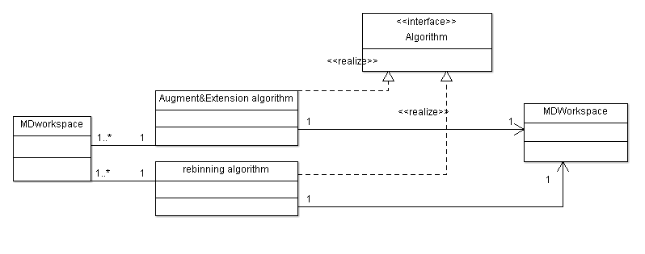
Figure 4 Combining multiple workspaces together

Interfaces
Visualisation workspace is build from one or more MANTID Nexus workspace or NxSpe workspaces plus the data which describe the particular reciprocal space. Some of these data can be obtained from the instrument log files but others need explicit user input. The examples of the user input are the crystal lattice to build the reciprocal space (determines the meaningful AllGeometry object) and the crystal misalignment angles (allow to fix errors in the crystal orientation).

Input
- From 1 to N MANTID Nexus workspaces or NxSpe workspaces.
- Reciprocal geometry description object(s).
- Selection of instrument models (TOF PSD, TOF non-PSD, TOF powder, Indirect geometry, a model instrument for processing simulation data)

Output
MDWorkspace (N-dimensional visualisation and analysis workspace)

Component-Dependent Subsections

Visualisation

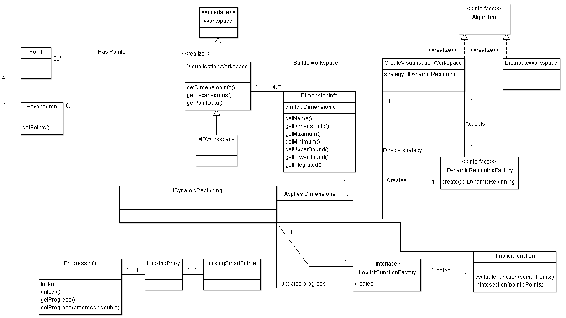
Figure 5: Class diagram for Visualisation/Rebinning Interaction

Introduction

The [URD] describes many aspects of the end product that rely on distributed visualisation. In the context of these user requirements, the visualisation feasibility report [FR] indicates that VisIt is an appropriate choice of framework to achieve these goals. Early prototypes using VisIt and Paraview support the feasibility report, by exploring the required design space.
Visualisation development revolves around the generation of plugins for the VisIt code base. This is recommended route to customisation and does not involve modification of any core code.
The general visualisation strategy is to lean on the VisIt and Mantid architectures as much as possible, so that only as thin bespoke visualisation layer is required. This strategy emphasises reuse within VTK and VisIt, for example, specialisation of existing filters where only small functional changes are needed. This strategy also promotes a model-view-presenter (MVP) architecture, where-by visualisation filters are highly dissociated from the back-end controlling algorithms.
The following types of plugins will need to be generated:
- Readers/Datasources for converting MDWorkspace files into visualisation pipeline head objects
- Filters: For applying computational steps against pipeline inputs, such as dynamic rebinning
- GUI plugins such as toolbars, menus and views specific to neutron data reduction and the readers and filters created

Interfaces
All visualisation processes must be provided with a multidimensional workspace (MDWorkspace). More specific sets of inputs are needed for those visualisation subcomponents providing rebinning and slicing operations.

Input
MDWorkspace
This workspace provides the structure that carries actual run data. This type is used for both input and output. The MDWorkspace contains data and dimensions. It provides methods which allow visualisation plugins to extract Cartesian point information, scalar values and cell data.
vtkRebinningStructuredGrid
Rebinning and slicing operations need to publish metadata about their inputs for subsequent rebinning operations. This type is compatible with the VisIt and VTK pipeline. This data structure may contain information relating to the location of a disk-based multidimensional workspace so that each filter can refer to the original raw data if required. By deriving vtkRebinningStructuredGrid from vtkDataSet, it is possible to make any filters utilising this type to be compatible with a large number of VisIts existing filters. vtkRebinningStructure instances must be generated by a customised vtkAlgorithm so that the appropriate port information can be provided.

Output
IDynamicRebinning
Indirectly generated via the IDynamicRebinningFactory. This type completely encapsulates GUI or command-line driven cuts to be applied to an existing MDWorkspace. As there are many ways in which to compute rebinned data, the IDynamicRebinning type is the root type in the Strategy Design Pattern (ref Strategy in Gamma et al) . The dynamic rebinning strategy will always require implicit functions and dimension information.
IImplicitFunction
Provides a description of an isosurface such that F = c, where F is a function of n-variables usually Cartesian coordinates and c is a constant. Specialisations of this type define plane(s) and spheres. Other specialisations allow users to provide their own function as plain text, which is interpreted and later executed. Using the Composite Pattern (“Design Patterns” by E. Gamma et al, Tessella Ref: 2025) a single implicit function may actually be composed of one or more nested Implicit functions
DimensionInfo
Only 4-dimensions from the full MDWorkspace may be visualised at any one time, these will be mapped to x, y, z and time. This type allows the filter to specify which dimensions of the n-Dimensional dataset are to be rebinned and how they map to orthogonal visualisation axes. Other dimensions are integrated over, and bounding information to specify the integration range is provided.
IDynamicRebinningFactory
Allows the rebinning-filtering type visualisation plugin to communicate with Mantid algorithms that actually perform the rebinning. This type supports a family of subtypes each of which can generate a specialisation of IDynamicRebinning. In this factory method (“Design Patterns” by E. Gamma et al, Tessella Ref: 2025), the visualisation plugins may generate rebinning strategies.
IImplicitFunctionFactory
Allows the UI code to provide an implicit function selection without having knowledge of that actual implicit function. This type serves a similar purpose to the IDynamicRebinningFactory. Where nested implicit functions are required, the corresponding factory type will accept other factory types as arguments.

Visualisation Implementation

VisIt Functionality
VisIt has been chosen as a third party visualisation library primarily because of its rich out-of-the-box functionality (see [FR]). VisIt offers ready solutions to many of the visualisation issues outlined in the [URD]. The following sections give a brief of some of the VisIt attributes relevant to the solution.

GUI Framework
VisIt is built using the Qt GUI framework. VisIt provides it’s major interfaces as Qt widgets for using within other custom user interfaces..

Views
VisIt supports a number of perspectives/views. Various Plots, 2D and 3D type views are standard..

Key Filters
VisIt comes pre-loaded with a large number of filters. Custom filters may specialise an existing filter, or be composed of many existing filters. Some filters which are likely to useful to the end user are:
- Cell Data to Point Data
- Point Data to Cell Data
- Tetrahedralize
- Clip
- Slice
- Python Programmable Filter

Interaction
VisIt readily supports zooming and panning. Many other interaction operations are also supported. Moving and rotating a plane which defines a slice is an example.

Data Reduction
VisIt strongly supports the visual data reduction and discovery paradigm. As a result it provides a number of ways to perform analysis on a visual data set. Data points may be selected, subdivided and tracked, or simply queried to find those with certain properties.

Scripting
VisIt provides Python wrappers for its classes. As a result, everything possible in the GUI may be achieved using the scripting API.

Marking
VisIt supports additional marking tools by default. Text labels, arrows, axes and legends are all available for decorating views.

Dimension Selection
The MDWorkspace carries data regarding any number of dimensions. Visualisation of these multiple dimensions is limited to four only, three of which are spatial and the fourth, which is time. To provide greatest flexibility, the user must choose how they wish to map dimensions in the MDWorkspace to those of the visualisation (see mock-up in Appendix B). If the number of dimensions in the MD workspace is greater than four then those dimensions not attributed to visualisation axes must be integrated over by providing an upper and lower bounds.
When a rebinning request is made via a customised filter, dimension information is sent as part of the request to the Mantid rebinning algorithm.
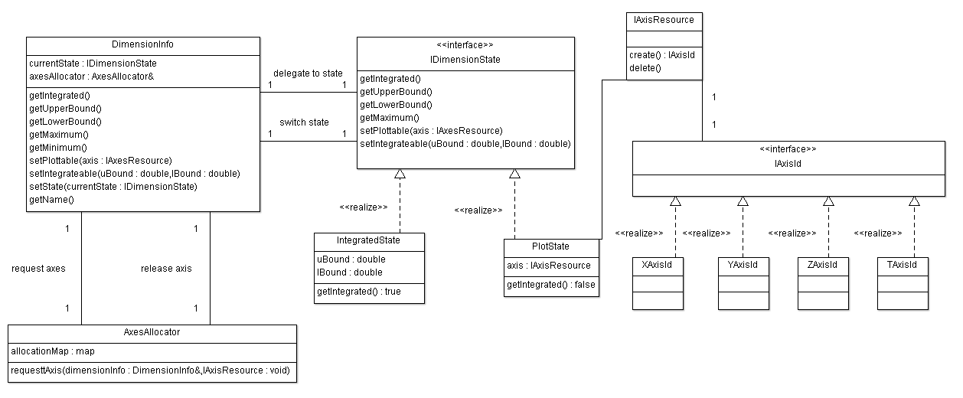
Figure 6: DimensionInfo type uses helper classes to track and switch between different physical axes or apply integration ranges.

Implicit Functions
A reoccurring user requirement is the ability to map a surface onto a visualisation dataset or to split the dataset along a boundary defined by a function. Surface projections should be handled directly in the visualisation layer and can be done so using existing VTK technologies. Slicing information on the other-hand must be passed to the Mantid algorithm, which will actually perform the work.
Communicating slicing information is made complex because of the range of geometries which may be used for slicing. Furthermore, scalar properties of the data may be used in addition to geometrical aspects to specify slices. The natural abstraction of this slicing requirement is to provide a generalised function that can perform operations on some subset of the full MDimensional data and its associated scalar values. Function objects (see Strategy Pattern in “Design Patterns” by E. Gamma et al, Tessella Ref: 2025) provide an effective solution to this problem. In essence, the function object encapsulates a slicing function behind a standard interface. The function object approach is suitable for slicing functions which range from very simple to fairly complex. In addition, once the function object is assembled, the Mantid algorithm will just have to execute it, regardless of how complex it is.
Function objects are used to represent implicit functions. Specialisations of this IImplicitFunction type define plane(s) and spheres. Other specialisations allow users to provide their own function as plain text, which is interpreted and later executed. Using the Composite Pattern (“Design Patterns” by E. Gamma et al, Tessella Ref: 2025) a single implicit function may actually be composed of one or more nested Implicit functions.

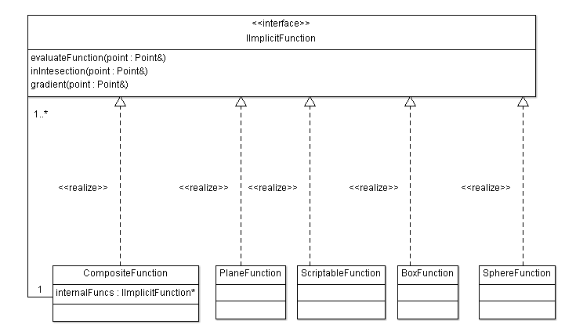
Figure 7: Implicit function providing a composite implementation as well as several default implementations.
VTK also supports the notion of implicit functions with the type vtkImplicitFunction and its realisations such as vtkPlane. The implicit function types described above bear no direct type relation to those in VTK so that back-end processing is not VTK dependent. In order to draw isosurfaces via vtkContour filters, IImplicitFunction types will be mapped to vtkImplicitFunctions.

GUI Customisation and Interaction
No modifications or additions are planned for the core VisIt code. Visualisation development will adhere to the VisIt supported mechanisms. Core VisIt code is a third-party code base and must not be altered.
In order to tailor VisIt into a suitable mode for the application domain modifications to the default interface must be made (this is possible via supported mechanisms). Many of the data sources and filters generated require specific user inputs for proper information. Other filters require specific visual interaction mechanisms to be provided.

Simple Interface
The aim of the simple interface is to provide the minimum necessary set of options to allow users to perform visual data reduction on neutron data.
A complete Qt based bespoke user interface will be provided for the visualisation. This is planned for, but not limited to, integration with the existing MantidPlot GUI. The majority of this work involves removing toolkit elements rather than adding them in. A mock-up of this user interface is provided in Appendix C.
The simple interface will pre-load plugins developed as part of this project.

Advanced Interface
The advanced interface will support users who need to utilise aspects of the VisIt framework that are not available in the simple interface.
The initial plan for this interface is to use the existing VisIt user interface with no direct customisation. Plugins developed as part of this project may need to be loaded manually. If the interface fails to support the level of usability required then a custom user interface will be built.

Rebinning
There are many ways to rebin neutron data. To support the rebinning functionality across the application, it shall be provided as a Strategy (see “Design Patterns” by E. Gamma et al, Tessella Ref: 2025), so that most of the development can remain ignorant to the implementation details of each variant and so that introduction of new rebinning strategies are easy. At the time of writing, three distinct rebinning strategies have been identified and more will likely requested later. Details on these rebinning types are covered in a later section.
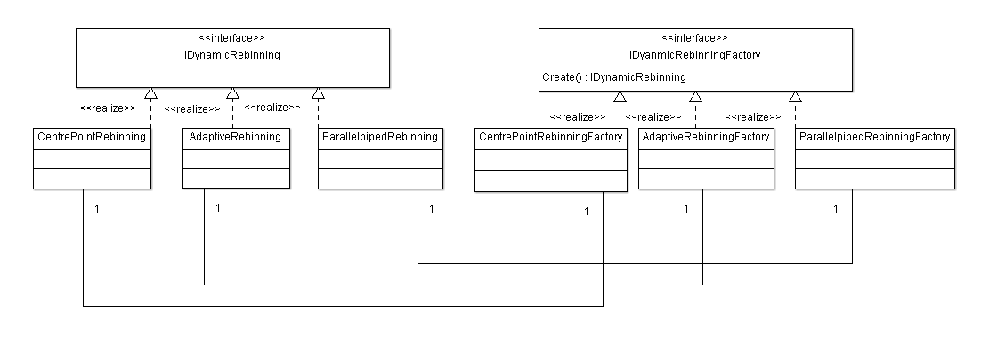
The application may attempt to select the rebinning method deemed optimal; however, users may wish to override automated selections. This implies that the IDynamicRebinningAlgorithm may need to be constructed by the GUI and passed to the rebinning algorithm since it is at that point that selection is made. Instead of directly constructing the IDyanamicRebinning strategy, the plugin should construct and IDynamicRebinningFactory, which can be passed to the rebinning Mantid algorithm. Essentially, this allows the view to decide what will be constructed and lets the controller decide when it should be constructed. The factory method approach also shields the view from the details of the IDynamicRebinning strategy. As the project grows, more rebinning strategies can be realised without having to coordinate conditional statements across solution components.

Figure 8: Dynamic rebinning strategy approach.

Distributed Computing
Distributed computing is critical to swift processing of the visualisation datasets and handling of large data volumes. The visualisation feasibility study demonstrated that VisIt performs well in a distributed computing mode. Through prototypes, it has been verified that custom filters developed as VisIt plugins can be made to work in a distributed mode taking advantage of data parallelisation offered by VisIt. The project will support both client-only stand-alone visualisation and distributed visualisation. Although VisIt supports many types of distributed visualisation, their recommendation of a combined data server and renderer server will be followed.

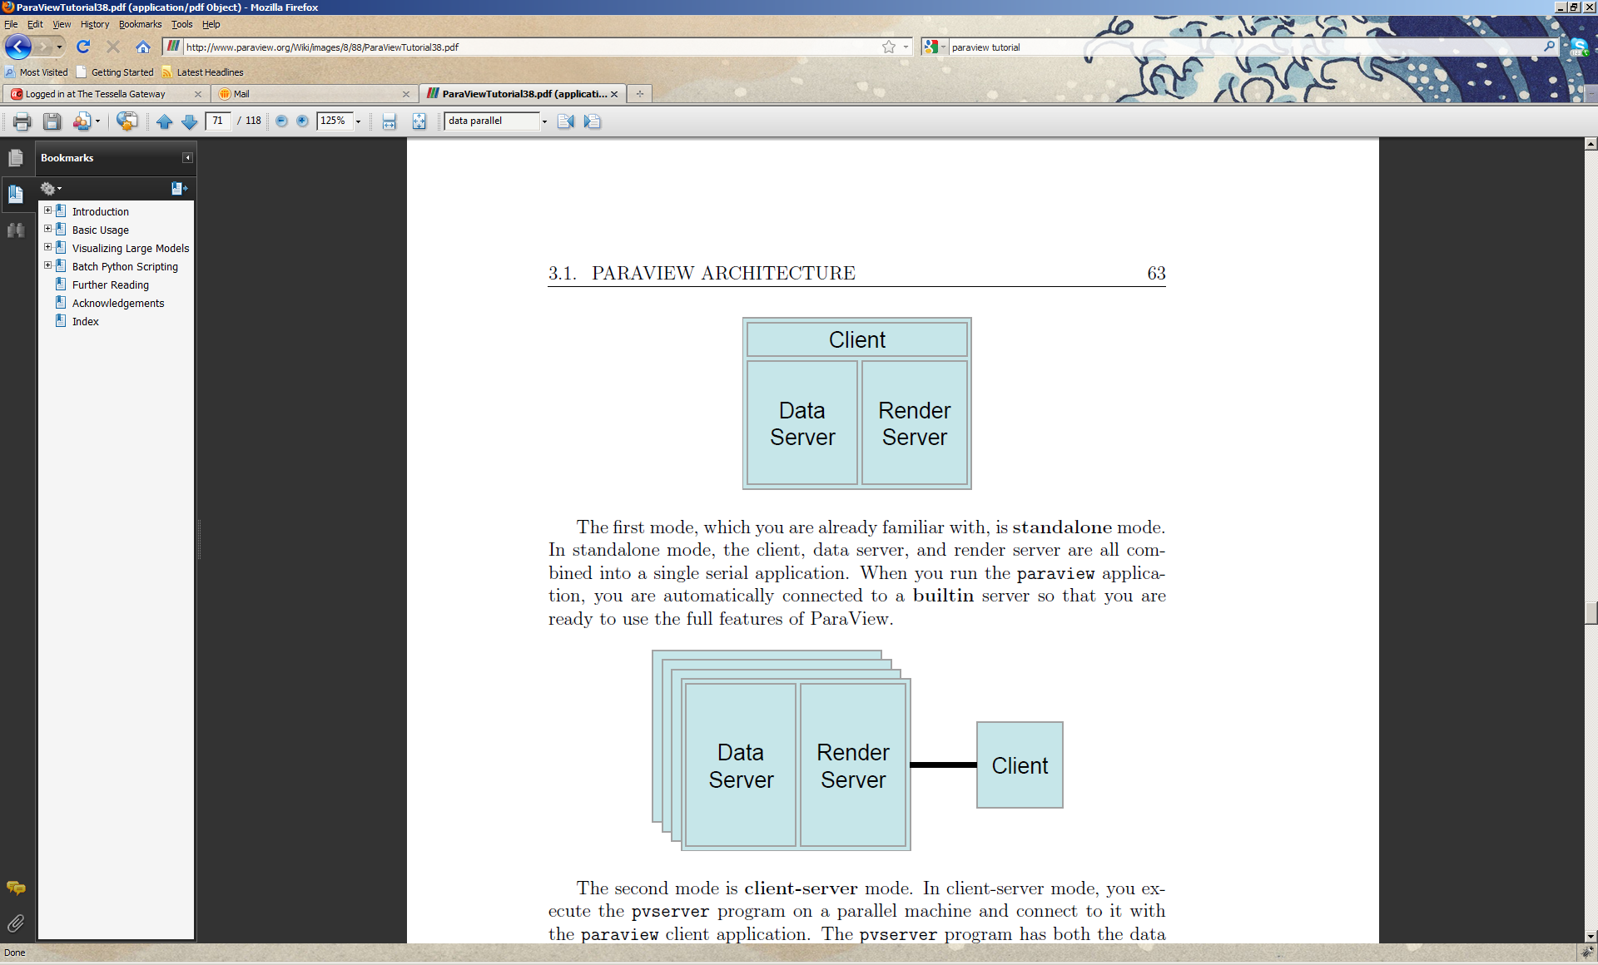
Figure 9: Stand-alone mode. Client acts as data server and renderer server.
Figure 10: Distributed mode with combined data and renderer server and separated client.
To facilitate parallel processing, where vtkDataSet derived data structures are used, data structures must determine and coordinate their extent in the context of the total number of processers available. This information is provided by the VisIt framework.
An outstanding issue is the parallelisation of adaptive rebinning operations, where each parallel process must have knowledge of its bin boundaries.

Non-orthogonal axes
Visualisation plugins will work in terms of point and cell information required by VisIt. Where non-orthogonal axes are to be used, Mantid Algorithms will transform the results into a Cartesian coordinate system and provide point information for display.

Rebinning

Introduction

Interfaces

Input

Output

Component-Dependent Subsections

Simulation and Fitting GUI and Command Line

Introduction
The previous software that implemented this functionality, Tobyfit, provides a GUI for the user to select the cuts of interest, the scattering and background models to be used along with various choices for the calculation procedures. Having defined the required set of cuts and the way in which they should be simulated or subject to a least squares optimisation, a job to do this can be submitted. Mantid should provide a similar GUI to allow job description, submission and inspection of the results.

Interfaces

Input
The primary input data to the simulation and fitting will be one or more MDWorkspaces that will define the data to be fitted, or the range of data to be simulated. In addition a user interface will capture several additional pieces of information as defined in section 6.3 below.
By this point the MDWorkspaces will contain 1D or 2D cuts of the larger multidimensional data, and will therefore be much smaller than the original dataset.

Output
The outputs of this interface are the retrieved results of the simulation or fitting jobs. These can be displayed as a list of fitted parameters, or as graphs of simulated or fitted data against experimental results. The graphs will be 1D or 2D plots and displayed using existing MantidPlot functionality.

User Interface
The GUI for analysis will be built within MantidPlot. It will offer the same functionality as the current Tobyfit GUI and will provide separate simple and advanced user options. The simple user options will include:
- Selection of particular cuts that will be used in simulation or fitting
- Selection of background model and S(Q,w) model to use from predefined set
- Define values for the parameters of these models
- Crystal unit cell dimensions
- For fitting, mark parameters to fit with optional limits and binding to other parameters.
- Submit job to a resource for simulation or fit
- Retrieve data for completed jobs
- View results of calculation against data
An advanced section of the GUI will give access to additional options including
- Setting and fitting of instrument parameters related to spectrometer, chopper and moderator
- Sample shape dimensions and crystal orientation correction.
The GUI will also provide management of simulation and fit jobs. The user may wish to submit several jobs at once and the GUI will keep track of each and allow inspection and comparison of results from different jobs. A persistent storage of job information is needed to allow for jobs that do not complete in the current Mantid session and for comparison with saved calculations.

Command line
The underlying operations performed by the user interface mentioned above will be implemented as Mantid Algorithms (see MADD). This will allow all of the operations performed by the user interface to also be accessible from Python and our other APIs.

Job Submission

Introduction
This section describes how simulation and optimization jobs will be dealt with from the Mantid frame work. It is assumed that optimization or simulation process will often require substantial computation and the user will wish to run this task on a parallel cluster resource, if one is available. The user will select a number of cuts for analysis, along with a model of the scattering process and (optionally) parameters within this model that are to be fitted. These selections will be made either from a Graphical User Interface within Mantid, or by running a script. This data is then written to disk and a job submission process invoked to send the data and the task to a remote resource. The same approach will be used even if the user has opted to use the local resource to run the computation.
One important case is the submission of jobs to Grid resources, such as those of the NGS (UK National Grid Service), Teragrid or other local grids. The current interface that is supported to these resources is the Globus GT2 interface, though this may change in the future and it is desirable to allow easy substitution of other interfaces. SNS have the requirement of an interface to the Slurm (https://computing.llnl.gov/linux/slurm/) batch system.
A standard API for job submission to grid resources, SAGA (http://saga.cct.lsu.edu/) has been defined and has at least three implementations available at the current time. One implementation is in C++ and two in Java. The C++ implementation would appear be the natural choice for Mantid since this is the development language used for the project. However, there is a need to support both Windows and Linux/Unix like systems. The support for job submission from Windows platforms to Globus systems is only available in the Java implementations. The three implementations are:
- Saga C++ binding from the Louisiana State University, latest release 1.5. This is the most comprehensive implementation of the Saga standard. Supported on most 32 and 64 bit Linux systems and MacOS X, but not Windows. Adaptors exist for Cloud computing, Condor, LSF, Local Fork, Globus, SSH, GridSAM and AWS (Amazon Web Services).
- Saga Java binding from Vrije Universiteit (VU), Amsterdam. This implementation is a layer on top of the JavaGAT (http://www.cs.vu.nl/ibis/javagat.html ) software package from the same group. The Saga Java package is release 1.0.1 from April 2009. It supports various adaptors including SSH, Glite, GridSam, Globus, Local fork, SGE and Unicore.
- JSAGA from the IN2P3 Computing Centre, http://grid.in2p3.fr/jsaga/ which supports adaptors for Glite, Globus GT2 and GT4, LFC, NAREGI, SRM, SSH and Unicore.
Of the two Java implementations the JSAGA one seems to have better on-going support at present and supports a wide range of adaptors.

Interfaces

Input
The inputs to the job submission will be contain all of the information gathered in section 6.3 together with the MDWorkspace files associated with those jobs.

Output
Job submission to a Globus resource will return a string which identifies the job. This string is needed to query the job status. Since the jobs may be long running it is necessary for the information about active jobs to be stored. Other adaptors will return similar information that can be used to track jobs.

Grid resource discovery
Both the distributed visualisation and the analytic job submission require knowledge of the back end computing resources available in a particular environment. VisIt already defines a resource file format to list the available visualisation resources, but we don’t want to store this information in multiple places. As such all of the computational resources and capabilities will be stored in a Mantid XML file, and the required file for VisIt will be written at run time from the information contained within.

Job submission operations
There are only a small set of operations that the Grid job submission tool needs to provide:
- Initialisation of the security context. For a Globus resource this is creation of the proxy certificate that subsequent operations will depend on to authenticate operations. For an SSH connection it would be getting the username and password for the context. Other grid systems (e.g. Unicore, Cloud Computing) require similar setup. For slurm job submission a security context may not be required.
- Query of available resources. For a grid system a list of possible resources will be maintained and the interface can check the status of these before offering to send jobs to them. For slurm a list of resources and currnet load may be useful.
- Job submission to a selected resource. The job will consist of a set of files containing the cuts plus other required data. The submission process needs to manage the transfer of these files to the computational resource.
- Monitoring of the job progress. Two separate aspects are: checking if the job finished and discovering the progress of a running job. The first task is a simple query operation in SAGA, while the second can be handled with a file transfer operation.
- Gathering the output from the completed task. In the case of a simulation this will be cut files of the same format as the input ones, but with calculated rather than experimental data. A user requirement is to be able to view the calculated background independently of the total scattering and this can be done be providing two cut output files for each input cut, one with the total scattering and one with the background contribution only.
These operations will be implemented via calls to the Java SAGA API. Calling a Java API directly from C++ is possible but not trivial. A simpler approach is to actually invoke a separate process running the Java VM to run the required operation. The Poco library is already used in Mantid and could provide a simple, portable way of wrapping a Java process to call Java functions. A pipe mechanise is used to send requests, such as initiate grid security context and return the result of the request. Keeping a very simple interface for the Saga operations means that it will be easy to replace the particular SAGA package with another one, if required. This might be the case if an essential adaptor is only available in one implementation.

Quatitative Analysis Job Processing

Introduction
The simulation and fitting jobs defined by the user interface in section 6, and submitted as defined in section 7 will be processed by a back end computing version of the Mantid software. It will also be possible to process them using the user version of Mantid for use when the job is submitted to the local computer.

Interfaces

Input
A complete job will comprise of the following:
- A python script containing commands to do the following:
  - Define the simulation or quatitive analysis
  - Set all fit or simalution parameters, constraints, initial guesses, fixed values and tied parameters
  - Initialise the Mantid framework, perform the analysis and save the results
- All of the required MDWorkspaces for the job.
The use of a self executing python script to define and perform the job will make debugging and rerunning of previous jobs easier, and will ensure that we maintain robust command line access to all of this functionality.

Output
The output of a completed simulation job will be a set of MDWorkspace files containing the simulated data.
For a fitting job the output will be
- Results of the fit operation (Success or failures reason, Quality of fit, number of iterations)
- a saved CSV? File of the optimised parameters
- a saved CSV?? File of the normalised covariance matrix
- a set of MDWorkspace files containing the fitted data
The job submission framework will handle the transport of these result files from the computing resource back to the client computer.

SuperComputing Mantid [scMantid]
To perform this and other back end processing resources it is important that a version of Mantid is created that is easy to install in remote server farm. As such the following will be changes will be implemented:
- Statically link as many libraries as possible
- Look to remove large and awkward dependencies – OpenCascade in particular
- Do not include Mantidplot or any of the QT based dependencies
- Preserve the C++ and python plugin mechanism
- Preserve the Python API
- Drop the Matlab API

Quantitative Analysis
The quantitative analysis will primarily use the CurveFitting framework that has already been developed in Mantid although there will need to be several further additional classes implemented.

Nice diagram

Curve Fitting Extensions

Whizz bang version of Fit

MCResolution

Additional Peak functions
There are several inbuild peak shape functions in TobyFit that we will need to import in Mantid.

Optimised version of Levenberg-Marquadt optimiser
Tobyfit contains an optimised version of the Levenberg Marquadt optimiser, if that proves to be more efficient than the GSL version then that will be implemented as an optional optimiser.

Simulation
Simulation jobs are simpler than those that require optimisation in that they simple perform a single evaluation of the functions specified and return the result.

System Wide Features

Language
See Mantid ADD.

On-line help
See Mantid ADD.

Error-handling
No errors or exceptions should be automatically swallowed in the code without being propagated in some form to the surface. Custom exception types may be provided where the default system types are not sufficiently descriptive. Exceptions may be re-thrown, provided that the original exception information is also propagated. Decisions regarding the display of errors are to be made as late as possible and are not a core framework concern.
See Mantid ADD.

Automated Debugging, Testing and Diagnostics
Any software generated against the Mantid framework, will provide extensive unit test coverage at least up to the standards covered in the original Mantid ADD. Except for prototyping, test driven development (TDD) practices should be followed to ensure the highest quality output. In addition, software testing strategies will take advantage of the googlemock framework to promote decoupling via dependency injection.

Build Systems
The Mantid project uses SCons for software construction, While VisIt uses a separate build system, converting from one system to the other is impractical. Fortunately, there is a logical division between functionality on both sides of this build interface, so separation of binary components is an option. In fact, it is better from an architectural point of view to promote this form of separation as it forces decoupling and enhances software quality.

The solution adopted is to control the overall build process using SCons. VisIt plugins will be generated using the visit build system, but SCons will initialise the build process.

Interfaces will need to be made available across these build environments. Where MVP is used, presenter interfaces will live on the Mantid side, but concrete implementations of these interfaces, with knowledge of the exact visualisation framework will live on the VisIt side.

Speed and Capacity
See Mantid ADD.

Statutory and Regulatory
See Mantid ADD.

Cross-Reference to User Requirements

URD Section | ADD Section | Comments
U3.1.2.1 | 5.5.1.6 | Both Mantid and VisIt provide python scripting.
U3.1.2.2 | 5.5.1.6
U3.1.2.3 | 5.5.1.6
U3.2.1.3 | 5.5.1.7
U3.2.2.1 | 5.5.2 | Complete flexibility on how axis are displayed.
U3.2.2.2 | 5.5.2
U3.2.2.3 | 5.5.3 | Ability to provide interactors for this unresolved.
U3.2.2.4 | 5.5.2
U3.2.2.5 | 5.5.2, 5.5.3 | Any dimensions may be selected.  Implicit function and vtkContour provide integration and display.
U3.2.2.6 | 5.5.2, 5.5.3 | Scriptable implicit function may utilise muParser to interpret and execute user provided equation.
U3.2.2.8 | 5.5.3 | Implicit function and vtkContour provide projection and display.
U3.2.3.1 | 5.5.1.3 | VisIt supports clipping and slicing operations.
U3.2.3.2 | 5.5.1.3
U3.2.3.3 | 5.5.1.3 | Using slicing type filters
U3.2.3.5 | 5.5.5 | Rebinning operations will improve resolution upon slicing.
U3.2.4.1 | 5.5.1.3
U3.2.2.1 | 5.5.2
U3.2.2.10 |  | Sumspec design not completed
U3.2.2.11 |  | Flattened instrument view design not completed
U3.2.2.14 | 5.5.1.2
U3.2.2.15 |  | Symmetrisation type support not fully designed
U3.2.2.16 | 5.5.3
U3.2.2.17 |  | Unknown solution
U3.2.5.1 | 5.5.1.3, 5.5.1.7
U3.2.5.2 | 5.5.1.3, 5.5.1.7
U3.2.5.3 | 5.5.7
U3.2.5.4 |  | Addition of additional vectors unresolved.
U3.2.6.1 | 5.5.1.2, 5.5.1.7 | Axes markers may be added or removed
U3.2.6.2 | 5.5.1.2, 5.5.1.7 | Axes markers may be added or removed
U3.2.6.3 | 5.5.1.2 | Any scaling operation may be achieved using Python programmable filter.
U3.2.7.1 | 5.5.1.2 | Point Data to Cell Data and Cell Data to Point Data filters.  Rebinning filters are based on a custom algorithm type, which can return data in a variety of concrete structure data types.
U3.2.9.1 | 5.5.1.6 | Trace recording of GUI operations as equivalent Python statements are available. These may be reexecuted.

Third-Party Software
Name | Reason and Justification | License | Reference
VisIt | Reasons and justification outlined in visualisation feasibility report [FR].  Prototypes relating to [URD] functionality available in  http://svn.mantidproject.org/mantid/trunk/Documents/Pilot/Visualisation_and_Analysis/Visualisation | Berkely Software Distribution | https://wci.llnl.gov/codes/visit/home.html
Googlemock | Encourages dependency injection and makes software more testable.  Highly portable. | Berkely Software Distribution | http://code.google.com/p/googlemock/
Qt | The Qt framework is used as the standard interface within Mantid and should provide the flexibility to build the required GUI for this application. | LGPL
JSAGA | This package is available on Windows, Linux and MacOS X. It provides the required functionality for job submission and monitoring. Supports Gobus and SSH based job submission, plus others. | LGPL | http://grid.in2p3.fr/jsaga/
slurm | This batch system is widely used at SNS. | GPL

Appendix A: Common Designs
A number of standard solutions to reoccurring problems in the project are treated here.

Model View Presenter (MVP)
The emerging architecture of the system is one in which there is an overall high level of complexity, but strong divisions and responsibilities within the overall solution. Each subcomponent of the system may be less complex than the overall solution providing that strict division of responsibilities is maintained. The model view presenter design presents a decoupled approach to design making each subcomponent more testable and more readily distributable for development. The MVP pattern is most applicable because each VisIt filter will need to instantiate its own controller/presenter, which is capable of constructing a Mantid instance (the model). The exact approach adopted will follow Martin Fowler recommendations (http://martinfowler.com/eaaDev/PassiveScreen.html)

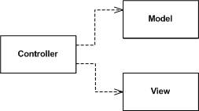
Figure 11: Passive Model View Presenter (MVP). Controller is presenter in diagram.

Static Factories
The overall solution consists of several distinct components. A reoccurring situation is that that one component will need to pass complex parameters to another. Where polymorphism is required, the passing component will need to direct the instantiation of the correct concrete type. A direct, but unfavourable design, is one in which the concrete type is directly instantiated from the passing component. There are many drawbacks of this situation. One disadvantage is that the passing component is unnecessarily exposed the full interface of the constructed object, which it will often have no remit to modify, especially where an MVP type approach is adopted. A second disadvantage is that the constructed object has a lifespan, which is unnatural in relation to the actual object which utilises it. The lifespan issue presents a conceptual barrier to understanding of the model, is against good OO practice and will result in unnecessary memory utilisation.
The general solution to the problems outlined above is to allow one component to decide what is constructed and the other to decide when to construct it. This constructional solution is well treated and referred to in this context as a Factory Method (“Design Patterns” by E. Gamma et al, Tessella Ref: 2025). Many components of the system communicate in terms of Factory Methods, where covariance is utilised to instantiate the desired concrete types. This is particularly prevalent in view objects, where users make selections, which correspond to algorithm choices, yet actual knowledge of algorithm implementations in the view would be detrimental to the overall architecture.
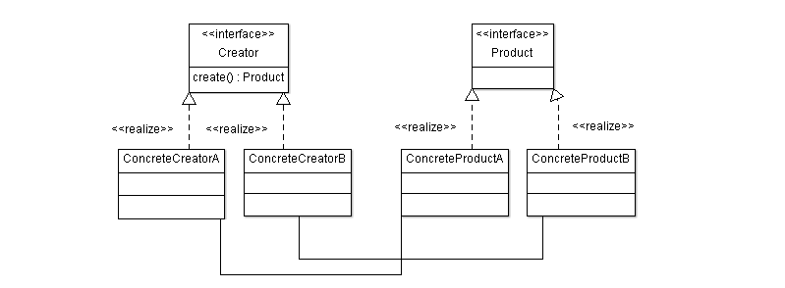
Figure 12: Factory method

Resource Management
The preference is for all acquired resources to follow the RAII (Resource Allocation Is Initialisation, see “C++ In a Nutshell” by Listener). For heap-based memory allocation, resource management should be performed via automatic or shared pointers using the current variant adopted by the Mantid Project. For other resource management, in the absence of a specific framework type (such as vtkSmartPointer for VisIt), a template with appropriate implicit and explicit specialisations should be created and utilised.
In production code, only where automated resource management is known and proven to significantly reduce performance should it not be used. Prototypes need not comply with this specification.

Executors
Where multi-processing is required, to ensure proper operation, it must be verified that any particular routine is:
- Functionally correct
- Correctly executed under a multi-processing scenario
The Executor Pattern (“Growing Object-Oriented Software Guided by Tests” by S. Freeman et al) is simply a Strategy Pattern (“Design Patterns” by E. Gamma et al, Tessella Ref: 2025) designed for separating multi-processing/concurrency aspects from functional aspects. The executor can either be selected at runtime or at compile time using Policy Based Design (“Modern C++ Design”, by A. Alexandrescu)

Locking proxies
While performance demands specified in the URD, imply as much of the code as possible should be run concurrently, certain routines should not and must not be accessed by multiple threads simultaneously. Using proxies (“More Effective C++”, by S. Meyers) and locking smart pointers (“Modern C++ Design”, by A. Alexandrescu”) we can ensure that locking and unlocking events are automatically called on these critical routines.

Appendix B: Dimension selection UI Mockup

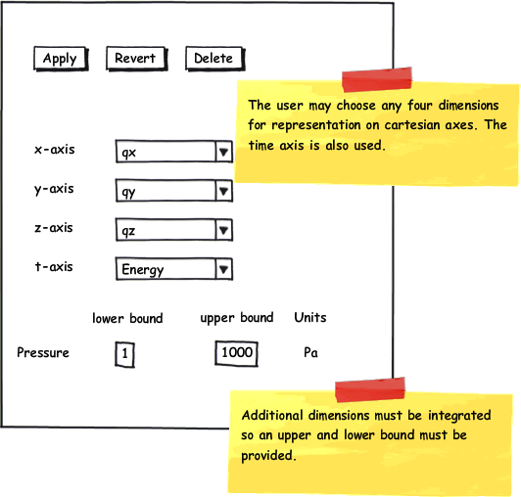
Figure 13: Mock-up dimension selection for object browser.

Appendix C: Simple Visualization UI Mockup

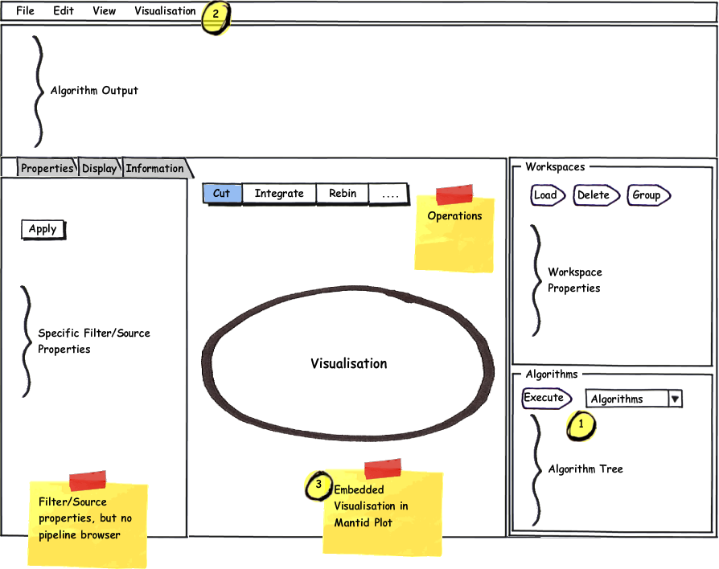
Figure 14: Visualisation in MantidPlot

