Tessella Project Number: 6466
Tessella plc 26 The Quadrant, Abingdon Science Park, Abingdon, Oxfordshire, OX14 3YS, UK
T: +44 (0)1235 555511 | F: +44 (0)1235 553301 | E: info@tessella.com | www.tessella.com

Client: ISIS

Visualisation and Analysis Mantid Extensions
Architectural Design Document



Document Control
This document is under document control. All members of the distribution list will receive updated copies whenever alterations are made. All other copies are uncontrolled.

Document Owner
Name | Role | Company
Owen Arnold | Owner | Tessella

Document Approval
The following are required to approve this document. Their approval signifies that the document is fit for purpose and approved for use.
NB: Different approvers will have different approval roles E.g.
- The Quality Manager’s approval signifies that it meets the requirements of Tessella’s QMS
- The Subject Expert’s approval signifies that it is technically correct
- The Client’s approval signifies that it meets their requirements.
Name | Approval Role | Company
 |  | Tessella

Distribution
Name | Role | Company
 |  | ISIS
Notes Projects Database 6466 | Filing | Tessella
All staff working on the project should have ready access to a controlled copy of this document. If they do not have access to NPD where they are working then the Project Manager or a member of the project team should be included on the distribution list. Please remember that if you are including information about any individuals then there must be enough information in the plan to be useful but nothing that they would find insulting.

Revision History
Author | Issue | Date | Description
Owen Arnold |  | 02-Aug-2010 | 1st version written

References
Document | Ref | Date | Details & Issue
Software Requirements | [SRD] | 01-Nov-2008 | NPD/xxxx/SR/SRD V1.R1.M0

Table of Contents
1 Introduction 6
1.1 Purpose of this Document 6
1.2 Scope of this Document 6
1.3 Context of this Issue 6
1.4 Definition of Terms 6
2 System Overview 6
2.1 Overview and Context 6
2.2 Interfaces Overview 7
2.3 Build Systems 8
3 Common Designs 8
4 System Wide Features 10
4.1 Language 10
4.2 On-line help 10
4.3 Error-handling 10
4.4 Automated Debugging, Testing and Diagnostics 10
4.5 Speed and Capacity 10
4.6 Statutory and Regulatory 10
5 Visualisation 10
5.1 Introduction 11
5.2 Interfaces 11
5.3 Cross-Reference to User Requirements 12
5.4 Third-Party Software 14
5.5 Visualisation Implementation 14
6 Rebinning 18
6.1 Introduction 18
6.2 Interfaces 18
6.3 Cross-Reference to User Requirements 18
6.4 Third-Party Software 19
6.5 Component-Dependent Subsections 19
7 Grid Computing 19
7.1 Introduction 19
7.2 Interfaces 19
7.3 Cross-Reference to User Requirements 19
7.4 Third-Party Software 19
7.5 Component-Dependent Subsections 20
8 Appendix A 20
9 Appendix B 20

Introduction

Purpose of this Document
This document describes the design of the visualisation and analysis extension application. The original ADD for Mantid may be accessed at: https://svn.mantidproject.org/mantid/trunk/Documents/Design/Architecture Design Document.doc This ADD is based on the system specified in the Software Requirements Document [SRD] https://svn.mantidproject.org/mantid/trunk/Documents/Requirements/Visualisation_and_Analysis/Visualisation_and_Analysis_URD.doc . It will form the basis of the planning of the development phase and will then be updated at the end of the development to act as a guide for maintaining the system.

Scope of this Document

This document is an extension to the original Mantid [ADD] to cover visualisation and analysis enhancements to the original system.

Context of this Issue
This is the first draft of the ADD and after internal review will be updated and released to the customer.

Definition of Terms

ADD | The Architectural Design Document (this document), the high level design document for the entire system.
URD | The User Requirements Document, records the users’ requirements for the system.
SRD | The Software Requirements Document, specifies the behaviour of the software system.
FR | Feasibility report on visualisation technologies
PD | Proposal Document
MADD | Mantid Architectural Design Document

System Overview

Overview and Context
This solution is a response to the problems identified in the [PD] and specific user requirements described in the [URD]. Briefly, this system has two high level objectives. Firstly it must allow rapid visualisation and analysis of extremely large datasets such as those produced by the LET and WISH instruments. Secondly, it must consolidate existing tools and knowledge from existing bespoke developments (such as Horace) under the Mantid umbrella. This second objective is aimed at creating a one-stop-shop facility for all analysis.
The system is generally designed to explore and operate upon multidimensional workspaces (MDWorkspaces) generated by Mantid. The system is specifically geared to handle large volumes of data. Aspects of the system are direct extensions to the original Mantid platform and are built into that environment. Visualisation aspects of the system are developed against ParaView and use secondary modules to communicate with the Mantid framework. Other third party library developments operate in a similar way.

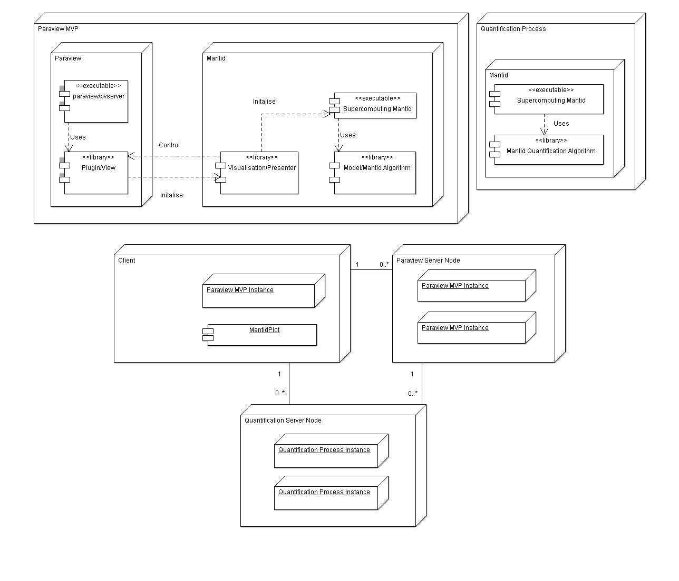
Figure 1: Deployment diagram depicting major system components.

Inputs
The system operates upon MDworkspaces.

Outputs

The major system output are MDworkspaces derived from the original input, upon which, multiple operations have been performed.

Visualisation outputs are available in the form of graphs, screenshots, and video files.

Interfaces Overview
High-level view of interacting components. Touch points between distinct components are treated here. Detailed specifications are provided in relevant subsections.
The dynamic rebinning strategy binds rebinning type filters to rebinning type Mantid algorithms.

<<component>>

RebinningAlgorithm
IDynamicRebinning
<<component>>

VisualRebinningFilter

Figure 2: IDynamicRebinning

Build Systems
CMake, the native build environment for ParaView, is heavily embedded into the ParaView project. At the same time, the Mantid project uses SCons for software construction. Converting from one system to the other is impractical. Fortunately, there is a logical division between functionality on both sides of this build interface, so separation of binary components is an option. In fact, it is better from an architectural point of view to promote this form of separation as it forces decoupling and enhances software quality.

The solution adopted is to control the overall build process using SCons. ParaView plugins will be generated using CMake, but SCons will initialise the build process. CMake scripts for ParaView plugins will refer to Mantid components directly as binary library files.

Interfaces will need to be made available across these build environments. Where MVP is used, presenter interfaces will live on the Mantid side, but concrete implementations of these interfaces, with knowledge of the exact visualisation framework will live on the ParaView side.

Common Designs
A number of standard solutions to reoccurring problems in the project are treated here.

Model View Presenter (MVP)
The emerging architecture of the system is one in which there is an overall high level of complexity, but strong divisions and responsibilities within the overall solution. Each subcomponent of the system may be less complex than the overall solution providing that strict division of responsibilities is maintained. The model view presenter design presents a decoupled approach to design making each subcomponent more testable and more readily distributable for development. The MVP pattern is most applicable because each ParaView filter will need to instantiate its own controller/presenter, which is capable of constructing a Mantid instance (the model). The exact approach adopted will follow Martin Fowler recommendations (http://martinfowler.com/eaaDev/PassiveScreen.html)

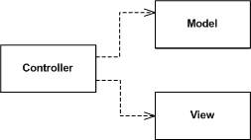
Figure 3: Passive Model View Presenter (MVP). Controller is presenter in diagram.

Static Factories
The overall solution consists of several distinct components. A reoccurring situation is that that one component will need to pass complex parameters to another. Where polymorphism is required, the passing component will need to direct the instantiation of the correct concrete type. A direct, but unfavourable design, is one in which the concrete type is directly instantiated from the passing component. There are many drawbacks of this situation. One disadvantage is that the passing component is unnecessarily exposed the full interface of the constructed object, which it will often have no remit to modify, especially where an MVP type approach is adopted. A second disadvantage is that the constructed object has a lifespan, which is unnatural in relation to the actual object which utilises it. The lifespan issue presents a conceptual barrier to understanding of the model, is against good OO practice and will result in unnecessary memory utilisation.
The general solution to the problems outlined above is to allow one component to decide what is constructed and the other to decide when to construct it. This constructional solution is well treated and referred to in this context as a Factory Method (“Design Patterns” by E. Gamma et al, Tessella Ref: 2025). Many components of the system communicate in terms of Factory Methods, where covariance is utilised to instantiate the desired concrete types. This is particularly prevalent in view objects, where users make selections, which correspond to algorithm choices, yet actual knowledge of algorithm implementations in the view would be detrimental to the overall architecture.
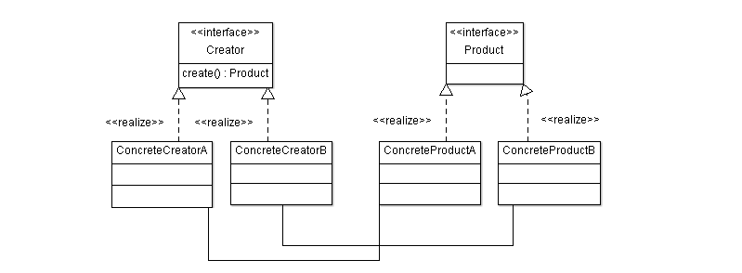
Figure 4: Factory method

Resource Management
The preference is for all acquired resources to follow the RAII (Resource Allocation Is Initialisation, see “C++ In a Nutshell” by Listener). For heap-based memory allocation, resource management should be performed via automatic or shared pointers using the current variant adopted by the Mantid Project. For other resource management, in the absence of a specific framework type (such as vtkSmartPointer for ParaView), a template with appropriate implicit and explicit specialisations should be created and utilised.
In production code, only where automated resource management is known and proven to significantly reduce performance should it not be used. Prototypes need not comply with this specification.

Executors
Where multi-processing is required, to ensure proper operation, it must be verified that any particular routine is:
- Functionally correct
- Correctly executed under a multi-processing scenario
The Executor Pattern (“Growing Object-Oriented Software Guided by Tests” by S. Freeman et al) is simply a Strategy Pattern (“Design Patterns” by E. Gamma et al, Tessella Ref: 2025) designed for separating multi-processing/concurrency aspects from functional aspects. The executor can either be selected at runtime or at compile time using Policy Based Design (“Modern C++ Design”, by A. Alexandrescu)

Locking proxies
While performance demands specified in the URD, imply as much of the code as possible should be run concurrently, certain routines should not and must not be accessed by multiple threads simultaneously. Using proxies (“More Effective C++”, by S. Meyers) and locking smart pointers (“Modern C++ Design”, by A. Alexandrescu”) we can ensure that locking and unlocking events are automatically called on these critical routines.

System Wide Features

Language
See Mantid ADD.

On-line help
See Mantid ADD.

Error-handling
No errors or exceptions should be automatically swallowed in the code without being propagated in some form to the surface. Custom exception types may be provided where the default system types are not sufficiently descriptive. Exceptions may be re-thrown, provided that the original exception information is also propagated. Decisions regarding the display of errors are to be made as late as possible and are not a core framework concern.
See Mantid ADD.

Automated Debugging, Testing and Diagnostics
Any software generated against the Mantid framework, will provide extensive unit test coverage at least up to the standards covered in the original Mantid ADD. Except for prototyping, test driven development (TDD) practices should be followed to ensure the highest quality output. In addition, software testing strategies will take advantage of the googlemock framework to promote decoupling via dependency injection.

Speed and Capacity
See Mantid ADD.

Statutory and Regulatory
See Mantid ADD.

Visualisation

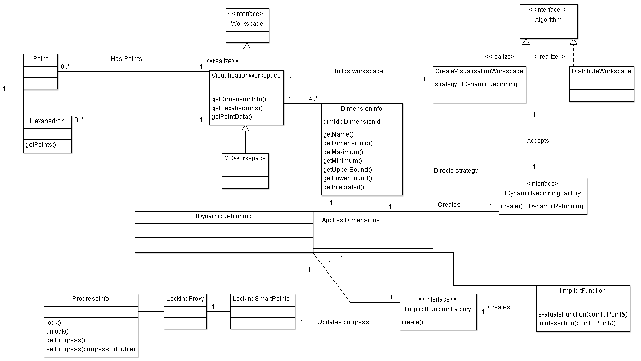
Figure 5: Class diagram for Visualisation/Rebinning Interaction

Introduction

The [URD] describes many aspects of the end product that rely on distributed visualisation. In the context of these user requirements, the visualisation feasibility report [FR] indicates that ParaView is the most appropriate choice of framework to achieve these goals. Early prototypes using ParaView support the feasibility report, by exploring the required design space.
Visualisation development revolves around the generation of plugins for the ParaView code base. This is the vendors recommended route to customisation and does not involve modification of any core code.
The general visualisation strategy is to lean on the ParaView and Mantid architectures as much as possible, so that only as thin bespoke visualisation layer is required. This strategy emphasises reuse at the VTK and ParaView front-end, for example, specialisation of existing filters where only small functional changes are needed. This strategy also promotes a model-view-presenter (MVP) architecture, where-by visualisation filters are highly dissociated from the back-end controlling algorithms.
The following types of plugins will need to be generated:
- Readers/Datasources for converting MDWorkspace files into visualisation pipeline head objects
- Filters: For applying computational steps against pipeline inputs, such as dynamic rebinning
- GUI plugins such as toolbars, menus and views specific to neutron data reduction and the readers and filters created

Interfaces
All visualisation processes must be provided with a multidimensional workspace (MDWorkspace). More specific sets of inputs are needed for those visualisation subcomponents providing rebinning and slicing operations.

Input
MDWorkspace
This workspace provides the structure that carries actual run data. This type is used for both input and output. The MDWorkspace contains data and dimensions. It provides methods which allow visualisation plugins to extract Cartesian point information, scalar values and cell data.
vtkRebinningStructuredGrid
Rebinning and slicing operations need to publish metadata about their inputs for subsequent rebinning operations. This type is compatible with the ParaView and VTK pipeline. This data structure may contain information relating to the location of a disk-based multidimensional workspace so that each filter can refer to the original raw data if required. By deriving vtkRebinningStructuredGrid from vtkDataSet, it is possible to make any filters utilising this type to be compatible with a large number of ParaViews existing filters. vtkRebinningStructure instances must be generated by a customised vtkAlgorithm so that the appropriate port information can be provided.

Output
IDynamicRebinning
Indirectly generated via the IDynamicRebinningFactory. This type completely encapsulates GUI or command-line driven cuts to be applied to an existing MDWorkspace. As there are many ways in which to compute rebinned data, the IDynamicRebinning type is the root type in the Strategy Design Pattern (ref Strategy in Gamma et al) . The dynamic rebinning strategy will always require implicit functions and dimension information.
IImplicitFunction
Provides a description of an isosurface such that F = c, where F is a function of n-variables usually Cartesian coordinates and c is a constant. Specialisations of this type define plane(s) and spheres. Other specialisations allow users to provide their own function as plain text, which is interpreted and later executed. Using the Composite Pattern (“Design Patterns” by E. Gamma et al, Tessella Ref: 2025) a single implicit function may actually be composed of one or more nested Implicit functions
DimensionInfo
Only 4-dimensions from the full MDWorkspace may be visualised at any one time. This type allows the filter to specify which dimensions of the n-Dimensional dataset are to be rebinned and how they map to orthogonal visualisation axes. Other dimensions are integrated over, and bounding information to specify the integration range is provided.
IDynamicRebinningFactory
Allows the rebinning-filtering type visualisation plugin to communicate with Mantid algorithms that actually perform the rebinning. This type supports a family of subtypes each of which can generate a specialisation of IDynamicRebinning. In this factory method (“Design Patterns” by E. Gamma et al, Tessella Ref: 2025), the visualisation plugins may generate rebinning strategies.
IImplicitFunctionFactory
Allows the UI code to provide an implicit function selection without having knowledge of that actual implicit function. This type serves a similar purpose to the IDynamicRebinningFactory. Where nested implicit functions are required, the corresponding factory type will accept other factory types as arguments.

Cross-Reference to User Requirements

URD Section | ADD Section | Comments
U3.1.2.1 | 5.5.1.6 | Both Mantid and ParaView provide python scripting.
U3.1.2.2 | 5.5.1.6
U3.1.2.3 | 5.5.1.6
U3.2.1.3 | 5.5.1.7
U3.2.2.1 | 5.5.2 | Complete flexibility on how axis are displayed.
U3.2.2.2 | 5.5.2
U3.2.2.3 | 5.5.3 | Ability to provide interactors for this unresolved.
U3.2.2.4 | 5.5.2
U3.2.2.5 | 5.5.2, 5.5.3 | Any dimensions may be selected.  Implicit function and vtkContour provide integration and display.
U3.2.2.6 | 5.5.2, 5.5.3 | Scriptable implicit function may utilise muParser to interpret and execute user provided equation.
U3.2.2.8 | 5.5.3 | Implicit function and vtkContour provide projection and display.
U3.2.3.1 | 5.5.1.3 | ParaView supports clipping and slicing operations.
U3.2.3.2 | 5.5.1.3
U3.2.3.3 | 5.5.1.3 | Using slicing type filters
U3.2.3.5 | 5.5.5 | Rebinning operations will improve resolution upon slicing.
U3.2.4.1 | 5.5.1.3
U3.2.2.1 | 5.5.2
U3.2.2.10 |  | Sumspec design not completed
U3.2.2.11 |  | Flattened instrument view design not completed
U3.2.2.14 | 5.5.1.2
U3.2.2.15 |  | Symmetrisation type support not fully designed
U3.2.2.16 | 5.5.3
U3.2.2.17 |  | Unknown solution
U3.2.5.1 | 5.5.1.3, 5.5.1.7
U3.2.5.2 | 5.5.1.3, 5.5.1.7
U3.2.5.3 | 5.5.7
U3.2.5.4 |  | Addition of additional vectors unresolved.
U3.2.6.1 | 5.5.1.2, 5.5.1.7 | Axes markers may be added or removed
U3.2.6.2 | 5.5.1.2, 5.5.1.7 | Axes markers may be added or removed
U3.2.6.3 | 5.5.1.2 | Any scaling operation may be achieved using Python programmable filter.
U3.2.7.1 | 5.5.1.2 | Point Data to Cell Data and Cell Data to Point Data filters.  Rebinning filters are based on a custom algorithm type, which can return data in a variety of concrete structure data types.
U3.2.9.1 | 5.5.1.6 | Trace recording of GUI operations as equivalent Python statements are available. These may be reexecuted.

Third-Party Software

Name | Reason and Justification | License | Reference
ParaView | Reasons and justification outlined in visualisation feasibility report [FR].  Prototypes relating to [URD] functionality available in  http://svn.mantidproject.org/mantid/trunk/Documents/Pilot/Visualisation_and_Analysis/Visualisation | Berkely Software Distribution | http://www.paraview.org
Googlemock | Encourages dependency injection and makes software more testable.  Highly portable. | Berkely Software Distribution | http://code.google.com/p/googlemock/

Visualisation Implementation

ParaView Functionality
ParaView has been chosen as a third party visualisation library primarily because of its rich out-of-the-box functionality (see [FR]). ParaView offers ready solutions to many of the visualisation issues outlined in the [URD]. The following sections give a brief of some of the ParaView attributes relevant to the solution. For greater depth see “The ParaView Guide” by A. Squillacote.

GUI Framework
ParaView 3.8 onwards is Qt based. The ParaView framework is highly customisable giving developers the option to build their own components from scratch or simply re-engineer existing ones. Consult the ParaView Guide (“The ParaView Guide” by A. Squillacote) for a full description of permissible development activities.

Views
ParaView supports a number of perspectives/views. Various Plots, 2D and 3D type views are standard. The standard ParaView application allows the view area to be sub-divided into numerous viewports. These viewports can be locked together, or remain independent. Each viewport allows a different perspective on the same pipeline (or branch of the pipeline) to be shown. Furthermore, each cell/point may contain several scalar properties, such as intensity and error. Each viewport may display a particular scalar property independently from its neighbours.

Key Filters
ParaView comes pre-loaded with a large number of filters. Custom filters may specialise an existing filter, or be composed of many existing filters. Some filters which are likely to useful to the end user are:
- Cell Data to Point Data
- Point Data to Cell Data
- Tetrahedralize
- Clip
- Slice
- Python Programmable Filter

Interaction
ParaView readily supports zooming and panning. Many other interaction operations are also supported. Moving and rotating a plane which defines a slice is an example. Viewports may be locked together so that camera interaction with one results in immediate camera update of the other.

Data Reduction
ParaView strongly supports the visual data reduction and discovery paradigm. As a result it provides a number of ways to perform analysis on a visual data set. Data points may be selected, subdivided and tracked, or simply queried to find those with certain properties.

Scripting
ParaView provides Python wrappers for its classes. A newly updated syntax recently introduced into the Python API makes it clear and expressive. As a result, everything possible in the GUI may be achieved using the scripting API.
Using the ParaView tracking macro, GUI commands are recorded and translated into Python scripts. Such scripts may be saved and re-run.

Marking
ParaView supports additional marking tools by default. Text labels, arrows, axes and legends are all available for decorating views.

Dimension Selection
The MDWorkspace carries data regarding any number of dimensions. Visualisation of these M-dimensions is limited to four only, three of which are spatial and the fourth, which is time. To provide greatest flexibility, the user may choose how they wish to map dimensions in the MDWorkspace to those of the visualisation (see mock-up in Appendix A). If the number of dimensions in the MD workspace is greater than four then those dimensions not attributed to visualisation axes must be integrated over by providing an upper and lower bounds.
When a rebinning request is made via a customised filter, dimension information is sent as part of the request to the Mantid rebinning algorithm.
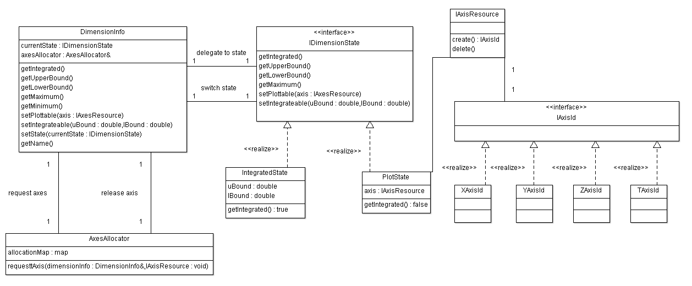
Figure 6: DimensionInfo type uses helper classes to track and switch between different physical axes or apply integration ranges.

Implicit Functions
A reoccurring user requirement is the ability to map a surface onto a visualisation dataset or to split the dataset along a boundary defined by a function. Surface projections should be handled directly in the visualisation layer and can be done so using existing VTK technologies. Slicing information on the other-hand must be passed to the Mantid algorithm, which will actually perform the work.
Communicating slicing information is made complex because of the range of geometries which may be used for slicing. Furthermore, scalar properties of the data may be used in addition to geometrical aspects to specify slices. The natural abstraction of this slicing requirement is to provide a generalised function that can perform operations on some subset of the full MDimensional data and its associated scalar values. Function objects (see Strategy Pattern in “Design Patterns” by E. Gamma et al, Tessella Ref: 2025) provide an effective solution to this problem. In essence, the function object encapsulates a slicing function behind a standard interface. The function object approach is suitable for slicing functions which range from very simple to fairly complex. In addition, once the function object is assembled, the Mantid algorithm will just have to execute it, regardless of how complex it is.
Function objects are used to represent implicit functions. Specialisations of this IImplicitFunction type define plane(s) and spheres. Other specialisations allow users to provide their own function as plain text, which is interpreted and later executed. Using the Composite Pattern (“Design Patterns” by E. Gamma et al, Tessella Ref: 2025) a single implicit function may actually be composed of one or more nested Implicit functions.

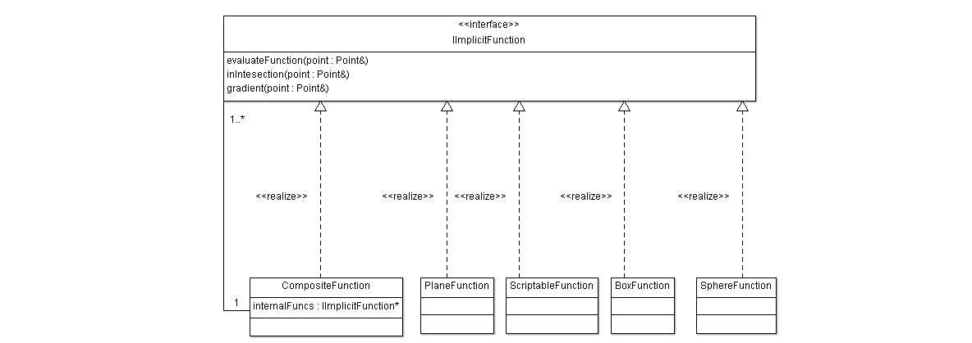
Figure 7: Implicit function providing a composite implementation as well as several default implementations.
VTK also supports the notion of implicit functions with the type vtkImplicitFunction and its realisations such as vtkPlane. The implicit function types described above bear no direct type relation to those in VTK so that back-end processing is not VTK dependent. In order to draw isosurfaces via vtkContour filters, IImplicitFunction types may be mapped to vtkImplicitFunctions.

GUI Customisation and Interaction

No modifications or additions are planned for the core ParaView code. Visualisation development will adhere to the ParaView supported mechanisms. Core ParaView code is a third-party code base and must not be altered.
In order to tailor ParaView into a suitable mode for the application domain modifications to the default interface must be made (this is possible via supported mechanisms). Many of the data sources and filters generated require specific user inputs for proper information. Other filters require specific visual interaction mechanisms to be provided.

Simple Interface
The aim of the simple interface is to provide the minimum necessary set of options to allow users to perform visual data reduction on neutron data.
A complete Qt based bespoke user interface will be provided for the visualisation. This is planned for, but not limited to, integration with the existing MantidPlot GUI. The majority of this work involves removing toolkit elements rather than adding them in. A mock-up of this user interface is provided in Appendix B.
The simple interface will pre-load plugins developed as part of this project.

Advanced Interface
The advanced interface will support users who need to utilise aspects of the ParaView framework that are not available in the simple interface.
The advanced interface involves no direct customisation. This interface is the default ParaView front-end. Plugins developed as part of this project may need to be loaded manually.

Rebinning
There are many ways to rebin neutron data. To support the rebinning functionality across the application, it shall be provided as a Strategy (see “Design Patterns” by E. Gamma et al, Tessella Ref: 2025), so that most of the development can remain ignorant to the implementation details of each variant and so that introduction of new rebinning strategies are easy. At the time of writing, three distinct rebinning strategies have been identified and more will likely requested later. Details on these rebinning types are covered in a later section.

The application may attempt to select the rebinning method deemed optimal; however, users may wish to override automated selections. This implies that the IDynamicRebinningAlgorithm may need to be constructed by the GUI and passed to the rebinning algorithm since it is at that point that selection is made. Instead of directly constructing the IDyanamicRebinning strategy, the plugin should construct and IDynamicRebinningFactory, which can be passed to the rebinning Mantid algorithm. Essentially, this allows the view to decide what will be constructed and lets the controller decide when it should be constructed. The factory method approach also shields the view from the details of the IDynamicRebinning strategy. As the project grows, more rebinning strategies can be realised without having to coordinate conditional statements across solution components.

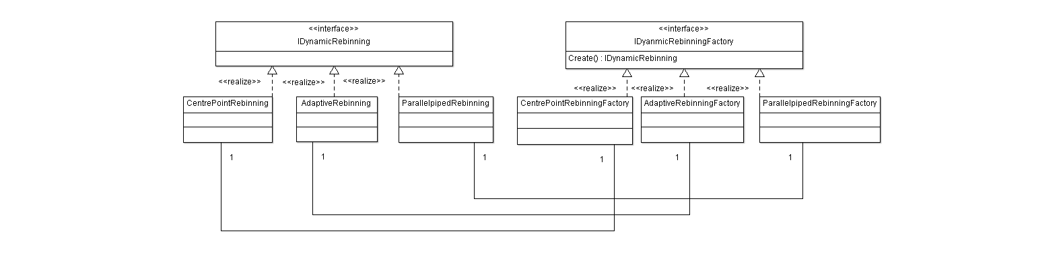
Figure 8: Dynamic rebinning strategy approach.

Distributed Computing
Distributed computing is critical to swift processing of the visualisation datasets and handling of large data volumes. The visualisation feasibility study demonstrated that ParaView performs well in a distributed computing mode. Through prototypes, it has been verified that custom filters developed as ParaView plugins can be made to work in a distributed mode taking advantage of data parallelisation offered by ParaView. The project will support both client-only stand-alone visualisation and distributed visualisation. Although ParaView supports many types of distributed visualisation, their recommendation of a combined data server and renderer server will be followed.

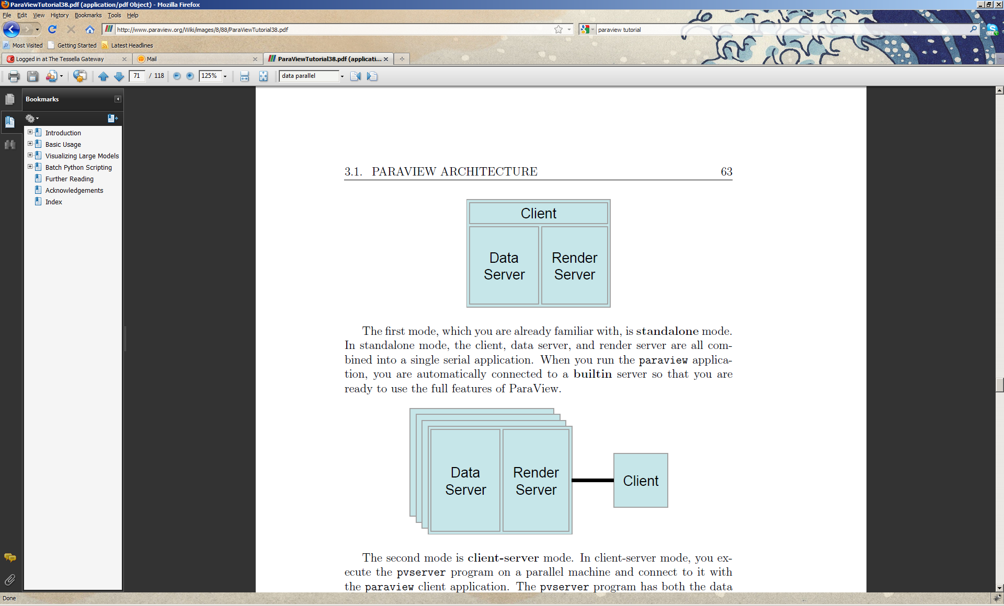
Figure 9: Stand-alone mode. Client acts as data server and renderer server.
Figure 10: Distrubuted mode with combined data and renderer server and separated client.
To facilitate parallel processing, where vtkDataSet derived data structures are used, data structures must determine and coordinate their extent in the context of the total number of processers available. This information is provided by the ParaView framework.
Plugins that are not meant for distributed computing should contain the correct xml so that they remain on the client.
An outstanding issue is the parallelisation of adaptive rebinning operations, where each parallel process must have knowledge of its bin boundaries.

Non-orthogonal axes
Visualisation plugins will work in terms of point and cell information required by ParaView. Where non-orthogonal axes are to be used, Mantid Algorithms will transform the results into a Cartesian coordinate system and provide point information for display.

Rebinning

Introduction

Interfaces

Input

Output

Cross-Reference to User Requirements

Third-Party Software
Name | Reason and Justification | License | Reference

Component-Dependent Subsections

Grid Computing

Introduction

Interfaces

Input

Output

Cross-Reference to User Requirements
URD Section | ADD Section | Comments

Third-Party Software
Name | Reason and Justification | License | Reference

Component-Dependent Subsections

Appendix A
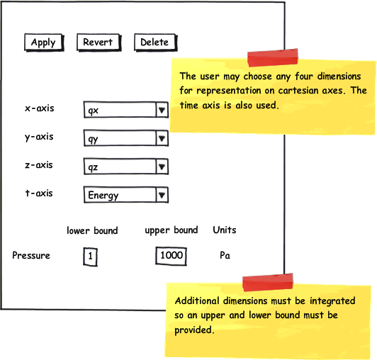
Figure 11: Mock-up dimension selection for object browser.

Appendix B

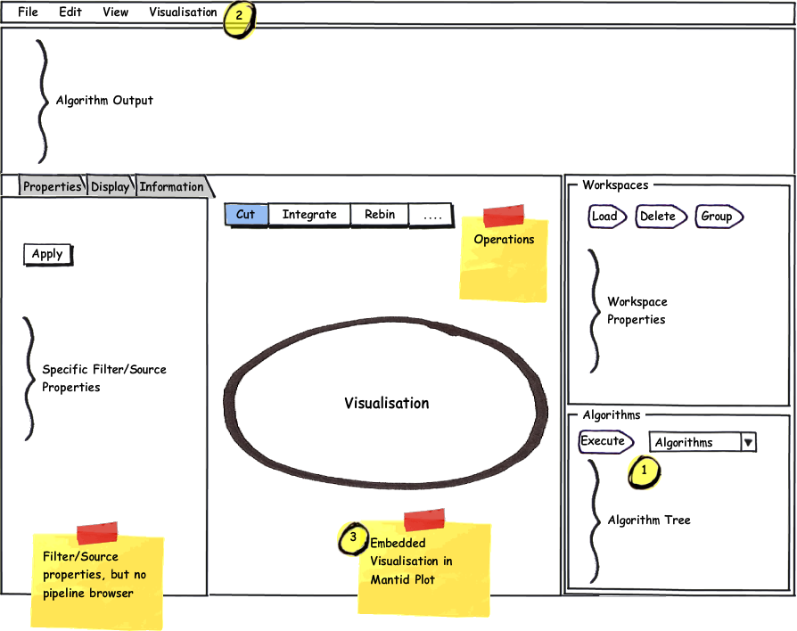
Figure 12: Visualisation in MantidPlot

