Tessella Project Number: 6466
Tessella plc 26 The Quadrant, Abingdon Science Park, Abingdon, Oxfordshire, OX14 3YS, UK
T: +44 (0)1235 555511 | F: +44 (0)1235 553301 | E: info@tessella.com | www.tessella.com

Client: ISIS

Visualisation and Analysis Extensions for MANTID
Software Requirements Document



Document Control
This document is under document control. All members of the distribution list will receive updated copies whenever alterations are made. All other copies are uncontrolled.

Document Owner
Name | Role | Company
Owen Arnold | Owner | Tessella

Document Approval
The following are required to approve this document. Their approval signifies that the document is fit for purpose and approved for use.

Name | Approval Role | Company
Nick Draper |  | Tessella

Distribution
Name | Role | Company
MANTID SVN Repository  https://svn.mantidproject.org/mantid | Filing | ISIS

Revision History
Author | Issue | Date | Description
Owen Arnold | 1 | 21-May-2010 | 1st version written

References
Document | Ref | Date | Details & Issue
Proposal Document | [PD] |  | V6.R1.M0
User Requirements Document | [URD]
Mantid Software Requirements Documen | [MSRD] | 5th October 2007 | V1.R1.M0

Table of Contents
1 Introduction 6
1.1 Purpose of this Document 6
1.2 Scope of this Document 6
1.3 Context of this Issue 6
1.4 Definition of Terms 6
2 General Description 6
2.1 Project Context 6
2.2 General Capabilities 7
2.3 Environmental Considerations 7
2.4 System Context 7
2.5 General constraints and assumptions 7
2.6 Outstanding Issues 7
3 Logical Model 8
4 Processing 9
4.1 Functional Requirements 9
5 User Interface 9
5.1 Functional Requirements 9
6 Algorithms 10
6.1 Functional Requirements 10
7 Data Storage 10
7.1 Functional Requirements 10
8 External Interfaces 10
8.1 Functional Requirements 10
9 System Wide Requirements 12
9.1 Platform Requirements 12
9.2 Documentation Requirements 12
9.3 Speed and Capacity Requirements 12
9.4 Testing Functional Requirements 13
9.5 Installation Requirements 13
9.6 Security Requirements 13
9.7 Quality, Reliability and Maintainability Requirements 13
9.8 Safety Requirements 14
9.9 Statutory and Regulatory Requirements 14
10 Cross references 14
10.1 URD-SRD Cross Reference 14
10.2 SRD Source Cross reference 14

Introduction

Purpose of this Document
This document describes the software requirements of the Visualisation and Analysis extensions to Mantid application.
It is based on the system described in the User Requirements Document [URD].
It will form the context for the design phase and will be used to derive the system test script. It will be used as the contractual description of the delivered system throughout the project. Deviations are inevitable though, so a list of deviations will be maintained and the SRD will be updated at the end of the project.

Scope of this Document
These requirements cover the development of the enhanced visualisation aspects of the Mantid framework. They also encompass the new Analysis applications. This document only covers the enhancements and additions to the Mantid Framework. The Mantid SRD [MSRD] covers the original system.

Contxt of this Issue
This is the first draft of the SRD and after internal review will be updated and released to the project wiki.

Definition of Terms

SRD | The Software Requirements Document, specifies the behaviour of the software system.
URD | The User Requirements Document, catalogues the users’ requirements for the system.
MSRD | Mantid Software Requirements Document
PD | Proposal Document
ADD | The Architectural Design Document, the high level design document for the entire system.

Specific requirements status flags:
M | Mandatory requirement. This feature must be built into the final product.
D | Desirable requirement. This feature should be built into the final product unless its cost is too high.
O | Optional requirement. This feature can be built into the final product at the Project Manager's discretion.
E | Possible future enhancement. This feature is recorded here so that the idea is not lost. It must not be included in the final product.
X | Deleted requirement. Gravestone retained for reference.

General Description
Keep this section brief. It should contain general background information only makes the subsequent sections understandable. If some sections are repeated from the URD then include cross references rather than repeating chunks.
This contains a general description of the project background. Requirements given here directly or indirectly will only be part of the final deliverables if listed explicitly in sections 4 onwards.

Project Context
The recent instrument installations and retrofits at TS1 and TS2 have greatly increased both the resolutions and sizes of the neutron detector arrays at RAL. While this hardware is now producing massive datasets, the analysis tools available are, insufficiently suited to make full use of the instrument outputs. Scientists at ISIS must become familiar with a large number of these existing, distinct tools in order to complete their end-to-end analysis. For more details on the context of this issue refer to [PD].
The project has the following major aims:
- To close the gap between the hardware capabilities and analysis-software capabilities. The solution entails the creation of a new cross-platform suite of visualisation and analysis tools suited to processing the new detector outputs.
- To create a one-stop-shop for all analysis build upon the existing Mantid framework, which has proved highly successful at RAL over the past few years.
Existing tools at ISIS such as Horace, Mslice and TobyFit, will heavily influence the end product.

General Capabilities
The main capabilities of the system will be to provide rapid and detailed visualisation of the massive datasets generated by instrument detectors. The users will be provided with a one-stop-shop for visualisation and analysis, which is seamlessly integrated into the Mantid framework.
The project has the following major aims:
- To close the gap between the hardware capabilities and analysis-software capabilities. The solution entails the creation of a new cross-platform suite of visualisation and analysis tools suited to processing the new detector outputs.
- To create a one-stop-shop for all analysis build upon the existing Mantid framework, which has proved highly successful at RAL over the past few years.

Environmental Considerations
The data analysis framework is primarily designed to support the analysis of the experiments performed at the ISIS neutron spallation facility at RAL, however this system will be released under the open source GPL agreement, as such it could be used throughout the neutron diffraction community.
The system needs to support instrument scientists within the ISIS facility and visiting scientists who will take their data away for analysis. Instrument scientists within the ISIS facility will generally have capable computers running Unix/Linux or windows operating systems as well as access to the internal ISIS network and internet access. Visiting scientists will wish to run the framework on a far more mixed environment, from rather low specification laptops to very capable servers, and may be running unix/linux, windows or Mac OS X. It cannot be assumed that visiting scientists will have access to the internet and will not be able to access the ISIS internal network.
Hardware requirements will be elaborated upon later.

System Context
Mantid Framework
RAW data files
NEXUS data files
Analysis Tools
Instrument log files
Standard Algorithms
User Defined Algorithms
Visualisation Tools
Core Extensions
i.e. MD Workspaces

General constraints and assumptions
The system must be developed in C++ dure to the use of this language at RAL, and it’s relatively common use in large-scale physics analysis. This project will adhere to all guidelines and restrictions laid down during the course of the Mantid project.

Outstanding Issues
Outstanding issues have been documented against the relevant requirements.

Logical Model
This section contains a high level model of the system which should ideally contain some diagrams.
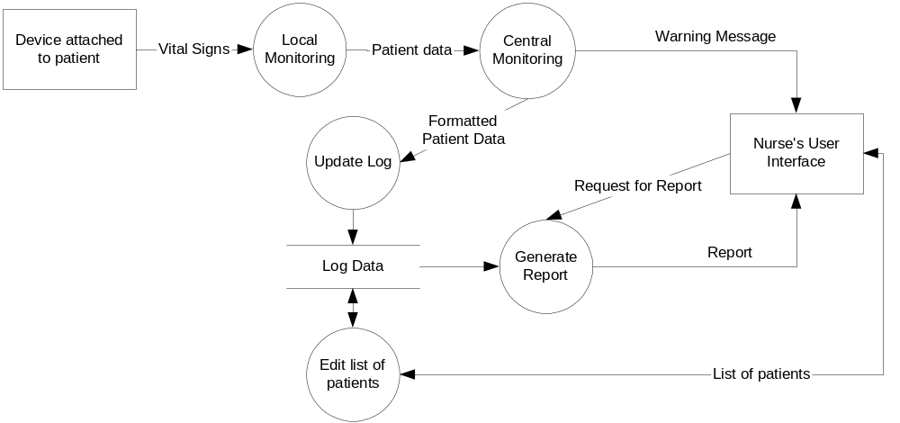
A data flow diagram is comprehensible to most users to put the specific requirements into context. If it is accepted that the system will include a database then it is useful to show this e.g.“the database must do xyz”. However it should not go into lower levels of implementation detail as this would constrain the design choices.

Alternatively, use a high-level class diagram of the logical objects in the system i.e. the nouns from the description of the requirements.
If a Use Cases Document has not been produced, it may be useful to include a brief description here of the main use cases and actors. This can give an alternative way of looking at the system and can help to establish things like whether different user roles should be supported.

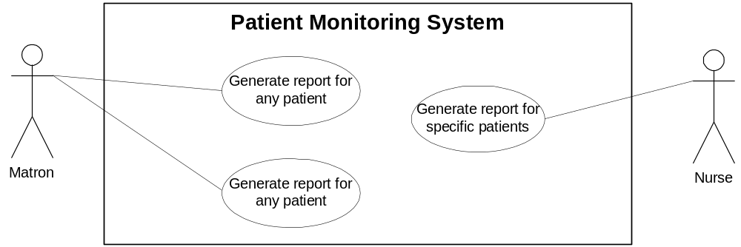

Processing
Sections Error: Reference source not found to Error: Reference source not found are intended to give a sensible default structure to the SRD. The intention is to group the requirements into types that are addressed by different parts of the architecture, different parts of the design document and different methods of design. This makes traceability and cross checking easier. Alternative breakdowns may be more suitable for some projects.
This section should describe the business logic and the processes that the software must support. It can be broken down into subsections if necessary. For instance this section should describe requirements that you would expect to implement in classes ‘behind’ the interface, in background processes, in stored procedures etc. – where these are not better classified as algorithms (because of their complexity) or as handling interfaces to other systems. Requirements that are to do with presentation and simple user input validation should be in the User Interface section.

Functional Requirements
In this and subsequent sections, each requirement must be labelled, described and prioritised. Each label should be of the form SA.B.C, where A is the section number, B the sub-section number and C the requirement number within that sub-section.
Each requirement must have a short discrete description of what is required. This is essential for cross-reference and reviewing. It can be hard to do, so it may be necessary to write a rough natural language description first and then extract the requirements from that. Using a table to format the entries in the SRD is intended to encourage keeping the requirements short and discrete.
Every requirement should have an indication of its origin, when the requirements are derived from other documents it helps to quote the actual text if you have rephrased it to make it clearer and more precise. Once the source document’s authors have reviewed the SRD it may be possible to remove the quotations. This source section may be replaced by the table in the cross reference section described below.
Finally every requirement has optionally a description of any outstanding issues concerning the requirement. It is likely that for several iterations the SRD will be a working document and it is quite acceptable for it to contain commentary such as “what does this mean?”, “why should it do this?”, “do you realise what the consequences of this requirement are?” and “could this be satisfied this way?”.
Note that before quoting a fixed price for requirements expressed using these categories, the desirable requirements must be eliminated or relegated to optional or extension.

Label | Requirement | Necessity
S4.1.1 | On entry to the application the user must select from one of the protocols available to them. Subsequently all data displayed must be in the context of the selected protocol.  Source:  Issue: | M
S4.1.2 | Investigators must only be able to see detailed centre information for their own centre.  Source:  Issue: | M
S4.1.3 | Investigators must only be able to see subject information for subjects recruited at their centre.  Source:  Issue: | M
S4.1.4 | The system will do abc. | X

User Interface
It is important to strike a balance between specifying intricate GUI details (leading to an impossibly constrained design) and ignoring the GUI completely.
This section should list the principal screens of the application (not message boxes and confirmation dialogues) and listing the main functional (as opposed to cosmetic) requirements of the screens. Include a diagram specifying the navigation between these principal screens if such navigation is a requirement, otherwise leave it until the design stage.
Don’t describe appearances, list the required input/output fields and describe the requirements of any diagrams/charts. Demonstration screenshots should not form part of the requirements but can be used to elicit them e.g. prototype or ‘paper prototype’. A few ‘appearance’ requirements are acceptable e.g. presence of toolbars, controls having an accelerator key.
If relevant, consider requirements for operation on small/low resolution screens, using alternative codepages/characters, languages or fonts.

Functional Requirements
Label | Requirement | Necessity
S5.1.1 | The ‘people query’ screen must allow users to search for ‘people’ details by:  Name – text field with simple ‘*’ wildcard.  Role – drop down list.  Centre – drop down list.  Contact address - text field with simple ‘*’ wildcard.  People records matching all the specified criteria should be displayed in a ‘people list’ screen.  Source:  Issue: | M

Algorithms
This should list (or reference) any algorithms that the software must implement. Algorithm requirements are quite specialised – they only occur in a minority of projects. Typically they will reference a particular published algorithm, or the selection of algorithm may be part of the design exercise. Usually a very few requirements can specify a very significant part of the implementation.
A useful technique for agreeing algorithms with a customer can be to implement a restricted version of the algorithm in Excel. An agreed Excel implementation, referenced by this document, with user supplied input and checked results can then form part of the acceptance test for the full algorithm.

Functional Requirements
Label | Requirement | Necessity
S6.1.1 | The system must fit a quadratic logistic regression [Ref xyz] to the probability of subjects surviving at each dose strength.  Source:  Issue: | M

Data Storage
This section will usually cover what data is to be stored in the application database. It only describes the data that will be directly visible to the user. It describes the ‘logical’ model of the data rather than the ‘physical’ model, which is left to the design stage. It need not be in 3rd normal form. It should describe the principal ‘tables’ and their fields. For each field it should give data-type and valid data range.

Functional Requirements
Label | Requirement | Necessity
S7.1.1 | The system must store experimental data which should include:  Experiment ID (PK)  Instrument name (text string – up to 10 chars) (FK into instrument table)  Experimenter name (text string – up to 30 chars) (FK into experimenter table)  Substance name (text string – up to 30 chars)  Substance number (if available) (text string – up to 10 chars) (FK into customer substance table held in master substance database)  Log book reference (string of the form ‘Lnnn/nnn’ or ‘Lnnnn/nnn’)  Experiment data and time (to the minute)  Magnification (100, 500, 1000)  Image (‘,tif’ file)  Source:  Issue: | M

External Interfaces
Description or references to any external APIs, file formats, serial protocols, web services, database interfaces etc that must be adhered to.

Functional Requirements
Label | Requirement | Necessity
S8.1.1 | The system must be able to upload data exported from the existing Data8 system. This data will be in an ascii text file, the format of the file is documented in (ref to customer doc)  Source:  Issue: | M
S8.1.2 | The system must provide access to experimental data via a web service. The service will provide a simple operation to retrieve the main experimental data (except the image file) (see S7.1.1) by Experiment ID.  Source:  Issue: | M

System Wide Requirements
Most of these sections will be very brief but act as an important checklist.

Platform Requirements
Remember this should be as specific as possible i.e. operating system service packs.

Label | Requirement | Necessity
Sn.n.n | Source:  Issue: | M

Documentation Requirements
This should list all the deliverable documents that form part of the final system. This should include electronic documents such as web pages and help systems.

Label | Requirement | Necessity
Sn.n.n | Source:  Issue: | M
Or …

No documentation is required by the customer.

Speed and Capacity Requirements
If the user requirements state that performance/file-size etc are not an issue or do not mention performance at all then the SRD should still state some requirements because this bounds what we will deliver. In this situation, the performance requirements stated should be easy to achieve given the target hardware (which should also be included). On Fixed Price projects these must be stated such that we do not introduce additional requirements that we have not already specified or not costed.
However if there are performance-related user requirements then it is important to specify them quite clearly in the SRD. It is advisable to write measurable targets stating the hardware that will be used. A good way to specify performance is to write two targets - one desirable and one mandatory.
In either case the requirements should be made clear to the client and if additional performance requirements are needed, the PM should treat this as a project change

Label | Requirement | Necessity
S9.3.1 | The system must be able to hold and manage at least:  1,000,000 experiments,  100 instruments  1000 experimenters  Source:  Issue: | M
S9.3.2 | On the target hardware with no other applications running the system must be able to return experiment details from 500,000 records, for a given experiment ID in 2 seconds. | M
S9.3.3 | On the target hardware with no other applications running the system must display the first results for any experiment query in the system test script in 10 seconds. | M

Testing Functional Requirements
This contains any functionality that must be added to enable testing to be performed. This does not mean the Visual Studio debugger. This means diagnostics available to the customer (e.g. screen to test a serial port, a permanent log of errors must be kept after the application crashes, a debug mode where intermediate calculation results are exported etc).

Label | Requirement | Necessity
S9.4.1 | The system testing must be performed with 500,000 experiment test records, 50 instruments, 500 experimenters, 10,000 substances.  Source:  Issue: | M
Or …
There are no specific requirements for testing.

Installation Requirements
This describes how installation should be performed i.e. whether a setup.exe is required, whether different installation options are required.

Label | Requirement | Necessity
Sn.n.n | Source:  Issue: | X

Security Requirements
Label | Requirement | Necessity
Sn.n.n | Source:  Issue: | X
Or …

There are no specific Security requirements.

Quality, Reliability and Maintainability Requirements
These should be specific where possible e.g. must conform to customer’s coding standards.

Label | Requirement | Necessity
Sn.n.n | Source:  Issue: | X
Or …

There are no specific Quality, Reliability or Maintainability requirements.

Safety Requirements
Label | Requirement | Necessity
Sn.n.n | Source:  Issue: | X
Or …

There are no specific Safety requirements.

Statutory and Regulatory Requirements
Tessella is not aware of any Regulatory and Statutory requirements relating to this project although we have not carried out any specific investigation to confirm this. It is the customer’s responsibility to advise us if there are such issues that need to be addressed.
Or

Label | Requirement | Necessity
S9.9.1 | Source:  Issue: | X

Cross references

URD-SRD Cross Reference
This section shows how each URD requirement is fulfilled by the SRD

This is mandatory whatever form the User Requirements were supplied in
A macro has been written to automatically generate this. Select Tools-Macro-Macros and run the macro called CrossRefSRDSourcesToReqs. Carefully read the dialog telling you the expected format of input data before proceeding.

URD Section | SRD Section | Comments

SRD Source Cross reference
This section shows where each SRD requirement came from.

This is only required if this information is not held in the table above. The main cross reference source will be the URD.

SRD Section | Source | Comments

