Error Propagation in Arithmetic Calculations

Type of Calculation | Example* | Standard Deviation of x
Addition or Subtraction | 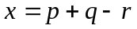 | 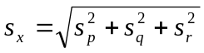
Multiplication or Division | 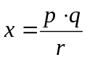 | 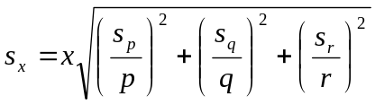
Exponentiation | 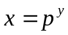 | 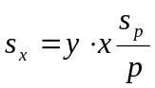
Logarithm | 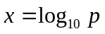 | 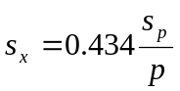
Natural Logarithm | 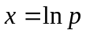 | 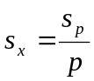
Antilogarithm | 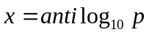 | 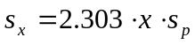
Natural Antilogarithm | 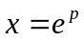 | 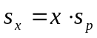
* p, q, and r are experimental variables whose standard deviations are s_{p}, s_{q}, and s_{r}, respectively: y is a constant.

Least Squares Error Analysis

With a set of data points, the error for a linear fit can be found following these equations:
(x and y are the data points and N is the number of data points)

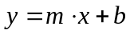 : line equation
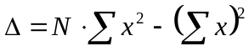 :
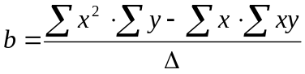 : y-intercept
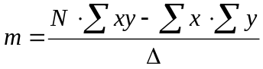 : slope
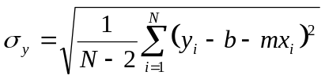 : standard deviation of the y’s
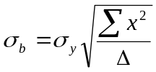 : standard deviation of the y-intercept
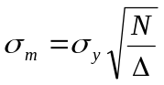 : standard deviation of the slope
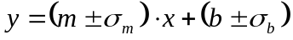 : line equation with error

This system of equations is what Microsoft Excel uses in its LINEST function.

