
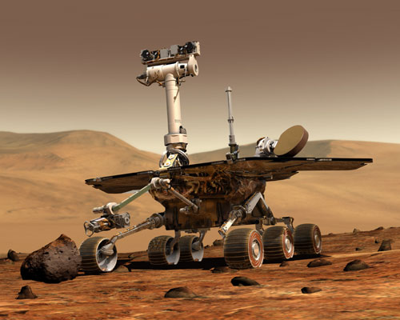

Software Requirements Specification

for

Spirit Pathfinding Engine

Document Information
Company | Four Factor Studios © 2011
Author | Michael K. Antonelli
Revision Date | 12-February-2011
Software Version Number | 0.1
Document Revision Number | 0

Software Version History

Name | Date | Software Changes | Version
Michael K. Antonelli | 12-February-2011 | Initial Revision | 0.1

Document Revision History

Name | Date | Document Changes | Revision #
Michael K. Antonelli | 12-February-2011 | Initial Revision | 0

Table of Contents
1.Introduction 4
1.1Purpose 4
1.2Document Conventions 4
1.3Project Scope 4
1.4References 4
2.Overall Description 5
2.1Product Perspective 5
2.2Product Features 6
2.2.1Initialization 6
2.2.2Engine 6
2.2.3Pathfinding 6
2.3Operating Environment 6
2.4Design Constraints 6
2.5User Documentation 6
3.System Features 7
3.1Initialization 7
3.2Pause/Resume 7

Introduction

Purpose
Spirit is a pathfinding engine which will determine least resistive paths between locations. Spirit is intended to be a self-contained dynamic library which runs along side a host program. The host program will pass Spirit required pathing data and objects at initialization, and in return Spirit will allow objects to request pathing solutions.

Document Conventions
This document loosely follows IEEE 830 Software Requirements Standards. It will contain an introduction, an overall description, software functional requirements, and additional information including appendicies.

Project Scope
Spirit is a self-contained software component which may be part of a bigger project. Spirit will have its own integration specifications for other software to use to communicate with it. Spirit will have the ability to read several formats of data provided the correct libraries are used. This project will include both the Spirit engine along with some included libraries for Four Factor Studios projects.

References
[IEEE 830-1998] IEEE Recommended Practice for Software Requirements Specifications
[SDL-1.2.14] Simple DirectMedia Library

Overall Description

Product Perspective
Spirit consists of libraries and algorithms which are used for computing paths, an engine for parallel processing of pathing, and interfaces which allow other software packages to bi-directionally communicate with Spirit. Libraries include stack and queue implementations, sorting implementations, pathing algorithms, event handling, and utility functions. The engine will include processing logic, initialization and cleanup routines, error handling, logging, parallel processing, and reporting. The interfaces will include path cost structures, object structures, suggested path structures, and exposed functions for client interactions.
========================Insert Diagrams Here==========================

Product Features
Spirit provides the following functions to a host program.

Initialization
During initialization the host program shall send Spirit path cost data, a shared lock variable for synchronization, and the location of the objects list. Spirit can optionally take a log location, otherwise it shall output to its own log file. Spirit shall then start up its threaded process.

Engine
Spirit shall have an engine which controls scheduling of work. The engine is the primary processing unit in Spirit. Under reasonable conditions the engine shall not interrupt the primary game engine. The engine shall implement use of a priority system which describes actions which need to be completed immediately, and actions which are not urgent. The engine shall make use of a lock variable to prevent consuming resources of the host program.

Pathfinding
Spirit shall implement a pathfinding algorthm which attempts to determine low cost paths to a goal. Spirit attempt to determine usable paths immediately, and then Spirit shall use free processing time to attempt to computer improved paths. Spirit shall attempt to give the engine a usable path within one host program loop. This path may not be a solution guaranteed path. Spirit will continue to attempt to find closed solutions paths.

Operating Environment
Spirit shall be platform agnostic. Where platform specific calls must be used, macros or an abstraction library will be used in its place such that Spirit can easily become cross platform. Spirit depends on [SDL-1.2.14] or greater.

Design Constraints
Spirit is required to operate in short quantums of time. Spirit is required to return possible paths which may not have a solution yet.

User Documentation
All code in Spirit shall have commenting containing the basics regarding the operation of the given function. Software requirements shall be updated with released program versions. Design Specifications shall be made available where possible for clients to use Spirit.

System Features
This section describes the design intent of Spirit's features. These features directly relate a Spirit design entity.

Initialization
Initialization shall be called upon startup. Spirit will begin its pathfinding routines and logging during this activity. Spirit will return a status to the host program about its usability.

Pause/Resume
Spirit shall be pausable. The host shall be able to issue a pause command to Spirit which will prevent Spirit from operating until a resume command is issued. When a pause is issued, Spirit may finish some of its current actions and will not yield immediately.

